Laboratory Assignment 6: Introduction to Field Programmable Gate Arrays
ECE 0201: Digital Circuits and Systems
(45 Points)
Name
张鹤扬 Stefan

Submission Checklist:
Write within boxes, do not move boxes
Write your full name in the box above
 Save this file as a PDF before uploading, keep the number of pages (8) unchanged
 Note “TO BE CONTINUED” in the answer box if you used the extra pages (7-8)
Part I: Tutorials (5 points)
[(A) Insert a screenshot of your VHDL code for Part I.] (1 points)
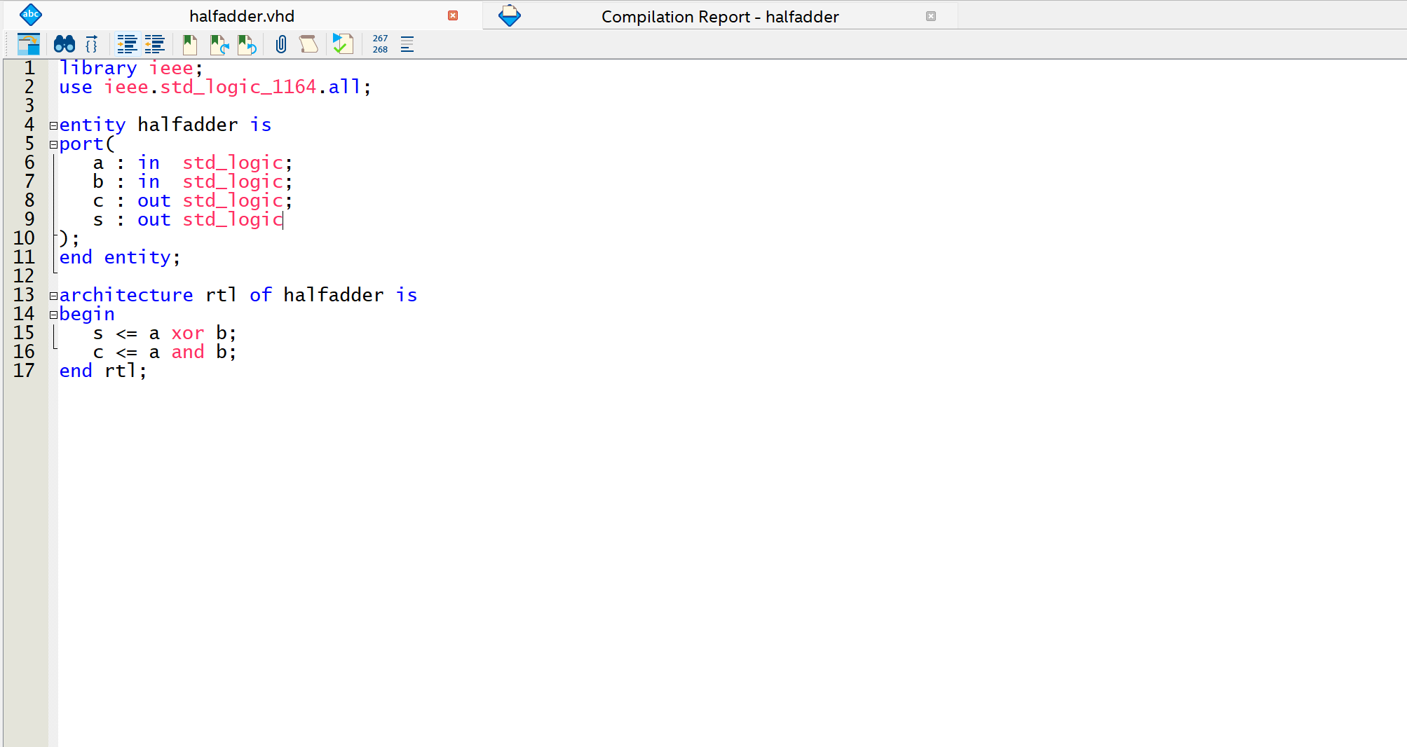
[(B) Insert an image of your ModelSim Simulation.] (2 points)
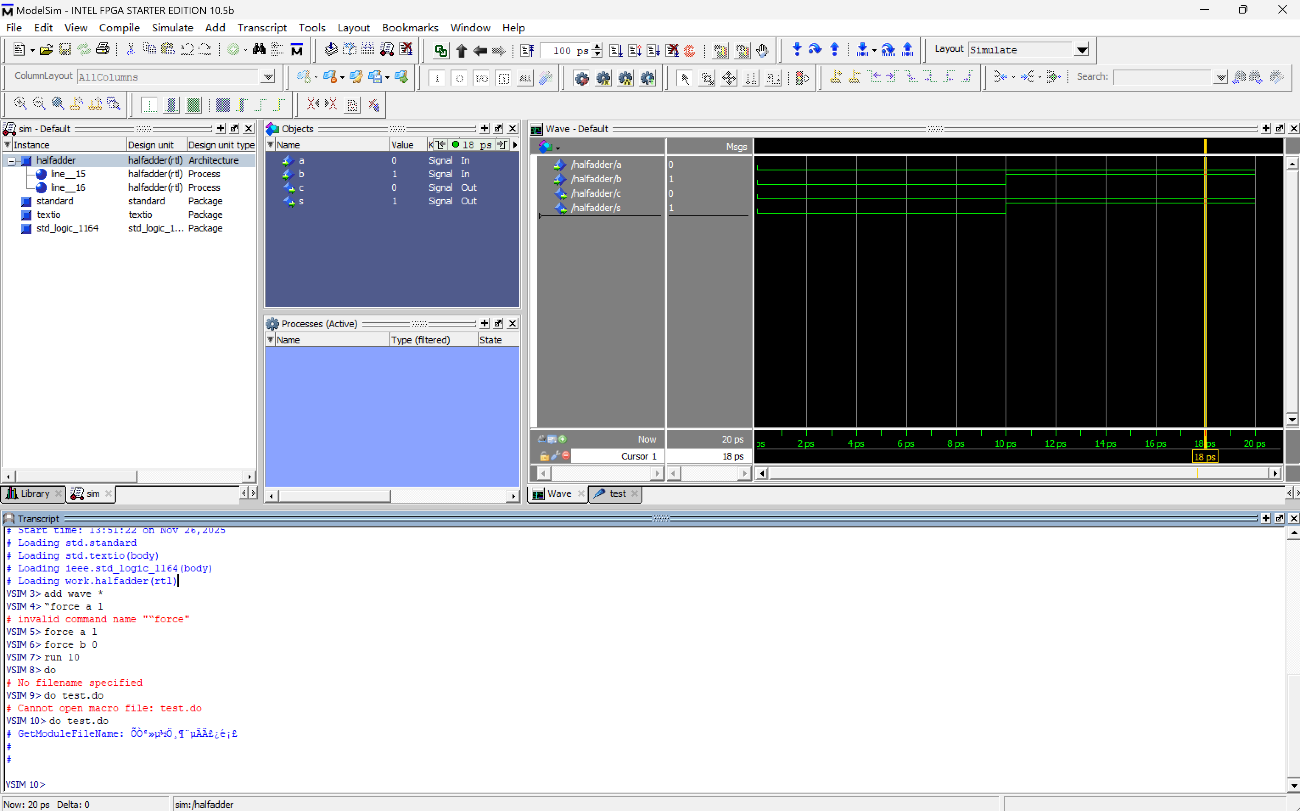
[(C) Insert the text of your do file.] (1 points)
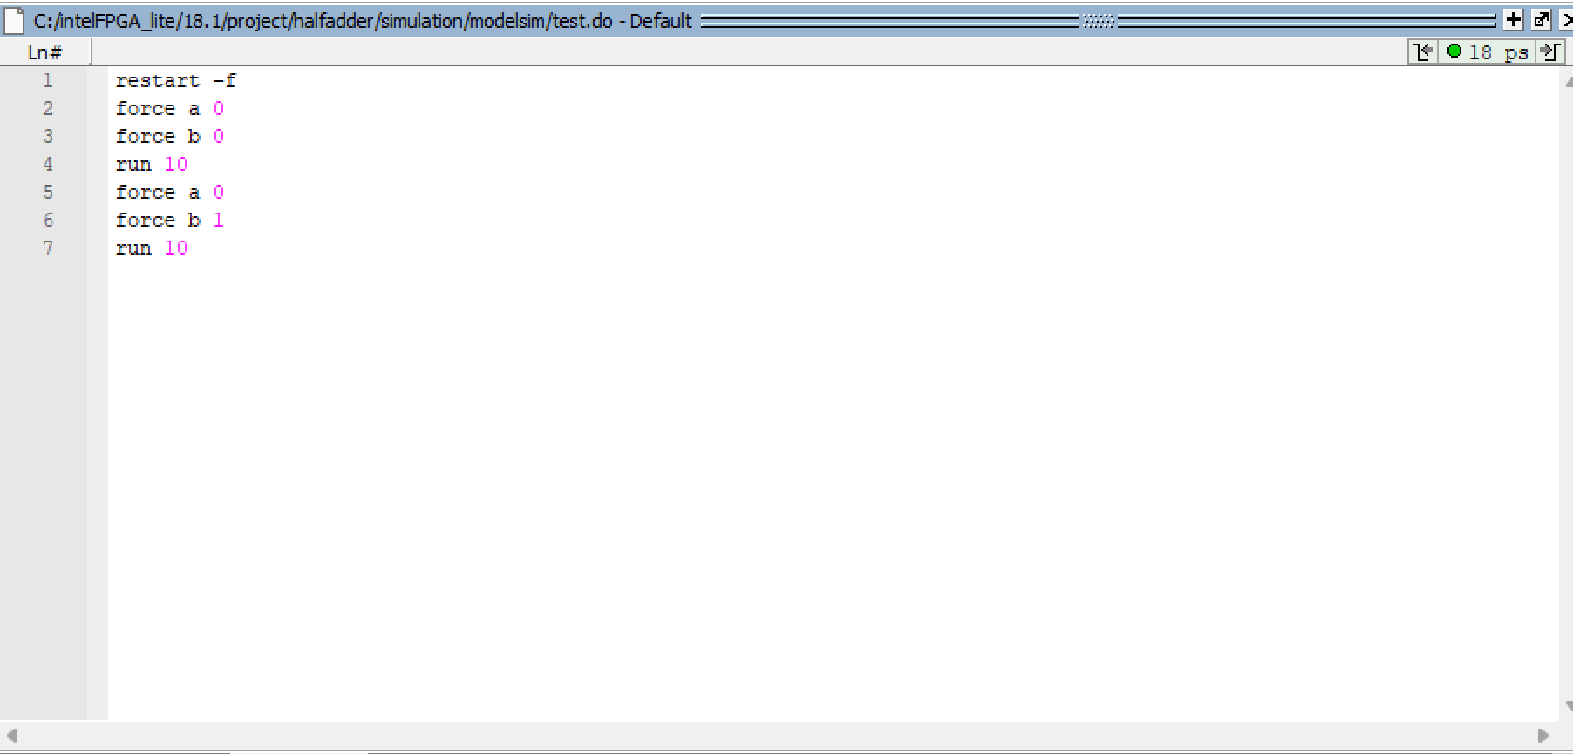
[(D) Insert a screenshot of the Pin Planner.] (1 point)
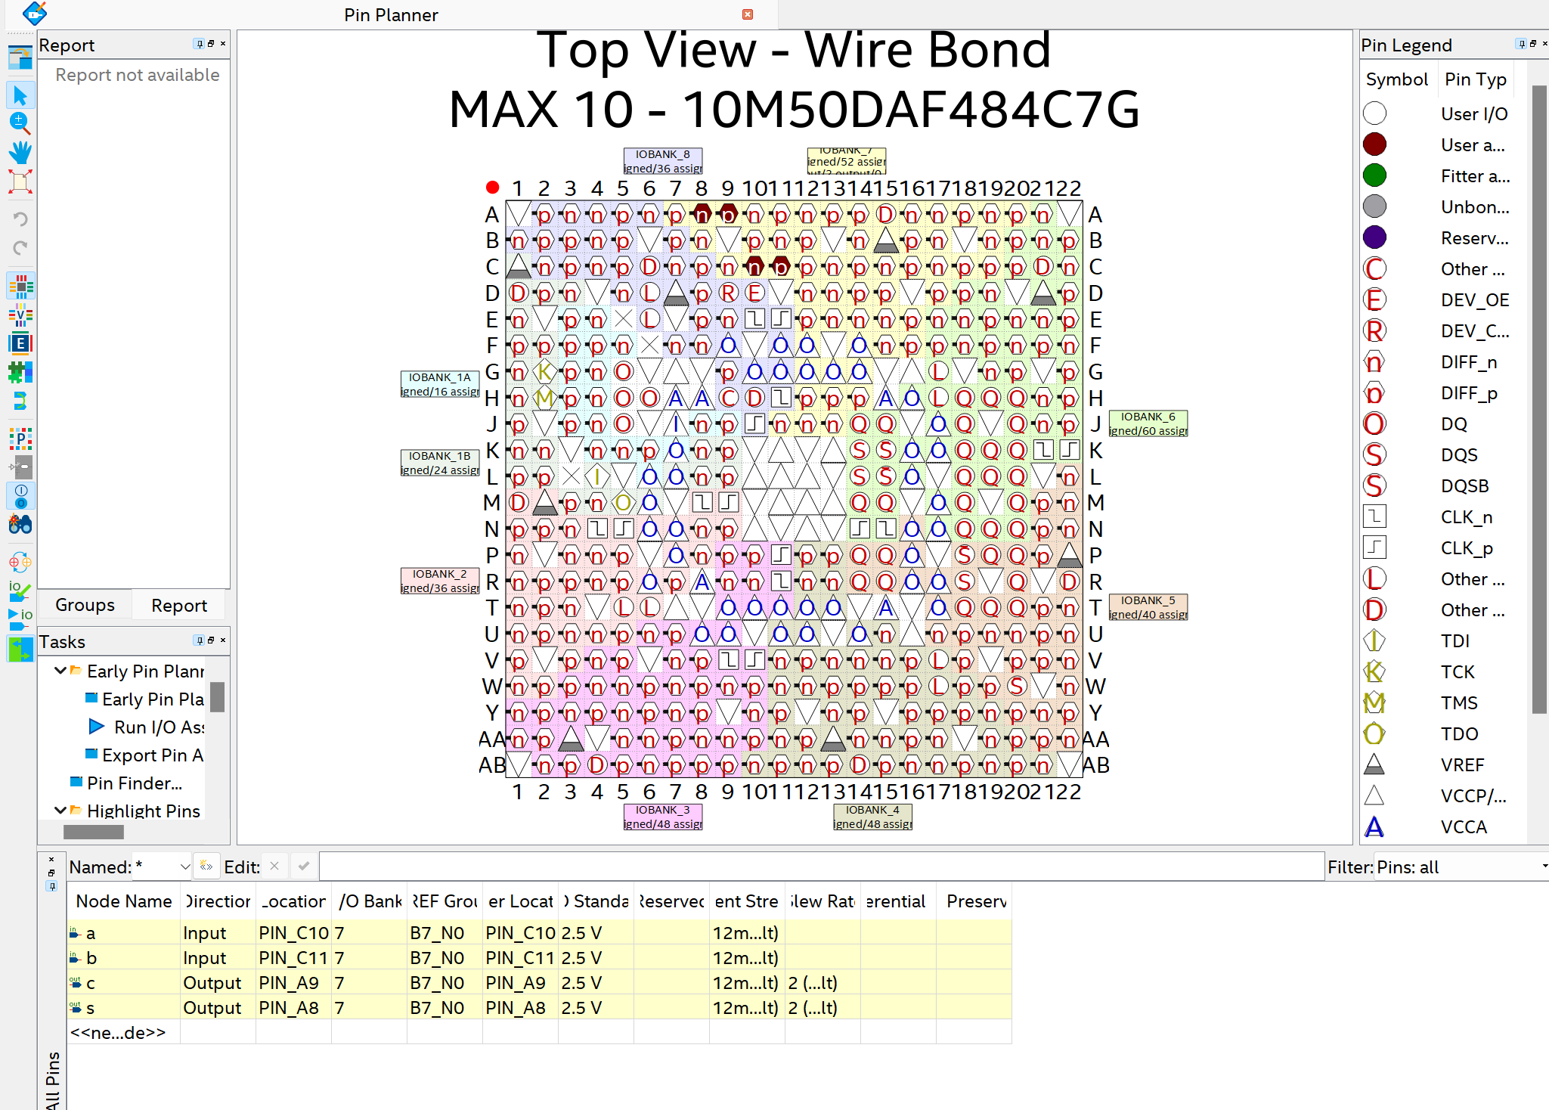

Part II: Rock-Paper-Scissors! (40 points)
[(A) Insert a screenshot of your VHDL code for Part II.] (4 points)
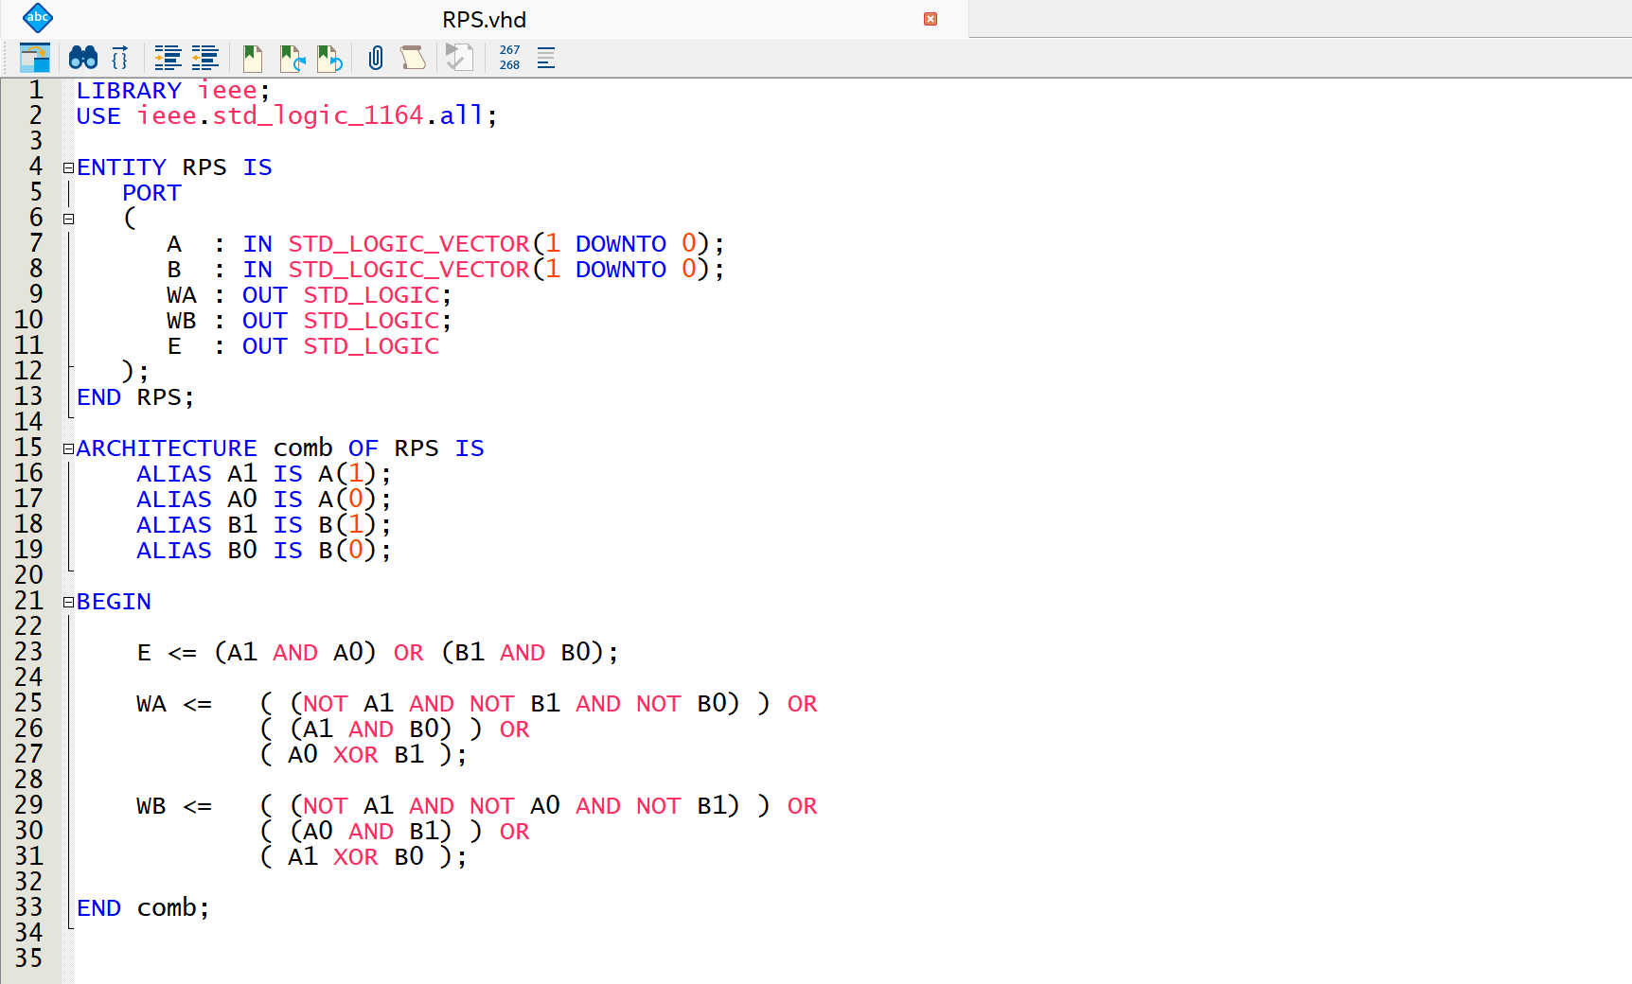
[(B) Insert an image of your ModelSim Simulation.] (4 points)
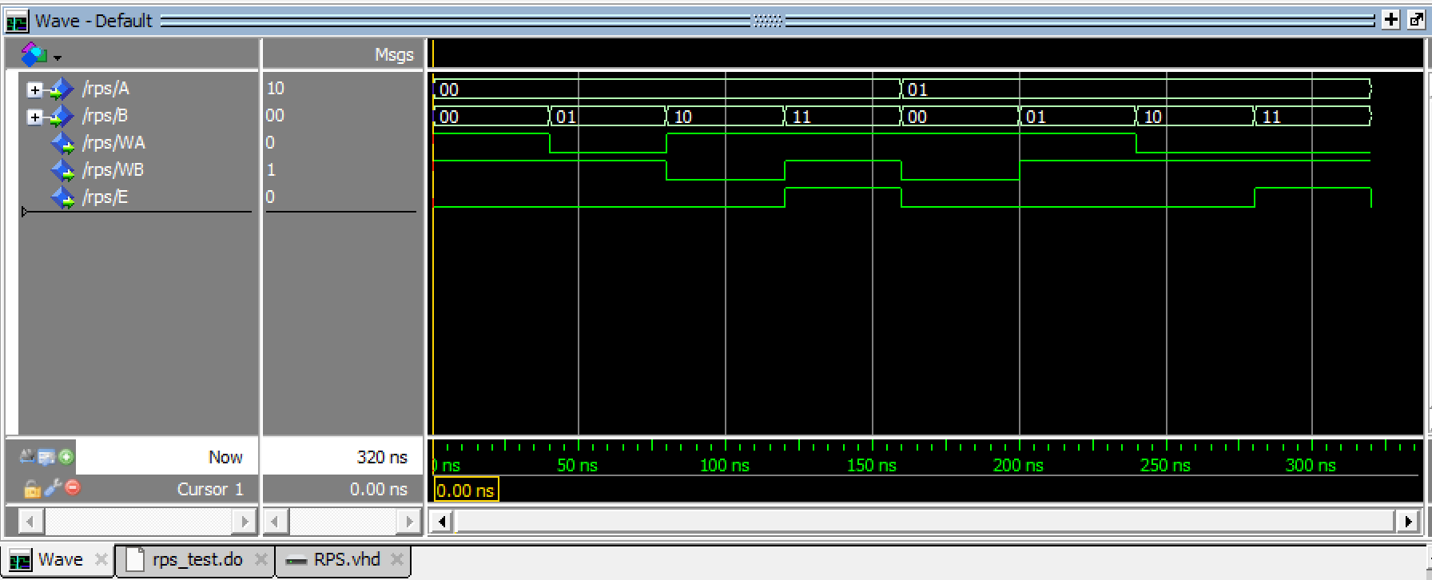
[(C) Insert the text of your do file.] (2 points)
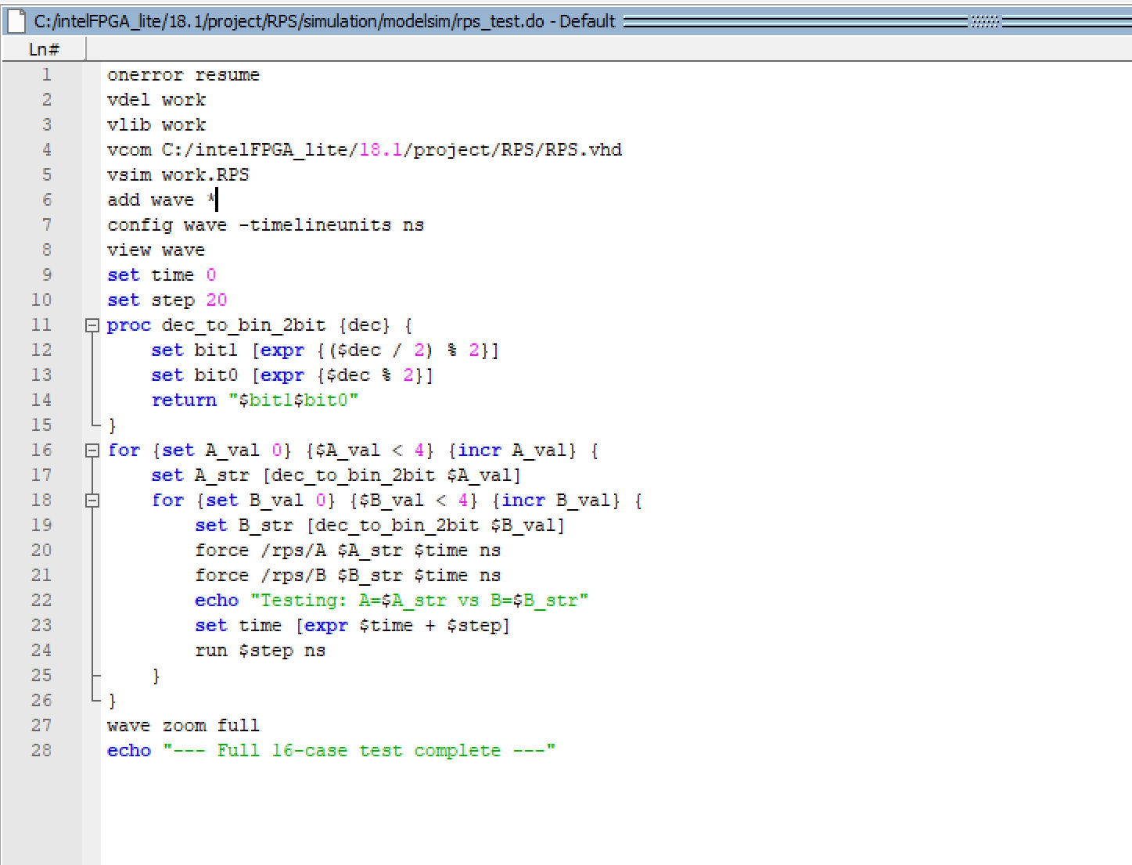
[(D) Demonstrate your FPGA implementation to the TA for Lab 6 check-off.] (30 points)

[Leave the page unchanged if you are not going to use. Otherwise, specify the problem number you are working on here. Don’t forget to notify “TO BE CONTINUED” in the original problem box]

[Leave the page unchanged if you are not going to use. Otherwise, specify the problem number you are working on here. Don’t forget to notify “TO BE CONTINUED” in the original problem box]

