Laboratory Assignment 5: Optimization Implementations of Logic Functions
ECE 0201: Digital Circuits and Systems
(45 Points)
Name
张鹤扬Stefan
Submission Checklist:
Write within boxes, do not move boxes
Write your full name in the box above
Save this file as a PDF before uploading, keep the number of pages (6) unchanged
Note “TO BE CONTINUED” in the answer box if you used the extra page (6)

Part II: Getting Started
[(A) Define your abstraction and create a truth table] (4 points)
1. Definition:
condition | Error | Paper | Scissor | Rock
X₁X₀ | 11 | 00 | 01 | 10
Note: X can be A or B.
2. Abstraction:
Switch open is 0, close is 1;
LED ON is 1, OFF is 0
3. Truth table:
A₁A₀ | B₁B₀ | W_{A} | W_{B} | E
00 | 00 | 1 | 1 | 0
00 | 01 | 0 | 1 | 0
00 | 11 | - | - | 1
00 | 10 | 1 | 0 | 0
01 | 00 | 1 | 0 | 0
01 | 01 | 1 | 1 | 0
01 | 11 | - | - | 1
01 | 10 | 0 | 1 | 0
11 | 00 | - | - | 1
11 | 01 | - | - | 1
11 | 11 | - | - | 1
11 | 10 | - | - | 1
10 | 00 | 0 | 1 | 0
10 | 01 | 1 | 0 | 0
10 | 11 | - | - | 1
10 | 10 | 1 | 1 | 0
* - are don’t care the value
[(B) Explain how you have chosen to indicate a tie, and why you made this design choice (3 points)]
Indication: A tie is represented by both WA and WB being asserted (lighted) simultaneously.
Reason: Treating the tie condition as WA = WB = 1 introduces additional minterms into the K-maps for WA and WB. This increases grouping opportunities, thereby yielding simpler (fewer literals or gates) sum-of-products expressions.
[(C) Write and simplify a logic function for each output (show K-maps if you choose to use them)] (4 points)
1. Error: From the truth table, E = 1 whenever A equals 11₂ (i.e., A1A0 = 11) or B equals 11₂ (i.e., B1B0 = 11).
$$E=A_{1}A_{0}+B_{1}B_{0}$$
2. W_{A}: WA must be 1 whenever A wins or when the scores are tied. Additionally, whenever the error condition occurs (E LED on), the states of WA and WB are irrelevant and may be treated as don’t-care (“X”). This allows us to fill X’s in the corresponding cells of the WA K-map.
A₁A₀ B₁B₀ | 00 | 01 | 11 | 10
00 | 1 | 0 | X | 1
01 | 1 | 1 | X | 0
11 | X | X | X | X
10 | 0 | 1 | X | 1

$$W_{A}=A_{1}^{'}B_{1}^{'}B_{0}^{'}+A_{1}B_{0}+A_{0}⊕B_{1}$$
3.W_{B}: WB must be 1 whenever B wins or when the scores are tied. Similarly, under the error condition (E LED on), the states of WA and WB become irrelevant and are marked as don’t-care (“X”) in the WB K-map.
A₁A₀ B₁B₀ | 00 | 01 | 11 | 10
00 | 1 | 1 | X | 0
01 | 0 | 1 | X | 1
11 | X | X | X | X
10 | 1 | 0 | X | 1

$$W_{B}=A_{1}^{'}A_{0}^{'}B_{1}^{'}+A_{0}B_{1}+A_{1}⊕B_{0}$$

[(D) Draw a gate-level schematic that implements your logic functions and insert a picture of it here] (4 points)

(E) (5 points)
How many gates would the canonical design require? 9
How many gates does your design require? 17
How many IC Chips did you use? 5

[(F) Build the circuit and insert a picture of it here] (5 points)
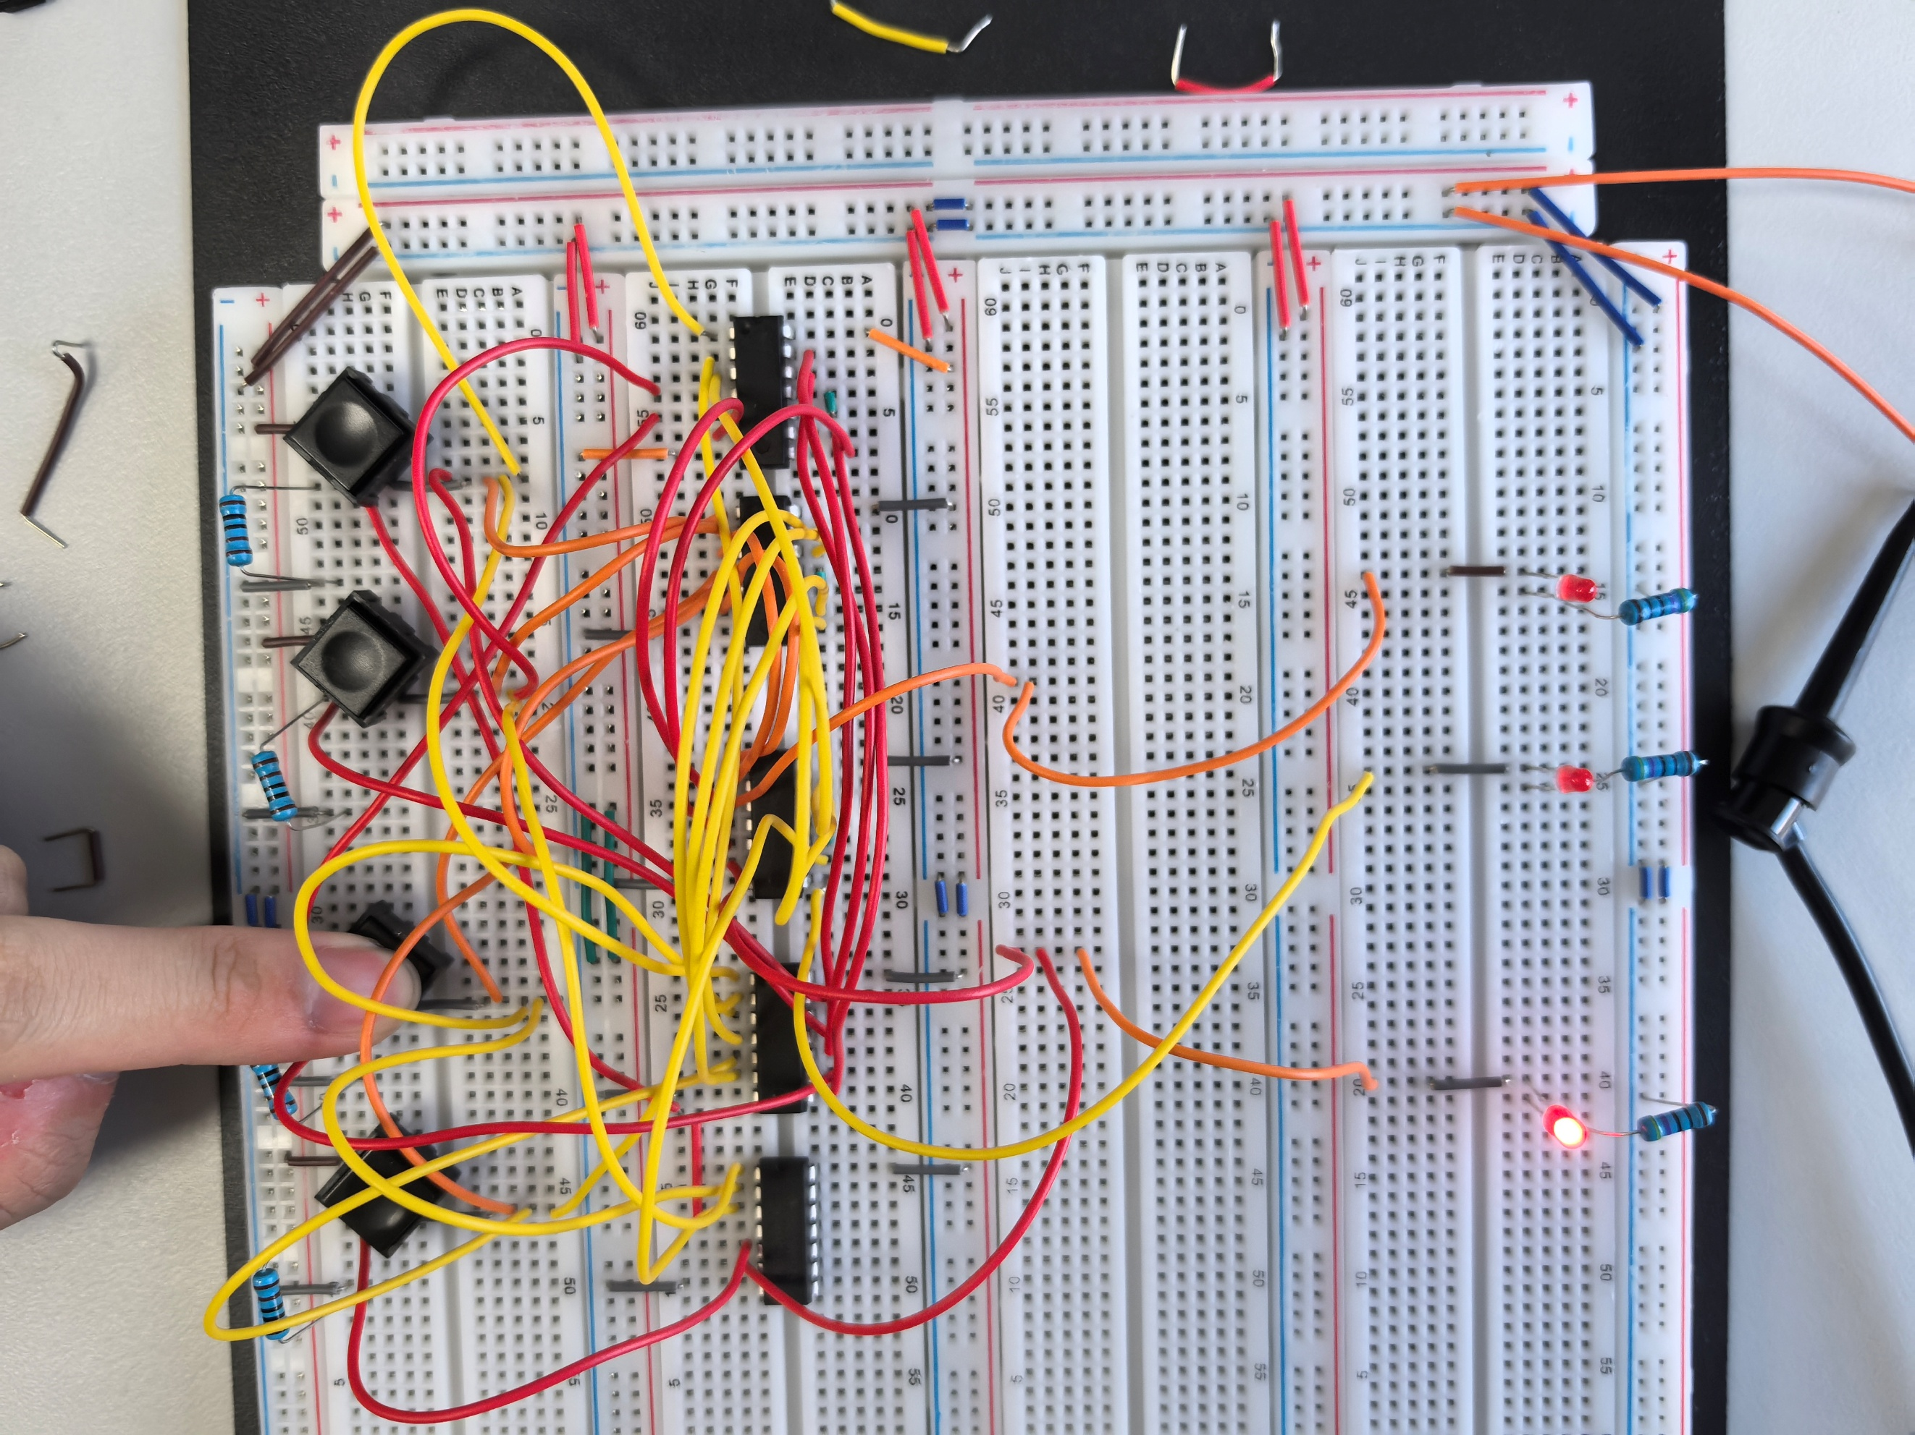
[(G) Demonstrate the functionality of your circuit to a TA] (20 points)
[Leave the page unchanged if you are not going to use. Otherwise, specify the problem number you are working on here. Don’t forget to notify “TO BE CONTINUED” in the original problem box]

