Laboratory Assignment 8: Arithmetic Circuits and Behavioral VHDL
ECE 0201: Digital Circuits and Systems
(50 Points)
Name
张鹤扬Stefan
Submission Checklist:
Write within boxes, do not move boxes
Write your full name in the box above
Save this file as a PDF before uploading, keep the number of pages (9) unchanged
Note “TO BE CONTINUED” in the answer box if you used the extra pages (8-9)

Part I: Synthesis of a Ripple-Carry Adder (16 points)
[(A) Insert a picture of your Full Adder schematic for Part I.] (3 points)
[(B) 8-bit Ripple Carry Adder Cost for Part I.] (3 points)

[(C) Insert a screenshot of your synthesized logic network (RTL Viewer Schematic) for the Ripple Carry Adder circuit in Part I.] (2 points)
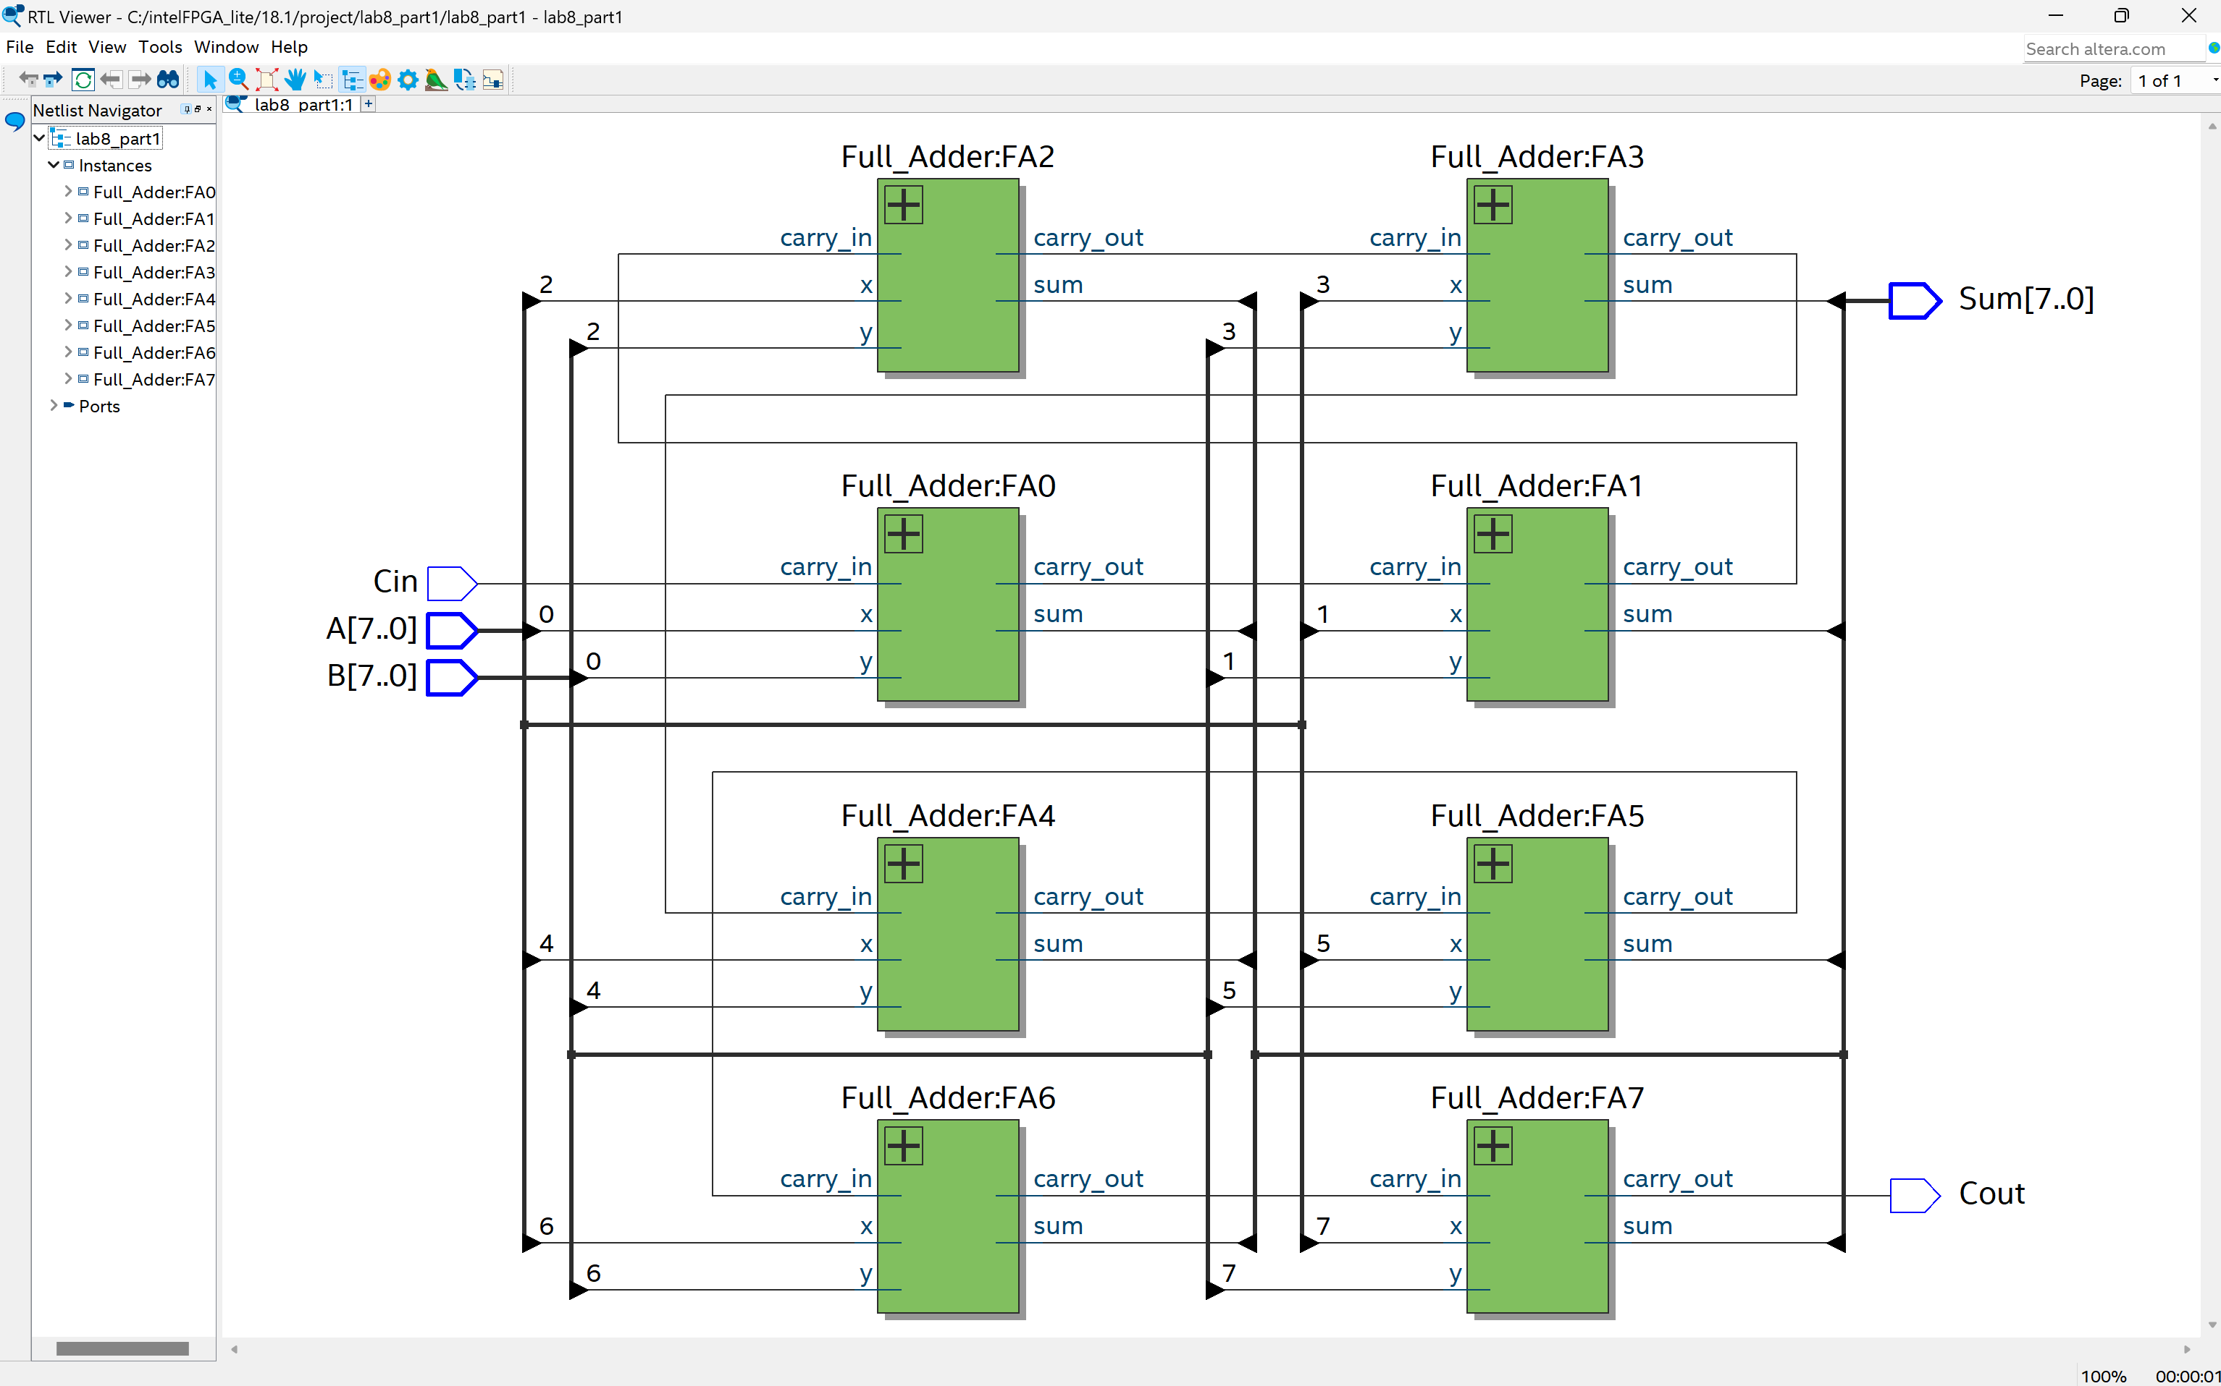
[(D) Insert a screenshot of your synthesized logic network (RTL Viewer Schematic) for the Full Adder circuit in Part I (not Ripple-Carry Adder, just a single Full Adder).] (2 points)
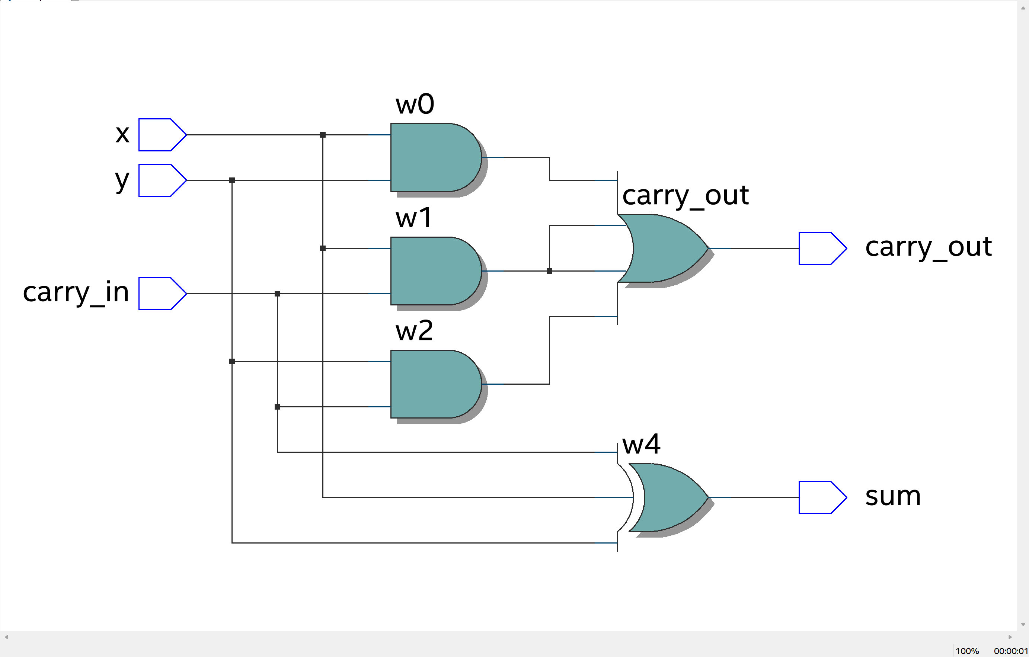
[(E) 8-bit Ripple Carry Adder Cost from RTL viewer – Comment on significance vs Part B.] (4 points)

[(F) Insert a screenshot from the Technology Map Viewer for your 8-bit RCA.] (2 points)
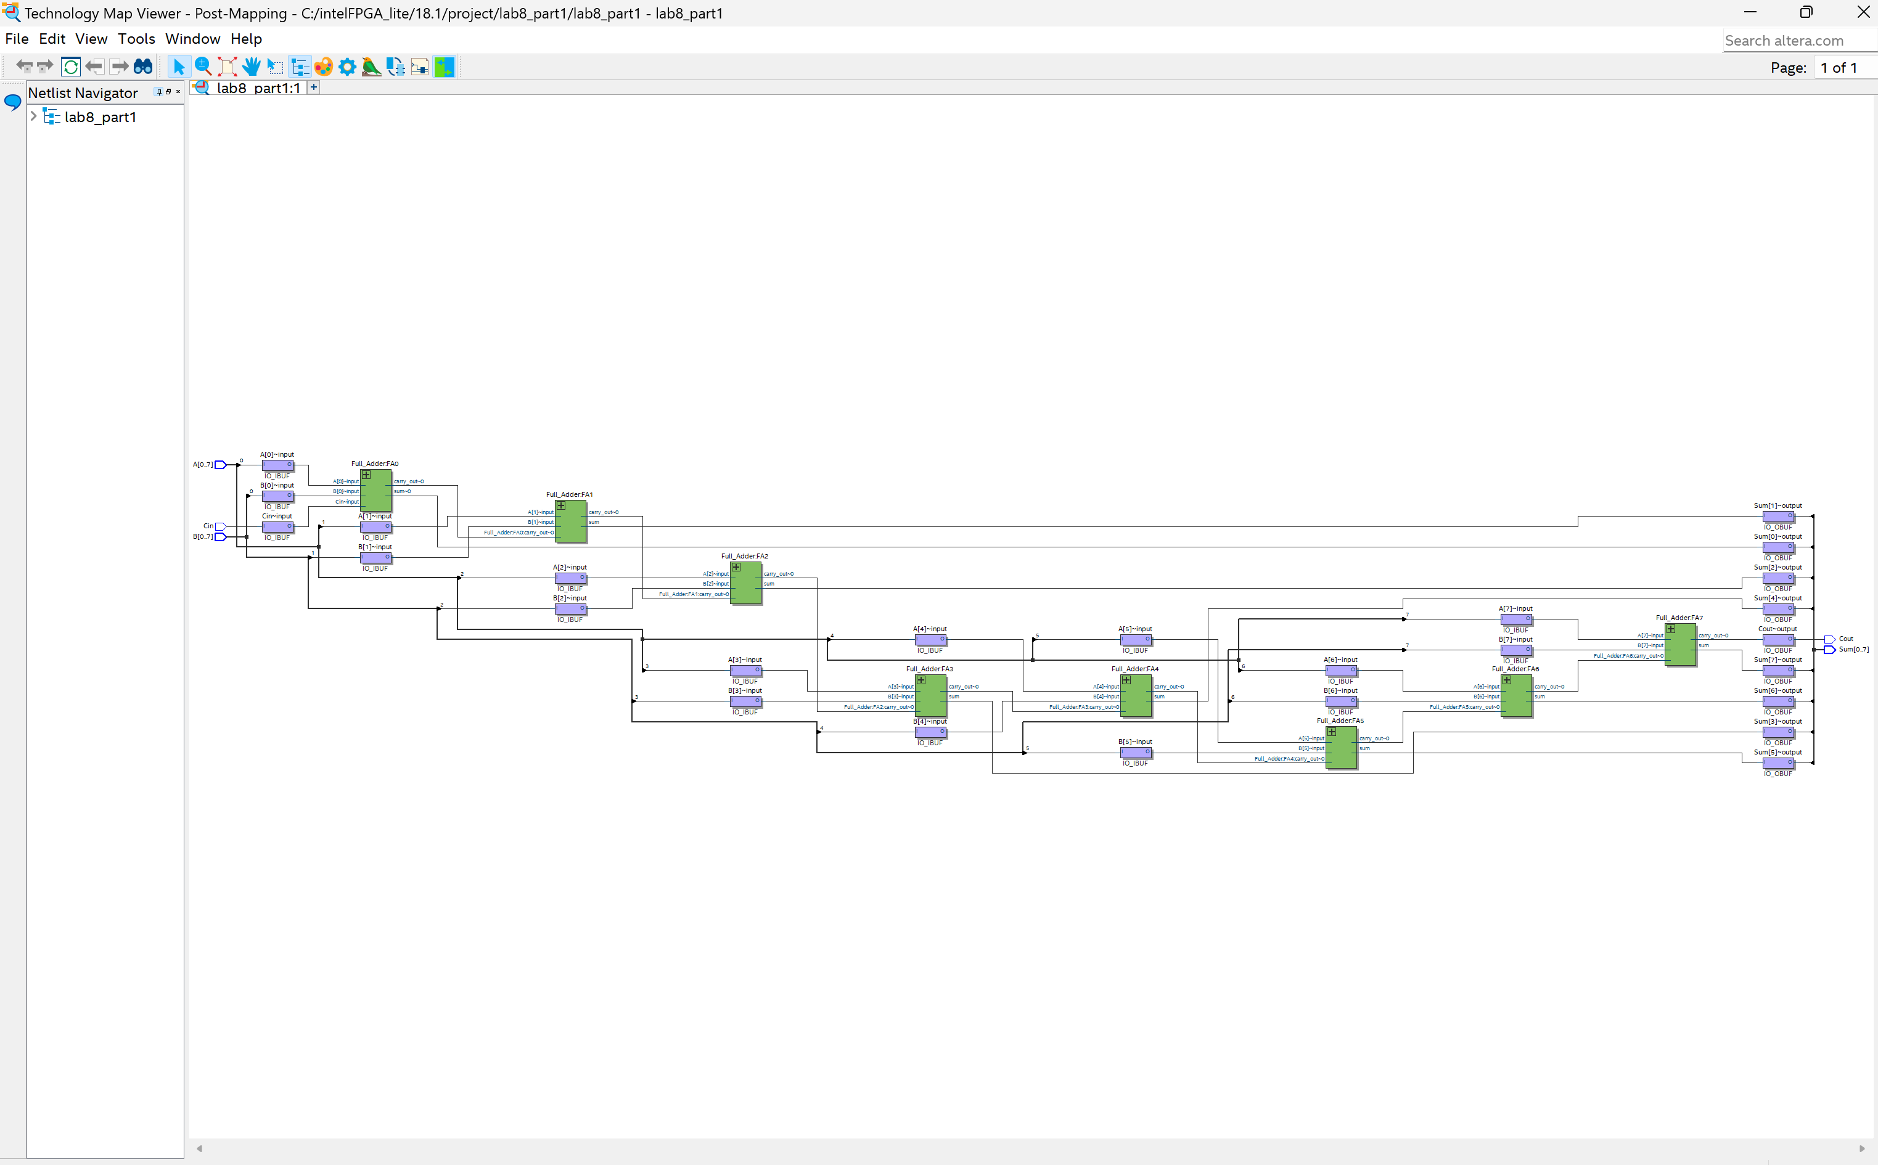
Part II: Introduction to Behavioral VHDL (7 points)
[(A) Insert a screenshot of your MUX Synthesis Results (RTL Viewer) for Part II.] (3 points)
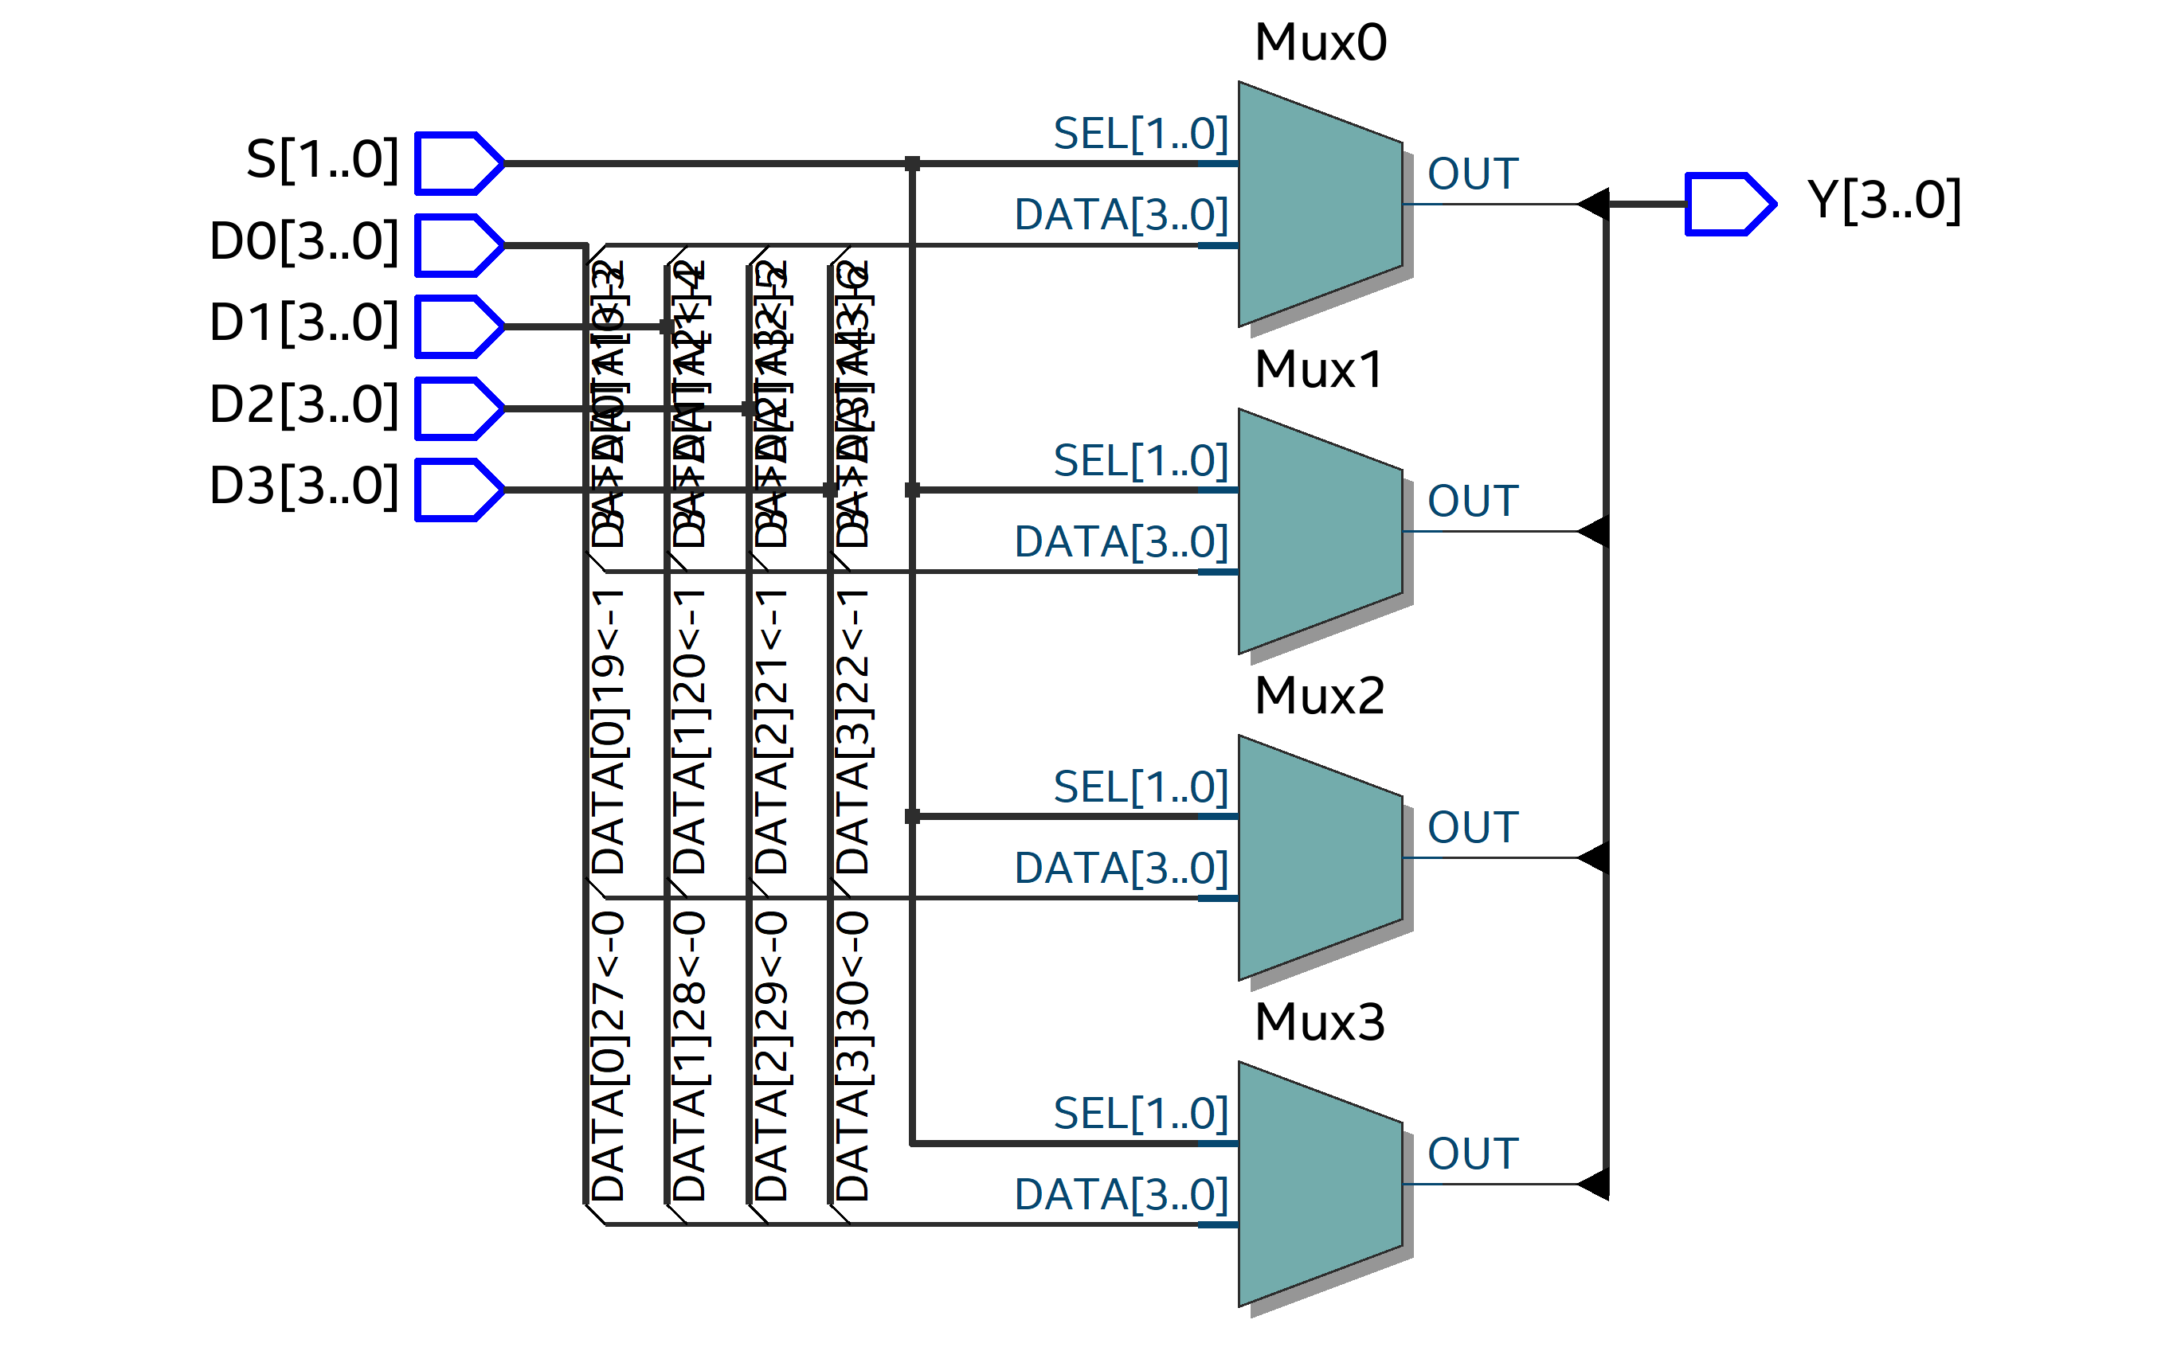
[(B) Comment on these Synthesis Results vs the previous MUX implementation.] (4 points)

Part III: VHDL Arithmetic (8 points)
[(A) Insert a screenshot of your Synthesis Result (RTL Viewer) for Part III 8-bit Binary Adder.] (2 points)
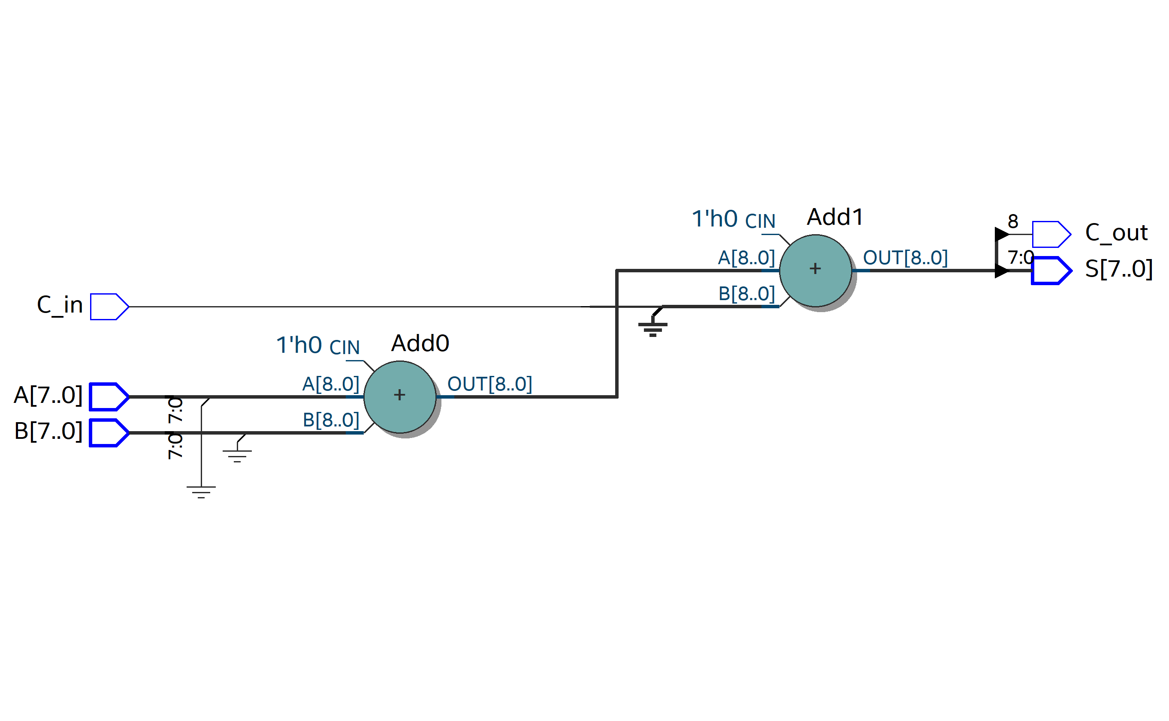
[(B) Insert a screenshot of the Technology Map Viewer for this 8-bit adder.] (2 points)
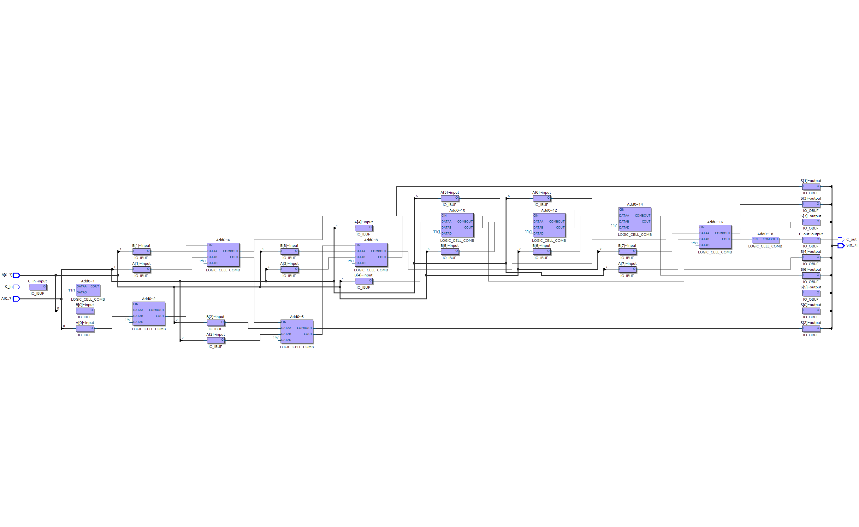
[(C) Comment on these Synthesis Results vs the Synthesis Results of the Ripple Carry Adder from Part I and the structure of the FPGA.] (4 points)

Part IV: Timing Simulations (19 points)
[(A) Report the simulated delay of one stage of your ripple carry adder, and show your simulation result. How does this compare to what you would expect from the RTL viewer schematic?] (4 points)

[(B) Insert a screenshot of your ModelSim simulation results demonstrating the critical path delay, and report the delay.] (5 points)

[(C) Demonstrate your VHDL implementation and timing simulation for the lab checkoff.] (10 points)

[Leave the page unchanged if you are not going to use. Otherwise, specify the problem number you are working on here. Don’t forget to notify “TO BE CONTINUED” in the original problem box]

[Leave the page unchanged if you are not going to use. Otherwise, specify the problem number you are working on here. Don’t forget to notify “TO BE CONTINUED” in the original problem box]

