Laboratory Assignment 9: Latches and Flip-Flops
ECE 0201: Digital Circuits and Systems
(50 Points)

Name
张鹤扬 Stefan
Submission Checklist:
Write within boxes, do not move boxes
Write your full name in the box above
Save this file as a PDF before uploading, keep the number of pages (8) unchanged
Note “TO BE CONTINUED” in the answer box if you used the extra pages (7-8)

Part I: D Flip-Flop (15 points)
[(A) Insert a screenshot of your VHDL code for Part I.] (3 points)
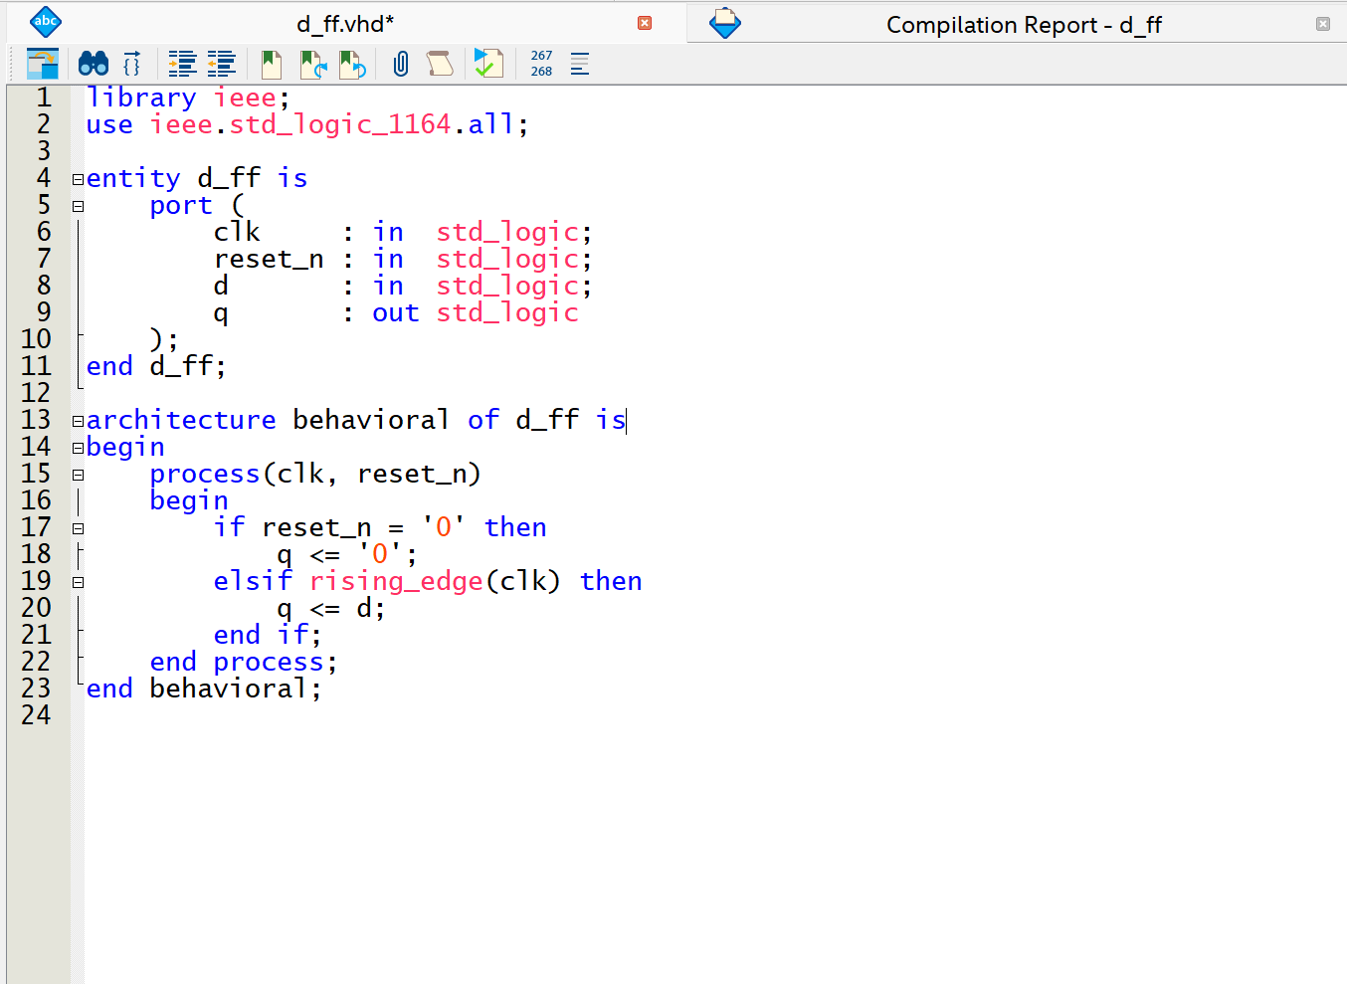
[(B) Insert a screenshot of your implementation from the RTL Viewer (Tools Netlist Viewers RTL Viewer).] (2 points)
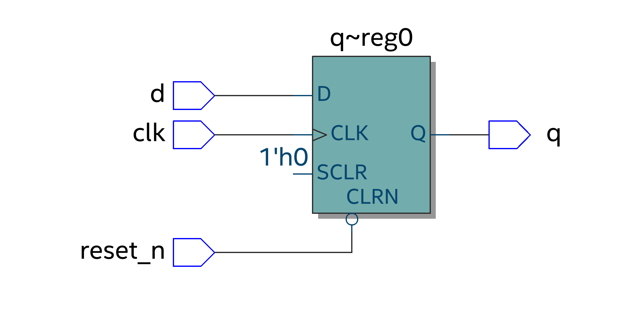
[(C) Insert a screenshot of your functional waveform simulation showing inputs and simulated outputs.] (3 points)
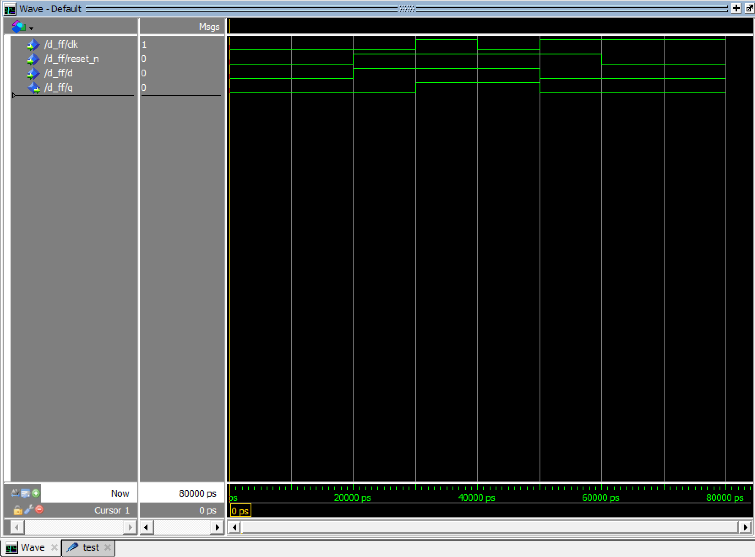
[(D) Demonstrate your circuit to the TA for the first Lab 9 check-off.] (7 points)

Part II: 8-Bit Accumulator Circuit (35 points)
[(A) Insert a screenshot of your VHDL code for the register component.] (3 points)
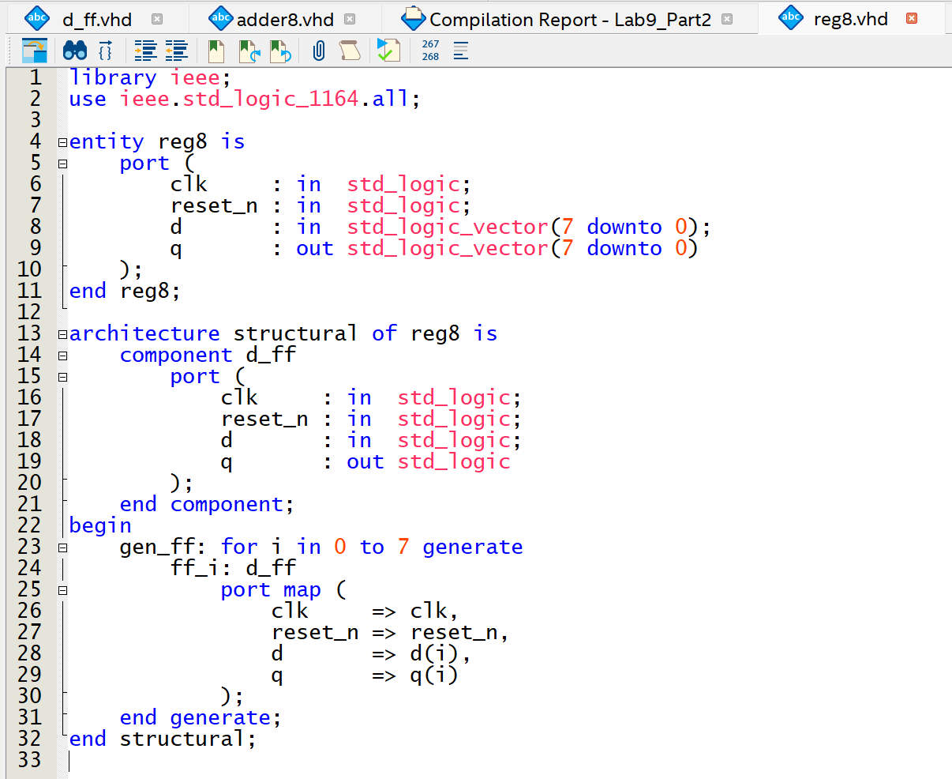
[(B) Insert a screenshot of your VHDL code for the overflow circuit.] (3 points)
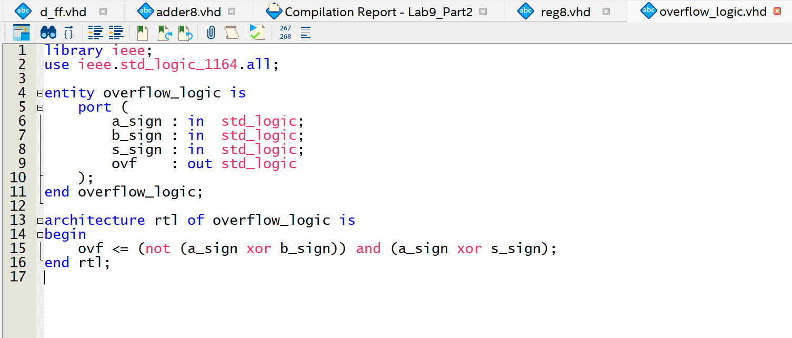
[(C) Insert a screenshot of your top-level VHDL code for the accumulator circuit.] (5 points)
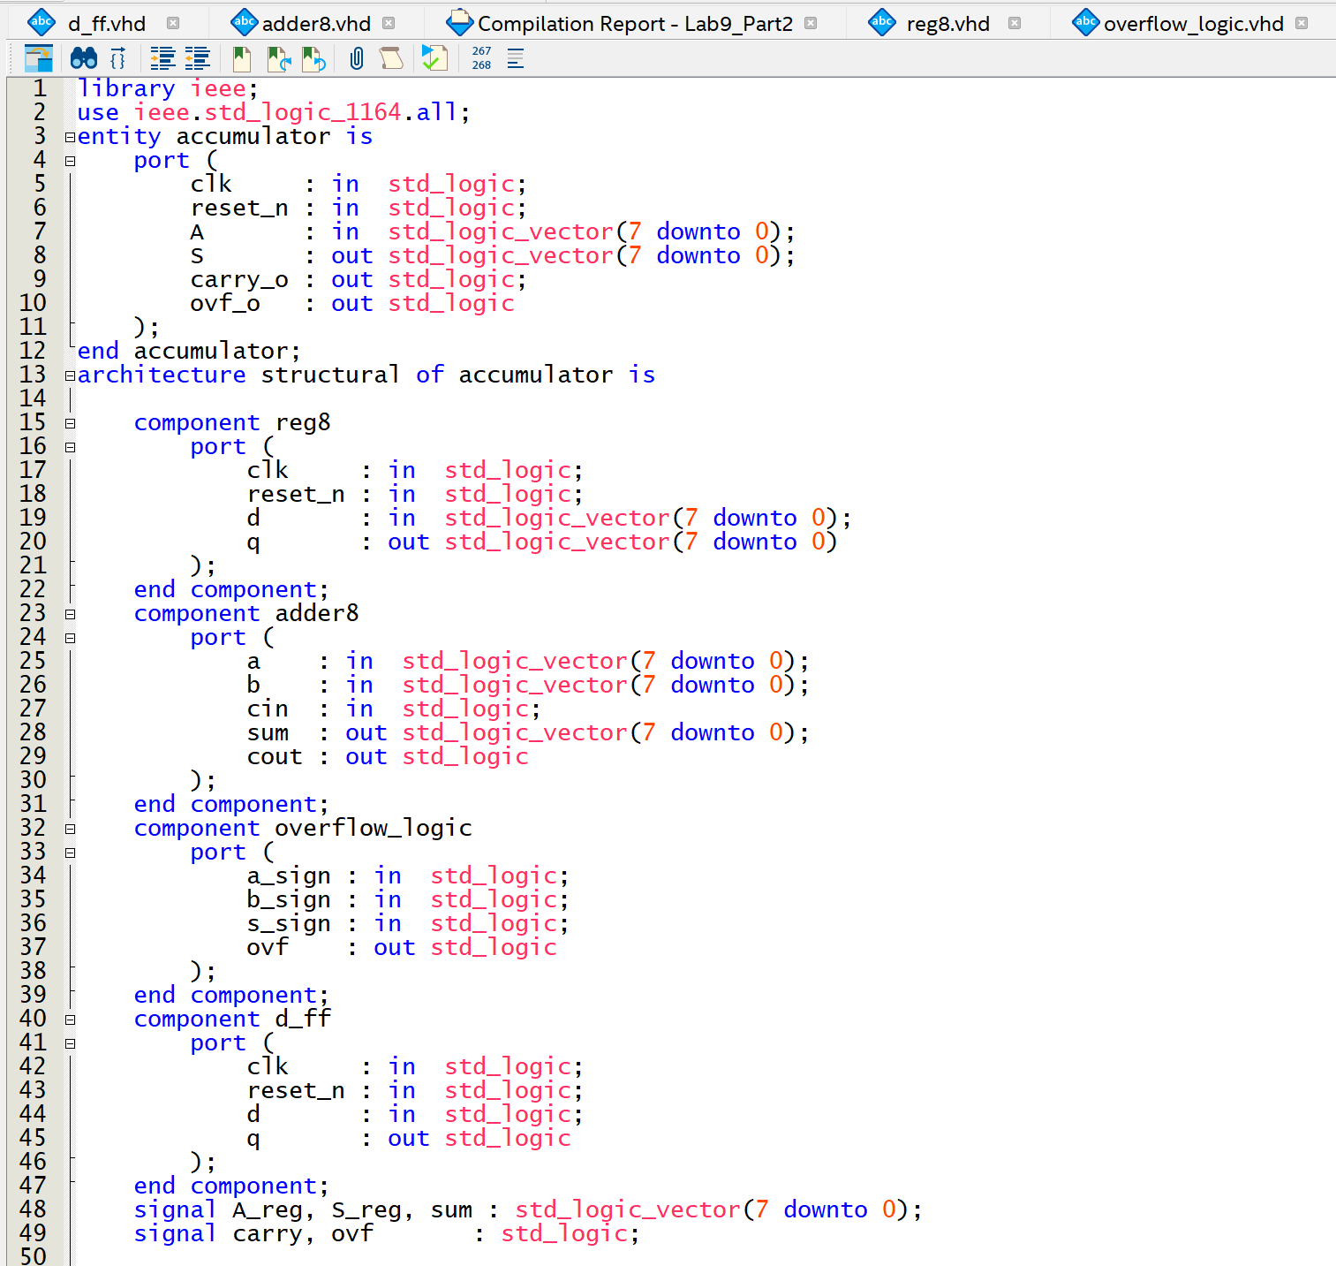
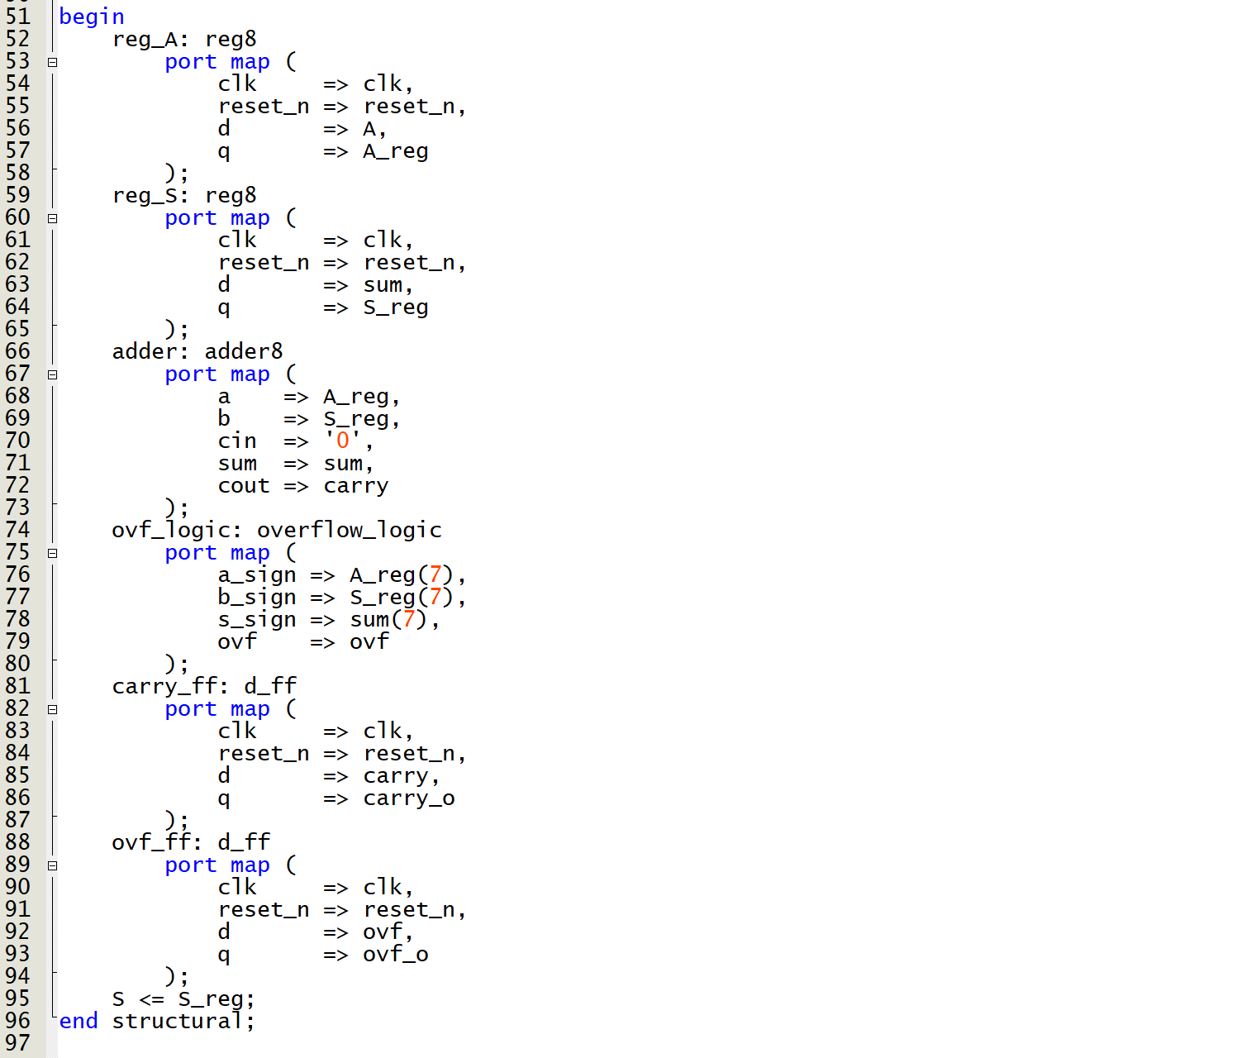
[(D) Insert a screenshot of your ModelSim waveform simulation showing inputs and simulated outputs.] (4 points)
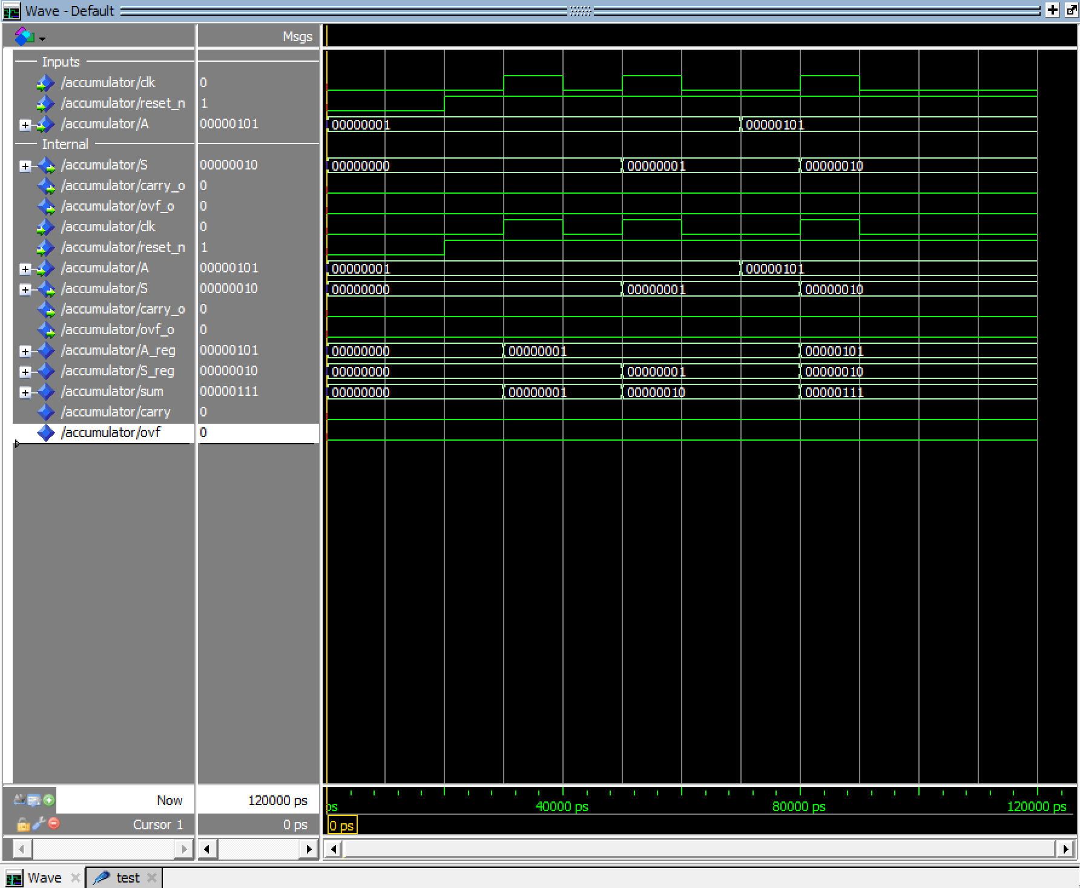
[(E) Demonstrate your circuit to the TA for the second Lab 9 check-off.] (20 points)

[Leave the page unchanged if you are not going to use. Otherwise, specify the problem number you are working on here. Don’t forget to notify “TO BE CONTINUED” in the original problem box]

[Leave the page unchanged if you are not going to use. Otherwise, specify the problem number you are working on here. Don’t forget to notify “TO BE CONTINUED” in the original problem box]

