Laboratory Assignment 7: Logic Design with Combinational Building Blocks
ECE 0201: Digital Circuits and Systems
(50 Points)

Name

Submission Checklist:
Write within boxes, do not move boxes
Write your full name in the box above
Save this file as a PDF before uploading, keep the number of pages (10) unchanged
Note “TO BE CONTINUED” in the answer box if you used the extra pages (9-10)

Part I: 4-Bit BCD to 7-Segment Display (10 points)
[(A) Show your derivation of logic functions for 7-segment display segments.] (3 points)
[(B) Insert a screenshot of your VHDL code for Part I.] (3 points)
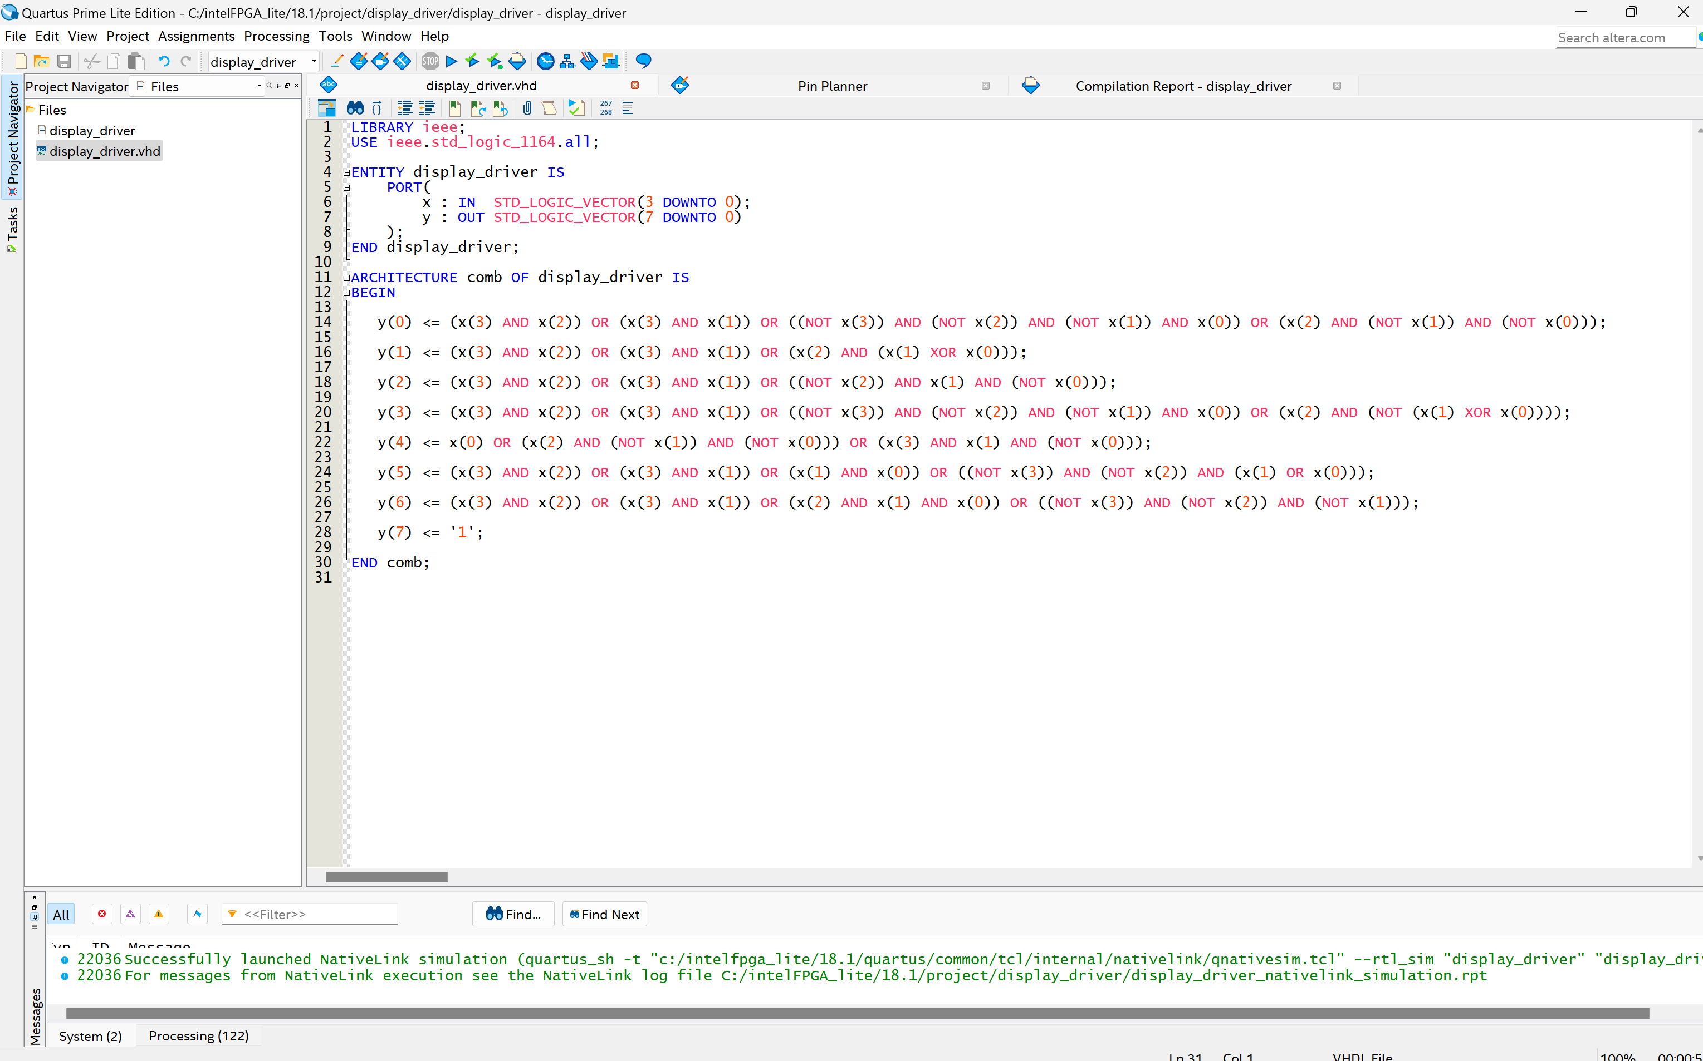
[(B) Insert a screenshot of your ModelSim simulation for Part I.] (4 points)
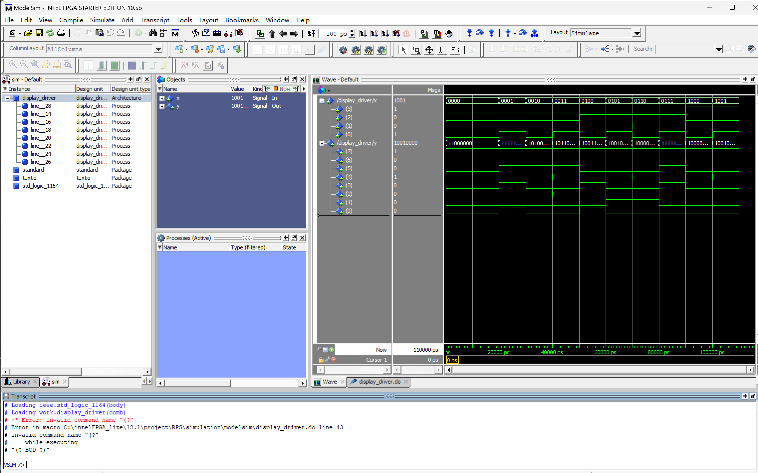

Part II: Multiple 7-segment Display Drivers (32 points)
[(A) Insert a screenshot of your VHDL code for Part II.] (2 points)
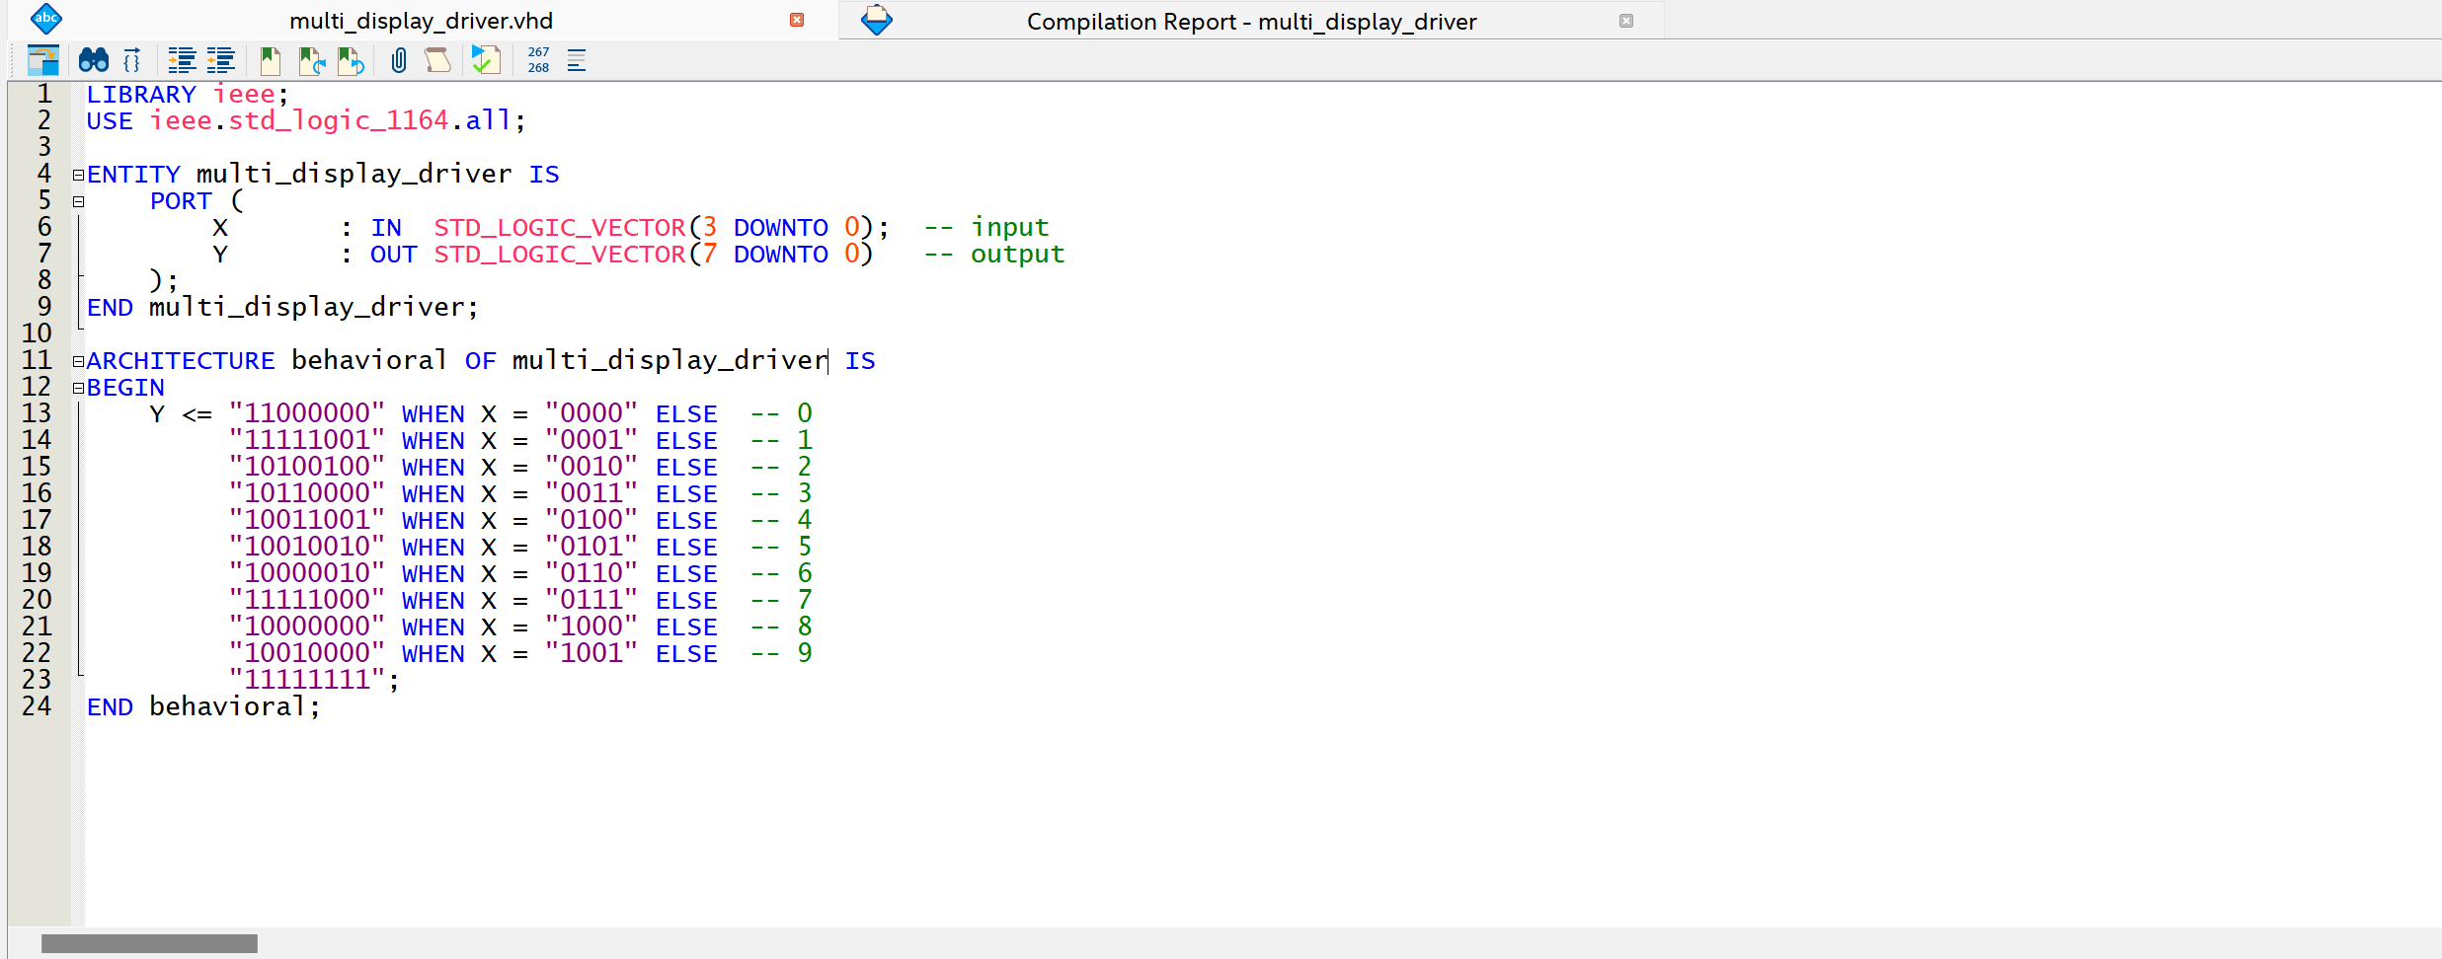

[(B) Insert a screenshot of your ModelSim simulation for Part II.] (2 points)
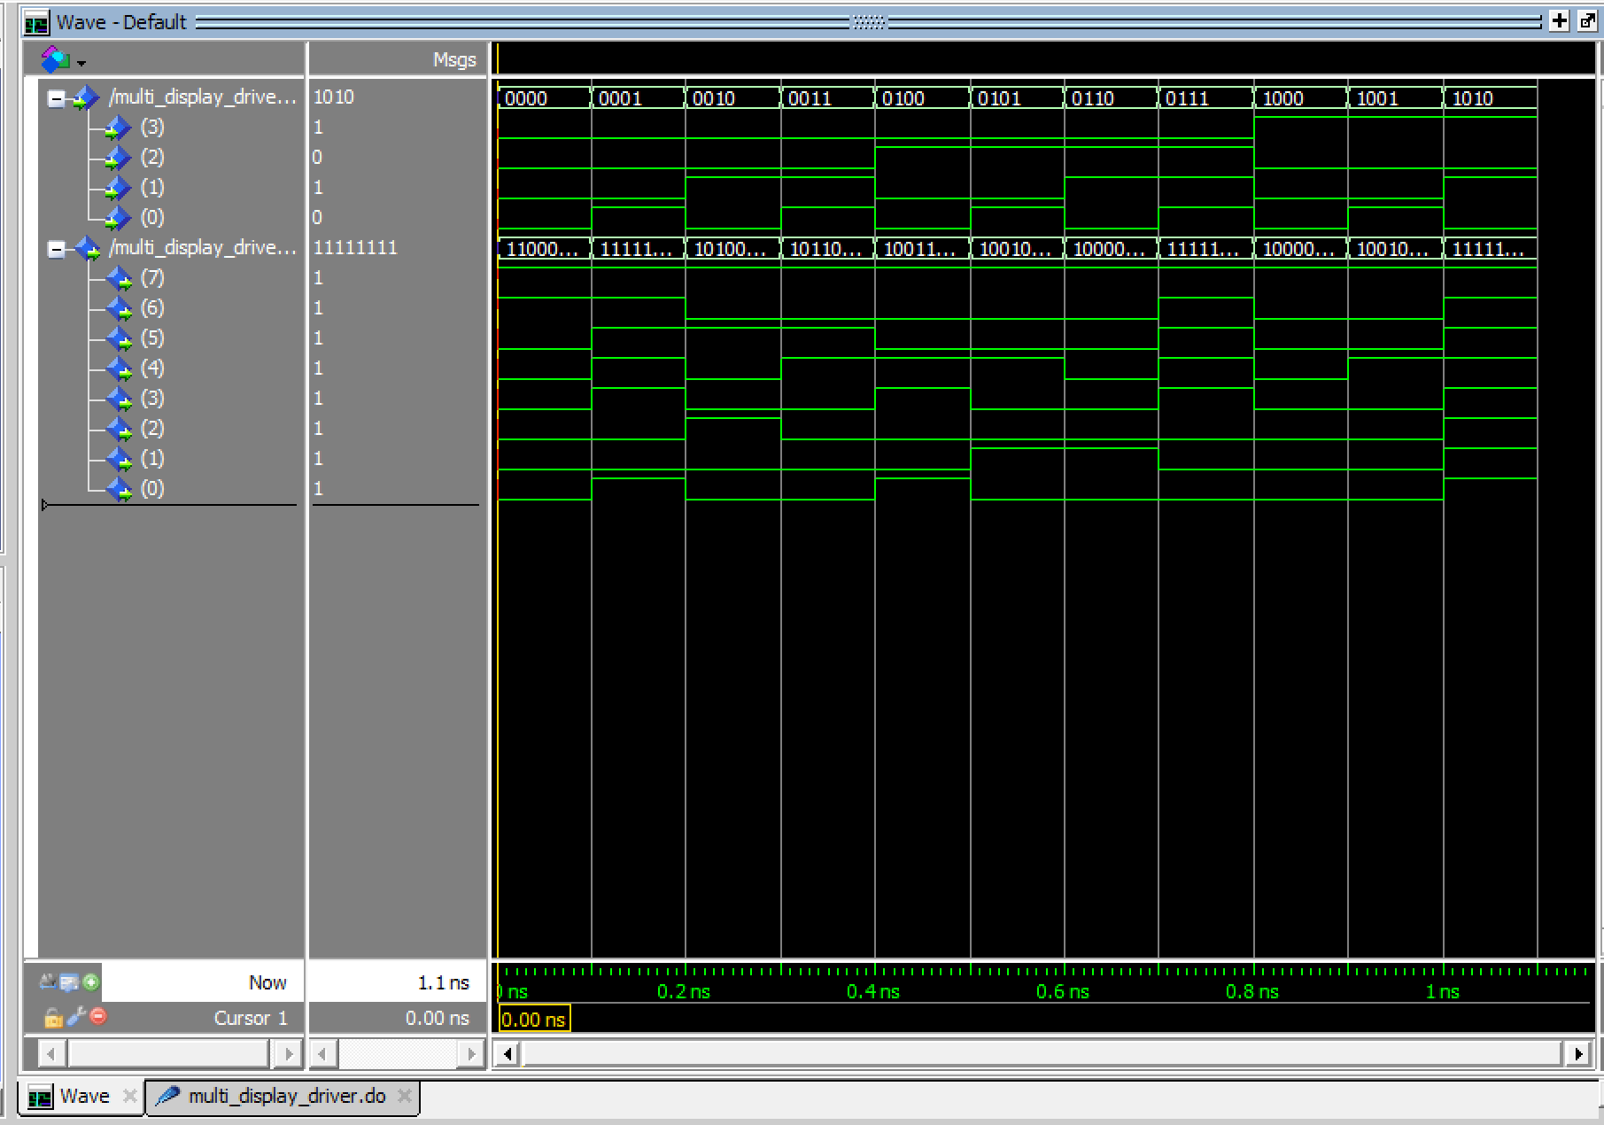
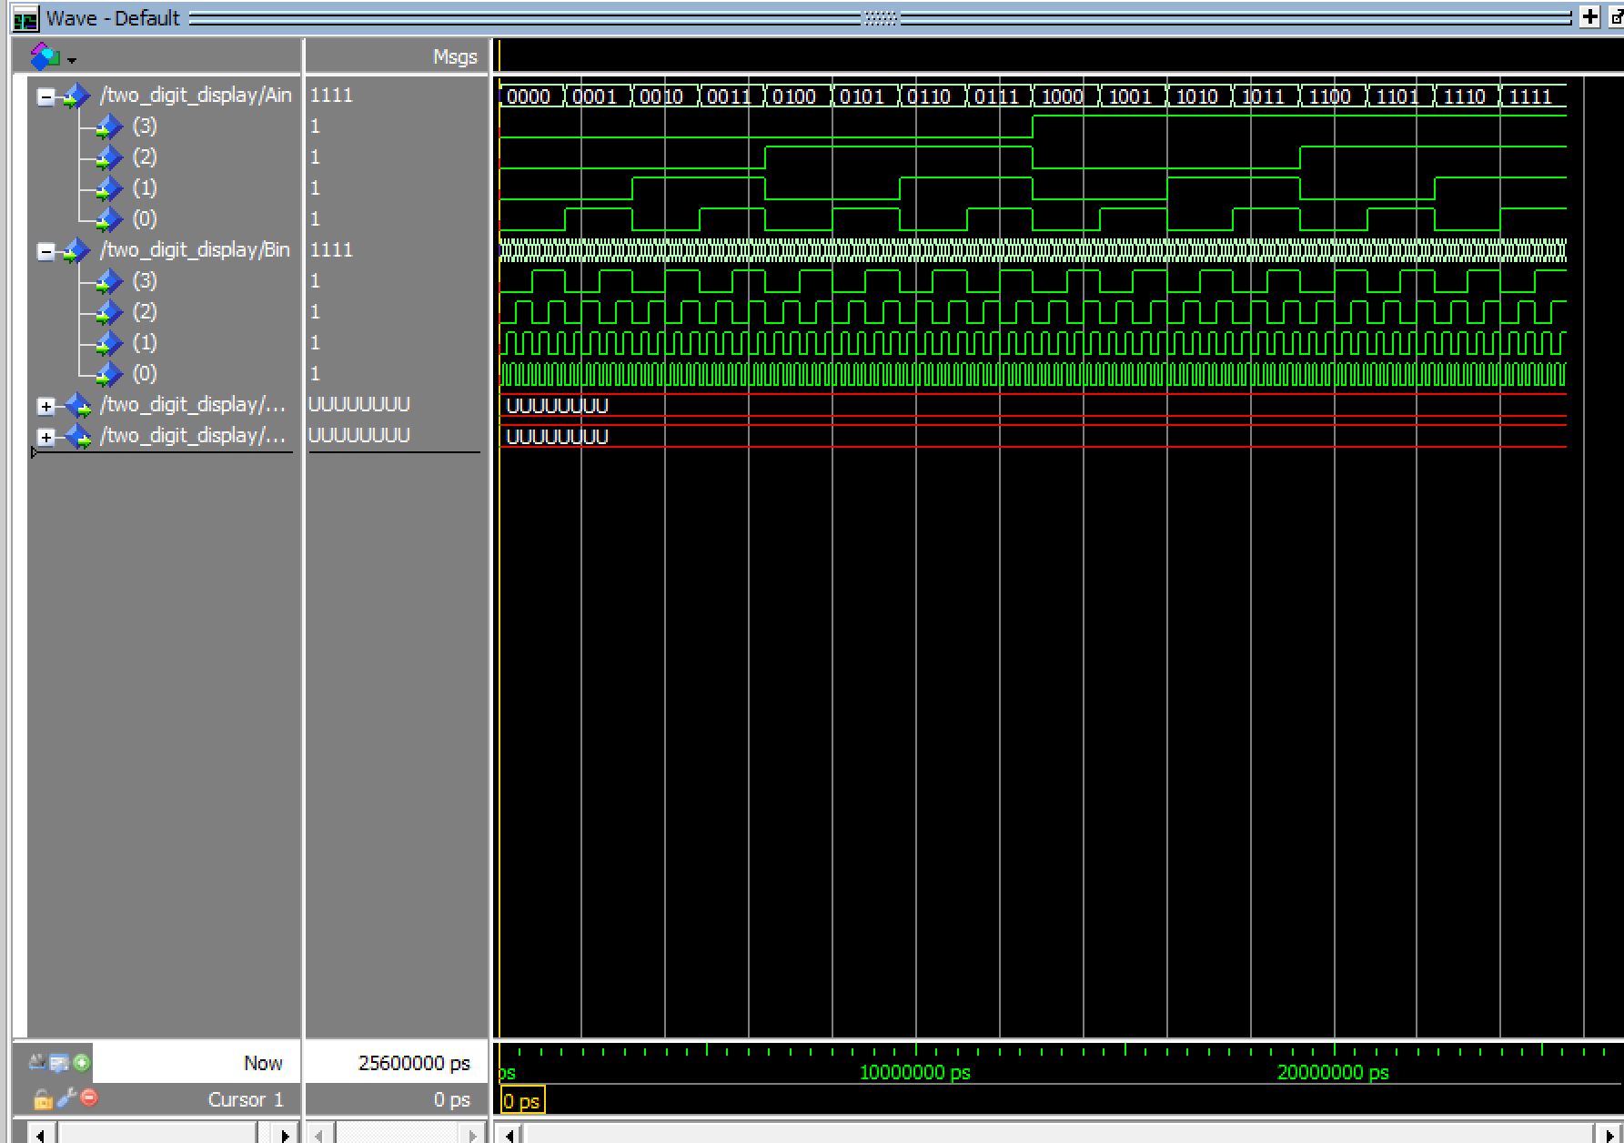
[(C) Demonstrate your circuit to the TA for Lab 7 check-off.] (28 points)

Part III: 4-bit 4:1 MUX (8 points)
[(A) Insert a screenshot of your VHDL code for Part III.] (3 points)
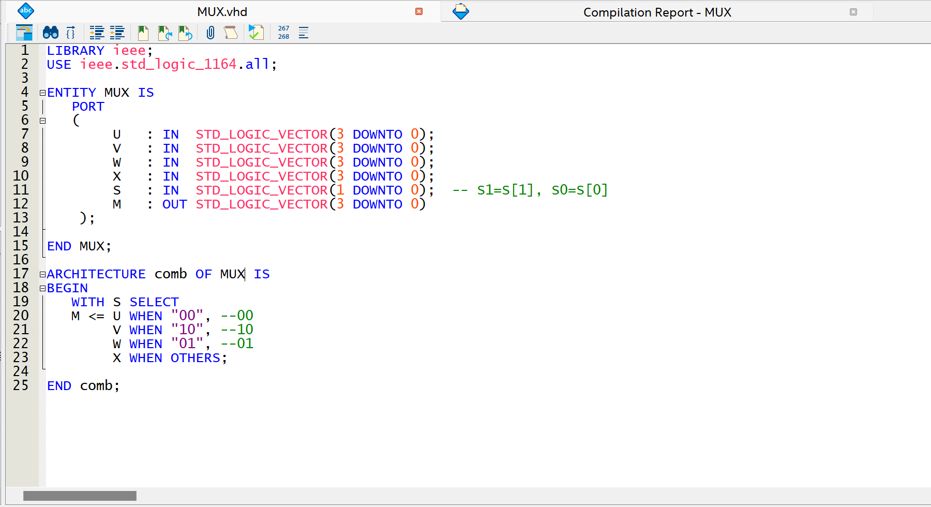
[(B) Insert an image of your ModelSim Simulation.] (4 points)
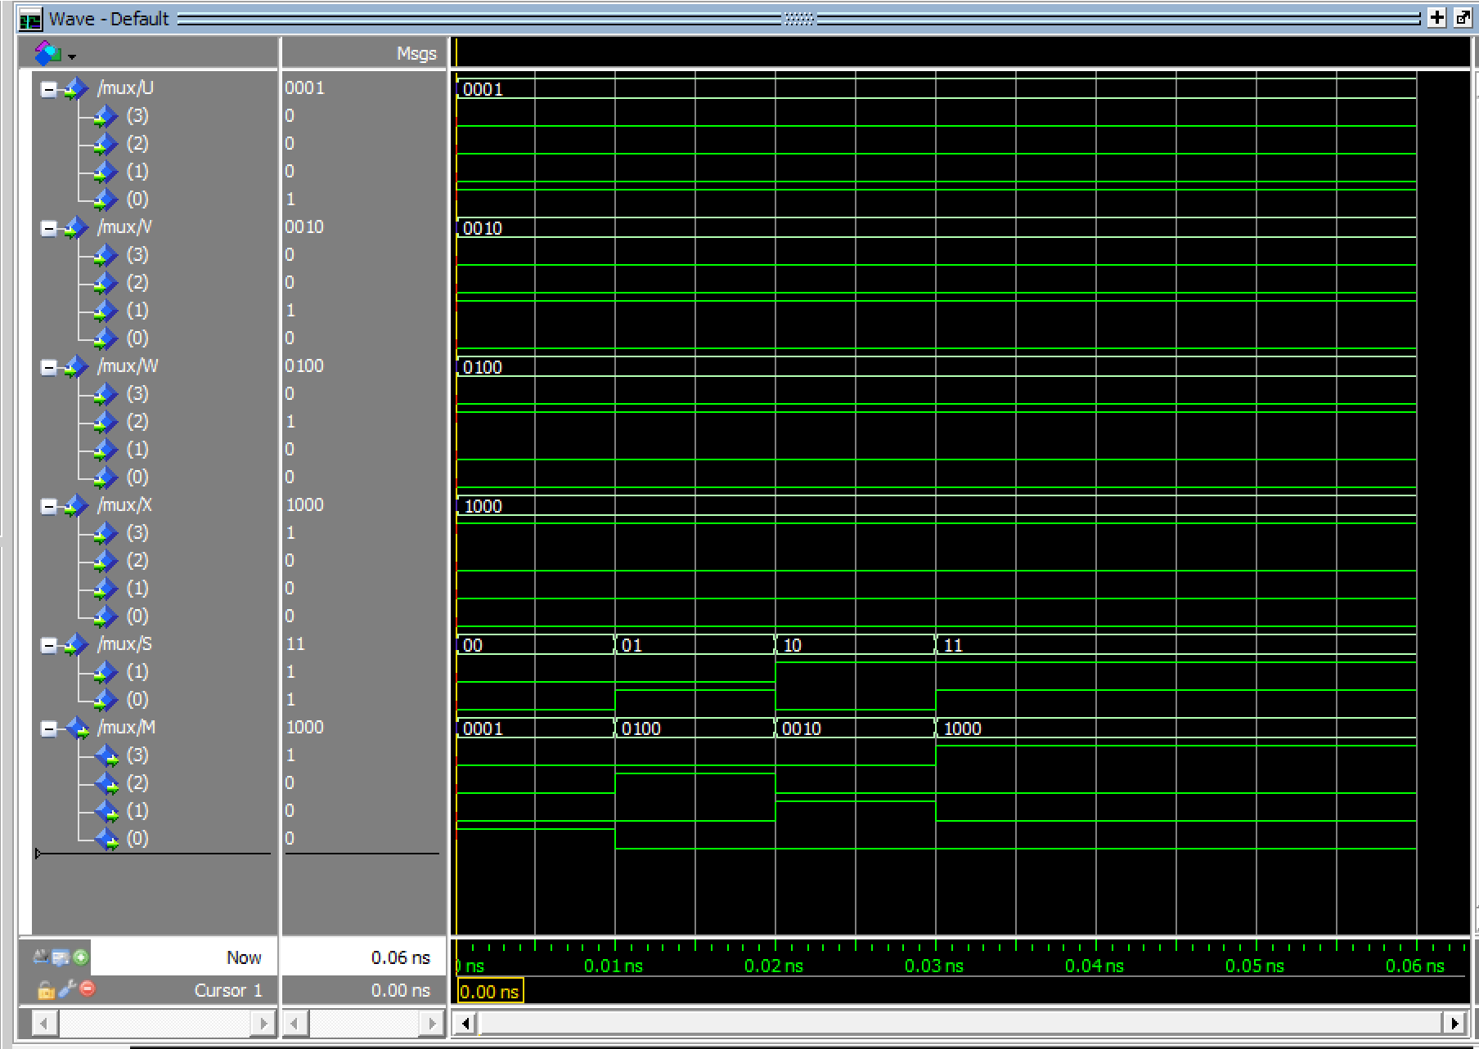
[(C) Insert the text of your do file.] (1 point)
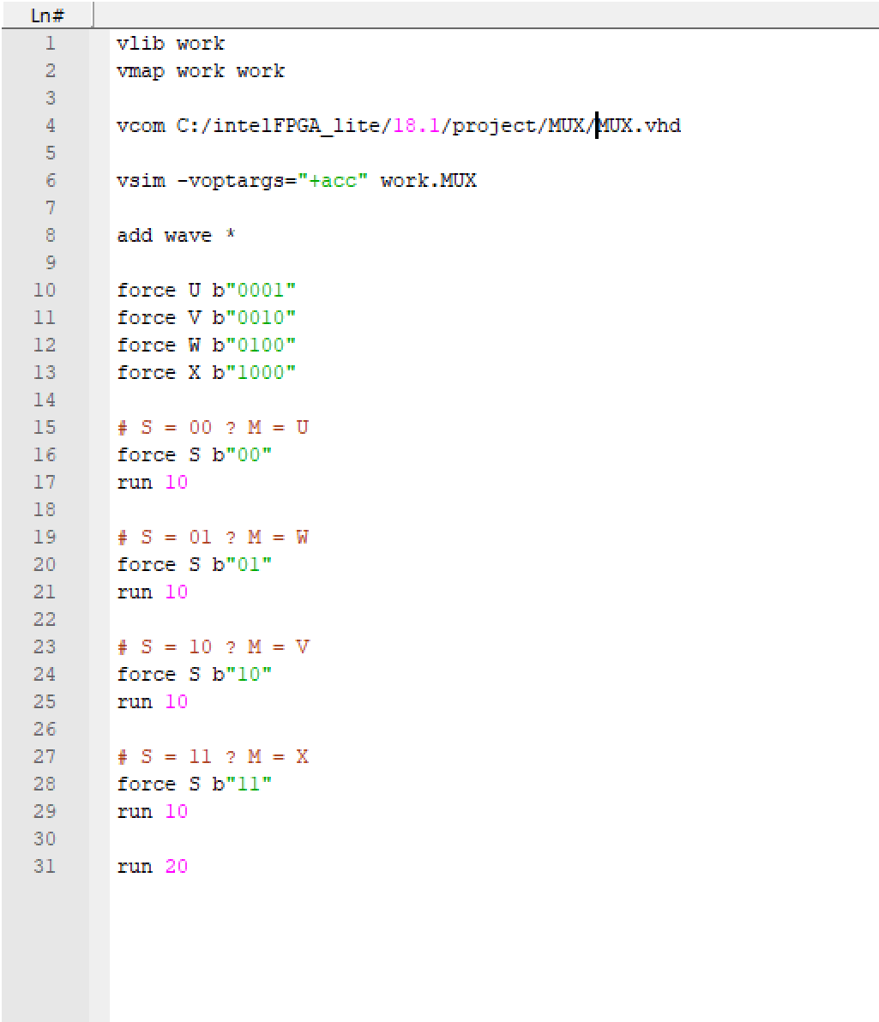
[Leave the page unchanged if you are not going to use. Otherwise, specify the problem number you are working on here. Don’t forget to notify “TO BE CONTINUED” in the original problem box]

[Leave the page unchanged if you are not going to use. Otherwise, specify the problem number you are working on here. Don’t forget to notify “TO BE CONTINUED” in the original problem box]

