Categories of software:
System software: programs that manage the computer hardware and the programs that run on them. Examples: operating systems, utility programs, software development tools
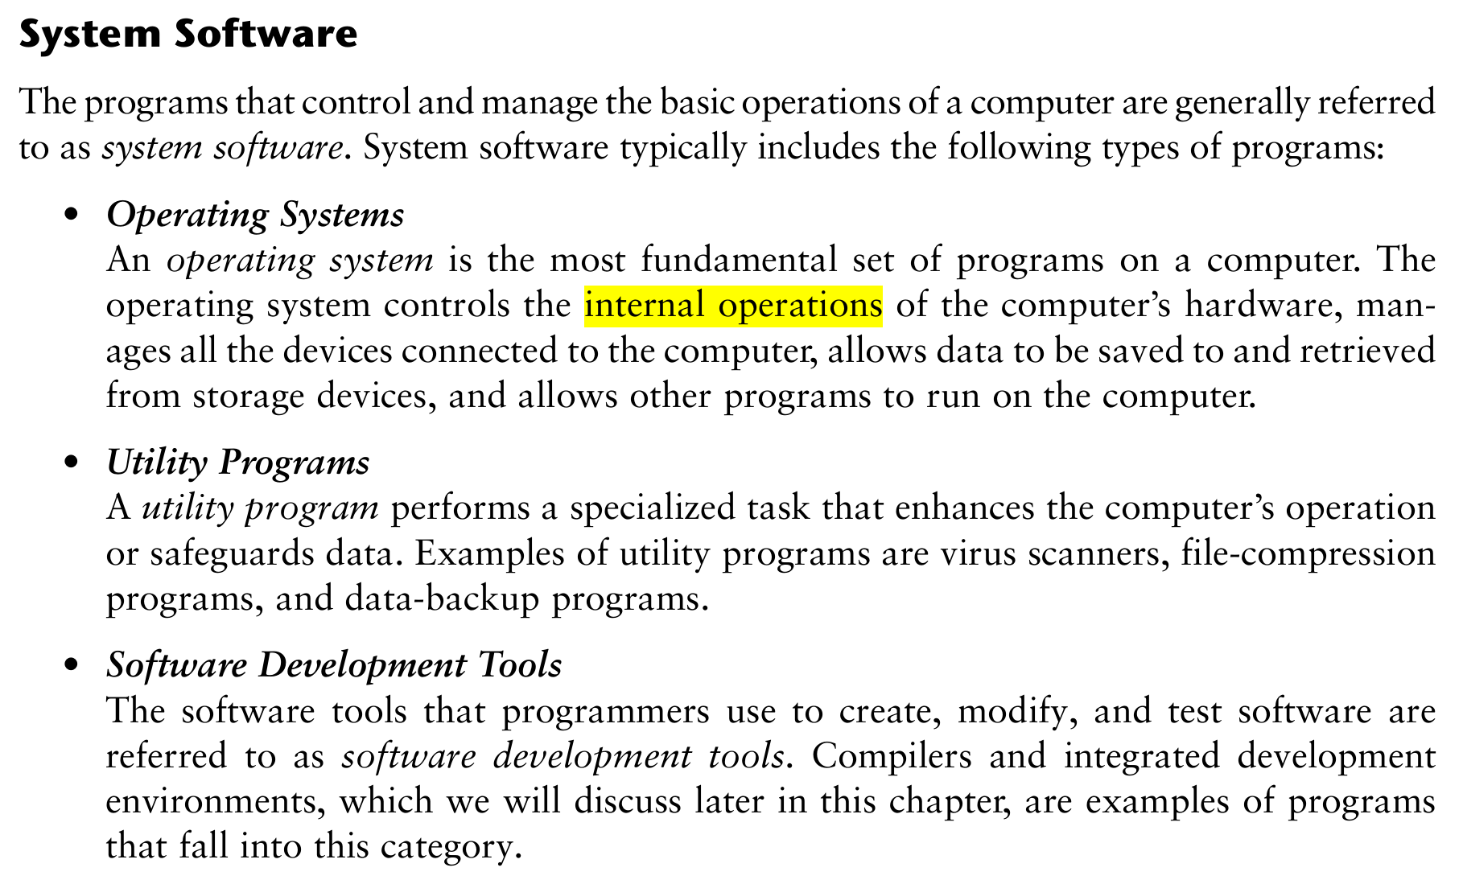
Application software: programs that provide services to the user. Examples : word processing, games, programs to solve specific problems
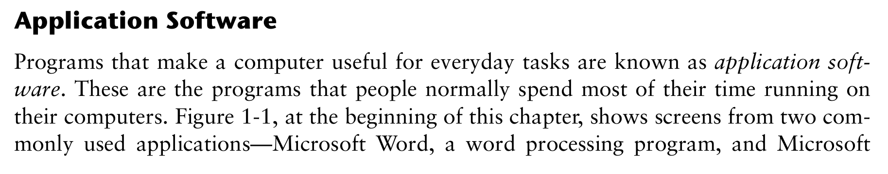
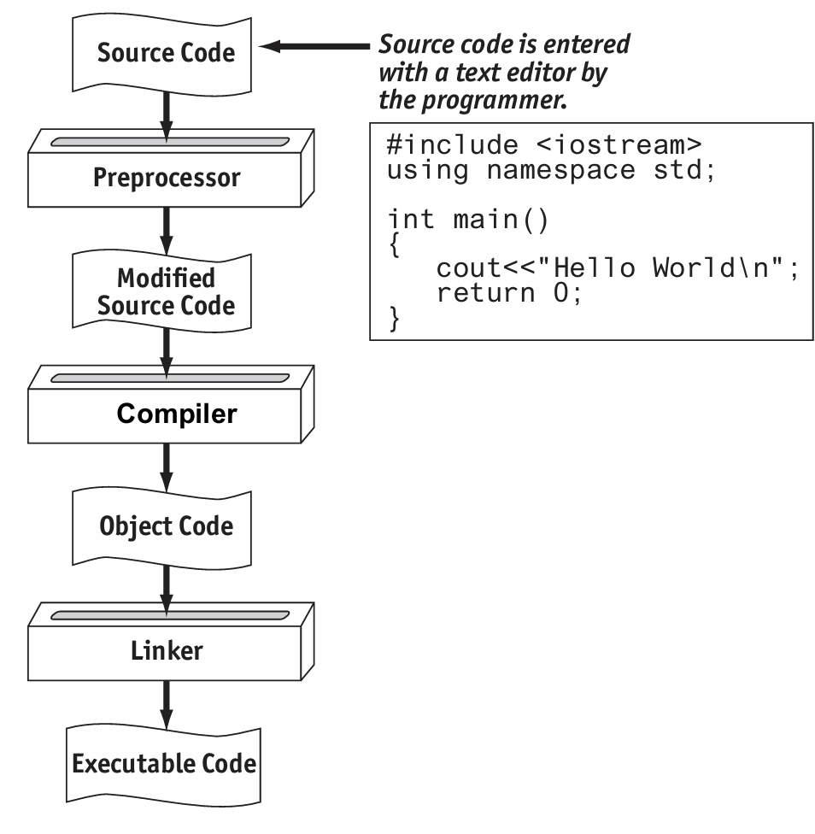
Main memory is commonly known as random-access memory or RAM
A(n) algorithm is an ordered set of steps written in human language to perform a task or to solve any problem.
A program’s ability to run on several different types of computer systems is called portability
Words that have special meaning in a programming language are called Keywords
A(n) compiler translates each source code instruction to the equivalent machine language instruction(s).
Delimiter characters or symbols mark the beginning or end of programming statements, or separate items in a list.
The statement #include is a(n) pre-processor directive
The three primary activities of a program are input, processing, and output.

Chapter2
How many operands does each of the following types of operators require? 1: Unary; 2: Binary; 3: Ternary
Display the values of y and z on the screen. cout << y << " " << z;
Display the number of bytes used by an integer variable. cout << sizeof(int);
11. When you are writing cout, you are using A) a ternary operator B) a library function C) a stream insertion operator D) a stream object
13. The following data 72 'A' "Hello World" 2.8712 are all examples of _________.
A) variables B) literals or constants C) strings D) none of the above
18. How would each of the following numbers be represented in E notation?
A) 3.287 × 106 B) −978.65 × 1012 C) 7.65491 × 10−3 D) −58710.23 × 10−4
A) 3.287E6 B) -9.7865E14 C) 7.65491E-3 D)-5.871023E0
24. T F Variable names may be up to 31 characters long.
- 答案： F (False)
- 知识点解释： C++ 变量名长度通常无严格限制（取决于编译器），但 31 字符是过时的限制。

