CSE340: Computer Architecture

Handout_Chapter - 2: Instructions: Language of the
Computer



Prepared by: Partha Bhoumik (PBK)
Course Coordinator, CSE340

The RISC-V Instruction Set

To command a computer’s hardware, you must speak its language. The words of a computer’s language are called instructions and its vocabulary is called an instruction set. The chosen instruction set is RISC-V, originally developed at UC Berkeley starting in 2010.
RISC stands for Reduced Instruction Set Computer.

To understand more about ISA. You can read this article
RISC-V has a modular design. Base ISA + Optional Extension.

Different Units

Unit | Size (bits)
Double Word (D) | 64
Word (W) | 32
Half Word (H) | 16
Byte (B) | 8

Note: The size of a word varies in different architectures.

Registers in RISC-V

Used for frequently accessed data. Registers are faster than memory. Data must be in registers to perform any arithmetic operations.

RISC-V has a 32 X 64-bit register file. This means there are 32 registers each can store 64 bits of data.

What do you understand by a 64-bit architecture?

RISC-V register details:
Theoretically, you can store any information in any register but architects or programmers decided to follow a convention, in which they use certain registers for certain purposes. It increases the readability of the code.

Register Number | Functionality
x0 | Holds constant value 0. (Zero register)
x1 | Stores the return address where you should return to after a function call is executed (Return Address register)
x2 | Stores an address in the memory with the top of the stack. (Stack Pointer register)
x3 | Global Pointer register.
x4 | Thread Pointer register.
x5 to x7 and x28 to x31 | Temporary register.
x8 | Frame Pointer register.
x9, x18 to x27 | Saved Register.
x10 to x11 | Function arguments/ Return Values
x12 to x17 | Function arguments
Operands

The part of an instruction that contains the data to be acted on or the memory location of the data.

Based on the physical location of data, there are three types of operands in RISC-V:
i. Register Operand. (Small capacity + Faster access time)
ii. Memory Operand. (Large capacity + Longer access time)
iii. Constant/Immediate. (Data is present in the instruction itself)

Register Operand

A register operand refers to a situation where the data used in an instruction is stored in a register.

Add Instruction:
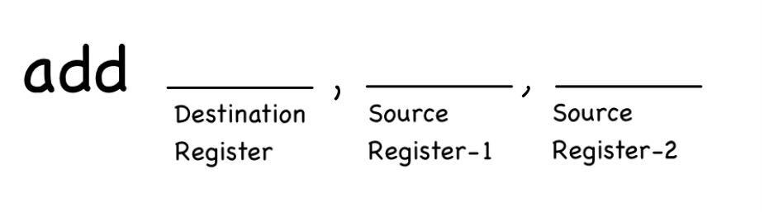
This is an arithmetic instruction that performs integer addition.

Syntax:

Example:
add x18, x19, x20
Explanation:

Operands:
x19: Contains the first operand, which is 12.
x20: Contains the second operand, which is 10.

Destination:
x18: The result of the addition will be stored in this register.

Execution:
i. The processor reads the values stored in x19 (12) and x20 (10).
ii. It performs the addition: 12 + 10 = 22. (val of source reg1 + val of source reg2)
iii. The result, 22, is written into the destination register x18.

Outcome:
After execution, the contents of the registers will be:
x18 = 22
x19 = 12 (unchanged)
x20 = 10 (unchanged)

Sub Instruction:
This is an arithmetic instruction that performs integer subtraction.
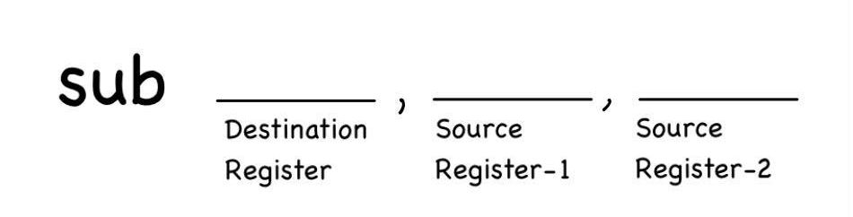
Syntax:

Example:
sub x18, x19, x20
Explanation:

Operands:
x19: Contains the first operand, which is 12.
x20: Contains the second operand, which is 10.

Destination:
x18: The result of the addition will be stored in this register.

Execution:
i. The processor reads the values stored in x19 (12) and x20 (10).
ii. It performs the addition: 12 - 10 = 2. (val of source reg1 - val of source reg2)
iii. The result, 2, is written into the destination register x18.

Outcome:
After execution, the contents of the registers will be:
x18 = 2
x19 = 12 (unchanged)
x20 = 10 (unchanged)

Memory Operand

Composite data, such as an array, is stored in memory. To perform arithmetic operations on this data, it must be loaded into a register first.

Memory features:

i. Memory is Byte addressed:
Each slot in memory can store 8 bits of data.
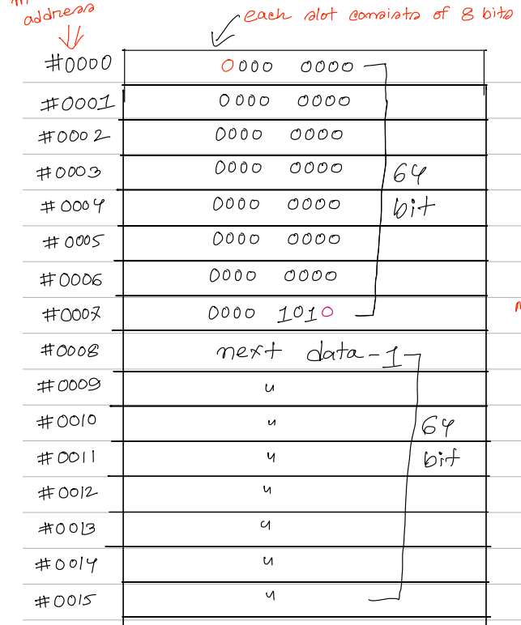

ii. No alignment restrictions:
Alignment means that a word must start at an address that is a multiple of 4, and a double word must start at an address that is a multiple of 8. However, RISC-V allows data to be stored in both aligned and unaligned ways, providing flexibility in memory storage.

iii. RISC-V is little endian:
Endianness refers to the order in which a computer stores the bytes of multi-byte data in memory.

Two approaches:
1. Little Endian -
Least Significant Byte is stored at the lowest address.
Example: Storing the following 64-bit data in memory in little-endian approach.
0000 0000 1010 0000 0000 0000 0000 1010 0000 0000 0000 0000 0000 0000 0000 1010
Assuming the memory address starts from 0.

Address (Decimal) | Data (Binary)
0 | 0000 1010 | Byte-7
1 | 0000 0000 | Byte-6
2 | 0000 0000 | Byte-5
3 | 0000 0000 | Byte-4
4 | 0000 1010 | Byte-3
5 | 0000 0000 | Byte-2
6 | 1010 0000 | Byte-1
7 | 0000 0000 | Byte-0
2. Big Endian -
Most Significant Byte is stored at the lowest address.
Example: Storing the following 64-bit data in memory in big-endian approach.
0000 0000 1010 0000 0000 0000 0000 1010 0000 0000 0000 0000 0000 0000 0000 1010
Assuming the memory address starts from 0.

Address (Decimal) | Data (Binary)
0 | 0000 0000 | Byte-0
1 | 1010 0000 | Byte-1
2 | 0000 0000 | Byte-2
3 | 0000 1010 | Byte-3
4 | 0000 1010 | Byte-4
5 | 0000 0000 | Byte-5
6 | 1010 0000 | Byte-6
7 | 0000 1010 | Byte-7

Load Instruction:
Loads data from memory to register.
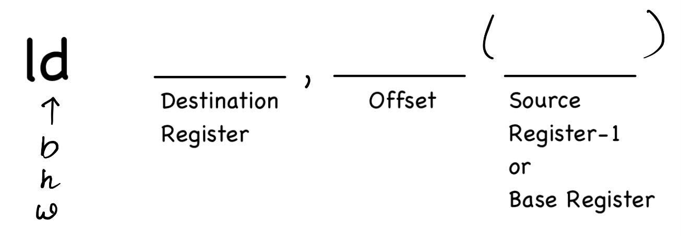
Syntax:

Example:
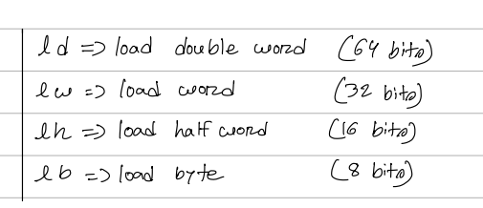
ld x18, 10(x20)

Explanation:
ld stands for load double word (64 bits). This means 64 bits of data will be loaded from memory into the destination register.
Operands:
x20: Contains the Base address.
10 is the offset.
Destination:
x18: The data fetched from memory will be loaded into the x18 register.

Let's assume,
x20 has a value 10 inside it.
Data memory:
Location | Value
20 | 50
21 | 50
22 | 50
23 | 50
24 | 50
25 | 50
26 | 50
27 | 50

Execution:
[for simplicity of calculation we are assuming all the values are in decimal]
i. The processor calculates the effective memory address by adding the base address in x20 (10) and the offset (10), resulting in an effective address of 20.
ii. The processor then fetches the 64-bit data from the calculated address in the data memory, which is 20 in this case.
iii. In memory location 20, the stored data is 50.
iv. The fetched data 50 is then loaded into the destination register x18.

Outcome:
After execution, the contents of the registers will be:
x18 = 50 (loaded from memory).
x20 = 10 (unchanged).

Store Instruction:
Stores data from the register to memory.
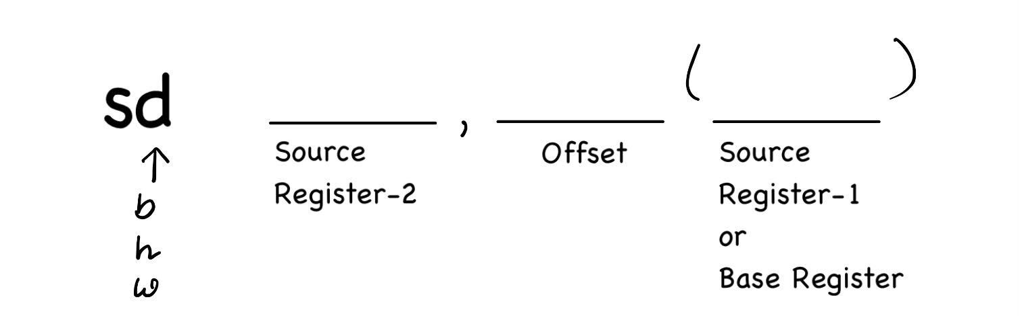
Syntax:

Example:

sd x18, 10(x20)
Explanation:
sd stands for store double word (64 bits). This instruction stores 64 bits of data from a register into memory.
Operands:
x20: Contains the Base address.
x18: The source register containing the 64-bit data to be stored in memory.
10 is the offset.
Destination:
The memory location is calculated by adding the value of the base register and offset.
Let's assume,
x20 has a value 10 inside it.
Data memory:
Location | Value
20 | 50
21 | 50
22 | 50
23 | 50
24 | 50
25 | 50
26 | 50
27 | 50

Execution:
[for simplicity of calculation we are assuming the values are stored in decimal]
i. The processor calculates the effective memory address by adding the base address in x20 and the offset (10):
Effective address = x20 + 10 = 10 + 10 = 20.
ii. It then stores the 64-bit value from x18 into memory at the calculated address 20.

Outcome:
After execution, both x18 and x20 will remain unchanged.

Example of compiling a statement when an operand is in Memory:
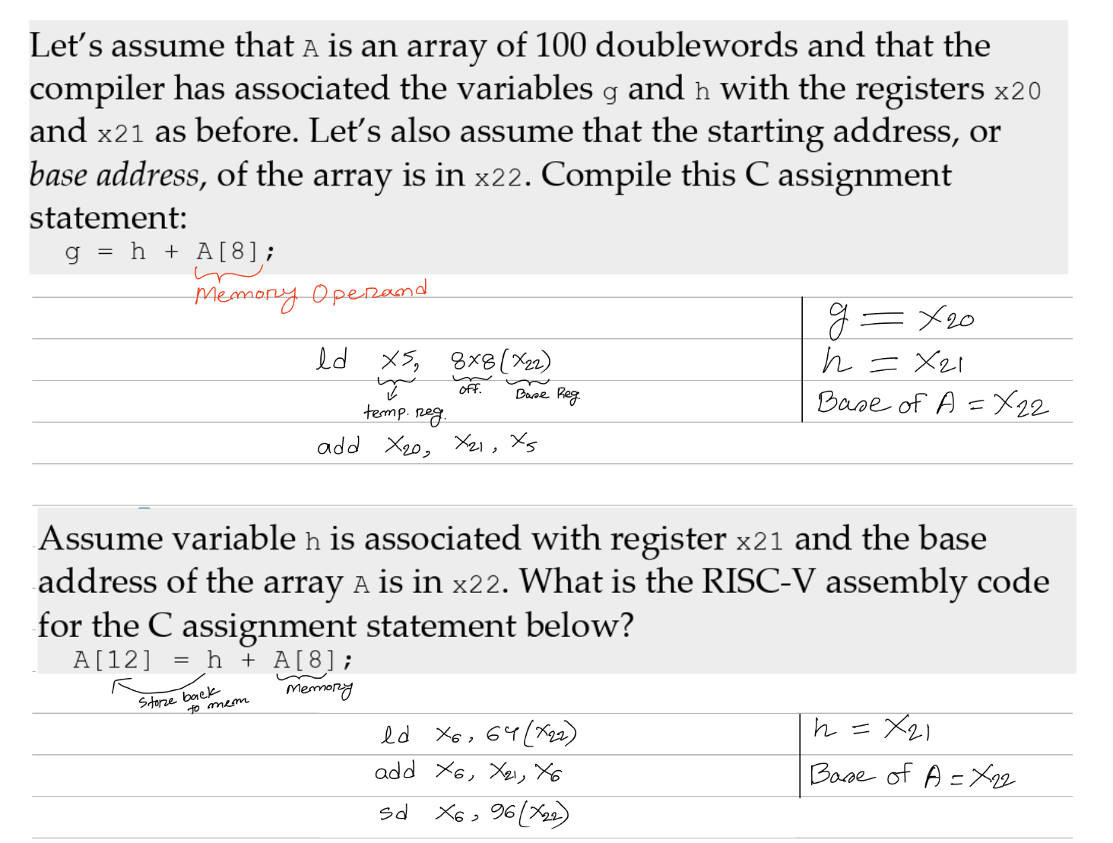
Note:
i. A is an array of 100 doublewords meaning A has 100 indices and each size of doubleword (64 bits).
ii. The base address of the array is in x22 means the location of the starting index, A[0] is stored in register x22.
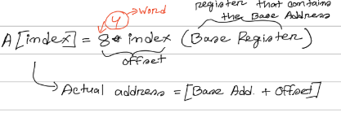

Immediate Operand

Constant data specified in the instruction itself.

Addi Instruction:
This is an arithmetic instruction that performs integer addition.
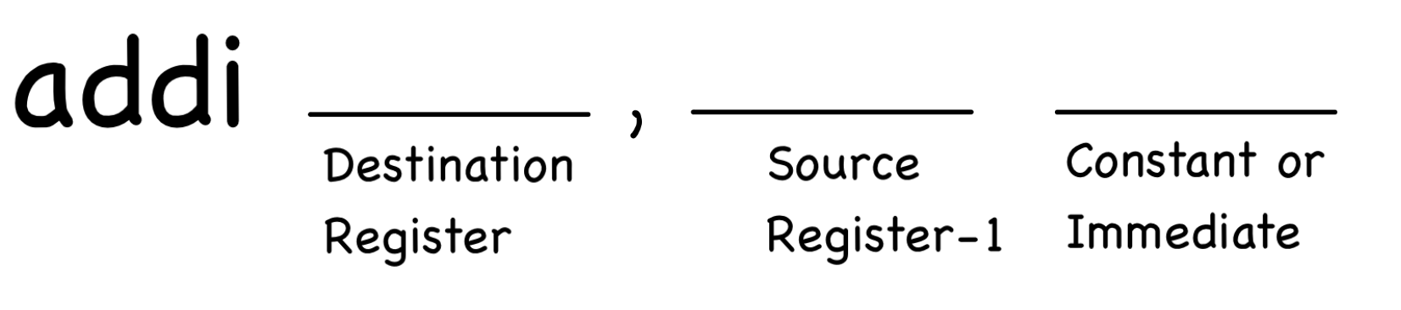
Syntax:

Example:
addi x18, x19, 10
Explanation:

Operands:
x19: Contains the first operand, which is 12.
10: is the immediate or constant.

Destination:
x18: The result of the addition will be stored in this register.

Execution:
i. The processor reads the value stored in x19 (12).
ii. It performs the addition: 12 + 10 = 22. (val of source reg1 + constant)
iii. The result, 22, is written into the destination register x18.

Outcome:
After execution, the contents of the registers will be:
x18 = 22
x19 = 12 (unchanged)

Note:
There is no Subi instruction.
Let's say, you want to subtract 4 from the value inside x22 register and store the result again in x22.
Addi x22, x22, -4

Sign Extension

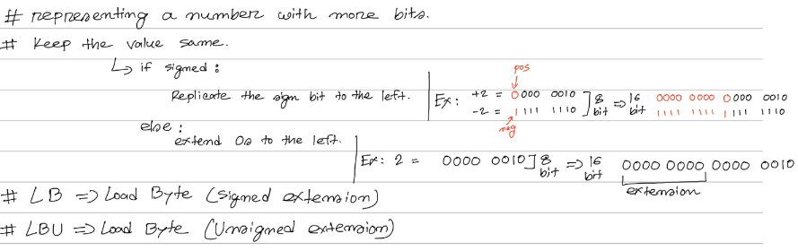

And Instruction

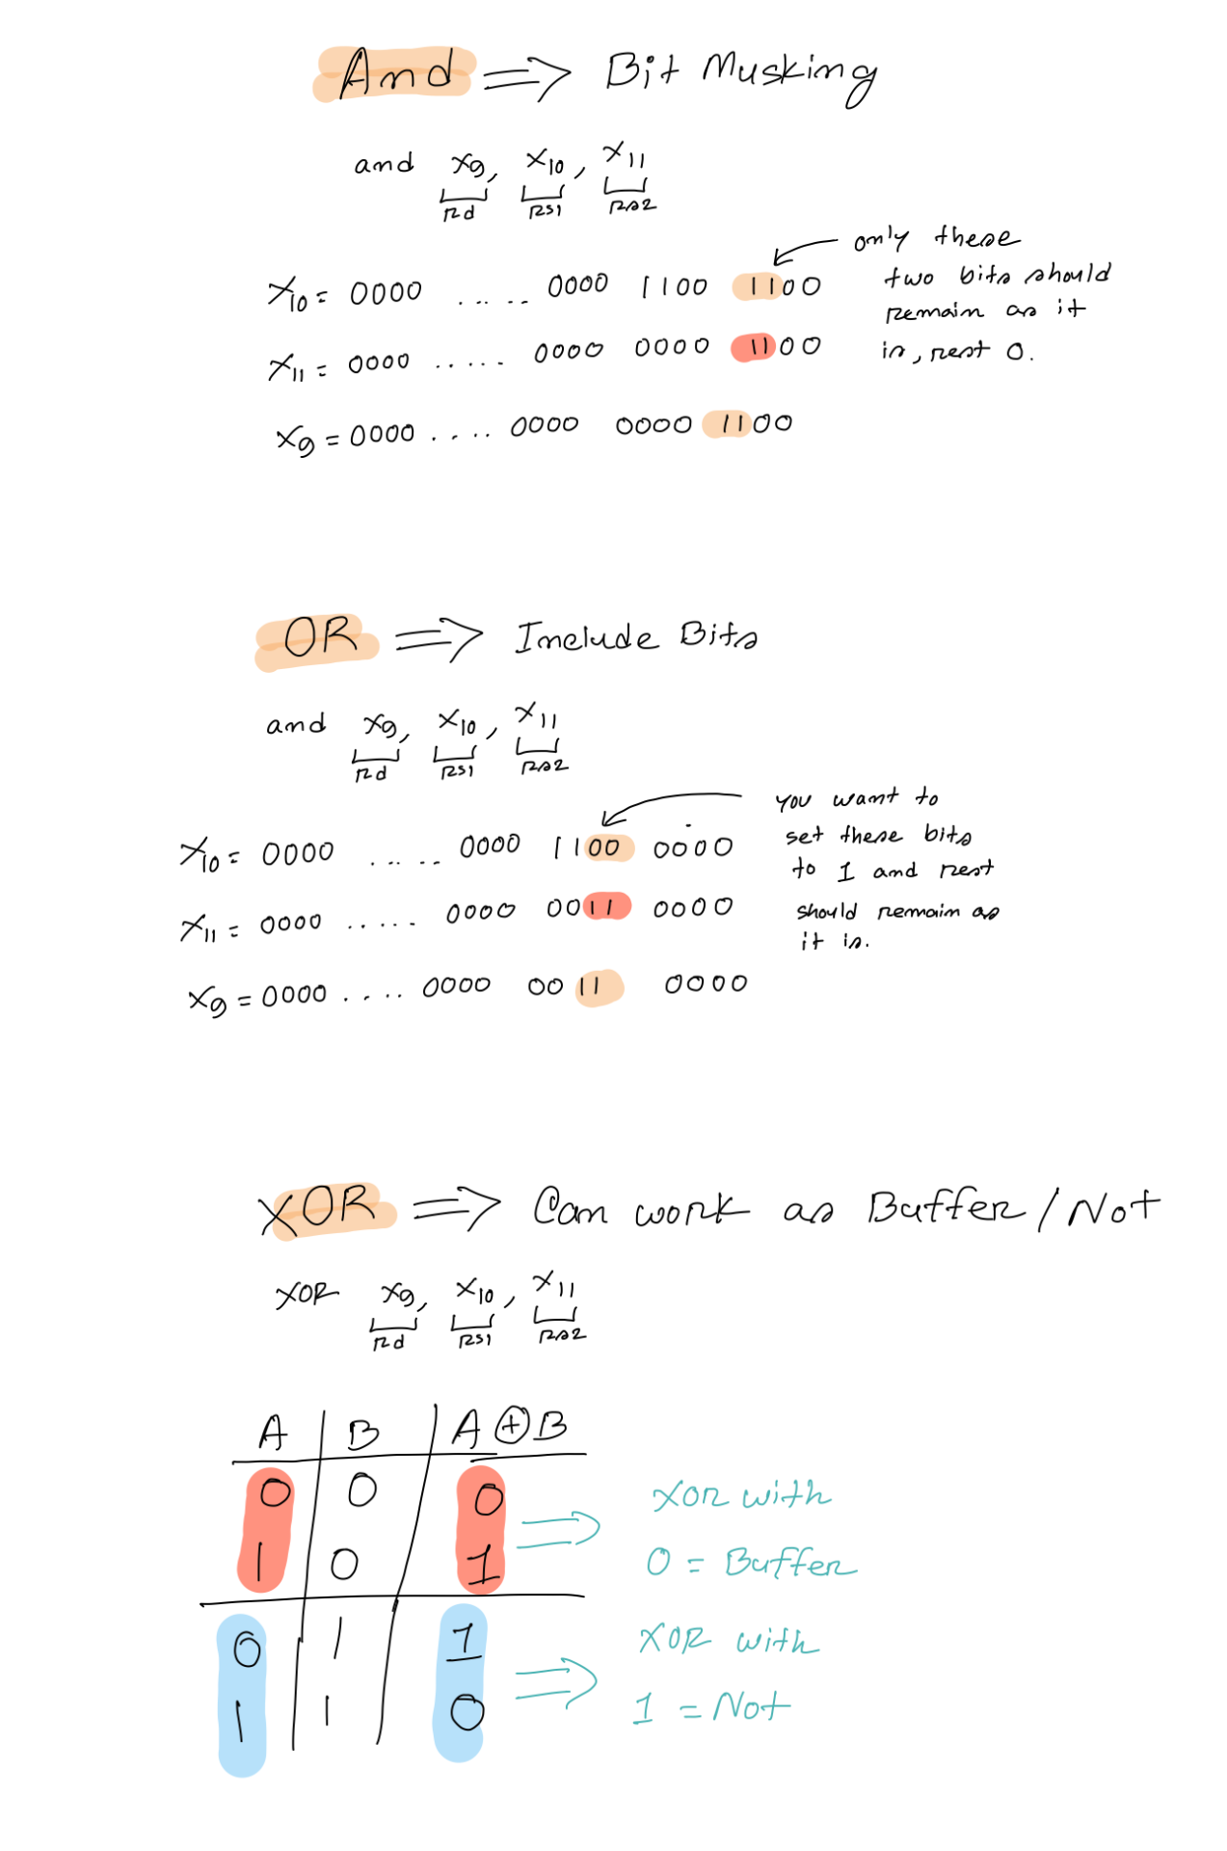

OR Instruction

OR => Include Bits

OR X₉, X₁₀, X₁₁

X₁₀ = 0000 …. 0000 1100 0000 ;
You want to include bits in the 4th and 5th position of the X₁₀ register. Show the contents of the Mask to do in register X₁₁ and after executing the above mentioned instruction, show the contents of X₉ register.

Mask, X₁₁ = 0000 …. 0000 0011 0000;
After executing the instruction, contents of X₉
= 0000 …. 0000 1111 0000

XOR Instruction

SLLi Instruction

Slli stands for Shift Left Logical Immediate. This instruction shifts the bits of the value in the source register to the left by a specified number of positions (immediate value), filling the vacant lower bits with zeros.
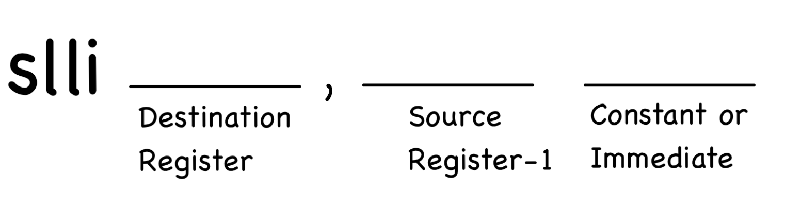
Syntax:

Example:
slli x18, x19, 2
Explanation:

Operands:
x19: Contains the first operand, which is 12.
2: Specifies the number of positions each bit will be shifted to the left.

Destination:
x18: The result of the shifting will be stored in this register.

Execution:
i. The processor reads the values stored in x19 (12) and immediate is 2.
ii. 12 in 64 bits = 0000 0000 0000 0000 0000 0000 0000 0000
0000 0000 0000 0000 0000 0000 0000 1100
Shifting each bit to the left by 2 positions,
00 0000 0000 0000 0000 0000 0000 0000 0000
0000 0000 0000 0000 0000 0000 0011 0000
The first two 00 will be lost; which will create a vacancy in the last two bits. That vacancy will be filled up by two 0s.
0000 0000 0000 0000 0000 0000 0000 0000
0000 0000 0000 0000 0000 0000 0011 0000

iii. The result,
0000 0000 0000 0000 0000 0000 0000 0000
0000 0000 0000 0000 0000 0000 0011 0000
(48 in decimal) is written into the destination register x18.

Outcome:
After execution, the contents of the registers will be:
x18 = 48
x19 = 12 (unchanged)

If you shift a value that is stored in a register by more than 63 bits what happens?
We can also perform multiplication by 2^{i} using slli instruction.

Slli x11, x19, 4

After executing this instruction, x11 will have, value inside x19 * 2^4

SRLi Instruction

Srli stands for Shift Right Logical Immediate. This instruction shifts the bits of the value in the source register to the right by a specified number of positions (immediate value), filling the vacant lower bits with zeros.
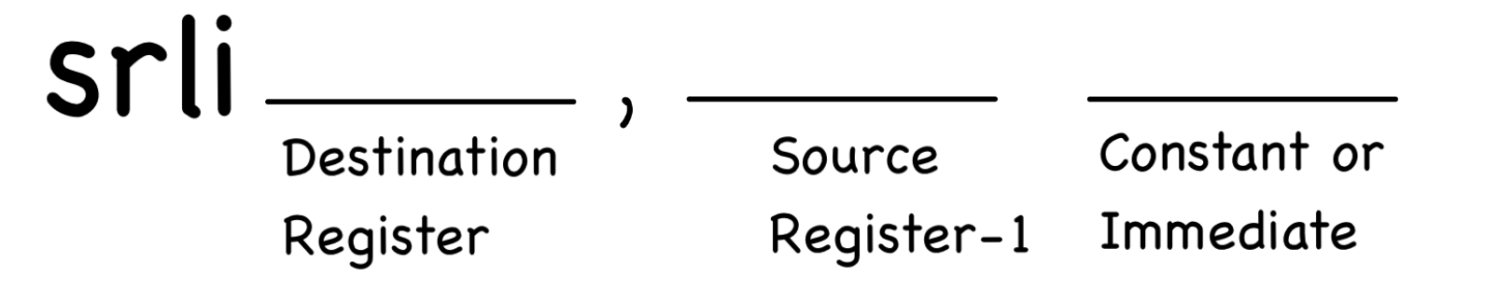
Syntax:

Example:
srli x18, x19, 2

Explanation:
Operands:
x19: Contains the first operand, which is 12.
2: Specifies the number of positions each bit will be shifted to the right.

Destination:
x18: The result of the shifting will be stored in this register.

Execution:
i. The processor reads the values stored in x19 (12) and immediate is 2.
ii. 12 in 64 bits = 0000 0000 0000 0000 0000 0000 0000 0000
0000 0000 0000 0000 0000 0000 0000 1100
Shifting each bit to the right by 2 positions,
0000 0000 0000 0000 0000 0000 0000 0000
0000 0000 0000 0000 0000 0000 0000 001100
The last two 0s will be lost; which will create a vacancy in the first two bits. That vacancy will be filled up by two 0s.
0000 0000 0000 0000 0000 0000 0000 0000
0000 0000 0000 0000 0000 0000 0000 0011

iii. The result,
0000 0000 0000 0000 0000 0000 0000 0000
0000 0000 0000 0000 0000 0000 0000 0011
(3 in decimal) is written into the destination register x18.

Outcome:
After execution, the contents of the registers will be:
x18 = 3
x19 = 12 (unchanged)

If you shift a value that is stored in a register by more than 63 bits what happens?
We can also perform division by 2^{i} using slli instruction.

Srli x11, x19, 4
After executing this instruction, x11 will have, value inside x19 / 2^4

Translating RISC-V assembly instructions to machine code

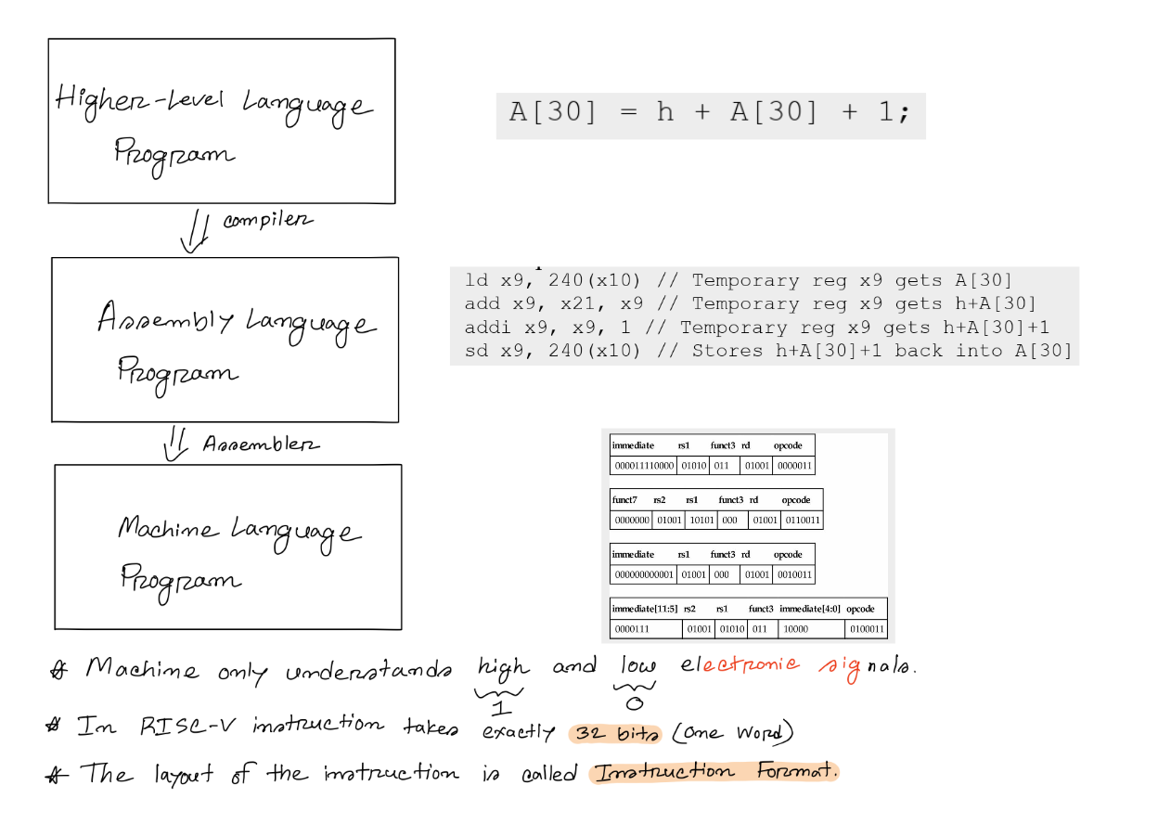
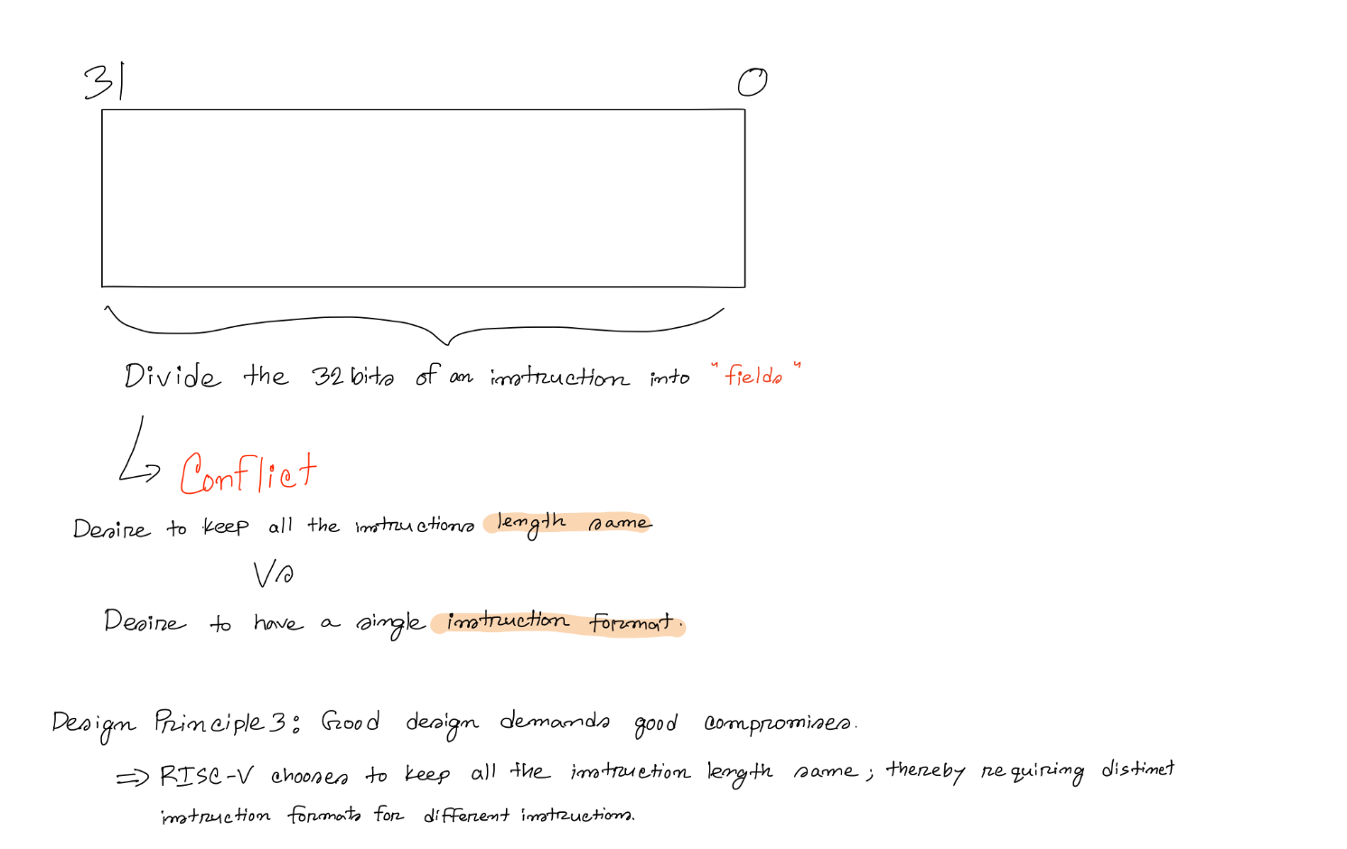

Instruction Formats

1. R type: Instructions that use 3 registers. (Add, Sub, Sll, Srl, And, Or, Xor,.....)
2. I type: Instructions that use 2 registers (1 source, 1 destination) and 1
immediate. (Addi, Load, Slli, Srli, Andi, Ori, Xori,.....)
3. S type: Instructions that use 2 registers (2 sources) and 1
immediate. (Store)
4. U type: Instructions that use 1 register (1 destination) and 1
immediate (LUI)
5. SB type: Instructions that use 2 register sources and label
6. UJ type: Instructions that use 1 register destination and label

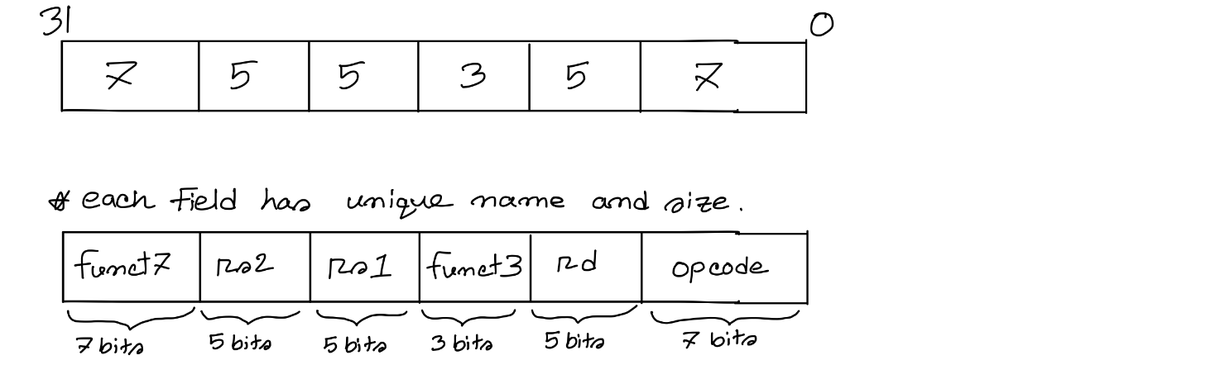
R-type Instruction Format

Field | Bit Length | Description
opcode | 7 bits | It determines if the instruction is of the R-type or not.
rs1 | 5 bits | Source Register 1 – Number of the source register-1.
rs2 | 5 bits | Source Register 2 – Number of the source register-2.
funct3 | 3 bits | Both of these two fields are used to specify the exact operation (add, sub,...) within the R-type format.
funct7 | 7 bits
rd | 5 bits | Destination Register – Number of the destination register.

Example:
Add x21, x22, x23; convert it to its corresponding machine code where, Opcode = 0110011, Funct3 = 000 and Funct7 = 0000000. Show your final answer in hex format.
Solution:
Rs1 = 22 = 10110  Rs2 = 23 = 10111  Rd = 21 = 10101  Opcode = 0110011  Funct3 = 000  Funct7 = 0000000 | Forming the 32-bit machine code now,
  0000000 | 10111 | 10110 | 000 | 10101 | 0110011
  funct7 | rs2 | rs1 | funct3 | rd | opcode

(00000001011110110000101010110011)₂ = 017B0AB3₁₆

Now, given a machine code think, how can you decode and find the corresponding assembly code?

I-type Instruction Format
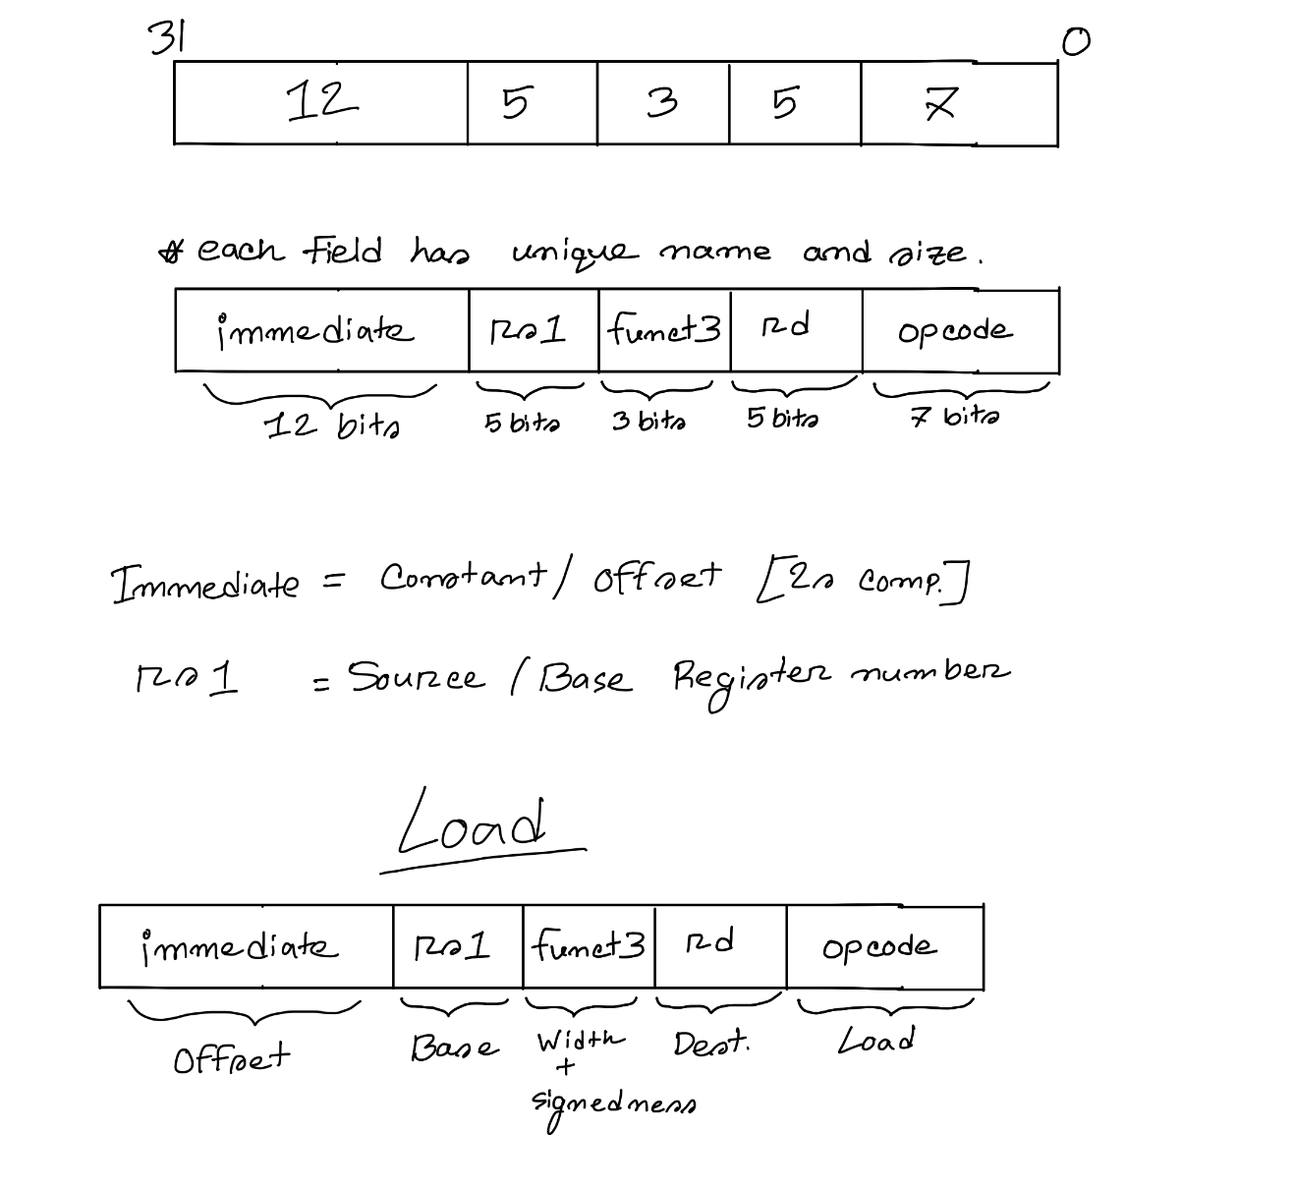

Field | Bit Length | Description
opcode | 7 bits | It determines both if the instruction is of the I-type or not and the specific instruction (addi, load,...) itself.
rs1 | 5 bits | Source Register 1 – Number of the source register-1.
funct3 | 3 bits | In the case of load instruction specifies the size and signedness of the data being loaded.
immediate | 12 bits | the constant itself in 2s complement mode
rd | 5 bits | Destination Register – Number of the destination register.
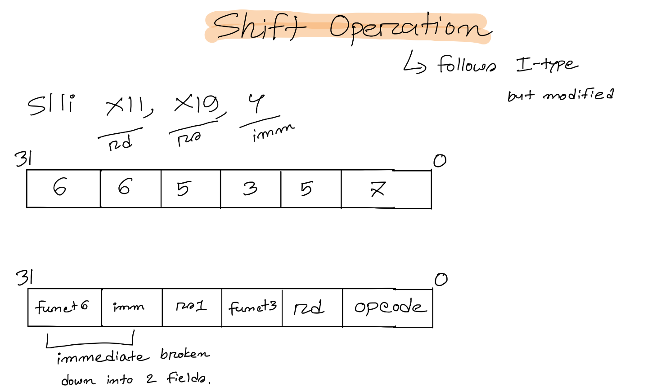

To answer why shift follows a modified version of I type, remember what would happen if you shift a 64-bit value more than 63 times?
Now, check how many bits are necessary to represent 63 in binary.
Example1:
Addi x21, x22, -4; convert it to its corresponding machine code where, Opcode = 0010011, Funct3 = 000. Show your final answer in hex format.
Solution:
Rs1 = 22 = 10110  Rd = 21 = 10101  Opcode = 0010011  Funct3 = 000  Immediate = -4  4 = 100  +4 = 0100  = 0000 0000 0100  -4 = 1111 1111 1100 | Forming the 32-bit machine code now,  (2s complement)
  1111 1111 1100 |  | 10110 | 000 | 10101 | 0010011
  immediate |  | rs1 | funct3 | rd | opcode

(11111111110010110000101010010011)₂ = FFCB0A93₁₆

Now, try to do the reverse yourself.

Example2:
Ld x21, 10(x22); convert it to its corresponding machine code where, Opcode = 0000011, Funct3 = 010. Show your final answer in hex format.
Solution:
Rs1 = 22 = 10110  Rd = 21 = 10101  Opcode = 0000011  Funct3 = 010  Immediate = +10  10 = 1010  +10 = 01010  = 0000 0000 1010 | Forming the 32-bit machine code now,  (2s complement)
  0000 0000 1010 |  | 10110 | 010 | 10101 | 0000011
  immediate |  | rs1 | funct3 | rd | opcode
(00000000101010110010101010000011)₂ = 00AB2A833₁₆

Now, try to do the reverse yourself.

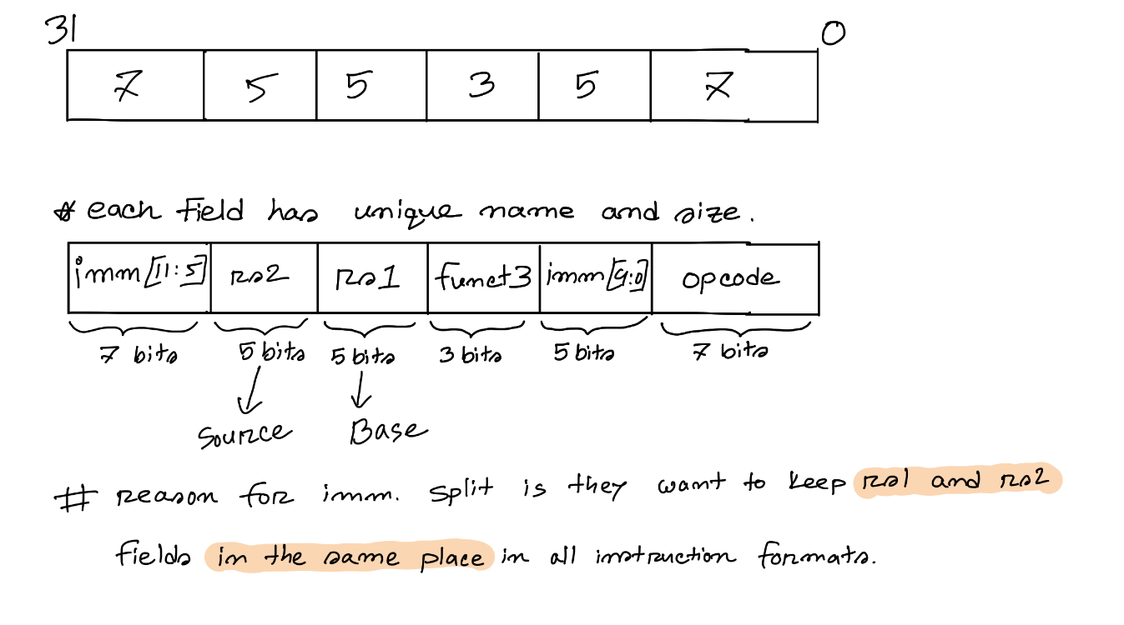
S-type Instruction Format

Field | Bit Length | Description
opcode | 7 bits | It determines both if the instruction is of the S-type or not and the specific instruction (addi, load,...) itself.
rs1 | 5 bits | Source Register 1 – Number of the source register-1.
rs2 | 5 bits | Source Register 2 – Number of the source register-2.
funct3 | 3 bits | In the case of load instruction specifies the size and signedness of the data being loaded.
immediate | 12 bits | the constant itself in 2s complement mode
Example:
Sd x21, 10(x22); convert it to its corresponding machine code where, Opcode = 0100011, Funct3 = 010. Show your final answer in hex format.
Solution:
Rs1 = 22 = 10110  Rs2 = 21 = 10101  Opcode = 0100011  Funct3 = 010  Immediate = +10  10 = 1010  +10 = 01010  = 0000000 01010 | Forming the 32-bit machine code now,  (2s complement)
  0000000 |  | 10101 | 10110 | 010 | 01010 | 0100011
  imm[11:5] |  | rs2 | rs1 | funct3 | immd[4:0] | opcode
(00000001010110110010010100100011)₂ = 015B2523₁₆
Now, try to do the reverse yourself.


Decision Making

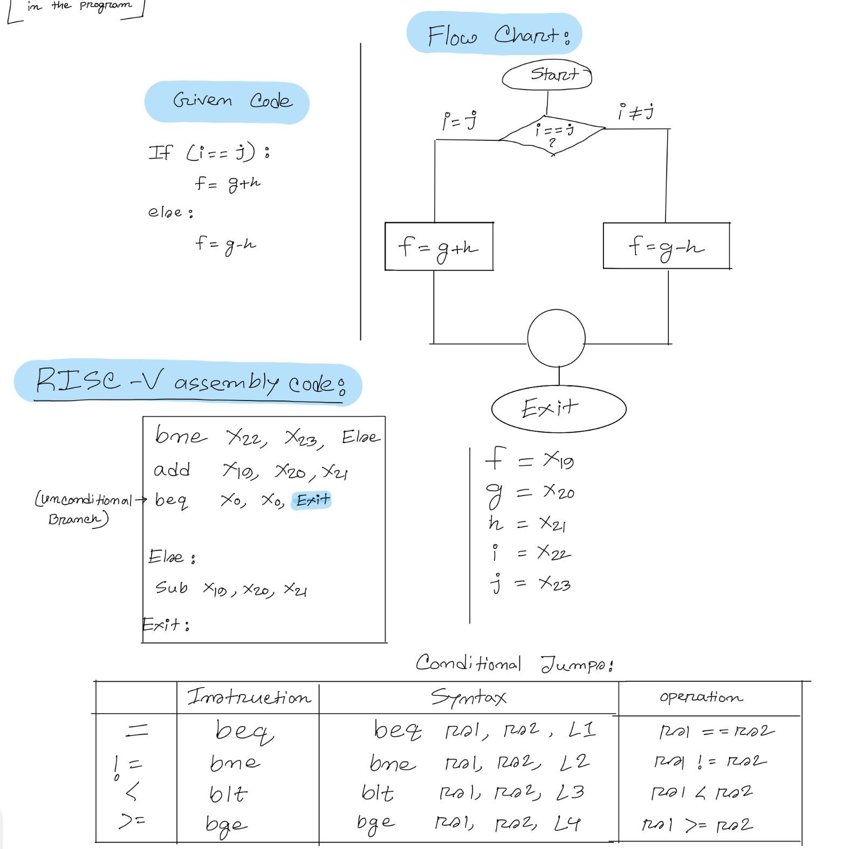

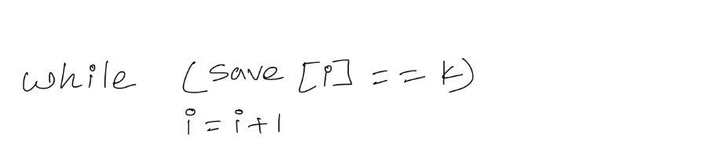
Loop

Assume that i and k correspond to registers x22 and x24 and the base of the
word array save is in x25. What is the RISC-V assembly code corresponding to this C code?

Solution:
Loop: | // We need to add the label Loop to it so that we can branch back to that instruction at the end of the loop:
slli x10, x22, 2 | // x10 = i * 4
add x10, x10, x25 | To get the address of save[i], we need to add x10 and the base of save in x25:  // x10 = address of save[i]
lw x9, 0(x10) | Now we can use that address to load save[i] into a temporary register:  // x9 = save[i]
bne x9, x24, Exit | The next instruction performs the loop test, exiting if save[i] ≠ k:  // go to Exit if save[i] ≠ k
addi x22, x22, 1 | // i = i + 1
beq x0, x0, Loop | // go to Loop
Exit:

Try the same for a for loop yourself.

Program Counter

PC or Program Counter is the register that holds the address of the instruction to be executed.

Unconditional Jump

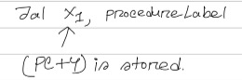
Jal instruction:
// jump to ProcedureAddress and write
return address to x1

Jal stands for jump and link;
It does not check any condition before jumping like beq, bne, bge, blt.
The link portion means that an address or link is formed that points to the calling site to allow the procedure to return to the proper address.
This “link,” stored in register x1, is called the return address.

Jalr instruction:
Jalr x0, 0(x1)

Jalr stands for jump and link register;
The jalr instruction branches to the address stored in register x1

LUI instruction
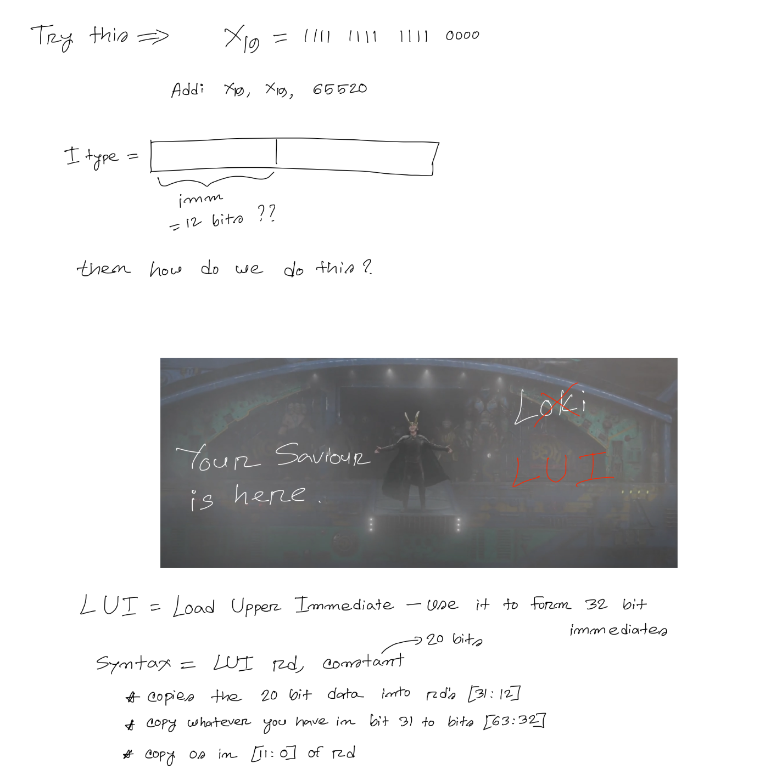

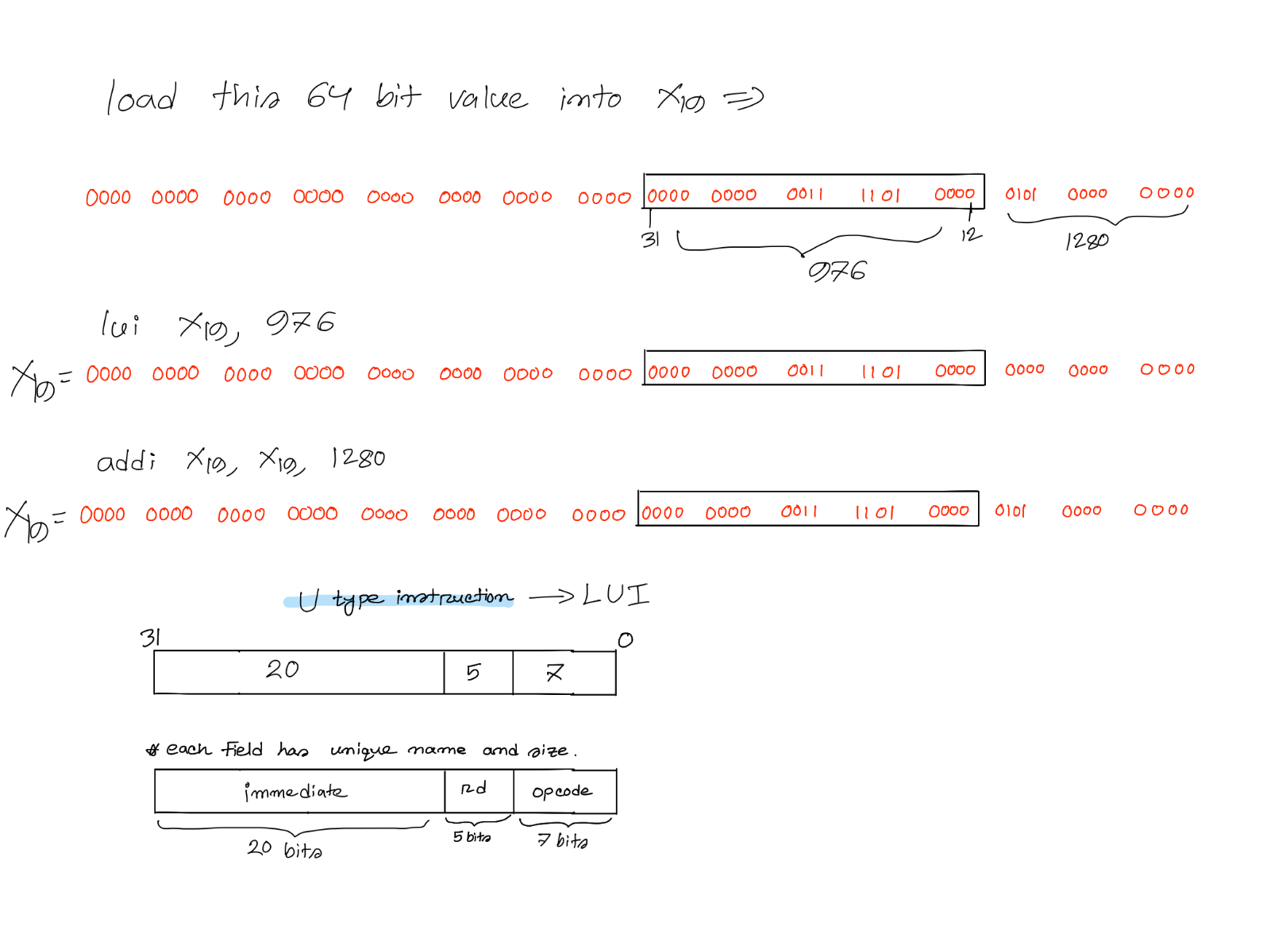

U-type Instruction Format

Field | Bit Length | Description
opcode | 7 bits | It determines both if the instruction is of the U-type or not and the specific instruction (LUI) itself.
rd | 5 bits | Destination Register – Number of the destination register.
immediate | 20 bits | the constant itself in 2s complement mode

Example:
LUI x21, 10; convert it to its corresponding machine code where Opcode = 0110111. Show your final answer in hex format.

Solution:
Rd = 21 = 10101  Opcode = 0100011  Immediate = +10  10 = 1010  +10 = 0 1010  = 0000 0000 0000  0000 1010 | Forming the 32-bit machine code now,  (2s complement)
  0000 0000 0000 0000 1010 |  |  |  |  | 10101 | 0110111
  imm[19:0] |  |  |  |  | rd | opcode
(00000000000000001010101010110111)₂ = 0000AAB7₁₆

Now, try to do the reverse yourself.

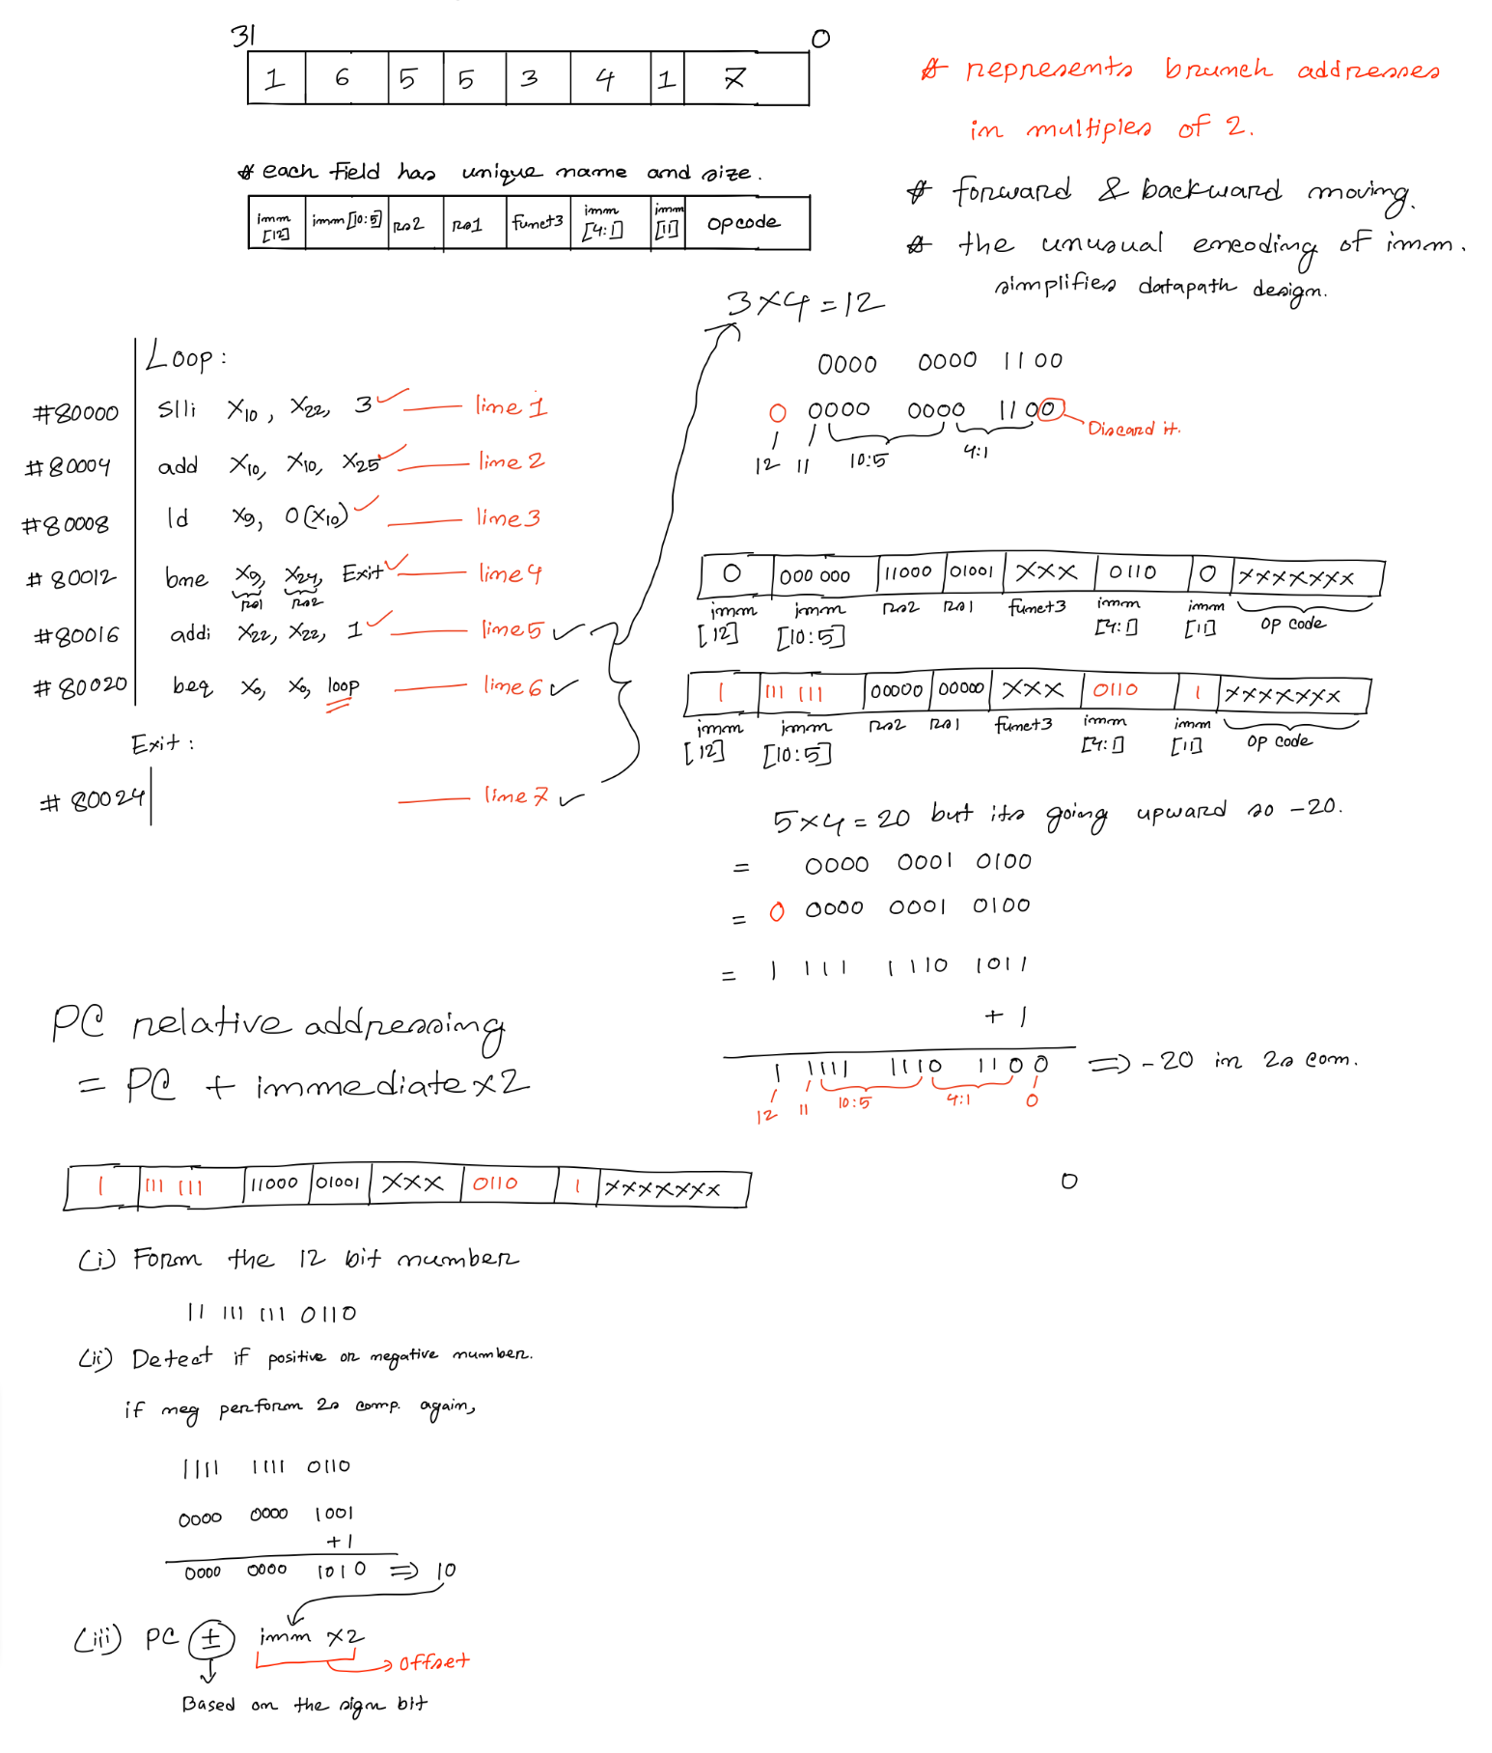
SB-type Instruction Format



UJ-type Instruction Format
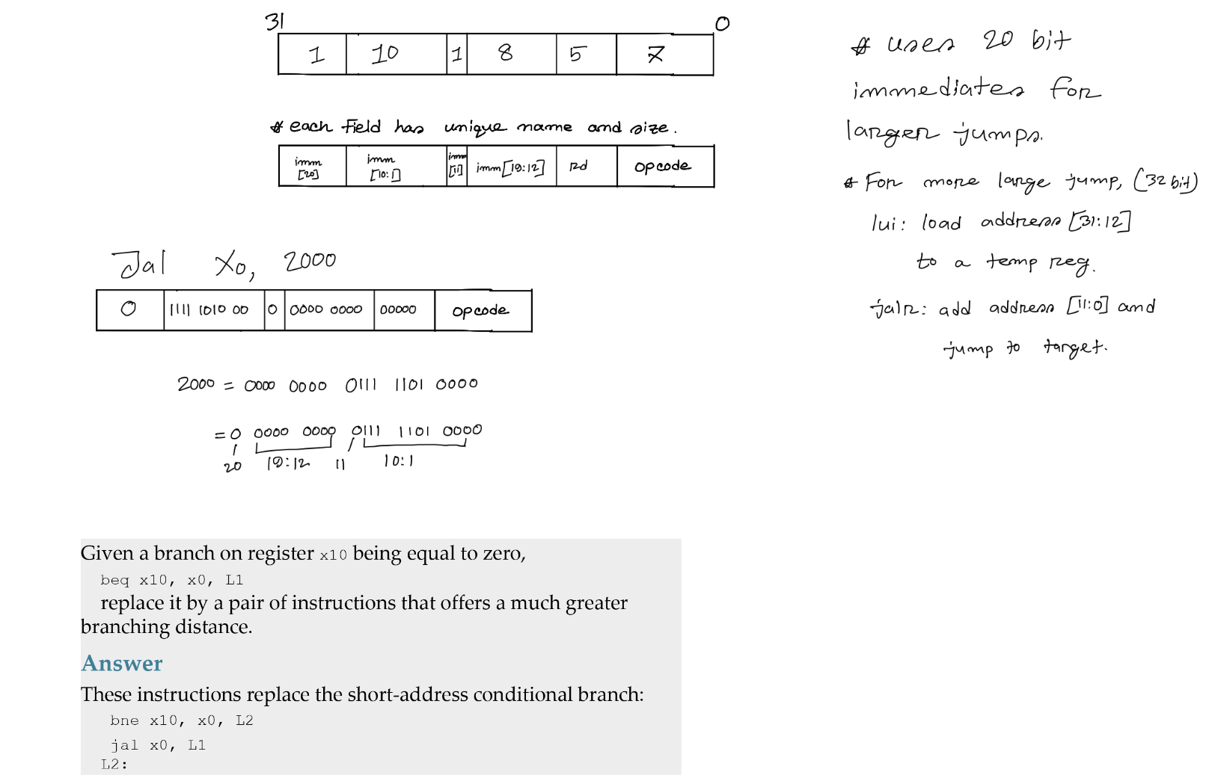

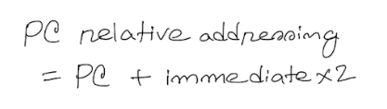

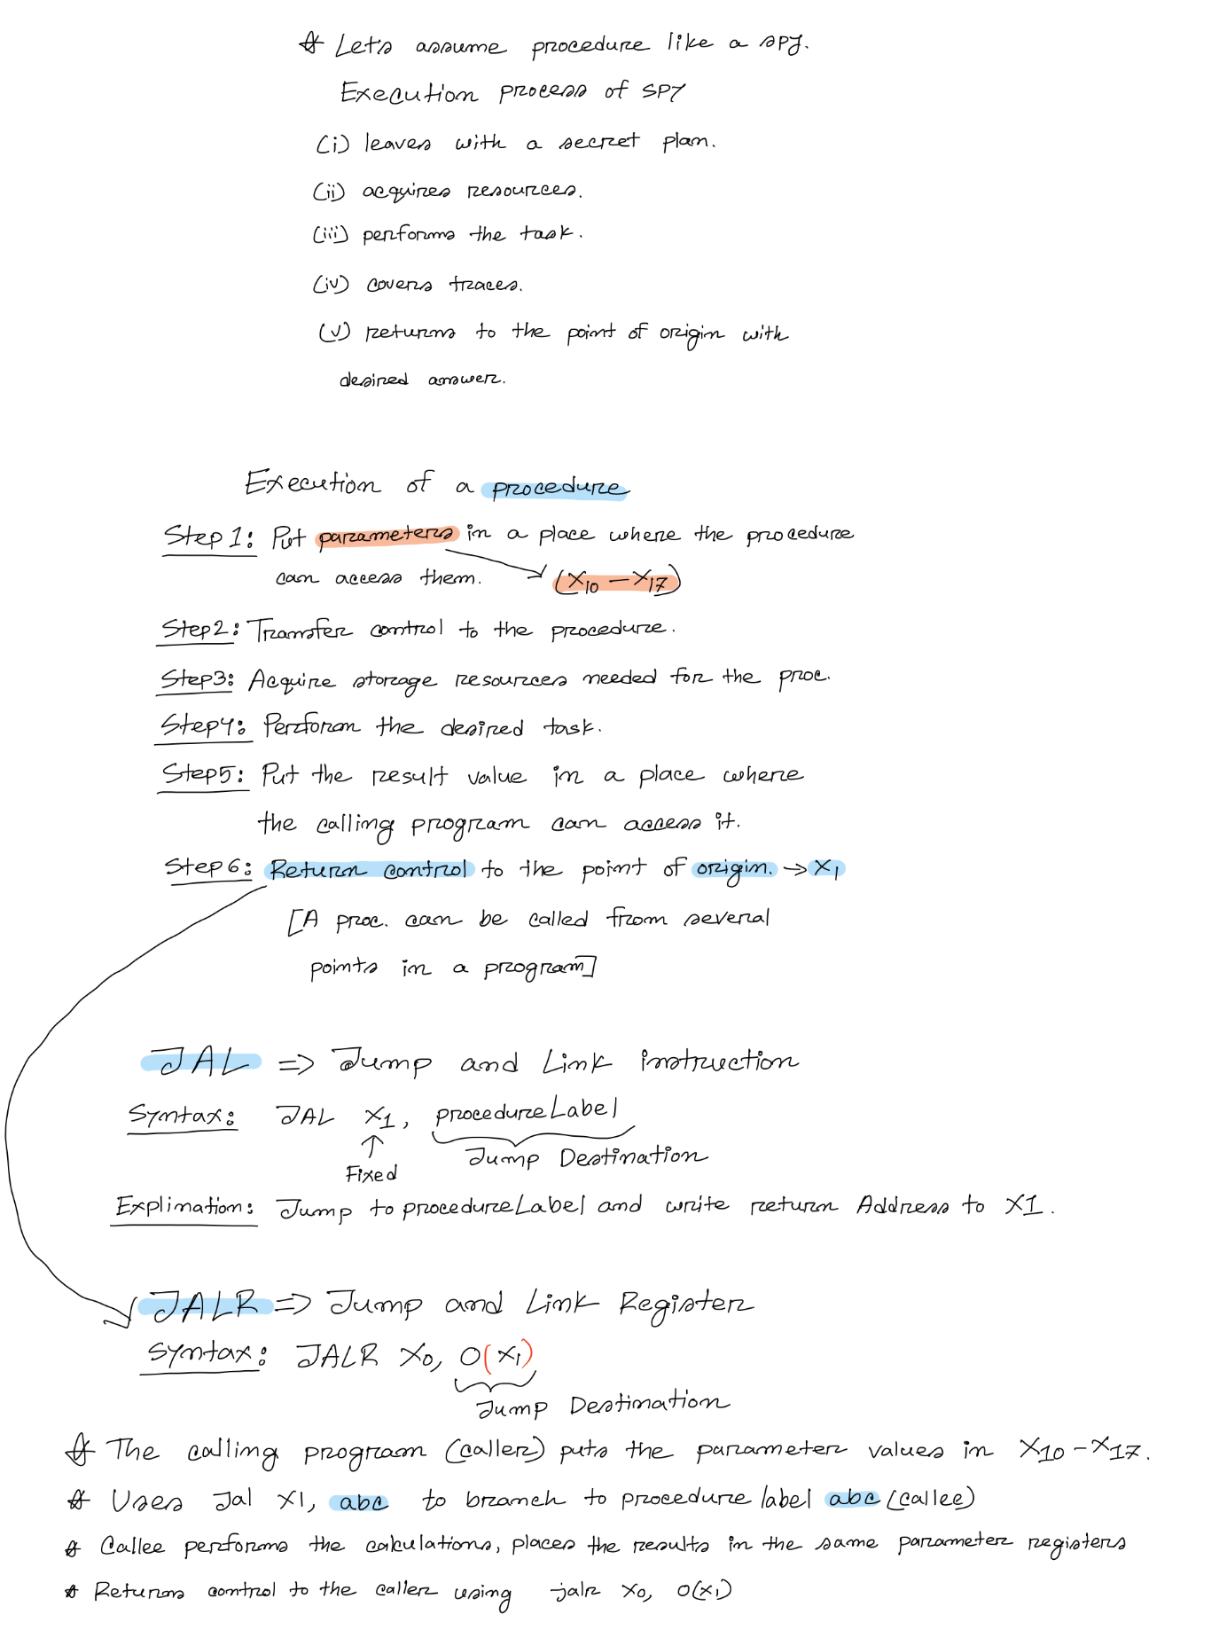
Procedure Calling

Sample Leaf Procedure translation:
Construct the equivalent RISC-V code of the following high level code.

int x = 0;
int y = 9;
int z = addition (x, y);

int addition (int a, int b) {
int c = a + b;
int d = (b - a) / 8;
return c+d;
}

Variables x, y, z are stored in registers X₂₀, X₂₁, X₂₂. Arguments x, y are passed using register X₁₃, X₁₄. Variables c and d from the addition function also use the registers X₂₁, X₂₂.

Solution:

Addi X₂₀, X₀, 0 | X₂₀ = 0 -> int x = 0;
Addi X₂₁, X₀, 9 | X₂₁ = 9 -> int y = 9;
Addi X₁₃, X₂₀, 0 | X₁₃ = X₂₀ -> setting the arguments for transfer;
Addi X₁₄, X₂₁, 0 | X₁₄ = X₂₁ -> setting the arguments for transfer;
Jal X₁, addition
Addi X₂₂, X₁₀, 0 | As the value was returned using the X₁₀ register. So copying it to Z
Beq X0, X0, Exit
addition:
 | Since registers X21 and X22 are used in the main function and will also be used in the callee function, their original values must be stored in the stack to avoid ambiguity
Addi X₂, X₂, -16 | Decreasing the stack pointer 16 memory locations.  Why?  register size = 64 bit;  1 memory location = 8 bits.  So to store 64 bits you need 8 memory locations;  1 register data needs 8 locations  So, 2 register data needs 16 locations.
Sd X₂₁, 0(X₂) | Stored X₂₁ in stack
Sd X₂₂, 8(X₂) | Stored X₂₂ in stack
Add X₂₁, X₁₃, X₁₄ | int c = a + b;
Sub X₂₂, X₁₄, X₁₃ | d = b - a
Srli X₂₂, X₂₂, 3 | int d = (b - a) / 8;
Add X₁₀, X₂₁, X₂₂ | X₁₀ = c + d;  Why X₁₀ ?  remember , X₁₀ is a return value register
Ld X₂₁, 0(X₂) | Restore the previous value of X₂₁ from stack
Ld X₂₂, 8(X₂) | Restore the previous value of X₂₂ from stack
Addi X₂, X₂, 16 | Increase the stack pointer
Jalr X₀, 0(X₁) | Returning control to the caller
Exit:

