UCLA Loneliness Scale Analysis

# UCLA 3-Item Loneliness Scale Data

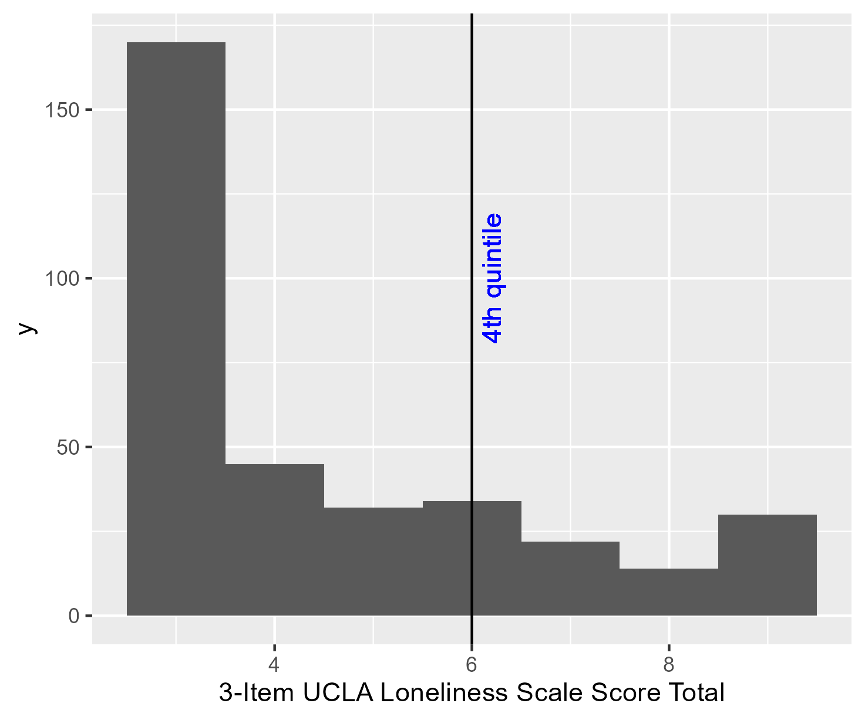

## Missing Data Summary

|  | **Missing** | **Non-missing** |
| --- | --- | --- |
| **UCLA LS lack companionship** | 563 | 392 |
| **UCLA LS feel left out** | 562 | 393 |
| **UCLA LS feel isolated** | 563 | 392 |
| **Total** | **566** | **389** |
| The values in the 'Missing' column represent the number of rows with missing values for each variable, or in the case of the total, the number of rows with any missing value. The values in the 'Non-missing' column represent the number of rows with non-missing values for each variable, or in the case of the total, the number of rows no missing values. | | |

## Missing Data Summary Excluding Period before Loneliness Scale Data was Collected

Loneliness Scale data was not collected from the beginning of the study. The first date when not all the loneliness scale variables were missing was 2022-01-17. The corresponding MedStar ID was 'f561525ec4f94a17af7ba3e2c12fee0f'. Data for dates prior to 2022-01-17 were filtered out.

|  | **Missing** | **Non-missing** |
| --- | --- | --- |
| **UCLA LS lack companionship** | 23 | 392 |
| **UCLA LS feel left out** | 22 | 393 |
| **UCLA LS feel isolated** | 23 | 392 |
| **Total** | **26** | **389** |
| The values in the 'Missing' column represent the number of rows with missing values for each variable, or in the case of the total, the number of rows with any missing value. The values in the 'Non-missing' column represent the number of rows with non-missing values for each variable, or in the case of the total, the number of rows no missing values. | | |

## Unique Patient Counts Summary

Unique and Non-unique Name Counts

| Value | Count |
| --- | --- |
| Unique people | 347 |
| People with multiple MedStar IDs | 34 |
| People with only one MedStar ID | 313 |
| Total unique MedStar IDs | 389 |

# Predictor variables

## Sociodemographic Information

### Missing Data Summary

|  | **Missing** | **Non-missing** |
| --- | --- | --- |
| **Race/ ethnicity** | 14 | 333 |
| **Sexual orientation** | 5 | 342 |
| **Marital Status** | 1 | 346 |
| **Employment status** | 4 | 343 |
| **Household income** | 43 | 304 |
| **Veteran status** | 1 | 346 |
| **Age** | 0 | 347 |
| **Education attainment** | 4 | 343 |
| **Household size** | 1 | 346 |
| **Sex** | 0 | 347 |
| **Total** | **67** | **280** |
| The values in the 'Missing' column represent the number of rows with missing values for each variable, or in the case of the total, the number of rows with any missing value. The values in the 'Non-missing' column represent the number of rows with non-missing values for each variable, or in the case of the total, the number of rows no missing values. | | |

## PEG 3-Item Pain Assessment

### Missing Data Summary

|  | **Missing** | **Non-missing** |
| --- | --- | --- |
| **PEG pain** | 0 | 347 |
| **PEG enjoyment** | 3 | 344 |
| **PEG activity** | 7 | 340 |
| **Total** | **8** | **339** |
| The values in the 'Missing' column represent the number of rows with missing values for each variable, or in the case of the total, the number of rows with any missing value. The values in the 'Non-missing' column represent the number of rows with non-missing values for each variable, or in the case of the total, the number of rows no missing values. | | |

## Geriatric Depression Scale

### Missing Data Summary

|  | **Missing** | **Non-missing** |
| --- | --- | --- |
| **GDS satisfied** | 0 | 347 |
| **GDS hopeless** | 2 | 345 |
| **GDS better off** | 0 | 347 |
| **GDS activities** | 2 | 345 |
| **GDS empty** | 0 | 347 |
| **GDS bored** | 0 | 347 |
| **GDS spirits** | 2 | 345 |
| **GDS afraid** | 0 | 347 |
| **GDS happy** | 2 | 345 |
| **GDS helpless** | 0 | 347 |
| **GDS home** | 4 | 343 |
| **GDS memory** | 2 | 345 |
| **GDS alive** | 4 | 343 |
| **GDS worthless** | 1 | 346 |
| **GDS energy** | 4 | 343 |
| **GDS total score** | 19 | 328 |
| **Total** | **19** | **328** |
| The values in the 'Missing' column represent the number of rows with missing values for each variable, or in the case of the total, the number of rows with any missing value. The values in the 'Non-missing' column represent the number of rows with non-missing values for each variable, or in the case of the total, the number of rows no missing values. | | |

## Medical Outcomes Study

### Missing Data Summary

|  | **Missing** | **Non-missing** |
| --- | --- | --- |
| **MOS limited social** | 6 | 341 |
| **MOS nervous** | 8 | 339 |
| **MOS calm** | 9 | 338 |
| **MOS blue** | 9 | 338 |
| **MOS happy** | 5 | 342 |
| **Total** | **23** | **324** |
| The values in the 'Missing' column represent the number of rows with missing values for each variable, or in the case of the total, the number of rows with any missing value. The values in the 'Non-missing' column represent the number of rows with non-missing values for each variable, or in the case of the total, the number of rows no missing values. | | |

## AUDIT-C Scale

### Missing Data Summary

|  | **Missing** | **Non-missing** |
| --- | --- | --- |
| **AUDIT-C drink** | 263 | 84 |
| **AUDIT-C day** | 295 | 52 |
| **AUDIT-C five** | 273 | 74 |
| **AUDIT-C total score** | 295 | 52 |
| **Total** | **295** | **52** |
| The values in the 'Missing' column represent the number of rows with missing values for each variable, or in the case of the total, the number of rows with any missing value. The values in the 'Non-missing' column represent the number of rows with non-missing values for each variable, or in the case of the total, the number of rows no missing values. | | |

## Self Report

### Missing Data Summary

|  | **Missing** | **Non-missing** |
| --- | --- | --- |
| **Ever physical abuse** | 19 | 328 |
| **Ever sexual abuse** | 21 | 326 |
| **Ever emotional or psychological abuse** | 16 | 331 |
| **Ever financial exploitation** | 37 | 310 |
| **Potential neglect (bills)** | 7 | 340 |
| **Potential neglect (cleaning)** | 10 | 337 |
| **Potential neglect (food/ medicine)** | 4 | 343 |
| **Potential neglect (transport)** | 2 | 345 |
| **Potential neglect (household tasks)** | 7 | 340 |
| **Potential neglect (getting ready)** | 6 | 341 |
| **Any potential neglect** | 22 | 325 |
| **Physical abuse 65 or older** | 22 | 325 |
| **Sexual abuse 65 or older** | 24 | 323 |
| **Emotional or psychological abuse 65 or older** | 17 | 330 |
| **Financial exploitation 65 or older** | 40 | 307 |
| **Past month physical abuse** | 64 | 283 |
| **Past month sexual abuse** | 72 | 275 |
| **Past month emotional or psychological abuse** | 61 | 286 |
| **Past month financial exploitation** | 53 | 294 |
| **Any ever abuse** | 50 | 297 |
| **Any abuse 65 or older** | 71 | 276 |
| **Any past month abuse** | 142 | 205 |
| **Total** | **159** | **188** |
| The values in the 'Missing' column represent the number of rows with missing values for each variable, or in the case of the total, the number of rows with any missing value. The values in the 'Non-missing' column represent the number of rows with non-missing values for each variable, or in the case of the total, the number of rows no missing values. | | |

# All Variables

|  | **Missing** | **Non-missing** |
| --- | --- | --- |
| **UCLA LS lack companionship** | 0 | 347 |
| **UCLA LS feel left out** | 0 | 347 |
| **UCLA LS feel isolated** | 0 | 347 |
| **UCLA LS total score** | 0 | 347 |
| **PEG total score** | 8 | 339 |
| **GDS total score** | 19 | 328 |
| **MOS limited social** | 6 | 341 |
| **MOS nervous** | 8 | 339 |
| **MOS calm** | 9 | 338 |
| **MOS blue** | 9 | 338 |
| **MOS happy** | 5 | 342 |
| **Race/ ethnicity** | 14 | 333 |
| **Sexual orientation** | 5 | 342 |
| **Marital Status** | 1 | 346 |
| **Employment status** | 4 | 343 |
| **Household income** | 43 | 304 |
| **Veteran status** | 1 | 346 |
| **Age** | 0 | 347 |
| **Education attainment** | 4 | 343 |
| **Household size** | 1 | 346 |
| **Any abuse 65 or older** | 71 | 276 |
| **Sex** | 0 | 347 |
| **Total** | **148** | **199** |
| The values in the 'Missing' column represent the number of rows with missing values for each variable, or in the case of the total, the number of rows with any missing value. The values in the 'Non-missing' column represent the number of rows with non-missing values for each variable, or in the case of the total, the number of rows no missing values. | | |

# MICE Package Missingness Imputation Output

Below are density plots for the output of the MICE missingness imputation. Variables with 1 or less missing values in the original data do not have density plots.

