Test Research Paper

Brad Cannell

8/20/2019

# Test paragraph

First responders are the only medical professionals positioned to bypass barriers to the detection and documentation of EM. Unlike other providers, EMS and law enforcement routinely respond to calls to the older adult’s residence and are frequently able to directly observe the older adult in the context of their living environment and caregiving situation.1–3 Access to observable cues in the physical and social environment creates opportunities to identify, report, and document EM that may otherwise never happen.

## Some notes

* I copied and pasted a paragraph from one of the DETECT papers.
* Here are some notes on adding citations into the document: <https://rmarkdown.rstudio.com/authoring_bibliographies_and_citations.html>
* I grabbed the information needed for the bibtex file directly from Paperpile.
* I knitted this Rmd file to a Word document.

## Simulate someone adding a new paragraph

Here, I am just simulating someone adding a new paragraph to the Word document and sending it to me. I think this situation is simpler than making track changes to an existing paragraph and sending it to me. Note that I did bold the text above (“Simulate someone adding a new paragraph”), and I’ll probably need to figure out the easiest way to get formatting back into the Rmd document. I’m not too worried about it though. I use relatively few headers and whatnot in my papers. Additionally, Officer may help with this stuff.

After typing this paragraph, I saved it. Then I cut and paste the text into the Rmd document. Then I knitted the Word document again.

# Figures

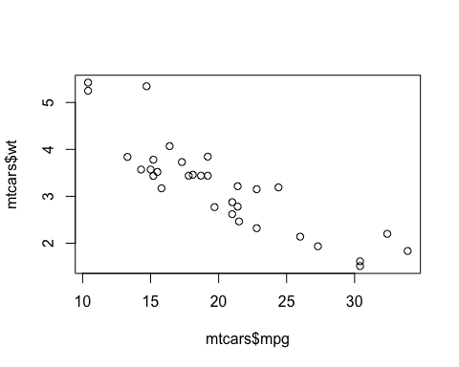

# References