Supplementary Material

Page 2 | Search strategy, eligibility criteria, study selection, and data handling
Page 4 | PRISMA diagram
Page 6 | Table S1. Trial Characteristics
Page 9 | Table S2. Risk of Bias Assessment
Page 31 | Table S3. Detailed References
Page 34 | Statistical Details

Search Strategy, Eligibility Criteria, Study Selection, and Data Handling

Search strategy
We searched PubMed (MEDLINE via NCBI) from inception to October 19, 2025, with no date limits. The full, reproducible PubMed strategy was:

(
"mechanical thrombectomy"[tiab] OR "endovascular thrombectomy"[tiab] OR
"aspiration thrombectomy"[tiab] OR "stent retriever*"[tiab] OR stentriever*[tiab] OR
Solitaire[tiab] OR Trevo[tiab] OR Penumbra[tiab]
)
AND
(
stroke[tiab] OR "ischemic stroke"[tiab] OR "large vessel occlusion"[tiab] OR LVO[tiab] OR
"basilar artery"[tiab] OR "basilar occlusion"[tiab]
)
AND
(
randomized controlled trial[Publication Type] OR random*[tiab] OR trial[tiab]
)
NOT (animals[mh] NOT humans[mh])
AND english[lang]

This search returned 327 records.

Eligibility criteria
- Design: randomized.
- Population: adults with acute ischemic stroke (anterior or posterior circulation).
- Intervention: mechanical thrombectomy (including stent retrievers and/or aspiration).
- Comparator: best medical management (with or without IV thrombolysis).
- Outcomes: functional outcomes (modified Rankin Scale)
- Exclusions: non-randomized studies

Study selection and data handling
We screened titles/abstracts and then full texts, with disagreements resolved by consensus, as documented in the PRISMA 2020 diagram on the following page.

For each included trial we extracted trial design, population, time window, imaging selection, intervention details (device/approach), comparator, and outcomes (including full-ordinal mRS where available).

For mRS results that were presented as percentages, we obtained mRS counts by assuming the the reported percentage of patients achieving the given mRS score was obtained by dividing the number of patients achieving that score in the intention-to-treat population divided by the total number of patients in the intention-to-treat population across all 6 mRS categories.

PRISMA-style diagram of search strategy and results.

Table S1. Trial Characteristics
Trial | Year | Occlusion territory | Time window | Imaging selection | Population | Randomized (N) | Primary endpoint | Key exclusion/selection feature | Notes
TESLA | 2024 | ICA/M1 (anterior LVO) | ≤6 h | NCCT ASPECTS; CTA | Large-core | 300 | mRS shift 90d | ASPECTS ≤5 | —
DISTAL | 2025 | Distal/DMVO | ≤6 h | CTA | Medium/distal vessel | 543 | mRS shift 90d | DMVO only | —
ESCAPE-MeVO | 2025 | M2/MeVO | ≤12 h | CTA; collateral | Medium vessel | 530 | mRS shift 90d | MeVO only | —
SELECT2-Lancet | 2023 | ICA/M1 | ≤24 h | NCCT ASPECTS; CTP core | Large-core | 352 | mRS shift 90d | ASPECTS 3-5 or core ≥50 mL | —
THERAPY | 2016 | ICA/M1 | ≤6 h | CTA | Early-window standard LVO | 381 | mRS shift 90d | IVT eligible | —
MR CLEAN- LATE | 2023 | ICA/M1 | 6-24 h | CTA collateral | Late-window/mismatch | 535 | mRS shift 90d | Good collaterals | —
THRACE | 2016 | ICA/M1 | ≤5 h | CTA | Early-window standard LVO | 414 | mRS 0-2 90d | IVT eligible | —
PISTE | 2017 | ICA/M1 | ≤6 h | CTA | Early-window standard LVO | 65 | mRS shift 90d | Pragmatic | —
POSITIVE | 2022 | Mixed | ≤12 h | CTP mismatch | Late-window/mismatch | 202 | mRS shift 90d | Perfusion-selected | —
RESILIENT | 2020 | ICA/M1 | ≤8 h | CTA | Early-window standard LVO | 221 | mRS 0-2 90d | Public system | —
DEFUSE-3 | 2018 | ICA/M1 | 6-16 h | CTP/MRP mismatch | Late-window/mismatch | 182 | mRS shift 90d | Core <70 mL | —
DAWN | 2018 | ICA/M1 | 6-24 h | CTP/MRP mismatch | Late-window/mismatch | 206 | mRS shift 90d | Clin-core mismatch | —
BASICS | 2021 | Basilar | ≤6 h | CTA/MRA | Basilar | 300 | mRS shift 90d | BAO only | —
BEST | 2020 | Basilar | ≤8 h | CTA/MRA | Basilar | 131 | mRS 0-3 90d | BAO only | Early stop
BAOCHE | 2022 | Basilar | 6-24 h | CTA/MRA | Basilar | 217 | mRS shift 90d | NIHSS ≥10 | —
ATTENTION | 2022 | Basilar | ≤12 h | CTA/MRA | Basilar | 340 | mRS shift 90d | BAO only | —
EXTEND-IA | 2015 | ICA/M1 | ≤6 h | CTP mismatch | Early-window standard LVO | 70 | mRS shift 90d | Perfusion-selected | —
SWIFT PRIME | 2015 | ICA/M1 | ≤6 h | CTA ± CTP | Early-window standard LVO | 196 | mRS shift 90d | IVT eligible | —
ESCAPE | 2015 | ICA/M1 | ≤12 h | CTA; collateral | Early-window standard LVO | 316 | mRS shift 90d | Good collaterals | —
REVASCAT | 2015 | ICA/M1 | ≤8 h | CTA | Early-window standard LVO | 206 | mRS shift 90d | ASPECTS ≥7 | —
MR CLEAN | 2015 | ICA/M1 | ≤6 h | CTA | Early-window standard LVO | 500 | mRS shift 90d | Pragmatic | —
IMS III | 2013 | ICA/M1 | ≤6 h | CTA optional | Early-window standard LVO | 656 | mRS 0-2 90d | IVT eligible | —
SYNTHESIS | 2013 | Mixed | ≤4.5 h | None/standard | Early-window standard LVO | 362 | mRS 0-1 90d | No CTA req. | —
MR RESCUE | 2013 | ICA/M1 | ≤8 h | CTP/MRP | Early-window standard LVO | 118 | mRS shift 90d | Imaging strata | —
RESCUE- Japan LIMIT | 2022 | ICA/M1 | ≤6 h | NCCT ASPECTS | Large core | 203 | mRS shift 90d | ASPECTS 3-5 | —
ANGEL-ASPECT | 2022 | ICA/M1 | ≤24 h | NCCT/CTP core | Large core | 456 | mRS shift 90d | Core ≥70 mL | —
SELECT2 | 2023 | ICA/M1 (anterior LVO) | ≤24 h | NCCT ASPECTS; CTP core | Large-core | 352 | mRS shift 90d | ASPECTS 3-5 or core ≥50 mL | Early stop
THRILL | 2016 | ICA/M1 | ≤6 h | NR | Early-window standard LVO | 80 | NR | IVT ineligible | Early stop
EASI | 2017 | Mixed | ≤6 h | NR | Early-window standard LVO | 44 | mRS 0-2 90d | Small RCT | —
TENSION | 2024 | ICA/M1 | ≤12 h | NCCT ASPECTS | Large-core | 253 | mRS shift 90d | ASPECTS 3-5 | —

Table S2. Risk of Bias Assessment
1. Writing Committee for the TESLA Investigators, Yoo AJ, Zaidat OO, Sheth SA, Rai AT, Ortega-Gutierrez S, et al. Thrombectomy for stroke with large infarct on noncontrast CT: The TESLA randomized clinical trial: The TESLA randomized clinical trial. JAMA. 2024 Sep 23;332(16):1355–66.
Study Characteristics
Methods | Randomized, multicenter, open‐label, phase III trial
Participants | Ages 18-85; 24 hr of onset or last known well; NIHSS 6 or higher, ICA or MCA m1 occlusion on CTA; prestroke mRS of 0-1, ASPECTS 2-5 stroke on CT
Interventions | Endovascular treatment using standard thrombectomy devices and usual medical care
Outcomes | Improvement in 90-day functional outcome measure UW-mRS
Funding Source | Medtronic, Cerenovus, Penumbra, Stryker, and Genentech.
Notes
Risk of Bias
Bias | Authors Judgement | Support for Judgement
Random sequence generation (selection bias) | Low risk | Quote: "randomly assigned patients, in a 1:1 ratio, to either endovascular thrombectomy or no endovascular thrombectomy, in addition to usual medical care. Patients were assigned to study groups using an internet-based, stratified-randomization procedure with permuted-block technique with randomly selected block sizes of 4, 6, 8, 10, and 12. Randomization was stratified for age (≤70 or >70 years), baseline ASPECTS (2 to 3 or 4 to 5), baseline NIHSS score (≤16 or >16), and time from stroke onset to imaging"
Allocation concealment (selection bias) | Low risk | Centralized, web-based randomization via secure electronic system
Blinding of participants and researchers (performance bias) | High risk | Open label
Blinding of outcome assessment (detection bias) | Low risk | Blinded end point assessment
Incomplete outcome data (attrition bias) | Low risk | 1 patient per group lost to follow up
Selective reporting (reporting bias) | Low risk | Reported prespecified analyses.
Other bias

2. Psychogios M, Brehm A, Ribo M, Rizzo F, Strbian D, Räty S, et al. Endovascular treatment for stroke due to occlusion of medium or distal vessels. N Engl J Med [Internet]. 2025 Feb 5 [cited 2025 Mar 19]; Available from: https://www.nejm.org/doi/full/10.1056/NEJMoa2408954
Study Characteristics
Methods | International multicenter randomized trial
Participants | 18 yrs or older, acute ischemic stroke caused by occlusion of medium or distal vessels confirmed by CTA or MRA; NIHSS 4 or higher
Interventions | Endovascular treatment left to discretion of treatment physician
Outcomes | mRS at 90 days; secondary NIHSS change at 24 hrs and mRS 0 or 1
Funding Source | Swiss National Science Foundation
Notes
Risk of Bias
Bias | Authors Judgement | Support for Judgement
Random sequence generation (selection bias) | Low risk | Randomization via secuTrial, maintaining balanced distribution of stratification factors
Allocation concealment (selection bias) | Low risk | Allocated via data management system secuTrial, displayed to treating physician only after patient registered in trial
Blinding of participants and researchers (performance bias) | High risk | Open label
Blinding of outcome assessment (detection bias) | Low risk | NIHSS after 90 days assessed by a person unaware of treatment allocation
Incomplete outcome data (attrition bias) | Low risk | No participants were lost to follow-up, but 3 withdrew consent before completing the 3-month follow-up period
Selective reporting (reporting bias) | Low risk | Reported prespecified analyses.
Other bias

3. Goyal M, Ospel JM, Ganesh A, Dowlatshahi D, Volders D, Möhlenbruch MA, et al. Endovascular treatment of stroke due to medium-vessel occlusion. N Engl J Med [Internet]. 2025 Feb 5 [cited 2025 Mar 19]; Available from: https://www.nejm.org/doi/full/10.1056/NEJMoa2411668
Study Characteristics
Methods | Phase 3, multicenter, prospective, randomized, open label trial
Participants | At least 18 years old, acute stroke caused by medium vessel occlusion (M2/M3, A2/3, P2/3); baseline NIHSS >5
Interventions | EVT with Solitaire X family device for first thrombus-retrieval with or without concurrent aspiration
Outcomes | mRS at 90 days
Funding Source | Canadian Institutes for Health Research and Medtronic
Notes
Risk of Bias
Bias | Authors Judgement | Support for Judgement
Random sequence generation (selection bias) | Low risk | Quote: "Randomization was performed with the use of a real-time, dynamic Web-based algorithm with minimal sufficient balance to achieve distribution balance”
Allocation concealment (selection bias) | Low risk | Randomization occurred after imaging performed and was recorded on the central server, when the enrolling physician or trial coordinator entered the and then randomized
Blinding of participants and researchers (performance bias) | High risk | Open label
Blinding of outcome assessment (detection bias) | Low risk | Primary outcome at 90 days was conducted by an assessor blinded to the acute intervention and acute hospital stay
Incomplete outcome data (attrition bias) | Low risk | Loss to follow up was minimal, balanced across groups, and outcome data nearly complete with blinded assessment
Selective reporting (reporting bias) | Low risk | Reported prespecified analyses.
Other bias

4. Bendszus M, Fiehler J, Subtil F, Bonekamp S, Aamodt AH, Fuentes B, et al. Endovascular thrombectomy for acute ischaemic stroke with established large infarct: multicentre, open-label, randomised trial. Lancet. 2023 Nov 11;402(10414):1753–63.
Study Characteristics
Methods | Randomized, multicenter, open-label, blinded endpoint, two-arm, post-market trial
Participants | Acute stroke w/ focal M1 occlusion or intracranial ICA, ASPECTS 3-5, <11h onset, >18 yrs old, NIHSS <26, 0-2 mRS preop
Interventions | EVT or medical treatment
Outcomes | mRS at 90 (±14) days
Funding Source | EU Horizon 2020
Notes | Stopped the trial early after the boundaries for efficacy were crossed at the first interim analysis on Feb 21, 2023, when 222 patients had reached the primary outcome
Risk of Bias
Bias | Authors Judgement | Support for Judgement
Random sequence generation (selection bias) | Low risk | Quote: "Patients were randomly assigned in a 1:1 ratio using a central, web-based module, with a permuted block design (random block sizes of two and four)"
Allocation concealment (selection bias) | Low risk | Central web-based randomization
Blinding of participants and researchers (performance bias) | High risk | Open label
Blinding of outcome assessment (detection bias) | Low risk | Quote: "All follow-up examinations were conducted by investigators or trial personnel masked to the patients' group assignment”
Incomplete outcome data (attrition bias) | Low risk | 90-day mRS completed
Selective reporting (reporting bias) | Low risk | Reported prespecified analyses.
Other bias

5. Mocco J, Zaidat OO, von Kummer R, Yoo AJ, Gupta R, Lopes D, et al. Aspiration Thrombectomy After Intravenous Alteplase Versus Intravenous Alteplase Alone. Stroke. 2016 Sep;47(9):2331–8.
Study Characteristics
Methods | Randomized, multicenter, open‐label, controlled phase III, treatment trial
Participants | 18 to 85 years; Presenting symptoms consistent with an acute ischemic stroke; Evidence of LVO in anterior circulation; NIHSS score 8 or greater or aphasic at presentation
Interventions | Intravenous alteplase alone vs EVT using mainly the Penumbra System and intravenous alteplase.
Outcomes | modified Rankin Scale score 0 to 2 at 90 days follow‐up
Funding Source | No specific grant from funding agencies in the public, commercial, or not‐for‐profit sectors
Notes
Risk of Bias
Bias | Authors Judgement | Support for Judgement
Random sequence generation (selection bias) | Unclear risk | Performed by centralized interactive voice response system. Stratified according to enrolling center
Allocation concealment (selection bias) | Low risk | Performed by centralized interactive voice response system. Stratified according to enrolling center
Blinding of participants and researchers (performance bias) | High risk | Open label
Blinding of outcome assessment (detection bias) | Low risk | Outcome assessment was performed by blinded, trained, certified investigators and assessed by independent blinded adjudicators.
Incomplete outcome data (attrition bias) | Unclear risk | 12 participants were lost to follow‐up. Intention‐to‐treat analysis provided.
Selective reporting (reporting bias) | Low risk | Reported prespecified analyses.
Other bias | Low risk | Trial enrollment was halted by steering committee after results from MR CLEAN.

6. Olthuis SGH, Pirson FAV, Pinckaers FME, Hinsenveld WH, Nieboer D, Ceulemans A, et al. Endovascular treatment versus no endovascular treatment after 6-24 h in patients with ischaemic stroke and collateral flow on CT angiography (MR CLEAN-LATE) in the Netherlands: a multicentre, open-label, blinded-endpoint, randomised, controlled, phase 3 trial. Lancet. 2023 Apr 22;401(10385):1371–80.
Study Characteristics
Methods | multicenter, open-label, blinded-endpoint, randomized, controlled, phase III trial
Participants | >18 yrs old, ischemic stroke, late window with anterior circulation LVO, NIHSS at least 2
Interventions | Endovascular therapy vs best medical therapy
Outcomes | mRS at 90 days
Funding Source | Collaboration for New Treatments of Acute Stroke consortium, Dutch Heart Foundation, Stryker, Medtronic, Cerenovus, Top Sector Life Sciences & Health, and the Netherlands Brain Foundation.
Notes
Risk of Bias
Bias | Authors Judgement | Support for Judgement
Random sequence generation (selection bias) | Low risk | Quote: "Randomization was web based using permuted blocks of varying block sizes (eight to 20) and stratified by center"
Allocation concealment (selection bias) | Low risk | Central, secure web-based randomization
Blinding of participants and researchers (performance bias) | High risk | Open label
Blinding of outcome assessment (detection bias) | Low risk | Blinded adjudication
Incomplete outcome data (attrition bias) | Low risk | Quote: "no patients were lost to follow-up, data on the primary outcome were available for all 502 patients."
Selective reporting (reporting bias) | Low risk | Reported prespecified analyses.
Other bias

7. Bracard S, Ducrocq X, Mas JL, Soudant M, Oppenheim C, Moulin T, et al. Mechanical thrombectomy after intravenous alteplase versus alteplase alone after stroke (THRACE): a randomised controlled trial. Lancet Neurol. 2016 Oct;15(11):1138–47.
Study Characteristics
Methods | Randomized multicenter clinical trial
Participants | Acute ischemic stroke, NIHSS 11 to 24; Onset to randomization within 3 hours; Occlusion of the intracranial carotid, the MCA (M1) or the upper third of the basilar artery
Interventions | tPA + mechanical thrombectomy versus standard intravenous thrombolysis with alteplase alone
Outcomes | Primary outcome: modified Rankin Scale score at 90 days
Funding Source | French Ministry of Health
Notes | Trial was terminated due to efficacy.
Risk of Bias
Bias | Authors Judgement | Support for Judgement
Random sequence generation (selection bias) | Low risk | Randomization performed by computer analyst masked to center and participants with the help of a computer‐generated sequence and stratified by center and sequential minimization to avoid imbalance.
Allocation concealment (selection bias) | Low risk | Centralized telephone/web randomization
Blinding of participants and researchers (performance bias) | High risk | Open label
Blinding of outcome assessment (detection bias) | Low risk | Primary endpoint was assessed by independent evaluators blinded to treatment allocation
Incomplete outcome data (attrition bias) | Unclear risk | 4 participants lost to follow‐up and with missing data were excluded from analysis (modified intention‐to‐treat analysis).
Selective reporting (reporting bias) | Low risk | Reported prespecified analyses.
Other bias | Low risk | Trial Steering Committee terminated trial early after 414 participants because of efficacy.

8. Muir KW, Ford GA, Messow CM, Ford I, Murray A, Clifton A, et al. Endovascular therapy for acute ischaemic stroke: the Pragmatic Ischaemic Stroke Thrombectomy Evaluation (PISTE) randomised, controlled trial. J Neurol Neurosurg Psychiatry. 2017 Jan;88(1):38–44.
Study Characteristics
Methods | Randomized controlled, multicenter, open‐label, phase III treatment trial
Participants | Patients aged 18 years and older; NIHSS score ≥ 6; Occlusion of the main MCA trunk, MCA bifurcation or intracranial internal carotid artery (carotid T, M1 or single proximal M2 branch)
Interventions | Mechanical thrombectomy vs best medical management. Both groups were given intravenous thrombolytic treatment.
Outcomes | modified Rankin Scale score 0 to 2 at 90 days follow‐up
Funding Source | Stroke Association, National Institute of Health Research Health Technology Assessment Programme, unrestricted grants from Codman and Covidien and others
Notes | Trial stopped early because of results from other trials.
Risk of Bias
Bias | Authors Judgement | Support for Judgement
Random sequence generation (selection bias) | Low risk | Computer‐based randomization with a minimization algorithm for age, stroke severity, and symptom‐onset to treatment time
Allocation concealment (selection bias) | Low risk | Central telephone randomization
Blinding of participants and researchers (performance bias) | High risk | Open label
Blinding of outcome assessment (detection bias) | Low risk | Blinded outcome assessment
Incomplete outcome data (attrition bias) | Low risk | No participants lost to follow‐up. Intention‐to‐treat analysis provided.
Selective reporting (reporting bias) | Low risk | Reported prespecified analyses
Other bias | Low risk | Trial terminated early after review of other trial data.

9. Mocco J, Siddiqui AH, Fiorella D, Alexander MJ, Arthur AS, Baxter BW, et al. POSITIVE: Perfusion imaging selection of ischemic stroke patients for endovascular therapy. J Neurointerv Surg. 2022 Feb;14(2):126–32.
Study Characteristics
Methods | multicenter, randomized, prospective, phase III trial
Participants | 18 yrs or older, NIHSS at least 8, LVO from distal ICA to M1, 0-12 hrs from symptom onset, pre-event mRS 0-1, salvageable penumbral region
Interventions | thrombectomy vs BMT
Outcomes | mRS at 90 days
Funding Source | Canon Medical Systems, Medtronic Neurovascular, Penumbra, and Stryker Neurovascular
Notes | early study termination
Risk of Bias
Bias | Authors Judgement | Support for Judgement
Random sequence generation (selection bias) | Low risk | Quote: "randomly assigned by REDCap, a central web-based system, in a 1:1 manner to treatment with either best MM or combined best MM and thrombectomy"
Allocation concealment (selection bias) | Low risk | Centralized web-based randomization
Blinding of participants and researchers (performance bias) | High risk | Open label
Blinding of outcome assessment (detection bias) | Low risk | Functional outcomes assessed by blinded evaluators
Incomplete outcome data (attrition bias) | Low risk | no patients lost to follow up
Selective reporting (reporting bias) | Low risk | Reported prespecified analyses
Other bias

10. Martins SO, Mont’Alverne F, Rebello LC, Abud DG, Silva GS, Lima FO, et al. Thrombectomy for Stroke in the Public Health Care System of Brazil. N Engl J Med. 2020 Jun 11;382(24):2316–26.
Study Characteristics
Methods | Randomized controlled, multicenter, open‐label, prospective, blinded outcome evaluation trial
Participants | Patients with proximal arterial occlusion in the anterior circulation that could be treated within 8 hours after onset of stroke symptoms
Interventions | Standard care plus mechanical thrombectomy or standard care alone. In the intervention group, thrombectomy was performed with the Solitaire FR stent retriever or Penumbra aspiration system.
Outcomes | disability at 90 days evaluated by the distribution of scores on the modified Rankin Scale
Funding Source | Unrestricted grant from the Brazilian Ministry of Health
Notes
Risk of Bias
Bias | Authors Judgement | Support for Judgement
Random sequence generation (selection bias) | Low risk | Randomization performed in real time by dynamic, internet‐based procedure and with a minimization algorithm.
Allocation concealment (selection bias) | Low risk | Central web-based randomization
Blinding of participants and researchers (performance bias) | High risk | Open label
Blinding of outcome assessment (detection bias) | Low risk | Blinded outcome assessment
Incomplete outcome data (attrition bias) | Low risk | All analyses were conducted according to the intention‐to‐treat principle. 1 participant lost to follow‐up
Selective reporting (reporting bias) | Low risk | Reported prespecified outcomes
Other bias | Low risk | Trial was terminated early because of efficacy.

11. Albers GW, Marks MP, Kemp S, Christensen S, Tsai JP, Ortega-Gutierrez S, et al. Thrombectomy for Stroke at 6 to 16 Hours with Selection by Perfusion Imaging. N Engl J Med. 2018 Feb 22;378(8):708–18.
Study Characteristics
Methods | Multicenter, randomized, open‐label trial with blinded outcome assessment
Participants | acute ischemic stroke presenting 6-16 hours from LKW; proximal MCA or internal carotid artery occlusion
Interventions | Endovascular therapy (thrombectomy) plus standard medical treatment vs standard medical treatment alone.
Outcomes | Primary outcome: ordinal core on the modified Rankin Scale at 90 days follow‐up
Funding Source | National Institute of Neurological Disorders and Stroke
Notes
Risk of Bias
Bias | Authors Judgement | Support for Judgement
Random sequence generation (selection bias) | Low risk | Computer‐based, dynamic randomization system. Stratified according to age, core infarct volume, time from symptom onset to enrolment, baseline NIHSS, and trial site
Allocation concealment (selection bias) | Low risk | Central web-based randomization
Blinding of participants and researchers (performance bias) | High risk | Open label
Blinding of outcome assessment (detection bias) | Low risk | Outcome assessed by certified rater who was blinded to trial assignment.
Incomplete outcome data (attrition bias) | Unclear risk | 3 participants lost to follow‐up and intention‐to‐treat analysis provided.
Selective reporting (reporting bias) | Low risk | Reported prespecified analyses.
Other bias | Low risk | After an early interim analysis following the DAWN trial results and at 182 randomized participants, the trial was halted due to efficacy.

12. Nogueira RG, Jadhav AP, Haussen DC, Bonafe A, Budzik RF, Bhuva P, et al. Thrombectomy 6 to 24 Hours after Stroke with a Mismatch between Deficit and Infarct. N Engl J Med. 2018 Jan 4;378(1):11–21.
Study Characteristics
Methods | Randomized, multicenter, open‐label, controlled phase II/III, treatment trial
Participants | acute ischemic stroke, and participant belongs to one of the following subgroups: (1) participant has failed IV‐tPA therapy (defined as a confirmed persistent occlusion 60 minutes after administration), (2) participant is contraindicated for IV‐tPA administration; age ≥ 18 years ; Baseline NIHSS ≥ 10 (assessed within 1 hour prior to measuring core infarct volume) ; Participant may be randomized between 6 to 24 hours after time last known well. pre‐stroke mRS must be 0 or 1
Interventions | Endovascular thrombectomy treatment (Trevo stent) plus best medical management vs best medical management. Thrombectomy was performed with the use of the Trevo device, a retrievable stent. Rescue reperfusion therapy or pharmacological agents were not permitted.
Outcomes | Weighted modified Rankin Scale score at 90 days follow‐up
Funding Source | Stryker Neurovascular
Notes | Terminated early due to efficacy
Risk of Bias
Bias | Authors Judgement | Support for Judgement
Random sequence generation (selection bias) | Low risk | Randomization performed with a central web‐based procedure with block minimization to balance the 2 groups and stratified according to mismatch criteria.
Allocation concealment (selection bias) | Low risk | Centralized web-based randomization
Blinding of participants and researchers (performance bias) | High risk | Open label
Blinding of outcome assessment (detection bias) | Low risk | Outcome assessment was performed by certified assessors unaware of treatment assignment. Adjudication performed by an independent clinical‐events committee.
Incomplete outcome data (attrition bias) | Low risk | No participants lost to follow‐up. Reported all participants and intention‐to‐treat.
Selective reporting (reporting bias) | Low risk | Reported prespecified analyses.
Other bias | Low risk | At 31 months and 206 participants enrolled, the trial was stopped prematurely because of the results of a prespecified interim analysis.

13. Langezaal LCM, van der Hoeven EJRJ, Mont’Alverne FJA, de Carvalho JJF, Lima FO, Dippel DWJ, et al. Endovascular Therapy for Stroke Due to Basilar-Artery Occlusion. N Engl J Med. 2021 May 20;384(20):1910–20.
Study Characteristics
Methods | multicenter, open-label, international, randomized, controlled trial w/ blinded outcome assessment
Participants | <85yrs old, acute symptoms of basilar ischemia + corresponding imaging, NIHSS 10 or more
Interventions | EVT or BMT
Outcomes | mRS 0-3 at 90 days
Funding Source | Dutch Heart Foundation
Notes
Risk of Bias
Bias | Authors Judgement | Support for Judgement
Random sequence generation (selection bias) | Low risk | Quote: "Randomization was conducted with the use of a central, Web-based procedure with permuted blocks (size 2) and was stratified according to center, use of intravenous thrombolysis, and NIHSS score (<20 or ≥20)."
Allocation concealment (selection bias) | Low risk | Centralized web-based randomization
Blinding of participants and researchers (performance bias) | High risk | Open label
Blinding of outcome assessment (detection bias) | Low risk | Outcome assessor was masked
Incomplete outcome data (attrition bias) | Low risk | no patients lost to follow up
Selective reporting (reporting bias) | Low risk | Reported prespecified analyses.
Other bias

14. Liu X, Dai Q, Ye R, Zi W, Liu Y, Wang H, et al. Endovascular treatment versus standard medical treatment for vertebrobasilar artery occlusion (BEST): an open-label, randomised controlled trial. Lancet Neurol. 2020 Feb;19(2):115–22.
Study Characteristics
Methods | Randomized controlled, multicenter, open‐label trial at 28 centers in China
Participants | Patients presenting within 8 hours of vertebrobasilar occlusion
Interventions | Endovascular therapy plus standard medical treatment or standard medical therapy alone. The endovascular procedure consisted of mechanical thrombectomy with stent retriever (the preferred method) or thrombo‐aspiration devices.
Outcomes | Primary outcome: modified Rankin Scale score of 3 or lower at 90 days assessed on an intention‐to‐treat basis
Funding Source | Jiangsu Provincial Special Program of Medical Science
Notes
Risk of Bias
Bias | Authors Judgement | Support for Judgement
Random sequence generation (selection bias) | Low risk | Computer‐generated randomization and stratified by participating centers
Allocation concealment (selection bias) | Low risk | Central web-based randomization
Blinding of participants and researchers (performance bias) | High risk | Open label
Blinding of outcome assessment (detection bias) | Low risk | Assessment was done by certified rater not aware of the trial group assignments.
Incomplete outcome data (attrition bias) | Low risk | No participants lost to follow‐up. Reported all participants and intention‐to‐treat.
Selective reporting (reporting bias) | Low risk | Reported prespecified analyses.
Other bias | Unclear risk | The trial was terminated prematurely by the steering committee based on recommendations from the data and safety monitoring board regarding excessive crossovers and progressive drop in the average rate of valid per‐center recruitment.

15. Tao C, Nogueira RG, Zhu Y, Sun J, Han H, Yuan G, et al. Trial of Endovascular Treatment of Acute Basilar-Artery Occlusion. N Engl J Med. 2022 Oct 13;387(15):1361–72.
Study Characteristics
Methods | multicenter, prospective randomized, open label
Participants | at least 18yo, mod-severe basilar artery stroke, NIHSS 10 or more, confirmed on CT
Interventions | EVT vs BMT
Outcomes | mRS at 90 days
Funding Source | Program for Innovative Research Team of the First Affiliated Hospital of USTC
Notes
Risk of Bias
Bias | Authors Judgement | Support for Judgement
Random sequence generation (selection bias) | Low risk | Quote: "The randomization procedure was Web-based on mobile devices or webpage platforms"
Allocation concealment (selection bias) | Low risk | Central web-based randomization
Blinding of participants and researchers (performance bias) | High risk | Open label
Blinding of outcome assessment (detection bias) | Low risk | Quote: "An independent clinical-event adjudication committee, whose members were unaware of the trial-group assignments, adjudicated the primary and secondary efficacy outcomes"
Incomplete outcome data (attrition bias) | Low risk | no patients lost to follow up
Selective reporting (reporting bias) | Low risk | Reported prespecified analyses.
Other bias

16. Jovin TG, Li C, Wu L, Wu C, Chen J, Jiang C, et al. Trial of Thrombectomy 6 to 24 Hours after Stroke Due to Basilar-Artery Occlusion. N Engl J Med. 2022 Oct 13;387(15):1373–84.
Study Characteristics
Methods | multicenter, open label, randomized, controlled trial, blinded outcomes
Participants | 18-80 yrs old, occlusion of basilar artery or intracranial b/l VA, 6-24 hours after symptom onset, prestroke mRS 0-1, NIHSS at least 6
Interventions | thrombectomy vs BMT
Outcomes | mRS 0-3 at 90 days
Funding Source | Chinese National Ministry of Science and Technology
Notes
Risk of Bias
Bias | Authors Judgement | Support for Judgement
Random sequence generation (selection bias) | Low risk | Quote: "Randomization was performed by means of a central, Web-based procedure, with the use of a minimization process to balance the two treatment groups and with stratification according to age (≤70 years or >70 years), the time from symptom onset to randomization (6 to 12 hours or >12 to 24 hours), and baseline NIHSS score (6 to 20 or >20)."
Allocation concealment (selection bias) | Low risk | Central web-based randomization
Blinding of participants and researchers (performance bias) | High risk | Open label
Blinding of outcome assessment (detection bias) | Low risk | Quote: "Outcomes were obtained by means of a structured interview conducted by local assessors (in person or by telephone) who were unaware of the treatment assignments"
Incomplete outcome data (attrition bias) | Low risk | 3 patients lost to follow up
Selective reporting (reporting bias) | Low risk | Reported prespecified analyses.
Other bias

17. Campbell BCV, Mitchell PJ, Kleinig TJ, Dewey HM, Churilov L, Yassi N, et al. Endovascular therapy for ischemic stroke with perfusion-imaging selection. N Engl J Med. 2015 Mar 12;372(11):1009–18.
Study Characteristics
Methods | RCT
Participants | alteplase within 4.5 hours after the onset of anterior circulation ischemic stroke; occlusion of the internal carotid artery or of the first or second segment of the MCA. Participants were required to have functional independence before the stroke episode, defined as mRS score 0 to 2.
Interventions | Thrombectomy with the Solitaire FR (Flow Restoration) stent retriever (intervention group) ; No intra‐arterial treatment (controls) ; All participants received 0.9 mg of alteplase per kilogram of body weight less than 4.5 hours after the onset of ischemic stroke.
Outcomes | Primary outcomes: reperfusion at 24 hours; and early neurological improvement (defined as reduction of NIHSS score ≥ 8 or score 0 to 1 at day 3). ; Secondary outcomes: death, mRS score at 90 days follow‐up, and sICH
Funding Source | Australian National Health and Medical Research Council and others
Notes
Risk of Bias
Bias | Authors Judgement | Support for Judgement
Random sequence generation (selection bias) | Low risk | Randomization procedure was computer‐generated randomization code lists, with stratification for site of baseline arterial occlusion.
Allocation concealment (selection bias) | Low risk | Central web-based randomization
Blinding of participants and researchers (performance bias) | High risk | Open label
Blinding of outcome assessment (detection bias) | Low risk | Neurological impairment and functional scores were measured by a clinician blinded to assigned intervention.
Incomplete outcome data (attrition bias) | Low risk | No participants lost to follow‐up and intention‐to‐treat analysis provided.
Selective reporting (reporting bias) | Low risk | Reported prespecified analyses.
Other bias | Unclear risk | The trial was stopped early because of evidence of efficacy after 70 participants had undergone randomization and because of the publication of MR CLEAN.

18. Saver JL, Goyal M, Bonafe A, Diener HC, Levy EI, Pereira VM, et al. Stent-retriever thrombectomy after intravenous t-PA vs. t-PA alone in stroke. N Engl J Med. 2015 Jun 11;372(24):2285–95.
Study Characteristics
Methods | RCT
Participants | Age 18 to 80 years; Clinical signs consistent with acute ischemic stroke; NIHSS scores ≥ 8 and < 30 at the time of randomization
Interventions | Intravenous alteplase followed by endovascular thrombectomy with the use of Solitaire FR or Solitaire 2 device versus intravenous alteplase and best medical treatment alone
Outcomes | modified Rankin Scale score 0 to 2 at 90 days follow‐up
Funding Source | Covidien
Notes
Risk of Bias
Bias | Authors Judgement | Support for Judgement
Random sequence generation (selection bias) | Low risk | Using a minimization algorithm for investigational site, stroke severity, age, and occlusion location
Allocation concealment (selection bias) | Low risk | Central web-based randomization
Blinding of participants and researchers (performance bias) | High risk | Open label
Blinding of outcome assessment (detection bias) | Low risk | Blinded outcome assessment
Incomplete outcome data (attrition bias) | Low risk | No participants lost to follow‐up
Selective reporting (reporting bias) | Low risk | Reported prespecified analyses
Other bias | Low risk | Trial was terminated early because of efficacy after 196 participants.

19. Goyal M, Demchuk AM, Menon BK, Eesa M, Rempel JL, Thornton J, et al. Randomized assessment of rapid endovascular treatment of ischemic stroke. N Engl J Med. 2015 Mar 12;372(11):1019–30.
Study Characteristics
Methods | RCT
Participants | Patients with a proximal intracranial occlusion in the anterior circulation were included up to 12 hours after symptom onset. Patients with a large infarct core or poor collateral circulation on CT and CT angiography were excluded.
Interventions | Standard care according to local guidelines (control group) ; Standard care plus endovascular thrombectomy intervention with the use of available thrombectomy devices (intervention group).
Outcomes | Primary outcome was modified Rankin Scale score at 90 days.;
Funding Source | Funded by Covidien and others
Notes
Risk of Bias
Bias | Authors Judgement | Support for Judgement
Random sequence generation (selection bias) | Low risk | Real‐time, dynamic, internet‐based, randomization with minimization procedure to achieve distribution balance regarding age, sex, baseline NIHSS score (range 0 to 42), site of arterial occlusion, baseline ASPECT score, and status with respect to intravenous alteplase treatment
Allocation concealment (selection bias) | Low risk | Central web-based randomization
Blinding of participants and researchers (performance bias) | High risk | Open label
Blinding of outcome assessment (detection bias) | Low risk | Clinical outcomes were assessed by trained personnel blinded to treatment allocation. Interpretation of images was performed at an external core laboratory by personnel blinded to treatment allocation.
Incomplete outcome data (attrition bias) | Low risk | 4 participants (1.3%) were lost to follow‐up. Missing outcome data for these participants were not imputed.
Selective reporting (reporting bias) | Low risk | Reported prespecified analyses
Other bias | Unclear risk | The trial was stopped early because of evidence of efficacy after an interim analysis following the MR CLEAN results and at 316 randomized participants.

20. Jovin TG, Chamorro A, Cobo E, de Miquel MA, Molina CA, Rovira A, et al. Thrombectomy within 8 hours after symptom onset in ischemic stroke. N Engl J Med. 2015 Jun 11;372(24):2296–306.
Study Characteristics
Methods | RCT
Participants | Acute ischaemic. No significant pre‐stroke functional disability (mRS ≤ 1); Baseline NIHSS score obtained prior to randomization must be equal or higher than 6 points; Age ≥ 18 and ≤ 85 years; Hypodensity on CT or restricted diffusion amounting to an ASPECTS of < 7 on non‐contrast CT or < 6 on DWI MRI. Patients 81 to 85 years old with ASPECTS on non‐contrast CT or DWI MRI < 9 were excluded.
Interventions | Endovascular thrombectomy with the Solitaire stent retriever and medical therapy (including intravenous alteplase when eligible) versus medical treatment alone.
Outcomes | modified Rankin Scale score 0 to 2 at 90 days follow‐up
Funding Source | Fundació Ictus Malaltia Vascular through an unrestricted grant from Covidien and others
Notes
Risk of Bias
Bias | Authors Judgement | Support for Judgement
Random sequence generation (selection bias) | Low risk | Real‐time computerized randomization stratified according to age, baseline NIHSS, therapeutic window, occlusion site, and participating center
Allocation concealment (selection bias) | Low risk | Central web-based randomization
Blinding of participants and researchers (performance bias) | High risk | Open label
Blinding of outcome assessment (detection bias) | Low risk | Blinded outcome assessment
Incomplete outcome data (attrition bias) | Low risk | 1 participant lost to follow‐up (withdrew consent)
Selective reporting (reporting bias) | Low risk | Reported prespecified analyses
Other bias | Low risk | Trial was terminated early because of lack of equipoise after positive results from other similar trials at 206 randomized participants.

21. Berkhemer OA, Fransen PSS, Beumer D, van den Berg LA, Lingsma HF, Yoo AJ, et al. A randomized trial of intraarterial treatment for acute ischemic stroke. N Engl J Med. 2015 Jan 1;372(1):11–20.
Study Characteristics
Methods | RCT
Participants | A clinical diagnosis of acute stroke, with a deficit on the NIHSS of 2 points or more; CT or MRI scan ruling out intracranial hemorrhage; Intracranial arterial occlusion of the distal intracranial carotid artery or middle (M1/M2) or anterior (A1/A2) cerebral artery, Age 18 years or over
Interventions | Approved intervention was both intra‐arterial treatment, which consisted of arterial catheterization with a microcatheter to the level of occlusion and delivery of a thrombolytic agent, or mechanical thrombectomy, or both. The method of endovascular intervention was left to the discretion of the local neurointerventionist.
Outcomes | Score on the modified Rankin Scale at 3 months
Funding Source | Dutch Heart Foundation and others
Notes
Risk of Bias
Bias | Authors Judgement | Support for Judgement
Random sequence generation (selection bias) | Low risk | Computer‐ and web‐based randomization with the use of permuted blocks. Stratified according to medical center, use of intravenous alteplase, planned treatment method, and stroke severity
Allocation concealment (selection bias) | Low risk | Central web-based randomization
Blinding of participants and researchers (performance bias) | High risk | Open label
Blinding of outcome assessment (detection bias) | Low risk | Blinded outcome assessment.
Incomplete outcome data (attrition bias) | Low risk | 2 participants lost to follow‐up (withdrew consent after randomization), and intention‐to‐treat analysis provided
Selective reporting (reporting bias) | Low risk | Reported prespecified analyses
Other bias | Low risk | Not terminated prematurely

22. Broderick JP, Palesch YY, Demchuk AM, Yeatts SD, Khatri P, Hill MD, et al. Endovascular therapy after intravenous t-PA versus t-PA alone for stroke. N Engl J Med. 2013 Mar 7;368(10):893–903.
Study Characteristics
Methods | RCT
Participants | intravenous r‐tPA within 3 hours after symptom onset. In the first part of the study, patients were eligible if they had an NIHSS score of 10 or higher. After 284 of the 656 participants were included, identification of occlusion with the use of CT angiography was allowed to determine trial eligibility for patients with an NIHSS score of 8 or 9.
Interventions | All participants received intravenous r‐tPA. Randomization was required within 40 minutes after the initiation of the infusion. Participants randomly assigned to IV r‐tPA received the remainder of the standard dose. The method of endovascular intervention was determined by the neurointerventionalist, who could choose between mechanical thrombectomy with stent retrievers, Penumbra system or Solitaire FR revascularization device or endovascular intra‐arterial delivery of tPA by means of microcatheter.
Outcomes | modified Rankin Scale score of 2 or less at 90 days
Funding Source | National Institutes of Health and others
Notes | The planned sample size was 900 participants
Risk of Bias
Bias | Authors Judgement | Support for Judgement
Random sequence generation (selection bias) | Low risk | Computer‐based randomization using a computer‐based algorithm.
Allocation concealment (selection bias) | Low risk | Central telephone-based randomization
Blinding of participants and researchers (performance bias) | High risk | Open label
Blinding of outcome assessment (detection bias) | Low risk | Outcome assessment was by personnel blinded to allocated treatment.
Incomplete outcome data (attrition bias) | Low risk | An unfavorable imputation was applied for 27 participants (14 participants for whom the primary outcome was assessed outside the specified 30‐day window, and 13 for whom the primary outcome was not assessed).Intention‐to‐treat analysis was provided.
Selective reporting (reporting bias) | Low risk | Reported prespecified analyses.
Other bias | Unclear risk | The study was stopped early because of futility after 656 participants had undergone randomization following a prespecified rule. A total of 23% participants randomized to intervention did not receive thrombectomy because there was no lesion identified during the endovascular procedure.

23. Ciccone A, Valvassori L, Nichelatti M, Sgoifo A, Ponzio M, Sterzi R, et al. Endovascular Treatment for Acute Ischemic Stroke. N Engl J Med. 2013 Mar 7;368(10):904–13.
Study Characteristics
Methods | multicenter, open-treatment blinded end point trial
Participants | 18-80yrs, acute stroke
Interventions | EVT vs BMT
Outcomes | disability free survival at 90 days
Funding Source | Italian Medicines Agency (AIFA)
Notes
Risk of Bias
Bias | Authors Judgement | Support for Judgement
Random sequence generation (selection bias) | Low risk | Quote: "centralized, simple randomization online. A single randomization list was prepared with the use of a hardware system, available at www.random.org."
Allocation concealment (selection bias) | Low risk | Central telephone-based randomization
Blinding of participants and researchers (performance bias) | Unclear risk | No mention of participant or researcher bias
Blinding of outcome assessment (detection bias) | Low risk | Quote: "Long-term clinical condition was assessed 90 days after randomization by means of a telephone interview by a single neurologist, who was not aware of treatment assignments"
Incomplete outcome data (attrition bias) | Low risk | no patients were lost to follow up
Selective reporting (reporting bias) | Low risk | Reported prespecified analyses.
Other bias

24. Kidwell CS, Jahan R, Gornbein J, Alger JR, Nenov V, Ajani Z, et al. A trial of imaging selection and endovascular treatment for ischemic stroke. N Engl J Med. 2013 Mar 7;368(10):914–23.
Study Characteristics
Methods | RCT
Participants | acute cerebral ischemia (NIHSS ≥ 6); Age ≥ 18 ≤ 85 years; Large vessel proximal anterior circulation occlusion (internal carotid, M1 or M2 MCA); Premorbid modified Rankin Scale score of 0 to 2; Allowed but not required: patients treated with IV‐tPA up to 4.5 hours from symptom onset
Interventions | Mechanical thrombectomy (Merci Retriever or Penumbra System) plus best medical treatment vs best medical treatment. Participants in the embolectomy group could be treated with any combination of FDA‐cleared embolectomy devices, including the Merci Retriever and the Penumbra System.
Outcomes | modified Rankin Scale score 0 to 2 at 90 days follow‐up
Funding Source | National Institute of Neurological Disorders and Stroke
Notes
Risk of Bias
Bias | Authors Judgement | Support for Judgement
Random sequence generation (selection bias) | Low risk | Computer‐based randomization. Stratified according to penumbral pattern on brain imaging
Allocation concealment (selection bias) | Low risk | Central web-based randomization
Blinding of participants and researchers (performance bias) | High risk | Open label
Blinding of outcome assessment (detection bias) | Low risk | Blinded outcome assessment
Incomplete outcome data (attrition bias) | High risk | Per‐protocol analyses. 9 participants excluded from the analyses (5 did not have target lesion on vessel imaging; 2 did not have post‐tPA vessel imaging; 2 had failed perfusion imaging).
Selective reporting (reporting bias) | Low risk | Reported prespecified analyses
Other bias | Low risk | Not terminated prematurely

25. Yoshimura S, Sakai N, Yamagami H, Uchida K, Beppu M, Toyoda K, et al. Endovascular Therapy for Acute Stroke with a Large Ischemic Region. N Engl J Med. 2022 Apr 7;386(14):1303–13.
Study Characteristics
Methods | open-label, parallel-group, randomized, multicenter trial
Participants | 18 years or more, NIHSS 6 or more, 0-1 pre-event mRS, ICA/M1 occlusion
Interventions | EVT vs BMT
Outcomes | mRS 0-3 at 90 days
Funding Source | Mihara Cerebrovascular Disorder Research Promotion Fund and the Japanese Society for Neuroendovascular Therapy
Notes
Risk of Bias
Bias | Authors Judgement | Support for Judgement
Random sequence generation (selection bias) | Low risk | Quote: "Randomization was performed centrally with the use of a stochastic minimization algorithm to balance trial-group assignments within hospitals on the basis of age (<75 or ≥75 years), interval between the time that a patient was last known to be well and the time of hospital arrival (<120 or ≥120 minutes), NIHSS score at admission (<21 or ≥21), and use of recombinant tissue plasminogen activator (rt-PA)"
Allocation concealment (selection bias) | Low risk | Central web-based randomization
Blinding of participants and researchers (performance bias) | High risk | Open label
Blinding of outcome assessment (detection bias) | Low risk | Quote: "The scores on the modified Rankin scale at 90 days were determined by physicians or physical therapists who were trained to obtain this score and were unaware of the trial-group assignments"
Incomplete outcome data (attrition bias) | Low risk | no patients lost to follow up
Selective reporting (reporting bias) | Low risk | Reported prespecified analyses
Other bias

26. Huo X, Ma G, Tong X, Zhang X, Pan Y, Nguyen TN, et al. Trial of Endovascular Therapy for Acute Ischemic Stroke with Large Infarct. N Engl J Med [Internet]. 2023 Feb 10; Available from: http://dx.doi.org/10.1056/NEJMoa2213379
Study Characteristics
Methods | multicenter, randomized, open label trial, blinded endpoint
Participants | 18-80, NIHSS 6-30, mRS pre-event 0-1, LVO distal ICA or M1
Interventions | EVT vs BMT
Outcomes | mRS at 90 days
Funding Source | Covidien Healthcare International Trading [Shanghai]
Notes | trial was stopped early because of evidence of the efficacy of endovascular therapy after the second interim analysis
Risk of Bias
Bias | Authors Judgement | Support for Judgement
Random sequence generation (selection bias) | Low risk | Quote: "eligible participants were randomly assigned in a 1:1 ratio"
Allocation concealment (selection bias) | Low risk | Central web-based randomization
Blinding of participants and researchers (performance bias) | High risk | Open label
Blinding of outcome assessment (detection bias) | Low risk | performed by members unaware of treatment group assignments
Incomplete outcome data (attrition bias) | Low risk | No patients lost to follow up
Selective reporting (reporting bias) | Low risk | Reported prespecified analyses
Other bias

27. Sarraj A, Hassan AE, Abraham MG, Ortega-Gutierrez S, Kasner SE, Hussain MS, et al. Trial of Endovascular Thrombectomy for Large Ischemic Strokes. N Engl J Med [Internet]. 2023 Feb 10; Available from: http://dx.doi.org/10.1056/NEJMoa2214403
Study Characteristics
Methods | phase III, international, randomized, open-label, blinded end point assessment
Participants | 18-85, ICA/M1 occlusion, ASPECTS 3-5
Interventions | EVT vs BMT
Outcomes | mRS at 90 days
Funding Source | Stryker Neurovascular
Notes
Risk of Bias
Bias | Authors Judgement | Support for Judgement
Random sequence generation (selection bias) | Low risk | Quote: "Randomization was performed with the use of a central, Web-based module with an adaptive (minimization) procedure to balance groups across key clinical and imaging characteristics"
Allocation concealment (selection bias) | Low risk | Central web-based randomization
Blinding of participants and researchers (performance bias) | High risk | Open label
Blinding of outcome assessment (detection bias) | Low risk | Quote: "Trained, certified assessors who were unaware of trial-group assignments and imaging results collected 30-day and 90-day outcomes"
Incomplete outcome data (attrition bias) | Low risk | 3 patients lost to follow up
Selective reporting (reporting bias) | Low risk | Reported prespecified analyses
Other bias

28. Bendszus M, Thomalla G, Hacke W, Knauth M, Gerloff C, Bonekamp S, et al. Early termination of THRILL, a prospective study of mechanical thrombectomy in patients with acute ischemic stroke ineligible for i.v. thrombolysis. Clin Neuroradiol. 2016 Dec 5;26(4):499–500.
Study Characteristics
Methods | Prospective, multicenter, open-label, blinded endpoint, randomized control trial
Participants | LVO in anterior circulation no eligible for IV tPA, up to 8 hours after symptom onset
Interventions | Mechanical thrombectomy with stentriever vs. best medical care
Outcomes | Primary endpoint is mRS 90 days after stroke, secondary outcomes are mRS of 1 or less
Funding Source | Funding not reported
Notes | Halted early after MR CLEAN study results
Risk of Bias
Bias | Authors Judgement | Support for Judgement
Random sequence generation (selection bias) | Low risk | Randomization with parallel assignment
Allocation concealment (selection bias) | Unclear risk | Randomization method described; allocation concealment not clearly detailed
Blinding of participants and researchers (performance bias) | High risk | Open label
Blinding of outcome assessment (detection bias) | Unclear risk | Blinding of outcome assessment cannot be assumed
Incomplete outcome data (attrition bias) | High risk | Only 4 patients with reported data due to early termination
Selective reporting (reporting bias) | High risk | Only 4 patients with reported data due to early termination
Other bias

29. Khoury NN, Darsaut TE, Ghostine J, Deschaintre Y, Daneault N, Durocher A, et al. Endovascular thrombectomy and medical therapy versus medical therapy alone in acute stroke: A randomized care trial. J Neuroradiol. 2017 Jun;44(3):198–202.
Study Characteristics
Methods | Randomized control trial
Participants | Age 18 years or older, NIHSS of at least 8, symptom onset <5 hours or presence of clinical-imaging mismatch, suspected/proven M1/M2 occ, supraclinoid ICA, or basilar artery
Interventions | Mechanical thrombectomy plus standard care or standard treatment
Outcomes | Proportion of independent patients at 90 days (mRS 0-2), primary safety outcomes were death at 90 days and sICH at 24hrs
Funding Source | No funding source
Notes | Trial terminated early following results of MR CLEAN
Risk of Bias
Bias | Authors Judgement | Support for Judgement
Random sequence generation (selection bias) | Low risk | Randomly allocated 1:1 through web-based application package (medscinet.com). Quote: “For patients allocated to thrombectomy, a simultaneous second randomization was conducted in the event that a tandem lesion (severe ipsilateral cervical ICA stenosis or occlusion) was identified”
Allocation concealment (selection bias) | Unclear risk | Randomization method described; allocation concealment not clearly detailed
Blinding of participants and researchers (performance bias) | High risk | Open label
Blinding of outcome assessment (detection bias) | High risk | Quote: “All data and outcome measures were collected by routine care personnel in this care trial design and thus, no blinding was involved”
Incomplete outcome data (attrition bias) | Low risk | Follow up at 90 days was completed for all surviving patients
Selective reporting (reporting bias) | Low risk | Reported prespecified analyses
Other bias

30. Costalat V, Jovin TG, Albucher JF, Cognard C, Henon H, Nouri N, et al. Trial of thrombectomy for stroke with a large infarct of unrestricted size. N Engl J Med. 2024 May 9;390(18):1677–89.
Study Characteristics
Methods | Multicenter, prospective, open label, randomized, controlled trial with blinded outcome evaluation
Participants | 18 years or older, ICA or M1, prestrike mRS 0-1, ASPECTS 5 or less within 6.5 hours of symptom onset
Interventions | Endovascular thrombectomy + medical care or medical care alone
Outcomes | Primary outcome: mRS at 90 days , primary safety outcome was death from any cause at 90 days, ancillary safety outcome was sICH
Funding Source | Funded by Montpellier University Hospital; LASTE ClinicalTrials.gov number, NCT03811769
Notes | Trial stopped early because results of similar trials favored thrombectomy
Risk of Bias
Bias | Authors Judgement | Support for Judgement
Random sequence generation (selection bias) | Low risk | Assigned 1:1 ratio with the use of a central, Web-based procedure, with a minimization process to balance the two trial groups
Allocation concealment (selection bias) | Low risk | Centralized web-based randomization
Blinding of participants and researchers (performance bias) | High risk | Open label
Blinding of outcome assessment (detection bias) | Low risk | Blinded outcome evaluation
Incomplete outcome data (attrition bias) | Low risk | 1 patient lost to follow up, 1 withdrew consent
Selective reporting (reporting bias) | Low risk | Reported prespecified analyses
Other bias

Table S3. Detailed References

SYNTHESIS | Ciccone A, Valvassori L, Nichelatti M, Sgoifo A, Ponzio M, Sterzi R, et al. Endovascular Treatment for Acute Ischemic Stroke. N Engl J Med. 2013 Mar 7;368(10):904–13.
IMSIII | Broderick JP, Palesch YY, Demchuk AM, Yeatts SD, Khatri P, Hill MD, et al. Endovascular therapy after intravenous t-PA versus t-PA alone for stroke. N Engl J Med. 2013 Mar 7;368(10):893–903.
MRRESCUE | Kidwell CS, Jahan R, Gornbein J, Alger JR, Nenov V, Ajani Z, et al. A trial of imaging selection and endovascular treatment for ischemic stroke. N Engl J Med. 2013 Mar 7;368(10):914–23.
THRILL | Bendszus M, Thomalla G, Hacke W, Knauth M, Gerloff C, Bonekamp S, et al. Early termination of THRILL, a prospective study of mechanical thrombectomy in patients with acute ischemic stroke ineligible for i.v. thrombolysis. Clin Neuroradiol. 2016 Dec 5;26(4):499–500.
EASI | Khoury NN, Darsaut TE, Ghostine J, Deschaintre Y, Daneault N, Durocher A, et al. Endovascular thrombectomy and medical therapy versus medical therapy alone in acute stroke: A randomized care trial. J Neuroradiol. 2017 June;44(3):198–202
LASTE | Costalat V, Jovin TG, Albucher JF, Cognard C, Henon H, Nouri N, et al. Trial of thrombectomy for stroke with a large infarct of unrestricted size. N Engl J Med. 2024 May 9;390(18):1677–89.
TESLA | Writing Committee for the TESLA Investigators, Yoo AJ, Zaidat OO, Sheth SA, Rai AT, Ortega-Gutierrez S, et al. Thrombectomy for stroke with large infarct on noncontrast CT: The TESLA randomized clinical trial: The TESLA randomized clinical trial. JAMA. 2024 Sept 23;332(16):1355–66.
DISTAL | Psychogios M, Brehm A, Ribo M, Rizzo F, Strbian D, Räty S, et al. Endovascular treatment for stroke due to occlusion of medium or distal vessels. N Engl J Med [Internet]. 2025 Feb 5 [cited 2025 Mar 19]; Available from: https://www.nejm.org/doi/full/10.1056/NEJMoa2408954
ESCAPEMEVO | Goyal M, Ospel JM, Ganesh A, Dowlatshahi D, Volders D, Möhlenbruch MA, et al. Endovascular treatment of stroke due to medium-vessel occlusion. N Engl J Med [Internet]. 2025 Feb 5 [cited 2025 Mar 19]; Available from: https://www.nejm.org/doi/full/10.1056/NEJMoa2411668
TENSION | Bendszus M, Fiehler J, Subtil F, Bonekamp S, Aamodt AH, Fuentes B, et al. Endovascular thrombectomy for acute ischaemic stroke with established large infarct: multicentre, open-label, randomised trial. Lancet. 2023 Nov 11;402(10414):1753–63.
THERAPY | Mocco J, Zaidat OO, von Kummer R, Yoo AJ, Gupta R, Lopes D, et al. Aspiration Thrombectomy After Intravenous Alteplase Versus Intravenous Alteplase Alone. Stroke. 2016 Sept;47(9):2331–8
MRCLEANLATE | Olthuis SGH, Pirson FAV, Pinckaers FME, Hinsenveld WH, Nieboer D, Ceulemans A, et al. Endovascular treatment versus no endovascular treatment after 6-24 h in patients with ischaemic stroke and collateral flow on CT angiography (MR CLEAN-LATE) in the Netherlands: a multicentre, open-label, blinded-endpoint, randomised, controlled, phase 3 trial. Lancet. 2023 Apr 22;401(10385):1371–80.
THRACE | Bracard S, Ducrocq X, Mas JL, Soudant M, Oppenheim C, Moulin T, et al. Mechanical thrombectomy after intravenous alteplase versus alteplase alone after stroke (THRACE): a randomised controlled trial. Lancet Neurol. 2016 Oct;15(11):1138–47
PISTE | Muir KW, Ford GA, Messow C-M, Ford I, Murray A, Clifton A, et al. Endovascular therapy for acute ischaemic stroke: the Pragmatic Ischaemic Stroke Thrombectomy Evaluation (PISTE) randomised, controlled trial. J Neurol Neurosurg Psychiatry. 2017 Jan;88(1):38–44
POSITIVE | Mocco J, Siddiqui AH, Fiorella D, Alexander MJ, Arthur AS, Baxter BW, et al. POSITIVE: Perfusion imaging selection of ischemic stroke patients for endovascular therapy. J Neurointerv Surg. 2022 Feb;14(2):126–32.
RESILIENT | Martins SO, Mont’Alverne F, Rebello LC, Abud DG, Silva GS, Lima FO, et al. Thrombectomy for Stroke in the Public Health Care System of Brazil. N Engl J Med. 2020 June 11;382(24):2316–26
DEFUSE3 | Albers GW, Marks MP, Kemp S, Christensen S, Tsai JP, Ortega-Gutierrez S, et al. Thrombectomy for Stroke at 6 to 16 Hours with Selection by Perfusion Imaging. N Engl J Med. 2018 Feb 22;378(8):708–18
DAWN | Nogueira RG, Jadhav AP, Haussen DC, Bonafe A, Budzik RF, Bhuva P, et al. Thrombectomy 6 to 24 Hours after Stroke with a Mismatch between Deficit and Infarct. N Engl J Med. 2018 Jan 4;378(1):11–21.
BASICS | Langezaal LCM, van der Hoeven EJRJ, Mont’Alverne FJA, de Carvalho JJF, Lima FO, Dippel DWJ, et al. Endovascular Therapy for Stroke Due to Basilar-Artery Occlusion. N Engl J Med. 2021 May 20;384(20):1910–20.
BEST | Liu X, Dai Q, Ye R, Zi W, Liu Y, Wang H, et al. Endovascular treatment versus standard medical treatment for vertebrobasilar artery occlusion (BEST): an open-label, randomised controlled trial. Lancet Neurol. 2020 Feb;19(2):115–22
ATTENTION | Tao C, Nogueira RG, Zhu Y, Sun J, Han H, Yuan G, et al. Trial of Endovascular Treatment of Acute Basilar-Artery Occlusion. N Engl J Med. 2022 Oct 13;387(15):1361–72
BAOCHE | Jovin TG, Li C, Wu L, Wu C, Chen J, Jiang C, et al. Trial of Thrombectomy 6 to 24 Hours after Stroke Due to Basilar-Artery Occlusion. N Engl J Med. 2022 Oct 13;387(15):1373–84
EXTENDIA | Campbell BCV, Mitchell PJ, Kleinig TJ, Dewey HM, Churilov L, Yassi N, et al. Endovascular therapy for ischemic stroke with perfusion-imaging selection. N Engl J Med. 2015 Mar 12;372(11):1009–18
SWIFTPRIME | Saver JL, Goyal M, Bonafe A, Diener H-C, Levy EI, Pereira VM, et al. Stent-retriever thrombectomy after intravenous t-PA vs. t-PA alone in stroke. N Engl J Med. 2015 June 11;372(24):2285–95.
ESCAPE | Goyal M, Demchuk AM, Menon BK, Eesa M, Rempel JL, Thornton J, et al. Randomized assessment of rapid endovascular treatment of ischemic stroke. N Engl J Med. 2015 Mar 12;372(11):1019–30
REVASCAT | Jovin TG, Chamorro A, Cobo E, de Miquel MA, Molina CA, Rovira A, et al. Thrombectomy within 8 hours after symptom onset in ischemic stroke. N Engl J Med. 2015 June 11;372(24):2296–306.
MRCLEAN | Berkhemer OA, Fransen PSS, Beumer D, van den Berg LA, Lingsma HF, Yoo AJ, et al. A randomized trial of intraarterial treatment for acute ischemic stroke. N Engl J Med. 2015 Jan 1;372(1):11–20
RESCUEJAPAN | Yoshimura S, Sakai N, Yamagami H, Uchida K, Beppu M, Toyoda K, et al. Endovascular Therapy for Acute Stroke with a Large Ischemic Region. N Engl J Med. 2022 Apr 7;386(14):1303–13
ANGEL | Huo X, Ma G, Tong X, Zhang X, Pan Y, Nguyen TN, et al. Trial of Endovascular Therapy for Acute Ischemic Stroke with Large Infarct. N Engl J Med [Internet]. 2023 Feb 10; Available from: http://dx.doi.org/10.1056/NEJMoa2213379
SELECT2 | Sarraj A, Hassan AE, Abraham MG, Ortega-Gutierrez S, Kasner SE, Hussain MS, et al. Trial of Endovascular Thrombectomy for Large Ischemic Strokes. N Engl J Med [Internet]. 2023 Feb 10; Available from: http://dx.doi.org/10.1056/NEJMoa2214403

Statistical Details
Main Model Specification

> summary(model)
Family: cumulative
Links: mu = logit
Formula: ordinal_value ~ treatment + (1 + treatment | trial)
Data: data_long (Number of observations: 8100)
Draws: 4 chains, each with iter = 2000; warmup = 1000; thin = 1;
total post-warmup draws = 4000

Multilevel Hyperparameters:
~trial (Number of levels: 30)
Estimate Est.Error l-95% CI u-95% CI Rhat Bulk_ESS Tail_ESS
sd(Intercept) 0.75 0.11 0.57 1.00 1.00 1003 1605
sd(treatmentthrombectomy) 0.35 0.08 0.22 0.51 1.00 1472 2142
cor(Intercept,treatmentthrombectomy) -0.49 0.18 -0.79 -0.09 1.00 2250 2565

Regression Coefficients:
Estimate Est.Error l-95% CI u-95% CI Rhat Bulk_ESS Tail_ESS
Intercept[1] -1.08 0.15 -1.37 -0.80 1.01 490 1069
Intercept[2] -0.52 0.14 -0.81 -0.24 1.01 485 1124
Intercept[3] 0.25 0.14 -0.03 0.53 1.01 488 949
Intercept[4] 0.96 0.14 0.67 1.23 1.01 488 953
Intercept[5] 1.69 0.14 1.41 1.98 1.01 496 1114
Intercept[6] 2.91 0.15 2.62 3.21 1.01 520 1028
treatmentthrombectomy 0.46 0.08 0.30 0.62 1.00 1467 2271

Further Distributional Parameters:
Estimate Est.Error l-95% CI u-95% CI Rhat Bulk_ESS Tail_ESS
disc 1.00 0.00 1.00 1.00 NA NA NA

Draws were sampled using sample(hmc). For each parameter, Bulk_ESS
and Tail_ESS are effective sample size measures, and Rhat is the potential
scale reduction factor on split chains (at convergence, Rhat = 1).

Model Diagnostics

Trace Plots

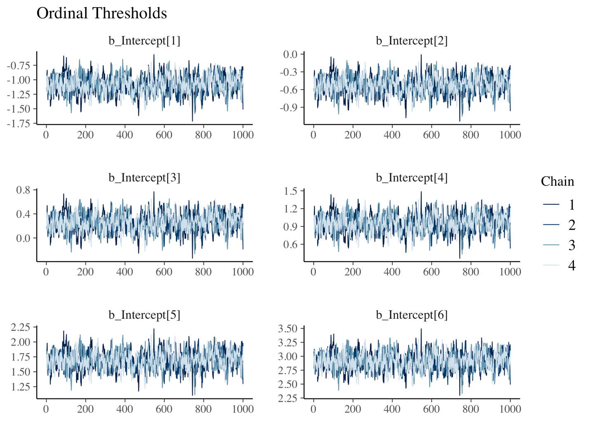

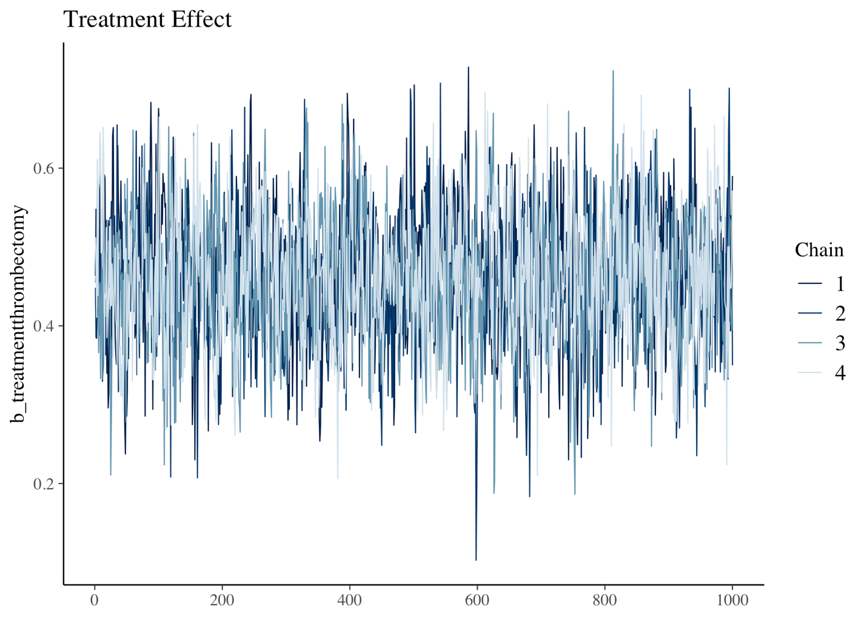
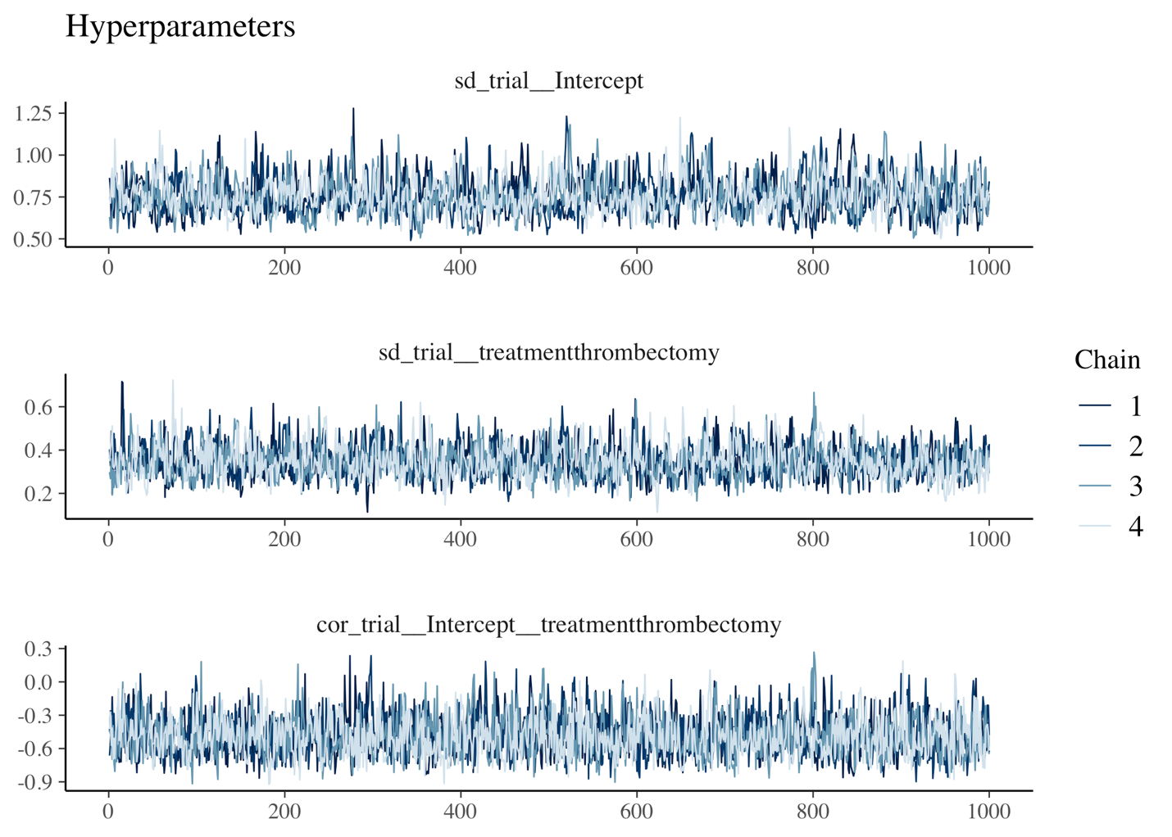
R-hat values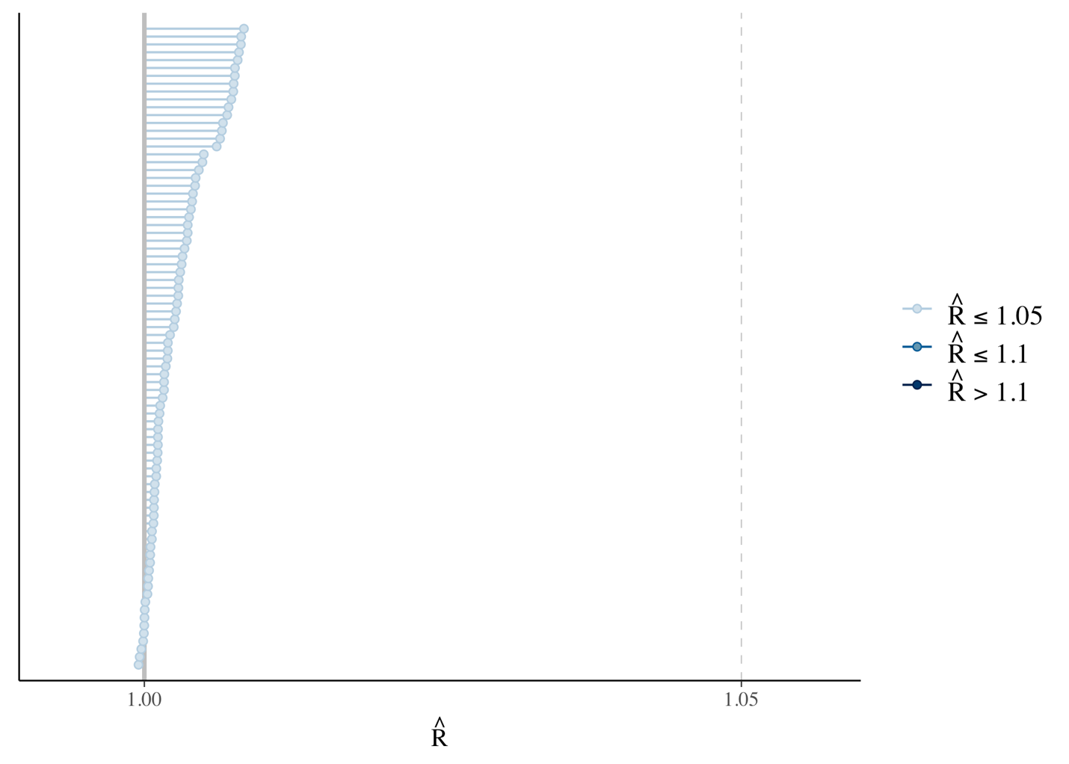

Effective sample sizes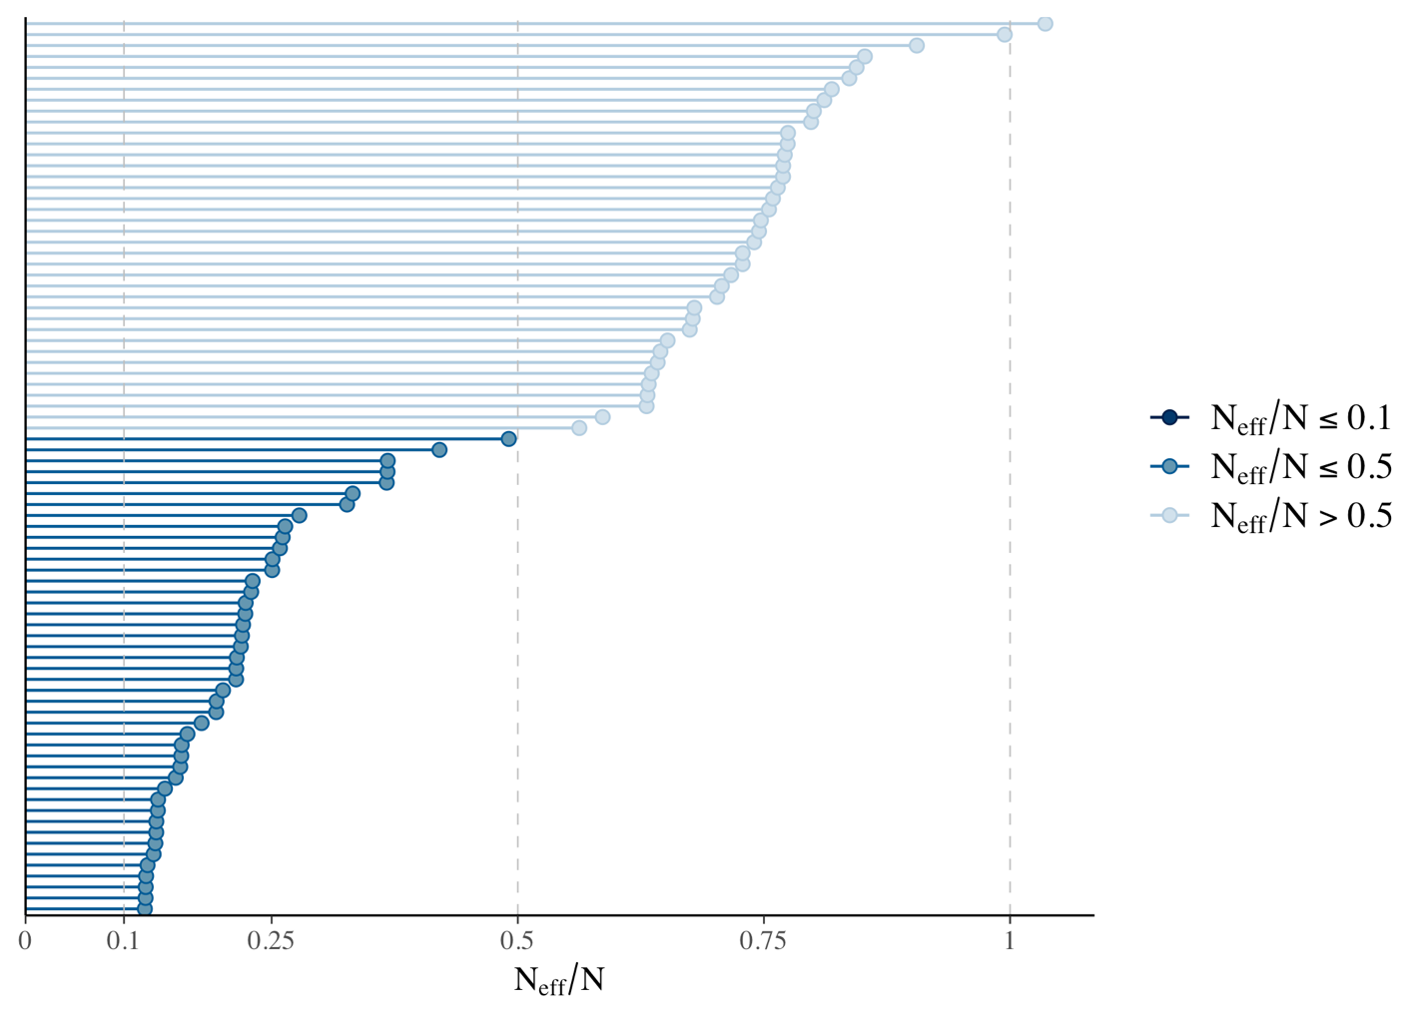

Posterior predictive check

Sensitivity Analysis for Priors
Alternative Models – “Ordinal (PO + unequal var)”

Family: cumulative
Links: mu = logit; disc = log
Formula: mrs_better | weights(count) ~ treatment + (1 + treatment | trial)
disc ~ 0 + treatment
Data: data_long (Number of observations: 420)
Draws: 4 chains, each with iter = 2000; warmup = 1000; thin = 1;
total post-warmup draws = 4000

Multilevel Hyperparameters:
~trial (Number of levels: 30)
Estimate Est.Error l-95% CI u-95% CI Rhat
sd(Intercept) 0.80 0.11 0.61 1.04 1.00
sd(treatmentthrombectomy) 0.37 0.08 0.23 0.55 1.00
cor(Intercept,treatmentthrombectomy) -0.46 0.19 -0.76 -0.06 1.00
Bulk_ESS Tail_ESS
sd(Intercept) 953 1673
sd(treatmentthrombectomy) 1421 2471
cor(Intercept,treatmentthrombectomy) 2216 2709

Regression Coefficients:
Estimate Est.Error l-95% CI u-95% CI Rhat Bulk_ESS
Intercept[1] -1.18 0.15 -1.47 -0.89 1.01 581
Intercept[2] -0.58 0.15 -0.87 -0.29 1.01 574
Intercept[3] 0.25 0.15 -0.04 0.54 1.01 567
Intercept[4] 1.01 0.15 0.72 1.30 1.01 579
Intercept[5] 1.81 0.15 1.51 2.10 1.01 575
Intercept[6] 3.13 0.16 2.81 3.44 1.01 622
treatmentthrombectomy 0.48 0.08 0.31 0.64 1.00 1236
disc_treatmentthrombectomy -0.14 0.02 -0.18 -0.09 1.00 3733
Tail_ESS
Intercept[1] 1069
Intercept[2] 986
Intercept[3] 996
Intercept[4] 1047
Intercept[5] 1058
Intercept[6] 1131
treatmentthrombectomy 2244
disc_treatmentthrombectomy 3013

Draws were sampled using sample(hmc). For each parameter, Bulk_ESS
and Tail_ESS are effective sample size measures, and Rhat is the potential
scale reduction factor on split chains (at convergence, Rhat = 1).

Alternative Models – “Ordinal (adjacent-category)”

Family: acat
Links: mu = logit
Formula: mrs_better | weights(count) ~ treatment + (1 + treatment | trial)
Data: data_long %>% filter(count > 0) (Number of observations: 403)
Draws: 4 chains, each with iter = 2000; warmup = 1000; thin = 1;
total post-warmup draws = 4000

Multilevel Hyperparameters:
~trial (Number of levels: 30)
Estimate Est.Error l-95% CI u-95% CI Rhat
sd(Intercept) 0.25 0.04 0.19 0.33 1.00
sd(treatmentthrombectomy) 0.11 0.02 0.07 0.17 1.00
cor(Intercept,treatmentthrombectomy) -0.62 0.16 -0.87 -0.28 1.00
Bulk_ESS Tail_ESS
sd(Intercept) 784 1553
sd(treatmentthrombectomy) 1308 2274
cor(Intercept,treatmentthrombectomy) 2138 2466

Regression Coefficients:
Estimate Est.Error l-95% CI u-95% CI Rhat Bulk_ESS
Intercept[1] 0.82 0.06 0.69 0.94 1.00 783
Intercept[2] -0.42 0.06 -0.54 -0.30 1.00 899
Intercept[3] 0.19 0.06 0.07 0.31 1.00 801
Intercept[4] 0.27 0.06 0.14 0.39 1.00 876
Intercept[5] 0.18 0.06 0.06 0.31 1.00 832
Intercept[6] 0.74 0.07 0.61 0.88 1.00 1066
treatmentthrombectomy 0.15 0.03 0.10 0.20 1.00 1044
Tail_ESS
Intercept[1] 1491
Intercept[2] 1773
Intercept[3] 1591
Intercept[4] 1900
Intercept[5] 1886
Intercept[6] 2077
treatmentthrombectomy 1702

Further Distributional Parameters:
Estimate Est.Error l-95% CI u-95% CI Rhat Bulk_ESS Tail_ESS
disc 1.00 0.00 1.00 1.00 NA NA NA

Draws were sampled using sample(hmc). For each parameter, Bulk_ESS
and Tail_ESS are effective sample size measures, and Rhat is the potential
scale reduction factor on split chains (at convergence, Rhat = 1).

Alternative Models – “Binary”

Family: binomial
Links: mu = logit
Formula: good_n | trials(total_n) ~ treatment + (1 + treatment | trial)
Data: data_bin (Number of observations: 60)
Draws: 4 chains, each with iter = 2000; warmup = 1000; thin = 1;
total post-warmup draws = 4000

Multilevel Hyperparameters:
~trial (Number of levels: 30)
Estimate Est.Error l-95% CI u-95% CI Rhat
sd(Intercept) 0.98 0.14 0.74 1.29 1.00
sd(treatmentthrombectomy) 0.54 0.10 0.37 0.78 1.01
cor(Intercept,treatmentthrombectomy) -0.65 0.14 -0.88 -0.32 1.00
Bulk_ESS Tail_ESS
sd(Intercept) 966 1923
sd(treatmentthrombectomy) 1198 2086
cor(Intercept,treatmentthrombectomy) 2193 2636

Regression Coefficients:
Estimate Est.Error l-95% CI u-95% CI Rhat Bulk_ESS
Intercept -1.16 0.18 -1.52 -0.81 1.01 556
treatmentthrombectomy 0.67 0.12 0.44 0.90 1.00 1034
Tail_ESS
Intercept 1215
treatmentthrombectomy 1740

Draws were sampled using sample(hmc). For each parameter, Bulk_ESS
and Tail_ESS are effective sample size measures, and Rhat is the potential
scale reduction factor on split chains (at convergence, Rhat = 1).

