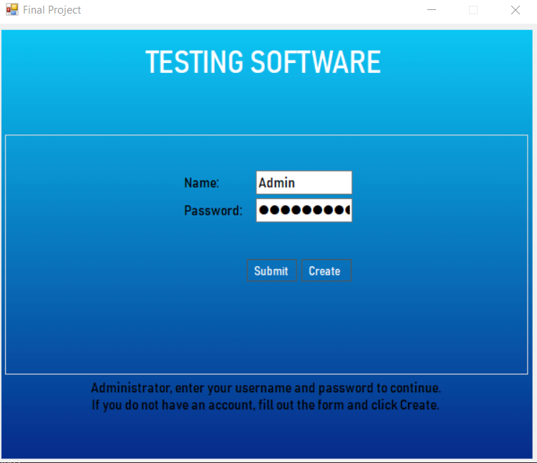

1. After loading the program, you will be prompted to enter your Admin Name and Password. You can create a new Admin by following the instructions, but for testing purposes, you can click Submit and a new Admin will be created for you.

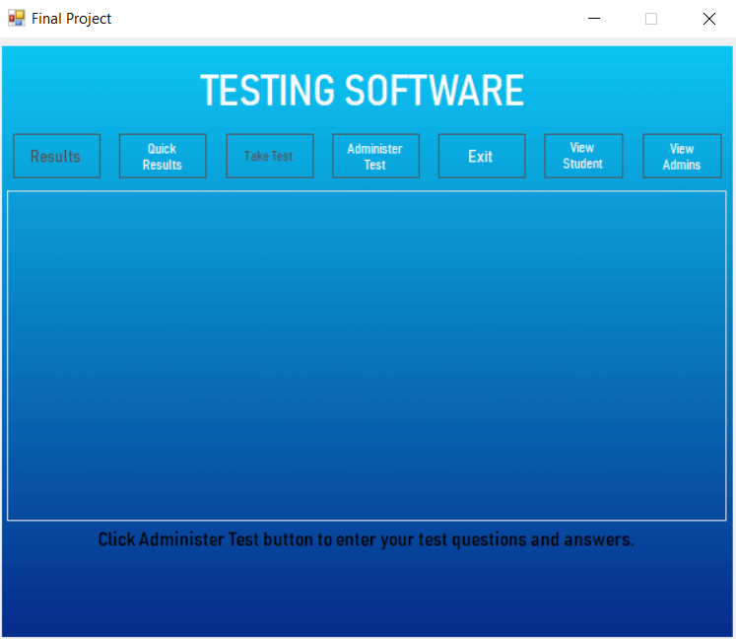

1. This is the main dashboard. A few of the buttons are disabled until the test has been entered. Click “Administer Test” to enter the test questions.

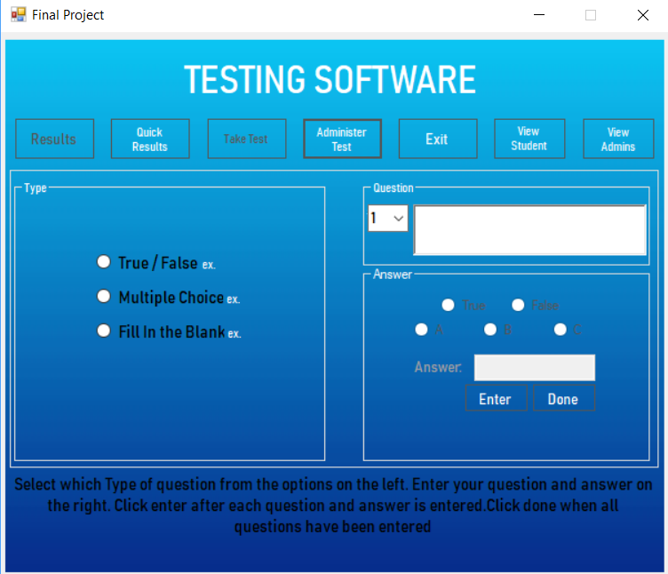

1. This is the test form. Enter a type of question, the question, and select the answer that will be stored for that question. You can click the “ex” label next to each type of question to view an example of how to input each type of question.

\*\*\*\*\*\*UNCOMMENT THE CODE (AT LINE 629) TO AUTO-FILL 3 QUESTIONS AND ANSWERS FOR TESTING PURPOSES\*\*\*\*\*\*\*\*\*\*\*\*\*\*\*\*\*\*\*\*\*\*\*\*\*\*\*\*\*\*\*\*\*\*\*\*\*\*\*\*\*\*\*\*\*\*\*\*\*\*\*\*\*\*\*\*\*\*\*\*\*\*\*\*\*\*\*\*\*\*\*\*\*\*\*

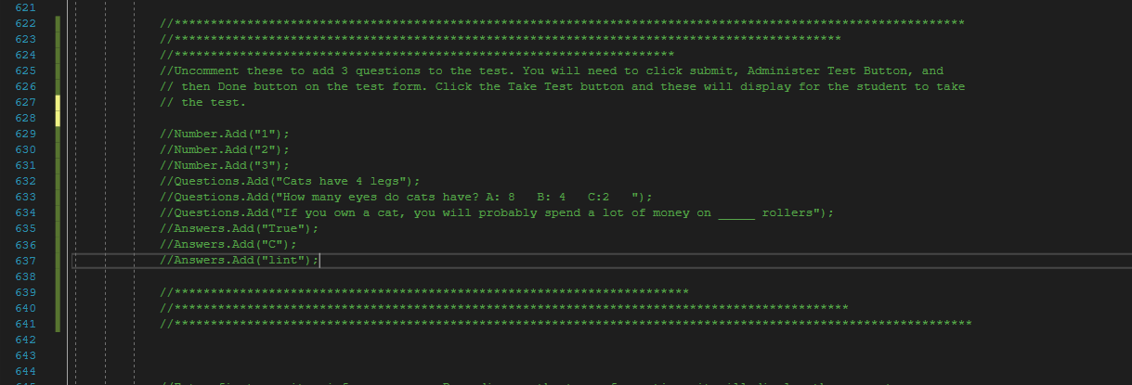

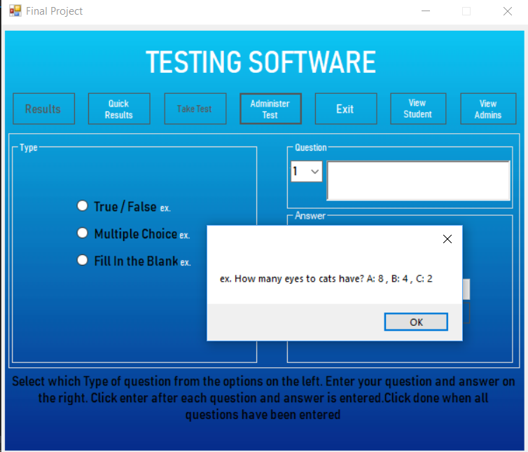

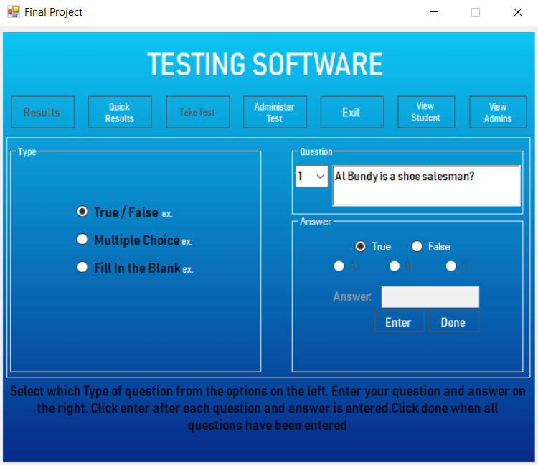

1. The number box will auto populate to the next number after the enter button is clicked.

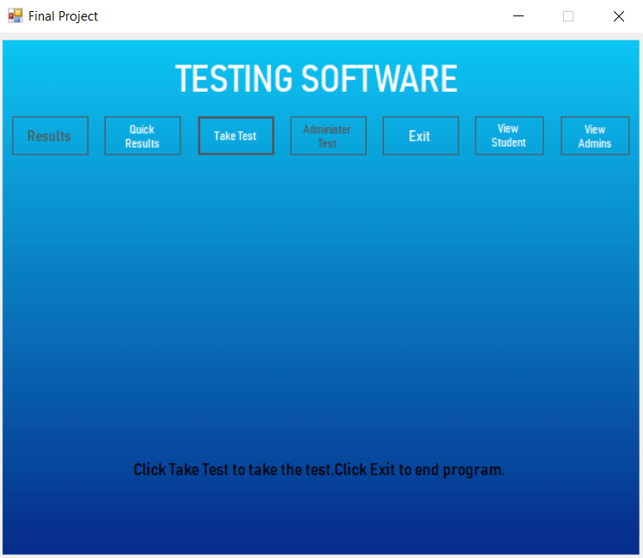

1. After clicking done, you are brought to the main dashboard again. This time the “Take Test” button is enabled. Click it to take the test.

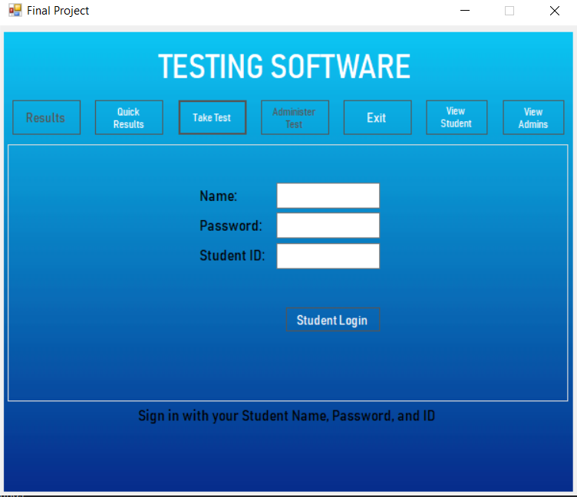

1. The student will be prompted to sign in with their Name, Password, and ID. For testing, at this time, as long as there is something typed in each box it will satisfy the requirements and allow the student to log in.

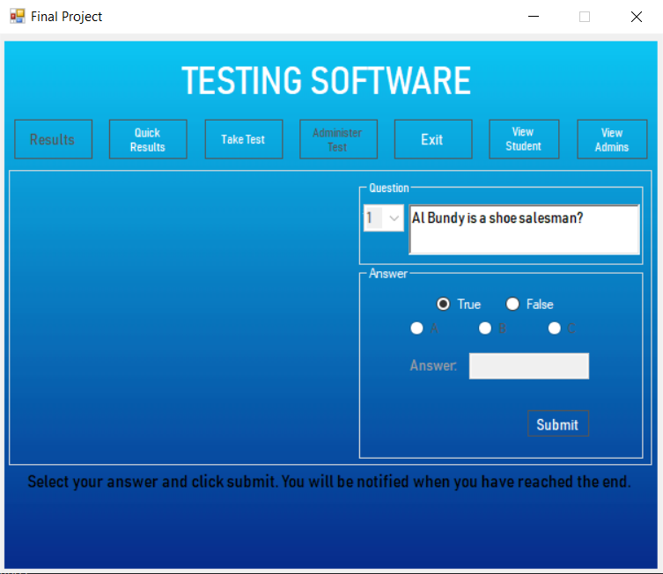

1. The test is displayed. After each answer is submitted, the form will populate with the next question.

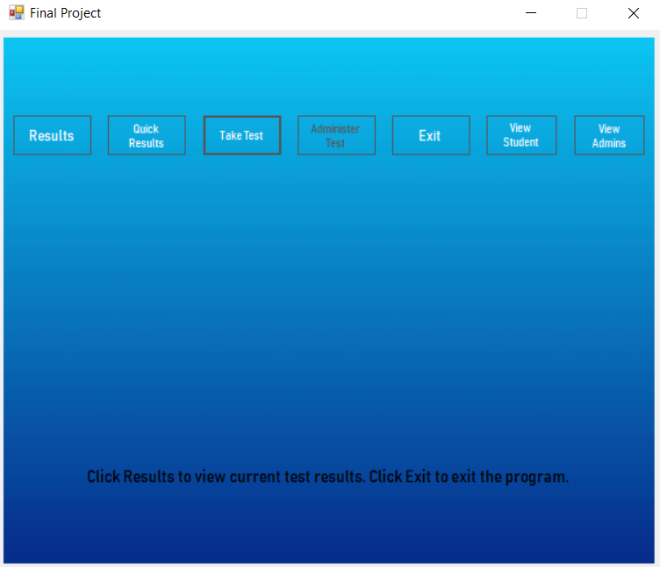

1. You will then be brought back to the main dashboard. This time the “Results” button is enabled. Click it to view the results of the current test.

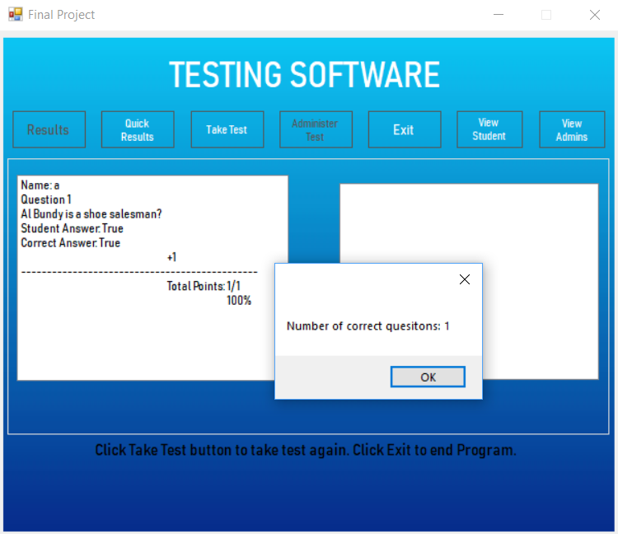

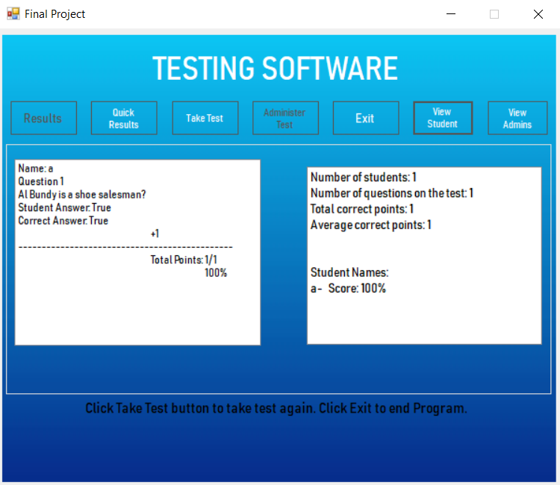

1. After each test is taken the Results of the left will show for the current test, and the averages on the right will continue to accumulate all students and scores until the program is closed.

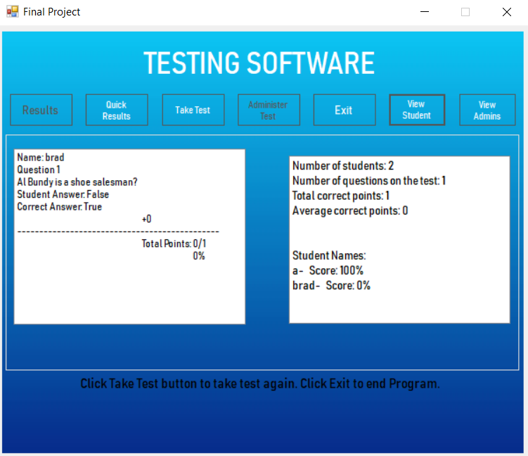

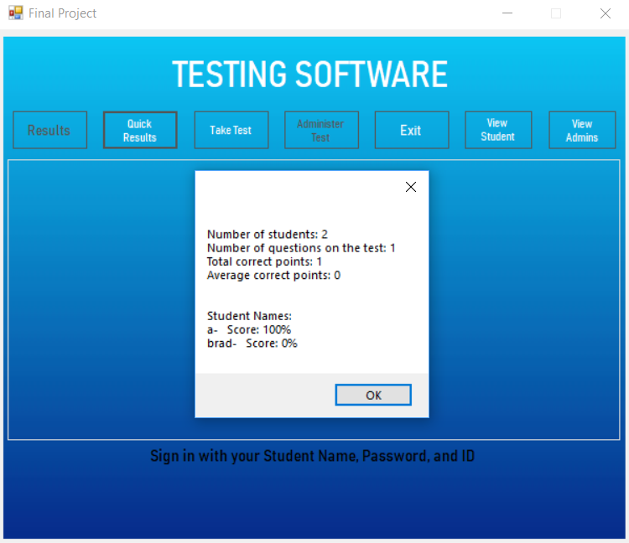

1. After the first test has been graded and viewed through “Results”, the “Quick Results” will give a quick snapshot of averages and the names of students that have taken the test along with their score.

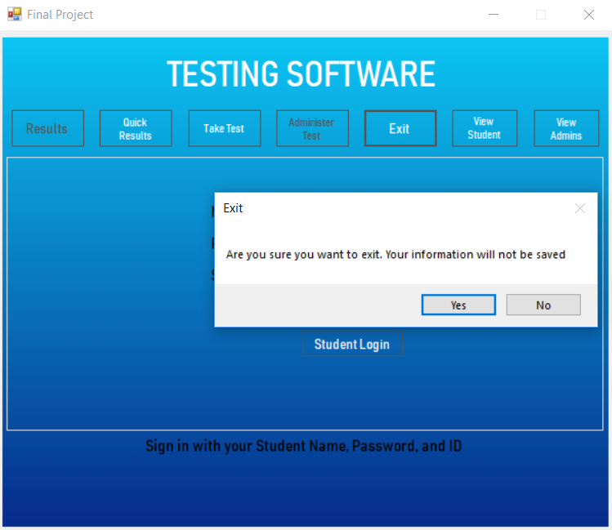

1. Clicking Exit will end the program.