1.使用Hoeffding's檢定發現綜觀這18年來，僅臺南市、高雄市、新竹縣、澎湖縣、新竹市的出生率跟平均薪資成相關(不獨立)，同時這些縣市的薪資與出生率皆呈現負相關，另外，也可以發現從2011年之後整體薪資與出生率皆呈現正相關。

2.若改變資料，看新資是否高於平均與出生率是否高於平均的關係，可以經由mcnemar檢定發現從2005年開始，有顯著一致性

3.將縣市區分為南北，北部為台中以北，南部為台中以南，並扣除花東，由無母數曼尼檢定可以知道，在出生率的部分，每一年皆呈現南北台灣的出生率一致，可見出生率不受是否為南北縣市所影響

4.使用無母數Wilcoxon pair檢定可以發現2016年的出生率明顯較1999-2007、2012低，卻也明顯較2010高

pay <- read.csv("M:/106s/cloud/hw1/hw1/aa.csv", header=F)

colnames(pay) <- c("year",cityname)

birth <- read.csv("M:/106s/cloud/hw1/hw1/a2.csv", header=T)

pay <- pay[, -(23:24)]

birth <- birth[2:19, 1:22]

install.packages("testforDEP",repos="http://cran.us.r-project.org")

library(testforDEP)

cor_city <- c()

cor_year <- c()

col_h <- c()

hoe_p_city <- c()

hoe_d_city <- c()

hoe_p_year <- c()

hoe_d_year <- c()

mar_p <- c()

mann_birth_p <- c()

mann_birth_w <- c()

wil_pair_p <- c()

wil_pair_w <- c()

all_agr <- 0

all_neg <- 0

p_agr_b_neg <- 0

p_neg_b_agr <- 0

cityname <- c("區域別總計","新北市","臺北市","桃園市","臺中市","臺南市","高雄市","宜蘭縣","新竹縣","苗栗縣","彰化縣","南投縣","雲林縣","嘉義縣","屏東縣","臺東縣","花蓮縣","澎湖縣","基隆市","新竹市","嘉義市")

#test1-1

windows()

plot(1, type="n", xaxt="n", xlab="", ylab="p-value", main = "p-value for hoeffding test for 18 years", ylim=c(0, 1), xlim=c(0, 45))

abline(h=0.05)

for (i in 2:22){

hoe_p_city[i-1] <- hoeffd(pay [, i], birth[, i])$P[1, 2]

hoe_d_city[i-1] <- hoeffd(pay [, i], birth[, i])$D[1, 2]

cor_city[i-1] <- cor(as.numeric(pay [, i]), as.numeric(birth[, i]))

col_h[i-1] <- ifelse(hoe_p_city[i-1] <= 0.05, "red", "black")

points(x=2*i-1, y=hoe_p_city[i-1], col=col_h[i-1])

text(x=2*i-1, y=hoe_p_city[i-1]-0.03, labels=cityname[i-1], cex=0.7, col=col_h[i-1])

}

windows()

plot(1, type="n", xaxt="n", yaxt="n", xlab="", ylab="", main = paste("hoeffding test and cor btw birth and pay", "for all the cities", sep="\n"), ylim=c(0, 22), xlim=c(0, 4))

abline(v=1:3)

abline(h=1:21)

for (i in 1:21){

text(0.5, i-0.5, labels=cityname[i], col = col_h[i])

text(1.5, i-0.5, labels=round(hoe_d_city[i], 4), col=col_h[i])

text(2.5, i-0.5, labels=round(hoe_p_city[i], 4), col=col_h[i])

text(3.5, i-0.5, labels=round(cor_city[i], 4), col=col_h[i])

}

text(0.5, 21.9, labels="city")

text(1.5, 21.9, labels=paste("statistic" ,"D", sep="\n"))

text(2.5, 21.9, labels="p-value")

text(3.5, 21.9, labels="cor(pay, birth)")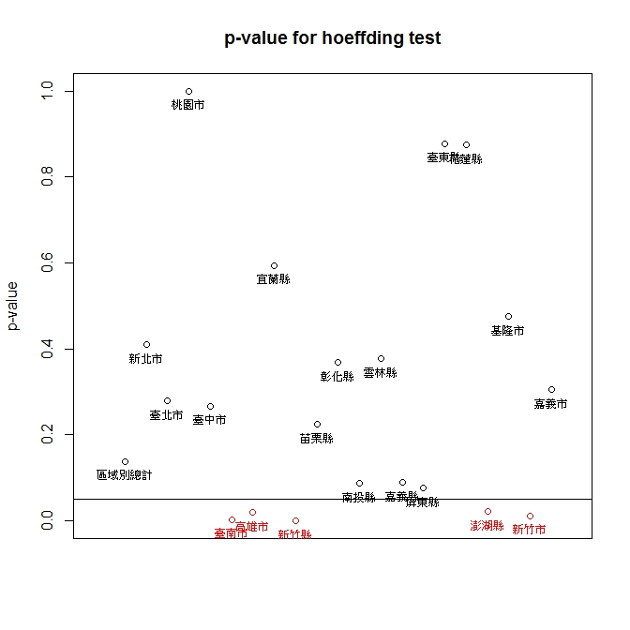

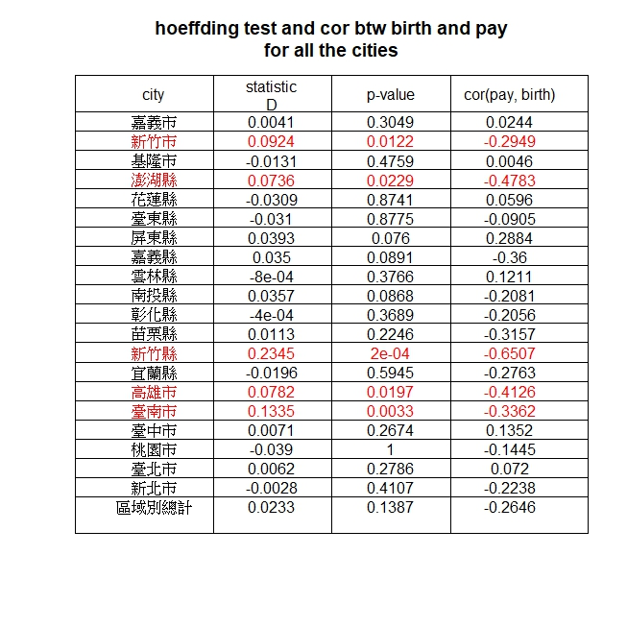

#test1-2

for (i in 1:18){

hoe_p_year[i] <- hoeffd(as.numeric(pay[i, -1]), as.numeric(birth[i, -1]))$P[1, 2]

hoe_d_year[i] <- hoeffd(as.numeric(pay[i, -1]), as.numeric(birth[i, -1]))$D[1, 2]

cor_year[i] <- cor(as.numeric(pay[i, -1]), as.numeric(birth[i, -1]))

}

hoe_p_year <- round(hoe_p_year, 4)

hoe_d_year <- round(hoe_d_year, 4)

cor_year <- round(cor_year, 4)

windows()

col_h_year <- ifelse(hoe_p_year <= 0.05, "red", "black")

plot(x=as.numeric(pay[, 1]),hoe_p_year, xlab="", ylab="p-value", main = "p-value for hoeffding test for 18 years", ylim=c(0, 1), xlim=c(1998, 2017), col=col_h_year)

abline(h=0.05)

windows()

plot(1, type="n", xaxt="n", yaxt="n", xlab="", ylab="", main = paste("hoeffding test and cor btw birth and pay", "for all years", sep="\n"), ylim=c(0, 19), xlim=c(0, 4))

abline(v=1:3)

abline(h=1:18)

for(i in 1:18){

text(0.5, i-0.5, labels = i+1998, col=col_h_year[i])

text(1.5, i-0.5, labels = hoe_d_year[i] , col=col_h_year[i])

text(2.5, i-0.5, labels = hoe_p_year[i] , col=col_h_year[i])

text(3.5, i-0.5, labels = cor_year[i] , col=col_h_year[i])

}

text(0.5, 18.9, labels = "year")

text(1.5, 18.9, labels = paste("statistic" ,"D", sep="\n"))

text(2.5, 18.9, labels = "p-value")

text(3.5, 18.9, labels = paste("cor btw ", "birth and pay", sep="\n"))

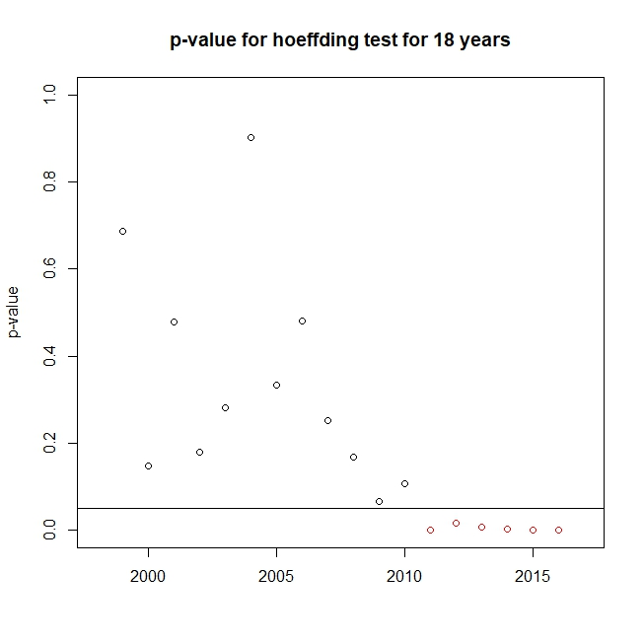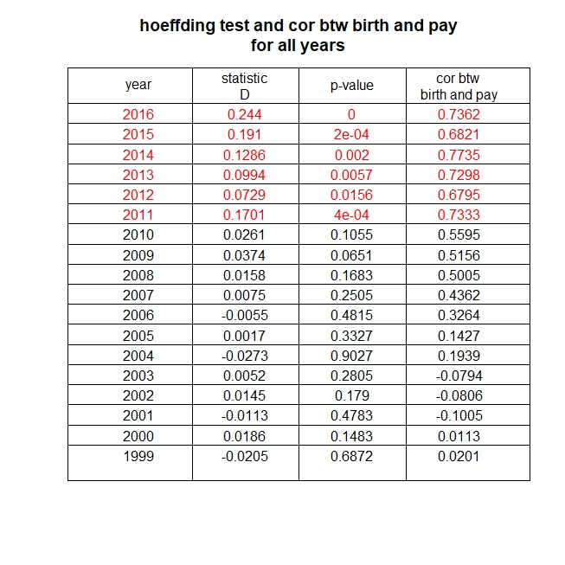

#test1-3

windows()

par(mfrow=c(1,2))

plot(1, type="n", xaxt="n", yaxt="n", xlab="", ylab="", main = paste("cor btw birth and pay", paste("for the cities", "that birth and pay are depandent",sep="\n"), sep="\n"), ylim=c(0, 6), xlim=c(0, 1))

abline(h=c(1:5))

abline(v=0.5)

for(i in 1:5){

id_city <- c(7, 8, 10, 19, 21)

id_city_name <- c("臺南市", "高雄市", "新竹縣", "澎湖縣", "新竹市")

cor_city[i] <- round(cor(pay [, id_city[i]], birth[, id_city[i]]), 4)

text(0.75, i-0.5, labels = cor_city[i])

text(0.25, i-0.5, labels = id_city_name [i])

}

text(0.75, 5.5, labels = paste("cor btw ", "birth and pay", sep="\n"))

text(0.25, 5.5, labels = "city")

plot(1, type="n", xaxt="n", yaxt="n", xlab="", ylab="", main = paste("cor btw birth and pay", paste("for the years", "that birth and pay are depandent",sep="\n"), sep="\n"), ylim=c(0, 7), xlim=c(0, 1))

abline(h=c(1:6))

abline(v=0.5)

for(i in 1:6){

cor_year[i] <- round(cor(as.numeric(pay[i+12, -1]), as.numeric(birth[i+12, -1])), 4)

text(0.75, i-0.5, labels = cor_year[i])

text(0.25, i-0.5, labels = i+2010)

}

text(0.75, 6.5, labels = paste("cor btw ", "birth and pay", sep="\n"))

text(0.25, 6.5, labels = "year")

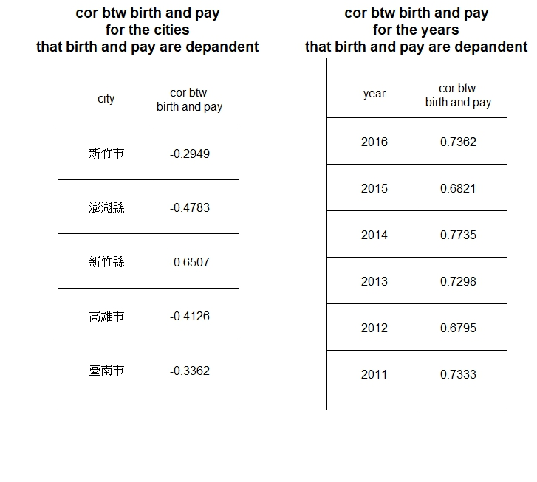

windows()

plot(1, xaxt="n", yaxt="n" ,type="n", main = paste("2016 table for agreement","p-value for Mcnemar test is 0.617", sep = "\n") , ylim=c(0, 1), xlim=c(0, 1), frame = T, ylab="payment isn't higher than country v.s. payment is higher than country", xlab="birth isn't higher than country v.s. birth is higher than country")

abline(v=0.5)

abline(h=0.5)

for (i in 1:18){

pay_compare <- as.vector(ifelse(pay[i, -(1:2)]>pay[i, 2], 1, 0))

birth_compare <- as.vector(ifelse(birth[i, -(1:2)]>birth[i, 2], 1, 0))

mar_p[i] <- mcnemar.test(pay_compare, birth_compare )$p.value

}

all_agr <- 0

all_neg <- 0

p_agr_b_neg <- 0

p_neg_b_agr <- 0

for (i in 1:20){

if (pay_compare[i]==1&birth_compare[i]==1) (all_agr <- all_agr+1)else (all_agr <- all_agr)

if (pay_compare[i]==0&birth_compare[i]==0) (all_neg <- all_neg+1)else (all_neg <- all_neg)

if (pay_compare[i]==1&birth_compare[i]==0) (p_agr_b_neg <- p_agr_b_neg +1)else (p_agr_b_neg <- p_agr_b_neg )

if (pay_compare[i]==0&birth_compare[i]==1) (p_neg_b_agr <- p_neg_b_agr+1)else (p_neg_b_agr <- p_neg_b_agr)

}

text(0.25, 0.25, labels = all_neg)

text(0.75, 0.25, labels = p_neg_b_agr)

text(0.25, 0.75, labels = p_agr_b_neg )

text(0.75, 0.75, labels = all_agr)

text(0.25, 0.1, labels=paste("specitivity=", round(all_neg/(all_neg+p_agr_b_neg ), 2)))

text(0.75, 0.6, labels=paste("sensitivity=", round(all_agr/(all_agr+p_neg_b_agr ), 2)))

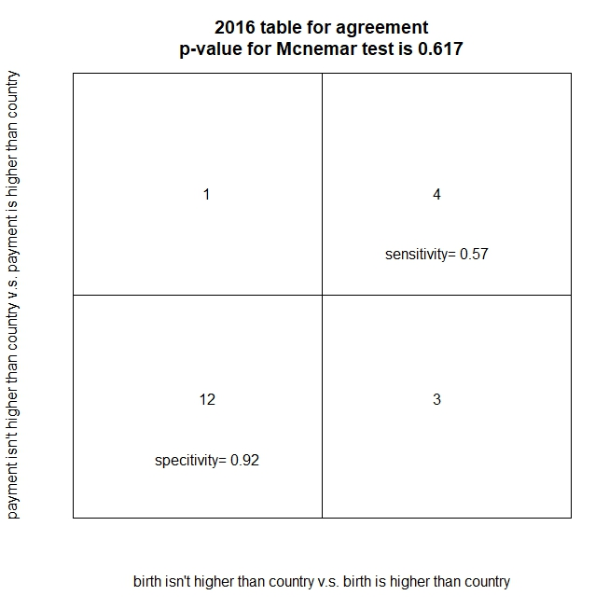

windows()

plot(1, type="n", xaxt="n", yaxt="n", xlab="", ylab="", main = "statistics about Mcnemar test", ylim=c(0, 19), xlim=c(0, 7))

abline(v=1:6)

abline(h=1:18)

for (i in 1:18){

all_agr <- 0

all_neg <- 0

p_agr_b_neg <- 0

p_neg_b_agr <- 0

pay_compare <- as.vector(ifelse(pay[i, -(1:2)]>pay[i, 2], 1, 0))

birth_compare <- as.vector(ifelse(birth[i, -(1:2)]>birth[i, 2], 1, 0))

for (j in 1:20){

if (pay_compare[j]==1&birth_compare[j]==1) (all_agr <- all_agr+1)else (all_agr <- all_agr)

if (pay_compare[j]==0&birth_compare[j]==0) (all_neg <- all_neg+1)else (all_neg <- all_neg)

if (pay_compare[j]==1&birth_compare[j]==0) (p_agr_b_neg <- p_agr_b_neg +1)else (p_agr_b_neg <- p_agr_b_neg )

if (pay_compare[j]==0&birth_compare[j]==1) (p_neg_b_agr <- p_neg_b_agr+1)else (p_neg_b_agr <- p_neg_b_agr)

}

mar_p[i] <- round(mcnemar.test(pay_compare, birth_compare )$p.value, 4)

mar_m[i] <- round(mcnemar.test(pay_compare, birth_compare )$statistic, 4)

col_mar[i] <- if (mar_p[i] <0.05) ("red") else ("black")

text(0.5, i-0.5, labels=as.vector(pay[, 1])[i], col = col_mar)

text(1.5, i-0.5, labels=(all_agr+all_neg), col=col_mar)

text(2.5, i-0.5, labels=(p_agr_b_neg+p_neg_b_agr), col=col_mar)

text(3.5, i-0.5, labels=round(all_agr/(all_agr+p_neg_b_agr), 4), col=col_mar)

text(4.5, i-0.5, labels=round(all_neg/(all_neg+p_agr_b_neg), 4), col=col_mar)

text(5.5, i-0.5, labels=mar_m[i], col=col_mar)

text(6.5, i-0.5, labels=mar_p[i], col=col_mar)

}

text(0.5, 18.75, labels="year")

text(1.5, 18.75, labels="agreement", cex=0.8)

text(2.5, 18.75, labels="disagreement", cex=0.7)

text(3.5, 18.75, labels="sensitivity", cex=0.8)

text(4.5, 18.75, labels="specitivity", cex=0.8)

text(5.5, 18.9, labels=paste("statistic", "M", sep="\n"), cex=0.8)

text(6.5, 18.75, labels="p-value")

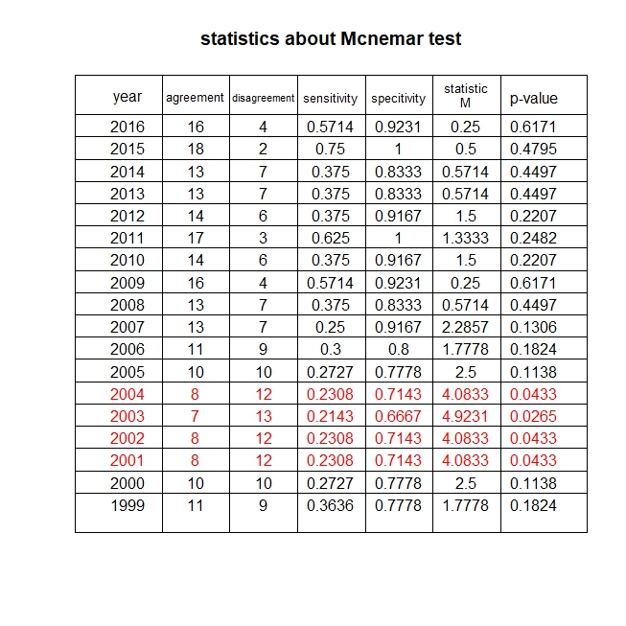

plot(x=as.numeric(pay[, 1]), y=mar_p, xlab="", ylab="p-value", main = "p-value for Mcnemar test for 18 years", ylim=c(0, 1), xlim=c(1998, 2017), col=col_mar)

abline(h=0.05)

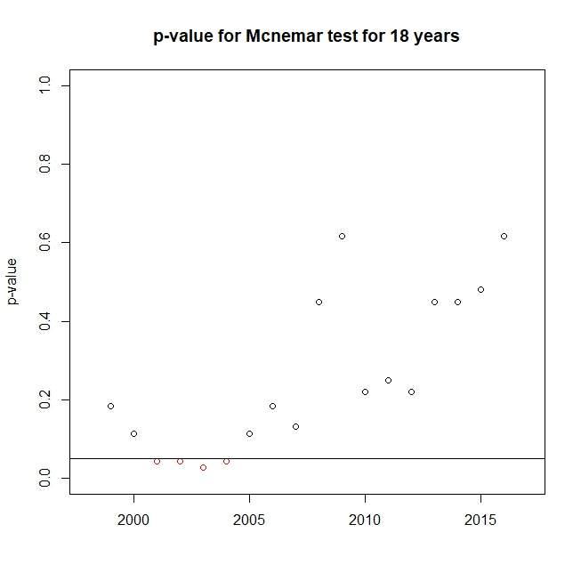

#TEST3

birth_n <- birth[, c(3:6, 9:11, 13, 20:21)]

birth_s<- birth[, c(7:8, 12, 14:16, 19, 22)]

windows()

for (i in 1:18){

mann_birth_p[i] <- wilcox.test(as.numeric(birth_n[i, ]), as.numeric(birth_s[i, ]))$p.value

mann_birth_w[i] <- wilcox.test(as.numeric(birth_n[i, ]), as.numeric(birth_s[i, ]))$statistic

}

mann_birth_p <- unlist(mann_birth_p)

col_m <- ifelse(mann_birth_p<0.05, "red", "black")

plot(y=mann_birth_p, x=as.vector(pay[, 1]), xlab="year", ylab="p-value", main = "p-value for birth location test", ylim=c(0, 1), xlim=c(1998, 2017), col=col_m)

abline(h=0.05)

plot(1, type="n", xaxt="n", yaxt="n", xlab="", ylab="", main = paste("difference birth rate", paste("btw northern and southern Taiwan", "H0:birth(year,north)=birth(year,south)",sep="\n"), sep="\n"), ylim=c(0, 19), xlim=c(0, 3))

abline(v=1:2)

abline(h=1:18)

for (i in 1:18){

text(0.5, i-0.5, labels=as.vector(pay[, 1])[i], col = col_m[i])

text(1.5, i-0.5, labels=round(mann_birth_w[i], 4), col=col_m[i])

text(2.5, i-0.5, labels=round(mann_birth_p[i], 4), col=col_m[i])

}

text(0.5, 18.5, labels="year")

text(1.5, 18.9, labels=paste("statistic" ,"W", sep="\n"))

text(2.5, 18.5, labels="p-value")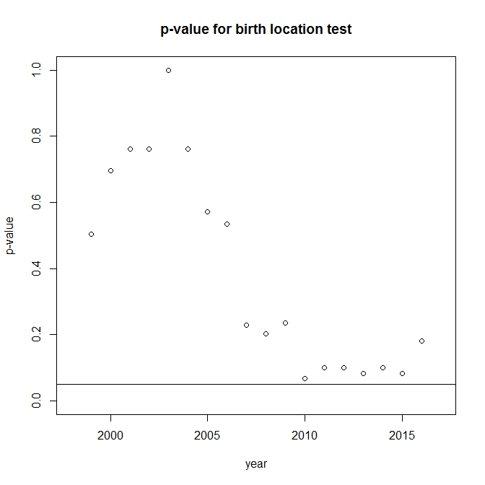

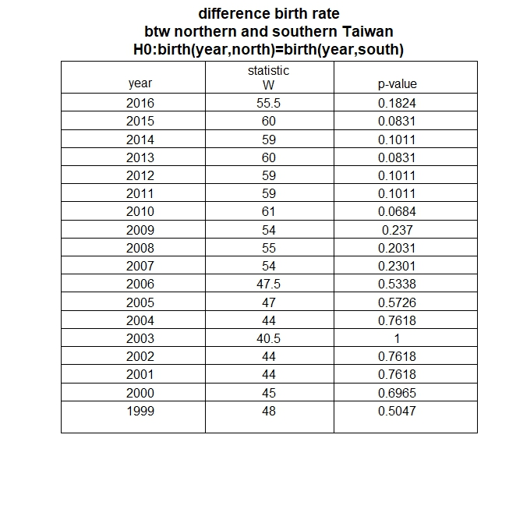

#test4

windows()

for (i in 1:18){

wil_pair_p[i] <-ifelse(i < 18, wilcox.test(as.numeric(birth[i, ]), as.numeric(birth[18, ]), paired = T)$p.value, "null")

wil_pair_w[i] <-ifelse(i < 18, wilcox.test(as.numeric(birth[i, ]), as.numeric(birth[18, ]), paired = T)$statistic, "null")

}

wil_pair_p <- round(as.numeric(wil_pair_p ), 4)

wil_pair_w <- round(as.numeric(wil_pair_w ), 4)

col_w <- ifelse(wil_pair_p<0.05, "red", "black")

plot(y=wil_pair_p , x=as.vector(pay[, 1]), xlab="year", ylab="p-value", main = "p-value for birth rate compare to this year test", ylim=c(0, 1), xlim=c(1998, 2017), col=col_w)

abline(h=0.05)

plot(1, type="n", xaxt="n", yaxt="n", xlab="", ylab="", main = paste("difference birth rate", paste("btw 2016 and other years", "H0:birth(2016)=birth(other year)",sep="\n"), sep="\n"), ylim=c(0, 18), xlim=c(0, 3))

abline(v=1:2)

abline(h=1:17)

for (i in 1:17){

text(0.5, i-0.5, labels=as.vector(pay[, 1])[i], col = col_w[i])

text(1.5, i-0.5, labels=round(wil_pair_w[i], 4), col=col_w[i])

text(2.5, i-0.5, labels=round(wil_pair_p[i], 4), col=col_w[i])

}

text(0.5, 17.5, labels="year")

text(1.5, 17.9, labels=paste("statistic" ,"W", sep="\n"))

text(2.5, 17.5, labels="p-value")