# Problem 1

## Part b: step input, no error:

fprintf('Problem 1, Part b: The steady state error is %0.3f (%0.1f%%)\n',abs(3-simout.Data(end)),abs(3-simout.Data(end))/3*100)

Problem 1, Part b: The steady state error is 0.226 (7.5%)

>>

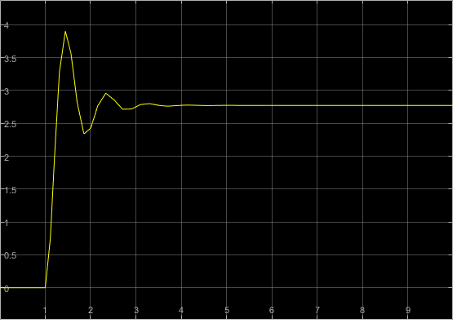

## Part d: no input, negative step disturbance

fprintf('Problem 1, Part d: The steady state error is %0.3f (%0.1f%%)\n',abs(simout.Data(end)),abs(simout.Data(end))/3*100)

Problem 1, Part d: The steady state error is 0.264 (8.8%)

>>

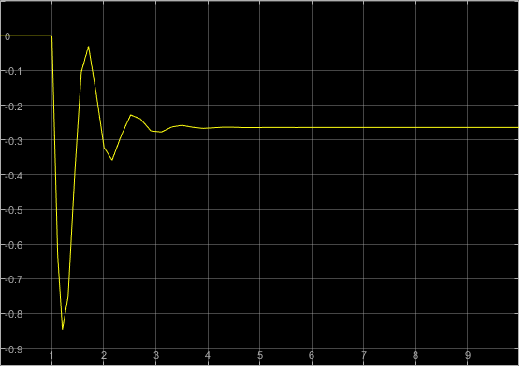

## Part f: step input, negative step disturbance

fprintf('Problem 1, Part f: The steady state error is %0.3f (%0.1f%%)\n',abs(3-simout.Data(end)),abs(3-simout.Data(end))/3*100)

Problem 1, Part f: The steady state error is 0.491 (16.4%)

>>

