Photos Rotate 180

Edit Image Adjustment Tab Light Brightness 100

Light Exposure 100

Light Contrast -100

Word Format Picture Picture Picture Corrections

Brightness/Contrast

Brightness 25 %

Contrast -50 %

Position [01], [02], [03]

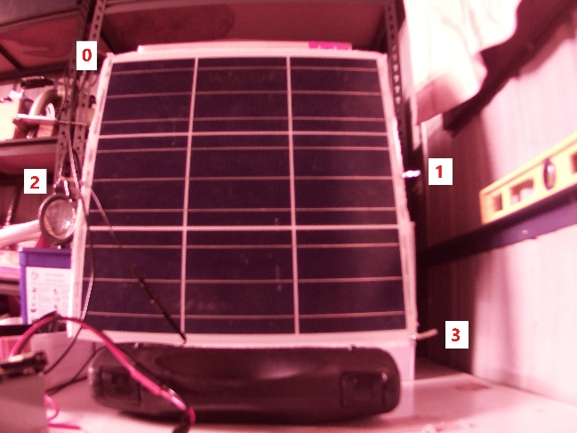 

Current 7 A, 8 A, 9 A

 

Pair Count: 10 20 50

 

