Robert Bradbury rbradb5@my.wgu.edu C++ Course Student ID 001467937 | IDE CLion
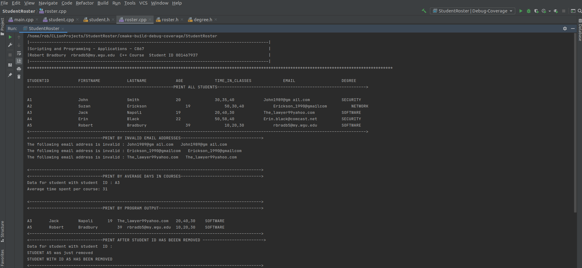
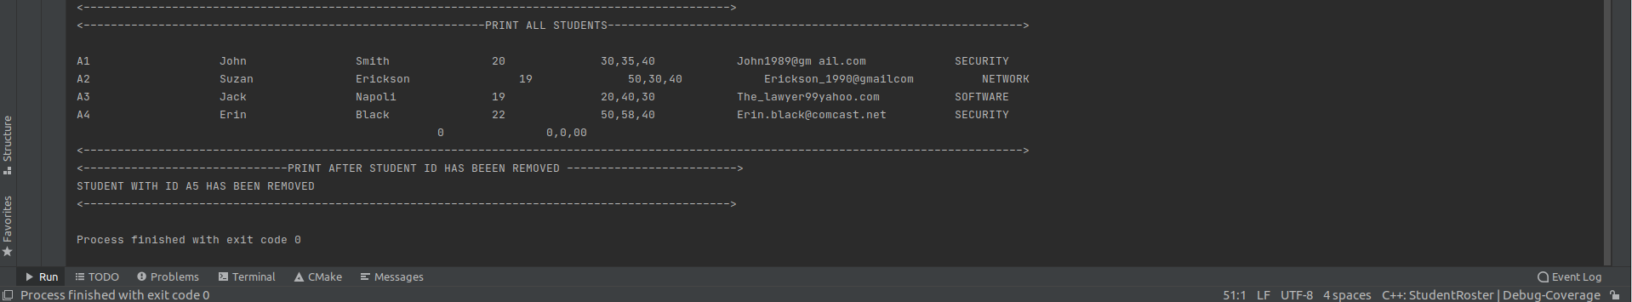

Main
