Connor Bradt

**Task 1**

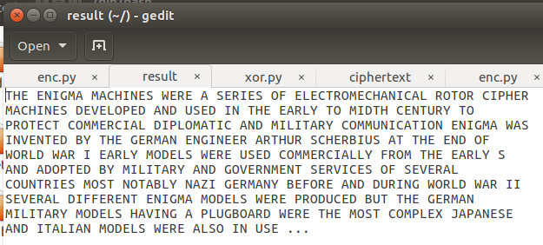

Text deciphered

**Task 2**

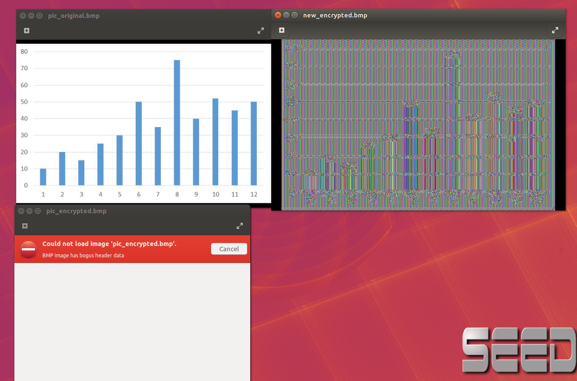

The first encryption had bum header data so the new encryption took the header of the original and the body of the first encryption to form the image.

**Task 6**

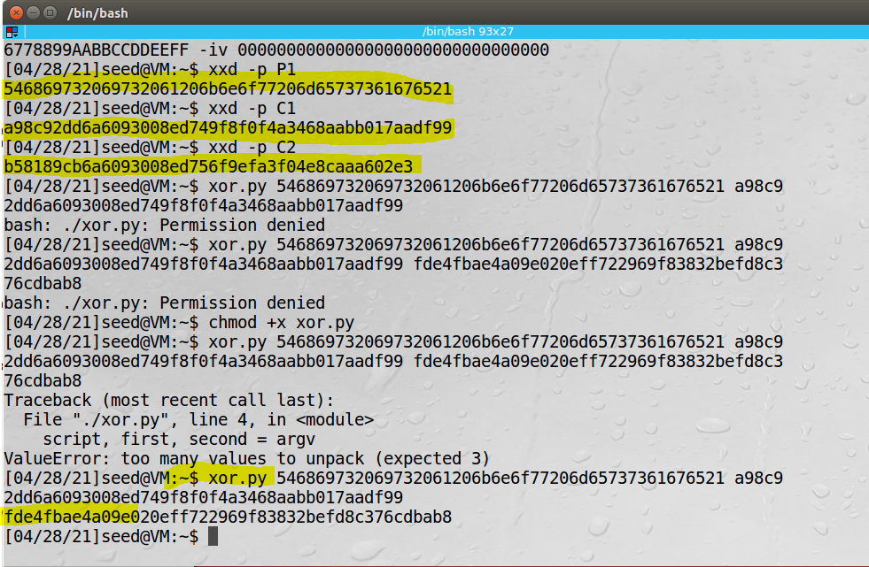

Hexdecimal data conversion and XOR.py result of P1 and C1

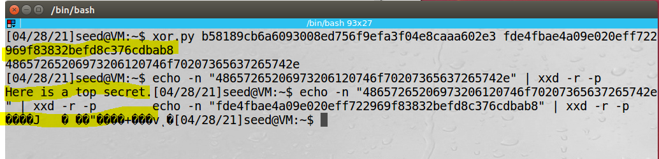

XOR.py result of output and C2 then hex string converted to ascii.

**Task 7**

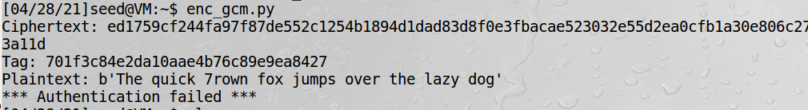

Git clone “repository URL”

Change directory(cd) to remote repository folder

Git remote add “name” “repository URL”

*create folder to copy the files to.

Change directory(cd ..) until home.

cp path/local_repo/src/* path/remote_repo/src ( easier to copy paths from home directory)

Change directory(cd) to remote repository folder

git rm --cached directory

git add directory (to avoid the git submodule issue. {may not be needed})

 git branch -r (to list all remote names for the remote repository)

git add local_repo/src/* (done in remote repository folder)

git commit –m “local files”

git push origin🡪(“remote name”) master

Try git fetch or **git pull** to get the extra report documents into the remote repository