Connor Bradt

**Task 1**

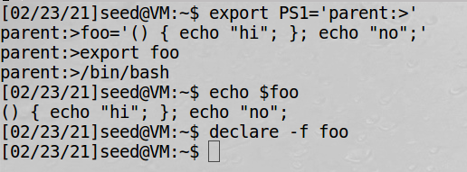

This is the “bash” version where the vulnerability is part of the command.

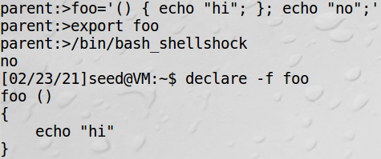

This is the “bash_shellshock” version where the vulnerability echo “no” is triggered.

**Task 2**

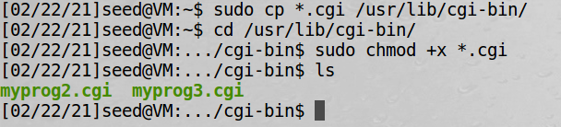

Setting up CGI programs

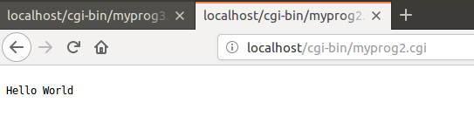

Accessing CGI program using URL

**Task 3**

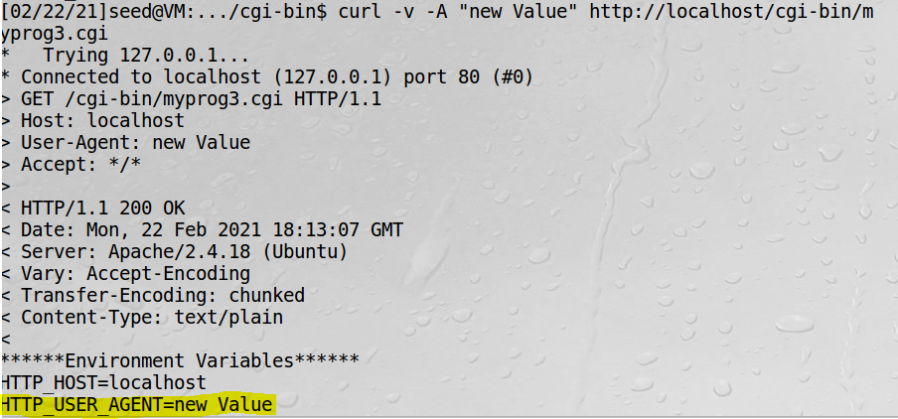

Accessing CGI program using curl -v -A and changed the “Agent” value to “new Value”. -A specifies the agent and -v specifies the variables.

**Task 4**

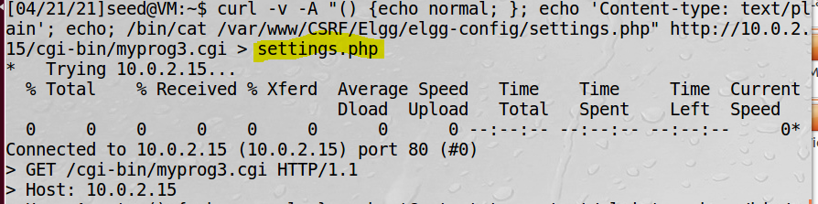

Check settings.php file.

www-data user id has no privilege to access etc/shadow file.

**Task 5**

Cc

**Task 6**

Cc

Git clone “repository URL”

Change directory(cd) to remote repository folder

Git remote add “name” “repository URL”

*create folder to copy the files to.

Change directory(cd ..) until home.

cp path/local_repo/src/* path/remote_repo/src ( easier to copy paths from home directory)

Change directory(cd) to remote repository folder

git rm --cached directory

git add directory (to avoid the git submodule issue. {may not be needed})

git add local_repo/src/* (done in remote repository folder)

git commit –m “local files”

git push origin(“remote name”) master