Connor Bradt

**Task 1**

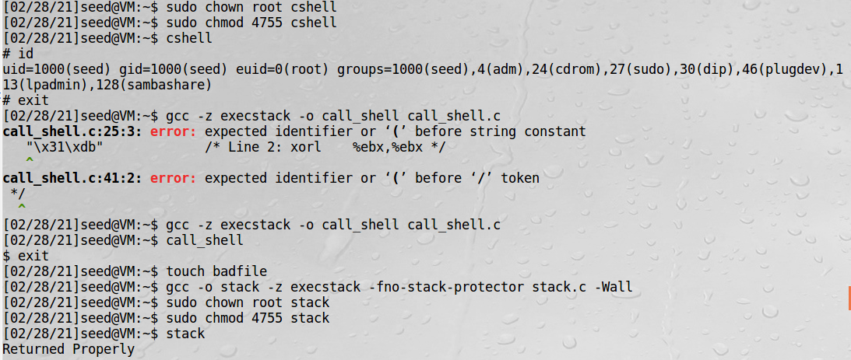

Setting up a vulnerable program to overflow attacks.

**Task 2**

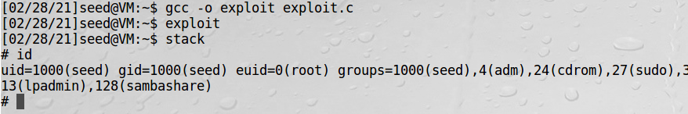

Successfully launched the overflow attack with the “exploit.c” program.

**Task 3**

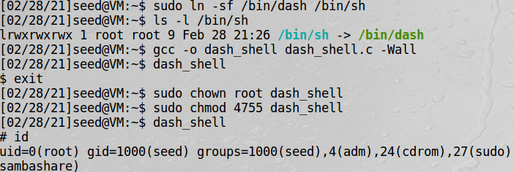

Accessing root shell via the “dash_shell.c” program.

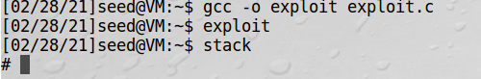

Successfully launched the overflow attack with the updated “exploit.c” program.

**Task 4**

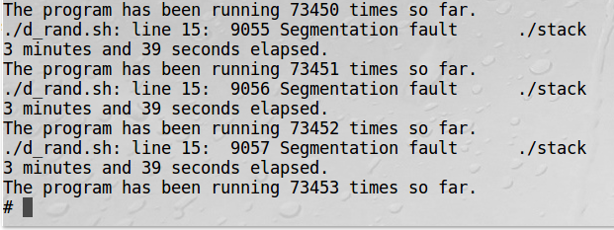

I’ll admit I was not expecting for this to stop before 30 minutes let alone 3min 39sec.

**Task 5**

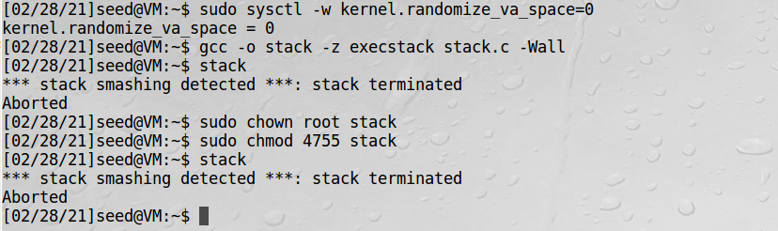

“stack.c” program was aborted with the StackGuard turned on.

**Task 6**

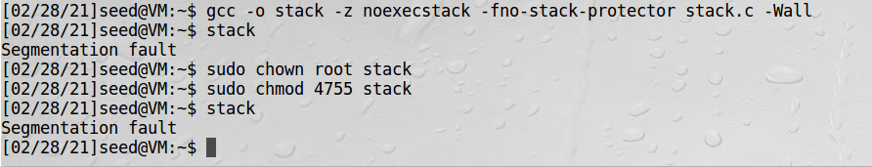

“stack.c” had segmentation faults with non-executable turned on.

Git clone “repository URL”

Change directory(cd) to remote repository folder

Git remote add “name” “repository URL”

*create folder to copy the files to.

Change directory(cd ..) until home.

cp path/local_repo/src/* path/remote_repo/src ( easier to copy paths from home directory)

Change directory(cd) to remote repository folder

git rm --cached directory

git add directory (to avoid the git submodule issue. {may not be needed})

git add local_repo/src/* (done in remote repository folder)

git commit –m “local files”

git push origin(“remote name”) master