Connor Bradt

**Task 1**

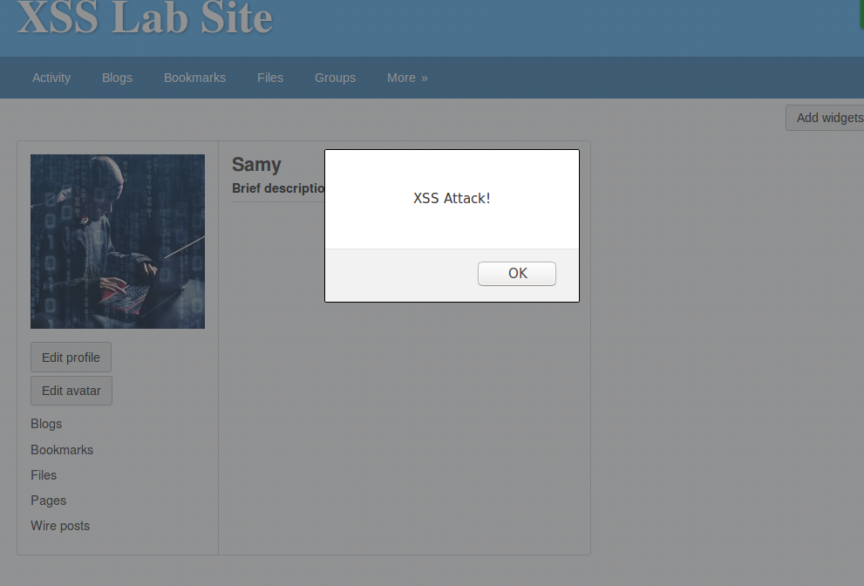

Attack message displayed.

**Task 2**

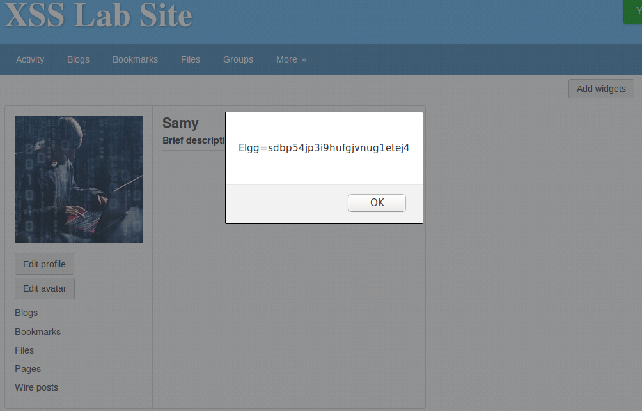

Cookies are displayed.

**Task 3**

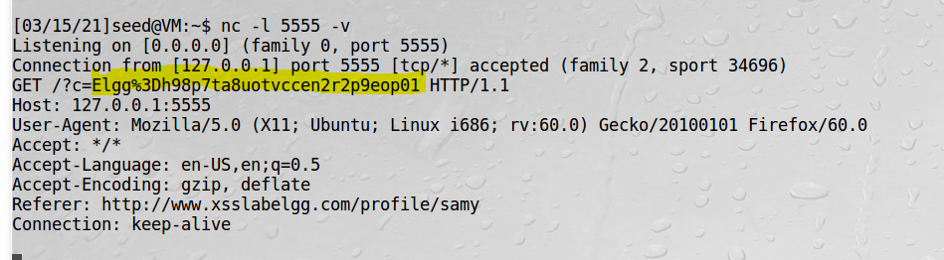

Boby’s cookies are stollen.

**Task 4**

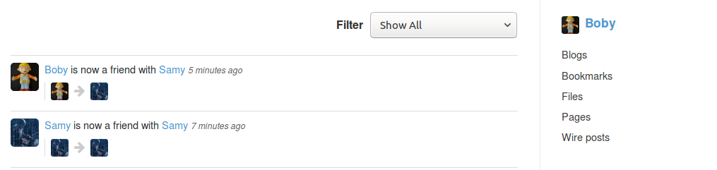

Successful “friendly” attack on victim account.

Q1.) lines 1 and 2 are used as countermeasures against CSRF attacks.

Q2.) the attack was unsuccessful with the visual editor mode because the code would be treated as plain displayable text.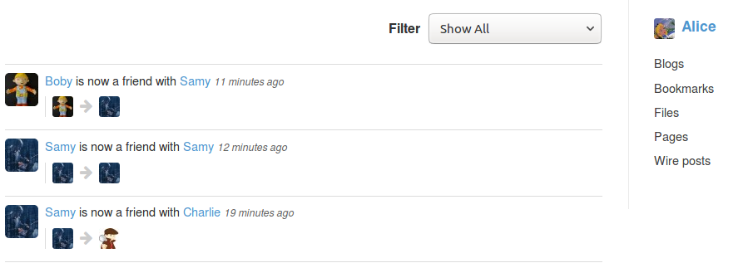

**Task 5**

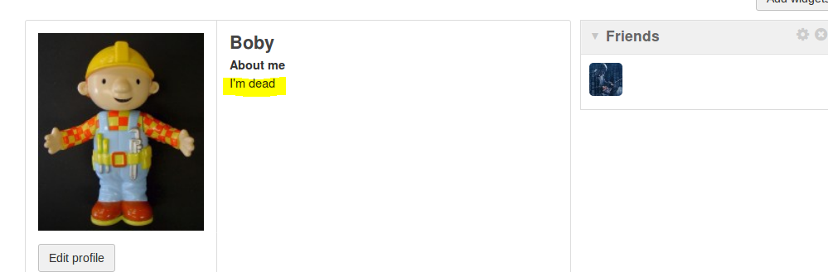

Boby died to an XSS profile editing attack.

Q3.) Line one is needed to prevent Charlie from committing suicide.

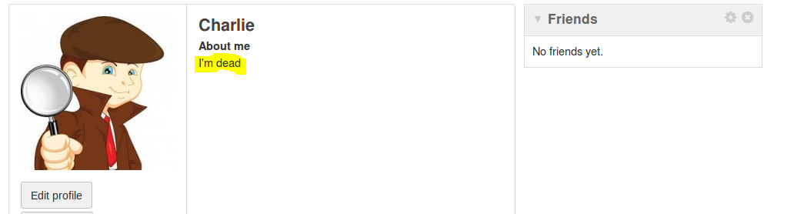

**Task 6**

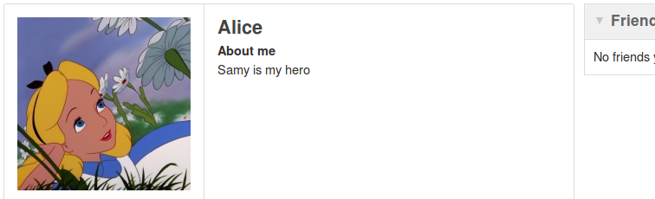



Alice was infected first then Admin get infected from Alice. (It’s a shame that Admin can’t have friends)

**Task 7**

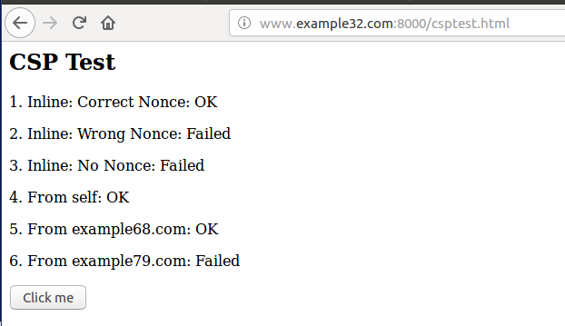

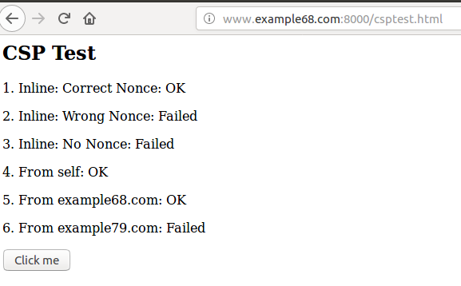

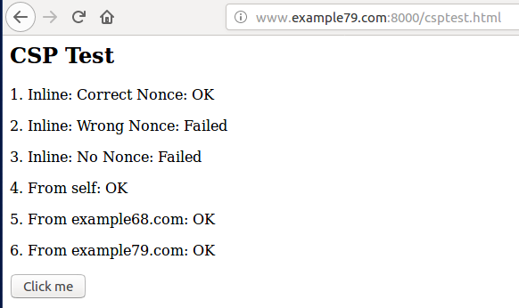

Git clone “repository URL”

Change directory(cd) to remote repository folder

Git remote add “name” “repository URL”

*create folder to copy the files to.

Change directory(cd ..) until home.

cp path/local_repo/src/* path/remote_repo/src ( easier to copy paths from home directory)

Change directory(cd) to remote repository folder

git rm --cached directory

git add directory (to avoid the git submodule issue. {may not be needed})

git add local_repo/src/* (done in remote repository folder)

git commit –m “local files”

git push origin(“remote name”) master

Try git fetch or **git pull** to get the extra report documents into the remote repository