Connor Bradt

**Task 1**

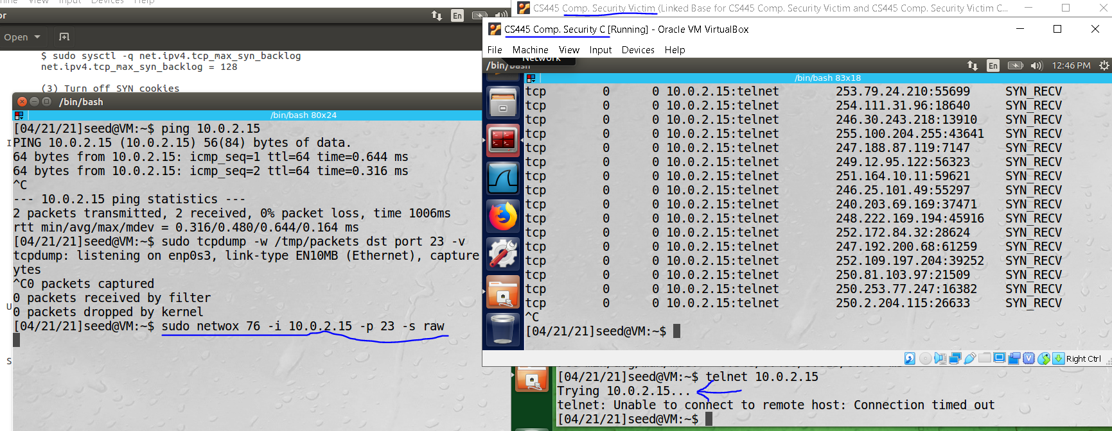

Netwox is running and causes a SYN flood attack on the victim when it tries to telnet 10.0.2.15.

**Task 2**

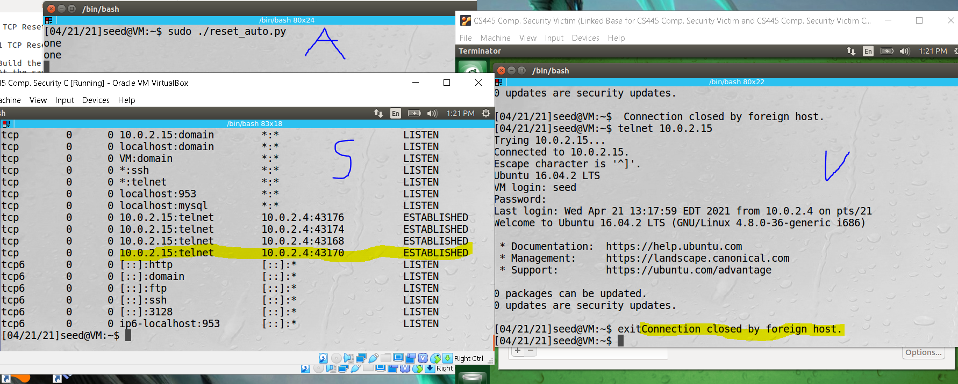

Telnet connection was established with 10.0.2.15 by the victim server (10.0.2.4).

The Attacking sever(10.0.2.5) executed a RST Attack program.

If the victim presses any key while in the terminal, then the victim will be disconnected from server 10.0.2.5.

**Task 4**

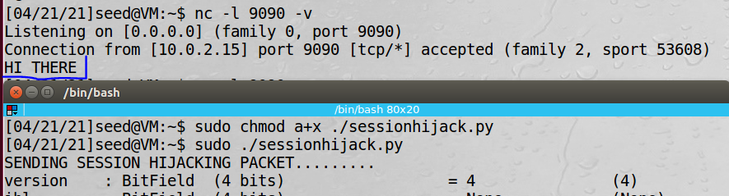

Session’s data was hijacked.

**Task 5**

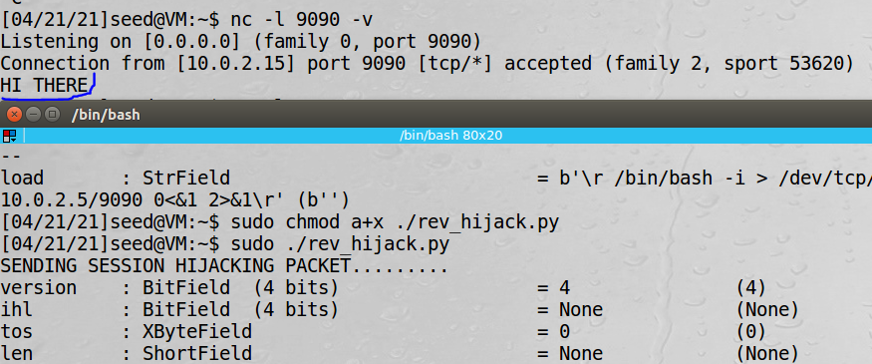

Session Hijack via a reverse shell program.

Git clone “repository URL”

Change directory(cd) to remote repository folder

Git remote add “name” “repository URL”

*create folder to copy the files to.

Change directory(cd ..) until home.

cp path/local_repo/src/* path/remote_repo/src ( easier to copy paths from home directory)

Change directory(cd) to remote repository folder

git rm --cached directory

git add directory (to avoid the git submodule issue. {may not be needed})

 git branch -r (to list all remote names for the remote repository)

git add local_repo/src/* (done in remote repository folder)

git commit –m “local files”

git push origin🡪(“remote name”) master

Try git fetch or **git pull** to get the extra report documents into the remote repository