DeLongTODAY: Fear of Rising Interest Rates No Reason to Shy Away from Fiscal Expansion

I am Brad DeLong, an economics professor at the University of California at Berkeley and a sometime Deputy Assistant Secretary of the U.S. Treasury. This is the weekly DeLongToday briefing. Here I hold forth here on the Leigh Bureau’s vimeo platform on my guesses as to what I think you most need to know about what our economy is doing to us right now.

I promised Wes Neff when he agreed to provide the infrastructure for this that I and my briefings would be: lively, interesting, curious, thoughtful, and relatively brief. Relatively.**

I promised I would provide briefings on a mix of: forecasting, politics, macroeconomic analysis, history, and political economy.

Today is a macroeconomic analysis briefing, trying to parry an erroneous current of thought that I see as gaining strength—the belief that we should be cautious about spending government money to get us back to full employment quickly because interest rates might rise suddenly and substantially at some time in the future. I am convinced that this argument is, well, completely wrong.

But first:

Over at Business Insider, the very sharp Dan Alpert has a column: “Trump's postelection flailing was a ridiculous farce, but it did expose the real threats to America”. He quotes Cornell Professor Robert Hockett, who says: “My worry, however, is now less about Trump than about what Trump has laid bare. One short-term exigency and three long-term transformations, I fear, that mix as stably as nitrate and glycerin where the durability of republican self-government is concerned…. The loss of productive opportunity to all but a few strata of American society over the past 50 years…. Second… a… media complex… making a psychic reality of unreality for… enraged millions…. Third is the degradation… [of] (small 'r') republican self-government…”

Search for it on Google. Daniel Alpert. Robert Hockett. A-l-p-e-r-t. H-o-c-k-e-t-t. Read, as they say, the whole thing.

Now for the main course:

In the first three Trump years, as the economy closed in on full employment, typical American incomes grew extremely strongly. In 2019 median household income was closing in on $69,000, more than 20% above the Obama-era nadir and 10% above the previous Clinton-era peak. This was in striking contrast to anything else we had seen since 2000.

The decade of the 2000s, you see, was a disaster for American incomes. Median real household income in 2011 was some $57,000, well below the year-2000’s $62,500. It did not recover, going nowheresville until 2015. Only in Obama’s last year, 2016, did median real household income clear its year-2000 peak.

Why? Labor economists talk about skill-biased technological change and the China shock and divide work into occupations and occupations into tasks and discuss how changing technology alters tasks and labor demand. But you have to hold very very strongly to the prior that the business cycle evens out in a time frame of less than a generation for that discourse to make any sense. And I do not see on what evidence that prior might be based on. I look at the data, and I think different. I think: large wage increases for typical workers require a high-pressure economy. And government from 2001 to 2016 did not prioritize attempting to deliver a high-pressure economy.

Now 73 million people voted for Donald Trump for president.

Few of those who voted for Trump are the plutocrats who benefitted handsomely from the Trump-McConnell-Ryan tax cut. Few of them, even, are plutocrat wannabees who anticipate benefitting from it. Few of them regard the installation of large numbers of reactionary judges on the federal courts as a major concern. The 73 million voted for Trump for many reasons. But one not-negligible reason is that, until the coming of COVID-19, when Trump was president the U.S. economy delivered handsome wage increases—wage increases for typical Americans that neither the Bush nor the Obama economy delivered, wage increases at a pace not seen since the economy back when Clinton was president.

If you fear Trump, reflect that if the U.S. economy fails to deliver similar healthy wage increases over the next four years, those 73 million and more will take note of the differential. And they may vote for a Trump—or for some Trump-like figure like Tom Cotton or Josh Hawley—for president in 2024. If you like Trump, reflect that the best way to honor his legacy and extend the positive part of his accomplishments—to make America great again—is to restore and then continue the high-pressure economy that he presided over.

So why did the high-pressure economy take so long to generate? Why did Americans have to wait until the end of 2019 before they could look back on five years in a row of more than trivial wage increases? Why did the typical American household spend 2001-2015 poorer than it had been at the end of the Clinton presidency?

Because, until the Trump years, workers looking for jobs and willing to accept a little less than they felt they deserved if that was what it took to get them were plentiful, and jobs looking for workers with employers willing to offer a little more than they felt was customary if that was what it took to get them filled were scarce.

In 2010—when the Obama administration began its pivot to austerity, and greatly downweighted the task of boosting employment back to normal levels and focused on attempting spending cuts and deficit reduction—the prime-age employment-to-population ratio was 75%, 5%-points below what 2007 had attained as full employment without any wage-pressure inflation, and 7%-points below what 2000 had attained as full employment. Yet Obama did not prioritize a return to full employment and a high-pressure economy, and pivoted to austerity nonetheless.

In 2013, when Federal Reserve Chair Ben Bernanke announced that the time for extraordinary monetary stimulus was over, and so administered the depressive shock to long-term interest rates called the “taper tantrum”, the prime-age employment-to-population ratio was less than 76%. Yet Ben Bernanke did not prioritize a return to full employment and pivoted back to “normal” monetary policy nonetheless.

And in 2015, when Federal Reserve Chair Janet Yellen began the most recent interest rate-raising cycle, plausibly knocking a percentage point or two off of mid-2010s economic growth in an economy that had looked as though it might be gaining recovery speed, the prime-age employment-to-population ratio was only 77%. Not until late in 2019—fully ten years after the nadir of the Great Recession business-cycle trough—would the U.S. economy once again reattain anything we could call “full employment”.

But now we hear, once again, that it is time for austerity. We hear, once again, that rock-bottom interest rates slam against the zero lower bound are unnatural. We hear, once again, that the deficit needs to be cut substantially and immediately. Fiscal hawks admit that right now financing the deficit and debt is not an issue. But, they say, it could become a crucial issue at any moment. Interest rates could turn on a dime and rise sharply if investor psychology undergoes one of its sudden psychological shifts. And then where would we be, unless we take steps now to cut the deficit savagely now?

Back in 2012 Larry Summers and I tried to teach the world that this line of thought was erroneous. We taught too lessons: First, we taught that when interest rates were very low the debt was not a drag but rather a source of resources for public purposes—that the national debt was then, as Alexander Hamilton said, a national blessing both because it satisfied savers’ very strong desire to hold safe assets and because it increased the government’s choice set.

Second, we taught that no matter what the level of interest rates, you are better confronting your debt-financing problems by rapidly returning the economy to a high-pressure state after a deep recession. Yes, you will have to incur additional debt to give the economy the fiscal spending boost for a rapid return to full employment, and if interest rates are high financing that extra debt can be painful. But if you do not rapidly return to full employment, then you will be stuck attempting to finance your debt on the basis of the lessened fiscal capacity of an economy permanently depressed well below the previous normal. We tried to reach both of those lessons.

It seems that we failed. Or that we did not completely succeed.

As I look around me now, I find that the the consensus view of what high-quality economists are thought to think—which is different from what high-quality economists do think—has absorbed only the first of the two lessons of the Fiscal Policy in a Depressed Economy paper we wrote for the Brookings Institution.

The lesson that has been absorbed is that financing the debt is not an issue as long as demand for safe assets remains very high and thus Treasury interest rates remain very low.

But the more important lesson has not been absorbed: In a deeply depressed economy, borrow-and-spend increases the country’s short- and long-run prosperity and so increases its fiscal capacity by more than it increases its fiscal debt burden. The ratio of debt to fiscal capacity goes down, not up, with larger deficits. And this holds whether interest rates are high or low.

Levels of productivity certainly and long-term employment plausibly as well as levels of income depend powerfully on the state of the economy. Whatever prosperity-linked economic objective you are interested in, it is much more easily attained the higher pressure the economy is. And if the past generation has anything to teach us, it is that expansionary fiscal and monetary policies remain, as they have always been, very powerful tools for generating a higher-pressure economy.

Very few people recognize that essentially all of the damage done to the US economy by the Great Recession of 2007 to 2010 was permanent. The US economy recovered most of the way back to its previous trend from the depths of the Ford recession of 1975 and the Reagan recession of 1982. It even, eventually, more than recovered back to its previous trend after the Bush recession of 1992–Good growth enabling structural economic policies by Clinton in the arrivalof the dot-com boom are to be thanked for that. But the economy did not quite recover back to its previous trend from the bush recession of 2001. And the output gap between what the US economy was producing in 2019 and what pre-2007 the trends suggested the economy would be capable of producing in 2019 Dash that output gap in 2019 is as great as the output gap between actual and potential production was at the depths of the great recession in 2010. Yes, you have a lower debt to finance if you pivot to austerity in a depression. But the damage, the permanent damage, you thereby do to your economy is long run productive potential does much more to destroy the base that supports the financing of your current debt then it does good by reducing the amount of that. Even on a narrow government finance perspective, the game is not worth the candle.

And yet here we are, with the Republicans senatorial majority blocking the spending that would help people get through the coronavirus plague without permanently losing their businesses in this position us for a rapid return to full employment. What is going on here?

I think what is going on is that republican legislators really do believe that the economy is depressed right now because too many people are overly scared of the coronavirus and can afford to stay home. Thus anything that makes people more scared of the coronavirus Is bad, for the economy at least. Hence ignorance is best: if we did less testing so that fewer cases were reported we would be less scared and so better off. That is, I think, really how they are thinking. And anything that makes it possible for more people to be able to afford to stay home is bad. The problem, they think, is not that spending is down because people are reacting to uncertainty and risk by saving, hoping to take that cruise or that vacation or go to that restaurant next year after the vaccine has arrived. The problem, they think, is that too few people are willing to show up to work.

This is, of course, nonsense. There is no point to people showing up to work if there are no customers. And it is the number of customers that has fallen, not the number of people willing to work. If it were the number of people willing to work that had fallen and caused the depression, we would see total spending continue blindly along its previous course while real production fell. But that is not what we see: what we see is that both production and spending grow and fall in tandem—with the change in nominal higher than the change in real by the 2%/year of inflation— as the plague hit the country. A supply-side recession because of too little ability to produce, like that of 1974-5, sees inflation rise. A demand-side recession because of too little spending does not. Guess which we have now?

And, of course, their tame economists are egging them on. I always have a very hard time knowing what to think about Casey Mulligan and Steve Moore. Are they really too stupid to draw an Aggregate Supply-Aggregate Demand diagram and note that prices and quantities move in opposite directions when it is the aggregate supply curve is shifting? Or do they know very well that they are talking bullshit when they claim that surges and ebbs in the desire to work are responsible? It was Milton Friedman, after all, who said: Supply curves slope up, demand curves slope down, and be very suspicious of anybody whose argument requires that they not do so.

And when Mulligan and Moore write something like this: “in August, job openings fell for the first time since the start of the pandemic. This certainly wasn’t because the economy was faltering. Third-quarter gross domestic product surged at a 33% annualized rate…” what am I supposed to think? I know that the third quarter growth rate is largely baked in the cake before September. And I know that the overwhelming bulk of the very high third-quarter growth rate came from very strong growth in May, June, and July—not from anything happening in August and September. They cannot be so foolish and so ill-informed not to know this, can they? They cannot be so cynical as to assume that their readers will never check, can they?

Right now it looks as though we are on the cusp of a second dip in the coronavirus plague depression, as the resurgent virus drives spending and incomes down further and as the Republican senate caucus blocks meaningful action. Then, in the spring, with the violets, large-scale vaccination will arrive. We will then begin the business of reknitting our country’s economic division of labor.

It would be much, much better for us all if we are then focused on spending whatever it takes to get the economy back to full employment quickly—whatever it takes. Especially if you are worried about financing the debt. You need as large a productive base as possible to make financing the debt easier, and it should not be a hard idea to grasp that that productive base requires spending to get back to full employment quickly.

Now when you accumulate debt, there are debt financing issues: We surely do not want the Treasury to finance anything additional by selling more 30-year TIPS exclusively. We equally surely do not want the Treasury to sell only more 3-month T-Bills. Debt management, and the interaction of debt management with safety-and-soundness regulation—i.e., how many Treasury securities and reserve deposits at the Fed we require leveraged financial institutions to hold as reserves rather than letting them get away with dodgy things that someone has rated AAA—are important and complex issues. And the ‘r’ in the equations above needs to be grossed up, by taking account of how additional debt may raise the rate at which existing debt is refinanced when it is rolled over.

The high-interest rate era of the 1980s and 1990s in which we worried about fiscal drag from expanded national debt is now long gone. Right now we are in what Larry calls “secular stagnation”, in which Treasury rates are very low, markets expect Treasury rates to remain very low for decades, and the term structure gives the U.S. government power to lock in very low interest rates on its debt for the long term.

In some ways the right way to think about government debt is not as a cost but as a profit center for the government—like the Medici Bank of the Late Middle Ages, savers are willing to pay the U.S. government to accept their money because they believe the U.S. government can keep it safe. And it is in that context that we should think about debt finance.

I’m Brad DeLong. This is my DeLong Today briefing.

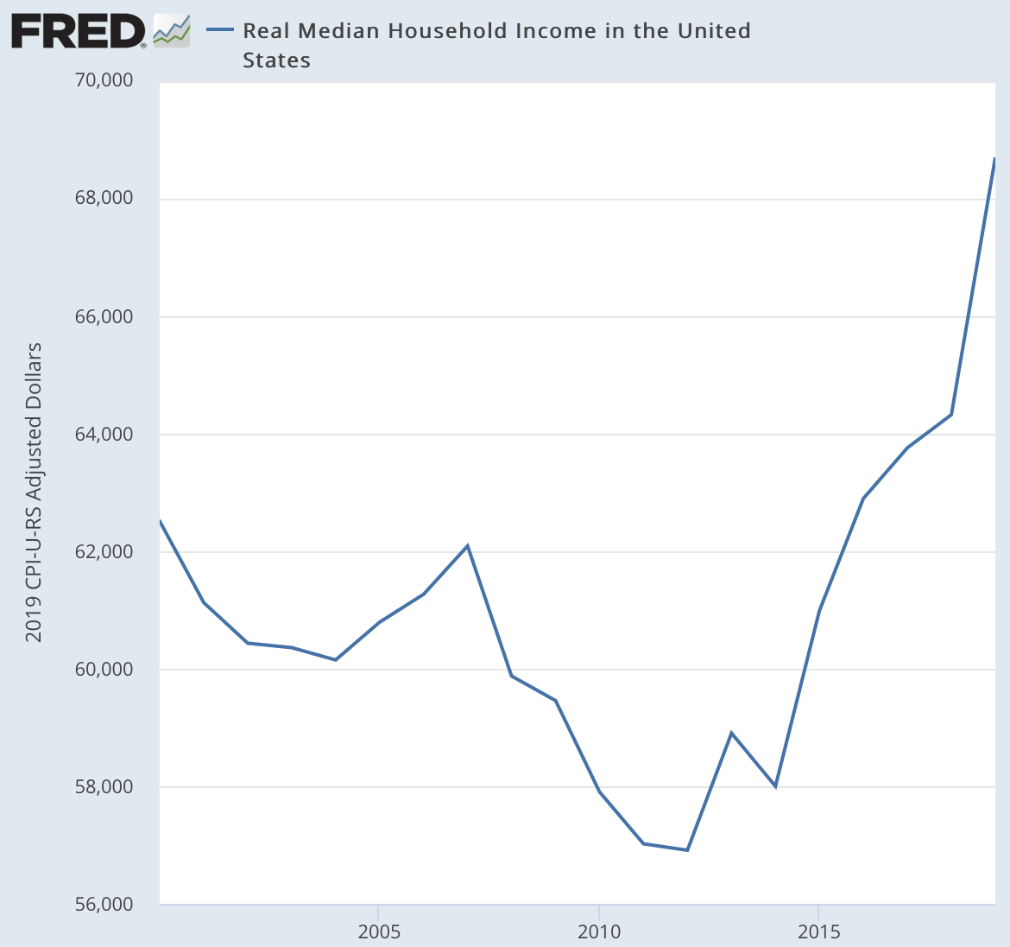
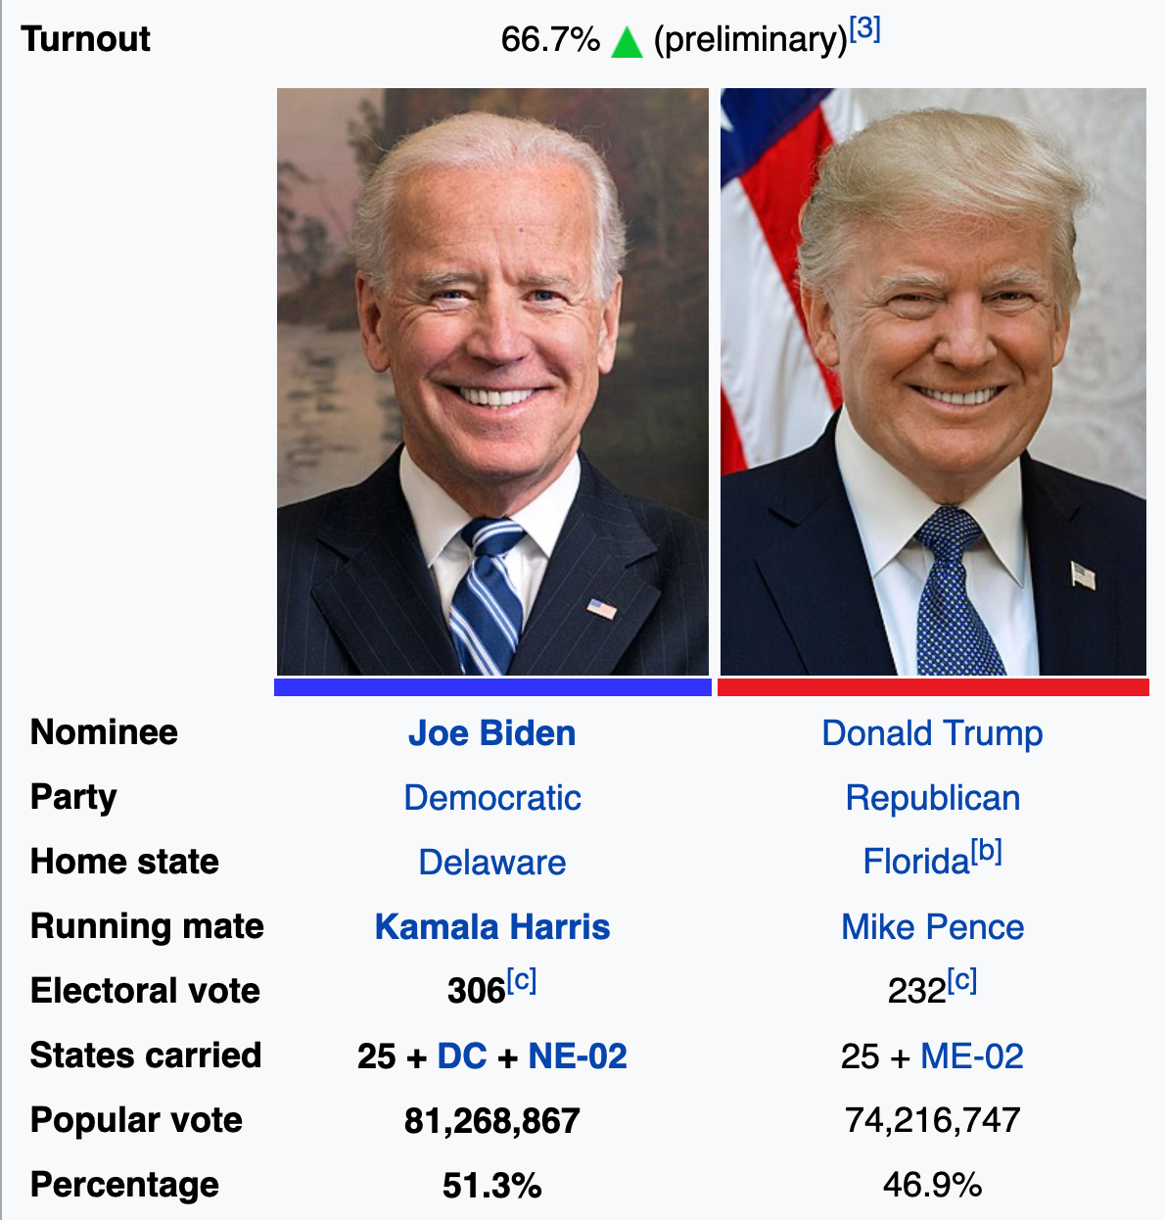
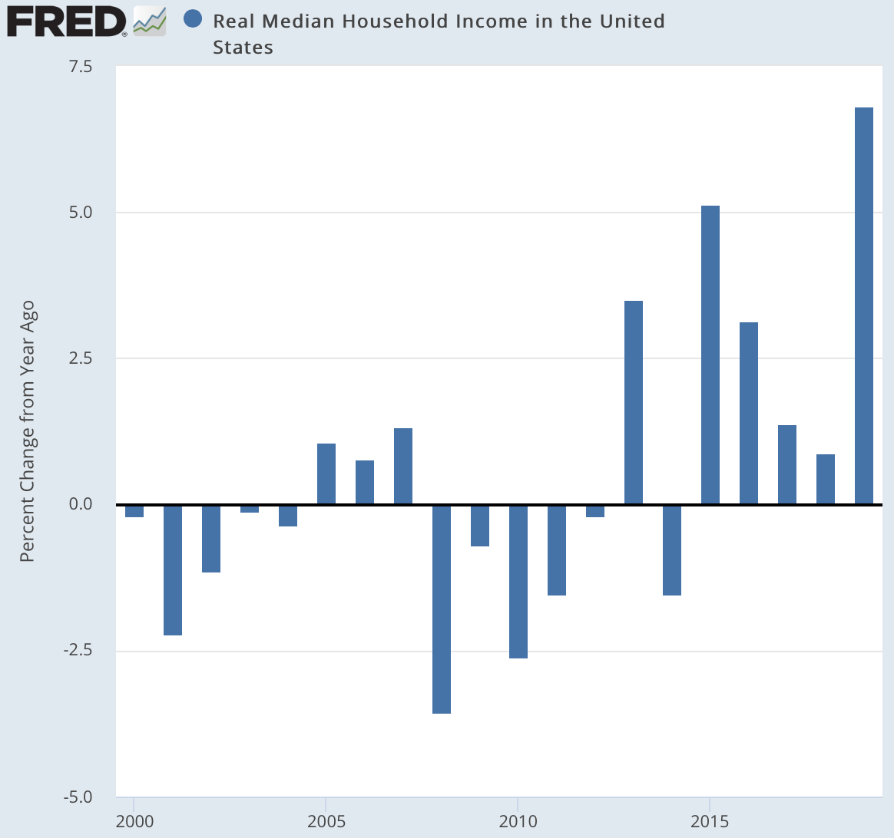
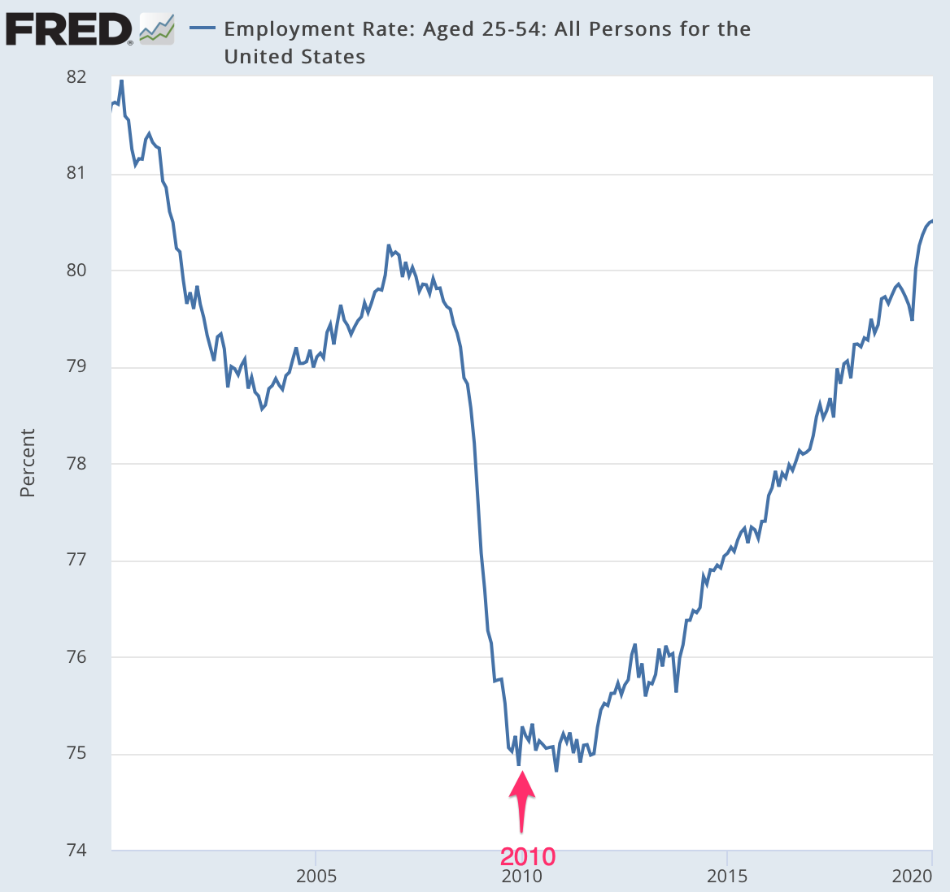

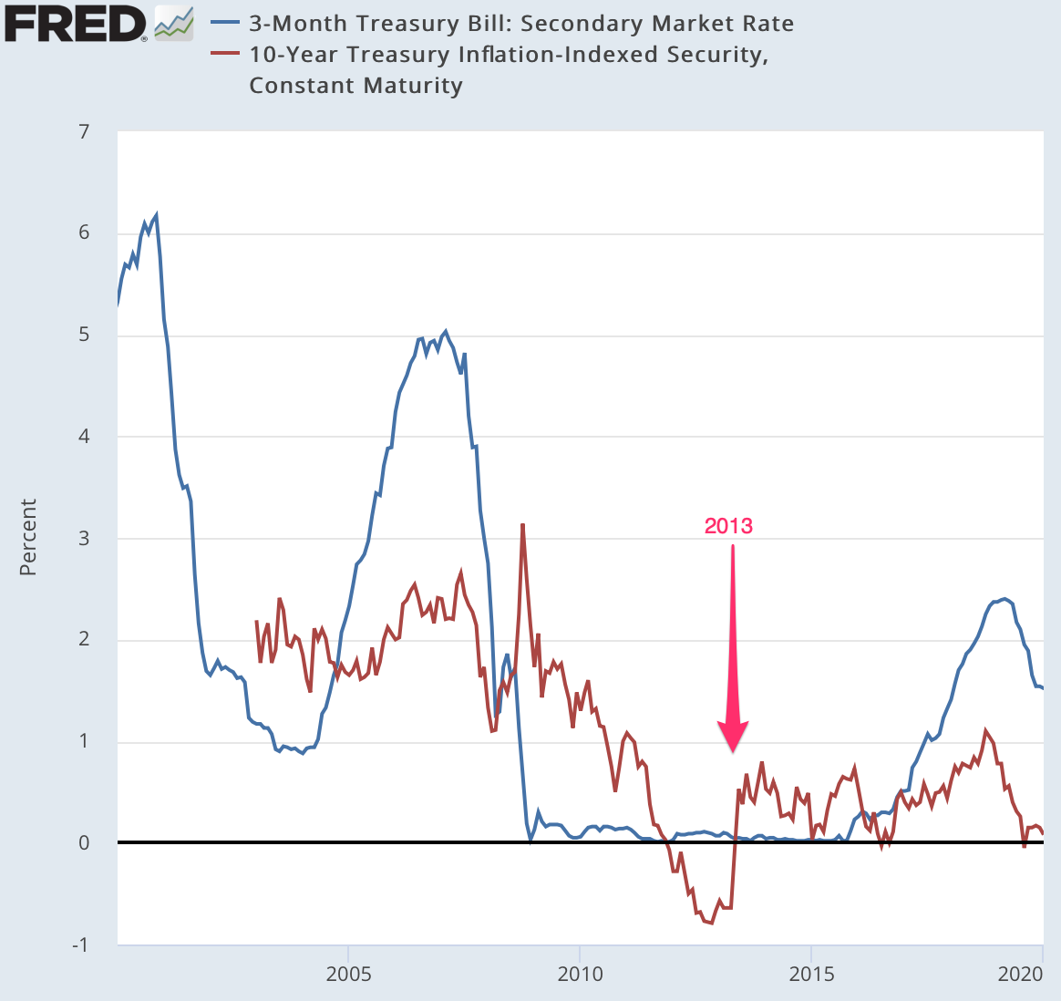
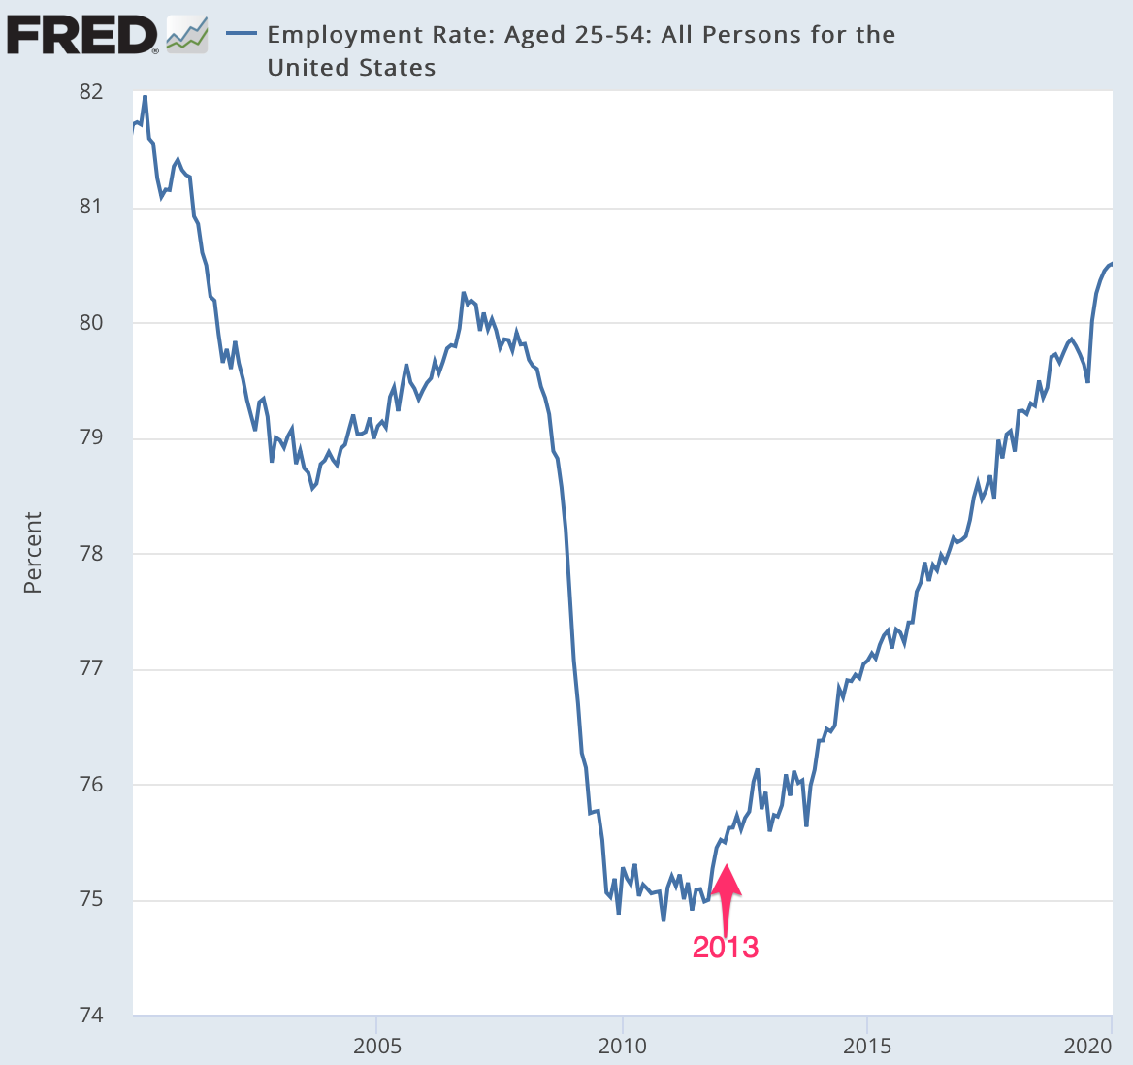
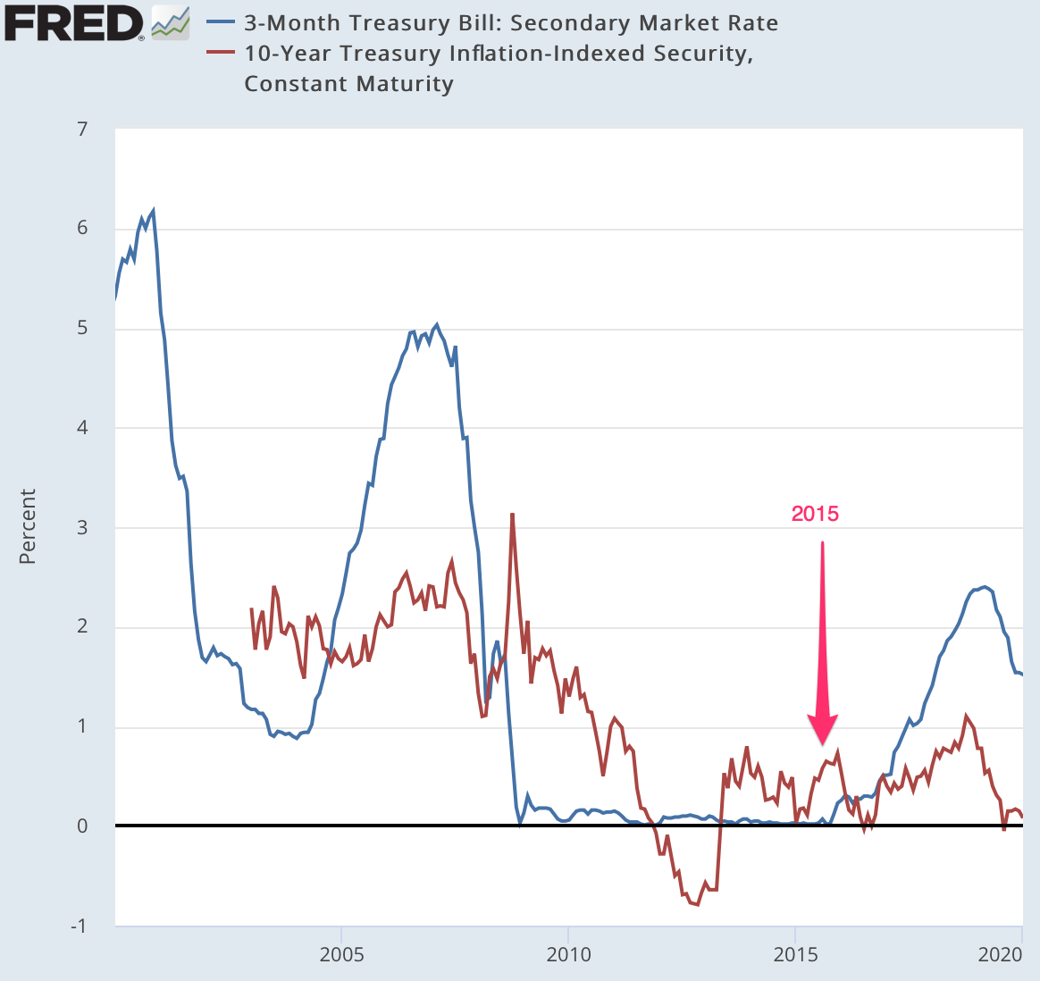
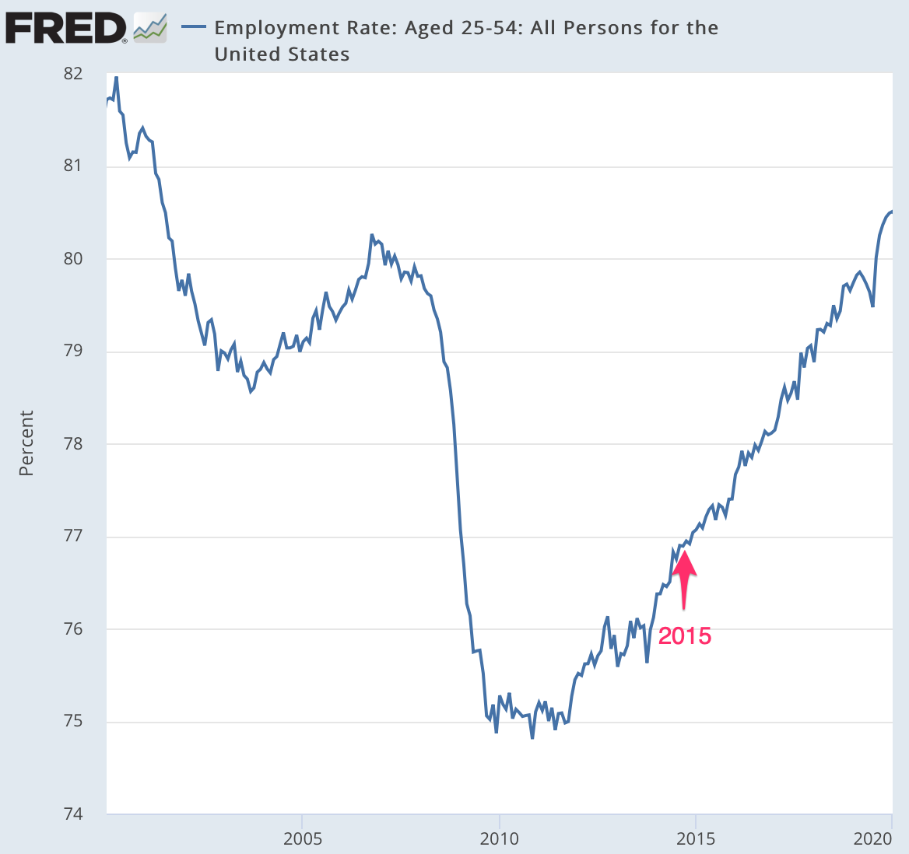

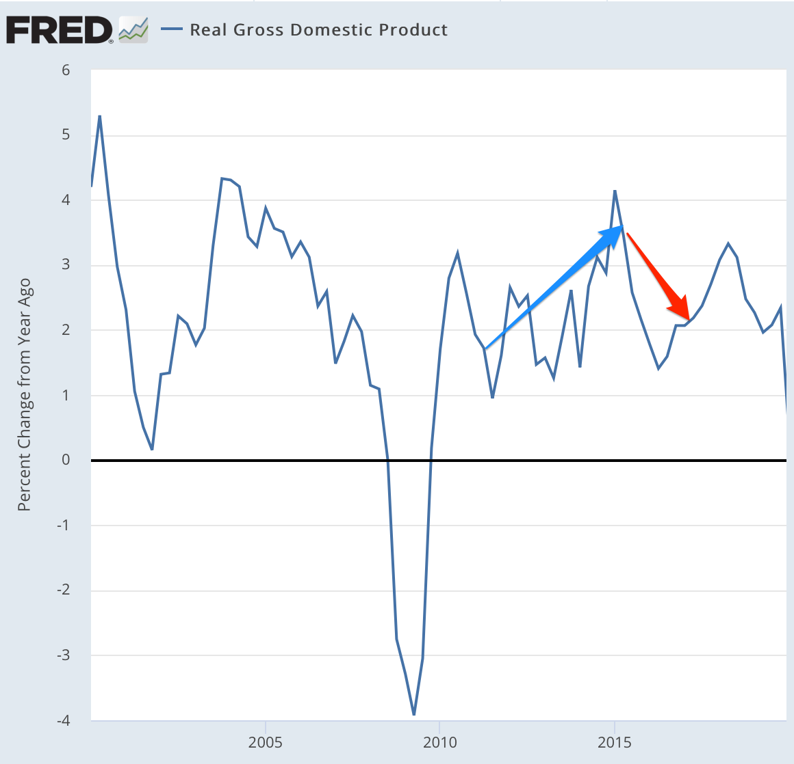
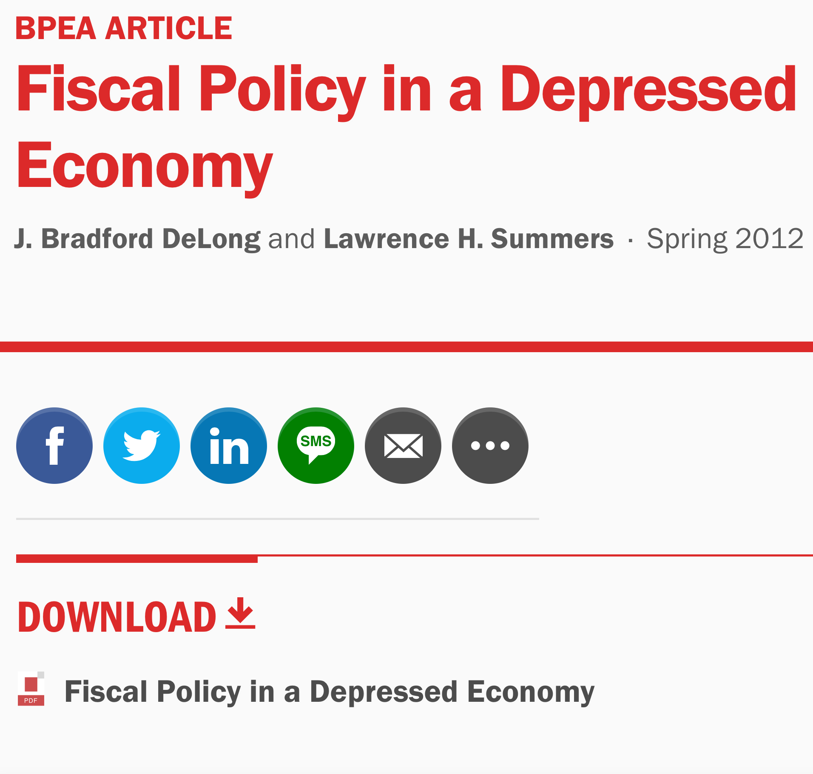
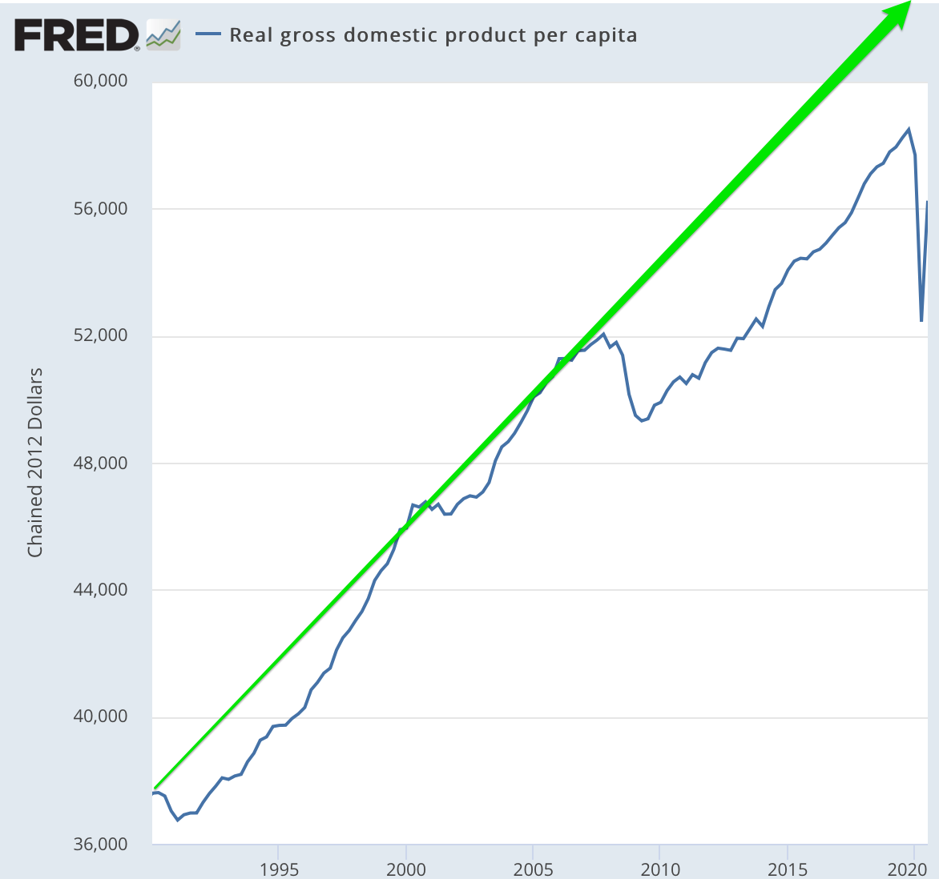
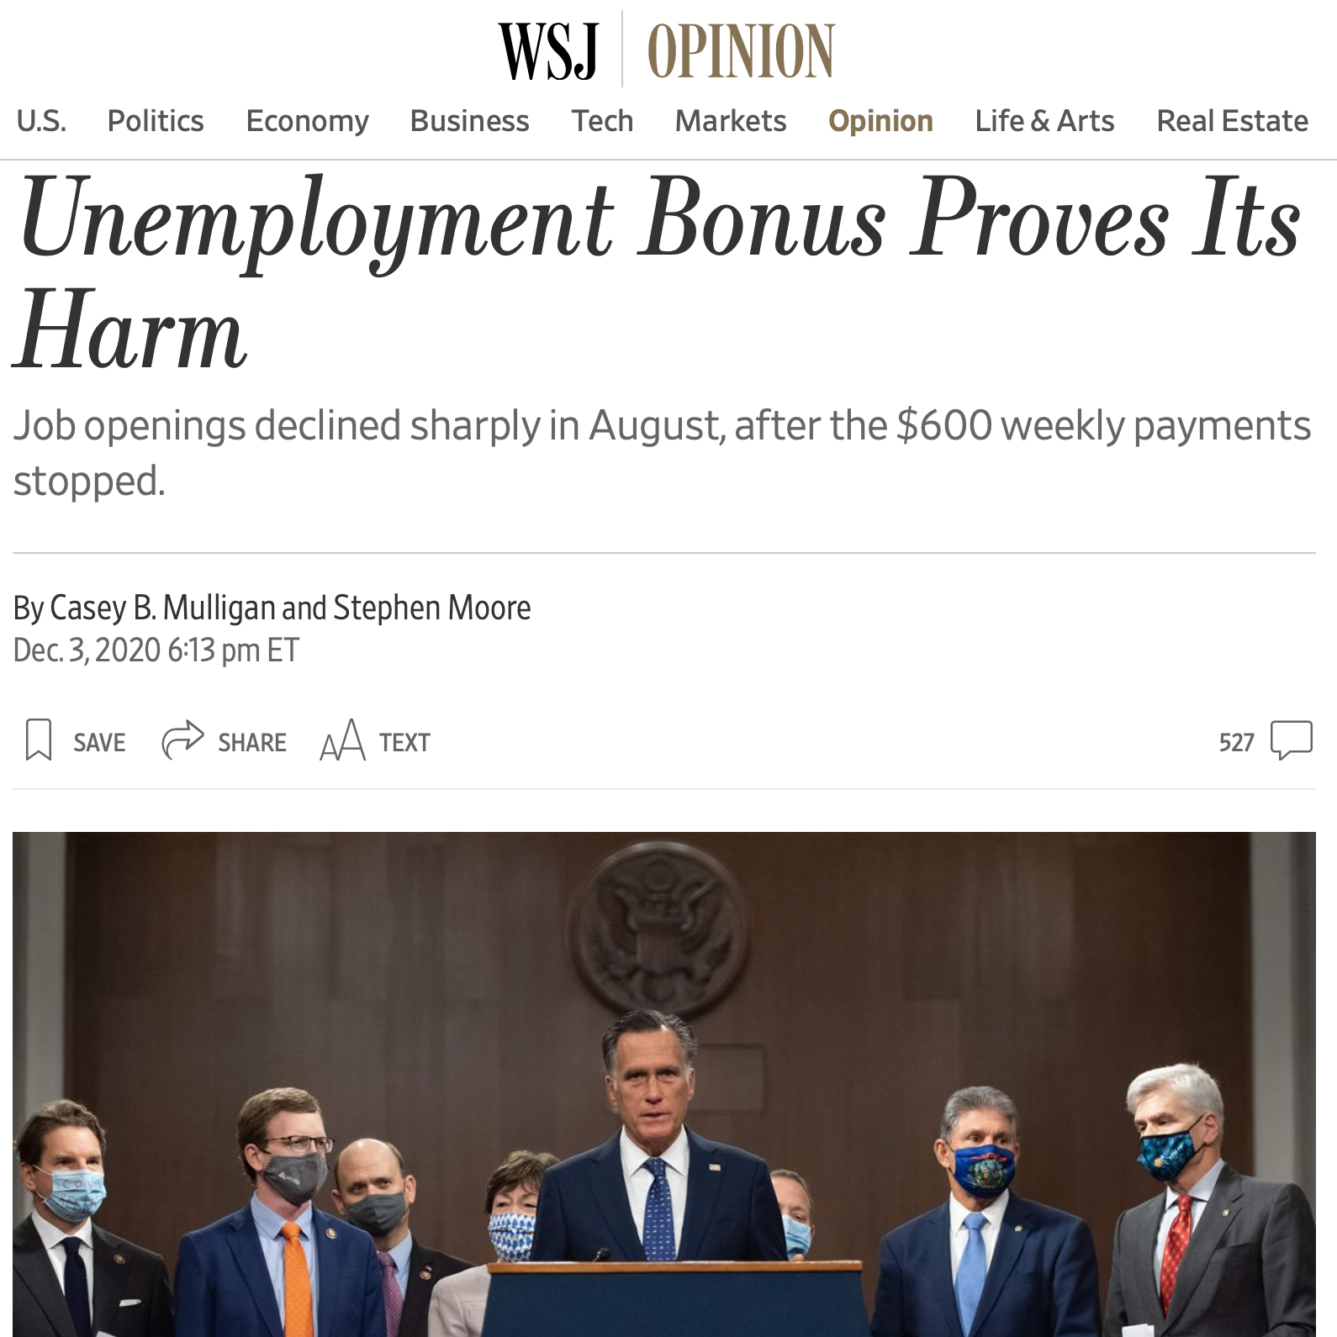

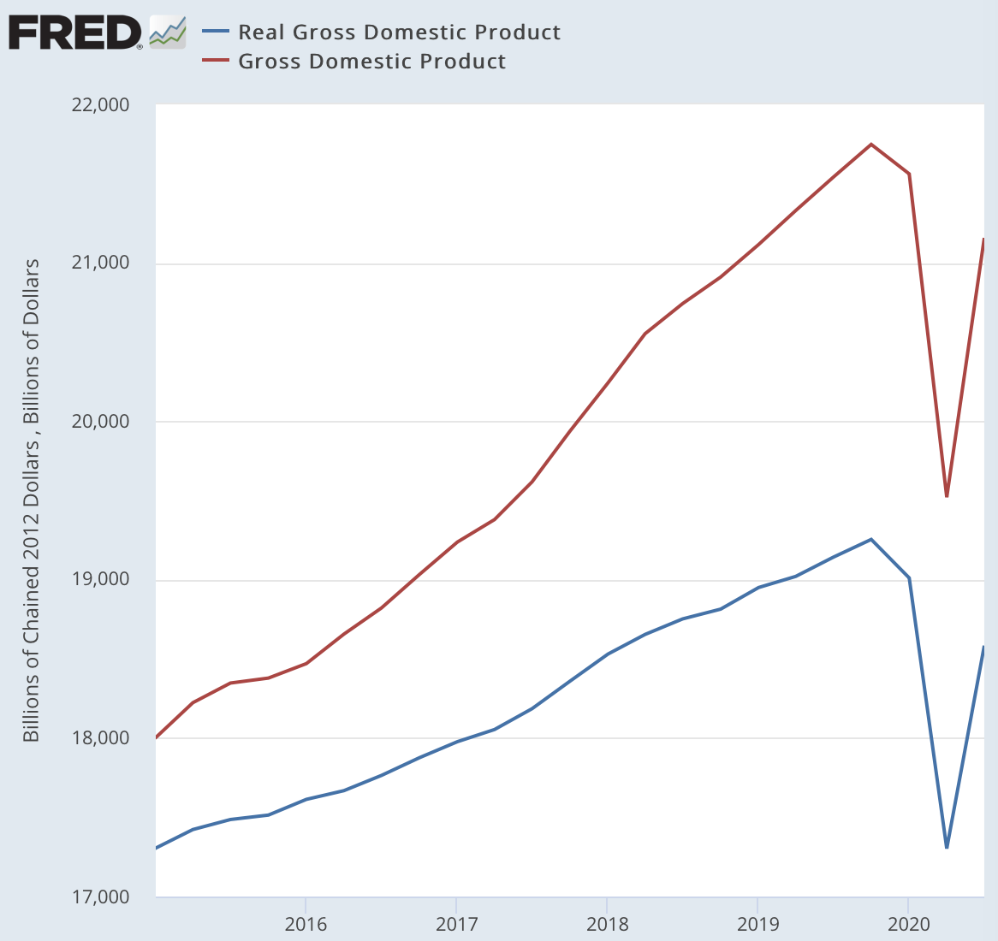
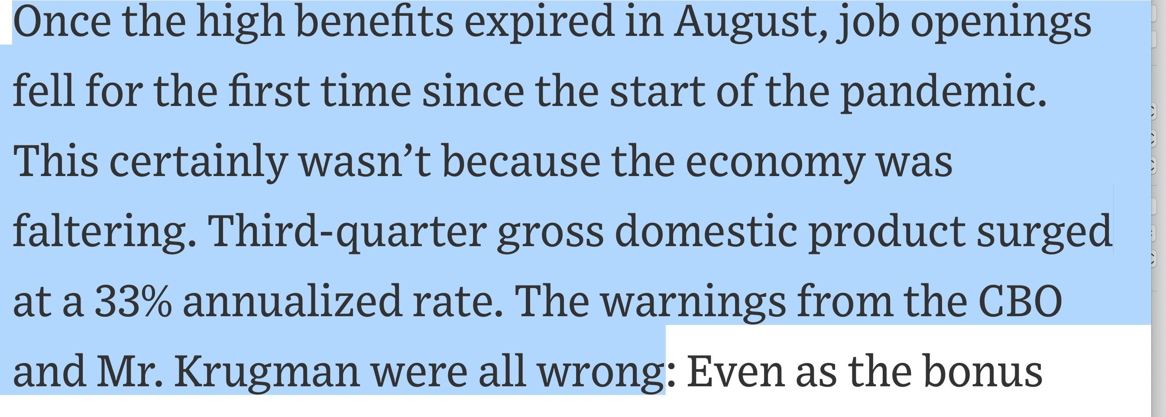
2966 words

