# Predicting EUR/USD with LSTM Network

Architectural Decision Document

### Bradley Droegkamp

# Architectural Components Overview

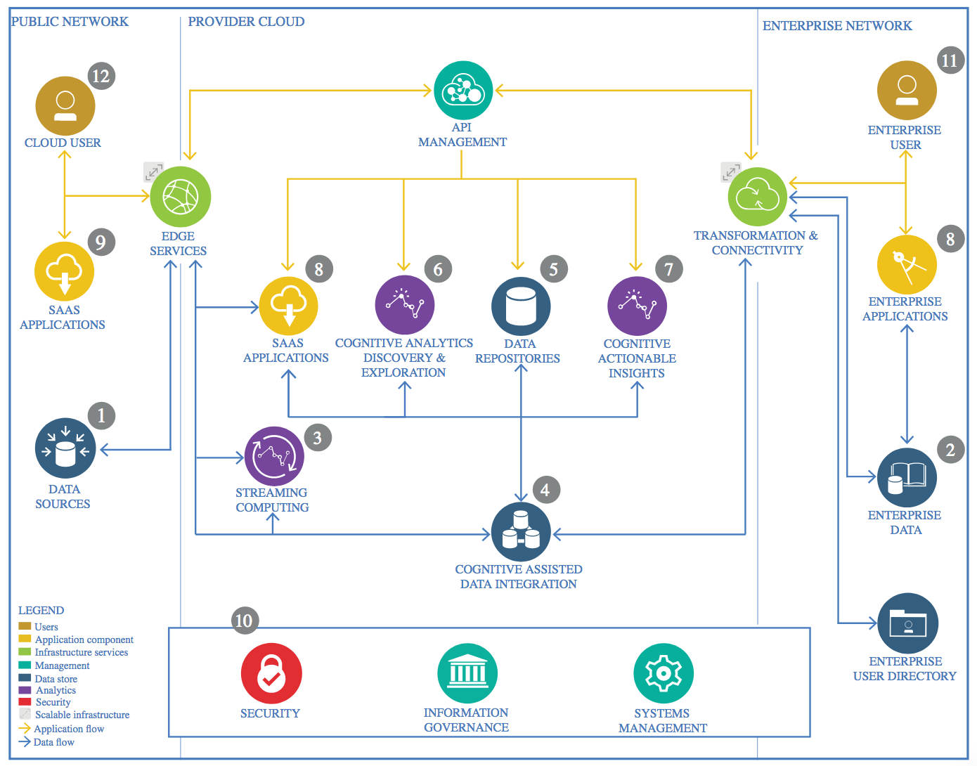

IBM Data and Analytics Reference Architecture. Source: IBM Corporation

## Data Source

### Technology Choice

The data set consists of 1-minute increment front-month EU price data from September 27, 2009 to April 18, 2018, though we will only use a subset. The data was purchased from a vendor of CME intraday data. Note the data contains all open hours of trading, which is a 23 hour trading day of 17:00(t-1) - 16:00 CST Monday(Sunday PM) to Friday. It is a .txt file that will be moved to IBM Cloud Storage.

### Justification

IBM Cloud Storage can efficiently store the data while making it easy to query.

## Streaming analytics

### Technology Choice

Again, accessing IBM Object Storage via Spark.

### Justification

IBM Cloud Storage can efficiently store the data while making it easy to query.

## Data Integration

### Technology Choice

Most of the analysis will be completed in a notebook on IBM’s Watson Experience, with Python 3.5 and Spark 2.1. However due to cloud account time limitations, some was completed in Python only on a local machine.

### Justification

The IBM environment can offer more parallel processing of data and modeling, making it a clear choice for if the potential of this modeling approach ramps up with more data and model optimization

## Data Repository

### Technology Choice

IBM Cloud Storage

### Justification

IBM Cloud Storage can efficiently store the data while making it easy to query.

## Discovery and Exploration

### Technology Choice

Most of the analysis will be completed in a notebook on IBM’s Watson Experience, with Python 3.5 and Spark 2.1. However due to cloud account time limitations, some was completed in Python only on a local machine.

### Justification

The IBM environment can offer more parallel processing of data and modeling, making it a clear choice for if the potential of this modeling approach ramps up with more data and model optimization

## Actionable Insights

### Technology Choice

Most of the analysis will be completed in a notebook on IBM’s Watson Experience, with Python 3.5 and Spark 2.1. However due to cloud account time limitations, some was completed in Python only on a local machine.

### Justification

The IBM environment can offer more parallel processing of data and modeling, making it a clear choice for if the potential of this modeling approach ramps up with more data and model optimization

## Applications / Data Products

### Technology Choice

Primarily for research and reporting purposes only at this point.

### Justification

Primarily for research and reporting purposes only at this point.

## Security, Information Governance and Systems Management

### Technology Choice

IBM Environment, MIT License, GitHub

### Justification

This project is for the open source community to do as they please. IBM and Github provide some level of security in terms of keeping the data private and maintaining versioning, respectively.