- Game theoretic approach is unusual because the success of a particular male’s strategy does not seem to depend upon the strategy of other males (or females) at all, as I think should be the case even for a playing the field game-theoretic approach. Need some reason for why the success of one male’s strategy might change given the background strategies in the population, else is this not just looking at the fitness of different phenotypes?
- Probably best to model the costs of each strategy (finding nuptial gift) explicitly, even if unknown. Whether or not the cost/benefit ratio is favourable might conceivably depend on the OSR.
- Interactions are between females and males, and it might be good to model female responses to each male strategy. This could definitely vary with the OSR or a female’s mating status.

Alternative reproductive tactics in a nuptial gift-giving spider, Pisaura mirabilis, maintained by condition-dependence

Anders P Charmouh^{1,2}, Caitlin Stern¹, Maria J Albo^{1,3} and Trine Bilde¹

¹Department of Biology, Aarhus University, Denmark
²School of Biological Sciences, University of Aberdeen, United Kingdom.
³Instituto de Investigaciones Biológicas Clemente Estable, Uruguay

Corresponding author: Anders P Charmouh

Abstract:
Variation is an inherent part of nature but in most cases, selection will remove variation rather than maintain it. The nursery web spider Pisaura mirabilis (Clerk 1757) provides an example of a system where males use a variety of alternative reproductive tactics (ARTs) in the courtship of females. Males court females with either a genuine gift consisting of an arthropod prey wrapped in silk, a worthless gift consisting of plant parts or empty exo-skeletons wrapped in silk or with no nuptial gift at all. Here, we analyse the mechanism responsible for the maintainance of ARTs in P.mirabilis i.e. whether ARTs are parts of a mixed strategy or a condition-dependent strategy. In a game theoretical framework, a model was developed by associating different fitness pay-off with the usage of different reproductive tactics. The model was parameterized using empirical data on male courtship, copulation, paternity success and on female mating status. Based on these variables, the model predicts the genuine and worthless gift tactic to confer a fitness pay-off which per encountered female on average is higher by a factor of approximately 3.05 and 2.74 respectively, compared to the no-gift tactic. Our result shows that the mechanism behind the maintenance of ARTs in P. mirabilis is consistent with a “best of a bad job” scenario, where condition-dependence leads males to employ less favourable tactics.

Keywords;
Alternative reproductive tactics, Eco-ecolutionary modelling, Pisaura mirabilis, stable behavioural polymorphism, nuptial gift-giving.

Introduction
Natural populations contain variation, and among these variants some have a higher fitness than others. Through the process of natural selection these variants tend to increase their frequency at the expense of others (Darwin, 1859). However, there are ways in which selection might preserve variation, for example in cases where the fitness of different variants is in some way frequency-dependent (Maynard Smith 1973). This is also true with regards to variation in male courtship behaviour, where males adopting so called alternative reproductive tactics (ARTs) may in the end experience equivalent fitness pay-offs (Shuster & Wade 1991). A tactic can be defined as a trait that serves some particular function, and ARTs can be defined as alternative tactics used in reproductive competition to obtain fertilizations (Oliveira, Taborsky & Brockmann 2008). Unlike a tactic, a strategy is usually defined as the “genetically based program” (Gross 1996) or some specific life-history plan, and a set of tactics can be thought of as the rules for acting out that plan. In other words, strategies are built by tactics (Oliveira, Taborsky & Brockmann 2008).
Another important distinction is that of mixed strategies and condition-dependent strategies. Consider some strategy consisting of the tactics and . The “genetically based program” of could be to randomly play and with some non-zero probability which would make a so-called mixed strategy. On the other hand, the strategy could be: Always play ; if not possible play ; if not possible, play . This would make a condition-dependent strategy, because the choice of tactics is not random, but depends on some condition (Maynard Smith 1984). A mixed strategy can only be an evolutionary stable strategy if all the tactics of which it is composed will on average confer equal fitness (Bishop & Cannings 1978). However, unlike mixed strategies, the tactics of condition-dependent strategies do not confer equals fitness. In our example of a condition-dependent strategy, and can be thought of as ways of making “the best of a bad job” (Maynard Smith 1984).
The distinction between mixed and condition-dependent strategies means that different tactics can be maintained in a population for quite different reasons. First, ARTs might be observed as the result of all individuals in the population adopting a single mixed strategy in which several different tactics are deployed, all of which on average confer equal fitness. In this case, multiple ARTs are observed even though no genetic polymorphism exists. Second, ARTs can be the result of all individuals adopting the same condition dependent strategy consisting of several different tactics. That is, all individuals are using the same strategy but since individuals will experience different conditions, their underlying strategy, prompts them to adopt different tactics. For example, if a male that provides a nuptial gift consisting of an insect prey fails to catch a prey, a ‘no gift tactic’ might be the second best choice, although a prey gift tactic is preferable as it provides longer copulations. Such scenarios have been documented several times (Koprowski 1993: Hart & Ratnieks 2001; Lee & Hays 2004), a famous example being among polymorphic dung beetles of the genus Onthophagus (Cooke 1990; Emlen 1994), where male dung beetles who happen to have shorter horns make the best of a bad job by deploying different reproductive tactic than dung beetles with long horns, which ultimately results in lower reproductive success.

The Pisaura mirabilis system
The nursery web spider Pisaura mirabilis (Clerk 1757) is an example of a system where males use ARTs to obtain inseminations and then vie for fertilizations post-copulation through intense sperm competition (Albo et al. 2011). Male courtship includes the offer of a nuptial gift, an insect prey wrapped in white silk (Bristowe 1958). During courtship, males can adopt several ARTs when approaching a female (Ghislandi et al 2018). Males can provide a genuine, nutritive gift for the female in the form of a captured arthropod wrapped in silk (Bristowe 1958; Nitzsche 2011). Males can also offer a nutritionally worthless gift, which usually consists of exoskeletons from already consumed arthropods, and in some cases even of indigestible plant material (Albo et al. 2011). Once the female accepts and begins consuming the gift, the male can initiate copulation by inserting each pedipalp into the female genitalia in alternating order (Bristowe and Locke 1926). Additionally, males can also attempt copulation without offering any kind of nuptial gift (Stålhandske 2001; Bilde et al. 2007). Remarkably, all three strategies have been observed simultaneously in wild -and experimental populations of P. mirabilis (Prokop & Semelbauer 2017; Ghislandi et al 2018 ) and individual males appear to be able to express all tactics (Hansen et al. 2008; Ghislandi et al. 2014, 2018), suggesting that different ARTs do not represent different strategies resulting from a genetic polymorphism.

What affects the fitness pay-offs of different ARTs?
Previous work on P. mirabilis suggests that the expected payoff a male will gain from mating depends not just on which tactic he adopts, but also on several ecological and demographic variables (Stålhandske 2001; Ghislandi et al. 2018). For example, the operational sex ratio (OSR), calculated as the number of males per receptive female in the population, may affect payoffs, as males are expected to encounter fewer receptive females as OSR increases, making each potential mate more valuable (Engqvist & Taborsky 2016). Thus, when the OSR is high, selection may favour higher investment in courtship and hence the genuine gift-giving tactic. Likewise, female mating status, whether a female is mated or unmated, has been shown experimentally to affect her reaction to different ARTs since, at least in some populations, mated females will never accept a male courting without a gift (Stålhandske 2001; Prokop & Maxwell 2009). These ecological and demographic variables may result in quite different pay-off values over the course of a mating season, making it conceivable that different tactics are optimal at different times (Hendrickx, Banthournout & Taborsky 2015; Ghislandi et al. 2018).

Furthermore, intense post-copulatory competition exists among males in the form of sperm competition (Matzke 2019). This may constitute an important selection pressure in the evolution and maintenance of ARTs in P. mirabilis: different ARTs result in different copulation durations, which is correlated with the number of sperm cells transferred during copulation (Albo et al. 2013). The genuine, worthless and no gift tactic result in long, intermediate and short copulation durations respectively, and for this reason, gift-giving is thought to be favoured by post-copulatory sexual selection due to an advantage in sperm competition, since success in sperm competition is correlated to copulation duration. Any gift-giving tactic (genuine or worthless) is thought to be favoured by pre-copulatory sexual selection since females show similar acceptance rates of males whether they court with a genuine or worthless gift (Albo et al. 2011). The no-gift tactic enjoys neither of these selective advantages, but simply saves the male the cost of producing a genuine or worthless gift resulting in a nutritional/energy benefit, which could favour this tactic when prey is scarce or males are in bad body condition (Ghislandi 2017, 2018; Prokop 2019).

What explains the co-existence of multiple ARTs in the nuptial gift-giving spider P. mirabilis? We develop a model to uncover by which mechanism this polymorphism of ARTs is maintained in P. mirabilis. The model uses male reproductive success as a fitness proxy to predict whether selection will favour an increase in the probability of adopting any particular ART. The fitness benefits of different tactics are modelled as a function of the number of receptive females, female mating status, female acceptance rates of males and the differential success in sperm competition yielded by different ARTs. If the difference between the average payoff over some seasonal period yielded by different ARTs is small, we may propose that all tactics are maintained in the population because they, on average, yield equal fitness (Monroe et al 2016). The no-gift and worthless-gift tactics, for example, might be favoured early in the mating season when OSR is low, yet might on average yield the same fitness pay-off as the genuine gift tactics if this is favoured once OSR increases (Magris & Tuni 2019). In this case, it becomes conceivable that all tactics have on average the same pay-off and thus remain in the population. If, on the other hand, the model predicts very large differences in the fitness pay-offs of different ARTs, it becomes unlikely that all tactics actually yield equal fitness pay-offs on average. We may then predict that one tactic always yields the highest fitness pay-off while inferior tactics are maintained in the population because they are part of a conditional strategy. In other words, tactics which results in much lower reproductive success could be a case of males occasionally adopting an inferior tactic when employing the optimal tactic is not possible or making “the best of a bad job” (Maynard Smith 1982).

Methods
By comparing partial derivatives of fitness functions in a game theoretical context, we developed a model to study how changes in ecological variables affect male reproductive success. These ecological variables are the number of receptive females, the mating status of the females and the pay-off values of different ARTs measured in terms of expected reproductive success per female encounter. This is done to test whether ARTs yield approximate equal fitness or not to determine whether ARTs in P. mirabilis are best understood as components of a single mixed strategy or components of a single condition dependent strategy.
A complex behavioural pattern like nuptial gift-giving is highly likely to be a quantitative trait, meaning it is influenced by small effects of many different alleles at many different loci. Thus, any single mutation at these loci is likely to result in only a slight alteration of the tendency to adopt any particular ART. For this reason, we modelled the changes in fitness by studying the effect of small changes in the tendency to adopt any specific ART by examining partial derivatives of a fitness function. The existing literature was surveyed to identify ecological variables relevant to selection pressures acting on ARTs in this species. A fitness function was derived to describe the fitness increments gained by males when mating. Since the three ARTs are not used in any direct male-to-male competition, it was illogical to analyse the mating system by constructing a pay-off matrix where different entries represent the pay-offs for different match-ups between males (Vincent & Brown 2005; McNamara 2013). Because of this, an approach akin to the “playing the field”-approach developed Maynard Smith (1982) was taken. This approach made it possible to model male fitness as a function of the male’s environment rather than as a function of the tactic deployed by some specific rival male. The mathematical representation of the model was implemented as a Python script (Python Software Foundation. Python Language Reference, version 3.6. Available at http://www.python.org) used to search relevant parts of the parameter space of the model. Afterwards, the model was parameterized using experimental data and the predictions of the model was illustrated graphically through colour-coded plots constructed using R (R Core Team (2020). R: A language and environment for statistical computing. R Foundation for Statistical Computing, Vienna, Austria. URL https://www.R-project.org/) and Maple (Maple (2019). Maplesoft, a division of Waterloo Maple Inc., Waterloo, Ontario.

The model:
As we initially follow the approach outlined by Ghislandi (2017), consider a population of P. mirabilis over some seasonal period . Let the probabilities of a male adopting the tactic no gift, worthless gift and genuine gift be respectively such that
(1)

since no other tactics are available to the males. Let be the proportion of unmated females in the seasonal period such that is the proportion of mated females in . Likewise, let the number of receptive females encountered by a male in be denoted by , with the upper bound of denoted by , as the number of receptive females encountered by a male is finite. Note that changes in can reflect changes in the OSR and change in reflect changes in the mating status of the females. We can define , , and as the pay-offs received by a male playing no gift, worthless gift and genuine gift respectively when courting an unmated female. Analogously, we define , , and as pay-offs received from courting a mated female. We may now partition the fitness increments that males obtain by defining

where s the fitness increment gained per encounter with mated females and is the fitness increments gained per encounter with unmated females.
Weighted by the frequencies of each female mating status type, the fitness increments which the male gains thus become and . As these pay-off occur for each encounter, the total fitness increment obtained from matings by a male during , must be given by the product of and the sum of and which will now be denoted such that

We now seek a rigorous way of investigating which changes in and selection might favour given some and . By construction of , we clearly always have . Likewise, for any , and obviously . In other words, there always exists some upper and lower bounds on the set of all possible values of since the number of times a male will encounter females per mating season is not unlimited. Since we know the parameter space of and , we can now define the set of relevant ecological conditions, , as

Since is differentiable, we can define a new function as

Put another way, the value of describes which partial derivative is largest in a specific point in and thus where selection will favour an increase. For example, if , the increase in fitness is greatest per increase in compared to any other tactic. The set is the parameter space of all and thus constituting a description of the ecological conditions that P. mirabilis males may experience (with respect to and ). Mapping the output of for every in results in a plot showing which change selection will favour – that is, which of the three probabilities selection will favour an increase in as a function of and .
Note that the fitness cost of giving and producing a gift is not included in the fitness function, since quantitative data relating the fitness cost of producing a gift does not exist. Rather, this variable is treated as the unknown variable of our equation, and the following approach is taken. Given some we will consider the differences between , and . Assuming that any difference is due to the cost of nuptial gift production, this gives us a way of estimating the fitness value of nuptial gifts necessary to make all tactics equal. If this value turns out to be unrealistically high, we may conjecture that some tactics are in fact unequal in the fitness yields, which has implications for our understanding of why they are maintained in the population.

Application and interpretation of the model:
The following serves to illustrate the method by which the model developed above was applied while using the notation introduced in the former section. We seek to evaluate for some relevant subset of .
We begin with a set of pay-off values shown in table 1.
Table 1:
A set of pay-off values conjectured by Ghislandi (2017) based on acceptance rates of males by females and copulation durations. , , and define the pay-offs received by a male using the no gift, worthless gift and genuine gift tactics, respectively, when courting an unmated female. Analogously, , , and are defined as pay-offs received from courting a mated female.

Partial derivatives of are calculated such that may be evaluated. Given set 1, these become , and .
We now decide which part of to explore by choosing a value of (the upper bound for ). Setting we may now evaluate in the specified part of . Each point in is now tied to its resulting output of . In other words, if for some we have the Python script would note that in the increase in fitness per increase in the probability of using the genuine gift tactic () is greater than the increase in fitness per increase in the probability of using any other tactic. Plotting whether selection will favour an increase in the probability of using the tactic no gift, worthless gift or genuine gift for all chosen points in yields a plot showing which tactic selection would favour to be used more frequency, before the cost of the gifts is considered.
The plots colour-code different outputs of . Points in where are coloured grey, points in where are coloured light grey and points in where are coloured black. As a result, grey indicate conditions under which the genuine gift tactic confer the highest fitness, light grey indicates conditions under which the genuine and worthless gift tactic confer the highest fitness, and black indicates conditions under which all tactics confer equal fitness. Using this colour-coding, we can visualize selection on the different tactics as a function of and given set 1 (figure 1).

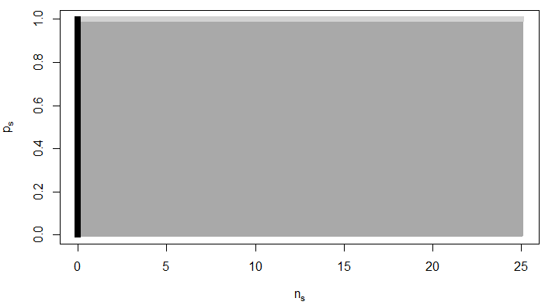
Figure 1: An illustration of which tactics are favoured by selection, before the cost of the nuptial gift is considered, if set 1 is used as pay-off values. Grey indicates conditions under which the genuine gift giving tactic is favoured. Light grey indicates conditions under which the worthless and genuine gift-giving tactic are favoured equally over the no gift tactic. Black indicates conditions under which all tactics are favoured to the same extent.
The final step in the application of the model is to interpret the output in the form of a colour-coded plot. In interpreting these plots, we are interested in when selection will favour using certain tactics more often. In other words, whether alleles causing males to adopt a specific tactic more frequently will spread through the population. All points ) where have been coloured grey (fig. 1.). This means that the grey section (fig. 1) represents ecological conditions (pairs of and ) where selection will favour males who increase the probability with which they use the genuine gift tactic – that is, selection will favour an increase in . Note that this increase in will result in a decrease of either or both due to equation 1. Light grey sections (fig. 1.) are points where That is, points where increase in the probability of using the worthless gift tactic yields just as much fitness as increasing the probability of using the genuine gift tactic – both being better than increasing the probability of using the no gift tactic. The black section (fig .1.) shows points where These are points where there is the same increase in fitness regardless of which tactic is used with an increased probability. It makes intuitive sense that the black section represents all because this section represents set of ecological circumstances in which males encounter exactly zero females. This means that, when the cost of nuptial gift production is not accounted for, the model predicts that all tactics fare equally when there is no reproduction at all.
We are now interested in the differences between the partial derivatives as a function of and . The magnitude of these difference will indicate whether it is plausible or not that all tactics on average confer equal fitness. The relationship between the partial derivative for set 1 was visualized (figure 2A-B).
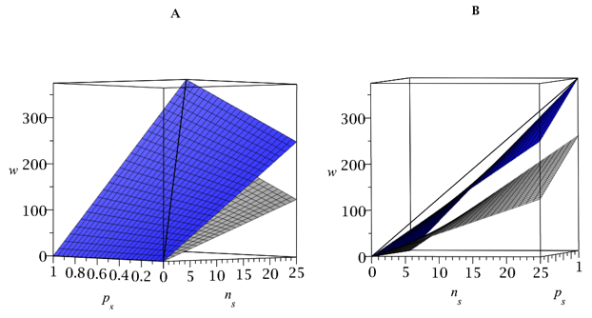
Figure 2:
A: 3D-plot illustrating the relationship between the change of relative fitness yield of different tactics (genuine gift: black, worthless gift: blue, no gift: grey) under different ecological conditions (n_{s}: numbers of females encountered by males. p_{s}: female mating status). B: Rotation of 2A illustrating that the change of relative fitness yield of the genuine gift and worthless gift tactic are equal when all females are unmated.
Given set 1, males using the genuine gift tactic more often will always experience the largest fitness gain whenever receptive females are present and some of these have been mated (fig 1.b-c). For set 1, it can be shown that the relationship between the partial derivatives (fig 1.b-c) is the same for all values of (the maximum number of females a male encounters during the season). In other words, given set 1,
and (proof not shown). As a further example, the effects of using different pay-off values (table 2) is illustrated (fig 3.).

Table 2:
Additional sets of arbitrarily chosen pay-off values. , , and define the pay-offs received by a male using the no gift, worthless gift and genuine gift tactics respectively when courting an unmated female. Analogously, , , and are defined as pay-offs received from courting a mated female.

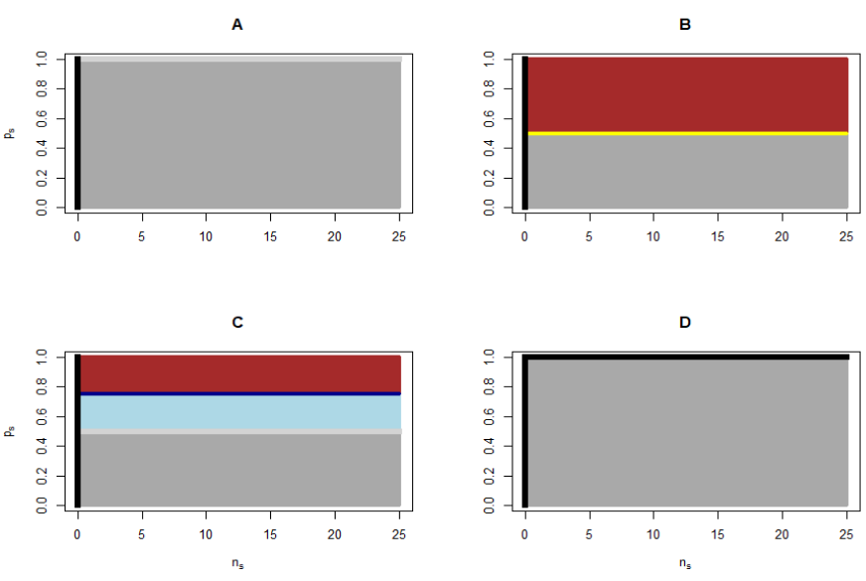
Figure 3: An illustration of which tactics are favoured by selection, before the cost of the nuptial gift is considered, given different sets of pay-off values. Same colour-coding as in figure 1 has been adopted for grey, light grey and black. Dark blue indicates conditions under which the worthless gift and no gift tactic are favoured equally over the genuine gift tactic. Yellow indicate conditions under which the genuine gift and the no gift tactic are equally favoured over the worthless gift tactic. Brown indicates conditions under which the no gift tactic is favoured. 3A). Set 1. 3B). Set 2. 3C). Set 3. 4D). Set 4.
The pay-off values strongly affect the degree to which selection favours different tactics. To make the model predictions as useful as possible, we used datasets from experimental and field studies to estimate the pay-off values , , , , , and .

Parameterization via experimental datasets:
Copulation duration differs significantly among males adopting different tactics (Albo et al. 2011). Since these differences in insertion duration have been shown to be correlated with the number of offspring sired, the differences can be used as a males fitness proxy which allows us to estimate values of , , , , , and . Albo et al. (2013) found a positive relationship between copulation duration and hatching success per mating. We used this relationship and the differences in insertion duration to calculate the expected hatching success per mating as a function of each tactic (data not shown).
Given the modelling framework previously outlined, we are interested in estimating the expected fitness increment gained per (encountered female) and not per successful mating (table 3). To accomplish this, we must consider that a male’s probability of being accepted by a female depends on his choice of tactic (Albo et al. 2011). One study showed that males adopting the no-gift tactic are allowed by the female to mate in approximately 40% of all cases, while there was no significant difference in the acceptance rate of males adopting the worthless gift or genuine gift tactic – these males had an acceptance rate not significantly different from 100% (Albo et al 2011). Multiplying the values of hatching success per mating by the appropriate constants we may now express the expected fitness increment per by continuing to use expected hatching success per mating as a fitness proxy. So far, these estimates can only be viewed as , , and not , , since the experiments of Albo et al. (2011), Albo et al. (2013) only used unmated females. Acceptance rates of mated females have also been investigated experimentally illustrating that, at least in some populations, mated females will never accept males without a gift (Ghislandi 2017). However, if courted with a genuine gift, one study showed that mated females will mate up to 16 times when starved and up to 8 times when satiated (Toft & Albo 2015). We assume the acceptance rate of males offering worthless gifts and genuine to mated females are similar to that of males offers worthless gifts and genuine gifts to unmated females.
The paternity (% eggs fertilized) of males per mating is negatively correlated the total number of female partners (Drengsgaard & Toft 1999). Thus, a male can expect to achieve a higher paternity if he mates with female that have mated with relatively few males (1-3). For simplicity, the number of males which the females had previously mated was not considered when calculating fitness pay-offs. A recent study showed that the mating order of males affects their expected reproductive success. That is, a male can expect a higher paternity percentage if he is one of the first males to mate with any given female (Matzke 2019). We assumed that all male had the same probability of mating in any order, allowing us to approximate fitness pay-offs as independent from the mating order.

Results
The following differences in fitness related variables between males adopting different ARTs were calculated and used for approximating fitness pay-offs of different ARTs (table 3):
Table 3:
Differences in mean insertion duration (min), expected hatching success per mating (proportion of hatched eggs) and expected hatching success per (proportion of hatched eggs) for different ARTs (no gift, worthless gift and genuine gift). Results shown SE.

By using reproductive success as a fitness proxy, a set of pay-off values was determined (table 4):
Table 4:
Empirically derived pay-off values for male ARTs calculated by using expected paternity per as a fitness proxy. , , and defines the pay-offs received by a male using the no gift, worthless gift and genuine gift tactic respectively when courting an unmated female. Analogously, , , and is defined as pay-offs received form courting a mated female.

Using the empirically derived pay-off values of table 4, we found the follow partial derivatives of : , , . The relationship between these partial derivates is very simple, but for consistency, the value of (the partial derivative of highest value in each point) is depicted in figure 4.

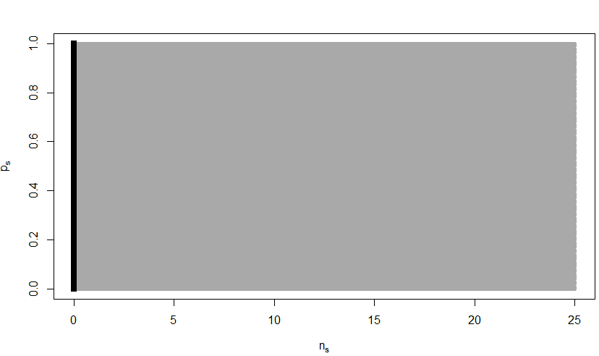
Figure 4:
An illustration of which tactics are favoured by selection, before the cost of the nuptial gift is considered, if set 5 is used as pay-off values. Grey indicates conditions under which the genuine gift giving tactic is favoured. Black indicates conditions under which all tactics are favoured to the same extent.
Since the pay-off values are derived on the basis of male reproductive success and not the cost of gift production, for all with meaning that whenever males encounters females, selection will, favour males who increase the probability of using the genuine gift tactic. Given that the cost of producing a gift has not yet been included, the generality of this conclusion is discussed in the following.
Discussion:
By considering sperm competition, the number of receptive females and the female mating status, our model predicts that reproductive success in males offering a genuine nuptial gift is higher by a factor of approximately 3.05 compared to males who offer no nuptial gifts at all. The model also predicts males who offer a worthless gift to have a reproductive success higher by a factor of approximately 2.74 compared to males offering no gift. To the extent that ~2.74 and ~3.05-fold differences in reproductive success constitutes large fitness gaps, this provides evidence for the hypothesis that the no gift tactic does not yield the same fitness as both gift-giving ARTs. This means that our model suggests that the no-gift tactic is maintained in the population as part of a condition-dependent strategy wherein males sometimes deploy the no gift tactic when they are unable to use the worthless gift or genuine gift tactics. That is, our analysis indicates that the no gift tactic is a case of males “making the best of a bad job”. This large discrepancy in fitness between the no gift and gift tactics lends support to the “best-of-a-bad-job” hypothesis as an explanation of why multiple ARTs co-exist. In other words, ARTs in P. mirabilis can be understood as parts of a condition dependent strategy and not a mixed strategy.
For this conclusion not to hold, it would require prey items to be incredibly valuable to males. That is, the act of consuming a prey item, rather than offering it as a gift, would for example require the prey item to contain enough energy for the male to approach ~3.05 times as many females if the no gift and genuine gift tactics were to yield equal reproductive success. This is true since the “mixed strategy”-hypothesis would require all tactics to have equal fitness due to Bishop-Cannings’ theorem (Bishop & Cannings 1978). The “mixed strategy”-hypothesis remains unsupported even when more variables are included in the analysis. For example, one study showed that the number of eggs produced by P. mirabilis females is positively correlated with the amount of prey they consume (Tuni et al. 2013). Thus, a male offering a genuine gift to a female could cause her to produce more eggs, giving him the opportunity to sire more offspring and hence increase his fitness (Trivers 1972; Toft & Albo 2015). While the gifts effect on female fecundity has not been considered in determining the pay-off of using the genuine gift tactic, please note that the inclusion of this effect would only make the genuine gift tactic even more favourable and hence increasing the gap in the fitness pay-off between the no gift and the genuine gift tactic. Furthermore, specifically for P. mirabilis, there is some evidence to suggest that the nuptial gifts do not increase the fecundity of the female (Stålhandske 2001). A study of sperm storage in female P. mirabilis documented that females will store slightly more sperm from males offering a genuine gift even when controlling for the differences in copulation duration which result from using either the genuine gift or the worthless gift tactic (Albo et al. 2013). Like before, the fact that the genuine gift tactic appear to facilitate higher sperm transfer per copulation time simply make the genuine gift tactic more favourable and the same conclusion would hold. Furthermore, it has been shown that males using the no gift tactic run a greater risk of falling victim to sexual cannibalism where the female attacks and eats the male during courtship or copulation (Bilde et al 2006; Toft & Albo 2016). Once again, we note that including the effects of sexual cannibalism in the estimation of the pay-off values (table 4) would only further disadvantage the no gift tactic and thus further widen the fitness gap. This means that our model suggests that the no gift tactic is maintained in the population as part of a condition dependent strategy wherein males sometimes deploy the no gift tactic when they are unable to use the worthless gift or genuine gift tactics. That is, our analysis indicates that the no gift tactic is a case of males “making the best of a bad job”.
It should be noted that the fitness gap between the worthless gift tactic and the genuine gift tactic is far less than the gap between both of these and the no gift tactics. This relatively small fitness gap makes it at least conceivable that the benefit of eating a nuptial gift rather the giving it away balances the reproductive advantage gained by giving genuine gifts. In other words, if producing worthless gifts results in more prey being available to the male, this increase in nourishment could balance the slightly lower reproductive success per female enjoyed by such males. This means that it is less clear whether the worthless gift tactic and the genuine gift tactic might on average confer equal fitness as better nourished males might be able to seek out more females which could make up for the lower per-female reproductive success enjoyed by males who give a worthless gift rather than a genuine one.
Despite not explicitly including gift cost in our analysis, our result suggests that the no gift tactic confers on average lower fitness than other tactics, regardless of OSR, female mating status, variance in egg production, cryptic mate choice and sexual cannibalism. If, as the data indicates, the no gift tactic is the result of “making the best of a bad job”, the P. mirabilis system would be distinct from systems where ARTs are the result of males with different phenotypes occupying different mating niches. Such a system is found in the dwarf spider Oedothorax gibbosus (Hendrickx et al 2015). In this system, two male morphs are present: one which develops fast and does most of its reproduction early in the mating season and one which develops slowly, provides nuptial gifts and reproduces mostly late in the mating season (Hendrickx et al 2015). Female resistance to male courting increases over the mating season, favouring nuptial gift-giving later in the mating season. Thus, in this system, the two tactics are maintained by environmental variation because the tactic with the highest fitness pay-off varies with ecological and demographical variables. Remarkably, such a system might also be present within the P. mirabilis system as it has recently been reported that a relatively larger abundance of small and possibly rapidly developed P. mirabilis males occur early in the mating season (Albo et al. 2019). Thus, these small males could be an example of an alternative male morph reproducing early in the season rather than the larger-sized male morph that reproduce later. However, the existence of two distinct life-history strategies among P. mirabilis males does not change the fact that the maintenance the no gift tactic in the population of normal male morphs appear to be best explained by males “making the best of a bad job”. Behavioral polymorphisms which are the result of males making the best of a bad job have been documented in several different systems, one example being the case of dung beetles of Onthophagus. Other systems include male eastern gray squirrels (Sciurus carolinensis), leaf cutting ants (Atta colombica) and green marine turtle (Chelonia mydas) all of which contain examples of condition-dependent strategies (Koprowski 1993: Hart & Ratnieks 2001; Lee & Hays 2004). These studies, like our, determine tactics to be a case of making the best of a bad job by evaluating the fitness pay-off given by some tactic relative to others. The work of Koprowski (1993) is especially analogous to ours as it is an example of another study where reproductive success is used as a fitness proxy which is then used to evaluate the fitness pay-offs of different ARTs.
References
Albo, M.J. Franco-Trecu, V. Wojciechowski, F. Toft, S. Bilde, T (2019). Maintenance of deceptive gifts in a natural spider population - ecological and demographic factors. Behavioural Ecology. 30, 4 993-1000.
Albo, M. J. Bilde, T. Uhl, Gabriele. (2013). Sperm storage mediated by cryptic female choice for nuptial gifts. Proceedings: Biological Sciences, 208, 1772, 1-6.
Albo, M. J. Winther, G. Tuni, C. et al. (2011). Worthless donations: male deception and female counter play in a nuptial gift-giving spider. BMC Evolutionary Biology, 11, 329-337.
Bilde, T. Tuni, C. Elsayed, R. Pekár, S. Toft, S. (2006). Death feigning in the face of sexual cannibalism. Biology Letters, 2, 1, 23-25.
Bilde, T. Tuni, Cristina. Elsayed, R. et al. (2007). Nuptial gift of male spiders: sensory exploitation of the female’s maternal care instinct or foraging motivation? Animals Behaviour, 73, 267-273.
Bishop, D.T. Cannings, C. (1978). "A generalized war of attrition". Journal of Theoretical Biology. 70, 85-124.
Bristowe, W.S. Locket, G.H. (1926). The Courtship of British Lycosid Spiders, and its probable significance. Proceedings of the Zoological Society of London. 96, 1, 317-347.
Bristowe, W.S. (1958). The world of spiders. Collins, London.
Cooke, D.F. (1990). Differences in courtship, mating and post- copulatory behaviour between male morphs of the dung beetle Onthophagus binodis Thunberg (Coleoptera: Scarabaeidae). Animal Behaviour. 40, 428-436.
Darwin, C.R. (1859). The Origin of Species by means of Natural Selection. Murray, London.
Drengsgaard, I. L. Toft, S. (1999). Sperm Competition in a Nuptial Feeding Spider, Pisaura mirabilis. Behaviour, 136, 7, 877-897.
Emlen, D.J. (1994) Environmental control of horn length dimorphism in the beetle Onthophagus acuminatus (Coleoptera: Scarabaeidae). Proceedings of the Royal Society B .256, 1346, 131-136.
Engqvist L, Taborsky, M. (2016). The evolution of genetic and conditional alternative reproductive tactics. Proceedings of the Royal Society B: Biological Sciences, 283, 1825, 1-10.
Ghislandi, P.G. Pekár, S. Matzke, M. et al. (2018). Resource availability, mating opportunity and sexual selection intensity influences the expression of male alternative reproductive tactics. Journal of Evolutionary Biology, 31, 7, 1035-1046.
Ghislandi, P.G. (2017). Sexual selection and alternative reproductive tactics in the nursery-web spider Pisaura mirabilis. Ph.D. dissertation. Genetics, Ecology and Evolution, Department of Bioscience, Aarhus University, Denmark.
Ghislandi, G.P. Albo, M.J. Tuni, C. et al. (2014). Evolution of deceit by worthless donations in a nuptial gift-giving spider. Current Zoology, 60, 1, 43-51.
Gross, M.R (1996). Alternative reproductive strategies and tactics: diversity within sexes. Trends in Ecology & Evolution. 11, 2, 92-98.
Hansen, L. S. Gonzales, S. F. Toft, S. Bilde, T. (2008). Thanatosis as an adaptive male mating strategy in the nuptial gift-giving spider Pisaura Mirabilis. Behavioural Ecology, 19, 3, 546-551.
Hart, A.G. Ratnieks, L.W. (2001). Leaf caching in the leafcutting ant Atta colombica: organizational shift, task partitioning and making the best of a bad job. Animal Behaviour. 62, 2, 227-234.
Hendrickx, F. Banthournout, B. Taborsky, M. (2015). Selection for costly sexual traits results in a vacant mating niche and male dimorphism. Evolution, 69, 8, 2105-2117.
Koprowski, J.L. (1993). Alternative reproductive tactics in male eastern gray squirrels: “making the best of a bad job”. Behavioral Ecology, 4, 2, 165-171.
Lee, P.L.M. Hays, G.C. (2004). Polyandry in a marine turtle: Females make the best of a bad job. PNAS. 101, 17, 6530-6535.
Magris, M. Tuni, C. (2019) Enough for all: no mating effort adjustment to varying mate availability in a gift-giving spider. Behavioural Ecology. 30, 5, 1461-1468.
Maple (2019). Maplesoft, a division of Waterloo Maple Inc., Waterloo, Ontario.
Matzke, M. (2019). Paternity patterns – the effect of mating order on reproductive success of male spiders Pisaura mirabilis. MSc thesis, Ludwig-Maximilian-Universität, München.
Maynard Smith, J. Price, G. (1973). The logic of animal conflict. Nature, 246, 1, 15–18.
Maynard Smith, J. (1982). Evolution and the Theory of Games. Cambridge: Cambridge University Press.
Maynard Smith, J. (1984). Game theory and the evolution of behaviour. The Behavioural and Brian Sciences. 7, 95-125.
McNamara, J.M. (2013). Towards a richer evolutionary game theory. Journal of the Royal Society, 10, 1, 544-553.
Monroe, M.J. Amundsen, T, Utne-Palm, A.C. Mobley, K.B. (2016). Seasonal variation in male alternative reproductive tactics. Journal of Evolutionary Biology, 29, 12, 2362-2372.
Nitzsche, R.O.M. (2011). Courtship, Mating and Agonistic Behaviour in Pisaura mirabilis (Clerk 1757). Arachnology, 15, 4, 93-120.
Oliveira, R.F. Taborsky, M. Brockmann, H.J. (2008). Alternative reproductive tactics: an integrative approach. Cambridge University Press.
Prokop, P. (2019). Male preferences for nuptial gifts and gift weight loss amongst the nusery web spider, Pisuara mirabilis. Journal of Ethology. 37, 363-370.
Prokop, P. Semelbauer, M. (2017). Biometrical and behavioural associations with offering nuptial gifts by males in the spider Pisaura mirabilis. Animal Behaviour, 129, 189-196.
Prokop, P. Maxwell M. R. (2009) Female feeding regime and polyandry in the nuptially feeding nursery web spider, Pisaura mirabilis. The Science of Nature. 96, 2, 259-65.
Python Software Foundation. Python Language Reference, version 3.6. Available at http://www.python.org
Toft, S. Albo, M, J. (2016). The shield effect: nuptial gifts protect males against pre-copulatory sexual cannibalism. Biology Letters, 12, 5.
Toft, S. Albo, M. (2015). Optimal numbers of matings: The conditional balance between benefits and costs of mating for females of a nuptial gift-giving spider. Journal of Evolutionary Biology, 28, 2, 457-467.
Trivers, R.L. (1972). Parental investment and sexual selection. Sexual Selection and the Descent of Man. Aldine, Chicago.
Tuni, C. Albo, M. J. Bilde, T. (2013). Polyandrous females acquire indirect benefits in a nuptial feeding species. Journal of Evolutionary Biology, 26, 6, 1307-1316.
Shuster, S.M. Wade, M.J. (1991). Equal mating success among male reproductive strategies in a marine isopod. Nature. 350, 608-610.
Stålhandske, P. (2001). Nuptial gift in the spider Pisaura mirabilis maintained by sexual selection. Behavioural Ecology, 12, 6, 691-697.
Vincent, T.S. Brown, J. S. (2005). Evolutionary Game Theory, Natural Selection, and Darwinian Dynamics. Cambridge: Cambridge University Press.

