Title:
Non-compliance and biased management decisions predict population trends of harvested species
Authors & affiliations:
Please do not include Personal Data (email address, postal address, etc.) in this field. Include only author names & affiliations
J. J. Cusack¹, A. B. Duthie¹, R. A. Pozo¹, S. Redpath², & N. Bunnefeld¹
¹University of Stirling; ²University of Aberdeen
Abstract: (Your abstract must use Normal style and must fit in this box. Your abstract should be no longer than 300 words. The box will ‘expand’ over 2 pages as you add text/diagrams into it.)
Preparation of Your Abstract
1. The title should be as brief as possible but long enough to indicate clearly the nature of the study. Capitalise the first letter of the first word ONLY (place names excluded). No full stop at the end.
2. Abstracts should state briefly and clearly the purpose, methods, results and conclusions of the work.
Introduction: Clearly state the purpose of the abstract
Methods: Describe your selection of observations or experimental subjects clearly
Results: Present your results in a logical sequence in text, tables and illustrations
Discussion: Emphasize new and important aspects of the study and conclusions that are drawn from them
Introduction: The influence of social processes on the management of wildlife harvesting is widely acknowledged, yet theoretical and empirical support for it is lacking. Here, we test how actions of policy lobbying and illegal harvesting implemented by stakeholders with conflicting interests affect wildlife mismanagement observed across a wide range of harvested species.

Methods: We develop a novel wildlife management model in which policy lobbying and illegal harvesting processes arise and interact as a result of the goal-oriented behavior of those seeking to exploit versus conserve wildlife. Building off of the established management strategy evaluation (MSE) framework and GMSE R package, we simulate a social-ecological system across a range of user compliance and manager bias parameter values to predict their effects on population dynamics. These predictions are mirrored in an analysis of the population trends of 206 IUCN Red Listed species under varying levels of harvesting regulation and poaching.
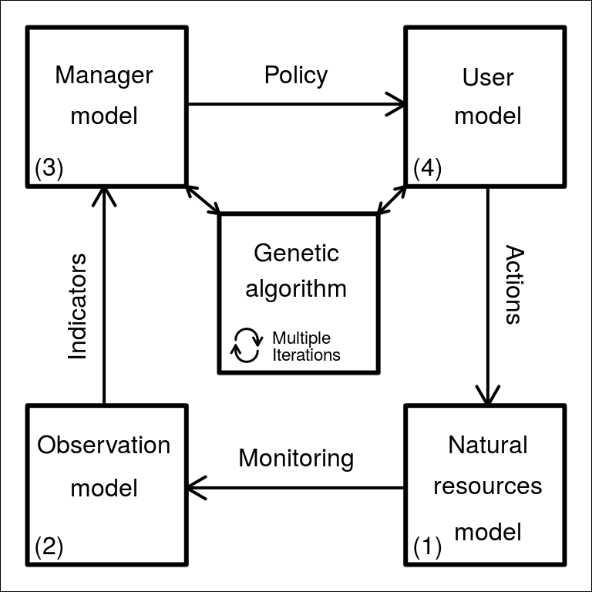

Results: Our simulations predict that management outcome is shaped by the interaction between management bias and user compliance levels. In simulations, non-compliance with harvesting rules was the primary driver of wildlife mismanagement, especially when management decisions were biased towards conservation interests. Predictions from our theoretical model were strongly correlated with those obtained from IUCN Red Listed species. The proportion of species showing a stable population trend was highest given high user compliance, particularly when harvest was regulated, while species populations were overwhelmingly decreasing when compliance was low.

Discussion: By combining existing management models with functions describing social processes driven by stakeholder goals, our modelling framework provides an important theoretical basis on which to build more reliable predictive tools that can support decision-making. Our joint theoretical and empirical analyses reveal the strong effect of user compliance on wildlife management outcomes, relative to management bias as a result of policy lobbying.

