Title:
Component response rate variation underlies the stability of complex systems
Authors & affiliations:
Please do not include Personal Data (email address, postal address, etc.) in this field. Include only author names & affiliations
A. B. Duthie
Biological and Environmental Sciences, University of Stirling
Abstract: (Your abstract must use Normal style and must fit in this box. Your abstract should be no longer than 300 words. The box will ‘expand’ over 2 pages as you add text/diagrams into it.)
Preparation of Your Abstract
1. The title should be as brief as possible but long enough to indicate clearly the nature of the study. Capitalise the first letter of the first word ONLY (place names excluded). No full stop at the end.
2. Abstracts should state briefly and clearly the purpose, methods, results and conclusions of the work.
Introduction: Clearly state the purpose of the abstract
Methods: Describe your selection of observations or experimental subjects clearly
Results: Present your results in a logical sequence in text, tables and illustrations
Discussion: Emphasize new and important aspects of the study and conclusions that are drawn from them
Introduction: Complex system stability generally decreases with increasing system size and interconnectivity, a counterintuitive result of widespread importance for socio-ecological systems. Properties of system components will cause them to respond to system perturbation at different rates (e.g., species generation times), but the consequences of such variation for stability are unexplored. Here I apply random matrix theory to test how variation in component response rate affects system stability.

Methods: A square matrix (A) models a network of interacting system components (e.g., an ecological community of species). Off-diagonal and diagonal elements of A model interactions between components and component self-regulation, respectively. I introduce a diagonal matrix (γ) to model component response rate variation effects on system dynamics. Simulations generate A and γ with elements sampled i.i.d. from known distributions, and eigenanalysis is used to determine whether or not systems are stable with and without γ for increasingly complex systems. Feasibility was checked for all systems, which assumes all components have positive values at equilibrium (e.g., species densities).

Results: As complexity increased, systems with varying component response rates were more likely to be stable than when response rates were uniform. Variation in component response rate was not stabilising per se; adding it to a particular system did not increase the probability that the system would be stable. Rather, highly complex systems that were stable were more likely to have varying component response rates critical for stability. Feasibility was unaffected by component response rate variation.

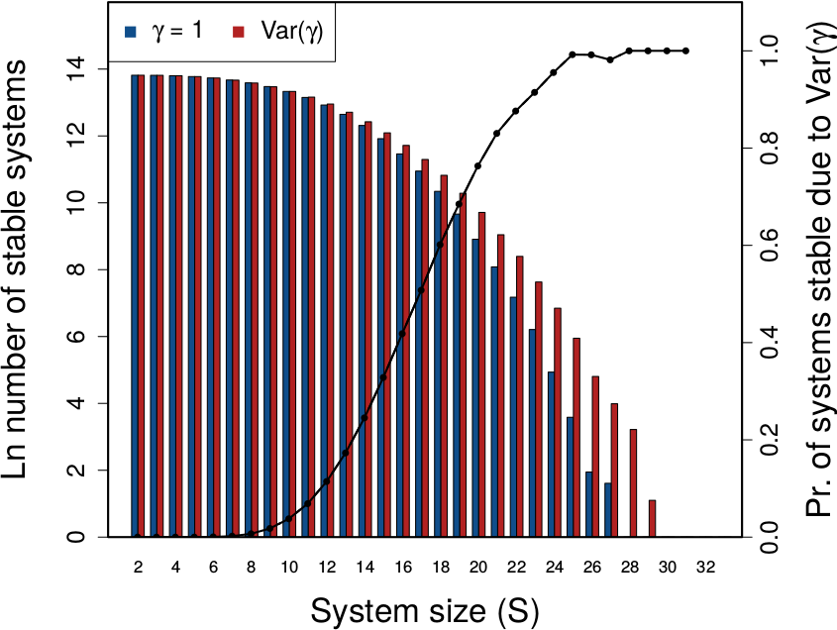

Discussion: Component response rate variation increases the upper bound of complexity at which stability can be realistically observed, so highly complex systems are more likely than not to vary in their component response rates, and for this variation to be critical for system stability. Hence, such variation might be critical for maintaining stability in many highly complex socio-ecological systems.

