**Research Proposal Ethics Checklist**  

To ensure integrity and safeguard the interests of researchers, participants and funders, all [research](https://www.stir.ac.uk/research/research-ethics-and-integrity/understanding-ethics/" \l "d.en.42102) conducted at, or through, the University of Stirling by members of staff, students (and their collaborators) is subject to internal ethical scrutiny **prior** to the commencement of research (**Figure 1**).

If you are aware that your [research](https://www.stir.ac.uk/research/research-ethics-and-integrity/understanding-ethics/" \l "d.en.42102) requires ethical approval by one of the Research Ethics Committees (RECs), completion of this checklist is **not** required. Please complete a **Research Proposal Ethical Approval Form** for the appropriate committee (see below) and submit this, along with any supporting documentation, via email to the committee secretary:

* **Animal Welfare and Ethical Review Body (AWERB)** – for research involving animals in any way (allnon-human vertebrates and invertebrates).
* **NHS, Invasive or Clinical Research (NICR)** – for health/patient research requiring approval by the NHS Research Ethics Committee and other research involving physically invasive procedures or intrusive interventions on human participants.
* **General University Ethics Panel (GUEP)** – for all other research (social, digital, environmental etc.).
* **Ethics Checklist -** If you are unsure about the ethical implications of your research, please complete the following Checklist. A completed and signed Checklist is required for **all** research proposals that have not been submitted for ethical review to one of the above committees. Once complete, this Checklist should be submitted to [ethics@stir.ac.uk](mailto:ethics@stir.ac.uk) apart from SMS students who should submit via Canvas.

**Figure 1: Ethics Decision Tree**

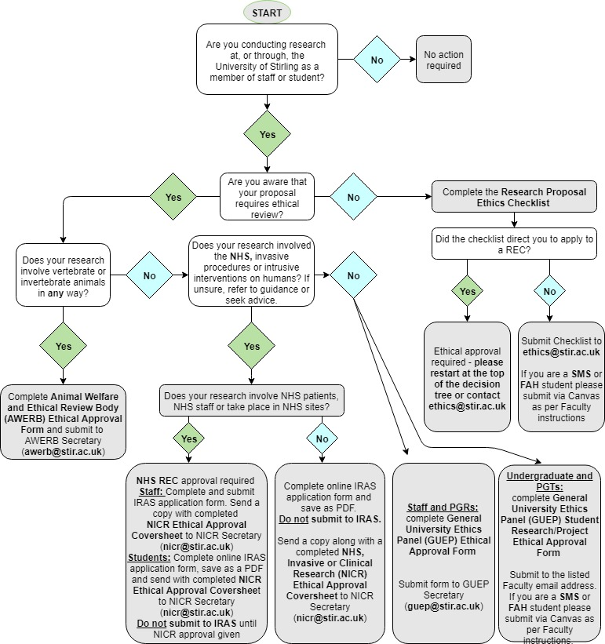

**Applicant details**

|  |
| --- |
| **Name of applicant: Alexander Bradley Duthie** |
| **Faculty affiliation:** Natural Sciences **Division:** NS Biological & Environmental Science  **Overseas campus:** If applicable click here to enter overseas campus affiliation |
| **Designation:** Research Staff |
| **Email address of applicant: alexander.duthie@stir.ac.uk** |
| **STUDENTS ONLY**  **Student ID number:** Click here to enter student ID number  **Degree programme:** Click here to enter text **Module code:** Click here to enter text.  **Supervisor name:** Click here to enter text |
| **STAFF ONLY**  **Job title: Leverhulme Early Career Research Fellow** |

**Project details**

|  |  |
| --- | --- |
| **Project title: Component response rate variation underlies the stability of complex systems** | |
| **Project funder: Leverhulme Trust** | |
| **Project start date:** 15/05/2019 | **Project end date:** 30/06/2019 |
| **Short project description:**  ***This project examines the stability of complex systems. It is entirely theory-driven, using the mathematics of random matrix theory and computer simulations to test whether or not complex systems that vary in system component response rates (i.e., how fast individual parts of a sytem respond to system perturbation) are likely to be more stable than systems in which component response rate does not vary. No data is collected or used.*** | |

**Please complete all sections which apply to your proposed research by checking Yes or No to each question.**

**SECTION A: Researcher safety**

|  |  |
| --- | --- |
| **A1.** Does the proposed research pose any particular risks to the researcher(s)?  Potential risks to consider include: working in a dangerous or isolated geographical area; lone working; working with equipment and manual handling; environmental hazards; chemical and biological hazards; and emotional risks associated with sensitive research. | **Yes  No** |
| If **YES** please complete a [risk assessment form](https://www.stir.ac.uk/research/research-ethics-and-integrity/ethics-forms/) and submit to your Faculty Safety Officer:  Click here to enter text | |
| |  | | --- | | ***PROCEED TO SECTION B*** | | |

**SECTION B: Research involving or impacting animals**

|  |  |
| --- | --- |
| **B1. Does your research project involve animals in any way?**  If YES, please submit an application to the Animal Welfare and Ethical Review Body (AWERB) ([click here](https://stir.box.com/s/03p7ztbre4ognd1u85vrxh0yiqad7rho)). | **Yes  No X** |
| |  | | --- | | ***IF NO PROCEED TO SECTION C*** | | |

**SECTION C: Research involving human participants**

|  |  |
| --- | --- |
| **C1. Does the proposed research involve human participants?**  **If YES *PLEASE COMPLETE QUESTIONS C2 – C12 below***  **If NO Please proceed to Section D** | **Yes  No** |
| **C2.** Does the proposed research involve the recruitment of staff or patients through the NHS or the use of NHS data or premises and/or equipment? Or take place in social care sites? | **Yes  No**  **If YES*, please submit an application to the*** [***NHS, Invasive or Clinical Research Committee***](https://www.stir.ac.uk/research/research-ethics-and-integrity/nhs-invasive-or-clinical-research/) |
| **C3 Does the proposed research involve:**  Research in health care settings in other countries  A clinical trial of an investigational medicinal product  A clinical investigation or other study of a [medical device](http://www.hra.nhs.uk/documents/2013/09/approval-of-medical-devices-research-version-2-april-2008.pdf)  A combined trial of an investigational medicinal product and an investigational medical device  Another clinical trial to study a novel intervention or randomised clinical trial to compare interventions in clinical practice  Working with human tissue samples (or other human biological samples) and data (specific project only) or Research tissue bank  Basic science study involving procedures with human participants:  Imaging investigations (MRI, ultrasound etc.)  Physical examinations (blood pressure, Pulse, Respiratory rate etc.)  Physical tests. (EEG, ECG, EMG, BioPAC etc.) If using EEG and following the University of Stirling’s [approved protocol](https://stir.box.com/v/EEGProtocol) please apply to GUEP.  Computer tests where there are potential health consequences e.g. dementia, sleep apnoea, depression tests  Filming or photography (as part of a health research study or in a health setting/context)  Sample-taking.  Questionnaires, surveys or interviews/focus groups with sensitive questions with implications for health (e.g. depression, mental health etc) | **Yes  No**  ***If YES, please submit an application to the*** [***NHS, Invasive or Clinical Research Committee***](https://www.stir.ac.uk/research/research-ethics-and-integrity/nhs-invasive-or-clinical-research/)***.*** |
| **C4.** Does the proposed research involve interviews with participants or the use of questionnaires? | **Yes  No** |
| **C5.** Does the proposed research involve [vulnerable adults](http://www.gov.scot/Publications/2009/01/30112831/3)? | **Yes  No** |
| **C6.** Does the proposed research involve children and young people under the age of eighteen? | **Yes  No** |
| **C7.** Does the proposed research involve participants who have particular communication/linguistic or developmental requirements? | **Yes  No** |
| **C8.** Does the proposed research involve [sensitive topics](http://www.esrc.ac.uk/funding/guidance-for-applicants/research-ethics/research-that-may-require-full-ethics-review/)? | **Yes  No** |
| **C9.** Could the proposed research induce psychological stress, anxiety or humiliation? | **Yes  No** |
| **C10.** Does the proposed research involve [deception, concealment or covert observation](https://stir.box.com/s/gjjxlyivsbhtk333m3jb0iu2n2oorku5)? | **Yes  No** |
| **C11.** Does the proposed research involve prisoners or those on court orders? | **Yes  No** |
| **C12.** Will the proposed research be undertaken outside of the UK or involve participants from outside the UK? | **Yes  No** |
| |  | | --- | | ***IF YES to C4 – C12 please apply to the*** [***General University Ethics Panel***](https://www.stir.ac.uk/research/research-ethics-and-integrity/general-university-ethics-panel/) | | |

**SECTION D: Data protection, copyright and other considerations**

|  |  |
| --- | --- |
| **D1.** Does the proposed research involve the [remote acquisition of data](https://stir.box.com/v/IMREthics) from or  about human participants using the internet and its associated technologies | **Yes  No** |
| **D2.** Does the proposed research involve accessing potentially sensitive data through third parties? | **Yes  No** |
| **D3.** Does the proposed research involve reproducing [copyrighted work](http://libguides.stir.ac.uk/copyright) in published form (other than brief citation)? | **Yes  No** |
| **D4.** Does the proposed work involve activities, which could temporarily or permanently damage or disturb the environment, or archaeological remains and artefacts? | **Yes  No** |
| **D5.** Does the proposed work involve a potential conflict of interest or raise ethical issues regarding the source of funding or where publication of research data may be restricted? | **Yes  No** |
| ***IF YES to D1 – D5 please apply to the*** [***General University Ethics Panel***](https://www.stir.ac.uk/research/research-ethics-and-integrity/general-university-ethics-panel/) | |
| |  | | --- | | ***IF NO PLEASE SIGN AND DATE*** | | |

Applicants are strongly encouraged to complete the Research Integrity training that is available via [Canvas](https://canvas.stir.ac.uk/enroll/CJ43KW)

If you have answered **YES** to any of these questions, further ethical review is required. Please seek advice from Research and Innovation Services ([ethics@stir.ac.uk](mailto:ethics@stir.ac.uk)) orcomplete the appropriate **Research Proposal Ethics Approval form**. If you have answered **NO** to all of the questions, sign and date the form and email it to [ethics@stir.ac.uk](mailto:ethics@stir.ac.uk).

By signing below (digital signatures accepted), you certify that the information provided is true and correct to the best of your knowledge. Applicants should expect to get an acknowledgement within 48 working hours that their checklist has been received. If you do not hear, please contact [ethics@stir.ac.uk](mailto:ethics@stir.ac.uk)

**STUDENTS**

**Applicant’s signature: Date:** Click here to enter a date

**Supervisor’s signature: Date:** Click here to enter a date

**STAFF**

**Applicant’s signature:**  **Date:** 01/05/2019

|  |
| --- |
| **FOR ADMINISTRATIVE USE ONLY:**  **Date received:** Click here to enter a date **Reference number:** Select year**/**Click here to enter number  **Checklist completed, signed and dated  For archiving  Query if further ethical review required**  **Notes:**  Click here to enter text |