Week 1: Practical

# Questions

This document includes fields for answering questions for the Week 1 practical. You do not need to turn this in, or even use it. A separate file to keep track of your progress, or a pen and paper, are completely fine.

## Exercise 1: Transferring data to a spreadsheet

Fill in 1 and 3 below with potential causes of error

1. Answer: Seeds are tallied incorrectly
2. Answer: Tallies are not counted correctly in the lab notebook
3. Answer: Counts are not correctly input into spreadsheet

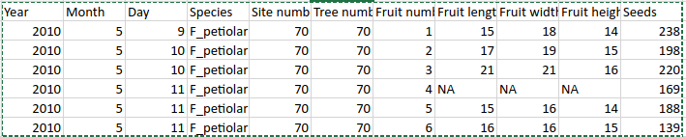

## Exercise 2: Making spreadsheet data tidy

How many columns did you need to create the new dataset?

2 columns

Are there any missing data in this dataset?

No missing data

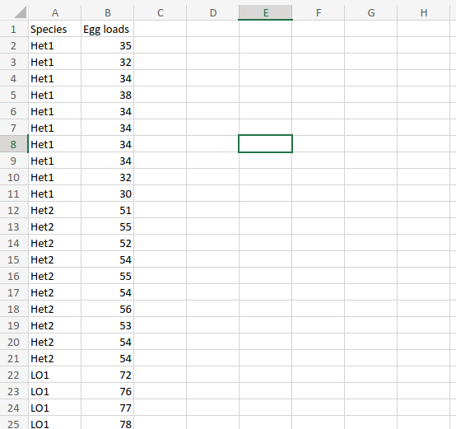

## Exercise 3: Making data tidy again

No questions were asked.

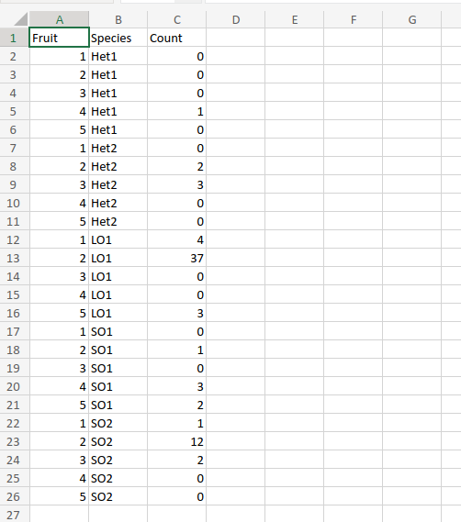

## Exercise 4: Tidy data and spreadsheet calculations

What columns should this new dataset include? Write your answer below.

Species, wasp number, Head length (mm), Head width (mm), Thorax length (mm), Thorax width (mm), Abdomen length (mm), Abdomen width (mm)

How many rows are needed?

26 rows of data (plus the header column)

What formula will you type into your empty spreadsheet cell to calculate Vthorax? Keep in mind the order of operations indicated in the equation above.

= (4/3) * 3.14 * (E2/2) * ( (F2/2)^2 )

What are some reasons that we might want to be cautious about our calculated wasp volumes? Explain in 2-3 sentences.

There is error associated with the measurement of fig wasp dimensions (e.g., length, width). There is also error because we are assuming that the head is a sphere and the thorax and abdomen are ellipses. These errors could compound on one another.

