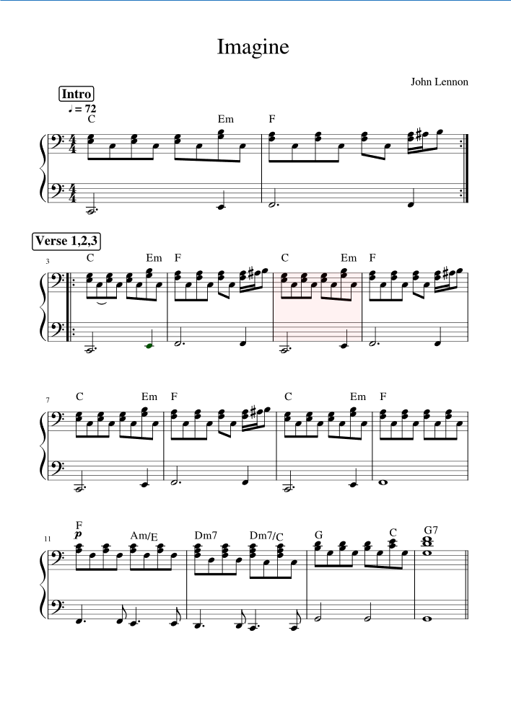

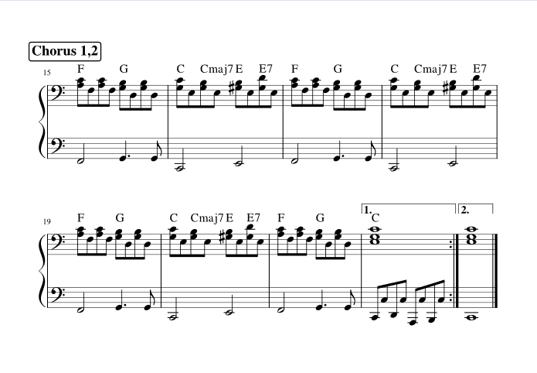

Imagine there's no heaven  
It's easy if you try  
No hell below us  
Above us only sky  
Imagine all the people  
Living for today... Aha-ah...  
  
Imagine there's no countries  
It isn't hard to do  
Nothing to kill or die for  
And no religion, too  
Imagine all the people  
Living life in peace... You...

You may say I'm a dreamer  
But I'm not the only one  
I hope someday you'll join us  
And the world will be as one

Imagine no possessions  
I wonder if you can  
No need for greed or hunger  
A brotherhood of man  
Imagine all the people  
Sharing all the world... You...  
  
You may say I'm a dreamer  
But I'm not the only one  
I hope someday you'll join us  
And the world will live as one