Group: David Ott and Bradford Smith

AbsenceCheck: Student Attendance Tracker and Notifier

**Low-level Design Document**

AbsenceCheck will include four subclasses: ac-config, ac-attendance, ac-notify, and ac-stats. Another class to be used will be one for accessing files, probably being provided by an outside library (io class, Python built-in).

* ac-config
  + will include the teacher’s name and email and a description

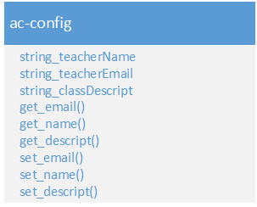

* ac-attendance
  + will use io (for reading from files)
  + will include the class attendance in some list of Student objects

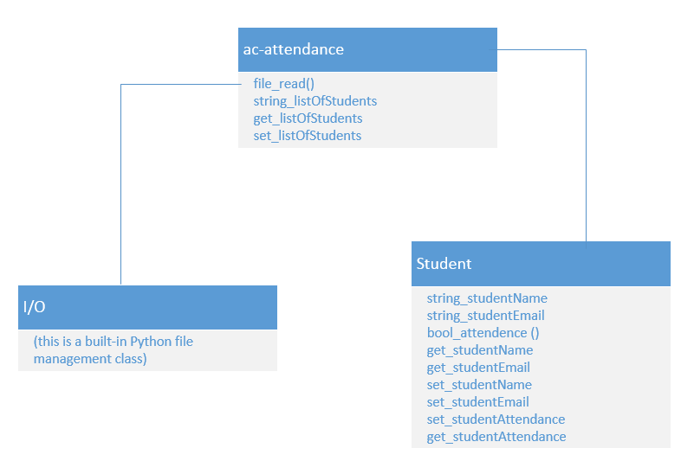

* ac-notify
  + will have an object of ac-config (for the email sender and body) and one of ac-attendance (to send emails to only the absent students)

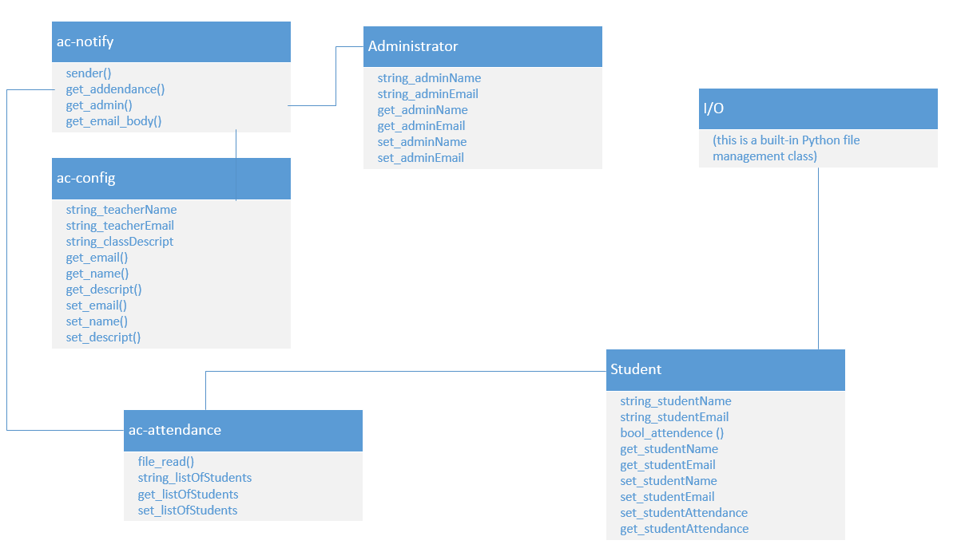

* ac-stats
  + will have an object ac-config (to get email sender), ac-attendance (to update cumulative attendance) and one of ac-notify (to send email to administrators, if desired)

