|  |
| --- |
| Hewlett-Packard |
| [Type the document title] |
| [Type the document subtitle] |
|  |
| **bvt** |
| **[Pick the date]** |

|  |
| --- |
| [Type the abstract of the document here. The abstract is typically a short summary of the contents of the document. Type the abstract of the document here. The abstract is typically a short summary of the contents of the document.] |

# C4 Model Context Views

## Device Level Context Views

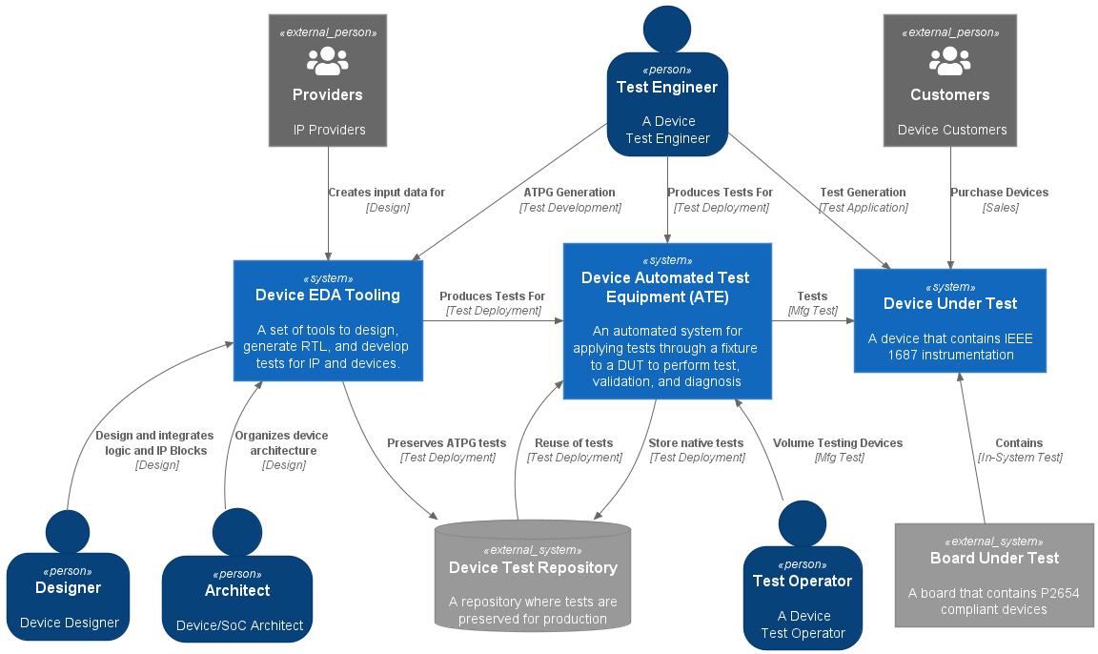

Figure : Device Context

## Board Level Context Views

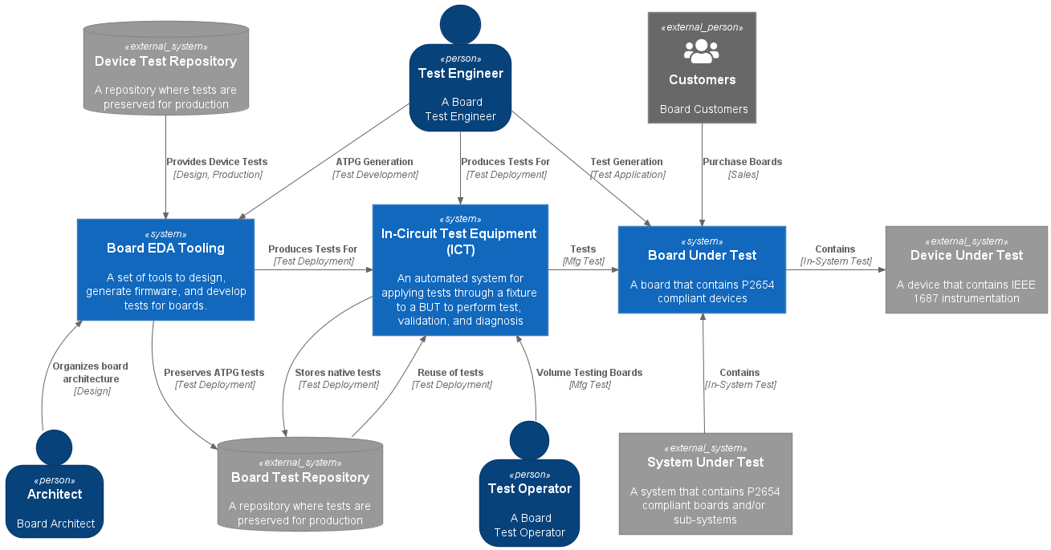

Figure : Board ICT Context

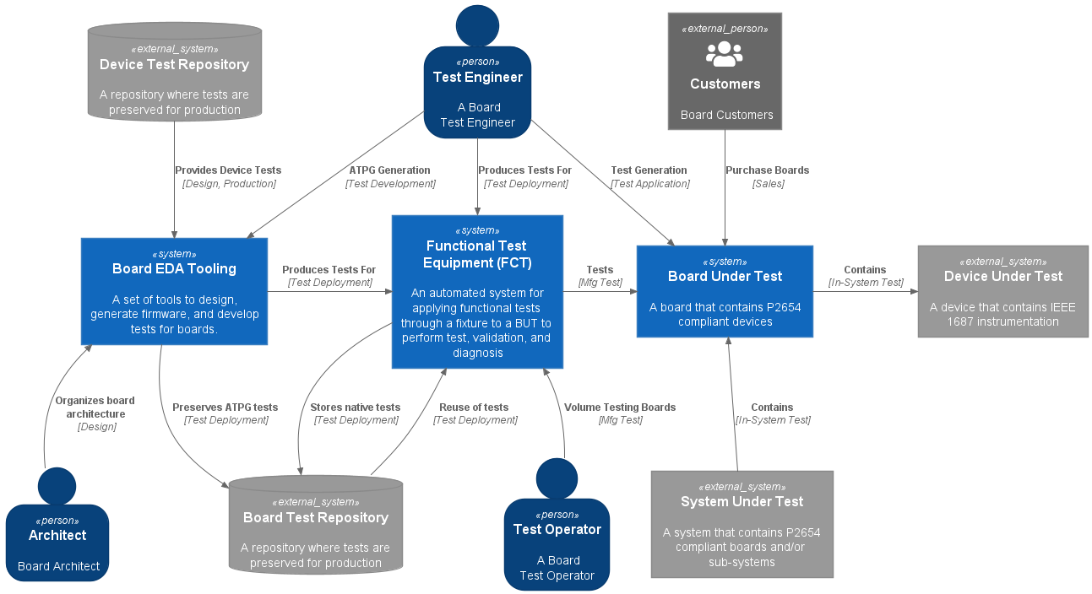

Figure : Board FCT Context

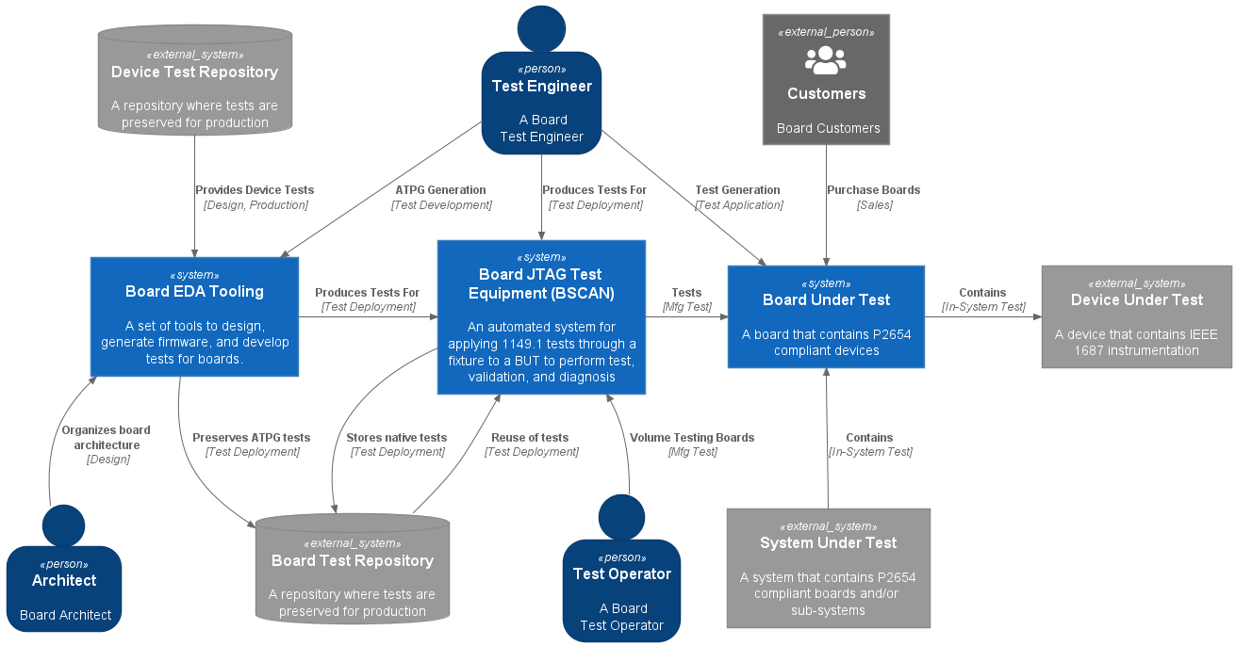

Figure : Board JTAG Context

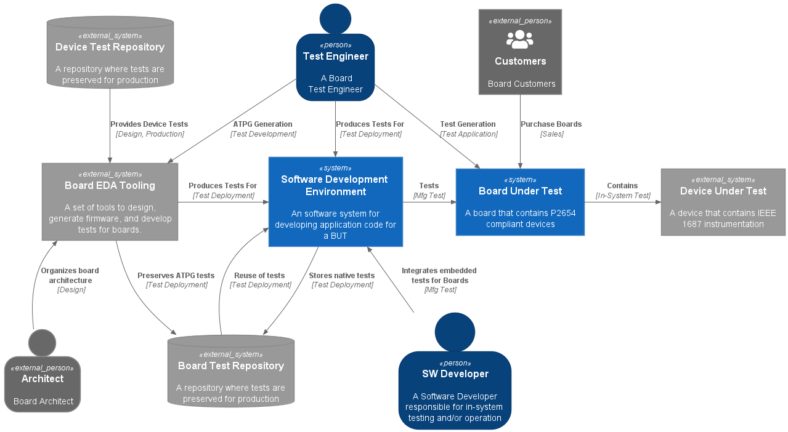

Figure : Board Embedded System Context

## System Level Context Views

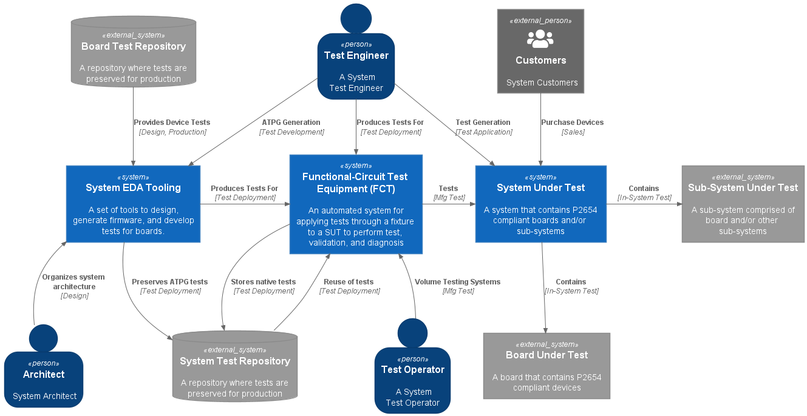

Figure : System FCT Context

# C4 Model Container Views

## Device Level Container Views

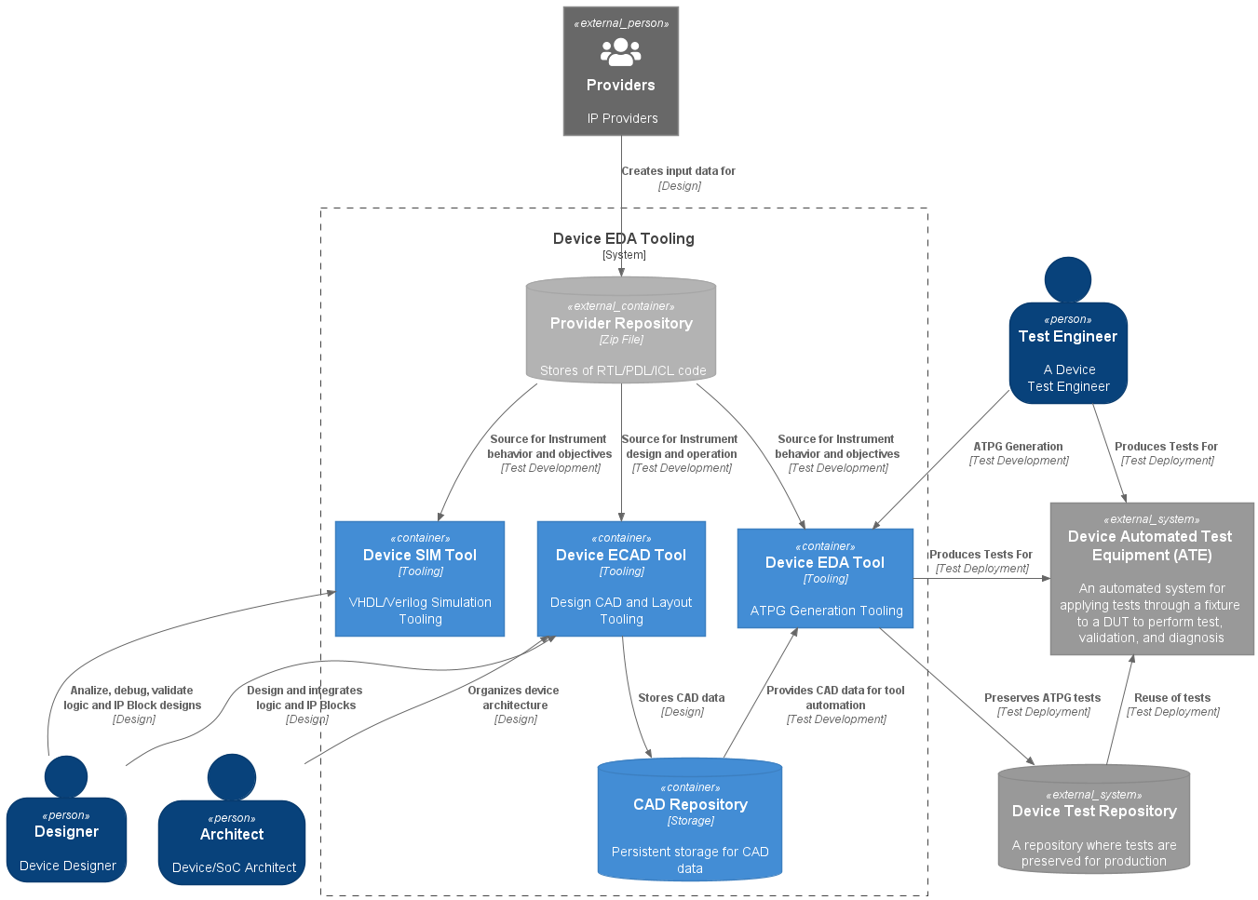

Figure 7: Device EDA Tooling System Containers

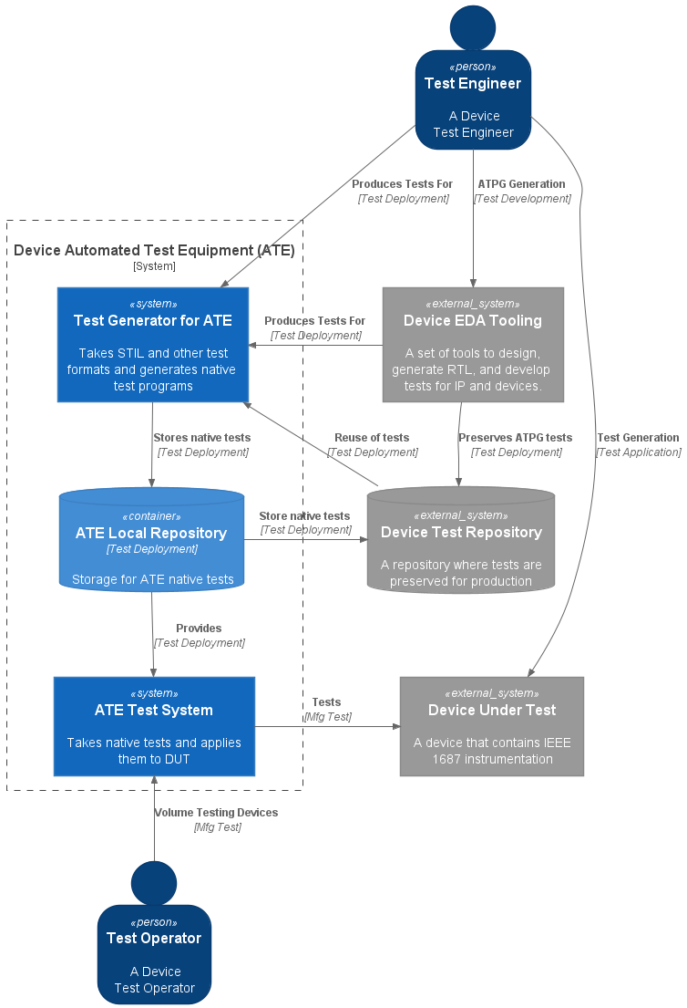

Figure : Device ATE System Containers

## Board Level Container Views

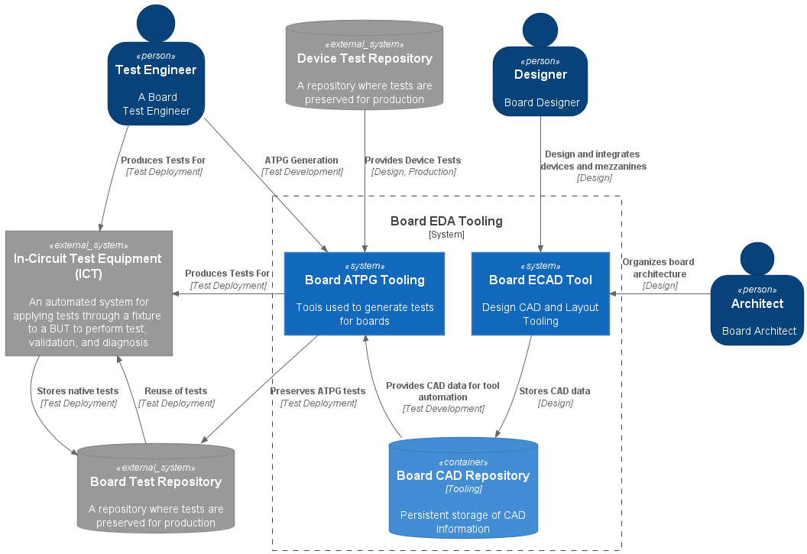

Figure : Board EDA Tooling System Containers

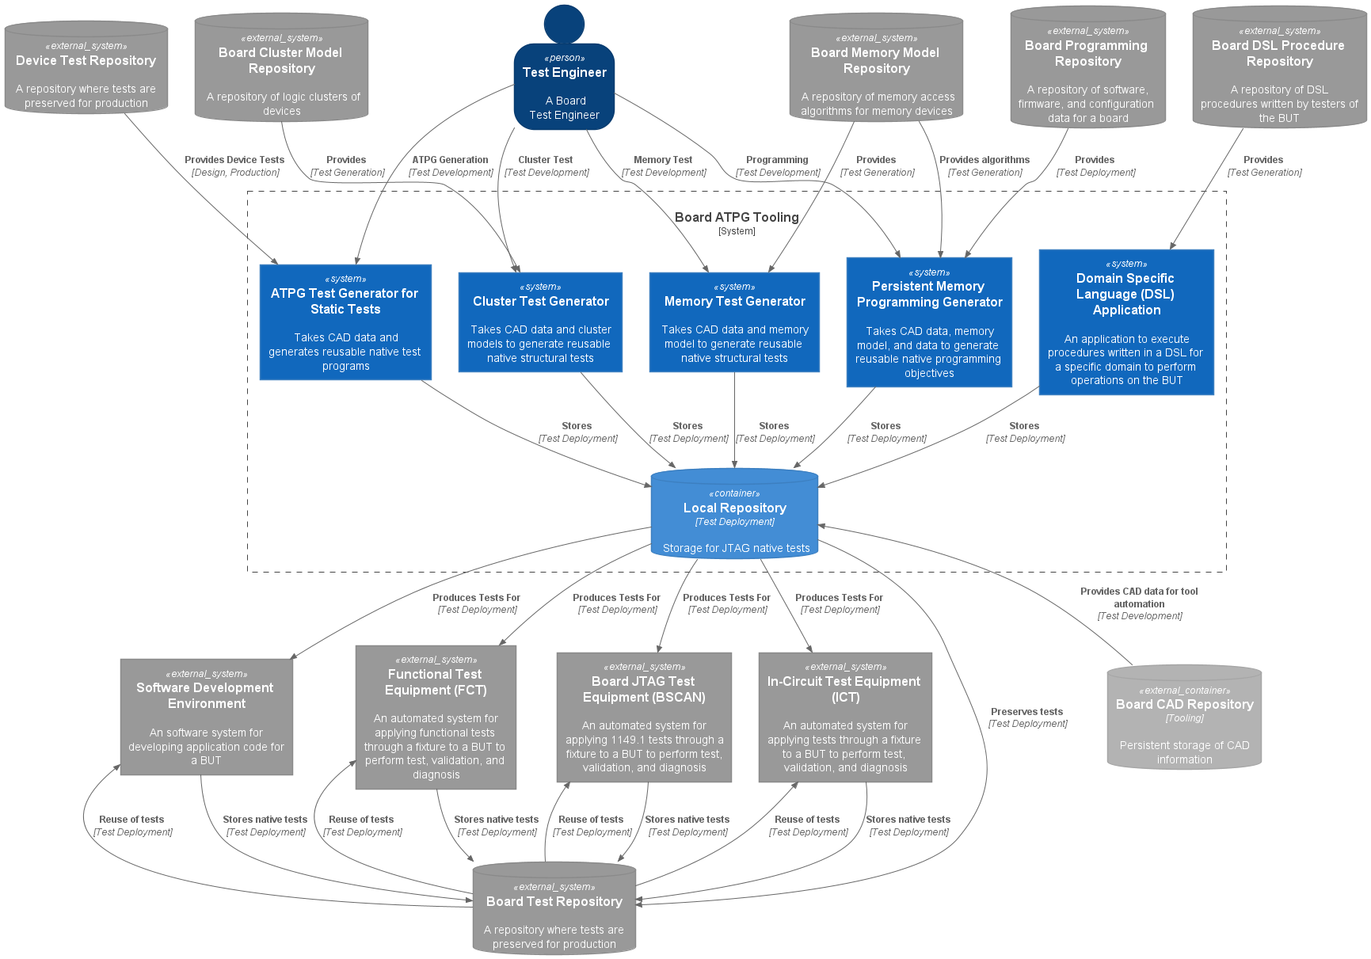

Figure : Board ATPG Tooling System Containers

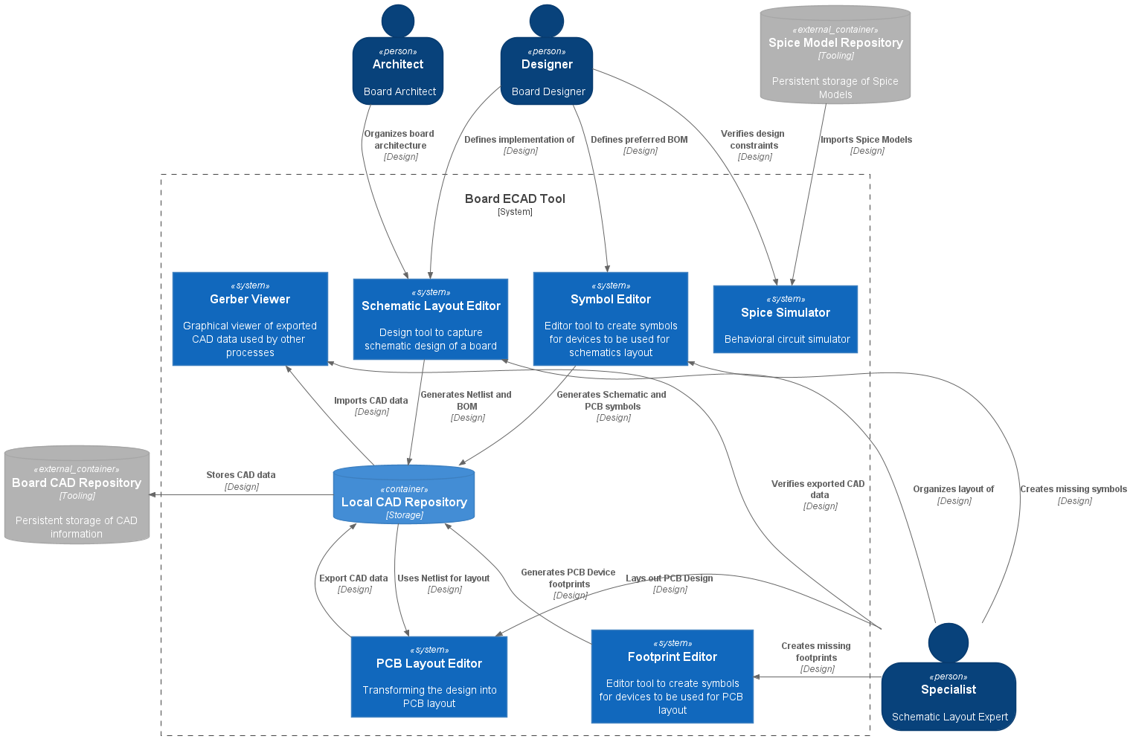

Figure : Board ECAD Tooling Containers

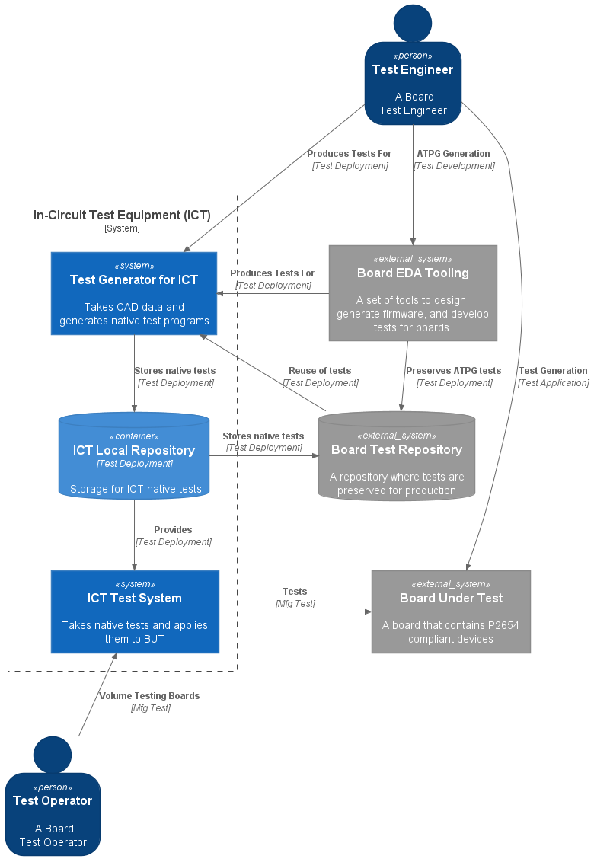

Figure : Board ICT System Containers

## System Level Containers Views

# C4 Model Component Views

## Device Level Component Views

## Board Level Component Views

## System Level Component Views

# C4 Model Code Views

## Device Level Code Views

## Board Level Code Views

## System Level Code Views