SE 319

Assignment 1 Report

Brad Gannon

For this assignment, I took the code provided for Lab 1 and made some additions and edits to conform to the specifications given. Firstly, I removed the parts of the code that listed information about the server, port number, address, and so forth. Also, I added some code in the client portion of the given code to prompt the user to provide their name and format it correctly. Lastly, I added a section to remove a client from the server if they send a specific message of “bye” or “Bye”. Here are screenshots of the desired output:

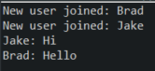

*Server console showing messages when new user joins and what they send*



*Sample of how it looks for prompt to enter name*

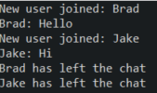

*Server console of users leaving chat*

I struggled to figure out how to broadcast messages from the server to the individual clients, however messages from the client are broadcasted back to the server. I tried implementing an ArrayList with the clients and sending messages from a client back to everyone in the ArrayList (except the sender), but this started causing errors elsewhere and I did not understand why. Overall, my code is essentially a repurposing of the lab code with some modifications to make it more functional in regard to the assignment specifications.