WE DEVELOP SOFTWARE LLC × KEONA HEALTH

ChristEye
  - Creation, intelligence, restoration and the future of medicine
A multidisciplinary research vision and mathematical prospectus
Developed by We Develop Software LLC | Proposed translational collaboration with Keona Health
November 2026 • Version 1.0
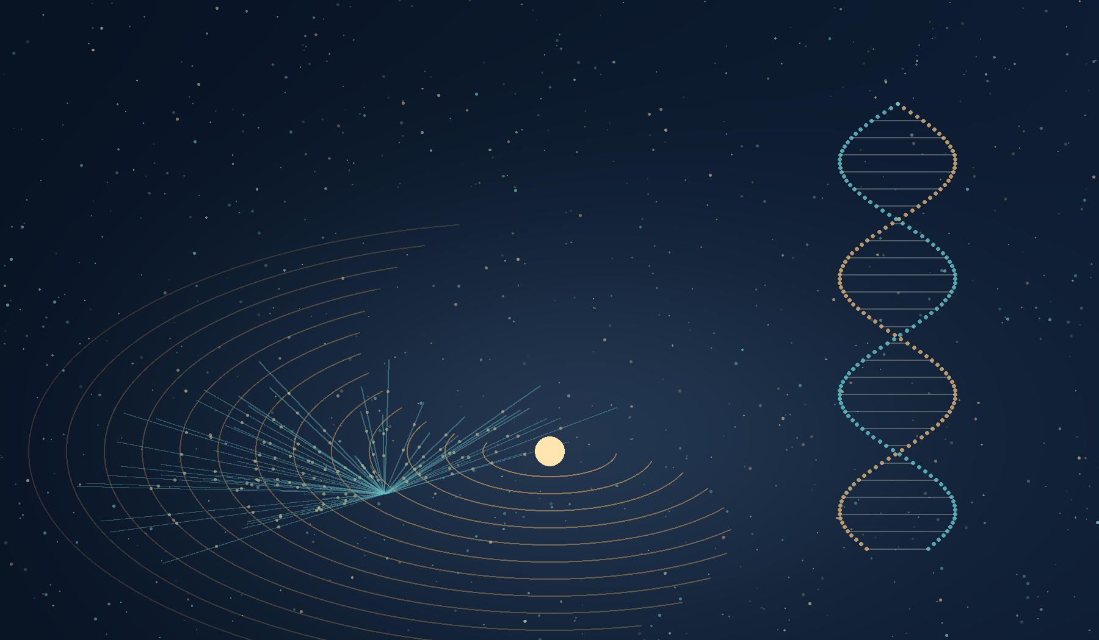
An artistic interpretation of a single thought unfolding into physical and living order.
A program for asking how possibility becomes persistent reality, how knowledge becomes understanding, and how damaged systems may recover their capacity for life.

The thought before the dust
Imagine the universe, and every speck of dust within it, first held as a thought in the mind of God. A thought does not arrive all at once in its final detail. It gathers shape, deepens into relationships, creates possibilities and continues to unfold. In this theological vision, creation likewise develops in the divine imagination until the moment when God manifests the forms of living creatures from the dust of the Garden.
The image is particularly striking: the forms of animals and human beings exist within an unfolding creation, and God takes what we might call a snapshot of those forms—not a photographic or laboratory event, but an act of divine intention—and gives embodied existence to what was contemplated. The dust is not insignificant. It becomes the site where thought, structure and living expression meet.
This is the creator's metaphysical interpretation of Genesis and creation. It is neither an experimental account of the origin of species nor a replacement for evolutionary biology or cosmology. Its value within ChristEye is the question it inspires: How can an initial possibility become a durable, functioning reality?
ChristEye takes that question seriously across disciplines. An embryo develops from inherited instructions and environmental signals. A neural connection changes through experience and retains a trace. A physical system crosses a threshold and settles into a persistent state. A physician identifies an early warning signal and acts to preserve an organism before damage becomes irreversible. These are not the same mechanisms; they are episodes in which possibility, influence, constraint and continuity can be studied together.
THE FOUNDATIONAL CONVICTION
Creation is not exhausted by the emergence of matter. What matters also is the ability of an organized system to maintain its integrity, receive and preserve information, respond wisely, and bring forth good Fruit. That conviction is the spiritual source of the ChristEye research program.

Executive perspective
We Develop Software LLC has developed ChristEye as a growing research architecture spanning adaptive computation, neural–glial memory, molecular signaling, physical transfer, system restoration and therapeutic control. Across 30 supplied research and concept documents, the program introduces a six-part core ontology—Soul, Lotus, Marrow, Winds, Roots and Heart—alongside Milk–Honey processes, Response Arbitration, Crown, Sylph, Viral Sanctuary, the Heart Engine and quantitative models of conservation and recovery.
The proposed collaboration with Keona Health connects this architecture to a patient-centered medical ambition: intelligent surveillance, earlier recognition of harmful biological changes, selective biologic intervention, and safe restoration of function. Potential future research includes therapeutic bacteriophages for certain bacterial infections, antiviral decoys, appropriately controlled viral therapeutics, and cancer-surveillance systems that learn from clinically validated data. None of these ChristEye-specific medical capabilities is established as safe or effective in humans today.
The program also looks outward—from a cell to a planet, from particle annihilation to black-hole information—and asks whether certain abstract relationships recur across scales: exchange, memory, constraint, state transition, judgment and measured consequence. Its scientific promise will be earned through falsifiable models and comparisons with existing physics, biology and medicine, not through metaphor alone.
Evidence tier | Meaning in this document
Established | Supported physical, biological or clinical mechanism, with ordinary limits of evidence.
Emerging | Reported research with incomplete replication, generalization or clinical translation.
Proposed | A ChristEye model, device architecture, measure or experiment that remains to be validated.
Speculative | A long-horizon possibility without a demonstrated enabling physical mechanism.
Theological | A faith-based interpretation or ethical motivation; not a laboratory measurement.

At a glance
Research scale | Principal question | Nearer-term output
Biological | How do signals and resources produce durable repair? | Four-Stream models, cell studies, controlled assays
Computational | Can retained learning improve safe choices? | Heart Engine and Sylph controllers
Medical | Can validated detection guide selective action? | Research-grade surveillance and decision support
Physical | How do transfers and history constrain change? | Conservation-led simulations and particle-event analysis
Cosmic | Which information and structural principles cross scales? | Falsifiable predictions, not claims of cosmic therapy

PART 1

The architecture of becoming
The original ChristEye language becomes scientifically useful when each concept has a distinct role, an observable counterpart and a clear evidence boundary.

1 Eight related components
The Soul names the identity and continuity of the whole. Marrow names inherited potential and the structural constraints from which an organism or device begins. Lotus names coordination, growth and action. Winds name typed exchanges of energy, matter, electrical activity or information-bearing physical signals. Roots name history and persistent support. Heart names need, value and response selection. The wider ChristEye vocabulary adds Spirit, the philosophical language for initiating influence, and Fruit, the measured consequences of a matured understanding.
Component | Scientific or engineering interpretation | Limit
Soul | System boundary, integrity and provenance | No detected soul variable
Spirit | An initiating influence or motivating concept | No verified independent spiritual force
Marrow | Genotype, lineage, physical constraints, architecture | Not a command to create arbitrary life
Lotus | Growth, action, state estimation, adaptation | Not a universal control organ
Winds | Explicit carrier, direction, rate and response pathway | Information is not free energy
Roots | Persistent molecular, cellular, neural or structural history | Not all persistence is conscious memory
Heart | Needs, priorities, safety and bounded arbitration | Optimization is not moral consciousness
Fruit | Measured durable function and consequences | Success must be defined per beneficiary

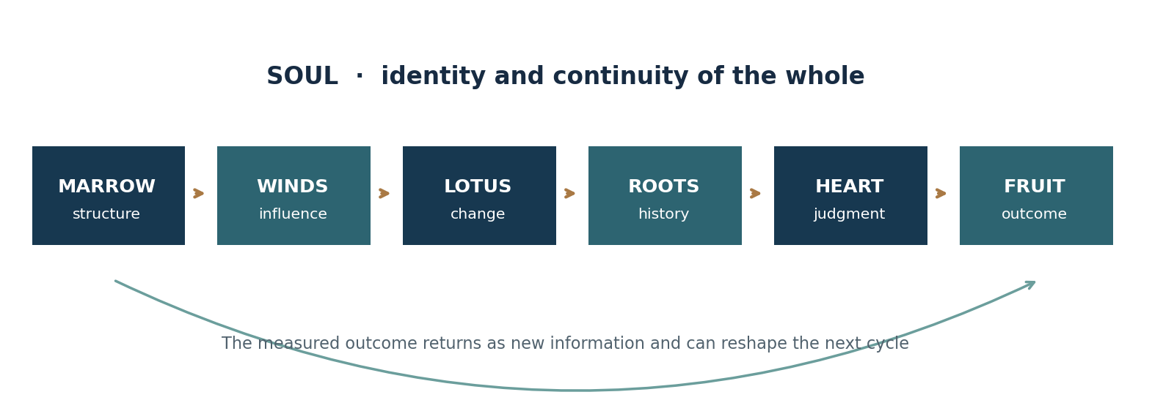
Figure 1. A functional architecture of development and feedback; not a claim that all systems literally possess a Soul or Heart.
What the architecture enables immediately is disciplined system modeling. An investigator must name the beneficiary, define the boundary, enumerate constraints, measure transfers, model persistent states and evaluate outcomes. It is this discipline—not the vocabulary by itself—that can improve engineering practice.

2 Honey pulls and Milk raises
In ChristEye, Honey denotes influences of recognition, attraction, recruitment or redirection. Milk denotes the resources and conditions under which a state can grow and persist. Their distinction is profound: a system can receive an invitation to change without having enough support to make the change durable; conversely, resources can be abundant while no appropriate transition is selected.
The four-process model further separates beneficial recruitment and support from harmful signaling and persistent dysfunction. These labels are relative to a defined beneficiary and endpoint: inflammation can be protective or damaging; nutrients can support healthy cells or pathogens; a pathway cannot simply be branded good or evil without context.
ChristEye process | Operational variable | Research meaning
Honey of Evil | H · damaging extracellular influence | A defined signal associated with a harmful transition
Milk of Evil | D · sustained dysfunction | A continuing state after the original challenge
Honey of Good | R · restoration-oriented signal | A defined influence associated with repair or resolution
Milk of Good | M · support adequacy | Metabolic, ionic and structural conditions supporting function

This produces an important experimental prediction: turning off a harmful signal may not reverse the state it already established. A successful restoration program may need to interrupt the source, redirect relevant signaling, rebuild resources and verify functional recovery after the intervention is withdrawn.

3 The twelve families of Winds
ChristEye originally used Winds for electrical, chemical and physiological flows. The expanded taxonomy recognizes twelve families, grouped by measurable carrier rather than by unverified spiritual properties.
Family | Established carriers or mechanisms | Potential role
Electromagnetic | Photons; radio through gamma radiation | Energy transfer and encoded signals
Particle | Electrons, positrons, protons, neutrinos | Particle/charge/momentum transfer
Molecular | Hormones, cytokines, neurotransmitters | Context-dependent biochemical messages
Electrical | Membrane potentials and ionic currents | Rapid biological signaling
Intracellular | Calcium and regulatory cascades | State translation inside cells
Gravitational | Gravitational interactions and waves | Motion and spacetime response
Mechanical | Pressure, vibration, fluid forces | Deformation, transport and sensing
Epigenetic | Regulatory inputs affecting chromatin | Longer-lived changes in expression
Interorganismal | Pheromones, vesicles, microbial products | Communication between organisms
Informational | Encoded patterns in physical carriers | Uncertainty reduction
Thermodynamic | Heat transfer and energy gradients | Work potential, loss and dissipation
Fields and plasma | Electric/magnetic fields, plasma streams | Charged-particle organization

A second classification concerns the job that a Wind performs. Inviting Winds change receptivity; Guiding Winds shape direction; Raising Winds support development; Communicating Winds carry distinguishable messages; Regulating Winds stabilize or end processes; Returning Winds carry consequences back to the source. These are functional descriptions, often overlapping, not six new fundamental forces.
Every scientific Wind requires a ledger: transmitted entity, carrier, source, recipient, units, rate, coupling mechanism, uncertainty and whether the effect is measured or merely inferred. This ledger prevents a conceptual analogy from quietly violating energy or mass conservation.

4 Roots and the memory of the universe
The strongest extension of Roots is the Principle of Persistent Influence: past interactions can leave measurable traces in present physical states. Crystals preserve lattice order. Molecules preserve bonding relationships. DNA preserves inherited sequences. Epigenetic and neural systems preserve some effects of experience. Geological formations preserve environmental history. Certain dynamical systems exhibit explicit history dependence.
A striking counterpart is gravitational-wave memory: in general relativity, a passing burst of gravitational radiation can leave a lasting relative displacement in an idealized array of free objects. This is not human memory and not a universal spiritual storage device. It is a reminder that physical history can be written into configurations and correlations.
The test is not whether every object can metaphorically be said to remember. The test is whether a precisely defined history variable improves the prediction of a future measurable response after controlling for the current state. That is how Roots could move from a fruitful metaphor to a reproducible modeling advantage.

5 Heart and the discipline of judgment
ChristEye Response Arbitration separates retained knowledge, access to that knowledge, valuation, immediate need and the selected action. An organism may remember what is beneficial yet respond differently when energy is scarce or inflammatory signals modify its state. A controller may contain the correct rule yet be unable to access it under noise. Treating these as different failure modes makes intervention more precise.
Judgment is proposed as nine linked processes: reception, verification, understanding, need recognition, consequence prediction, harm assessment, arbitration, execution and Fruit assessment. The beneficiary must be specified, as well as who else may be affected.
In medicine, this requires an independently defined set of permissible actions, hard safety limits, uncertainty thresholds, human review and a stop mechanism. A learned reward function must never authorize an unsafe intervention simply because another objective scores highly.
PART 2

Restoration oriented medicine
The translational vision connects biologically selective tools with validated sensing, adaptive analysis and carefully bounded clinical action.

6 We Develop Software LLC and Keona Health
We Develop Software LLC is the originator of the supplied ChristEye theory and research portfolio. A proposed collaboration with Keona Health would focus on the clinical translation of software-supported sensing, triage, longitudinal monitoring and decision support, subject to actual agreements, clinical oversight, regulatory requirements and independent validation.
The opportunity is not one magic medicine. It is a modular and staged platform: observe a defined state, compare it with a reliable baseline, estimate risk, select an allowed response, deploy only a separately validated intervention and learn from measured outcomes. Medical care remains governed by clinicians and evidence.
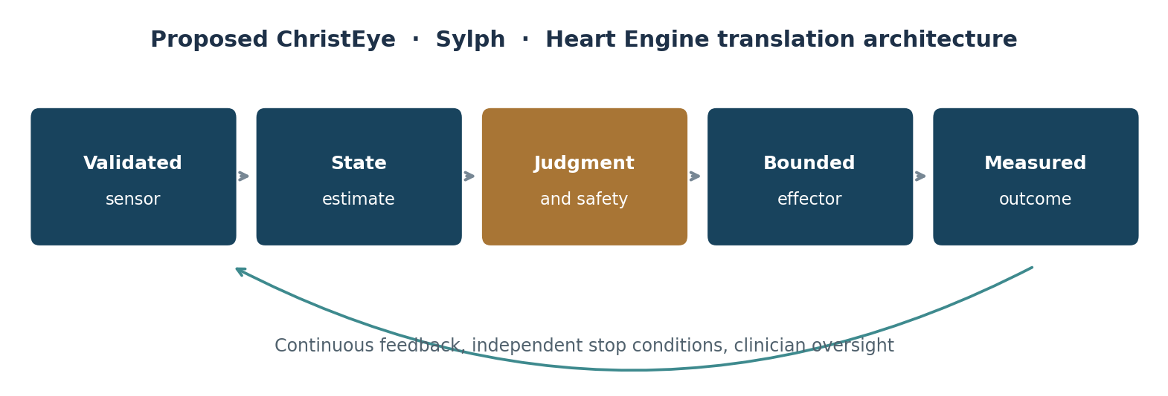
Figure 2. Proposed separation of sensing, decision support, safety authority and therapeutic action.

7 Healing phages and therapeutic viral systems
Bacteriophages are viruses that infect bacteria. Their host specificity creates opportunities for highly targeted antibacterial research, particularly where antibiotic resistance creates difficult clinical problems. Specificity is also a constraint: a phage active against one bacterial strain may fail against another, and bacteria may evolve resistance. Therapy requires validated identity, quality controls, microbiological susceptibility, safety assessment, dosing research and clinical trials.
ChristEye healing phages are therefore an aspiration for host-protective bacteriophage programs, not an already invented universal cure. The proposed contribution is a selective design-and-monitoring architecture: identify the harmful bacterial target, preserve beneficial organisms where possible, measure the host response and detect whether treatment changes resistance or inflammation.
The source documents also investigate Arbitrium, a real molecular communication system in certain bacteriophages that can bias lytic versus lysogenic regulation. This makes it a scientifically interesting model of context-sensitive viral decisions. It does not mean an independent human Arbitrium network has been discovered, nor that phages possess neurons, conscious intent or moral judgment.
ChristEye restorative viri is a broad research umbrella for carefully differentiated technologies: receptor-binding decoys that interrupt viral attachment; noninfectious viral models used in screening; approved or investigational oncolytic viruses that act in particular cancer contexts; and speculative viral mutualism strategies requiring much stronger evidence. A virus that protects one cell type might still threaten another, so any live-virus development belongs under formal biosafety and clinical oversight.
Existing medicine offers one important proof of principle: talimogene laherparepvec (T-VEC), an oncolytic herpesvirus therapy, is used for certain unresectable melanoma lesions. That approval supports the general concept of therapeutic viruses; it does not validate a ChristEye-specific viri platform or generalized cancer prevention. [E2]

8 Viral Sanctuary and molecular redirection
The ChristEye Viral Sanctuary concept proposes drawing harmful viral binding away from vulnerable tissue. Its nearer-term testable form is a nonpermissive, receptor-bearing decoy or noninfectious mimic that competes for binding. The idea is chemically intelligible: molecules bind through defined interactions, and the outcome depends on affinity, avidity, receptor availability and cellular context.
The safest initial experiments use noninfectious particles, purified components, or computational binding models. The goal is to demonstrate reduced target engagement without producing a new environment that supports viral replication. A true reciprocal viral–host mutualism would be an entirely separate evolutionary and clinical claim.
From the Milk–Honey perspective, a decoy can be a candidate recruiting influence, whereas an adequately supported healthy host cell reflects Milk of Good. The model therefore forces two questions: did the intervention redirect the particle, and did it preserve the host's function?

9 Sylph and cancer surveillance
Sylph is the proposed adaptive surveillance arm of ChristEye. Its long-horizon purpose is to learn clinically meaningful patterns of health, recognize emerging pathological changes and coordinate a safe response while minimizing injury to normal tissue. The current defensible design begins with data, not with an injected autonomous neural system.
A research-grade Sylph architecture might combine validated laboratory measurements, imaging outputs, longitudinal symptom history, pathology-confirmed diagnoses and carefully calibrated models. It would distinguish normal variation, injury, infection and malignant signals using prospective validation and control for confounding. An independent clinical safety authority would determine whether a recommendation is permitted.
Cancer surveillance, early detection, prevention and treatment must remain distinct. Finding a tumor earlier does not automatically prove that screening reduces deaths. The US National Cancer Institute notes that multicancer detection tests remain under clinical investigation and lack definitive evidence of overall cancer-mortality reduction. ChristEye must therefore measure sensitivity, specificity, positive predictive value, false alarms, overdiagnosis, follow-up burden and eventual patient outcomes. [E3]
An especially useful comparison is ordinary software versus trained cultured-neuron systems on exactly the same held-out biomarker tasks. The ChristEye Sylph experimental plan already proposes this. If biological processing fails to improve accuracy, calibration, efficiency or durability, the biological component should be discarded or redesigned rather than assumed superior.

10 Heart Engine and rooted biological intelligence
The Heart Engine proposes a bounded adaptive controller with sensor inputs, memory, context, learned response patterns, verified effectors and feedback. Neuronal engrams and learning-associated astrocyte ensembles provide emerging biological inspiration: different timescales of activity and glial regulation may contribute to learning and retention.
The central experiment is not to demonstrate that cells possess a spiritual Heart. It is to discover whether a trained neural–glial subsystem can outperform robust software baselines under defined conditions while remaining viable, stable, interpretable and safe. A device must not be described as conscious or clinically therapeutic on the basis of learned responses alone.
ChristEye module | Primary proposed role | First scientifically credible gate
Sylph | Cancer signal recognition and clinical coordination | Held-out validation; normal-tissue safety
Heart Engine | Adaptive memory and bounded response | Retention, reliability, safety override
Crown | Translate particle-event data into neural inputs | Synthetic event classification
Viral Sanctuary | Receptor-decoy interception | Noninfectious binding and viability assays
Arbitrium research | Context-dependent phage signaling | Molecular specificity in verified hosts
Living Table | Functional inventory of materials and processes | Mass, energy and component accounting
RCRC | Radiation-risk sensing and feedback modeling | Nonradiological bench simulations

11 Clinical obligations
An honest restorative medical platform must protect people from unvalidated biological releases, unsafe implants, false cancer alerts, uncontrolled interventions and unjustified clinical certainty. It must test model performance across patient populations, protect privacy, document provenance and preserve the ability to stop treatment.
Phage therapy remains investigational in many settings; the FDA describes expanded access as a regulated possibility for certain serious conditions when satisfactory alternatives are unavailable. It is not a substitute for clinical trials or evidence of approval. [E1]
- Begin with retrospective and noninfectious bench work, then prospective observational validation before any intervention.
- Use qualified institutional oversight for viral, cellular, genetic, animal and human research.
- Separate a diagnostic recommendation from a treatment command; require independent permission and audit.
- Report false positives, false negatives, adverse events, health inequities and downstream clinical outcomes.
- Define a stop condition and a negative-result criterion before every experimental stage.
PART 3

The universe as a question
Physical constraints are nonnegotiable. The imagination may ask new questions, but the equations must still balance.

12 Other particle and antimatter systems
ChristEye Crown begins with a tractable concept: translate information from recorded or simulated electron–positron annihilation events into safe optical patterns for a neural-network classifier. Annihilation at rest commonly produces two approximately back-to-back 511 keV photons. A culture receiving visible-light encodings of such events is processing information about radiation, not receiving antimatter or creating net matter.
The broader particle inquiry spans electrons and positrons, antiprotons and antineutrons, neutrino and antineutrino states, quarks and antiquarks, gauge bosons, the Higgs field and conjectural hidden sectors. Matter–antimatter asymmetry is an unsolved quantitative question of fundamental physics; no ChristEye document yet supplies a mechanism that explains it.
The proposed Particle Roots taxonomy classifies roles, not new species: constituents of stable structures, transport carriers, binding interactions, transformation products, decay products, correlating interactions and hypothetical hidden-sector candidates. It is useful only if it clarifies measurable processes beyond existing particle classifications.
One ambitious direction is asymmetric dark matter: could a hidden sector have experienced an asymmetry related to ordinary matter's abundance? Another is neutrino-sector CP violation. Both require predictions compatible with collider results, cosmological abundance, precision measurements and laboratory bounds.

13 Portals and the meaning of a boundary
A portal can mean a controlled interface between two systems; that definition is engineering-ready. Photonic links carry information. Quantum teleportation transfers a quantum state using shared entanglement and classical communication, not a human body. Microfluidic channels and engineered tissues selectively exchange chemicals or cells. Magnetic fields guide charged matter.
A traversable spacetime wormhole is different in kind. Certain mathematical spacetimes contain wormhole geometries, but no established technology can create a safe human-scale passage or supply the required stress-energy conditions. ChristEye may study theoretical constraints and analog simulations, but it cannot claim that neural activity, phages or antimatter create physical portals.
Portal class | Current grounding | Unresolved step
Information | Electronics, photonics, communication networks | Reliability, energy and security
Quantum state | Laboratory quantum teleportation protocols | Scalable fidelity and networking
Biological | Microfluidics, barriers and biosensors | Selectivity, compatibility, clinical safety
Field mediated | Electromagnetic control of charged particles | Applicable energy and geometry
Spacetime | Solutions of general relativity | Traversability, stability, physical creation

14 More genomes and helices
The Marrow–Roots architecture suggests that the information controlling a cell spans far more than DNA sequence: transcriptional regulation, chromatin configuration, three-dimensional genome organization, cell lineage, epigenetic memory, intercellular signaling and the local environment. These are interacting layers rather than seven different literal genomes.
DNA can form alternative structures such as triplexes and G-quadruplexes. But a third strand is not automatically a new hereditary language. A practical invention would be an auxiliary molecular recording and control layer that stores selected exposure history and informs future expression without pretending to rewrite the organism's entire identity.
The strongest prediction: when matched cells have the same genotype and similar measured current state, their accurately recorded histories will sometimes improve prediction of subsequent response. A rigorous experiment would compare state-only models to state-plus-history models on held-out cells.

15 What it could mean to heal the universe
The phrase healing the universe is compelling as a moral and philosophical aspiration. Scientifically, the universe is not known to be an injured organism, and there is no established cosmic immune system or restorative spiritual Wind. Yet restoration is meaningful at many nested scales: a damaged molecule can be repaired, a cell can recover homeostasis, tissue can regenerate within limits, an ecosystem can recover function, and planetary infrastructure can reduce pollution and waste.
In physical systems, 'restoration' must mean an explicitly defined target state or recovered capability, not a reversal of the second law of thermodynamics. Local order can increase while the total entropy of a sufficiently closed system obeys its thermodynamic constraints. Stars and galaxies undergo natural transformations, not clinically analogous illness.
The ChristEye expansion is therefore a cross-scale science of recovery and resilience: determine which damaging influences amplify, which constraints preserve dysfunction, which resources permit transition, and how to measure the persistence of a better state. This is powerful for planetary stewardship and bioengineering; extrapolation to black holes or the entire cosmos must be treated as an unverified analogy.

16 Beyond Hawking by making better predictions
Stephen Hawking's work on black-hole radiation and thermodynamics reshaped theoretical physics. A genuinely new ChristEye contribution would not dismiss those results. It would address a remaining quantitative problem more accurately than competing theories.
The black-hole information problem asks how quantum information behaves through evaporation. Modern approaches involving holography and gravitational islands have advanced the discussion substantially. A ChristEye Roots model would have to reproduce known entropy behavior and derive a distinct observable or calculational advantage.
The hot Big Bang model does not establish a unique account of any 'before'. Bounce and cyclic scenarios are scientific possibilities only when they specify dynamics and observational signatures. Matter–antimatter asymmetry, dark matter and quantum gravity remain major opportunities, but they do not become solved by renaming physical influences Winds.
Our standard for challenging a great scientific theory should be unusually high: a coherent equation, respected conservation rules, a numerical prediction, a practical test, and an observation that could refute the claim.
PART 4

The mathematical spine
The equations below bring together established balances, source-derived ChristEye hypotheses and proposed extensions. Symbols in distinct models are not automatically interchangeable.

17 Conservation and typed transfer
CE 01 Chemical state balance
Established/adapted. Concentrations c change through stoichiometric reactions S v and boundary flows B J. Each flux needs appropriate units, sources, sinks and conservation checks.
CE 02 Interface ledger
Established sign convention for the same conserved transfer measured from opposite sides. It is not a claim that a working system has no net physical flow.
CE 03 Universal state scaffold
Proposed architecture. X is system state; W typed influences; R available resources; H retained history; G growth; J action selection; θ unknown system-specific parameters. This is a modeling schema, not a newly discovered law.

18 The Four Stream dynamics
CE 04 Harmful signal accumulation
Source-derived proposal. External challenge E and dysfunction D contribute to H; clearance and selective interruption B reduce the signal. Decreasing H alone need not reverse D.
CE 05 Persistent dysfunction
Source-derived proposal. Dysfunction responds to harmful signaling and inadequate support, while restorative signaling R and support M may interact. The product RMD is an unverified synergy hypothesis.
CE 06 Restorative signal availability
Source-derived proposal. Restorative input, available support and signal turnover compete. Coefficients must be fitted and allowed to vary across cell types and contexts.

19 Binding, memory and judgment
CE 07 Reversible receptor binding
Established for a matching simple reversible binding model. Lower K_D generally indicates stronger equilibrium affinity; viral multivalency and cellular competition complicate the real system.
CE 08 Immediate response priority
Source-derived Response Arbitration hypothesis. Harm-associated signals, supportive states and need N affect priority, but no coefficient is universal or biologically established.
CE 09 Safety constrained decision
Proposed control principle. The optimizer may choose only from actions independently defined as permitted. Utility must specify whose outcomes are valued and how uncertainty is handled.
CE 10 Recovery capacity
Proposed dimensionless endpoint. A real restoration score must define the functional measure, comparison time, baseline, uncertainty and adverse effects; this simple ratio is not a universal physical constant.
CE 11 Matter and antimatter
Established annihilation channel at low center-of-mass energy. The outgoing photons carry energy and momentum; a neural computation of their detector record does not generate net matter.

20 Model verification
A useful ChristEye equation must improve a prediction or intervention against a serious baseline. For example, compare a Four-Stream dynamic model with a simpler linear inflammatory model on held-out samples, or a neural–glial classifier with a conventional digital model using identical training information and safety limits.
Before fitting parameters, declare the measured variables, sample selection, units, covariates, uncertainty intervals, comparison models and failure conditions. Avoid estimating a biological causal coefficient from the same outcomes later used to validate it. A mathematical symbol becomes scientifically meaningful when its measurement protocol survives scrutiny.
Equation family | What would count as evidence? | What would weaken it?
Roots and history | History improves out-of-sample prediction | No gain after controls
Milk–Honey synergy | Interaction model predicts recovery better | Additive model performs as well
Response arbitration | State predicts choices with memory controlled | Learning loss explains behavior better
Biohybrid control | Living system exceeds robust software baseline | Lower accuracy, stability or safety
Cross-scale model | New successful quantitative prediction | Only relabels existing equations

PART 5

Discoveries to pursue
The emerging research agenda ranges from feasible nonclinical experiments to deeply speculative theories. Every horizon needs an independent standard of proof.

21 Twelve candidate discoveries
Prediction | Test or discriminating observation | Status
1 Universal Roots | History-dependent state models outperform history-free models | Proposed
2 Returning Winds | Feedback provenance improves adaptation and safety | Engineering hypothesis
3 Four-Stream interaction | Combined interrupt/restore/support inputs show pre-specified benefit | Proposed
4 Cellular judgment | Physiological state alters action while memory persists | Proposed
5 Neural–glial assistance | Biological controller improves a defined task over software | Unverified
6 Viral decoy specificity | Noninfectious decoys lower target binding without host harm | Testable
7 Phage-aware care | Targeted phage selection improves an infection endpoint | Clinical research
8 Sylph baseline | Longitudinal signals improve discrimination at acceptable false-alarm rates | Proposed
9 Cellular history layer | Recorded exposure improves response predictions beyond genotype | Proposed
10 Particle-event translation | Neural networks classify safe representations with reproducible gains | Testable
11 Hidden-sector relations | New particle models predict constrained cosmological observables | Speculative
12 Cosmic restoration law | Quantitative cross-scale recovery relation beats domain models | Speculative

22 Unexpected connections worth exploring
From phage Arbitrium to judgment: a defined viral peptide network demonstrates that the state of a host environment can affect a phage replication decision. This is an analogy to context-dependent response arbitration, not evidence of human moral circuitry.
From astrocytes to Roots: slower glial states may influence retention and retrieval, suggesting a general engineering separation between fast information flow and slow stabilizing support.
From tumor surveillance to the Heart: cancer cells can benefit from their own growth while harming the organism. This illustrates why a controller must define the beneficiary at more than one level.
From viral decoys to portals: both are selective interfaces whose behavior depends on binding, transport, specificity and boundary conditions. One controls molecular engagement; another could control information flow.
From genomic memory to planetary recovery: histories of exposure shape the options available to cells and ecosystems. The analogy suggests common measurement principles, but not common physical coefficients.
From gravity to Roots: physical events can leave measurable lasting effects, raising questions about the role of history and correlations in cosmology without implying that the universe possesses conscious recollection.
From thermodynamics to healing: order can be restored locally through resource-consuming work. An honest restoration model accounts for energy, heat, waste and the cost of sustaining a repaired state.
From AI safety to medicine: both fields must keep uncertain classifiers from directly controlling high-impact effectors. A separate safety layer and audit trail are architectural requirements, not optional features.

23 A staged program for translation
Horizon | Research work | Decision gate
Stage 1 Now | Unify nomenclature, digital simulations, annotated data and noninfectious binding models | Reproducible measurement and baselines
Stage 2 Nonclinical | Four-Stream assays, neural classification, biomarker calibration and controlled phage studies | Independent oversight and meaningful gains
Stage 3 Translation | Regulated device and biologic development with clinical partners | Safety, quality, efficacy and governance
Stage 4 Foundational | Cosmological and particle models with discriminating tests | Quantitative evidence over existing theories

The most productive first portfolio would join three strands: the Universal Roots Equation, a typed Wind Translation Matrix, and the Four-Stream Restoration Model. Together they define what is entering the system, what remains after an influence has passed, and what conditions might restore durable function.

Closing vision
ChristEye began with a question large enough to reach from the dust of the Garden to the most distant galaxies: how does thought, possibility or pattern become an enduring reality? Its answer cannot be a single poetic sentence or a single new equation. It must become a discipline of careful observation, conservation, history, action and responsibility.
We Develop Software LLC has created the conceptual architecture. With a thoughtfully structured collaboration involving Keona Health and qualified scientific and clinical partners, the next task is to bring its most concrete insights into tests that could eventually help patients: earlier recognition, more selective interventions, safer decisions, stronger recovery and fewer harms.
The horizon remains wider. We can ask whether new kinds of memory exist in matter, whether hidden particles change our cosmic story, whether more sophisticated biological information layers can be engineered, and whether physical connectivity holds surprises yet undiscovered. We can ask what it would mean to restore creation without pretending that a metaphor is already a cure.
The measure of Understanding will be its Fruit: the ability to make sound predictions, protect life, withstand contradiction, learn from failure and produce benefits that endure.

Research source ledger
The scientific research concepts and equations in this prospectus were synthesized from the supplied ChristEye collections, basis.zip, concepts.zip and principles.zip (30 documents), especially the following source manuscripts. Names and source-version labels are retained for traceability.
• ChristEye Central Framework Soul Lotus Marrow Winds Roots Heart v1.0 (2026)
• ChristEye The Raising of Knowledge and Formation of Understanding v1 (2026)
• ChristEye Methodology Restoration Oriented Systems Thinking (2026)
• ChristEye Equations Expanded Guide v2 (2026)
• ChristEye Four Stream Strategy and Equations v1 (2026)
• ChristEye Response Arbitration Scientific Basis v1.1 (2026)
• ChristEye Honey Milk Antiviral Antiphage Scientific Basis v3 (2026)
• ChristEye Viral Sanctuary Theory and Scientific Rationale (2026)
• ChristEye Sylph Cancer Surveillance Concept v0.2 (2026)
• ChristEye Sylph Experimental Design v1.1 (2026)
• ChristEye Heart Engine v0.1 (2026)
• ChristEye Crown Scientific Basis v1.0 (2026)
• ChristEye Scientific Technical Specification v0.1 (2026)
• ChristEye RCRC 001 Scientific Basis v1.0 (2026)

Selected public scientific references
[E1] U.S. Food and Drug Administration. Expanded Access. https://www.fda.gov/news-events/public-health-focus/expanded-access
[E2] National Cancer Institute. Melanoma Treatment PDQ; oncolytic virus therapy including T-VEC. https://www.cancer.gov/types/skin/hp/melanoma-treatment-pdq
[E3] National Cancer Institute, Division of Cancer Prevention. Questions and Answers about Multi-Cancer Detection Tests. https://prevention.cancer.gov/research-areas/networks-consortia-programs/csrn/q-a-about-mcd-tests
[E4] Hawking, S. W. Particle creation by black holes. Communications in Mathematical Physics 43, 199–220 (1975).
[E5] Morris, M. S. and Thorne, K. S. Wormholes in spacetime and their use for interstellar travel. American Journal of Physics 56, 395 (1988).

Authorship and status
We Develop Software LLC — ChristEye conceptual and technical development. Keona Health — identified as a proposed collaborator for translation into health-centered research and future medical systems. This document is a vision and research prospectus, not a representation that a formal joint venture, clinical study, product approval or institutional endorsement has already been executed.
Scientific and clinical notice. ChristEye-specific healing phages, viri, cancer surveillance, living controllers and cosmic restoration models are not validated treatments or established physical laws. All proposed medical work requires appropriate experimental evidence, independent ethics and biosafety review, and applicable regulatory authorization. The theological creation narrative is explicitly philosophical and should not be read as a scientific result.
© 2026 We Develop Software LLC. ChristEye research vision. All rights reserved.
From a thought, to a speck of dust, to the enduring work of understanding.

