RESEARCH SYNTHESIS / CE-FP-001

ChristEye Four-Process
Damage & Restoration Atlas
A computational study of astrocyte memory regulation, extracellular signaling, paracrine senescence, and the conditions for reliable learned responses.
Scientific status: Proposed framework and software prototype. No treatment, new medication, prevention of senescence, or human efficacy has been demonstrated.

The central research question
Can changes in extracellular chemical signaling and persistent cellular states predict inappropriate learned responses and the spread of tissue dysfunction, beyond what can be explained by neural activity, cell identity, and baseline stress alone?

Four functional categories
ChristEye category | Operational research definition | Typical measurement
Honey of Evil | Context-specific external signals empirically linked to propagation of damage. | Defined SASP/DAMP ligands, receptor state, exposure duration
Milk of Evil | Persistent intracellular or tissue dysfunction reinforcing impaired function. | Multimarker senescence state, mitochondrial injury, unresolved stress
Honey of Good | External signals supporting context-appropriate resolution, protection, or repair. | Measured protective ligands, receptor engagement, resolution
Milk of Good | Homeostatic capacity sustaining normal cell and network function. | Metabolic integrity, ionic balance, viability, retained task accuracy
These categories describe observable function, not moral substances. The same molecule can be beneficial in one context and harmful in another. Milk and Honey are metaphorical labels, not edible substances.

A result worth pursuing
The target is not universal elimination of senescence. Transient senescence can support repair and tumor suppression, while persistent or poorly cleared senescent states can contribute to chronic inflammation. The aim is to detect damaging propagation early, preserve protective immune functions, and test safe restoration of actual tissue function.

1 / Four source programs, four distinct measurements
Study | Biological evidence | Most useful reanalysis | Boundary
Guayasamin · eLife 2025 | Mouse stress history, lateral-amygdala astrocyte calcium/Cx43, neutral versus threat-cue behavior. | Compare cue discrimination and astrocyte measurements by true animal ID; avoid pseudoreplication. | Stress condition ≠ demonstrated senescence.
Bukalo · Nature 2026 | Amygdala astrocyte calcium, neuronal representations, fear retrieval and extinction. | Within-stage and animal-level timing; neuronal-only versus glial-plus-neuronal prediction. | Not proof of an independent astrocyte mind.
Dewa · Nature 2025 | Multiday astrocytic state, noradrenergic signals, IGFBP2, Fos, memory stabilization. | Compare per-animal/region/condition transcriptional and response measures. | Not proven content-addressable astrocyte storage.
Russo · Aging Cell 2026 | Human brain cell-culture senescence and secreted factors; CCL2 and MIF candidates. | Separate cell-type-specific damage propagation from gene-expression changes. | Does not measure anger, recall, or behavior.
These papers do not share animals, time series, or intervention protocols. The toolkit creates independent analyses and a labeled cross-study evidence graph, not a fictional joint cohort.

2 / What the findings can jointly suggest
- A memory can remain retrievable while a learned response becomes less context-selective; astrocyte dysfunction can alter discrimination in mice.
- Astrocytes can support neuronal representations of recall and extinction; their responses often have slower time courses than neuronal signals.
- Selected memory-associated astrocytic transcriptional states can persist over several days and contribute to stabilization.
- Secreted factors from some senescent brain-cell cultures can induce senescence-associated changes in other cells.
Unproven bridge: specific senescence-associated secretions directly alter astrocyte memory regulation to produce a particular behavioral error. This is the cross-study hypothesis—not a result already demonstrated.

3 / Four proposed empirical tests
ID | Falsifiable test
H1 · Extracellular value | Do measured extracellular features improve senescence-state prediction over matched cell-intrinsic features?
H2 · Learning fidelity | Do astrocyte features improve held-out prediction of neutral/conditioned response discrimination beyond neuronal activity?
H3 · Directed influence | Are ligand → receptor → downstream state changes supported in the same biological preparation, with independent controls?
H4 · Recovery | Does changing the identified state restore appropriate discrimination or viable tissue function, rather than suppressing a marker only?

4 / The four-state equations (illustrative research model)
Define s(t) = multimarker-assessed senescent fraction; HE(t) = context-defined damaging external signal load; ME(t) = persistent dysfunctional internal state; HG(t) = context-defined recovery-supportive external signaling; MG(t) = physiological homeostasis; F(t) = task-response fidelity. The example software treats all state variables as normalized 0–1 quantities, not measured SI units.
hazard = max(0, a₀ + a₁ HE + a₂ ME − a₃ HG − a₄ MG)
A candidate onset risk increases with particular damaging states and may decrease with protective processes.
ds/dt = (1−s) hazard − (kclear + uclear) s
The modeled senescent fraction depends on onset and hypothetical removal. Removal of a cell is not rejuvenation of the same cell.
dHE/dt = qS s + qM ME − (dE + ublock) HE
Secretions may accumulate and clear; ublock is a hypothetical mathematical control, not a drug or dose.
dME/dt = rE HE + rS s − (dM + rG MG) ME
Persistent damage may be sustained or resolved, depending on context.
dF/dt = krec (1−F)(HG+MG)/2 − kdis F(HE+ME)/2
A proposed link between the four process groups and retained-response fidelity. Entirely hypothetical.

5 / What the simulation does—and does not do
The program uses arbitrary coefficients and compares six hypothetical scenarios: no control, early signal containment, late containment, early physiological support, combined support/containment, and early clearance support. It is a software demonstration that exposes model assumptions. None is a validated intervention, and favorable curves do not establish that senescence can be prevented or reversed in mice or humans.
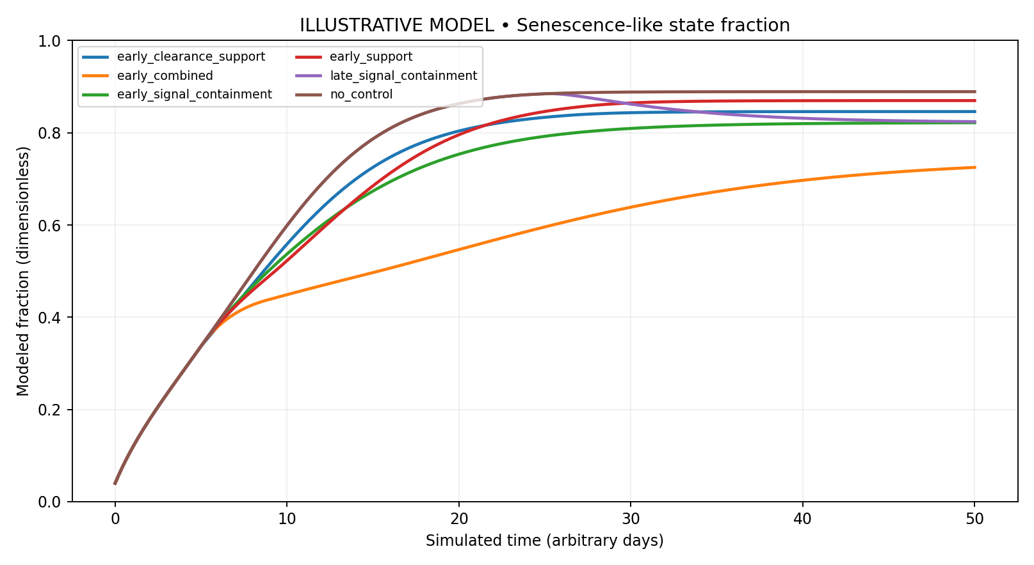
Figure 1. Simulated normalized trajectories. Synthetic mechanism demonstration only. Not fitted to biological data; not treatment-effect estimates.

6 / Designing an early-warning system without false certainty
A clinically meaningful early-warning detector would estimate the probability of new persistent senescence-associated changes at a future time, conditional on longitudinal molecular state, cell type, tissue, and physiological context. Real senescence cannot be established by elevated p16, p21, or SA-β-gal alone; normal differentiation, inflammation, and damage may share these markers.
Candidate indicator | Why it matters | Interpretation limit
p16, p21, DNA damage indicators | Associated with growth arrest or stress; part of senescence assessments. | Each is nonspecific; neurons are often nondividing even when healthy.
SASP ligands / receptor pairs | Potential paracrine pathway (CCL2, MIF, etc.). | An elevated ligand may reflect repair or response to injury.
Mitochondrial and metabolic state | Tests persistent physiological dysfunction. | Metabolic state varies with activity and differentiation.
Astrocyte Cx43 / calcium | Associated with regulation of cue discrimination in mice. | Not a validated universal senescence detector.
Behavioral and electrophysiological outcomes | Tracks whether the living system functions more reliably. | Must be matched to individual experimental subjects.

7 / Candidate restoration strategies: only as research classes
- Prevention: identify and mitigate a verified initiating injury or prolonged stressor without blocking normal repair signaling.
- Propagation containment: test whether interrupting a proven extracellular feedback edge reduces secondary senescence in matched nonclinical systems.
- Physiological resolution: support return of normal metabolic, ionic, and tissue-regulatory processes through appropriately validated interventions.
- Clearance: investigate healthy immune surveillance of persistent senescent cells while preserving tumor-suppressive and regenerative functions.
- Functional readout: measure restored viable function, accurate learned responses, and adverse effects—not just reduced inflammatory molecules.

8 / Proposed data workflow
Download publisher-source files → inspect biological unit IDs and assay type → normalize each study separately → compute within-study effect sizes and multiple-testing adjustments → construct evidence graph with direct versus hypothesized edges → develop held-out predictive models only with matched animal-level observations → revisit the four-state equations using empirically measured priors → test prospective validation in approved settings.

9 / Safety and interpretation rules
No compound, dose, cell-culture procedure, animal intervention, or neuromodulation setting is prescribed. No finding here demonstrates a universal harmful ghost or foreign network. The user’s symbolic terms can organize research questions but cannot replace cell-type-specific measurement, independent replication, qualified institutional oversight, and clinical safety evaluation.

10 / Primary scientific sources and data
Guayasamin et al. 2025, eLife, doi:10.7554/eLife.99988
https://elifesciences.org/articles/99988
OSF: https://osf.io/zsw6j/
Bukalo et al. 2026, Nature, doi:10.1038/s41586-025-10068-0
https://www.nature.com/articles/s41586-025-10068-0
Figure source spreadsheets available from the article; full custom analysis code on request.
Dewa et al. 2025, Nature, doi:10.1038/s41586-025-09619-2
https://www.nature.com/articles/s41586-025-09619-2
GSE272414; RIKEN neurodata archive; Jun-Nagai-Lab/Dewa-et-al analysis code.
Russo et al. 2026, Aging Cell, doi:10.1111/acel.70673
https://doi.org/10.1111/acel.70673
RNA-seq: E-MTAB-15005; supplementary secretome findings in article.
Majewska & Krizhanovsky 2025, Nature Aging, immune surveillance of senescent cells
https://www.nature.com/articles/s43587-025-00910-5
Review of immune clearance and important functions of senescence.
Muthamil et al. 2024, Advanced Biology, senescence biomarkers
https://doi.org/10.1002/adbi.202400079
Multiple independent markers required to classify senescence.

Deliverables accompanying this basis
- Runnable Python project with a Windows launcher, 4 automated tests, and synthetic demonstration outputs.
- Separate importer for each real source spreadsheet with explicit animal or biological-replicate identifiers.
- Published-results CSV (source-verified summary statistics only), study catalog, and direct-versus-hypothesized evidence graph.
- Model equations, control and uncertainty notes, and limitations in the README and documentation.
© 2026 We Develop Software LLC. Research concept attributed to the ChristEye framework creator. Published discoveries remain credited to the respective authors. This document is not a clinical claim.

11 / Revision: response arbitration and preserved Understanding
4 November 2026 | Revision v2. The creator has clarified that the ChristEye “ghost network” denotes a proposed competition between immediate need/threat responses and deeper, context-appropriate learned Understanding. The phrase “spirit of error” describes the proposed maladaptive arbitration and reinforcement loop in the inventor’s spiritual vocabulary; it is not an experimentally identified entity or a literal cellular accuser.
Reframed question: Can changes in the extracellular/glial/metabolic state alter which action is chosen even when learned response capability can be independently demonstrated? This is analytically different from whether an engram was deleted, modified, or incorrectly retrieved.
Stage | ChristEye description | Operational scientific interpretation
Unmet need / alarm | Urgency makes immediate relief attractive | Motivational state, cue salience, physiological stress and interoception
Honey of Evil | A pull toward an inappropriate immediate response | A measured extracellular signal associated with response bias in a defined context
Milk of Evil | Persistent condition reinforces the priority shift | Chronic metabolic, oxidative, ionic or inflammatory dysregulation and feedback
Arbitration | Immediate action wins over existing rooted Understanding | Choice priority, cue discrimination, inhibitory control, response latency
Fruit | Output does not match context-appropriate learned response | Observed choice or behavior; requires objective task criteria
Honey/Milk of Good | Restoration of the conditions for accurate response | Context-corrective signals and homeostasis; must preserve adaptive immune function

12 / New equations and testable separation
wI = sigmoid(b0 + bE H- + bM M- - bG H+ - bS M+ + bN Need)
Immediate-response weighting is a modelled variable, not a discovered biological arbiter.
P(action|context) = softmax[beta*(wI*U_immediate + (1-wI)*U_learned)]
Action values depend on task/context; an urgent response may be correct in genuine danger.
The original six-state senescence simulation is retained unchanged. New `christeye/arbitration.py` projects the simulated state onto immediate-versus-learned action selection. Its parameters are arbitrary, normalized, and uncalibrated. An increase in immediate selection is not evidence that an inflammatory signal inserted false information into astrocytes or that a hidden independent network acted.

13 / Evidence distinctions and study requirements
Guayasamin 2025: stress-related astrocytic calcium/Cx43 deficits and inaccurate fear discrimination. Bukalo 2026: astrocytes enable neuronal memory representations and extinction. Dewa 2025: a multiday astrocytic eligibility trace stabilizes memory, not demonstrated autonomous content storage. Russo 2026: brain-cell culture SASP can propagate senescence-associated phenotypes. Wang 2025: early inflammatory ATX/LPA-to-neuron signaling contributes to aggression in male mice. No study joins all five pathways in a single measured organism.
Study requirement: separately measure contextual discrimination, memory retention, immediate action choice, inflammatory/glial state, and physiological controls in the same biological units over time. If one variable is unavailable, report only the part of the hypothesis that the study can support. Treat four Milk/Honey labels as conditional functional categories, not permanent moral identities of molecules.

14 / Companion documents and revised software
- ChristEye_Response_Arbitration_Scientific_Basis_v1_1.docx — full theory, evidence ladder and equations.
- ChristEye_Response_Arbitration_Experimental_Protocol_v1_1.docx — dataset-specific tests, null hypotheses and research safeguards.
- ChristEye_Four_Process_Analysis_Toolkit_v0_2.zip — adds arbitration simulation, test suite, provenance and response priority source-data schema.

15 / Evidence gates for response restoration
Evidence gate | Minimum required observation | Why it matters
Discrimination | Response measured for a trained cue and a comparable safe cue within the same subject | Separates specificity loss from global increase in responding
Retention | Independent learned-response probe after sufficient delay | Separates intact Understanding from a changed action priority
Temporal precedence | Matched inflammatory, glial, neuronal and behavioral time ordering | Protects against reversing cause and effect
Cellular function | Cell-type-specific state and viability, not inflammation marker alone | Prevents incorrect classification of transient inflammation as senescence
Restoration | Behavioral accuracy and physiological health improve together under qualified controls | Avoids declaring success solely because a cytokine falls

16 / Counterexamples the theory must explain
An immediate response can save a life in a true emergency; it cannot be classed as pathological simply for being fast. Long-practiced appropriate responses can also be nearly instantaneous. Increased astrocyte activity may stabilize accurate memory or overgeneralized fear depending on circuit, timing and intervention. A senescence-associated secretome can influence cultured recipient cells without any observed change in memory or aggression. These counterexamples make contextual correctness, not reaction speed, the primary outcome.
No human treatment, universal senescence prevention, or independent conscious ghost mechanism is established by the revised research program.

