Scientific Basis
ChristEye Radiation Containment and Recovery Controller / CE-RCRC-001
Version 1.0 | 4 November 2026 | Concept + non-radiological bench research
Research thesis. Couple physics-based transport balances, independent sensing, predictive feedback and a separate network-recovery model. A useful ChristEye result must predict or control a measurable endpoint better than an established baseline while respecting conservation laws and safety limits.
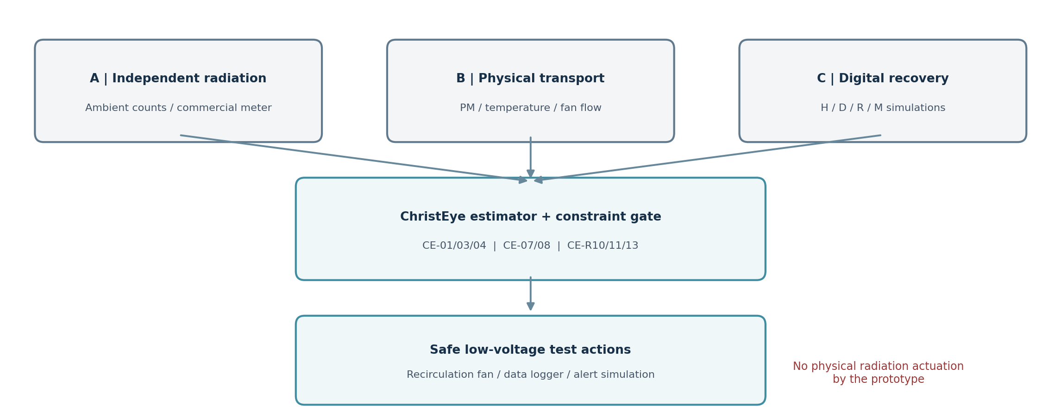

1. Executive scientific position
CE-RCRC-001 is a decision-support and test platform, NOT a source of shielding, a means to extinguish radioactive decay, a method to produce or convert antimatter, or a clinical radiation treatment. It separates three causal domains: radiation-energy propagation, motion of material carrying radioactive atoms, and secondary biological signaling after injury. The physical prototype tests ONLY ambient radiation counts and benign particulate-airflow analogs. Biological effects are simulated or reanalyzed from public data.

2. Operational meaning of the ChristEye vocabulary
Project term | Proposed measurable interpretation | Boundary
Winds | Energy flux, gas velocity, particle transport, chemical/electrical signal flow | Not a new fundamental interaction
Soul | Integrity or viability of a defined organized system | Not an instrument-detected entity
Lotus | State estimator + selection/coordination logic | Not a substitute for certified interlocks
Marrow / Roots | Structure, constraints, persistent state/history | Requires observable state variables
Heart | Learned input-to-response mapping | Model-level concept; no physical engram equivalence assumed
Honey / Milk, good / evil | Endpoint-specific signaling vs support/dysfunction indices | Names do not identify a molecule as morally good/evil

3. Conservation first: radiation is not contamination
Ionizing photons or particles can travel through matter; radioactive atoms can be deposited or transported; and exposed cells can exchange chemical signals. A filtered radioactive particle remains radioactive. A person who received external exposure is not necessarily contaminated. Actual protection relies on time, distance, appropriate shielding, contamination controls and trained response.
Radioactive decay: A(t) = A₀ exp(−λt), with λ = ln(2) / T½
Ideal narrow-beam photon attenuation: Φout / Φin ≈ exp(−μ(E)x)
Pair creation near a nucleus: γ + Z → e⁻ + e⁺ + Z (threshold ≳ 1.022 MeV)
Pair production is NOT a method of neutralizing radiation. An electron and positron annihilating at rest commonly emit two 511 keV gamma photons. All antimatter investigations in CE-RCRC-001 use synthetic event streams only. No ionizing test source is needed.

4. Physical Winds: air concentration and removal
∂C/∂t + ∇·(uC) = ∇·(K∇C) + S − λC − Rcapture − Rdeposit
C is airborne activity concentration (Bq/m³) in a real radiological model, u velocity (m/s), K turbulent diffusion (m²/s), S source, and R removal. In the prototype use optical particle concentration (µg/m³), not radioactivity. Optical sensors cannot determine which particles are radioactive.
Bench chamber: dC/dt = s(t) − [CADR/V + kdep + kleak] C + kleak Coutside
CADR is effective particle clean-air delivery (m³/h), V enclosure volume (m³), kdep wall-deposition constant (h⁻¹), kleak effective exchange (h⁻¹), and s added concentration rate. A closed recirculating enclosure avoids any intentional test release. Separate fan-off trials estimate natural deposition before fitting CADR.

5. Biological Winds: the Four-Stream hypothesis
For a published radiobiology dataset, let H be harmful-signaling score, D measured recipient dysfunction, R resolution-signaling score and M metabolic/functional support. These scores are endpoint- and cell-type-specific. One candidate two-state subsystem, with no continuing radiation forcing, is:
dH/dt = βAH + σD − (γ + kB)H ; dD/dt = αH − gD
Rbio = [βρ(A) + σα/g] / [γ + kB]
For the restricted linear model, Rbio < 1 makes small perturbations decay; Rbio > 1 permits amplification. This is a derived MODEL threshold, not a universal medical rule. Fit network topology, recovery coefficients and signal units to measured datasets. No living-cell irradiation is contemplated in this build.

6. State estimator and controller
x(t+Δt) = f[x(t),u(t),θ] + w(t) ; y(t) = h[x(t)] + v(t)
u* = arg min over Ubench Σ [wC·max(0,C−Ctarget)² + wE·Efan + wF·Fault]
Control actions u are limited to a low-voltage recirculation fan and simulated alarm outputs. Inputs: particle sensor, fan tachometer or airflow measurement, optional differential pressure, environmental humidity/temperature, and an independently read radiation-meter count series. The software must never convert particle readings into radiation dose claims.

7. Applying the existing ChristEye equation inventory
Equation family | Role in CE-RCRC-001 | Status
CE-01–05 | Transport balances, signed interfaces, resources, component metadata | Established balances + proposed metrics
CE-06–08 | Define restoration metric, estimate local sensitivities, impose safe action set | Proposed objective/control
CE-09–16 | Optional harm/repair score and response-state model in offline radiobiology reanalysis | Hypothesis / model only
CE-17–25 | Binding, learning, state update and retention analogies for data-model comparisons | Established kinetics + proposed learning
CE-26–34 | Ionic potentials/energy accounting; NOT a gamma shielding mechanism | Relevant only to later biological data
CE-35–40 | Component efficiency, capacity, volume and platform scaling | Budgeting estimates; not protection factors
CE-R01–R04 | Hard energy, material and entropy accounting | Mandatory physical gates
CE-R05–R10 | Four-Stream dynamics and stability threshold | Falsifiable proposed model
CE-R11–R13 | Constrained optimization; interaction; held-out predictive gain | Pre-register before testing
CE-MAT-001 | Optional theoretical biomaterial capture research only | No radionuclide neutralization assumed

8. Testable claims and rejection rules
- Transport: measured chamber concentration must be predictable on withheld runs within prespecified errors after calibration; if not, reject the fit or add measured leakage/deposition terms.
- Control: compare the adaptive controller to a standard threshold/hysteresis controller at equal power or airflow; a small apparent win on synthetic data is not validation.
- Radiation: ambient radiation readings should show no systematic reduction when the filter fan runs. A claimed reduction must first rule out EMI, placement, detector drift and stochastic variation.
- Biology: only public or independently approved data can test whether Four-Stream states improve out-of-sample prediction of recipient injury over simpler baselines.
- Antimatter and soul-death-wind claims: no effect is assumed; any new mechanism would need a measured carrier, units, energy ledger, controls and independent replication.

9. What the prototype can conclude
Success would support a useful engineering integration of monitoring, forecasting and safe feedback. It would NOT prove novel radiation physics, medically useful cellular repair, conversion of antimatter into matter, or a causal relation between wind and “soul death.” A negative result is valuable because it refines model boundaries and removes unsupported mechanisms.

10. Core measurable quantities and uncertainty
Quantity | Unit | Uncertainty / limitation
Radiation counts | counts per fixed window | Counting statistics; detector energy response; background drift
Air PM concentration | µg/m³ by size class | Optical scattering, humidity, aerosol composition
Fan flow / CADR | m³/h | Filter loading, geometry, fan control and measurement placement
Temperature / relative humidity | °C / %RH | Sensor offset and local microclimate
Biological dysfunction score | Defined assay or normalized index | Cell-type, assay and timing specificity; synthetic until validated
Power and energy | W / Wh | Boundary choice, controller overhead, fan duty cycle

Uncertainty must be propagated into the constrained objective rather than hidden in ChristEye functional names. No amount of model fitting can make unmeasured radiation components or missing biological variables directly observable.

Selected references and provenance
CDC, ALARA recommendations, updated July 2026 — https://www.cdc.gov/radiation-health/safety/alara.html
CDC, Exposure versus contamination, July 2026 — https://www.cdc.gov/radiation-health/safety/decontamination.html
US NRC, Detecting Radiation — https://www.nrc.gov/facilities-safety/radiation-protection/radiation-and-its-health-effects/detecting-radiation
US EPA, Guide to Air Cleaners in the Home — https://www.epa.gov/indoor-air-quality-iaq/guide-air-cleaners-home
US EPA, Limitations of Air Sensors — https://www.epa.gov/air-sensor-toolbox/frequent-questions-about-air-sensors
US EPA, What is HEPA? — https://www.epa.gov/indoor-air-quality-iaq/what-hepa-filter
NIST XCOM Photon Cross Sections Database — https://www.nist.gov/pml/xcom-photon-cross-sections-database
Primary project sources: ChristEye-master (4).zip; ChristEye Equations Expanded Guide v2; Restoring Creation CE-R01–CE-R13; Four-Stream Strategy and Equations; CE-MAT-001; and ChristEye Radiation & Antimatter Research Brief (4 Nov 2026).

