Construction Guide
ChristEye Radiation Containment and Recovery Controller / Physical Prototype
Version 1.0 | 4 November 2026 | Concept + non-radiological bench research
Build target: a ~100-liter indoor-only recirculating particulate chamber; a laptop running the offline ChristEye controller; ambient-background radiation observation from an independent commercial meter. LOW-VOLTAGE, NON-RADIOACTIVE demonstration only.
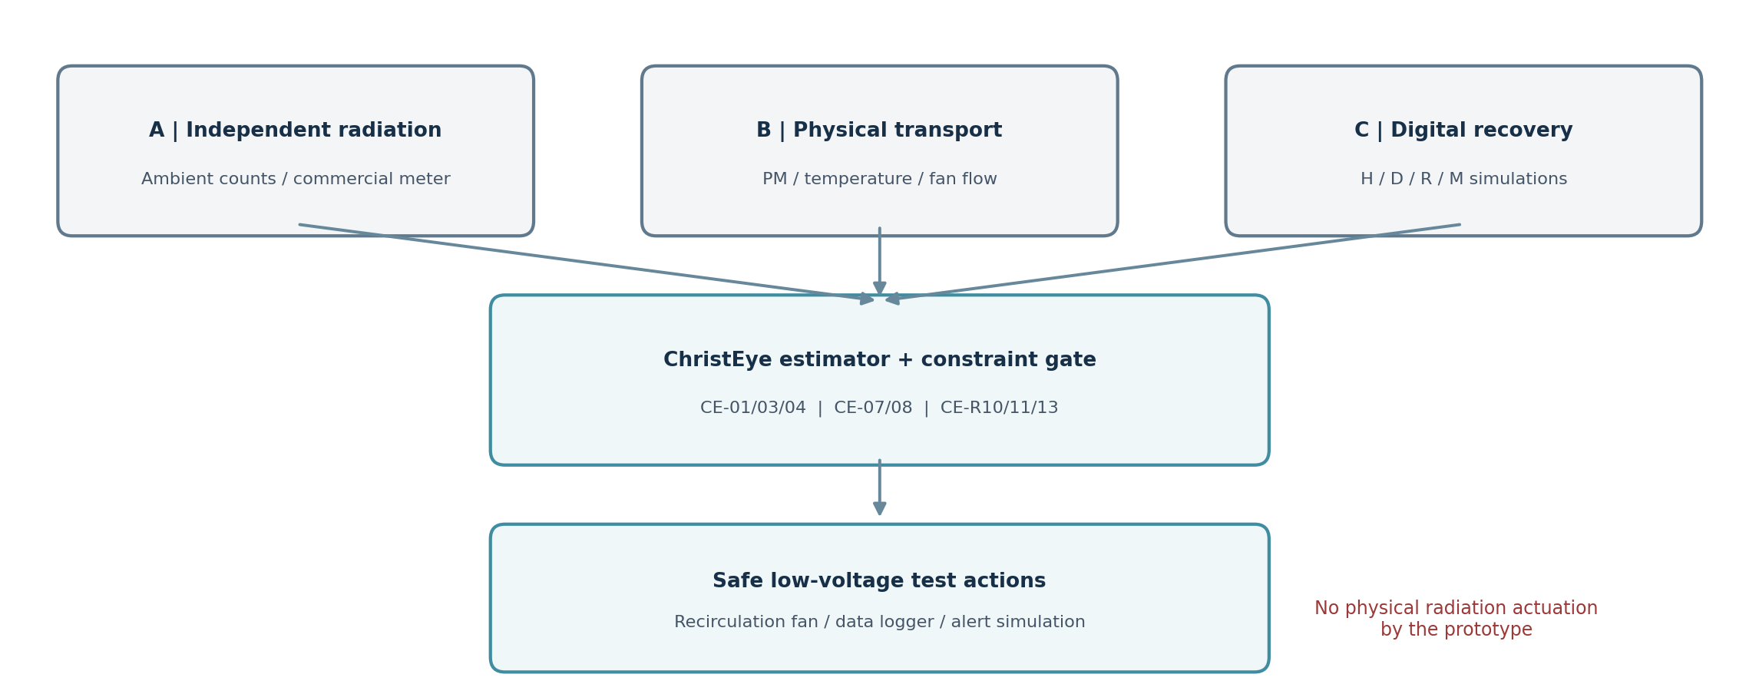

1. Build variants and safety boundary
Variant | What you build | What it can test
A. Software-first | Laptop and synthetic traces; no hardware necessary | Conservation, sensor faults, controller comparisons
B. Chamber prototype | Clear sealed storage box, internal fan+particle filter, 2 PM sensors | Physical filter response and environmental sensor effects
C. Observation add-on | Off-the-shelf radiation meter with its own alarm and calibration | Natural-background counts; independent logging only

Never use an improvised radioactive source; never put unknown contaminated material in the enclosure; do not use the chamber to protect people from radiation. The fan, enclosure and tubing do not constitute radiological containment. A licensed facility must design and validate any real deployment.

2. Bill of materials (planning allowances in USD)
Item | Qty | Budget | Note
Laptop or existing PC | 1 | existing | Offline analysis and CSV logging
Clear polypropylene storage enclosure ~60×40×40 cm | 1 | $25–60 | ~96 L internal nominal volume; measure actual usable volume
Off-the-shelf sealed HEPA cartridge | 1 | $15–45 | Consumer filter; sealed holder; not radiological service
Small enclosed low-voltage DC blower | 1 | $15–35 | 5–12 V; recirculates only inside chamber
Separate low-voltage fan power controller | 1 | $12–35 | Certified adapter, switch, inline fuse, PWM only if supported
Optical particle sensor module, e.g. SPS30 | 2 | $30–75 each | One inside and one ambient reference
Temperature / humidity sensor breakout | 1 | $10–25 | Track sensor bias from RH
Pico 2 W or comparable USB-capable MCU | 1 | $6–20 | Optional logger, 3.3V logic
3.3V/5V-compatible interface board + cabling | 1 | $15–35 | No direct 5V signal into 3.3V GPIO
Gasket tape, mounts, glands, brackets | set | $15–40 | No leaks or exposed moving blades
Simple handheld vane anemometer | 1 | $20–60 | Verify airflow near outlet, bench-only
Commercial radiation meter | optional | $80–450+ | Never rely on low-cost hobby meters for safety decisions

Estimated build allowance: approximately $200–$500 excluding PC and independent radiation meter; approximately $280–$950+ including a meter, depending on model. These are planning ranges, NOT vendor quotes; taxes, measurement reference equipment and validation can increase cost.

3. Physical layout of the chamber
Choose a clean, rigid, transparent storage box about 60 cm × 40 cm × 40 cm. Install a reusable gasket around the lid. Keep the fan, its covered intake, and the replaceable filter entirely INSIDE the box so airflow recirculates internally rather than exhausting into the room. Leave an unobstructed return route, and do not expose operators to blades.
Mount sensor A in representative interior air away from the fan jet and walls. Put sensor B OUTSIDE as the ambient reference. Secure cable exits with a suitable gasketed cable gland, or use battery/USB logging inside the chamber; neither method turns the box into certified containment. Use room air only—no smoke, incense, powders, sprays, radioisotopes or chemical aerosols added for this test.

4. Electrical architecture, precise boundaries
Power / data link | How to connect safely
PC → microcontroller | USB cable; computer-side CSV collection; no Internet needed
MCU 3.3V GPIO → sensor interface | Connect via manufacturer-approved breakout/logic-level translator; match wiring to actual board revision
5V PM sensor supply | Use manufacturer-rated regulated supply, common ground where specified; do NOT use 3.3V rail if the sensor requires 5V
Fan → low-voltage power source | Through a separately rated switched/fused controller; never power a fan directly from GPIO
Radiation meter → PC | Read commercial data export, or log display manually; not wired into fan safety function
Emergency/manual control | Hard power-off switch accessible outside enclosure; fan returns OFF on command/software fault in BENCH variant

A Sensirion SPS30, for example, is rated for a 4.5–5.5 V supply and supports I2C/UART; Raspberry Pi Pico 2 W GPIO is 3.3 V. Verify SDA/SCL pull-up voltages and any level-shift circuits from the specific supplier datasheet before power-up. An ordinary 5 V line is NOT a 5 V-safe signal pin.

5. Assembly procedure
- Work on an uncluttered, dry bench. Label enclosure, electronics, and sensors “NON-RADIOLOGICAL DEMONSTRATION.”
- Install internal fan grille and filter mount with nonconductive brackets; use commercially sealed filter media and do not cut the media.
- Measure true internal volume, subtract approximate occupied components, and record V in m³ (100 L = 0.100 m³).
- Install interior PM sensor out of direct fan flow; place external reference sensor nearby and away from drafts.
- Use the selected sensor manufacturer’s breakout board, connector and interface wiring. Check continuity, polarity, voltage and common-ground guidance with power off.
- Route low-voltage fan power separately from sensor cables. Install manual switch and use a certified DC adapter; never expose mains wiring.
- Verify fan airflow with lid OPEN and blades guarded. Close the lid and verify recirculation without visible enclosure collapse or pressure buildup.
- Power the logger; check timestamped PM, humidity, fan state, optional airflow and sensor-health messages.
- Position the independent radiation meter outside the chamber; collect ambient background with fan off and fan on, keeping detector position fixed.
- Run the offline digital twin before enabling automated fan control. Record configuration and firmware revisions in the run log.

6. Initial software modules
Module | Interface | Required behavior
sensor_ingest | timestamp, PM, RH, fan status | Reject invalid values, preserve raw measurements and units
state_estimate | C estimate, uncertainty, CADR, kdep | Parameter fits on training-only calibration data
constraint_gate | sensor freshness, fan fault, manual switch | No actuation if missing/out-of-range data; mark unsafe-to-infer
controllers | fixed timer, hysteresis, ChristEye candidate | Common measured sensors and power budget
rad_observer | commercial meter export or manual counts | Independent chart and threshold statistics only
four_stream_offline | H,D,R,M simulated or published dataset | No inputs into physical fan safety decisions
event_logger | CSV / checksum / run metadata | Log all interventions and sensor errors for reproducibility

7. Example starting configuration (change only after calibration)
- Chamber V = 0.100 m³ (illustrative, must measure).
- Nominal effective CADR = 0.50 m³/h for demonstration calculations (NOT assumed true).
- Particle sampling every 10 s; timestamp UTC; retain humidity and raw PM alongside filtered estimate.
- Optical PM comparison variable: µg/m³ for a specified particle size bin (e.g. PM2.5).
- Optional particle objective Ctarget = 10 µg/m³, an experiment target rather than a health guarantee.
- Fan control states: OFF / ON; one manual hard OFF switch; automatic command disabled by default.
- Radiation data: counts per minute in original meter units; never convert CPM to µSv/h without meter-specific calibration.

8. Acceptance checks before any automated trial
Check | Pass condition
Power | No exposed mains; cable stays cool; GPIO rated voltage respected
Mechanical | No unguarded fan, unsupported weight, cracked enclosure or stress
Software | All inputs timestamped with physical units, firmware ID and checksum
Loss of sensor | System marks INVALID and disables experimental automatic actions
Manual switch | Fan deenergizes independently of software
Radiation mode | No electrical or software path from ambient gamma count to fan actuation
Baseline | Stable 60-min environmental reference plus ≥12-h background radiation record if meter available

9. Mechanical placement drawing
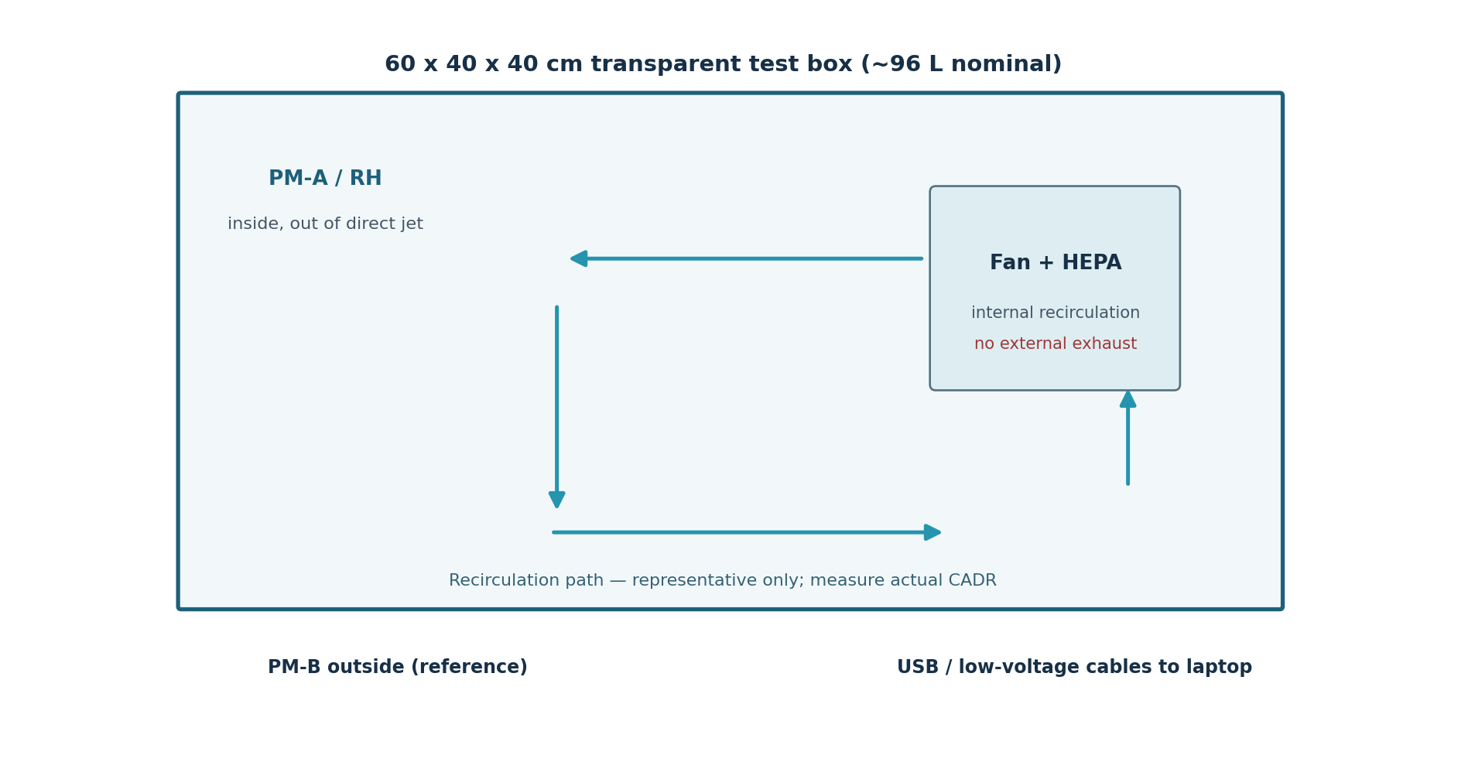
This sealed-looking box is a recirculation DEMONSTRATOR, not certified negative-pressure radioactive containment. The filter captures ordinary room particles only; it cannot shield the detector from gamma rays. A second independent radiation meter stays outside.

10. Optional microcontroller signal mapping
Connection | Suggested example on Pico 2 W | Electrical rule
Sensor A UART | GP0 TX / GP1 RX (UART0) | Approved 3.3V-safe interface and regulated sensor 5V supply
Sensor B UART | GP4 TX / GP5 RX (UART1) | Separate serial port; match TX/RX to actual sensor labels
Environmental I2C | GP6 SDA / GP7 SCL (I2C1) | Breakout supports 3.3V logic; follow its pull-up requirements
Fan power | Independent rated DC module | Do not run motor power from MCU pins; manual cutoff
Radiation meter | Independent log / export to PC | No fan-actuation path or dose conversion by MCU

Two SPS30 units use the same default I2C address, so DO NOT connect both unmodified to one I2C bus. Use independent UART ports as illustrated, separate I2C buses, a manufacturer-compatible multiplexer, or independent USB evaluation interfaces. Sensor pin numbers, cable colors and hardware-voltage levels depend on the actual purchased breakout; verify them before applying power.

11. Maintenance and what NOT to do
Use only ordinary clean household air. Filters in this research box should never knowingly receive radioactive material. Do not improvise lead shielding, connect an unregulated radioactive source, treat captured dust as harmless after a suspected event, attempt matter–antimatter reactions, or interpret a fan-induced pressure change as a spirit or soul signal. Keep the prototype out of emergency protective workflows.
Use EPA indoor-air sensor limitations for humidity, drift and accuracy when reporting any experimental result. For radiological deployment, an approved safety case, trained radiation safety officer, validated detector types, contamination plans and site-specific fail-state engineering are required.

Selected references and provenance
CDC, ALARA recommendations, updated July 2026 — https://www.cdc.gov/radiation-health/safety/alara.html
CDC, Exposure versus contamination, July 2026 — https://www.cdc.gov/radiation-health/safety/decontamination.html
US NRC, Detecting Radiation — https://www.nrc.gov/facilities-safety/radiation-protection/radiation-and-its-health-effects/detecting-radiation
US EPA, Guide to Air Cleaners in the Home — https://www.epa.gov/indoor-air-quality-iaq/guide-air-cleaners-home
US EPA, Limitations of Air Sensors — https://www.epa.gov/air-sensor-toolbox/frequent-questions-about-air-sensors
US EPA, What is HEPA? — https://www.epa.gov/indoor-air-quality-iaq/what-hepa-filter
NIST XCOM Photon Cross Sections Database — https://www.nist.gov/pml/xcom-photon-cross-sections-database
Sensirion SPS30 product specifications — https://sensirion.com/sps30
Raspberry Pi Pico 2 Documentation — https://www.raspberrypi.com/documentation/microcontrollers/pico-series.html
Primary project sources: ChristEye-master (4).zip; ChristEye Equations Expanded Guide v2; Restoring Creation CE-R01–CE-R13; Four-Stream Strategy and Equations; CE-MAT-001; and ChristEye Radiation & Antimatter Research Brief (4 Nov 2026).

