  - WE DEVELOP SOFTWARE LLC / CHRISTEYE

RESTORING
FUNCTIONAL ORDER
Wind coupling, damage propagation and active resolution across living and physical systems
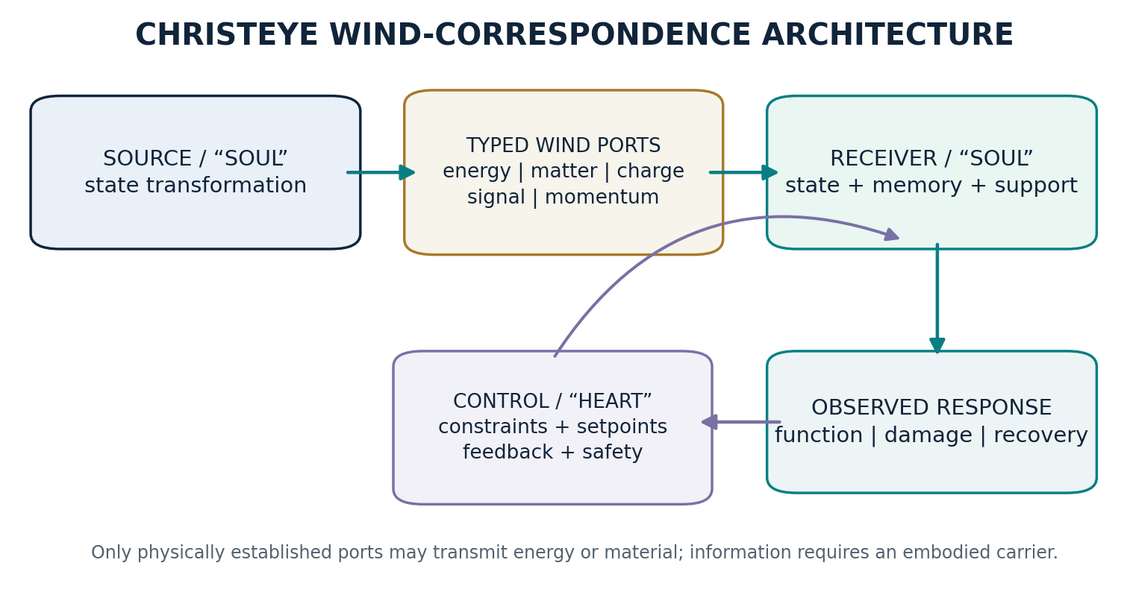
Conceptual illustration: measurable transfers through explicit physical ports; restoration is a functional objective, not a new force.
Research synthesis • Equation set CE-R01–CE-R13 • Experimental roadmap • Evidence ledger
Version 0.1 | November 4, 2026 | Prepared for interdisciplinary scientific review
Scientific boundary. “Restoring creation” is the motivating philosophical goal. The proposed scientific work concerns bounded biological and engineered systems. No evidence currently demonstrates cosmic inflammation, a transferable soul-death force, or restoration of the universe through a new physical Wind.

Executive abstract
ChristEye proposes a common language for system identity (“Soul”), inherited constraints (“Marrow”), activity (“Lotus”), history (“Roots”), goals and valuation (“Heart”), and exchanges (“Winds”). The associated Four-Stream vocabulary distinguishes damage-associated extracellular signaling (“Honey of Evil”), sustained dysfunction (“Milk of Evil”), resolution-oriented signals (“Honey of Good”), and homeostatic support (“Milk of Good”). These are deliberately nonstandard, explanatory labels; the corresponding empirical variables must be defined separately for each experiment.
The research objective is to determine when a disturbance propagates from an initiating system to a recipient network, when secondary effects persist after the initiating event, and which combinations of interrupting the harmful transmission, enhancing resolution, and rebuilding functional capacity produce durable recovery. Recent studies show cell-type-specific senescence transmission in human brain cell culture [1], dual mitochondrial and epigenetic control of senescence-associated inflammation [2], active resolution following apoptotic-cell clearance [3], and a neuroimmune circuit that regulates systemic inflammatory responses [4]. Together these results justify a focused systems-biology program; they do not validate a universal Ghost Network or a new force.
The mathematical proposal integrates established conservation balances and energy-preserving port descriptions with explicitly conjectural damage, resource, memory, and resolution state dynamics. A derived linearized amplification criterion is presented with its assumptions; an illustrative simulation shows why suppressing a signal can differ from resolving the state that continually produces it. The recommended first experiment is a noninfectious, cell-type-resolved conditioned-medium study with factorial controls, held-out validation and an explicit post-withdrawal functional endpoint.
Primary scientific claim. ChristEye may be useful as a translation and control framework if its state estimates and interventions improve out-of-sample prediction or recovery compared with established mechanistic models and standard feedback control. This advantage has not yet been demonstrated.

Reader’s map
Part | Scientific question
I. Observations | Which known mechanisms propagate damage and initiate resolution?
II. Translation | What must a Wind carry to physically affect another system?
III. Equations | Which conserved and nonconserved state variables define the model?
IV. Predictions | When does propagation amplify, decay, or leave persistent dysfunction?
V. Validation | Which controlled experiments can reject the proposed advantages?
VI. Boundaries | What cannot presently be inferred about black holes, antimatter or souls?

1. Scope, definitions and claims

1.1 The unit of analysis is a bounded system
A scientifically evaluable “Soul” is a system whose boundary, composition, lifetime and identity criterion are specified before the analysis. In a reaction-network study it may be a molecular species; in a cell-culture study a living cell or compartment; in astrophysics a particular compact object. The mathematical criteria for identity are investigator-defined. They do not establish a metaphysical or biological substance called a soul. “Birth” and “death” label transitions that create or remove the selected identity, not universal energy-release mechanisms.

1.2 Winds are typed, measurable interfaces
A Wind is a transfer described by the object transmitted, its carrier, direction, rate, units, interaction mechanism, and receiving conditions. Energy, charge, mass, momentum, molecular signals and information must not be treated as interchangeable. Information about a past state can persist in a material carrier or a statistical correlation; information alone does not generate power or cross a boundary without a mechanism.
ChristEye | Operational research meaning | Possible measurement
Soul | System boundary and continuity criterion | Unique state / lineage / lifecycle record
Marrow | Material and inherited constraints | Species composition, genotype, connectivity
Lotus | Allowed activity and adaptation | Time-resolved physiological or control output
Roots | Persistent state or memory | Delayed functional response; chromatin / network state
Winds | Typed physical, chemical and signal transfer | Flux, receptor occupancy, voltage, emitted spectrum
Heart | Declared function, need and safety objective | Function score, permitted target range
Honey of Evil | Causally damage-promoting signal bundle | Specific ligand–receptor and downstream readout
Milk of Evil | Persistent dysfunctional condition | Functional assay + metabolic and cell-state measures
Honey of Good | Causally resolution-promoting signal bundle | Mediator/pathway engagement and recovery readout
Milk of Good | Adequate homeostatic supply and capability | Energy status, nutrient delivery, ionic support

1.3 A strict evidence hierarchy
Tier | What is required | Status here
A — established | Independent replicated studies with specified mechanism | Signaling, efferocytosis, conservation laws
B — supported analogy | Same mathematical structure, different mechanism | Electrical / chemical port comparison
C — model hypothesis | Defined equations, observables and failure condition | CE-R harm–repair dynamics
D — speculative extension | No specific verified physical pathway | Cosmic Ghost Network and soul-death field

2. Biological basis: damage, persistence and resolution

2.1 Damage-associated signals do not have a fixed moral direction
Cellular stress and tissue injury can lead to release or exposure of DAMPs (including ATP, HMGB1 and mitochondrial material) and activation of innate immune receptors. Such signaling can be protective and transient, but sustained or misregulated activation can perpetuate injury [5]. A high inflammatory cytokine concentration is not automatically harmful in all contexts. Its timing, location, receptor repertoire, exposure history and recipient cell type determine interpretation.
Cell senescence likewise cannot be equated with death. Senescence is a durable stress-related state, often with cell-cycle arrest and secretory remodeling. It can protect against uncontrolled proliferation and support repair, while its persistent inflammatory program can contribute to tissue decline [6,7]. A “stop senescence immediately” objective would be biologically unsafe and scientifically underdefined.

2.2 The strongest direct support: directed paracrine spreading
Russo and Riessland (2026) compared the effect of conditioned media from senescent human brain-cell models. Transmission patterns depended on the sender and recipient cell types, with astrocytes and microglia important propagators in the tested system. Selected ligand/receptor interventions attenuated some secondary senescence phenotypes [1]. The conclusion is not that every signal spreads equally, but that the network adjacency and its edges can be experimentally measured.

2.3 The distinction between signaling and retained dysfunctional state
Martini and colleagues (2026) found that mitochondrial metabolism contributed to the epigenetic permissiveness of the SASP inflammatory program. Modifying the relevant metabolic axis reduced inflammatory outputs in experimental systems without necessarily reversing senescence-associated growth arrest [2]. This result closely motivates the ChristEye distinction between harmful extracellular “Honey” and persistent dysfunctional or altered cellular “Milk.” It also shows that reducing a signal is not synonymous with making a cell young or healthy.

2.4 Resolution is actively produced
Clearance of apoptotic cells (efferocytosis) does more than remove cellular debris. A 2024 Nature Metabolism study linked efferocytosis-dependent tryptophan metabolism to IDO1, kynurenine, AhR, pro-resolving mediators and increased clearance behavior in studied models [3]. Specialized pro-resolving mediators such as lipoxins, resolvins, protectins and maresins have documented roles in coordinating the termination and cleanup phases of inflammation [8]. These are candidates for a context-specific “Honey of Good,” not universal restorative substances or clinical recommendations.
A 2024 Nature study identified a body–brain neuroimmune circuit that detects inflammatory signals and regulates peripheral immune responses [4]. Separately, astrocyte-ensemble research demonstrates roles for non-neuronal cells in learned response and memory stability [9,10]. Together, these results justify measuring both the external inflammatory condition and the state of the responding neural circuit, without asserting that cellular signaling encodes theological knowledge.
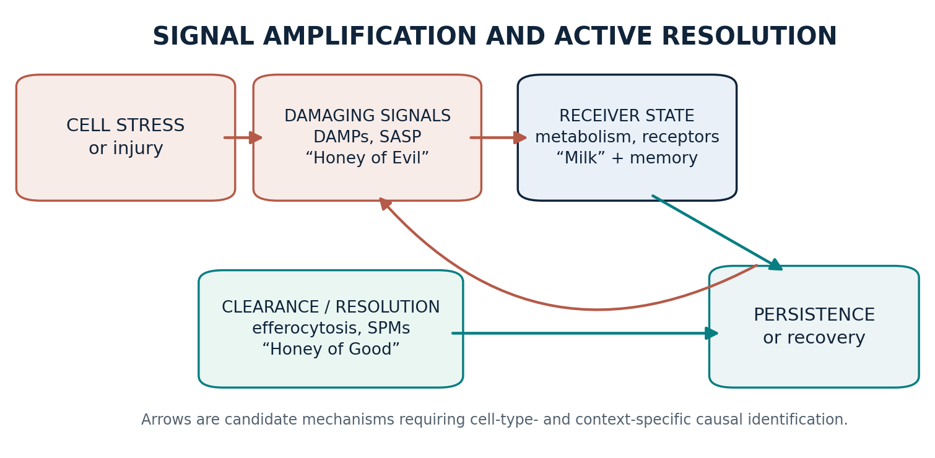
Figure 2. Proposed causal branches; arrows require independent experimental identification and need not generalize between tissues.

3. Connecting Winds between physical systems

3.1 The conservation-gate rule
A cross-system comparison is valid only after specifying source, emitted carriers, recipient susceptibility, system boundary, available energy and losses. The source need not undergo “death”: ordinary heat flow, receptor signaling, electric current and mechanical work are all valid transfers. Conversely, breaking a chemical bond commonly requires energy input, while formation of a bond can release it; the net energetics of the entire reaction determine heat production.
Bond-graph and port-Hamiltonian methods already formalize interconnection across mechanical, electrical and chemical systems by pairing an effort variable with a flow variable; their product has dimensions of power. ChristEye should adopt this mature engineering language rather than claiming a distinct universal Wind force [11,12].
Physical port | Effort × flow | Power units | Example
Electrical | Voltage (V) × current (A) | W | Sensor/controller coupling
Mechanical | Force (N) × speed (m/s) | W | Actuator displacing a mass
Chemical | Chemical potential (J/mol) × molar rate (mol/s) | W | Metabolic exchange or transport
Thermodynamic | Temperature (K) × entropy-flow rate (J/K/s) | W | Reversible thermal port accounting
Radiative | Spectral power × absorption fraction | W | Radiation absorbed by a scintillator

3.2 The transduction question
An event in domain A may alter domain B through a measurable transducer: absorbed radiation → electronic excitation → light, chemical ligand → receptor occupancy → altered gene expression, temperature gradient → thermoelectric voltage, or mechanical force → sensor current. A mathematically similar response curve across domains is not evidence of a shared material carrier. The test is whether a shared constrained model predicts new data better than the domain-specific alternative.

3.3 Black holes: related information questions, different physics
Black-hole entropy is related to event-horizon area, and Hawking radiation is a theoretical consequence of quantum fields in curved spacetime. Information preservation during evaporation remains the subject of active research; the Page curve and island calculations help motivate candidate quantum descriptions [13]. Neither entropy nor radiation establishes a cosmic DAMP-like Ghost Network. Black-hole outflows may support or suppress star formation through heating, compression, or gas removal [14], which is a physically meaningful example of context-dependent feedback, not cellular inflammation.

3.4 Antimatter: a distinct symmetry question
Matter–antimatter asymmetry is a major unresolved physics problem [15]. There is no established connection from cellular damage, emotional distress, or cosmic entropy to a growing tendency of matter to turn into antimatter. Any extension must specify a quantum-field mechanism, measurable conserved quantities, a quantitative prediction, and a discriminating test. The present research program does not posit such a mechanism.

4. Integrated mathematical model: CE-R series
All equations below distinguish established physical accounting from proposed coarse-grained dynamical choices. The model is not an experimentally derived law. Variables are indexed by bounded system i and time t. Unless otherwise indicated, H_i and R_i are nonnegative signal scores with calibrated units, D_i and M_i are dimensionless [0,1] indices, and Z_i is a nonnegative persistent-state proxy. Unlike nuclear or quantum variables, these biological indices can be operationally defined by specified assays.

4.1 Hard constraints: energy, matter and entropy
CE-R01 Power-port identity
Established/adapted. A port is defined only when the chosen effort–flow pair corresponds to physical power; k indexes carrier type.
CE-R02 Energy accounting
Established accounting. Internal chemical/electrical conversions must appear consistently in E or the port terms, never as free added energy.
CE-R03 Chemical species balance
Established/adapted. n [mol], v [mol/s] after scaling, S stoichiometric matrix, J transport [mol/s]. Elemental composition and charge balance constrain allowed reactions.
CE-R04 Entropy balance
Established nonequilibrium thermodynamics. S is thermodynamic entropy; σ internal entropy production. Local order can increase through exchange without violating the second law [16].

4.2 Causal signal–state dynamics
CE-R05 Harmful signal network
Hypothesis. A is directional, nonnegative, receptor-and-context-specific adjacency; ξ is an external challenge. The R term represents a measurable change in effective clearance, not guaranteed chemical neutralization.
CE-R06 Dysfunction state
Hypothesis. Separate damage induction from function recovery; D is not automatically equivalent to senescent-cell fraction.
CE-R07 Resolution signal
Proposed control-state representation. u_R is permitted input or endogenous production; λ represents signal turnover.
CE-R08 Metabolic support
Hypothesis. M has 0–1 normalization; s_i is a supported effective renewal rate. Physical fuel and oxygen budgets must be separately enforced through CE-R02/03.
CE-R09 Persistent trace / “Ghost” state
Hypothesis. Z operationalizes a lingering measurable physiological, chromatin or network memory, not a free-standing entity carrying a deceased system’s consciousness.
Interpretation. Honey of Evil ≈ H, Milk of Evil ≈ D plus any separate measured state deficit, Honey of Good ≈ R, Milk of Good ≈ M. The “Ghost Network” is a working name for distributed effects that persist through known carriers and state memory after the initiating event. Some forms of cell death generate protective clearance responses, so signs must be learned from evidence rather than assigned permanently.

4.3 Network stability and restoration threshold
For a restricted linearization near H=D=0, let A be a nonnegative connected adjacency matrix, with uniform coefficients; fix R and M, omit Z and external forcing; let the small-damage recovery rate be g > 0 and the H→D coupling be a. Then the largest growth mode follows a two-variable linear system. Its necessary and sufficient stability conditions reduce to the criterion below when all rates are positive and the Perron–Frobenius mode dominates.
CE-R10 Small-perturbation ratio
Derived criterion for the simplified two-state model only. A full multi-state, nonlinear network with Z, delays or state-dependent coefficients needs separate stability analysis.
The numerator has direct neighboring-signal amplification plus a two-way signal → damage → signal feedback contribution. Unlike a signal-only threshold, this expression includes the damage loop. It does not imply that a single medication or input universally returns all biological networks to health.

4.4 Restoration control and mechanism tests
CE-R11 Constrained objective
Proposed multi-objective criterion; include uncertainty, healthy immune activity, tissue identity and toxicity as hard constraints. The weights are predeclared and not moral properties.
CE-R12 Factorial interaction
An interaction contrast on a prespecified outcome Y. An effect larger than either intervention alone does not automatically establish synergy; scale and uncertainty matter.
CE-R13 Comparative predictive gain
Positive ΔL means a lower held-out predictive loss for the ChristEye model. Specify endpoints, splits, error metric, and complexity penalties in advance.

5. Model-based predictions and failure conditions

5.1 Prediction P1: topology determines which signals propagate
Different sender–receiver matrices should lead to different response patterns under the same source stimulus. In a brain-cell preparation, the same conditioned medium may affect astrocytes, microglia, neurons and endothelial cells differently. Failure condition: a model without cell-type edges predicts equally well [1].

5.2 Prediction P2: suppressing output need not repair the generating state
Reducing extracellular inflammatory signaling may reduce H quickly but leave D and Z high. Upon withdrawal, continued dysfunctional signaling could resume. This is consonant with a 2026 result in which lowering SASP-related output did not reverse senescence-associated growth arrest [2]. Failure condition: suppression alone gives complete durable recovery of preregistered functions.

5.3 Prediction P3: support and resolution may interact
If an activated resolution pathway requires sufficient metabolic capacity, the combined R × M response may exceed an additive expectation for a chosen functional outcome. It might instead be neutral or harmful in a given context. Test with a powered factorial design; reject the interaction if the confidence interval and effect-size criterion do not support it.

5.4 Prediction P4: history can change response to identical exposure
Different prior exposure or state memory Z may yield different reactions to the same later input. This is not peculiar to ChristEye; the hypothesis is that a common state-space representation improves prediction across tasks. Compare models that include measured chromatin history, prior cytokine exposure or glial state against memory-free alternatives.

5.5 A numerical demonstration of the threshold
Consider a three-node chain with ρ(A)=√2, β=0.4, μ=0.5 and q a/g=0.08 in consistent arbitrary time units. Here βρ(A)+qa/g≈0.646. The derived ratio changes from 1.29 with no added resolution-dependent clearance to about 0.99 with +0.15 and 0.86 with +0.25. These values are chosen for illustration, not fitted to biological measurements.
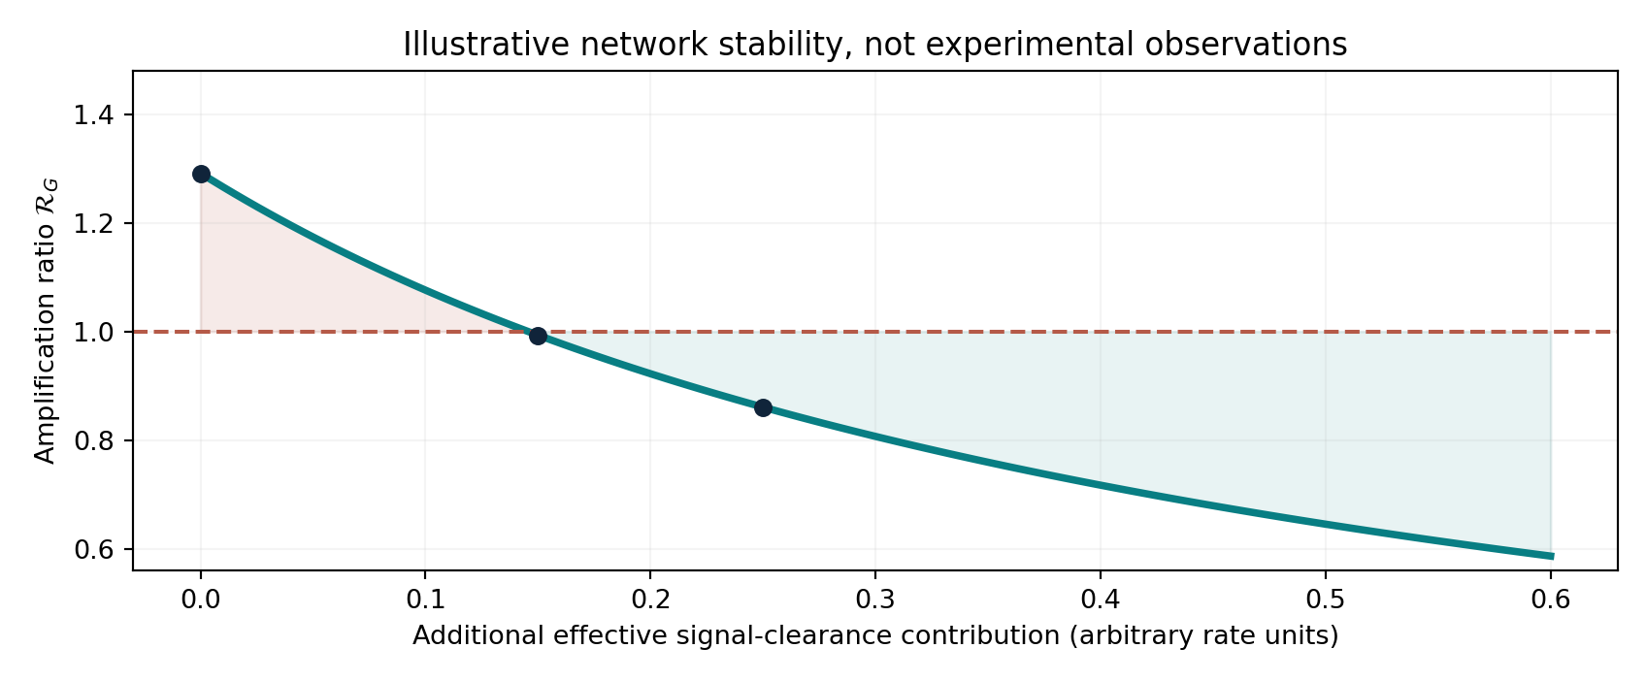
Figure 3. Hypothetical stability shift under a simplified model. The true threshold of a measured tissue network must be estimated from data.

5.6 A numerical demonstration of transient versus durable intervention
A second deliberately synthetic simulation uses three connected nodes with time-dependent signal suppression and combined resolution/resource interventions. Depending on chosen parameters, a time-limited signal intervention can reduce the observed inflammatory influence during exposure yet permit its recurrence. A combined intervention may alter the sustained state more substantially. This example demonstrates a modeling distinction, not the efficacy of an untested substance or treatment.
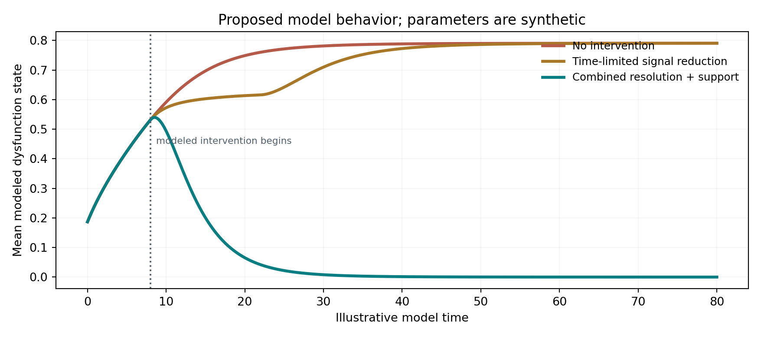
Figure 4. Qualitative trajectories from one illustrative, unvalidated ODE parameterization. No clinical or laboratory effect size should be inferred.

6. Experimental program: practical tests of Wind resolution

Program A — Directed secondary-senescence network
Core question. Do sender-cell secretomes produce causal, cell-type-specific recipient dysfunction, and does interrupting the transfer plus enhancing recovery provide a persistent functional benefit beyond either component alone?
Component | Proposed study specification
System | Noninfectious human cell lines or appropriately obtained human-derived cultures; prespecified source and receiver classes (e.g., astrocytes, microglia, endothelial cells).
Challenge | Well-characterized and institutionally approved stress or senescent conditioned medium; matched vehicle and handling controls.
Factors | A: selected source-to-recipient signal blocking; B: chosen biologically supported resolution-pathway modulation; C: correction of independently established support deficit.
Comparators | Full A×B×C factorial (8 arms), healthy reference, conditioned medium from matched non-senescent donors and assay-interference controls.
Primary endpoint | Preregistered post-washout recovery in a functional recipient assay, not cytokine reduction alone.
Secondary endpoints | Secretome, receptor target engagement, cell viability, metabolism, identity markers, multi-marker senescence profile and longer-lag recurrence.
Design/analysis | Randomize and blind measurements where feasible, model donor/batch random effects, use independent new donor and held-out time validation.
Interpretation | Do not conflate reduced SASP with elimination of senescent cells; report suppressive, restorative and potentially harmful effects separately.

Program B — Neural learning under altered inflammatory state
Use validated neural and glial model systems to ask whether a specified inflammatory input changes cue-specific responses or memory stability, and whether measured restoration of homeostatic support recovers learning-related function. Require a controlled task, baseline and delayed retention, activity/viability monitoring, and comparisons to decoder-only learning. Astrocyte-ensemble and body–brain findings provide motivation but do not prove that “knowledge” is literally carried by an extracellular molecule [4,9,10].

Program C — Safe physical transfer bench
Connect a low-power light source, calibrated photodetector and electrical RC receiver. Independently measure incoming optical power, photodetector conversion efficiency, stored electrical energy and output signal. Change only the receiver initial state or time constant; test whether CE-R01/02 and a state-space response predict the result. Compare against textbook circuit models: the objective is to test the cross-domain mapping, not to announce a new law.

Program D — Cross-scale model comparison
As an intellectual comparison, represent selected simulated black-hole feedback, thermal-control systems and cellular signaling networks using the same high-level graph metadata (source, carrier, receiver, transfer kernel, state memory, conserved quantities). Do not fit a universal scalar “good/evil wind,” and do not assume black-hole entropy is inflammatory signaling. The success criterion is reusable software structure or an out-of-sample predictive advantage, not metaphysical correspondence.

Pre-registration essentials
- Name one beneficiary and primary functional endpoint before selecting interventions.
- Predefine each cell type, sender–receiver link, assay calibration and directionality criterion.
- Power a factorial experiment for an interaction contrast; report confidence intervals, multiplicity and batch variation.
- Measure both acute suppression and delayed/washout recovery; separately track senescence and viability.
- Fit mechanistic and reduced models only on training sets; reserve held-out donors, days and perturbations.
- Disclose all attempted pathways, null results, adverse effects and failures to reproduce.

7. Measurement and data infrastructure

7.1 Minimal relational schema
Table | Essential fields | Purpose
systems | system_id, donor_or_source, type, boundary, identity_rule | Defines each Soul without metaphysical assumptions
interfaces | edge_id, source_id, receiver_id, carrier, units, mechanism | Defines observed directed Winds
time_series | timestamp, system_id, feature, value, uncertainty, batch | Stores H, D, R, M, Z proxies and raw assays
interventions | arm_id, target_edge_or_node, start, stop, exposure | Preserves intervention provenance
endpoints | functional_metric, baseline, followup, safety_flags | Separates signals from actual recovery
models | equation_version, parameters, fit_data, heldout_loss | Audits predictions and model drift

7.2 Parameter identifiability
A plausible-looking trajectory does not uniquely identify molecular mechanisms. q, β, a, clearance rates and state-memory parameters can compensate for one another. Predefine units; use independent pathway measurements, receptor/ligand perturbations, uncertainty quantification, sensitivity analysis and a held-out prediction task. If the network cannot distinguish mechanisms, reduce the model complexity before interpreting its parameters as causal.

7.3 Comparator models
At minimum: (i) independent exponential decay, (ii) ordinary linear network diffusion or state-space response, (iii) cytokine/SASP-only models, (iv) full ChristEye model without Z, and (v) full ChristEye model with Z and R×M coupling. An apparent victory over a straw-man baseline is not sufficient. Choose the same data budget and penalize additional model complexity.

8. Decision architecture for restoration

Step 1 — Identify an actual defect
Define a functional loss, survival issue, pathological signaling outcome or unsafe operating regime. Never label an entire material, person or population morally “evil” from an inferred network state.

Step 2 — Map real ports and constrained transfers
Measure what leaves the source, how the carrier crosses the boundary, what the receiver can detect and which balance law it obeys. If a port is unknown, mark it unverified and design a discriminating measurement rather than inventing a force.

Step 3 — Separate active source, persistent state and missing capacity
Determine whether the primary problem is continued harm production (H), lasting dysfunction (D or Z), insufficient support (M), inappropriate resolution response (R), or more than one. Do not assume that suppressing H restores D or that increasing M has no side effects.

Step 4 — Choose the least disruptive intervention
Prefer bounded, measurable, reversible and source-specific changes. Preserve protective immune function and organism identity; do not apply generic “more anti-inflammation” or “more growth” principles without context.

Step 5 — Verify functional restoration and persistence
Measure behavior after withdrawal, long enough to capture relapse, adaptation or delayed toxicity. A transient normal-looking biomarker is not sufficient evidence of recovery.

Step 6 — Generalize cautiously
Demonstrate replication, transferability, safer endpoints and out-of-sample predictive accuracy before claiming a technology platform.

9. Risk register and explicit nonclaims
Risk or misconception | Scientific boundary / mitigation
Soul death produces a new universal force | No such force is demonstrated; model only measured exchanges and transformations.
All inflammation is harmful | Inflammation has protective roles; evaluate context, intensity and duration.
SASP reduction means senescence reversed | Assess growth arrest, identity, viability, proliferation and function independently.
All cell types receive the same Honey | Estimate directed sender–receiver interaction and receptor dependence.
Metabolic fuel alone repairs the system | Resources are necessary but can support pathology too; enforce cell-type-specific safety.
Ghost Network communicates death universally | Use as a label for persistent traces in known carriers unless new evidence emerges.
Black holes damage the universe by cosmic inflammation | No evidence; astrophysical feedback differs mechanistically from cell inflammation.
Entropy causes conversion to antimatter | Not a physical consequence of the second law; baryogenesis is separate.
Nuclear fission can be primed with matching Winds | Not established; nuclear applications here are conceptual conservation examples only.
Cure or clinical recommendation from simulations | No; human use requires independent preclinical and clinical evidence.

10. Project roadmap and publication-ready milestones
Phase | Work product | Go / no-go criterion
0. Ontology and versioning | Stable term definitions, CE-R equations, signed balance/unit checks | No undefined carrier presented as a physical law.
1. Evidence graph | Cell-type-by-signal matrix with mechanism and study quality | At least one tractable causal edge and functional endpoint.
2. Reference computational model | Reproducible source code, synthetic benchmarks, model cards | Conservation checks, no leakage and stable parameter recovery.
3. Bench validation | Noninfectious directed-paracrine assay or low-power transfer setup | Model beats preregistered comparator on held-out test.
4. Resolution factorial | Independent signal, support and combined conditions | Functional recovery with interpretable uncertainty.
5. Persistence and translation | Washout, multi-donor replication, adverse-effect profile | Reproducible benefit before any animal/clinical proposal.

A publishable first paper could be titled “A Conservation-Constrained Network Model of Persistent Damage Signaling and Active Resolution.” The minimal contribution would be a well-annotated cross-cell communication graph, an identifiable feedback model, a held-out prediction challenge and a negative-control-rich restoration study. Broad “restoring creation” language can remain a philosophical preface, while the scientific title states the testable claim.

11. Final scientific position
The strongest version of this research is not a claim that molecular death makes the universe evil. It is a program for identifying how damaged systems propagate measurable disturbances, how recipient history and resources affect the resulting response, and how carefully controlled resolution can restore function. This interpretation is directly relevant to senescence, neuroimmune control, metabolism and engineered systems. It is not established for a hypothetical cosmic Ghost Network, black-hole information transfer to biology, or antimatter formation.
The next decisive milestone is simple to state and difficult to achieve: demonstrate an intervention selected from the ChristEye network model that produces durable, reproducible functional recovery and outperforms an appropriately matched conventional model. Reaching that milestone would convert a broad symbolic framework into a measurable scientific contribution.

Appendix A. Variable registry and units
Symbol | Meaning | Units / constraints
E_i | Energy stored within boundary i | J
P_ij | Power transferred over physical port | W
n_i | Chemical species inventory | mol
S_i | Thermodynamic entropy | J/K
σ_i | Internal entropy production rate | J/(K·s), ≥0
A_ij | Directed network influence / adjacency | dimensionless or explicitly calibrated
H_i | Harm-associated signal score | normalized or assay-calibrated
D_i | Functionally dysfunctional fraction/index | 0 to 1, not senescent count
R_i | Resolution-oriented signal score | normalized or assay-calibrated
M_i | Adequate resource / support index | 0 to 1
Z_i | Persistent physiological state proxy | nonnegative, specified assay
ρ(A) | Spectral radius of nonnegative matrix A | dimensionless
u_R, u_M | Permitted experimental inputs | state-dependent specified units
L | Held-out prediction loss | unit depends on endpoint

Appendix B. Where CE-R connects to the existing ChristEye archive
Earlier family | Integration here | Boundary
CE-01–04: Winds and conservation | CE-R01–R04 use flux, power, chemical species and entropy accounting | No additional mass or energy source is implied.
CE-06–11: restoration and damage | CE-R05–R08 formalize H/D/R/M process states | Coefficients are candidate, assay-dependent mechanisms.
CE-12–16: signaling and response | Directed A_ij source–receiver topology and state/history effects | A directed interaction is not equivalent to a universal network.
CE-19–25: Milk–Honey learning | R×M interaction and Z history state | Learning transfer remains a separate experimental claim.
CE-26–31: electrophysiology and energy | Use physical ports with correct units and budgets | No electrochemical free-energy exemption.
Four-Stream Strategy | Preserves separate H, D, R, M and optional memory | Signaling suppression ≠ senescent-cell clearance.

References and provenance
Reference numbers identify independent published work supporting specific mechanisms or methodological comparisons. They are not endorsements of the ChristEye ontology. Publication information and links were checked against public source pages on November 4, 2026.
[1] Russo T, Riessland M. Characterizing the SASP-Dependent Paracrine Spreading of Senescence Between Human Brain Cell Types. Aging Cell (2026). https://doi.org/10.1111/acel.70673
[2] Martini H et al. Mitochondrial metabolism and epigenetic crosstalk drive SASP. Nature (2026). https://doi.org/10.1038/s41586-026-10791-2
[3] Efferocytosis drives a tryptophan metabolism pathway in macrophages to promote tissue resolution. Nature Metabolism 6, 1736–1755 (2024). https://doi.org/10.1038/s42255-024-01115-7
[4] Jin H et al. A body–brain circuit that regulates body inflammatory responses. Nature 630, 695–703 (2024). https://doi.org/10.1038/s41586-024-07469-y
[5] Molecular mechanisms of acute inflammation: systemic responses and kidney-specific pathophysiology. Function (2026). https://journals.physiology.org/doi/full/10.1152/function.087.2025
[6] Salekeen R et al. Genomic, epigenomic and transcriptomic regulation of cellular senescence. Nature Reviews Genetics (2026). https://doi.org/10.1038/s41576-026-00982-y
[7] Hinterleitner C et al. Senescence in cancer: Hallmarks, paradoxes, and therapeutic promise. Cell 189, 2357–2378 (2026). https://doi.org/10.1016/j.cell.2026.03.005
[8] Fredman G, Serhan CN. Specialized pro-resolving mediators in vascular inflammation and atherosclerotic cardiovascular disease. Nature Reviews Cardiology 21, 808–823 (2024). https://doi.org/10.1038/s41569-023-00984-x
[9] Learning-associated astrocyte ensembles regulate memory recall. Nature 637, 478–486 (2025). https://doi.org/10.1038/s41586-024-08170-w
[10] The astrocytic ensemble acts as a multiday trace to stabilize memory. Nature (2025). https://doi.org/10.1038/s41586-025-09619-2
[11] Network thermodynamics of biological systems: A bond graph approach. Mathematical Biosciences (2022). https://doi.org/10.1016/j.mbs.2022.108899
[12] A review of the diverse applications of bond graphs in biology and physiology. Proceedings of the Royal Society A (2024). https://doi.org/10.1098/rspa.2023.0807
[13] Black-hole thermodynamics. Nature Reviews Physics (2026). https://doi.org/10.1038/s42254-026-00942-9
[14] NASA. Black Hole Triggering Star Formation in Henize 2-10 (2022). https://science.nasa.gov/asset/hubble/black-hole-triggering-star-formation-in-henize-2-10/
[15] CERN. Antimatter: the matter–antimatter asymmetry problem. https://home.cern/science/physics/antimatter
[16] Physical Chemistry Models for Chemical Research in the XXth and XXIst Centuries. ACS Physical Chemistry Au (2024). https://pubs.acs.org/doi/10.1021/acsphyschemau.3c00057
[17] McHugh D, Durán I, Gil J. Senescence as a therapeutic target in cancer and age-related diseases. Nature Reviews Drug Discovery 24, 57–71 (2025). https://doi.org/10.1038/s41573-024-01074-4
[18] Sánchez Romero J, Navarrete M. Astroengrams: rethinking the cellular substrate for memory. Nature Reviews Neuroscience 27, 289–300 (2026). https://doi.org/10.1038/s41583-025-01012-2

Internal starting material
We Develop Software LLC, ChristEye-master (3).zip (provided November 4, 2026): especially principles/ChristEye_Equations.docx; principles/ChristEye_Four_Stream_Strategy_and_Equations_v1.docx; basis/ChristEye_Central_Framework_Soul_Lotus_Marrow_Winds_Roots_Heart_v1.0.docx; principles/ChristEye_Methodology_Restoration_Oriented_Systems_Thinking.docx. The new CE-R labels denote a proposed extension of those source documents, not a revision of their established physical laws.

