THE CONSOLIDATED MATHEMATICAL FRAMEWORK

ChristEye
Equations
  - Living Periodic Table • Winds Translation • Soul Restoration • Milk & Honey • Neural Learning

Research formula compendium and comparative evaluation
Expanded Edition 2.0 | 4 November 2026 | We Develop Software LLC
This document consolidates the equations visible in the supplied screenshots and the previously compiled ChristEye Core Equations infographic, using the Living Table and Heart Engine source documents for notation checks. Duplicated expressions have been combined. Each formula is labeled to distinguish well-established science from ChristEye-specific hypotheses, definitions and adaptations. This expanded edition restores equation-by-equation explanations, contextual analysis and experimental implications from the supplied screenshots.
KEY PRINCIPLE
Integration is not equivalent to discovery of a new physical law. The proposed mappings, coefficients and biological interactions require specific measurement definitions, independent test data and reproducible predictive comparisons.
40 EQUATIONS / DETAILED DEFINITIONS / SCREENSHOT RECONSTRUCTION / COMPARATIVE SCORING
Scope: technical and research-oriented. Not a validated drug, oncology or antiviral treatment, and not a claim that “Soul,” “Heart,” “Milk,” “Honey,” or “Winds” are independently established scientific categories.

AT A GLANCE

How to read this compendium
The mathematical architecture contains six linked areas: (1) chemistry-to-ChristEye translation and flux conservation; (2) restoration and damage assessment; (3) cross-kingdom extracellular signaling and behavioral response; (4) Milk–Honey learning interactions; (5) biophysical energy and electrical constraints; and (6) total-system performance and sizing.

ChristEye operational vocabulary
Soul denotes the organized whole whose continued viability and functioning are assessed; Lotus denotes response coordination; Marrow denotes structural constraints and inherited organization; Winds denotes physical, chemical and electrical influences; Roots denotes persistent support, history and retained adaptation; Heart denotes learned or adaptive response formation. These are names within ChristEye, not established one-to-one biological entities.
In the four-part Milk/Honey classification, Honey refers to signaling or recognition influences, whereas Milk refers to persistent metabolic, ionic or functional support conditions. “Good” and “Evil” classify effects on a defined endpoint and beneficiary; they are not universal intrinsic moral properties of molecules.

Evidence labels
Label | Meaning
ESTABLISHED | A standard physical, mathematical or biochemical equation; included here as a building block, not a ChristEye discovery.
ADAPTED | An existing mathematical technique applied to the proposed ChristEye description.
PROPOSED / METRIC | A new labeling choice, outcome definition, model scaffold or mathematical formalization whose usefulness must be tested.
UNTESTED HYPOTHESIS | A specific proposed causal or interactive relationship not demonstrated for ChristEye.
PROVISIONAL | An equation or scaling assumption applicable only under explicit constraints.

Map of the equation families
Section | Topic | Entries
01 | Winds, translation and conservation | 5
02 | Restoration and damage inference | 6
03 | Cross-kingdom signaling and response | 7
04 | Milk–Honey learning and neural adaptation | 7
05 | Neural electrophysiology and bioenergetics | 6
06 | System efficiency and scale | 9
07 | Integrated cross-scale model | coupled formulation
08 | Comparison against established equation systems | ratings

EQUATION FAMILY / 01

Winds, translation and conservation
Crosswalking chemistry and physical fluxes into a functional systems description
CE-01 Chemical reaction and transport balance ESTABLISHED / ADAPTED
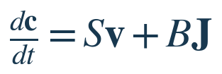
c = chemical concentrations; S = stoichiometric matrix; v = reaction-rate vector; J = boundary transport flux; B = boundary-to-state mapping. All terms must have compatible units.
Definitions: c is a vector of concentrations (e.g., mol L⁻¹); S is a reaction-stoichiometry matrix; v gives chemical reaction rates; J describes boundary transport; B converts oriented flows into state rates.
Interpretation: conservation is a constraint on the proposed Winds translation. Reactions can rearrange species, but the underlying elemental and charge balances must remain valid.
Experimental reading / limitations: choose a defined compartment, measure influx and efflux, reactions and accumulation; compare residual balance errors against experimental measurement uncertainty.
CE-02 ChristEye functional translation PROPOSED
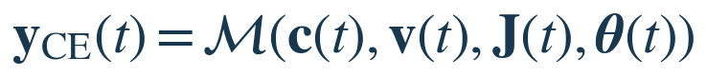
M translates measured chemical and physical quantities into ChristEye functional features. It is an undefined mapping to estimate and validate, not a newly discovered force.
Definitions: M is the proposed chemical-to-functional feature map; y_CE is a vector of ChristEye features; θ holds parameters learned or calibrated for the specific system.
Interpretation: calcium/potassium support electrophysiological regulation; lactate reflects metabolic support; receptor binding represents signaling; persistent synaptic changes can be described under Roots.
Experimental reading / limitations: translating descriptions is not changing one physical force into another. A useful map must specify dimensional inputs, normalization, empirical outputs and held-out prediction gains.
CE-03 Signed interface conservation ESTABLISHED / ADAPTED

Applies to the same conserved transfer recorded from two sides using opposite sign conventions. Additional sources and sinks require additional terms.
Definitions: J_A→B and J_B→A represent the same amount transported across one interface, recorded from opposite sides under a signed convention.
Interpretation: this is pairwise cancellation in an interface ledger, not a claim that actual matter stops flowing. An ongoing nonzero flux can be balanced.
Experimental reading / limitations: if synthesis, degradation, storage, other exits or different physical species are involved, a complete source–sink account is required.
CE-04 Resource budget for the Winds PROPOSED ADAPTATION
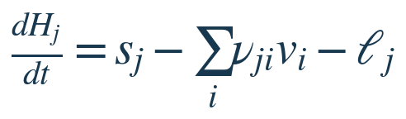
H_j = available stock of resource j; s_j = supply; nu_ji v_i = consumption; ell_j = loss. Here H_j means resource, not Honey.
Definitions: H_j is stock of a specified material/energy resource j, s_j is its supply rate, ν_ji v_i its utilization rate, and ℓ_j represents leaks and losses.
Interpretation: the Lotus cannot maintain activity indefinitely if the needed resource stores are depleted. Winds must be balanced against consumption and losses.
Experimental reading / limitations: measure the resource over time at matched activity and delivery conditions, and assess whether the budget predicts depletion and recovery.
CE-05 Component record for the Living Table PROPOSED METRIC
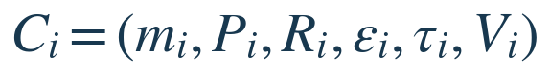
For component i: mass, power, useful output rate, error fraction, latency and viable fraction. The record is specified in the Living Table & Energy Framework.
Definitions: m_i mass; P_i electrical/metabolic power; R_i useful response rate; ε_i errors; τ_i response latency; V_i viable fraction.
Interpretation: the Living Table compares components by measurable operating characteristics rather than metaphor alone.
Experimental reading / limitations: agree on task, measurement window and power boundary before comparing a biological component with conventional hardware.

The Winds transition: chemical description → functional description
The screenshots define the Winds as electrical, molecular and physical flows. In a rigorous model the chemical state is represented by concentrations, reaction rates and boundary transport, while the proposed ChristEye representation identifies their roles in system function. Calcium and potassium can be mapped to neuronal excitability, lactate to metabolic support, receptor ligands to received messages, and retained connection changes to Roots. This does not transform physical forces or permit an arbitrary exchange of mass and energy: it creates a crosswalk between two levels of description.
For a single material crossing the A/B interface, the signed exchange terms cancel if both sides describe the same transfer. For a functioning open system, the total accumulation is instead supply plus generation minus consumption and losses. A predictive Winds map would require explicit calibrated features, dimensional checks, conservation residuals and performance on held-out examples.
EQUATION FAMILY / 02

Restoration and damage inference
Identifying beneficial or damaging changes for an explicitly defined beneficiary
CE-06 Restoration alignment score PROPOSED METRIC
F_H = healthy functional outcome; V_H = viable fraction; D_H = damage. Normalize the outcomes before weighting, and specify comparator and time window.
Definitions: ΔF_H is change in healthy function, ΔV_H change in viable fraction, ΔD_H change in damage; w_F, w_V and w_D are prespecified nonnegative weights.
Interpretation: a system is restorative only relative to the specified beneficiary and outcome criteria. The positive, near-zero and negative score cases mean net modeled improvement, ambiguous balance and deterioration.
Experimental reading / limitations: normalize differently scaled outcomes, document weights, include uncertainty and measure adverse effects separately. This is not a universal objective measure of a literal spiritual soul.
CE-07 Sensitivity to a Wind PROPOSED
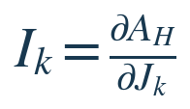
I_k is a local sensitivity of the restoration score to measured signal or flux J_k; a derivative alone does not prove causal effects.
Definitions: I_k measures sensitivity of the defined restoration alignment to a particular molecular, electrical or physical Wind J_k.
Interpretation: the sign suggests whether a controlled increase in the selected flow would improve or worsen the chosen restoration score locally.
Experimental reading / limitations: compare perturbed and control conditions with matched cell type, baseline, dose and timing; observational correlations do not establish that the Wind caused the change.
CE-08 Safety-constrained restoration choice PROPOSED / CONTROL THEORY
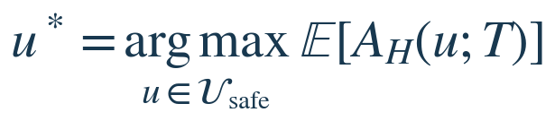
Select permitted intervention u maximizing expected restoration by horizon T. Requires validated safety constraints, dynamics, and uncertainty estimates.
Definitions: u is a candidate intervention, U_safe the set permitted by explicit safety constraints, T a prespecified observation horizon, and E the expectation over uncertainty.
Interpretation: the Lotus chooses among validated options using outcomes supplied by the Heart and history from Roots, while Winds carry input actions and feedback.
Experimental reading / limitations: numerical optimization cannot replace safety evidence. Unknown dynamics, unmodeled toxicity or incorrectly chosen objectives can make an apparently optimal action harmful.
CE-09 Harm-associated extracellular signal score PROPOSED METRIC
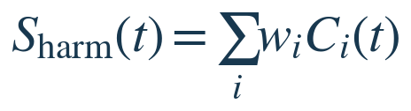
C_i = measured extracellular inflammatory signals; w_i = estimated contributions to a particular harmful endpoint. Coefficients vary with cell type and context.
Definitions: C_i(t) is a measured extracellular inflammatory signal and w_i is its experimentally estimated contribution to a defined harmful outcome.
Interpretation: this offers a provisional quantitative meaning for Honey of Evil: an external signaling pattern associated with damaging or dysregulated responses.
Experimental reading / limitations: the weights vary with cell type, dose, timing, receptors and context. A signal is not automatically harmful because it appears in the score.
CE-10 Repair-associated extracellular signal score PROPOSED METRIC
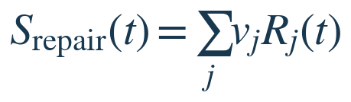
R_j = measured repair-associated signals; v_j = experimentally estimated outcome weights, which are not universal or always positive.
Definitions: R_j(t) denotes repair-associated signals and v_j their empirically determined weights relative to a stated protective or restorative endpoint.
Interpretation: the score formalizes Honey of Good as a response-guiding signal pattern rather than a fixed list of universally beneficial molecules.
Experimental reading / limitations: check whether changes in the score predict normalized functional recovery beyond a baseline model and whether the weights generalize across experiments.
CE-11 Recovery-capacity relationship PROPOSED RELATION
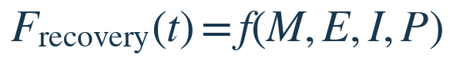
M = metabolic support; E = available energy; I = ionic homeostasis; P = preserved or restored functional plasticity. f is unspecified.
Definitions: M = metabolic support; E = energy availability; I = ionic homeostasis; P = retained or recovered functional plasticity.
Interpretation: Milk of Good concerns the physiological conditions that sustain a functional response, not merely the presence of a particular compound.
Experimental reading / limitations: f is not specified; a measured rise in ATP or metabolite concentration does not alone demonstrate reversal of senescence or successful recovery.

How the restoration score classifies outcomes
For a given beneficiary and controlled comparison, positive A_H means the weighted changes in function and viability exceed the weighted change in damage. Near-zero values mean the weighted balance is inconclusive; negative values mean modeled deterioration. Outcomes must be defined before weights are chosen so an apparent benefit cannot be manufactured simply by adjusting weights after seeing results.
The derivative I_k asks a more specific causal research question: holding relevant conditions controlled, does perturbing one Wind J_k improve or worsen the restoration score? The constrained optimizer then asks which permitted intervention could increase expected restoration without violating independently defined safety boundaries. These are engineering research decisions, not proof of a universally measurable metaphysical soul.
EQUATION FAMILY / 03

Cross-kingdom signaling and response
A common observation format for extracellular signaling, receptors, state and behavior
CE-12 General response relation PROPOSED SCHEMA
Cross-Kingdom External Signaling Atlas: list sender, molecular signal, receiving system, receptor, context, and measured response.
Definitions: internal state, emitted signals, receptor/regulatory machinery and environmental context are explanatory inputs; response is an experimentally measured output.
Interpretation: this is the proposed Cross-Kingdom External Signaling Atlas observation template that can be applied to bacteria, phages, plants, immune cells and neuronal systems.
Experimental reading / limitations: sender, signal identity and concentration, receiver and receptor, context, functional readout, timing, uncertainty and evidence of causal intervention.
CE-13 Cellular response-state dynamics PROPOSED SCHEMA
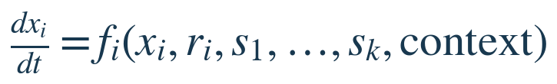
x_i = cell state; r_i = receptor state; s_k = extracellular signals. The functional form and parameters require observation and intervention.
Definitions: x_i is state of recipient cell i; r_i its receptor/regulator state; s_1...s_k the signals it encounters; f_i a system-specific response law.
Interpretation: the same chemical Wind can produce different cellular outcomes because the receiving Lotus, Marrow, Roots and regulatory context differ.
Experimental reading / limitations: estimate f_i rather than asserting a universal effect; compare multiple cell types and perturb receptor activity to distinguish mechanisms.
CE-14 Signal production dynamics ILLUSTRATIVE LIMITING CASE
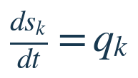
q_k is secretion or production rate. A full balance should add transport, uptake and degradation; this equality assumes those terms are omitted.
Definitions: s_k is local concentration of signal k; q_k its net assumed secretion term.
Interpretation: the screenshot writes ds_k/dt = secretion_k as an illustrative production relation, not a full extracellular signaling model.
Experimental reading / limitations: A real balance includes production, uptake, transport, diffusion, binding and degradation; otherwise it can imply unrealistic indefinite growth.
CE-15 Behavioral response under internal state and context PROPOSED SCHEMA
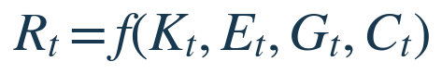
R_t = observed behavior; K_t = stored learning state; E_t = extracellular/inflammatory environment; G_t = glial regulation; C_t = cue/context.
Definitions: R_t observed behavioral response; K_t established learned memory/network state; E_t extracellular inflammatory environment; G_t astrocyte/microglia state; C_t cue and physiological context.
Interpretation: performance may change even when an acquired network representation remains retrievable; signaling can alter expression, generalization or reconsolidation.
Experimental reading / limitations: compare neural circuit measures, repeated cue-response trials and state changes while distinguishing temporary retrieval disruption from durable memory updating.
CE-16 Cue-discrimination score ESTABLISHED-STYLE METRIC
Proposed outcome for distinguishing cue-specific learning from inappropriate generalization. The probability estimates require clearly defined trials and conditions.
Definitions: P(fear | danger) and P(fear | neutral) are empirically estimated response probabilities under separate standardized cues.
Interpretation: a high D indicates better discrimination between the danger cue and a matched neutral cue; low D suggests reduced separation, not by itself the reason for the change.
Experimental reading / limitations: track D alongside inflammatory markers, astrocyte reactivity and engram-related activity under blinded evaluation and predeclared time windows.
CE-17 Reversible bimolecular binding kinetics ESTABLISHED
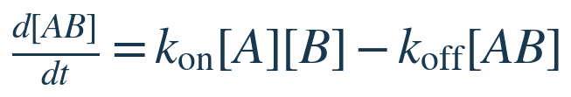
Mass-action association/dissociation model for simple 1:1 reversible binding; a candidate description of some ligand–receptor or viral-decoy interactions.
Definitions: [A], [B] and [AB] are free and bound concentrations; k_on is association-rate constant; k_off dissociation-rate constant.
Interpretation: molecular recognition and decoy interactions are subject to kinetic constraints, not simply beneficial/harmful labels.
Experimental reading / limitations: simple 1:1 reversible binding, well-mixed behavior and appropriate units; cooperative, multivalent and transport-limited binding needs richer equations.
CE-18 Binding dissociation constant ESTABLISHED
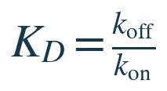
Applies to the matching simple 1:1 kinetic model under appropriate conditions; smaller K_D generally indicates higher binding affinity.
Definitions: K_D is an equilibrium dissociation constant obtained from the matching association and dissociation parameters.
Interpretation: under the simple binding model, lower K_D typically means higher affinity; affinity alone is not equivalent to neutralization or treatment.
Experimental reading / limitations: a receptor-bearing decoy must also avoid productive infection, toxicity and deleterious host effects before it can be described as protective.

Four questions for every Cross-Kingdom Signaling Atlas record
1. Which signals are produced, by whom, and under what conditions?
2. Which receptors and regulatory processes receive them?
3. Does the signal measurably change cellular function or behavior?
4. Does the change improve protection, adaptation or survival—or contribute to damage?
The chemical identity of a signal alone cannot classify it as protective or damaging. One cytokine or metabolite may support a short protective response and contribute to lasting harm at another concentration, duration or tissue context. Signal effects depend on receiver, dose, timing, receptors and the measured endpoint.
EQUATION FAMILY / 04

Milk–Honey learning and neural adaptation
Metabolic support, signaling, plasticity and retained response
CE-19 Milk–Honey learning interaction UNTESTED HYPOTHESIS
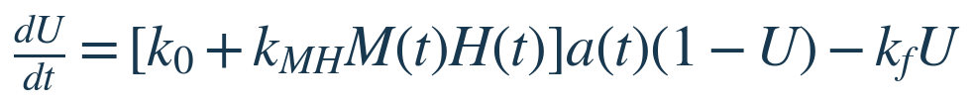
U in [0,1] = retained learning; M = normalized metabolic support; H = normalized stabilizing signals; a = task activity; k_f = loss rate. The multiplicative interaction is a hypothesis.
Definitions: U in [0,1] represents normalized retention; M(t) metabolic/ionic Milk support; H(t) stabilizing Honey signaling; a(t) relevant activity; k_MH interaction strength; k_f loss coefficient.
Interpretation: M×H hypothesizes that adequate resources plus molecular stabilization together improve response acquisition or retention more than either factor in isolation.
Experimental reading / limitations: compare full factorial conditions (low/high M and H), estimate the interaction with activity controlled, and confirm delayed learning retention and cell viability.
CE-20 Adaptive connection-strength rule PROPOSED / LEARNING THEORY
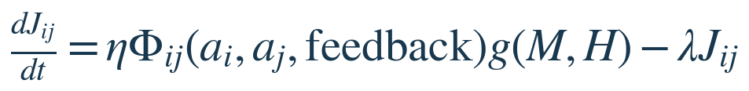
J_ij = connection-strength proxy; Phi = learning rule; g = Milk/Honey modulation; lambda = decay. Different J_ij from flux J_k in CE-07.
Definitions: J_ij is neural connection-strength proxy; η learning rate; Φ_ij a feedback-dependent plasticity rule; g(M,H) support modulation; λ decay.
Interpretation: this attempts to mathematically connect activity-bearing Winds, signal/resource support, the adapting Lotus and consolidated Roots.
Experimental reading / limitations: the precise form of Φ and g must be specified and inferred; not all learning is a simple change to individual pairwise synaptic weights.
CE-21 Honey candidate retention comparison PROPOSED METRIC

Difference in defined delayed-retention measurements between a future chemically specified candidate and a matched control; not evidence of an existing drug.
Definitions: R_U,Honey is delayed-retention outcome after a chemically specified candidate; R_U,control is the same defined outcome under an appropriate comparison.
Interpretation: this is a comparative outcome measure, not an equation defining molecular structure or how to synthesize a compound.
Experimental reading / limitations: The current Honey proposal identifies BDNF–TrkB modulation and possible astrocyte-associated IGFBP2 roles, but does not establish an active new molecule, dose or efficacy.
CE-22 Positive Milk–Honey interaction prediction UNTESTED HYPOTHESIS
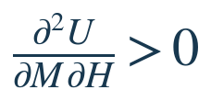
Proposes a positive cross-interaction over a specified operating range, conditional on a defined response surface and experimental controls.
Definitions: U is modeled retention, M and H are independently normalized metabolic-support and signaling inputs.
Interpretation: a positive mixed partial derivative predicts synergy in the specified local response surface: the impact of increasing M depends positively on H.
Experimental reading / limitations: fit additive and interactive alternatives using prespecified independent data; synergy may vanish or reverse under other cell types, exposures and times.
CE-23 Learning system state update PROPOSED / CONTROL THEORY
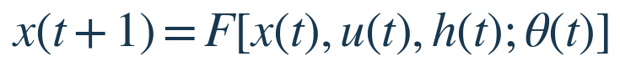
x = state; u = intervention or input; h = history or supporting state; theta = adaptive parameters. F requires model specification.
Definitions: x(t) system state; u(t) input or intervention; h(t) relevant historical/support state; θ(t) parameters; F one-step state-transition law.
Interpretation: the Heart Engine formalizes the idea that responses emerge from current input interacting with existing learning and support states.
Experimental reading / limitations: specifying F as a symbol is not a derivation. Predictive value requires state observables, trained parameters, time step and verified transitions.
CE-24 Adaptive parameter update PROPOSED / LEARNING THEORY
L is an unspecified update rule, potentially learned or derived from experiment.
Definitions: θ is adaptive parameters and L maps feedback with previous state and input to an incremental update.
Interpretation: this is the formal version of experience modifying subsequent responses; it can be instantiated as plasticity, reinforcement or parameter-estimation rules.
Experimental reading / limitations: disclose L, show stable learning rather than transient fluctuation, and compare against a nonlearning or standard algorithmic baseline.
CE-25 Normalized rooted-understanding retention PROPOSED METRIC
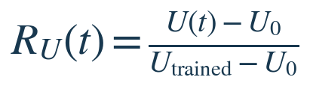
Compares observed understanding/retention U(t) with an untrained baseline U0 and trained reference. Undefined if the denominator is zero.
Definitions: U_0 is baseline measured understanding; U_trained a reference after training; U(t) subsequent outcome.
Interpretation: R_U normalizes the tested performance between an initial and a trained reference, connecting to the idea of rooted Understanding.
Experimental reading / limitations: training, testing and retention must be operationally defined; denominator cannot be zero, and values outside [0,1] are possible unless data are constrained.

What the Milk–Honey learning equations actually predict
The product M(t)H(t) is the key hypothesized interaction. The proposed model says that measured resource/metabolic support and appropriate stabilizing signals could improve retained learning together. Testing that claim requires a factorial experiment with independent Milk/Honey conditions, matched neural activity and cell viability, and a delayed retention measure. Positive synergy is a result to test—not an assumed biological law.
The plasticity equation connects the hypothesized support term g(M,H) to an independently defined activity-dependent learning law. In the Honey pharmacology program, the documents nominate BDNF–TrkB modulation and IGFBP2-related astrocyte signaling as targets to investigate. They do not provide the structure, synthesis or proven efficacy of a newly discovered drug.
EQUATION FAMILY / 05

Neural electrophysiology and bioenergetics
Established equations integrated into the Living Table physical layer
CE-26 Nernst equilibrium potential ESTABLISHED
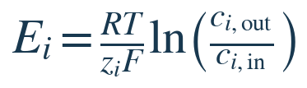
Ion equilibrium potential at temperature T; activities, rather than concentration approximations, are preferable for precision.
Definitions: R gas constant, T Kelvin, z_i ion valence, F Faraday constant, c_i inside/outside concentrations.
Interpretation: the equilibrium potential characterizes the electrochemical tendency of ion i across a membrane.
Experimental reading / limitations: equilibrium of a single permeant ionic species; use chemical activities and account for permeability, pumps and gating in full membrane models.
CE-27 Membrane ionic current ESTABLISHED
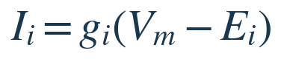
Ohmic conductance approximation for ionic current i.
Definitions: I_i ionic current, g_i conductance, V_m actual membrane potential, E_i reversal potential.
Interpretation: driving force (V_m−E_i) and conductance jointly determine current in an Ohmic approximation.
Experimental reading / limitations: voltage clamp, channel-state models and controlled ionic gradients; do not equate a single conductance with information processing.
CE-28 Lumped membrane voltage dynamics ESTABLISHED
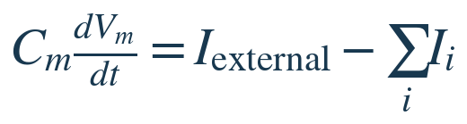
Current-balance relation with outward ionic current positive; a spatial axon requires a cable model and channel kinetics.
Definitions: C_m membrane capacitance; I_external imposed current; ΣI_i outward channel/ionic currents.
Interpretation: conservation of charge links electrical inputs and ionic currents to changing membrane voltage.
Experimental reading / limitations: lumped single-compartment balance; spatially extended axons need cable equations and biologically realistic channel kinetics.
CE-29 Electrochemical work for ion transport ESTABLISHED
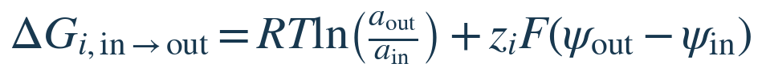
Molar free-energy difference from inside to outside; a is activity and psi electric potential.
Definitions: a_out/a_in are dimensionless activity ratios; ψ_out−ψ_in is potential difference; z_iF converts charge to molar energy.
Interpretation: ion transport is affected by both chemical gradient and electric potential and can consume or release free energy.
Experimental reading / limitations: specify transfer direction, pH and temperature as appropriate; gradients may be actively maintained at an ATP cost.
CE-30 Axon geometry, capacitance and resistance ESTABLISHED APPROXIMATION
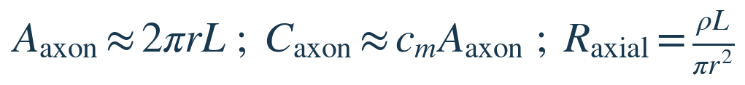
Unbranched cylindrical axon approximation: r radius, L length, c_m membrane capacitance per area, rho resistivity.
Definitions: r axon radius, L length, c_m capacitance per membrane area, ρ axial resistivity.
Interpretation: geometry shapes surface capacitance, axial resistance, conduction and overall biological computing resource needs.
Experimental reading / limitations: cylindrical uniform passive geometry is only a first approximation; branching and active conduction alter the relation.
CE-31 ATP chemical energy accounting ESTABLISHED ACCOUNTING

Approximate chemical-energy magnitude of hydrolyzed ATP molecules; Delta G depends on local conditions.
Definitions: n_ATP is moles of ATP hydrolyzed (or count with matching per-molecule ΔG); ΔG_ATP is magnitude of hydrolysis energy in matched units.
Interpretation: biochemical energy use must be counted when benchmarking living neural hardware against conventional processors.
Experimental reading / limitations: Avoid using an invariant energy per ATP across all biological states; electrochemical gradients, transport and upkeep must also be considered.

Why energy accounting is essential
The Nernst potential, Ohmic current approximation, membrane charge balance and electrochemical work equations explain the physical conditions required for neural excitability. The ATP and axonal geometry relations indicate why a biological computer requires both a signaling network and a continuous energy/support infrastructure.
Any comparison with electronic processors must account for total-system electricity, culture maintenance, interfaces, nutrient media and longevity—not just the energy of a single neural spike.
EQUATION FAMILY / 06

System efficiency and scale
Quantitative comparisons of energy, accuracy, capacity and total support costs
CE-32 Energy per correct response / task cost PROPOSED METRIC
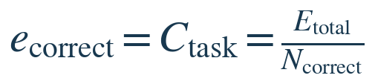
Equivalent expressions shown in the earlier infographic; merged to remove duplication. Compare identical tasks and include the whole-system energy boundary.
Definitions: E_total includes the chosen power/time boundary; N_correct is number of correct responses to a standardized task.
Interpretation: identical to the task-cost score, giving energetic cost per useful outcome rather than raw power alone.
Experimental reading / limitations: compare equal-accuracy tasks across training conditions and include pumps, media support, instruments, cooling and interfacing where applicable.
CE-33 Training efficiency gain PROPOSED METRIC

Relative improvement in energy per correct result; denominator must be nonzero and task performance must be comparable.
Definitions: e_before and e_after are energy per correct outcome before and after the specified training/engineering change.
Interpretation: G_E > 0 means lower cost per correct response; G_E < 0 means the energy cost increased.
Experimental reading / limitations: compare the same workload and precision requirement, propagate measurement uncertainty, and keep standby/life-support terms consistent.
CE-34 Axonal spike-energy cost PROPOSED METRIC
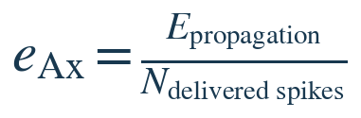
Energy for propagation per successfully delivered spike, requiring an explicit definition of success.
Definitions: E_propagation is estimated or measured axonal propagation energy; N_delivered spikes counts prespecified successfully propagated events.
Interpretation: compares energy cost of propagating spikes through a designed neural interconnect.
Experimental reading / limitations: successful spike conduction is not necessarily a correct task response; separate propagation efficiency from computational usefulness.
CE-35 Mass-normalized performance PROPOSED METRIC

Correct responses per energy per system mass. Units should be reported explicitly.
Definitions: N_correct is correct task outcomes; E_total energy; m_system total system mass.
Interpretation: combines energy efficiency with physical footprint for comparing devices.
Experimental reading / limitations: report units explicitly; do not omit heavy supporting instrumentation while counting only neural tissue mass.
CE-36 Lifetime energy amortization PROPOSED METRIC

Spreads training energy across measured useful task count, then adds operation cost.
Definitions: E_training energy for setup/training; N_lifetime tasks the actual or projected useful task count; E_operation/task operation energy per task.
Interpretation: a biological computing system that is costly to train must perform enough tasks to justify the overhead.
Experimental reading / limitations: sensitivity analyses for lifespan, culture replacement, calibration drift and performance degradation.
CE-37 Total biological platform power PROPOSED METRIC
Includes neuron, support, interface and life-support loads. Avoid double-counting power.
Definitions: N_n count of neurons; p_n mean power per neuron; P_support nutrient/media and environmental support; P_interface instrumentation; P_life support maintenance.
Interpretation: total system electricity cannot be estimated from neuronal spikes alone; ancillary and life-support loads often dominate.
Experimental reading / limitations: avoid double counting biological heat/ATP within external support, and state whether each power term is metabolic or electrical.
CE-38 Provisional neuron-capacity bound PROVISIONAL ASSUMPTION

Only meaningful if a tested, approximately linear scaling model exists; neural computation is typically distributed and nonlinear.
Definitions: R_required is target validated service throughput; r_validated a tested sustainable service rate per neuron.
Interpretation: the expression is a provisional lower bound only if neurons contribute in an approximately additive scalable way.
Experimental reading / limitations: distributed coding, network bottlenecks, collective dynamics and redundancy mean the linear formula may fail.
CE-39 Connection-count estimate PROPOSED ESTIMATE

Counts directed connection endpoints if k-bar is mean outgoing connections per neuron; not necessarily distinct physical axons.
Definitions: N_n count of neurons, k-bar mean outgoing connection count.
Interpretation: provides a basic graph-design estimate useful for physical routing and rough scaling.
Experimental reading / limitations: connection endpoints, functional synapses and independent axons differ; multiple synapses can connect the same neuron pair.
CE-40 Tissue and axon volume estimates ESTABLISHED GEOMETRY

Mass from density and volume; axon volume from cylindrical approximations. Do not double-count axons included in tissue volume.
Definitions: ρ_tissue density, V_tissue tissue volume; r_i and L_i describe axonal cylinder segments.
Interpretation: geometry and tissue density constrain packaging, transport demands and the practical feasibility of a biological device.
Experimental reading / limitations: avoid double counting neurites already included in tissue; real tissue includes extracellular matrix, glia, vascular/support components and voids.

Benchmarking a complete biological platform
The strongest performance comparison is task-matched: the same task, the same acceptable error rate, and total energy accounting. Energy per correct answer is meaningful only when tasks and the system boundary are comparable. Training costs should be amortized across the actual usable lifetime, and per-neuron capacity scaling should be treated as provisional until empirically demonstrated.
The Living Table can serve as a consistent measurement template recording mass, power, useful output, errors, latency and viable fraction, while the restoration layer evaluates whether the biological system remains safe and functional over time.
INTEGRATED SYSTEM / 07

Coupled ChristEye model
The prior discussion combined the translation, resource, learning and restoration layers into a single candidate control architecture. This is a proposed systems-modeling scaffold, not a fully specified solvable system.
INT-01 Chemical state ADAPTED

Chemical species and physical transport still follow conservation constraints.
Definitions: Integrated layer of the coupled candidate model.
Interpretation: This line connects the previously defined physical, resource, state or adaptation quantities.
Experimental reading / limitations: Its parameters and links need independent calibration and validation.
INT-02 Resource state PROPOSED
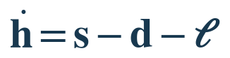
Resource supply minus demand and losses; unlike the earlier scalar resource equation, h is a vector.
Definitions: Integrated layer of the coupled candidate model.
Interpretation: This line connects the previously defined physical, resource, state or adaptation quantities.
Experimental reading / limitations: Its parameters and links need independent calibration and validation.
INT-03 Functional state PROPOSED
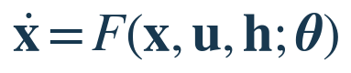
Continuous-time counterpart of the learning/control state-update relation.
Definitions: Integrated layer of the coupled candidate model.
Interpretation: This line connects the previously defined physical, resource, state or adaptation quantities.
Experimental reading / limitations: Its parameters and links need independent calibration and validation.
INT-04 Adaptation law PROPOSED
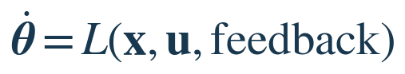
Unspecified learning and adaptation rule.
Definitions: Integrated layer of the coupled candidate model.
Interpretation: This line connects the previously defined physical, resource, state or adaptation quantities.
Experimental reading / limitations: Its parameters and links need independent calibration and validation.
INT-05 Restoration policy PROPOSED
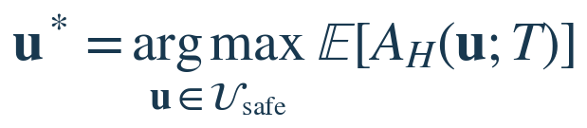
Optimizes defined measurable outcomes under independently justified constraints.
Definitions: Integrated layer of the coupled candidate model.
Interpretation: This line connects the previously defined physical, resource, state or adaptation quantities.
Experimental reading / limitations: Its parameters and links need independent calibration and validation.

What the couplings would need
To function as a predictive theory, the model needs experimentally defined variables; physical units; identifiable parameters; time and spatial scales; a concrete map M; context-dependent interactions; explicit noise and uncertainty; stable boundary conditions; and held-out predictions tested against standard alternatives.

Milk, Honey, and “Good/Evil” are context labels
The supplied screenshots classify extracellular inflammatory signals as candidate “Honey of Evil,” persistent metabolic dysfunction as “Milk of Evil,” regulatory or repair-directed cues as “Honey of Good,” and supportive metabolic or ionic conditions as “Milk of Good.” These are context-dependent research categories, not inherent moral or clinical properties of molecules.
ChristEye research role | Illustrative candidate signals/processes | Measured question
Honey of Evil | IL-1α, TNF-α, C1q; CCL2; MIF | Does this exposure initiate or propagate a defined harmful cell-state change?
Milk of Evil | Long-chain lipids / ELOVL1; ROS and mitochondrial dysfunction; succinate–HIF-1α; impaired EAAT/Kir4.1 | Does persistent metabolic or regulatory failure reinforce dysfunction?
Honey of Good | TGF-β or FGF, in suitable contexts | Does measured signaling reduce a specified damaging response?
Milk of Good | L-serine, D-serine and appropriate metabolic/ionic support | Do viability, cellular function and learning-related endpoints recover?

Detailed shortlist from the Milk/Honey screenshots
Research category | Chemical or mechanism | Experimental question
Honey of Evil | IL-1α; TNF-α; C1q | Initiation of altered astrocyte responses
Honey of Evil | CCL2; MIF | Propagation of senescence-associated markers
Milk of Evil | Long-chain saturated lipids; ELOVL1 pathway | Lipid accumulation and neuronal toxicity
Milk of Evil | Mitochondrial dysfunction; reactive oxygen species (ROS) | ATP depletion and oxidative stress
Milk of Evil | Succinate–HIF-1α signaling; altered histone marks | Persistent inflammatory response programming
Milk of Evil | Impaired EAAT1/EAAT2 and Kir4.1 function | Failure of glutamate and potassium regulation
Honey of Good | TGF-β and FGF, in suitable contexts | Reduction of specific harmful reactive states
Milk of Good | L-serine; D-serine; appropriate metabolic support | Recovery of neuronal signaling and cellular function

Distinguishing three competing explanations of altered behavior
Hypothesis | Predicted observation | Discriminating test
H1. Retrieval disruption | A previously learned response becomes temporarily unreliable during altered inflammatory state. | Does performance recover when the state resolves, without retraining?
H2. Contextual misgeneralization | The original cue response persists but increasingly also occurs for similar neutral cues. | Compare cue-specific behavior and neuronal activity across safe neutral contexts.
H3. Persistent memory updating | Changed behavior persists after inflammatory conditions resolve. | Delayed tests and circuit measurements support a lasting change.

Spontaneous recovery alone does not prove that memory was stored in exactly the same physical state. Alternative neuronal adaptations and relearning must be considered.

Host–virus and phage interpretation
ChristEye proposes classifying viral interactions by effects on a specific host: infection, productive replication, damage and protection. Viruses and bacteriophages depend on permissive host cells for replication. Supplying additional permissive cells is not itself a cure or destruction mechanism and can increase viral replication. A nonpermissive binding decoy is a distinct protective hypothesis, which would need assays verifying neutralization without productive infection, plus host-cell viability and safety.
A molecule may be beneficial or damaging according to cell type, dose, timing, receptor expression and the chosen endpoint; the table is not a treatment instruction. Likewise, the Honey drug work proposes a TrkB-centered target profile with astrocyte-related signaling considerations, not a chemically identified, synthesized or clinically validated compound.

EVALUATION / 08

Comparative ratings of equation systems
Ratings below are qualitative editorial judgments rather than measured scientific statistics. Compare them by dimension: a universal physical theory, an engineering toolkit and a biomedical research taxonomy have fundamentally different goals.
Framework | Integrative ambition | Formal maturity | Predictive evidence | Validation
General relativity | 9.5 | 10.0 | 10.0 | 10.0
Maxwell electrodynamics | 9.0 | 10.0 | 10.0 | 10.0
Quantum mechanics | 10.0 | 10.0 | 10.0 | 10.0
Newtonian mechanics | 8.5 | 10.0 | 9.5 | 10.0
Thermodynamics | 9.5 | 10.0 | 10.0 | 10.0
Particle Standard Model | 9.5 | 10.0 | 9.8 | 9.8
Control theory | 9.5 | 10.0 | 9.5 | 10.0
Systems biology / COBRA | 9.5 | 8.5 | 8.5 | 8.5
ChristEye: consolidated | 9.6 | 6.5 | 2.0 | 1.0

Updated ChristEye-only scorecard
Dimension | Score / 10 | Reason
Cross-domain concept synthesis | 9.6 | One vocabulary links flux, signaling, viability, learning and control.
Systems architecture | 9.3 | Distinct layers and feedback structure are defined.
Experimental testability | 8.2 | Several observables and comparator designs are identifiable.
Mathematical specification | 6.5 | Many F, f, g, M, L and weighting parameters remain unspecified.
Novel mathematical laws | 3.0 | Most equations adapt existing mathematics or define scores.
ChristEye-specific prediction evidence | 2.0 | Specific new predictions have been proposed but not independently established.
Independent validation | 1.0 | No demonstrated replicated integrated-system advantage supplied.

What the expanded set genuinely adds
Relative to the 20-equation core infographic, this collection now makes explicit (a) a chemistry-to-function translation map, (b) signed flux/resource accounting between systems, (c) an outcome-weighted restoration score and safety-constrained intervention selection, (d) harm/repair signal summaries, (e) a contextual cross-kingdom signal-response atlas, and (f) a falsifiable Milk–Honey interaction hypothesis for learned-response retention. These additions strengthen the modeling architecture and research roadmap. They do not yet establish a new fundamental physical law or a proven treatment.

Suggested scientific discriminating tests
• Winds: Can a defined ChristEye feature map improve held-out prediction of cell or network behavior over ordinary metabolite/flux-state features?
• Restoration: Are damage/repair weights stable across replicates, contexts and time horizons, and do selected actions improve prespecified endpoints over baseline controls?
• Milk–Honey: Does a factorial design yield a repeatable positive interaction for delayed retention after matching neural activity and basic viability?
• Signaling: Can context-aware models explain or predict cross-cell-type responses better than a simpler ligand–receptor network baseline?

Interpretation
The high 9.6/10 integration score represents intended conceptual breadth. It must not be read as a claim that ChristEye is more accurate or powerful than relativity, electromagnetism, quantum theory or established systems biology. Demonstrated scientific power depends on quantitative predictions, independent replication, explanatory gains and durable applications.

SOURCES & PROVENANCE / 09

Source inventory and audit notes
Primary project materials: ChristEye-master (2)(1).zip, previously shared in this conversation; 14 supplied screenshots of recent mathematical formulations; and ChristEye Core Equations infographic from the earlier turn.

Project documents used for original equation checks
• ChristEye Living Table & Energy Framework, version 0.5 (2026): Nernst, membrane current, electrochemical work, ATP accounting, performance, scaling, component record.
• ChristEye Living Periodic Table Landscape (2026): restoration alignment A_H, binding kinetics, binding K_D, energy-per-correct response, training gain.
• ChristEye Heart Engine (2026): state and learning updates, rooted-understanding ratio, energy/efficiency metrics.
• ChristEye Damage Response Network Scientific Basis (2026): illustrative extracellular-signal and cell-state response model.
• Cross-Kingdom Signaling Atlas, Restoration and Milk–Honey mathematical discussion (screenshots supplied on this request): response, harm/repair scores, Winds mapping, restoration optimizer, Milk–Honey interaction and testable behavior metrics.

Selected established-field context
• NASA Science. General Relativity and the Nature of Spacetime. https://science.nasa.gov/astrophysics/programs/physics-of-the-cosmos/general-relativity-and-the-nature-of-spacetime/
• Institute of Physics. Maxwell’s Equations. https://www.iop.org/explore-physics/big-ideas-physics/maxwells-equations
• National Academies / NCBI Bookshelf. Metabolic Systems Biology. https://www.ncbi.nlm.nih.gov/books/NBK84468/
• IEEE Technology Navigator. Control. https://technav.ieee.org/topic/control/

Editorial normalization
CE-32 combines duplicate energy-per-response and task-cost expressions. CE-14 names signal production q_k while preserving the screenshot’s simplified ds_k/dt = secretion_k meaning; it is not a complete extracellular signal balance. Formula CE-04 is transcribed from the supplied screenshot and classed as a proposed mass-balance adaptation. The single joint derivative in CE-22 is a testable interaction hypothesis, not a result. Every score is an informal estimate. No drug candidate, cure or physical transformation is validated by these equations alone.

