CHRISTEYE | RESEARCH SPECIFICATION
Neural-Controlled
Biomaterial Production
CE-MAT-001 · Equations, assumptions, example calculations, and validation strategy
Prepared for the ChristEye conceptual research framework | Version 1.0 | 4 November 2026

Executive summary
This document formalizes a proposed system in which a learning neural controller regulates a separate material-production module composed of suitable specialized cells, chemical processes, and supporting hardware. The model estimates retained mass from producer-cell count, cell effectiveness, neural-control quality, feedstock availability, energy, and loss.
It does not assert that neurons themselves create bulk mineral, that training turns cells into new elements, or that neural crest cells universally produce the proposed materials. The formulas are engineering hypotheses and accounting relationships that require calibration against measured experiments.

Core research question
Can an appropriately interfaced and trained neural network increase the quantity or quality of usable biomaterial produced per unit feedstock, energy, and time compared with a matched conventional controller?

What this specification contains
- A master production-and-loss equation with real resource constraints.
- Producer-cell population and per-cell output equations.
- A saturating neural-efficiency model and comparative improvement metric.
- Chemical flux, feedstock, and energy constraints.
- An explicitly hypothetical 30-day numerical model and sensitivity table.
- Inverse calculations for cells/neurons required to reach a target.
- A ChristEye component mapping and proposed experimental measurements.

1. System boundary and architecture
The modeled system contains (i) a participating neural population, (ii) an electrical or biochemical interface and feedback loop, (iii) a suitable material-producing cell population, (iv) nutrient/feedstock and energy inputs, and (v) sensors that report material mass and quality.
Cranial neural crest lineages can contribute to skeletal and connective tissues through differentiated descendants. For this proposed model, the relevant parameter is not total neural crest-cell count but the number of viable cells that are differentiated into an experimentally verified producer phenotype. A material other than mineralized extracellular matrix may require a completely different cell lineage or chemical module.

2. Master mass-production equation
Equation 1 | Net retained material

P_C denotes specialized-cell gross production capacity (mass/time); F_N is a dimensionless neural-control multiplier; P_S and P_E are the maximum rates permitted by feedstocks and energy; η_R is the fraction of produced mass retained; and M_L(T) represents further dissolution, degradation, or removal through time T.
The minimum operator encodes bottlenecks: additional neurons cannot overcome missing calcium, carbon, oxygen, nutrients, or energy. Retention and loss are kept separate so that deposited and remaining material are not confused.
Quantity | Units | Interpretation
M_net(T), M_L(T) | mg or g | Net retained mass; later removed or degraded mass
P_C, P_S, P_E | mg/day or g/day | Capacity under producer, feedstock, energy limits
F_N, η_R | dimensionless | Neural control and retained-fraction parameters
T | day or hour | Elapsed production time

3. Producer-cell population and rate
Equation 2 | Active producing cells
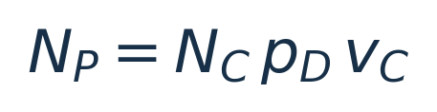
Equation 3 | Cellular production capacity
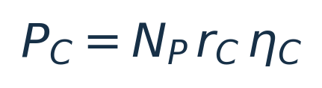
N_C is starting neural crest-lineage cell count; p_D the fraction that differentiates into the target producer type; v_C the viable, productive fraction; r_C the reference rate of product deposition per active producer cell (mass/cell/time); and η_C the effectiveness relative to that reference rate. A measured process might require separate parameters for mineral nucleation, extracellular-matrix synthesis, and mineralization.
Symbol | Definition | Model assumption
N_C | Starting lineage cells | Nonnegative count
p_D | Differentiated share | 0 to 1
v_C | Viable and productive share | 0 to 1
r_C | Reference output per cell/day | Must be measured
η_C | Production effectiveness | 0 to 1 in this formulation

4. Neural efficiency and comparative performance
Equation 4 | Saturating neural-control multiplier
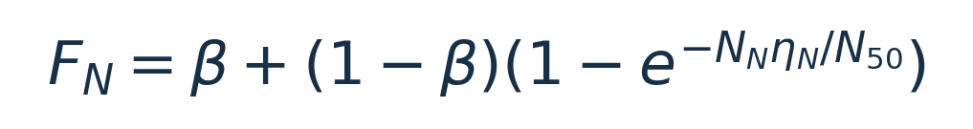
N_N is the number of participating neurons; η_N is experimentally measured relative control effectiveness (0–1); β is the matched baseline-control effectiveness; and N_50 is a fitted neuron-count scale. This is a proposed diminishing-returns curve rather than an established neural law. It approaches 1 from β as participating effective neuron count increases.
To test whether this mathematical curve is appropriate, fit multiple candidate models (including constant, linear, logarithmic, and saturating forms) using held-out data. An increased N_N without effective interface connectivity may confer no benefit.
Equation 5 | Material gain over a matched controller
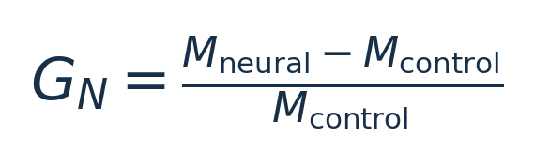
G_N is the fractional improvement in total retained or usable product relative to a matched conventional-controller condition. State which endpoint is used. The denominator must be positive, and experiments must match cell viability, resource availability, time, sensors, and environmental conditions.

5. Winds: chemical and energetic boundaries
Equation 6 | Reaction and transport balance
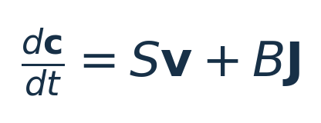
Here c is the vector of species concentrations; S the stoichiometric matrix; v the vector of reaction rates; J the boundary transport-flux vector; and B the mapping of transport fluxes into compartment chemical-state changes. Units and volume scaling must be consistently defined for the particular reactor.
Equation 7 | Feedstock-limited output
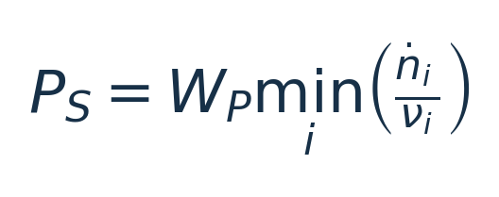
W_P is product molar mass; ṅ_i is the usable input molar flow of required reactant i; and ν_i is its stoichiometric requirement per unit product. This single-product expression is valid only when a chemically defined product and balanced reaction are specified. Multicomponent biomaterials require a composition-aware stoichiometric or mass-balance calculation.
Equation 8 | Energy-limited output
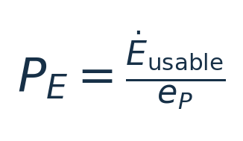
Ė_usable is the energy budget remaining after support and operation, and e_P is energy consumed per unit product. A complete accounting must include cell maintenance, culture controls, instruments, and the neural interface—not only the material-forming reaction.

6. Worked hypothetical 30-day mineral example
The following parameters are intentionally invented to demonstrate the calculations. They are NOT measured output rates for neural crest-derived osteoblasts or a prediction of achievable mineral production.
Input | Illustrative value | Meaning
Participating neurons (N_N) | 100,000 | Neural controller population
Neural effectiveness (η_N) | 0.70 | Assumed relative effectiveness
Baseline β / scale N_50 | 0.55 / 50,000 | Hypothetical efficiency curve
Starting crest cells (N_C) | 2,000,000 | Lineage starting population
Differentiation p_D / viability v_C | 0.50 / 0.80 | Assumed active-cell proportions
Cell effectiveness η_C | 0.70 | Assumed production effectiveness
Reference cell rate r_C | 0.02 micrograms/cell/day | Invented demonstration value
Feedstock limit P_S | 7.0 mg/day | Artificial cap for sample
Energy limit P_E | ≥ 7.0 mg/day | Assumed nonlimiting
Retained fraction η_R | 0.80 | Assumed retained proportion
Time T / later loss M_L | 30 days / 0 mg | Fixed integration assumptions

6.1 Calculated output
Active producer cells: N_P = 2,000,000 × 0.50 × 0.80 = 800,000 cells.
Neural multiplier: F_N = 0.8890. Gross cellular capacity P_C = 11.20 mg/day; after neural control, P_CF_N = 9.96 mg/day.
Feedstock constrains actual gross output to 7.00 mg/day. With 80% retention over 30 days and no later loss, M_net = 168.0 mg (0.168 g).

6.2 Sensitivity to neural count
Participating neurons | Neural multiplier | 30-day net material
0 | 0.550 | 147.84 mg
1,000 | 0.556 | 149.52 mg
10,000 | 0.609 | 163.64 mg
20,000 | 0.660 | 168.00 mg
50,000 | 0.777 | 168.00 mg
100,000 | 0.889 | 168.00 mg
200,000 | 0.973 | 168.00 mg

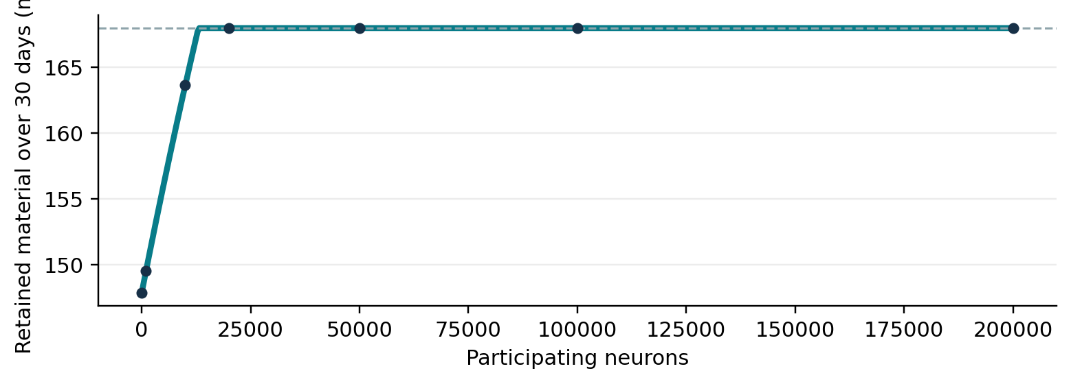
Figure 1. Simulated saturation under the assumed 7 mg/day feedstock ceiling. The plateau is a modeling consequence of the imposed supply cap—not evidence for a biological neural-count threshold.

7. Inverse design: required cells and neurons
For a target retained material mass M*, fixed operating time T, constant rates and efficiencies, sufficient feedstock and energy, and negligible later dissolution, we can solve for the starting producer lineage count.
Equation 9 | Required starting crest-cell lineage population
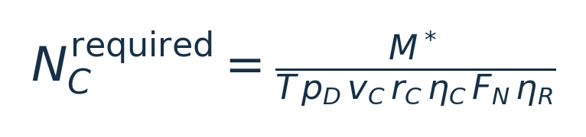
This shows the variables that must improve to reduce the number of starting cells: differentiation, viability, per-cell output, cell effectiveness, neural-control effectiveness, retention, or time.
Equation 10 | Required neural-control level
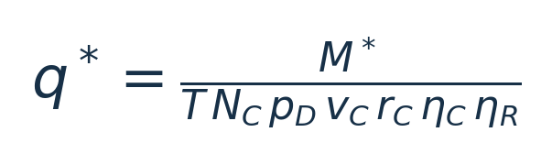
Equation 11 | Required neural population under the fitted curve
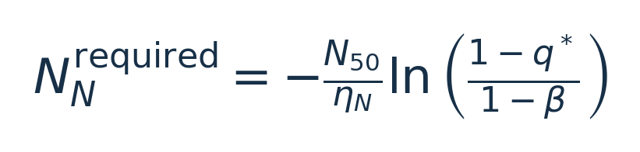
Equation 11 assumes η_N > 0 and β < q* < 1. When q* ≤ β, the baseline controller meets the target under this model. When q* ≥ 1, the target cannot be achieved through the neural multiplier alone. The required gross rate must also be within P_S and P_E; otherwise no number of neurons solves the problem.

8. Quality-adjusted product
Equation 12 | Usable retained mass

η_Q is the measured fraction of retained product meeting predefined specifications. For mineralized tissue, those may include composition, mechanical integrity, porosity, density, geometry, and absence of contamination. Producing more mass is not sufficient if quality falls.

9. ChristEye framework mapping
Framework term | Proposed role in CE-MAT-001
Marrow | Cell lineage, inherited capabilities, developmental constraints.
Lotus | Coordinates development, feedback, and material production.
Winds | Electrical activity, molecular/ionic flows, nutrient and energy transfers.
Roots | Retained controller parameters, learning history, cell-state persistence.
Heart | Target material quantity, quality and acceptable operating boundaries.
Soul | The integrated system whose function and continuity are evaluated.

10. Measurement and experimental validation
A practical first stage is an in-silico simulation followed by a nonclinical proof-of-concept using appropriate cell cultures, external sensors and conventional electronics. All biological work should follow institutional safety, ethics and biosafety review. Do not assume cultured neurons intentionally visualize a target material; test measurable closed-loop control performance.
Model parameter | Suggested observable | Validation question
N_N, η_N | Participating electrodes / firing statistics / held-out control task | Does neural participation predict better feedback control?
N_C, p_D, v_C | Lineage confirmation and viability/proliferation measurements | How many cells are genuinely active producers?
r_C, η_C | Deposited mass and producer phenotype over time | Does per-cell deposition remain stable?
P_S | Input/output species and elemental mass balance | Which reactant first limits product formation?
P_E | Calibrated energy consumption and auxiliary load | Is energy availability a binding constraint?
η_R, M_L | Retained vs lost or dissolved product mass | Where is product mass lost?
η_Q | Composition / mechanical / geometrical specifications | Does increased yield remain usable?
G_N | Matched neural-vs-conventional controller endpoints | Is there reproducible, attributable improvement?

10.1 Proposed experimental comparison
- Control A: material-producing cell culture under a conventional preprogrammed controller.
- Control B: the same cell population under a conventional adaptive controller.
- Test C: the same cell population and interface constraints with a learning neural controller.
- Use matched feedstock, vessel geometry, environmental monitoring, production time, and quality criteria.
- Blind mass and quality measurements when practical. Predefine target endpoints and statistical tests.
- Fit and compare alternative functional forms of F_N; report uncertainty intervals and out-of-sample prediction.
- Report net mass, usable mass, energy consumed, and feedstock-to-product yield—not only gross deposition.

10.2 Falsifiability and failure modes
The hypothesis fails to show an advantage if the neural controller does not outperform the matched adaptive controller on prespecified outcomes, if observed gain is explained by differing feedstocks or viable-cell counts, or if improvement in mass is offset by reduced material quality. Unexpected toxicity, unstable cell state, contamination, and loss of closed-loop reproducibility must be treated as failures or constraints.

11. Model assumptions and interpretation
- Conservation: the model does not create atoms, elements, energy, or water from thought; external matter and energy must be supplied.
- The crest-cell variable refers to a lineage source. Material output is attributed to validated differentiated producer cells, not to unspecified crest cells.
- The saturating neural-count equation is one candidate model. No current parameter value is claimed as empirically established.
- Cell populations may grow, die, change phenotype, or change output rate; the integral master equation is preferred when these quantities vary with time.
- The sample’s 0.02 micrograms per cell per day, 50% differentiation, 70% effectiveness, and other parameter values are not biological measurements.
- The model does not establish clinical, industrial, or commercial viability. Its value depends on future data and predictive comparisons.

12. Research deliverable and next step
Define one material system precisely—e.g. a mineralized extracellular matrix produced by validated osteoblast-lineage cells—then collect independent measurements for viable producer count, gross deposition, chemical losses, retained mass, quality, input flux, and energy consumption. Fit the baseline model first. Only then introduce and compare a neural controller to test whether its learning improves reproducible product yield or quality.

