THE CONSOLIDATED MATHEMATICAL FRAMEWORK

ChristEye
Equations
  - Living Periodic Table • Winds Translation • Soul Restoration • Milk & Honey • Neural Learning

Research formula compendium and comparative evaluation
Edition 1.0 | 4 November 2026 | We Develop Software LLC
This document consolidates the equations visible in the supplied screenshots and the previously compiled ChristEye Core Equations infographic, using the Living Table and Heart Engine source documents for notation checks. Duplicated expressions have been combined. Each formula is labeled to distinguish well-established science from ChristEye-specific hypotheses, definitions and adaptations.
KEY PRINCIPLE
Integration is not equivalent to discovery of a new physical law. The proposed mappings, coefficients and biological interactions require specific measurement definitions, independent test data and reproducible predictive comparisons.
40 NUMBERED EQUATION ENTRIES / 6 MODEL FAMILIES / COMPARATIVE SCORING
Scope: technical and research-oriented. Not a validated drug, oncology or antiviral treatment, and not a claim that “Soul,” “Heart,” “Milk,” “Honey,” or “Winds” are independently established scientific categories.

AT A GLANCE

How to read this compendium
The mathematical architecture contains six linked areas: (1) chemistry-to-ChristEye translation and flux conservation; (2) restoration and damage assessment; (3) cross-kingdom extracellular signaling and behavioral response; (4) Milk–Honey learning interactions; (5) biophysical energy and electrical constraints; and (6) total-system performance and sizing.

Evidence labels
Label | Meaning
ESTABLISHED | A standard physical, mathematical or biochemical equation; included here as a building block, not a ChristEye discovery.
ADAPTED | An existing mathematical technique applied to the proposed ChristEye description.
PROPOSED / METRIC | A new labeling choice, outcome definition, model scaffold or mathematical formalization whose usefulness must be tested.
UNTESTED HYPOTHESIS | A specific proposed causal or interactive relationship not demonstrated for ChristEye.
PROVISIONAL | An equation or scaling assumption applicable only under explicit constraints.

Map of the equation families
Section | Topic | Entries
01 | Winds, translation and conservation | 5
02 | Restoration and damage inference | 6
03 | Cross-kingdom signaling and response | 7
04 | Milk–Honey learning and neural adaptation | 7
05 | Neural electrophysiology and bioenergetics | 6
06 | System efficiency and scale | 9
07 | Integrated cross-scale model | coupled formulation
08 | Comparison against established equation systems | ratings

Notation warnings: H_j (resource stock) and H(t) (Honey signaling) are different quantities; J_k (transport flux) and J_ij (neural connection strength) are also different. R_t (behavioral response), R_U (retention measure), and R_i (repair-associated signal) should not be conflated.

EQUATION FAMILY / 01

Winds, translation and conservation
Crosswalking chemistry and physical fluxes into a functional systems description
CE-01 Chemical reaction and transport balance ESTABLISHED / ADAPTED
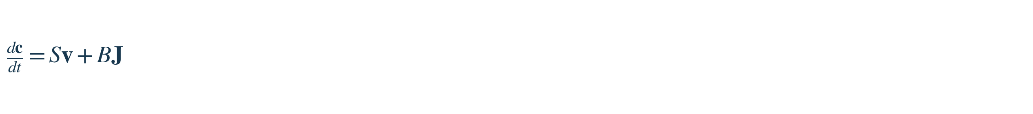
c = chemical concentrations; S = stoichiometric matrix; v = reaction-rate vector; J = boundary transport flux; B = boundary-to-state mapping. All terms must have compatible units.
CE-02 ChristEye functional translation PROPOSED
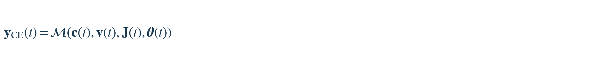
M translates measured chemical and physical quantities into ChristEye functional features. It is an undefined mapping to estimate and validate, not a newly discovered force.
CE-03 Signed interface conservation ESTABLISHED / ADAPTED
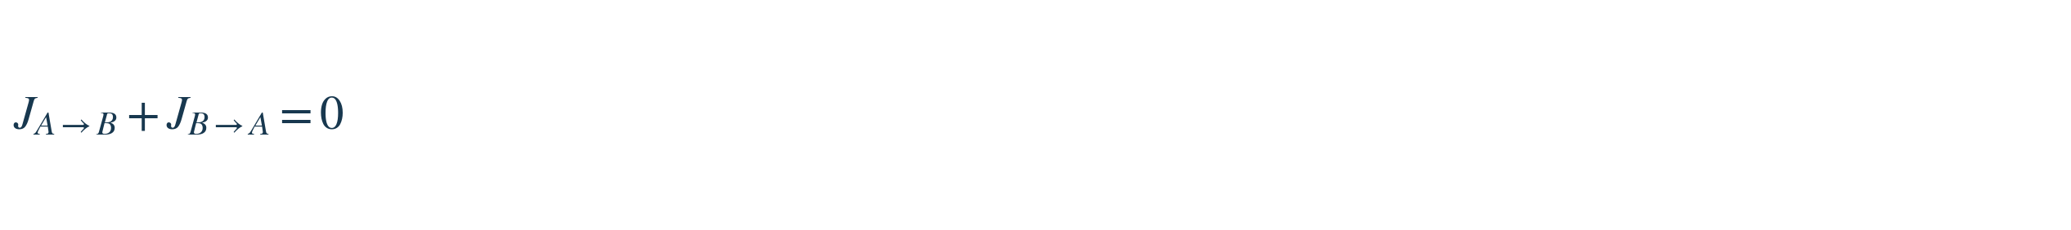
Applies to the same conserved transfer recorded from two sides using opposite sign conventions. Additional sources and sinks require additional terms.
CE-04 Resource budget for the Winds PROPOSED ADAPTATION
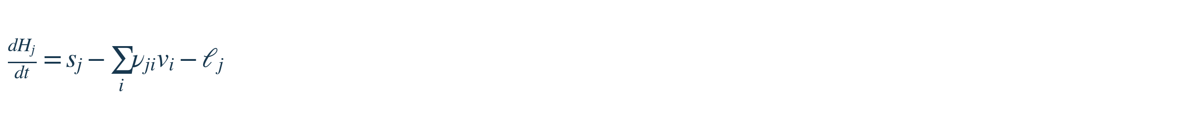
H_j = available stock of resource j; s_j = supply; nu_ji v_i = consumption; ell_j = loss. Here H_j means resource, not Honey.
CE-05 Component record for the Living Table PROPOSED METRIC
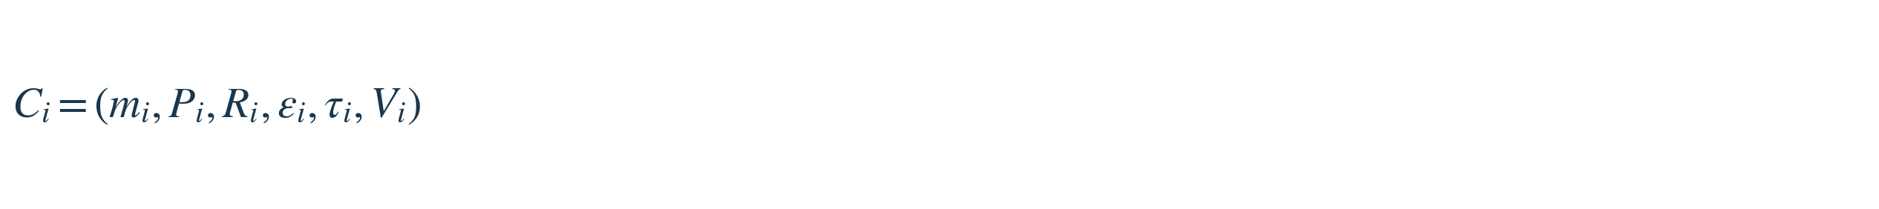
For component i: mass, power, useful output rate, error fraction, latency and viable fraction. The record is specified in the Living Table & Energy Framework.

EQUATION FAMILY / 02

Restoration and damage inference
Identifying beneficial or damaging changes for an explicitly defined beneficiary
CE-06 Restoration alignment score PROPOSED METRIC
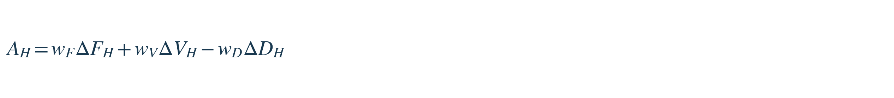
F_H = healthy functional outcome; V_H = viable fraction; D_H = damage. Normalize the outcomes before weighting, and specify comparator and time window.
CE-07 Sensitivity to a Wind PROPOSED
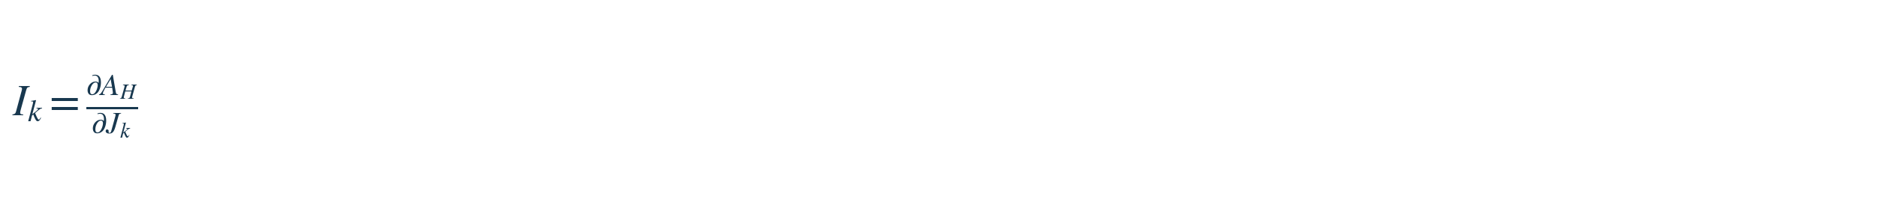
I_k is a local sensitivity of the restoration score to measured signal or flux J_k; a derivative alone does not prove causal effects.
CE-08 Safety-constrained restoration choice PROPOSED / CONTROL THEORY
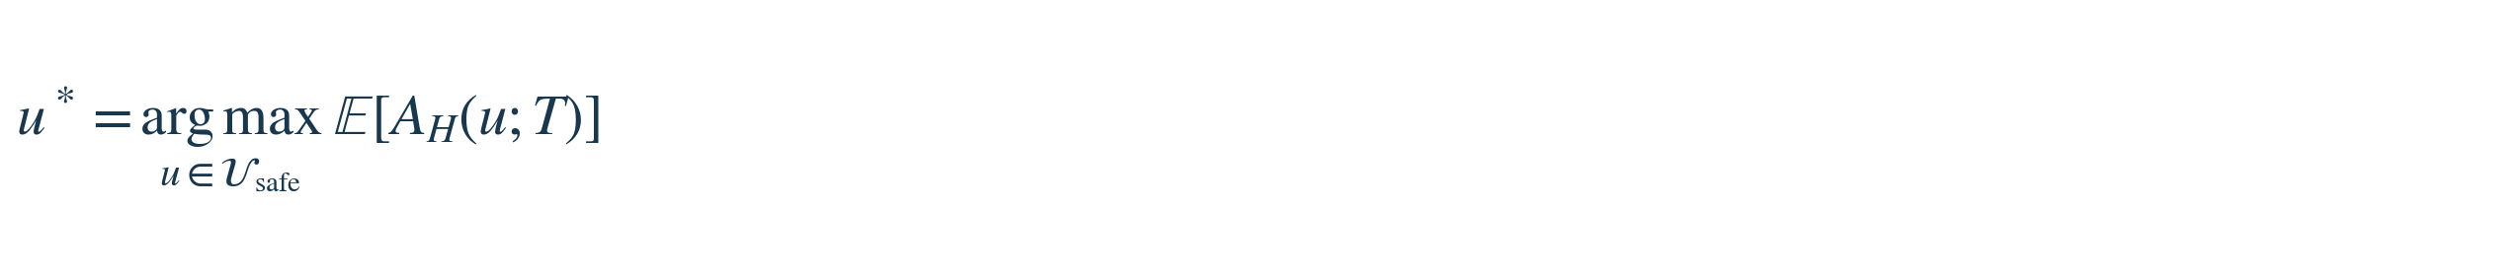
Select permitted intervention u maximizing expected restoration by horizon T. Requires validated safety constraints, dynamics, and uncertainty estimates.
CE-09 Harm-associated extracellular signal score PROPOSED METRIC
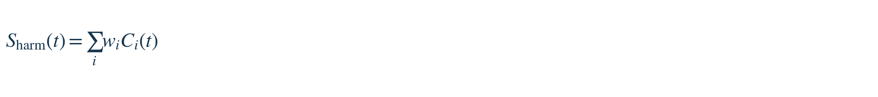
C_i = measured extracellular inflammatory signals; w_i = estimated contributions to a particular harmful endpoint. Coefficients vary with cell type and context.
CE-10 Repair-associated extracellular signal score PROPOSED METRIC
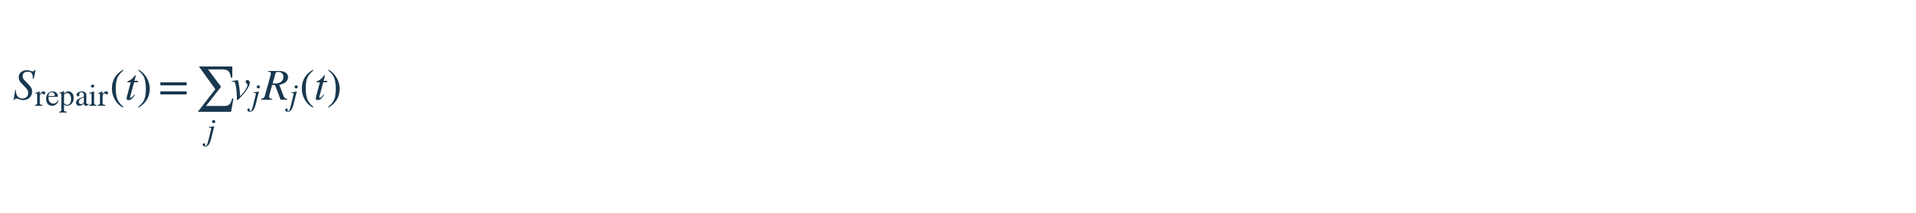
R_j = measured repair-associated signals; v_j = experimentally estimated outcome weights, which are not universal or always positive.
CE-11 Recovery-capacity relationship PROPOSED RELATION
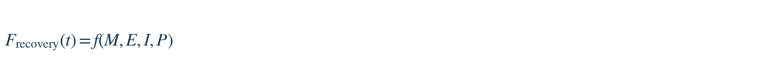
M = metabolic support; E = available energy; I = ionic homeostasis; P = preserved or restored functional plasticity. f is unspecified.

EQUATION FAMILY / 03

Cross-kingdom signaling and response
A common observation format for extracellular signaling, receptors, state and behavior
CE-12 General response relation PROPOSED SCHEMA
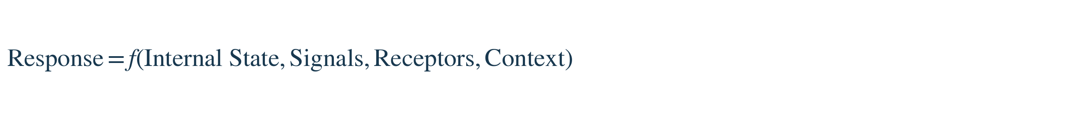
Cross-Kingdom External Signaling Atlas: list sender, molecular signal, receiving system, receptor, context, and measured response.
CE-13 Cellular response-state dynamics PROPOSED SCHEMA
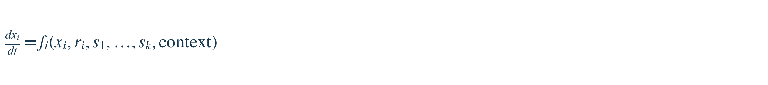
x_i = cell state; r_i = receptor state; s_k = extracellular signals. The functional form and parameters require observation and intervention.
CE-14 Signal production dynamics ILLUSTRATIVE LIMITING CASE
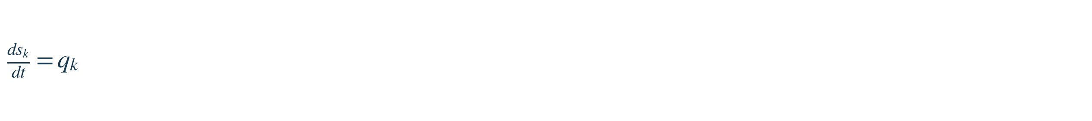
q_k is secretion or production rate. A full balance should add transport, uptake and degradation; this equality assumes those terms are omitted.
CE-15 Behavioral response under internal state and context PROPOSED SCHEMA
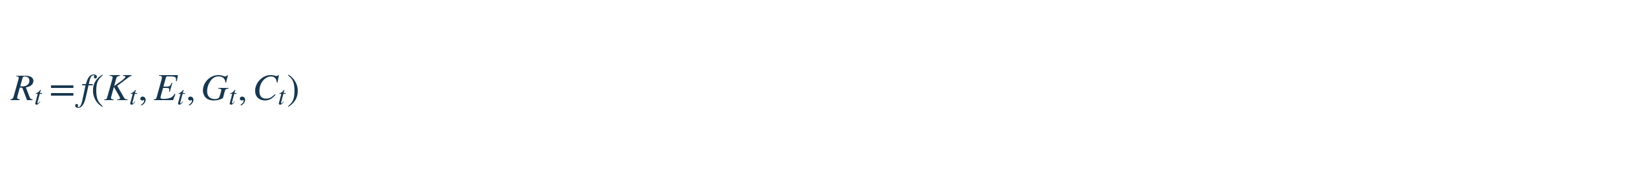
R_t = observed behavior; K_t = stored learning state; E_t = extracellular/inflammatory environment; G_t = glial regulation; C_t = cue/context.
CE-16 Cue-discrimination score ESTABLISHED-STYLE METRIC
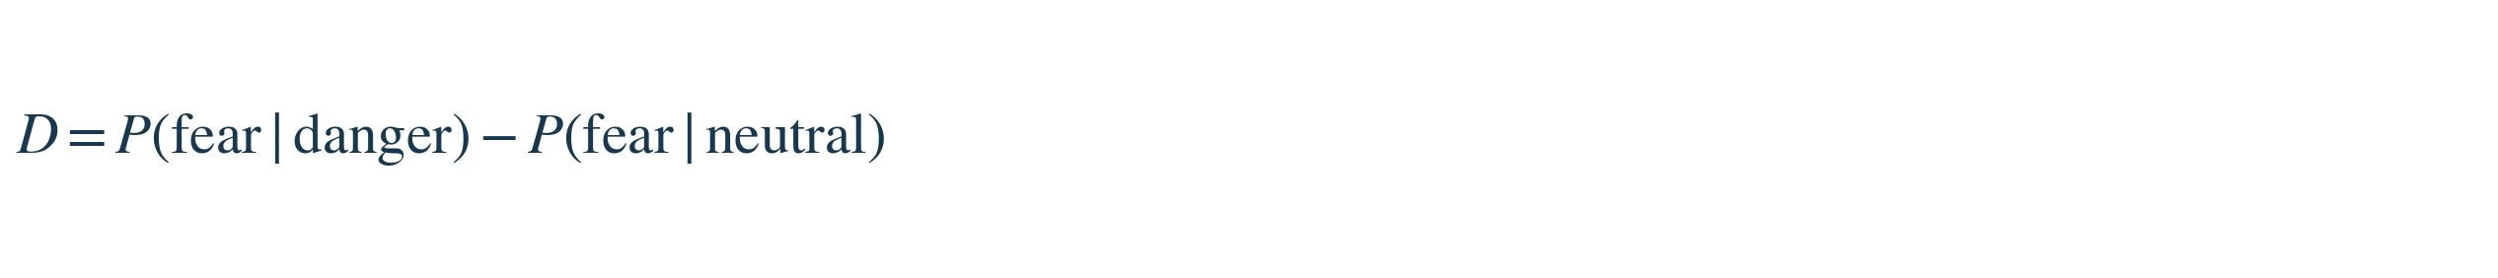
Proposed outcome for distinguishing cue-specific learning from inappropriate generalization. The probability estimates require clearly defined trials and conditions.
CE-17 Reversible bimolecular binding kinetics ESTABLISHED
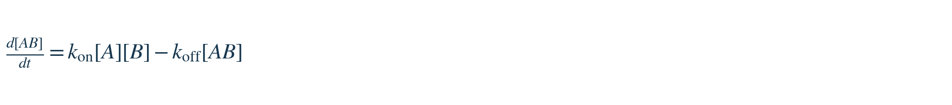
Mass-action association/dissociation model for simple 1:1 reversible binding; a candidate description of some ligand–receptor or viral-decoy interactions.
CE-18 Binding dissociation constant ESTABLISHED
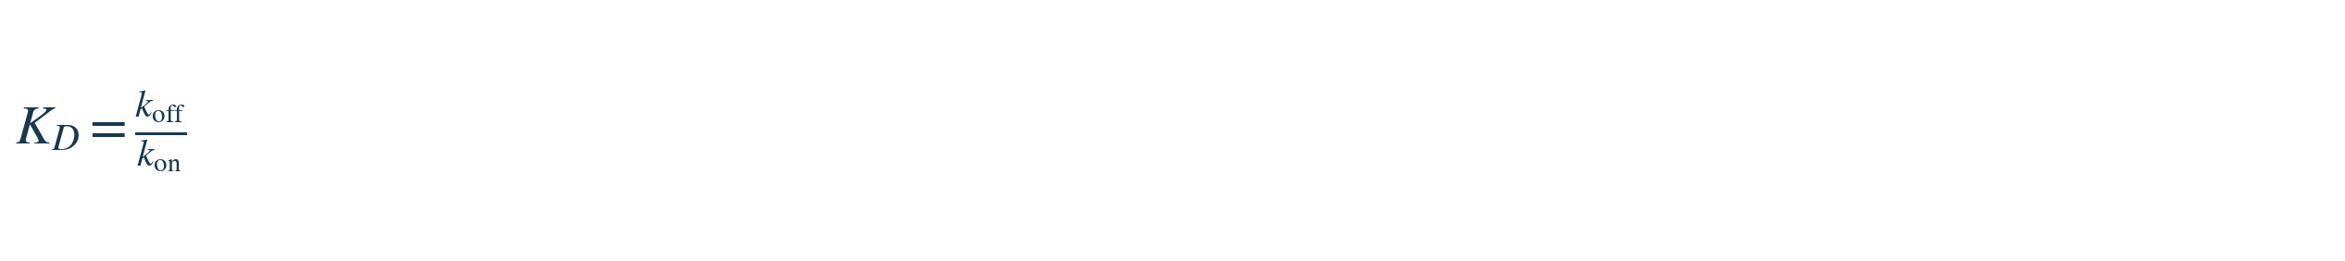
Applies to the matching simple 1:1 kinetic model under appropriate conditions; smaller K_D generally indicates higher binding affinity.

EQUATION FAMILY / 04

Milk–Honey learning and neural adaptation
Metabolic support, signaling, plasticity and retained response
CE-19 Milk–Honey learning interaction UNTESTED HYPOTHESIS
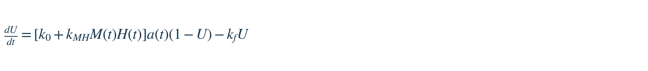
U in [0,1] = retained learning; M = normalized metabolic support; H = normalized stabilizing signals; a = task activity; k_f = loss rate. The multiplicative interaction is a hypothesis.
CE-20 Adaptive connection-strength rule PROPOSED / LEARNING THEORY
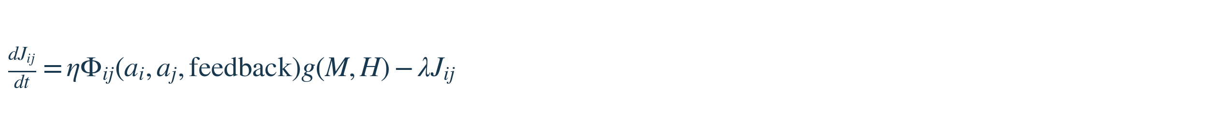
J_ij = connection-strength proxy; Phi = learning rule; g = Milk/Honey modulation; lambda = decay. Different J_ij from flux J_k in CE-07.
CE-21 Honey candidate retention comparison PROPOSED METRIC
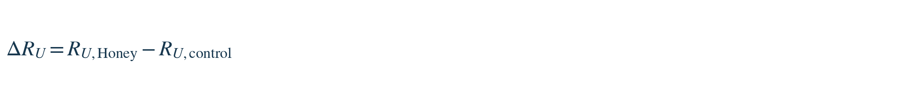
Difference in defined delayed-retention measurements between a future chemically specified candidate and a matched control; not evidence of an existing drug.
CE-22 Positive Milk–Honey interaction prediction UNTESTED HYPOTHESIS
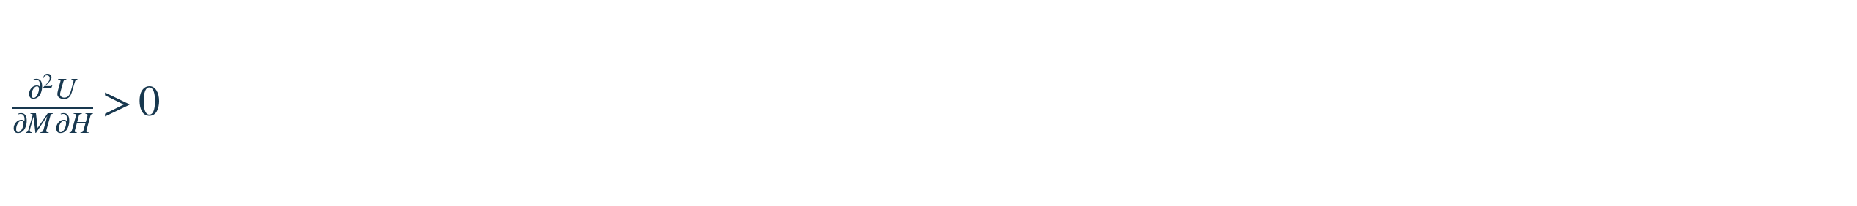
Proposes a positive cross-interaction over a specified operating range, conditional on a defined response surface and experimental controls.
CE-23 Learning system state update PROPOSED / CONTROL THEORY
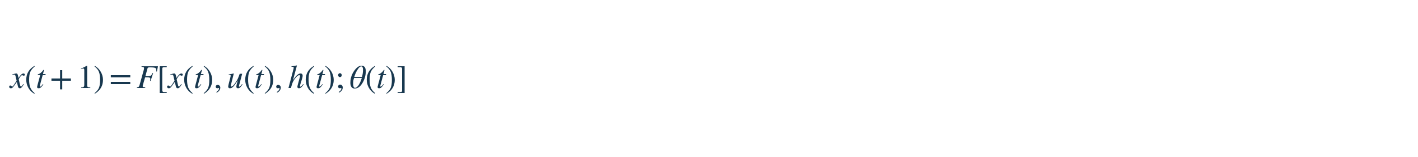
x = state; u = intervention or input; h = history or supporting state; theta = adaptive parameters. F requires model specification.
CE-24 Adaptive parameter update PROPOSED / LEARNING THEORY
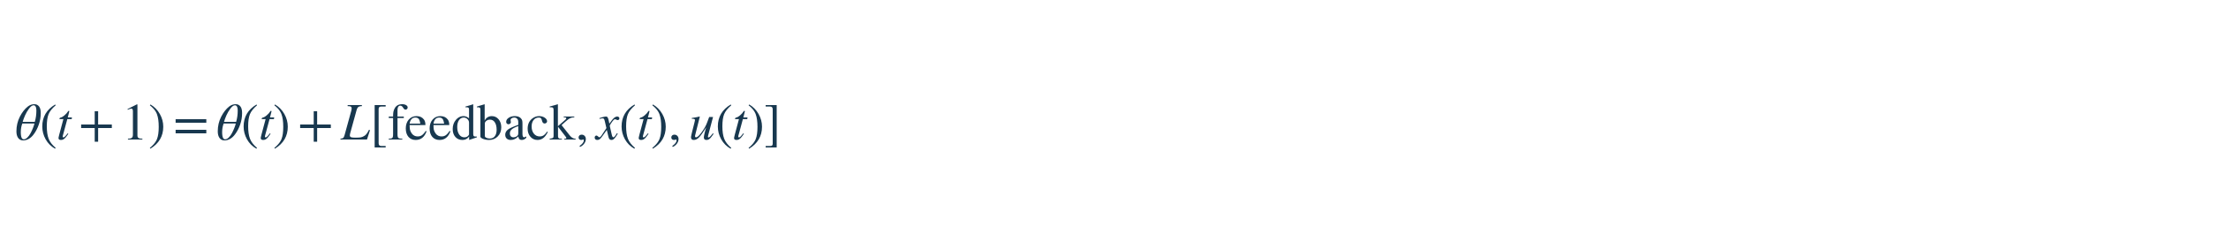
L is an unspecified update rule, potentially learned or derived from experiment.
CE-25 Normalized rooted-understanding retention PROPOSED METRIC
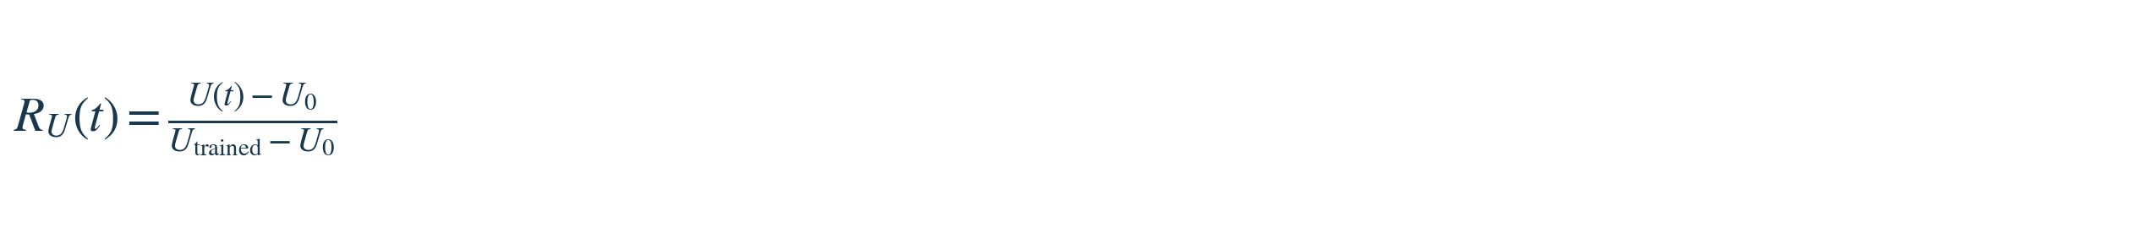
Compares observed understanding/retention U(t) with an untrained baseline U0 and trained reference. Undefined if the denominator is zero.

EQUATION FAMILY / 05

Neural electrophysiology and bioenergetics
Established equations integrated into the Living Table physical layer
CE-26 Nernst equilibrium potential ESTABLISHED
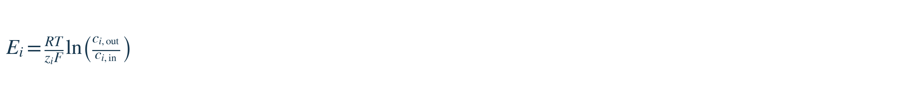
Ion equilibrium potential at temperature T; activities, rather than concentration approximations, are preferable for precision.
CE-27 Membrane ionic current ESTABLISHED
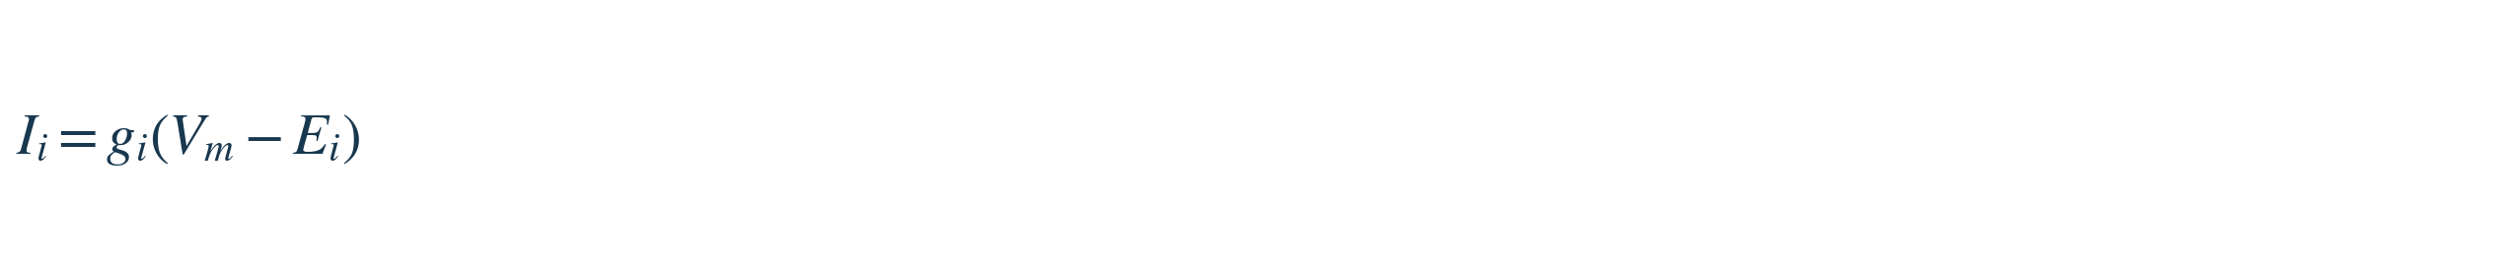
Ohmic conductance approximation for ionic current i.
CE-28 Lumped membrane voltage dynamics ESTABLISHED
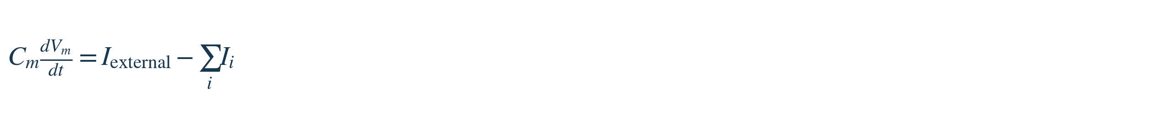
Current-balance relation with outward ionic current positive; a spatial axon requires a cable model and channel kinetics.
CE-29 Electrochemical work for ion transport ESTABLISHED
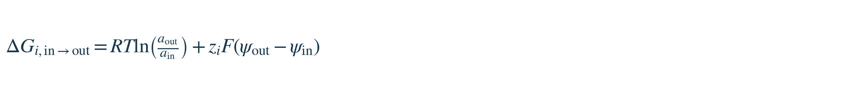
Molar free-energy difference from inside to outside; a is activity and psi electric potential.
CE-30 Axon geometry, capacitance and resistance ESTABLISHED APPROXIMATION
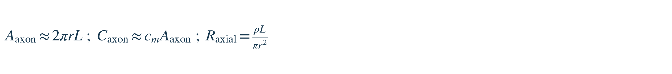
Unbranched cylindrical axon approximation: r radius, L length, c_m membrane capacitance per area, rho resistivity.
CE-31 ATP chemical energy accounting ESTABLISHED ACCOUNTING

Approximate chemical-energy magnitude of hydrolyzed ATP molecules; Delta G depends on local conditions.

EQUATION FAMILY / 06

System efficiency and scale
Quantitative comparisons of energy, accuracy, capacity and total support costs
CE-32 Energy per correct response / task cost PROPOSED METRIC
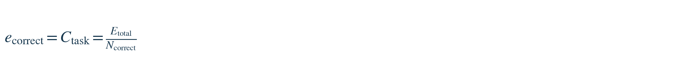
Equivalent expressions shown in the earlier infographic; merged to remove duplication. Compare identical tasks and include the whole-system energy boundary.
CE-33 Training efficiency gain PROPOSED METRIC
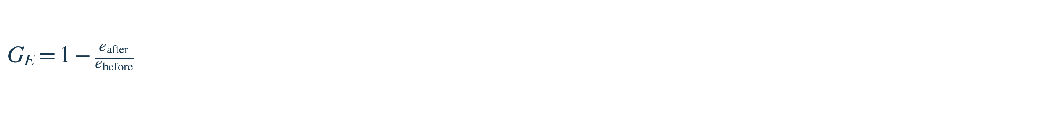
Relative improvement in energy per correct result; denominator must be nonzero and task performance must be comparable.
CE-34 Axonal spike-energy cost PROPOSED METRIC
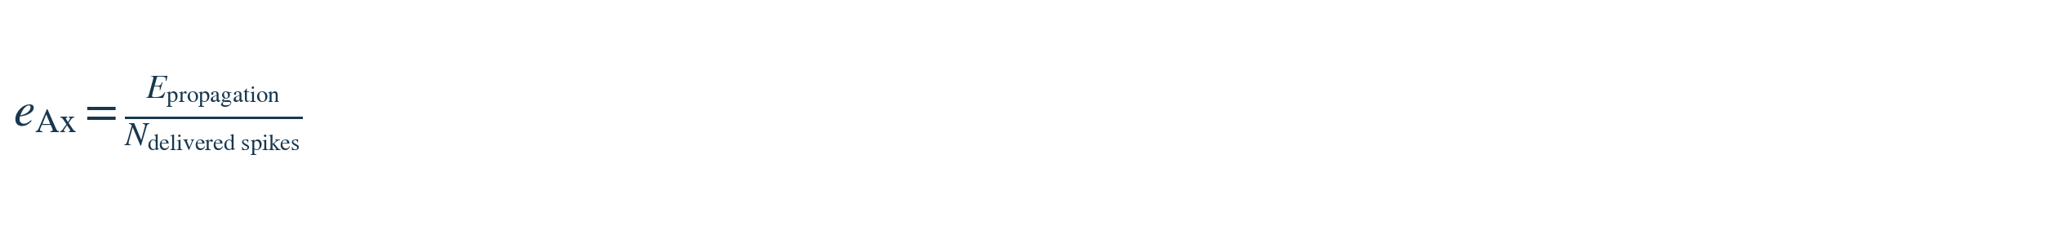
Energy for propagation per successfully delivered spike, requiring an explicit definition of success.
CE-35 Mass-normalized performance PROPOSED METRIC
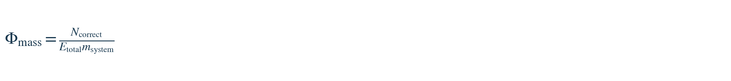
Correct responses per energy per system mass. Units should be reported explicitly.
CE-36 Lifetime energy amortization PROPOSED METRIC

Spreads training energy across measured useful task count, then adds operation cost.
CE-37 Total biological platform power PROPOSED METRIC
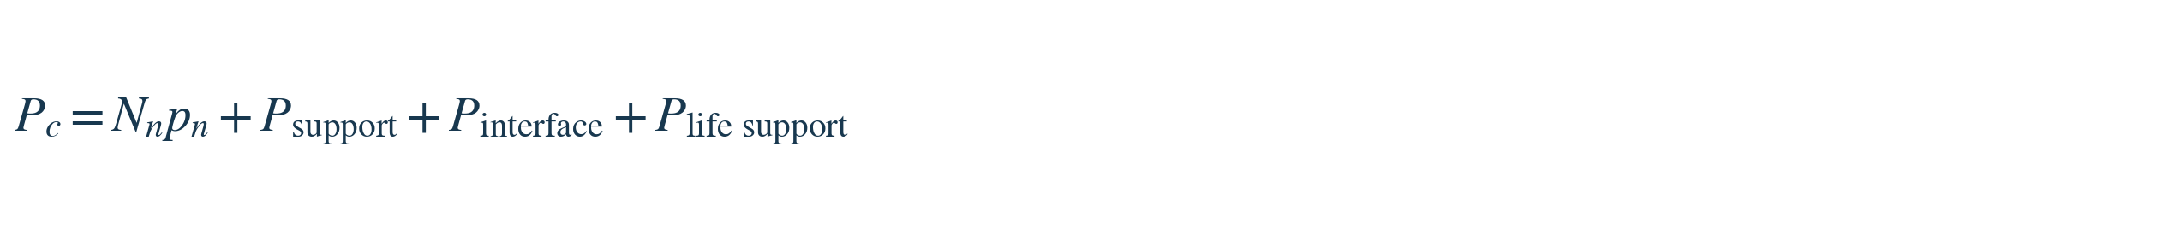
Includes neuron, support, interface and life-support loads. Avoid double-counting power.
CE-38 Provisional neuron-capacity bound PROVISIONAL ASSUMPTION
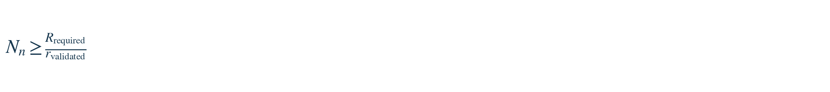
Only meaningful if a tested, approximately linear scaling model exists; neural computation is typically distributed and nonlinear.
CE-39 Connection-count estimate PROPOSED ESTIMATE

Counts directed connection endpoints if k-bar is mean outgoing connections per neuron; not necessarily distinct physical axons.
CE-40 Tissue and axon volume estimates ESTABLISHED GEOMETRY

Mass from density and volume; axon volume from cylindrical approximations. Do not double-count axons included in tissue volume.

INTEGRATED SYSTEM / 07

Coupled ChristEye model
The prior discussion combined the translation, resource, learning and restoration layers into a single candidate control architecture. This is a proposed systems-modeling scaffold, not a fully specified solvable system.
INT-01 Chemical state ADAPTED
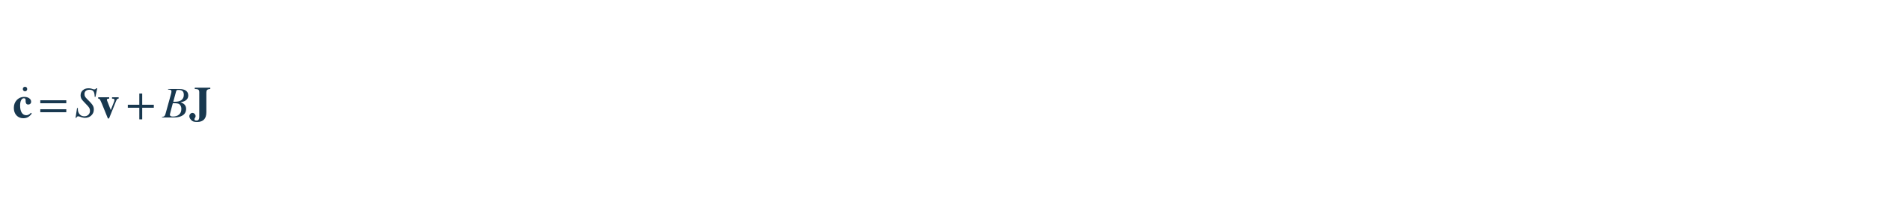
Chemical species and physical transport still follow conservation constraints.
INT-02 Resource state PROPOSED
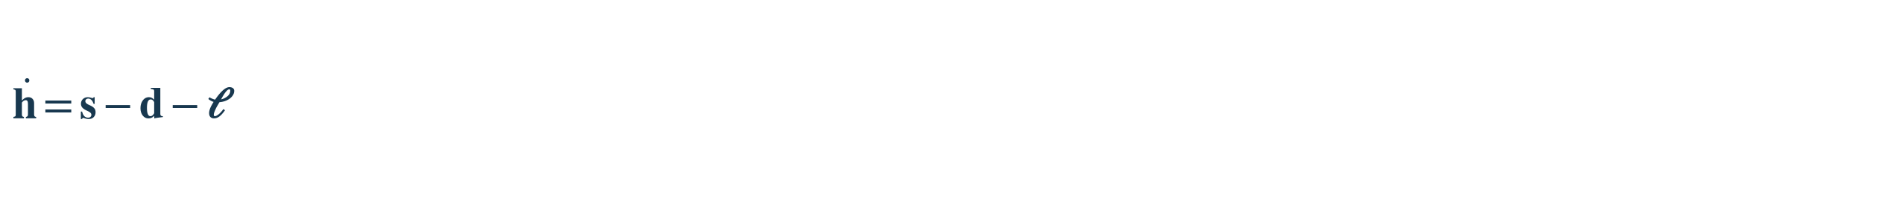
Resource supply minus demand and losses; unlike the earlier scalar resource equation, h is a vector.
INT-03 Functional state PROPOSED
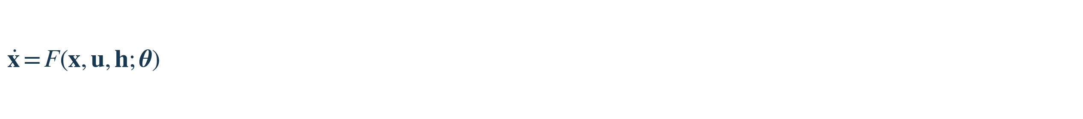
Continuous-time counterpart of the learning/control state-update relation.
INT-04 Adaptation law PROPOSED
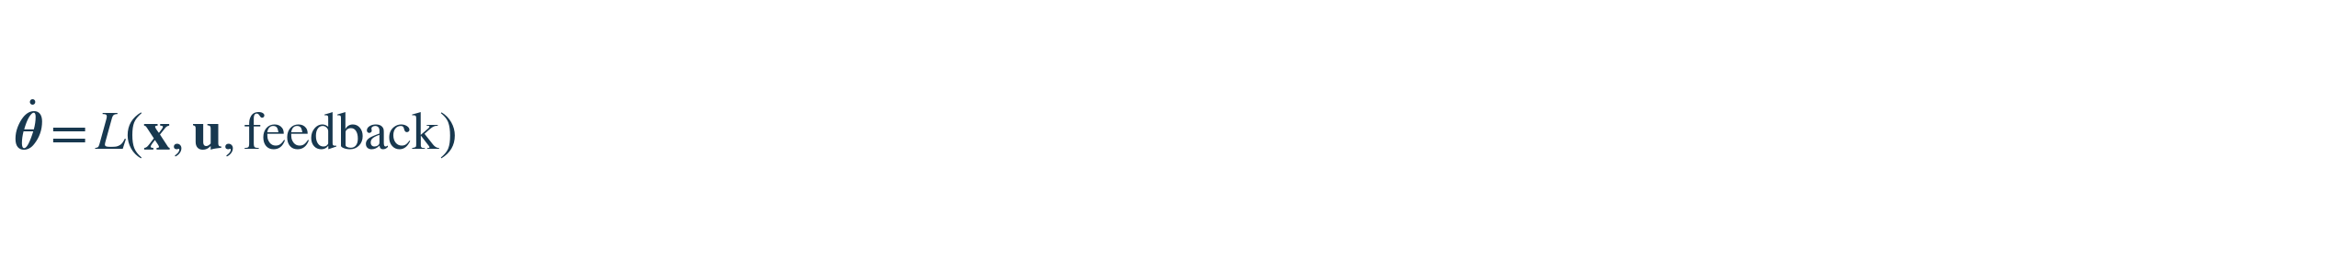
Unspecified learning and adaptation rule.
INT-05 Restoration policy PROPOSED
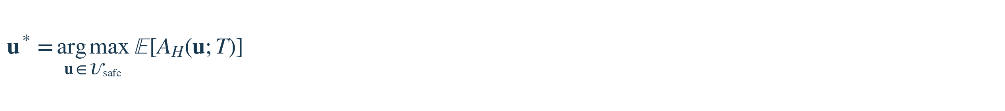
Optimizes defined measurable outcomes under independently justified constraints.

What the couplings would need
To function as a predictive theory, the model needs experimentally defined variables; physical units; identifiable parameters; time and spatial scales; a concrete map M; context-dependent interactions; explicit noise and uncertainty; stable boundary conditions; and held-out predictions tested against standard alternatives.

Milk, Honey, and “Good/Evil” are context labels
The supplied screenshots classify extracellular inflammatory signals as candidate “Honey of Evil,” persistent metabolic dysfunction as “Milk of Evil,” regulatory or repair-directed cues as “Honey of Good,” and supportive metabolic or ionic conditions as “Milk of Good.” These are context-dependent research categories, not inherent moral or clinical properties of molecules.
ChristEye research role | Illustrative candidate signals/processes | Measured question
Honey of Evil | IL-1α, TNF-α, C1q; CCL2; MIF | Does this exposure initiate or propagate a defined harmful cell-state change?
Milk of Evil | Long-chain lipids / ELOVL1; ROS and mitochondrial dysfunction; succinate–HIF-1α; impaired EAAT/Kir4.1 | Does persistent metabolic or regulatory failure reinforce dysfunction?
Honey of Good | TGF-β or FGF, in suitable contexts | Does measured signaling reduce a specified damaging response?
Milk of Good | L-serine, D-serine and appropriate metabolic/ionic support | Do viability, cellular function and learning-related endpoints recover?

A molecule may be beneficial or damaging according to cell type, dose, timing, receptor expression and the chosen endpoint; the table is not a treatment instruction. Likewise, the Honey drug work proposes a TrkB-centered target profile with astrocyte-related signaling considerations, not a chemically identified, synthesized or clinically validated compound.

EVALUATION / 08

Comparative ratings of equation systems
Ratings below are qualitative editorial judgments rather than measured scientific statistics. Compare them by dimension: a universal physical theory, an engineering toolkit and a biomedical research taxonomy have fundamentally different goals.
Framework | Integrative ambition | Formal maturity | Predictive evidence | Validation
General relativity | 9.5 | 10.0 | 10.0 | 10.0
Maxwell electrodynamics | 9.0 | 10.0 | 10.0 | 10.0
Quantum mechanics | 10.0 | 10.0 | 10.0 | 10.0
Newtonian mechanics | 8.5 | 10.0 | 9.5 | 10.0
Thermodynamics | 9.5 | 10.0 | 10.0 | 10.0
Particle Standard Model | 9.5 | 10.0 | 9.8 | 9.8
Control theory | 9.5 | 10.0 | 9.5 | 10.0
Systems biology / COBRA | 9.5 | 8.5 | 8.5 | 8.5
ChristEye: consolidated | 9.6 | 6.5 | 2.0 | 1.0

Updated ChristEye-only scorecard
Dimension | Score / 10 | Reason
Cross-domain concept synthesis | 9.6 | One vocabulary links flux, signaling, viability, learning and control.
Systems architecture | 9.3 | Distinct layers and feedback structure are defined.
Experimental testability | 8.2 | Several observables and comparator designs are identifiable.
Mathematical specification | 6.5 | Many F, f, g, M, L and weighting parameters remain unspecified.
Novel mathematical laws | 3.0 | Most equations adapt existing mathematics or define scores.
ChristEye-specific prediction evidence | 2.0 | Specific new predictions have been proposed but not independently established.
Independent validation | 1.0 | No demonstrated replicated integrated-system advantage supplied.

What the expanded set genuinely adds
Relative to the 20-equation core infographic, this collection now makes explicit (a) a chemistry-to-function translation map, (b) signed flux/resource accounting between systems, (c) an outcome-weighted restoration score and safety-constrained intervention selection, (d) harm/repair signal summaries, (e) a contextual cross-kingdom signal-response atlas, and (f) a falsifiable Milk–Honey interaction hypothesis for learned-response retention. These additions strengthen the modeling architecture and research roadmap. They do not yet establish a new fundamental physical law or a proven treatment.

Suggested scientific discriminating tests
• Winds: Can a defined ChristEye feature map improve held-out prediction of cell or network behavior over ordinary metabolite/flux-state features?
• Restoration: Are damage/repair weights stable across replicates, contexts and time horizons, and do selected actions improve prespecified endpoints over baseline controls?
• Milk–Honey: Does a factorial design yield a repeatable positive interaction for delayed retention after matching neural activity and basic viability?
• Signaling: Can context-aware models explain or predict cross-cell-type responses better than a simpler ligand–receptor network baseline?

Interpretation
The high 9.6/10 integration score represents intended conceptual breadth. It must not be read as a claim that ChristEye is more accurate or powerful than relativity, electromagnetism, quantum theory or established systems biology. Demonstrated scientific power depends on quantitative predictions, independent replication, explanatory gains and durable applications.

SOURCES & PROVENANCE / 09

Source inventory and audit notes
Primary project materials: ChristEye-master (2)(1).zip, previously shared in this conversation; 14 supplied screenshots of recent mathematical formulations; and ChristEye Core Equations infographic from the earlier turn.

Project documents used for original equation checks
• ChristEye Living Table & Energy Framework, version 0.5 (2026): Nernst, membrane current, electrochemical work, ATP accounting, performance, scaling, component record.
• ChristEye Living Periodic Table Landscape (2026): restoration alignment A_H, binding kinetics, binding K_D, energy-per-correct response, training gain.
• ChristEye Heart Engine (2026): state and learning updates, rooted-understanding ratio, energy/efficiency metrics.
• ChristEye Damage Response Network Scientific Basis (2026): illustrative extracellular-signal and cell-state response model.
• Cross-Kingdom Signaling Atlas, Restoration and Milk–Honey mathematical discussion (screenshots supplied on this request): response, harm/repair scores, Winds mapping, restoration optimizer, Milk–Honey interaction and testable behavior metrics.

Selected established-field context
• NASA Science. General Relativity and the Nature of Spacetime. https://science.nasa.gov/astrophysics/programs/physics-of-the-cosmos/general-relativity-and-the-nature-of-spacetime/
• Institute of Physics. Maxwell’s Equations. https://www.iop.org/explore-physics/big-ideas-physics/maxwells-equations
• National Academies / NCBI Bookshelf. Metabolic Systems Biology. https://www.ncbi.nlm.nih.gov/books/NBK84468/
• IEEE Technology Navigator. Control. https://technav.ieee.org/topic/control/

Editorial normalization
CE-32 combines duplicate energy-per-response and task-cost expressions. CE-14 names signal production q_k while preserving the screenshot’s simplified ds_k/dt = secretion_k meaning; it is not a complete extracellular signal balance. Formula CE-04 is transcribed from the supplied screenshot and classed as a proposed mass-balance adaptation. The single joint derivative in CE-22 is a testable interaction hypothesis, not a result. Every score is an informal estimate. No drug candidate, cure or physical transformation is validated by these equations alone.

