Cover Letter

How we ran each test

1 – source code for delete

2 – analysis of test cases necessary, Decision, so analysis of every decision statement in delete and how to make each decision go both ways

4 – test report with results from running each test case, includes failures

**Withdraw**

**Source Code**

elif (transCopy[0] == '02'):

for acct in range(len(masterAccts)):

if (master[acct][0] == transCopy[1]):

acctBalance = int(master[acct][1])

depAmount = int(transCopy[3])

acctBalance -= depAmount

master[acct][1] = str(master[acct][1])

master[acct][1] = str(acctBalance)

newStr = format(master[acct][0], master[acct][1], master[acct][2])

masterAccts[acct] = newStr

return masterAccts

**Analysis of Test Cases for Basic Block Testing**

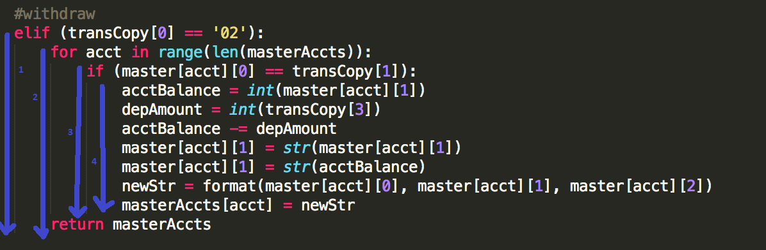

We have 4 basic blocks to cover for our Withdrawals in the back end.

|  |  |  |  |  |  |
| --- | --- | --- | --- | --- | --- |
| Block | transCopy[0] | masterAccts | master[acct][0] | transCopy[1] | Test |
| 1 | 02 | empty | empty | 000001 | 1 |
| 2 | 02 | 1 account | 000001 | 000002 | 2 |
| 3 | 02 | 1 account | 000001 | 000001 | 3 |
| 4 | 02 | 1 account | 000001 | 000001 |  |

**Actual Test Inputs for each Case**

Test 1

Merged Transactions file:

02_000001_BBBBBB_00000000_NNNNNNNNNNNNNNN

Master Accounts file: Empty

Test 2

Merged Transactions file:

02_000002_BBBBBB_00000100_NNNNNNNNNNNNNNN

Master Accounts file:

000001_00001000_ Bob

Test 3

Merged Transactions file:

02_000001_BBBBBB_00000100_Bob

Master Accounts file:

000001_00001000_ Bob

**Test Report**

|  |  |  |  |
| --- | --- | --- | --- |
| TEST # | Results | Failure (Yes/No) | Analysis |
|  |  |  |  |
|  |  |  |  |
|  |  |  |  |

**How Withdraw tests were executed**