Cover Letter

How we ran each test

1 – source code for delete

2 – analysis of test cases necessary, Decision, so analysis of every decision statement in delete and how to make each decision go both ways

4 – test report with results from running each test case, includes failures

**Withdraw**

**Source Code**

elif (transCopy[0] == '02'):

for acct in range(len(masterAccts)):

if (master[acct][0] == transCopy[1]):

acctBalance = int(master[acct][1])

depAmount = int(transCopy[3])

acctBalance -= depAmount

master[acct][1] = str(master[acct][1])

master[acct][1] = str(acctBalance)

newStr = format(master[acct][0], master[acct][1], master[acct][2])

masterAccts[acct] = newStr

return masterAccts

**Analysis of Test Cases for Basic Block Testing**

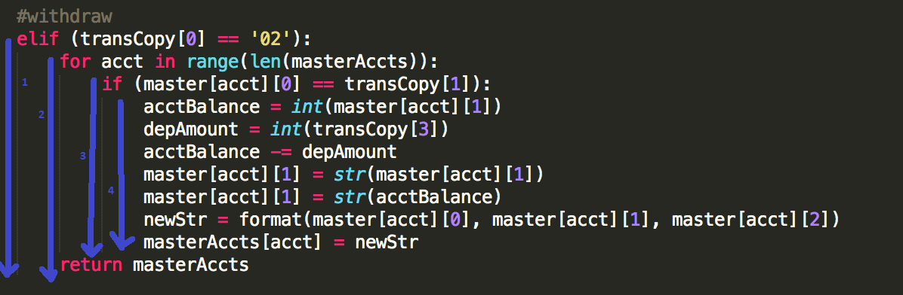

We have 4 basic blocks to cover for our Withdrawals in the back end.

|  |  |  |  |  |  |
| --- | --- | --- | --- | --- | --- |
| Block | transCopy[0] | masterAccts | master[acct][0] | transCopy[1] | Test |
| 1 | 02 | empty | empty | 000001 | 1 |
| 2 | 02 | 1 account | 000001 | 000002 | 2 |
| 3 | 02 | 1 account | 000001 | 000001 | 3 |
| 4 | 02 | 1 account | 000001 | 000001 |  |

**Actual Test Inputs for each Case**

Test 1

Merged Transactions file:

02_000001_BBBBBB_00000000_NNNNNNNNNNNNNNN

Master Accounts file: Empty

Test 2

Merged Transactions file:

02_000002_BBBBBB_00000100_NNNNNNNNNNNNNNN

Master Accounts file:

000001_00001000_ Bob

Test 3

Merged Transactions file:

02_000001_BBBBBB_00000100_Bob

Master Accounts file:

000001_00001000_ Bob

**Test Report**

|  |  |  |  |
| --- | --- | --- | --- |
| TEST # | Results | Failure (Yes/No) | Analysis |
| 1 | Empty Master accounts, and empty valid accounts files | No | Test 1 gave the correct output for the input |
| 2 | Printed incorrect master accounts, and valid accounts | Yes | Cause: incorrect format function in backend, leading to the return of a hard-coded string |
| 3 | Printed incorrect master accounts, and valid accounts | Yes | Cause: incorrect format function in backend, leading to the return of a hard-coded string |
| 2 | Incorrect output | Yes | Incorrect merged transactions file |
| 3 | Correct output, and updated master and valid accounts | No | Test 3 gave the correct output for the input on the second run |
| 2 | Correct output and updated master and valid accounts | No | Test 2 gave the correct output for the input on the third run |

**How Withdraw tests were executed**

Withdraw shell script

#!/bin/bash

cd testsuite1

python breakingbank-backend.py

cd ..

cd testsuite2

python breakingbank-backend.py

cd ..

cd testsuite3

python breakingbank-backend.py

The way we performed the tests on withdraw was running this shell script which went through each of our test suites and ran our back end. Each suite contained a master accounts file and a merged transactions file, as per the specified inputs.

**Delete**

**Source Code**

elif (transCopy[0] == '05'):

acctNum = int(trans[1])

transAcctName = trans[4]

for acct in range(master):

if (acctNum == acct[0]):

acctBalance = acct[1]

if (acctBalance == 0):

acctName = acct[2]

if (transAcctName == acctName):

masterAccts.remove(masterAccts[acct])

else:

throwError()

else:

throwError()

return masterAccts

**Analysis of Test Cases for Decision Testing**

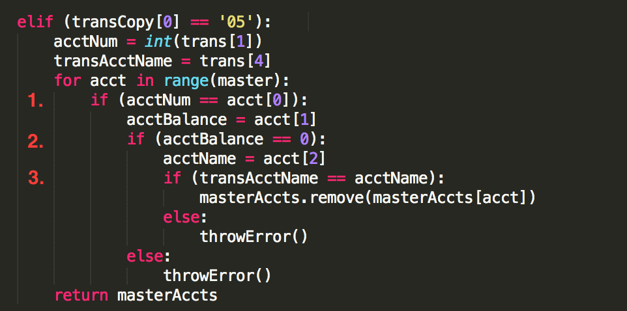

There are 3 decisions made in the block, thus we have 3 decision test cases.

|  |  |  |  |  |
| --- | --- | --- | --- | --- |
| Decision | masterAccts | master[acct][0] | transCopy[1] | Test |
| 1 | 1 account | 000001 | 000002 | 1 |
| 2 | 1 account | 000001 | 000001 | 2 |
| 3 | 1 account | 000001 | 000001 | 3 |
| 1 | 1 account | 000001 | 000001 | 4 |
| 2 | 1 account | 000001 | 000001 | 5 |
| 3 | 1 account | 000001 | 000001 | 6 |

|  |  |  |  |  |
| --- | --- | --- | --- | --- |
| Decision | transCopy[4] | acct[1] | acct[2] | Test |
| 1 | aaaaaaaaaaaaaaa | 00000000 | aaaaaaaaaaaaaaa | 1 |
| 2 | aaaaaaaaaaaaaaa | 00000001 | aaaaaaaaaaaaaaa | 2 |
| 3 | aaaaaaaaaaaaaab | 00000000 | aaaaaaaaaaaaaaa | 3 |
| 1 | aaaaaaaaaaaaaaa | 00000000 | aaaaaaaaaaaaaaa | 1 |
| 2 | aaaaaaaaaaaaaaa | 00000000 | aaaaaaaaaaaaaaa | 2 |
| 3 | aaaaaaaaaaaaaaa | 00000000 | aaaaaaaaaaaaaaa | 3 |

**Actual Test Inputs for each Case**

Test 1

Merged Transactions file:

05_000002_BBBBBB_00000000_aaaaaaaaaaaaaaa

Master Accounts file:

000001_00000000_aaaaaaaaaaaaaaa

Test 2

Merged Transactions file:

05_000001_BBBBBB_00000000_aaaaaaaaaaaaaaa

Master Accounts file:

000001_00000001_ aaaaaaaaaaaaaaa

Test 3

Merged Transactions file:

05_000001_BBBBBB_00000000_aaaaaaaaaaaaaab

Master Accounts file:

000001_00000001_aaaaaaaaaaaaaaa

Test 4

Merged Transactions file:

05_000001_BBBBBB_00000000_aaaaaaaaaaaaaaa

Master Accounts file:

000001_00000000_aaaaaaaaaaaaaaa

Test 5

Merged Transactions file:

05_000001_BBBBBB_00000000­_aaaaaaaaaaaaaaa

Master Accounts file:

000001_00000000_aaaaaaaaaaaaaaa

Test 6

Merged Transactions file:

05_000001_BBBBBB_00000000_aaaaaaaaaaaaaaa

Master Accounts file:

000001_00000000_aaaaaaaaaaaaaaa

Test Report

|  |  |  |  |
| --- | --- | --- | --- |
| TEST # | Results | Failure (Yes/No) | Analysis |
| 1 | Empty Master accounts, and empty valid accounts file | No | Gave correct output, but did not technically do anything, test case was altered after this result |
| 2 | 1 account in Master accounts, account has a non-zero balance | Yes | Wrote to valid accounts file, should have thrown fatal error instead, but a comparison on mismatched types was occurring, bug in code was fixed |
| 3 | 1 account in Master accounts, transaction account name and Master account name were different | Yes | Wrote to valid accounts file, did not throw fatal error because of a comparison on mismatched types, bug in code was fixed |
| 1 | Test case altered to contain different account number from transaction account number | No | Test 1 gave the correct output for the input |
| 2 | 1 account in Master accounts, account has a non-zero balance | No | Test 2 gave a fatal error, passed test |
| 3 | 1 account in Master accounts, account has a non-zero balance | No | Test 3 gave a fatal error, passed test |
| 4 | Added to test opposite outcome of decision 1. 1 account in Master accounts file, account number is same as transaction account number | No | Test 4 correctly deleted the account from master accounts file |
| 5 | Added to test opposite outcome of decision 2. 1 account in Master accounts file has zero balance | No | Test 5 correctly deleted the account from master accounts file |
| 6 | Added to test outcome of decision 3. 1 account in Master accounts file has same name as transaction account name | No | Test 6 correctly deleted the account from master accounts file |

**How delete tests were executed**

Delete shell script

#!/bin/bash

cd testsuite1

echo "testing suite 1"

python breakingbank-backend.py

cd ..

cd testsuite2

echo "testing suite 2"

python breakingbank-backend.py

cd ..

cd testsuite3

echo "testing suite 3"

python breakingbank-backend.py

cd ..

cd testsuite4

echo "testing suite 4"

python breakingbank-backend.py

cd ..

cd testsuite5

echo "testing suite 5"

python breakingbank-backend.py

cd ..

cd testsuite6

echo "testing suite 6"

python breakingbank-backend.py

The way we performed the tests on delete was running this shell script which went through each of our test suites and ran our back end. Each suite contained a master accounts file and a merged transactions file, as per the specified inputs.