Student Name: Radhika Balasubramaniam

1. **Given the provided data, what are three conclusions we can draw about Kickstarter campaigns?**

* From the data we can infer that there are more successful Kickstarter crowd funding projects in theater, music, and theater. For e.g. the projects in theater had 60% success rate, 35% failure rate and 2% cancellation rate
* Based on the calculations of Category and subcategory, we can infer that projects on category - food, games and publishing have more failure projects than successful projects. When we drill down further on the subcategory of food, we can infer that all the campaigns involving food trucks and restaurants failed. Similarly, all the projects associated in the category journalism is cancelled.

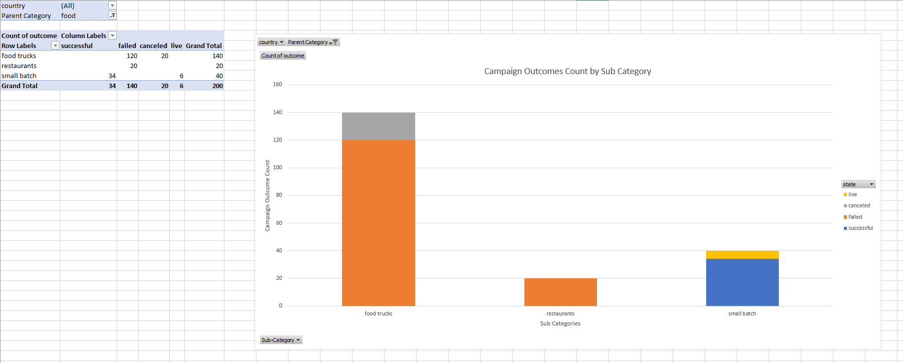

* Based on the calculations based on the launch date, we can infer that launch date has more direct relationship with projects success. For e.g.: The projects launched in May has 60% success rate compared to the 44% for the projects launched in the December. Also, in the launch date line chart, the success curve is showing a declining trend during the summertime of the year. From this we can infer the time of the year has an influence in the project success.

1. **What are some limitations of this dataset?**

* One of the limitations of the dataset it does not enough data to perform time series calculations. This would be helpful to learn the previous campaign success patterns to make more informed decisions
* The data set does not have the information from the marketing perspective such as pre-existing backers, advocate count etc. This will be able to provide more insight into their relation for the project success.

1. **What are some other possible tables and/or graphs that we could create?**

* We can use line charts based on the years to see the general success rate trend for the Kickstarter campaigns.
* We can create graphs to see if there is a co-relation that exists between the goal and campaign duration. From the graphs we can infer if the campaign duration has any effect on the goals.
* The statistical data had majority of projects almost (73%) from US. Hence a drill down into states can be used to see if the state has an influence in the project success and failures