Assembly Notes: Hemera – Hemera Mote rev. C

==============================

GERBER

Filenames are "hemera_C" with the following extensions:

.OTL BOARD OUTLINE
.TOP TOP METAL
.BOT BOTTOM METAL
.DRL NC DRILL

.SMB SOLDER MASK BOTTOM
.SMT SOLDER MASK TOP
.SPT SOLDER PASTE TOP
.SST SILK SCREEN TOP

OTHER FILES

Instructions.doc The instructions/design notes for the board
Pick Place for hemera_B.txt Insertion/Placement file
BOM_hemera_B.xls BOM in Excel format

PART SPECIFIC NOTES

D1 Polarity indicated by line on bottom of LED. Line should match line on PCB.

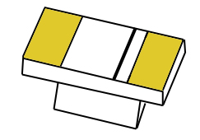

Line matches up with this side of the footprint

D2, D3 Polarity indicated by arrow pointing to pad on the LED. That pad should be on the side with the line on the PCB.
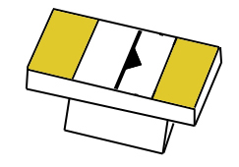


Pad pointed to by arrow matches up with this side of the footprint

D5 Polarity is indicated by a thin line on the top of the diode. The line should correspond to the line on the PCB.


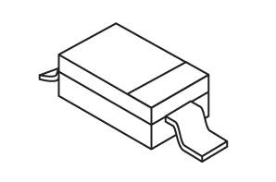

Line matches up with this side of the footprint

U1 The EPIC chip should be oriented so the small “1” in the corner lines up with the “U1” label and diagonal line.

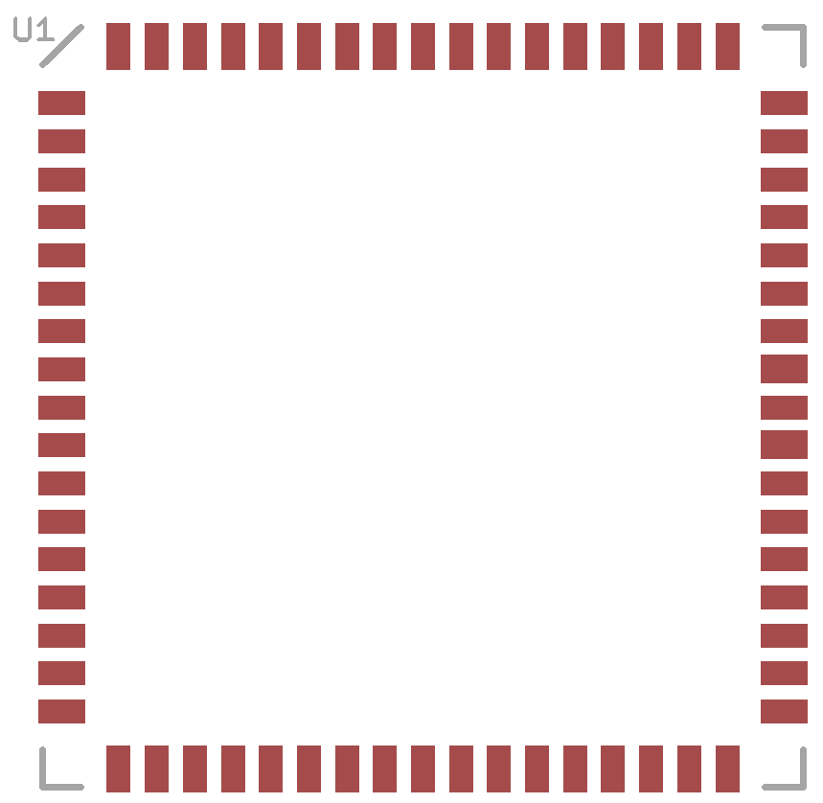

U2 The SHT11 should be oriented so the rectangle matches up with the rectangular hole in the SHT11. The dot on the SHT11 will also match the dot on the PCB.
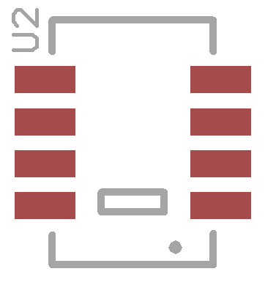
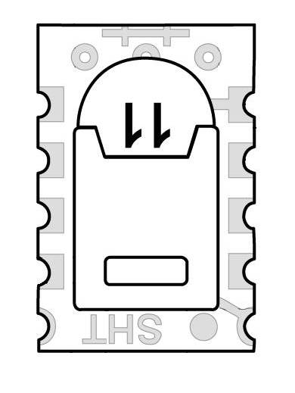

U6 The motion sensor should be inserted from the top of the board.

BH1 The battery holder should open towards the closer edge of the board.

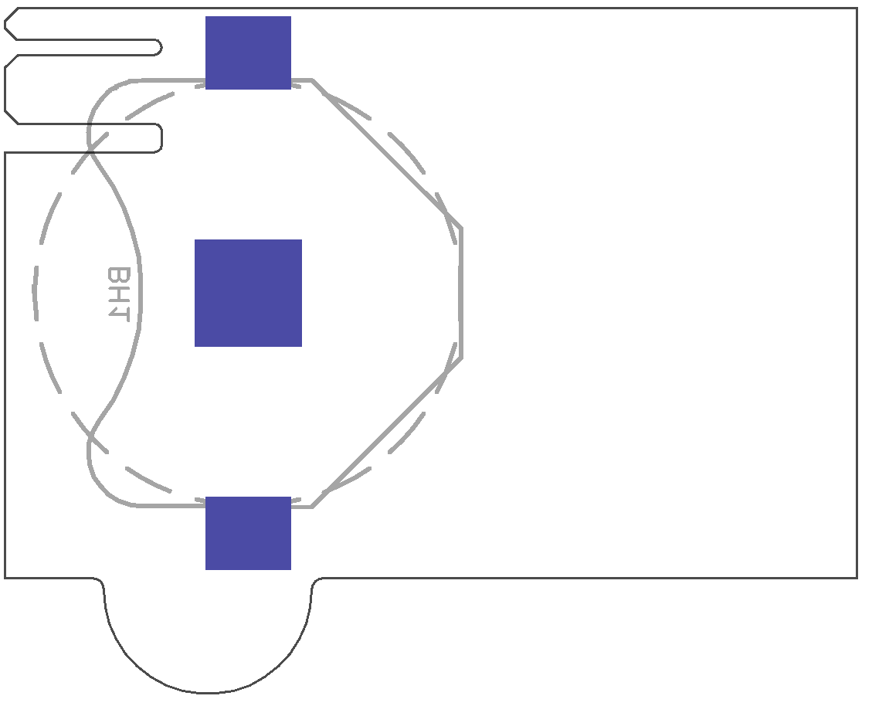
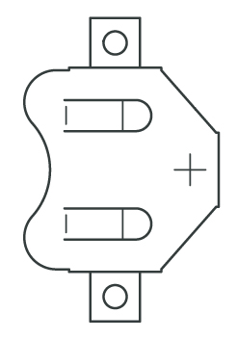

Battery opening

