Insight Group Technologies SQL Challenge

**Completed by: Bradley Jones**

Question 1:

CREATE TABLE item_master(

item_number INTEGER,

description VARCHAR(100),

category VARCHAR(20),

unit_weight DECIMAL,

unit_price DECIMAL

);

CREATE TABLE sales_order(

item_number INTEGER,

sales_order_id INTEGER,

sales_date DATE,

quantity_sold INTEGER

);

CREATE TABLE lookup_item_category(

category VARCHAR(20),

description VARCHAR(100)

);

Question 2:

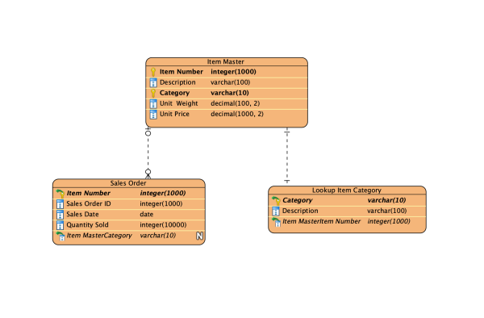

Question 3:

SELECT item_master.item_number, item_master.description, lookup_item_category.description FROM item_master

INNER JOIN sales_order ON item_master.item_number = sales_order.item_number

INNER JOIN lookup_item_category ON item_master.category = lookup_item_category.category;