Current tab example on the right:
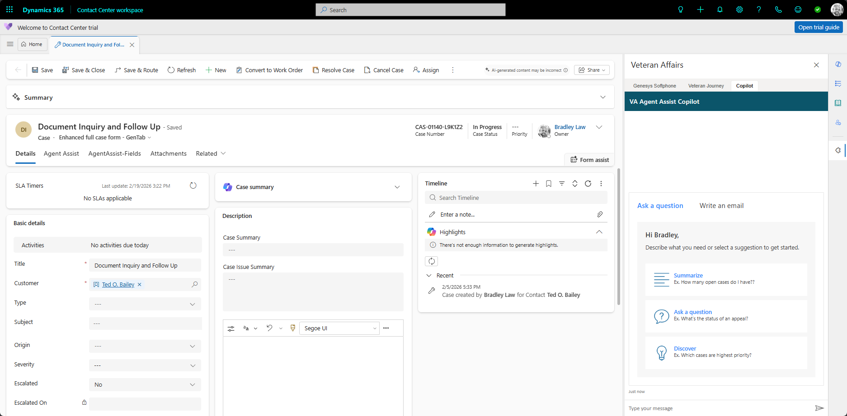

So I ask the agent a question, at the bottom you an see he output of the agent.
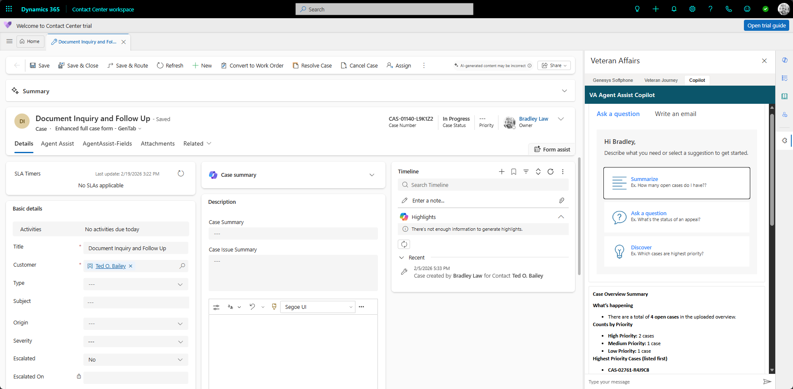

Then when I click off the sidecar tab
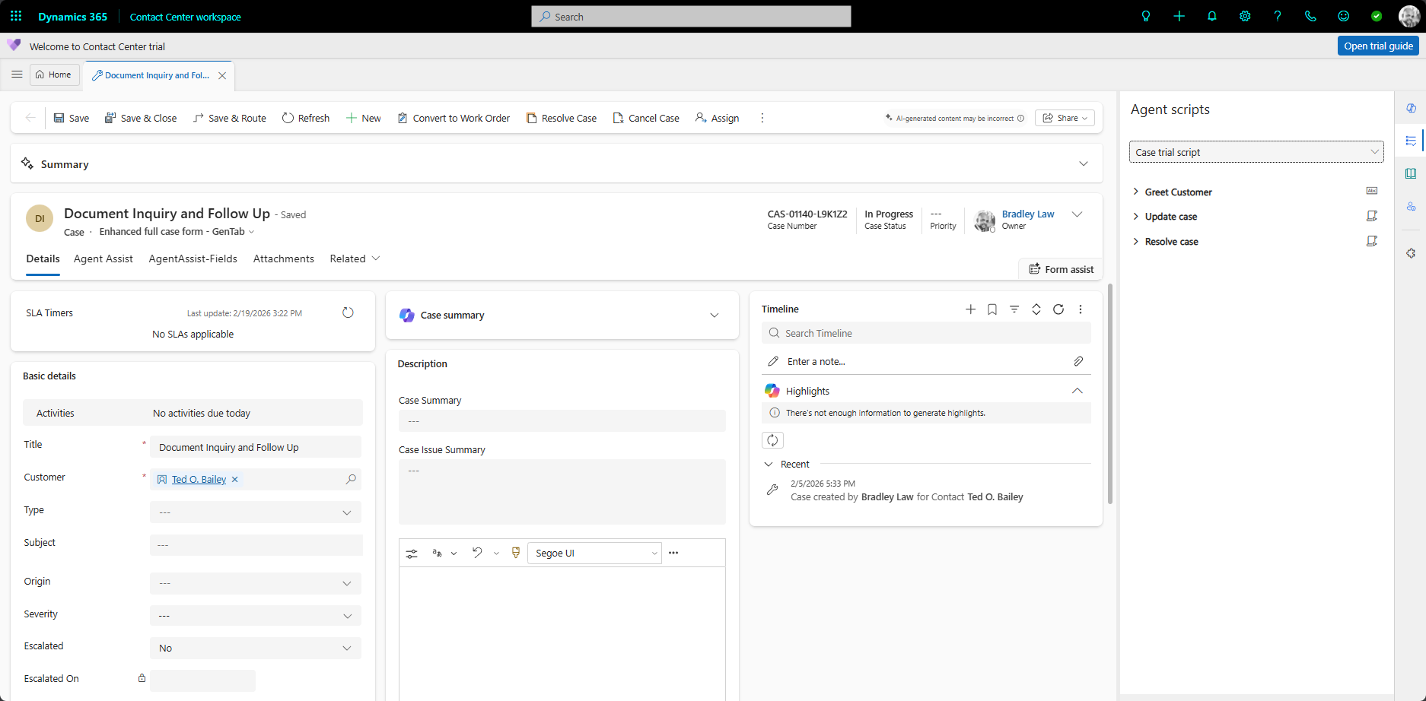

Then you go back the sidecar item it has started over.


