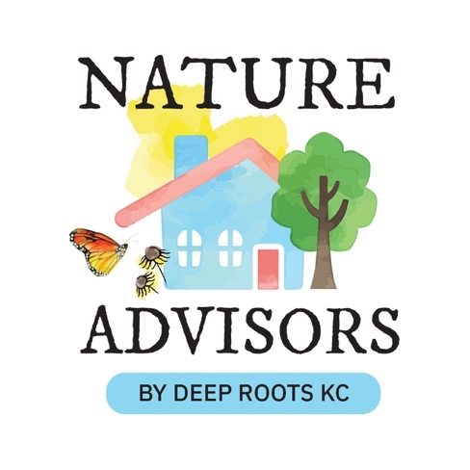 | Nature Advisors  Site Visit Report  {PLEASE MAKE A COPY BEFORE YOU EDIT}  [Name of client]  [Address]  [City, State ZIP]  [Date of Visit]  Nature Advisor(s):  [Nature Advisor Names]

[Client first name],

Sample introductory letter: It was such a pleasure to visit your property and talk about your goals for your home’s ecosystem support. The following is a detailed report of our conversation, highlights of your property’s existing nature-supporting qualities, and recommendations. We hope that the report provides you with more ideas to further your conservation and wildlife adventures.

Thank you for your time,
[Nature Advisor(s) names]

Table of Contents

I. NATURESCAPING 3
Area 1 – [Location – e.g., next to driveway] ([Front/Back/Side Yard]) 3
Area 2 – [Location – e.g., west side of house] ([Front/Back/Side Yard]) 4
Area 3 – [Location – e.g., Hell strip along street] ([Front/Back/Side Yard]) 5
II. NON-NATIVE, INVASIVE PLANTS & PROBLEMATIC PLANTS 9
III. WILDLIFE STEWARDSHIP STRUCTURES 11
IV. STORMWATER MANAGEMENT 13
V. EDUCATION AND VOLUNTEERISM 16
VI. RESOURCES 18
VII. DISCLAIMER 18

NATURESCAPING
We discussed opportunities around your landscape for the establishment of native habitat for bird and butterfly food/cover and, of course, your enjoyment as well. Our recommendations for each area of your property are outlined below. As discussed, we are not providing you with a particular design but rather lists of plants that are suited to the site conditions, will provide benefits to a variety of wildlife, and enhance soil health. Naturescaping is an ongoing process, and we discussed focusing on one or two areas at a time with the long-term vision for a regenerative, ecosystem-sustaining landscape.
If you’d like to learn more hands-on about gardening with natives, consider joining Cydney Ross’s Discover Native Gardening sessions, held five times a month at the Anita B. Gorman Conservation Discovery Center, 4750 Troost Ave., KCMO. These in-depth sessions are a great way to learn hands-on by planting, enjoying the camaraderie of other native gardening experts and enthusiasts! Seeing the right plants in the right place and watching them grow are keys to having a successful Native Garden. If you can’t be there to learn in person, our twice-monthly Curious by Nature webinars are the next best thing. Join virtual live sessions to learn about nature, small and large, across Kansas and Missouri. Bring your native landscape questions to ask our experts during the Q&A at the end of the program. Check out our most recent episodes, archived online here.
Please also consider joining us on Facebook at Deep Roots KC – Friends of Nature Advisors. It’s a supportive space where you can post questions, share pictures of your garden’s progress, and connect with others walking a similar path. We’ll be there to cheer you on as you grow your own homegrown native habitat.

Plant Recommendations
When suggesting plants for your landscape, we have provided a short list of those we feel best suited for the area’s site conditions, your interest, and habitat value. Each area may not be suitable for all the plants on the list, so you can select different combinations that work best for your landscape. Remember to plant with high density and diversity! The more layers, the healthier the natural community and the higher the habitat quality.
Two great starting points for plant selection can be our two short lists of Kansas City’s top-performing, high-value native species: Deep Roots’ “Sweet 16 Most Likely to Succeed” and Deep Roots KC Keystones.
[INSTRUCTIONS: Divide up the areas of the client’s property that you discussed with the client. Number each area and give it a name. Discuss what you saw in this area and give recommendations. Try to use as much of our groupings in the original educational content from Deep Roots’ “Sweet 16 Most Likely to Succeed” and Deep Roots KC Keystones.]

Area 1 – [Location – e.g., next to driveway] ([Front/Back/Side Yard])
[SAMPLE of using a design from “Sweet 16”] Use the “Bee in a Candy Store” or “Longer Season” designs and plant palettes from Deep Roots’ “Sweet 16 Most Likely to Succeed” to include in the bed along the driveway and next to the wall. These plant selections have good contrast in color and texture, plus they will be a big attractant to pollinators.

Area 2 – [Location – e.g., west side of house] ([Front/Back/Side Yard])
[SAMPLE of shady tree plantings and ground layer matrix options] Add one or two native trees to your front yard. A few stand-out trees that would be ideal for your front yard are below, especially since you expressed interest in trees that wouldn’t grow over the house.
- Sassafras (Sassafras albidum) – 30-60’ tall, fragrant leaves, medium-size tree with all-season interest, good fall color replacement for invasive Burning Bush
- American Smoketree (Cotinus obovatus) – 8-30’ tall, fluffy “smoke” effect from flowerheads, excellent Fall color, turning deep purple.
Plant a “Shadier Soft Landings” bed around and under your trees to protect the perimeter of the tree and to provide a “soft landing” for insects that fall from the tree and hibernate. The tree canopy will provide a great support network for hundreds of species of butterflies, moths, sawflies, and other insects – the primary food sources for songbirds. Introducing arrangements of shade-loving native plants beneath the drip line of the tree will not only serve as safe havens for developing larvae of those insects but will also reduce the footprint of turf grass that you must mow regularly during the growing season—a two-for-one beneficial practice. Consider some of these grass and sedge species in the understory:

Grasses:
- Bottlebrush Rye (Elymus hystrix) – Provides fabulous texture and interest in wooded areas and is perfect for planting under oaks and other deciduous trees where some light penetrates to the forest floor
- Virginia Wild Rye (Elymus virginicus) – Cool-season grass with flat leaves that grow in bunches and generally upright-positioned flowering structures that resemble those of wheat. Host plant for larvae of false wainscot and several other moths (including Elachista epimicta, E. illectella, and E. leucofrons).
- American Beakgrain (Diarrhena obovata) – Moderate-height perennial ground cover with dark green glossy, medium-texture foliage that turns white-tipped in winter.

Sedges:
- Oak Sedge (Carex albicans) – Small clump-forming perennial sedge with fountain-like form. Does best in part shade to shade in moderate soils. Use as a ground cover, low border, or between other species for mulch and weed control.
- Cedar Sedge (Carex eburnea) – Hair-like leaves. Plants spread slowly to form a fine-textured groundcover under trees, shrubs, and other dry shaded locations. Semi-evergreen. Ecological Benefits: Species of butterflies, leaf hoppers, grasshoppers, and beetles feed on sedge foliage.
Spring ephemeral wildflowers are a hallmark of a healthy forest ecosystem – your soft landings bed could feature any, or all the following, as a starting point.
- Celandine Poppy (Stylophorum diphyllum) – An early spring bloomer for the shade garden. Showy yellow flowers in April and May are held above lobed, blue-green leaves that bleed yellow.
- Columbine (Aquilegia canadensis) – Red and yellow nodding flowers in April and May. Source of nectar for butterflies, bumblebees and hummingbirds. Found naturally on rocky ledges and wooded rocky slopes. Grows and self-seeds easily
- Wild Geranium (Geranium maculatum) – A delightful plant for shady borders, shady native plant gardens or open woodland gardens.
- Jumpseed (Persicaria virginiana) – This one will spread rapidly if it’s happy; white arching flowers in late summer; spreading foliage mound 2-3' high and as wide; arrow-shaped leaves; tolerates deer, drought and wet soil.
- Jacob's Ladder (Polemonium reptans) – Very pretty, light blue, bell-shaped flowers in loose clusters appear on sprawling, weak stems in mid to late spring. The foliage looks fresh and green all through the growing season.

Area 3 – [Location – e.g., Hell strip along street] ([Front/Back/Side Yard])
[SAMPLE of referring to a Curious by Nature episode and resources] Watch Deep Roots’ Curious by Nature episode on “Gardening Challenges” where hell strip plantings are emphasized. Here are the resources for the episode, listing the recommended plants for a hell strip that will tolerate dry conditions and are salt-tolerant.
[SAMPLE of listing individual plant recommendations with hotlinks to plant databases] Consider a mix of the following plants selected from the list of resources above to expand your current hell strip planting.
- Purple Coneflower (Echinacea purpurea) – A staple of the native garden, providing a broad range of benefits to wildlife in all seasons. Countless pollinators nectar on spiky centers of flowers, and Goldfinches favor the seeds as winter fodder. Can also tolerate partial shade and a wide range of soils.
- Black-Eyed Susan (Rudbeckia hirta) – This plant is easy to grow quickly to give a bright show of color, but is rather short-lived, behaving like an annual or biennial. Abundant yellow flowers with dark brown centers will self-seed after blooming, and if deadheaded, will put on another display later in the year.
- Butterfly Milkweed (Asclepias tuberosa) – Bright orange, flat-topped flower clusters bloom for many weeks, June through July. Can be a host plant for the monarch butterfly and is a great nectar source for many other butterflies and pollinators. One of the ‘gateway plants’ for many native plant newcomers.
- Rose verbena (Glandularia canadensis) – A trailing, meandering plant that spreads quickly to form an attractive ground cover. Intoxicatingly fragrant, flat-topped clusters of rose-pink to rose-purple flowers appear on top of stems for several months from early spring, intermittently to frost (March-November).
- Little Bluestem (Schizachyrium scoparium) – A small, non-spreading, clump-forming grass with blue-green leaves that turn reddish orange in the fall. Fluffy silver seed heads are ornamental through winter. Host plant for larvae of a number of skipper butterflies.
- Aromatic Aster (Symphyotrichum oblongifolium) – One of the last wildflowers to bloom, this aster is loaded with blue-purple daisy-like flowers in late fall. By chopping the stems in late spring this aster grows into a tidy, compact, self-supporting mound and may even be grown as a short hedge or border.

Basic Design Tips
One of the best ways to decide what arrangements you would like to try is to see examples. The Loose Park Native Garden in Kansas City has one of the most diverse native gardens in the region. Here is the landscape design & native plants in that garden. We recommend visits throughout the year to see the seasonal variations. The Anita B. Gorman Discovery Center also has many examples of bioswales, native plant gardens, plants for pollinators, and other native design ideas. We also recommend taking inspiration from the Deep Roots native landscape webinars or using various online regional sources, such as from Grow Native.
For more visible spaces, you might consider these tips if you’d prefer to create a more traditional/designed look:
- Planting groupings of the same plant species will provide a consistent aesthetic.
- Planting shorter plants in discernible patterns can help create a “tidier” appearance.
- Including grasses and shrubs will add structure and provide a backdrop to flowering plants.
- Placing large stones strategically between the plantings, defining borders, and creating pathways can help to emphasize the look of a “designed” garden.
- Lightly mulching will help to suppress weed growth and give a more finished appearance until ground covers grow to fill in empty spaces

Management of a Habitat Garden
The management of native habitats is different from the maintenance of a traditional landscape. It focuses more on the health of the soil, plants, and respecting the cycle of nature in general. Best practices should be employed to continuously provide habitat for both ground-nesting and stem- or cavity-dwelling native bees.
Native Landscape Care Calendar from Grow native!
Reflections on Urban Native Gardening with Cody Hayo – Grow Native! Webinar
Water Smart: Steps to Establishing Your Native Plants

More useful information:
Native Garden Management Made Simple – Deep Roots KC
A Year of Native Garden Maintenance – Deep Roots KC
Maintenance of a Weed Free and Vibrant Native Plant Garden – ReWild Long Island (Excellent!)

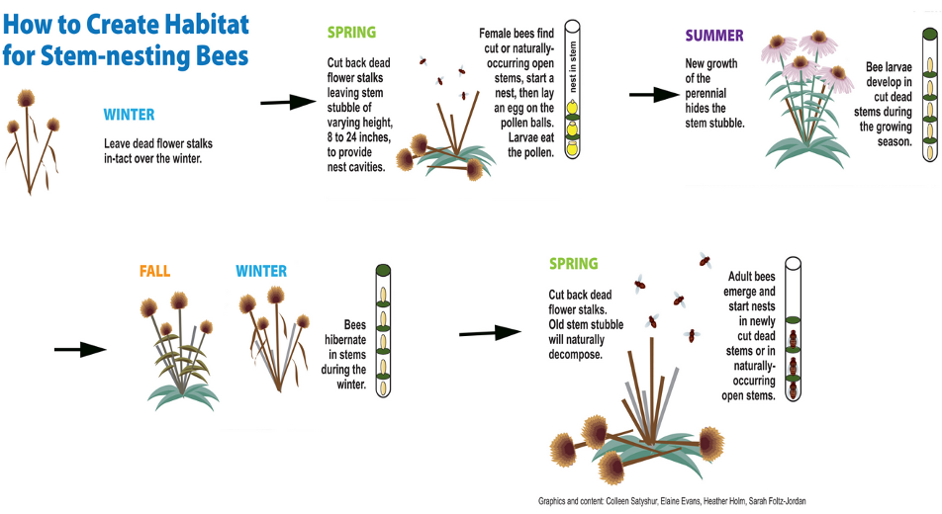

Our Bee champion, Heather Holm

Xerces Society – anything you want to know about the invertebrate conservation
Collecting and Cleaning Seeds from the Garden with Dolly Foster
Seed Collecting and Sharing is a Year-round activity. Please consider donating to a seed bank.
Kansas City Public Library Seed Library at the Ruiz Branch in MO and FL Schlagel Library in Wyandotte Co

Professionals Who Specialize in Design/Installation:
Belfield Botanica Co. - 913.660.2420. - BelfieldBotanica@gmail.com
Bonny in Time - 913.961.0881 - bonny.in.time@gmail.com
Bluestem Habitat Restoration -816.714.8342 - bluestemhabitatrestoration@gmail.com
Bur Oak Ventures - 816.974.3462 - kyle@buroakventures.com
GardenNerd Consultations – 816.868.0449 - gardenerd@rocketmail.com
KCNative Landscapes – 816.262.5109 - info@kcnativelandscapes.com
Ksquared Landscapes – 913.815.0322 - info@ksquaredlandscapes.com
Littlefoot Studio - 913.660.2967 - Bdringenberg@gmail.com
Native Gardens KC, LLC - Nativegardenskc@gmail.com
Orris Horticulture – travis@orrishorticulture.com 573.355.0786, iris@orrishorticulture.com 816.785.3773
Polli-Native - 913.701.4565 - Paul@atgib.com ; nanette@atgib.com
Rogue Natives - 913.244.7327 - roguenativesllc@gmail.com
Simplescapes - 816-535-0764 – shawn@simplescapes-kc.com
Grow Native Professional Resource Guide

Plants (Where to Find Them):
Deep Roots Native Plant Sales link
Deep Roots KC metro native plant nurseries

NON-NATIVE, INVASIVE PLANTS & PROBLEMATIC PLANTS
IF NO INVASIVE PLANTS WERE FOUND IN THE LANDSCAPE, please use the following text with the list of the Big Three. Continue with the “Why We Care About Invasive Plants” section.
Congratulations on an invasive-free landscape! We have provided links below to detailed resources about three plants causing the most severe environmental degradation in the region. Unfortunately, as you develop native habitat gardens, you will likely find these plants volunteering alongside the functional plants as birds spread their seeds. We encourage you to become familiar with them. While keeping vigil in your own landscape, perhaps you can share the information and recommendations for removal with your friends and neighbors.
Bush Honeysuckle (Lonicera maackii)
Japanese Honeysuckle (Lonicera japonica)
Wintercreeper (Euonymus fortunei)
English Ivy (Helix hedera)

IF INVASIVE PLANTS WERE FOUND IN THE LANDSCAPE, please use the following text with the list of the plants found and then the “More information” section listing the other “Big 3” invasives. Continue with the “Why We Care About Invasive Plants” section.
We found the following invasive plants in your landscape during our visit:
[keep the invasive plants found here (delete the others), then refer to the other(s) in the “More Information” paragraph below]
Bush Honeysuckle (Lonicera Maackii)
Japanese Honeysuckle (Lonicera japonica)
Wintercreeper (Euonymus fortunei)
For additional details on the ecology and steps to clear away these plants, see the linked references. Please follow the detailed instructions in the reference and follow all safety precautions.

Why We Care About Invasive Plants
Native plants struggle to compete with non-native invasives for light, nutrients, and moisture. Most of these plants were brought to the U.S. deliberately for ornamental value, erosion control, or other good intentions. Unfortunately, their spread was not impeded by insects and diseases that control them in their native country. Without intentional control, non-native invasives continue to spread, wreaking havoc on native landscapes.
Invasive plants such as Bush Honeysuckle have allelopathic root systems, which means their roots produce and release chemicals into the soil around them to prevent other plants from growing! Therefore, leaving a Bush Honeysuckle in your yard will make it more difficult for new plants to get established, even after it’s removed from the landscape.
Non-native plants may look attractive. However, they do not support the reproduction of butterflies and moths or birds that depend upon their caterpillars for food. Native Missouri songbirds need insect protein most frequently caterpillars to feed their young.
No native plants = fewer native insects/butterflies/moths = further decline in songbirds!!
With landscapes full of non-native and invasive plants that do not provide nourishment, the insects have retreated to the countryside, forcing many of our native songbirds to do the same. We are depleting their food sources when landscaping with non-native plants. We strongly recommend visiting HOMEGROWN NATIONAL PARK by Doug Tallamy for a full description of these interactions.

Professionals Who Specialize in Invasive Removal & Natural Resources Mgmt.:
Belfield Botanica Co. - 913.660.2420. - BelfieldBotanica@gmail.com
Bluestem Habitat Restoration - 816.714.8342 - bluestemhabitatrestoration@gmail.com
Bur Oak Ventures - 816.974.3462 kyle@buroakventures.com
Habitat Architects – 816.645.0026
Kansas Property Services - 785-845-4072 - kansaspropertyservices@gmail.com
Orris Horticulture – travis@orrishorticulture.com 573.355.0786, iris@orrishorticulture.com 816.785.3773
Otto’s Environmental Improvements - 816.652.6886
Polli-Native - 913.701.4565 Paul@atgib.com ; nanette@atgib.com
Rogue Natives - 913.244.7327 - roguenativesllc@gmail.com
Grow Native Professional Resource Guide

WILDLIFE STEWARDSHIP STRUCTURES
Attention, Nature Advisors:
There are four management practices listed below: bird nest box, bird bath, bee hotel, bat box. Delete what is not appropriate for your homeowner. For instance, if they already have clean, working bird baths, delete it.
*If they do not seem interested in incorporating these then delete this section*
Once you have completed this section, please return to this instruction and delete it.

Bird Nest Box
An artificial nest box provides supplemental nest opportunities for the birds while giving you and your family a chance to see them up close. Local bird supply stores are good resources for manufactured bird houses, many constructed of 100% recycled materials. Be clear about which species you are interested in attracting. Quality houses are built to accommodate different birds.
If you would like to build your own nest boxes, we recommend a couple of resources offered by the Cornell Lab of Ornithology. This article would be a great place to start for a review of best practices for creating a safe and successful birdhouse:
Features of a Good Birdhouse - NestWatch
Visit this page for a thorough listing of nest box plans organized by species: All About Birdhouses - NestWatch where you can find the ideal nest box plans to support the specific bird that you want to attract or perhaps have seen visit your yard.

Bird Bath
Birds seek water to clean their feathers for optimum flight ability as well as to quench their thirst. It can be as simple as a large plant saucer. Learn more here.

Bat Box (IF Discussed)
You might be interested/You also expressed interest in helping our native bats on your property. Some of our bats are endangered and face dramatic challenges with the still-mysterious White Nose Syndrome. Providing supplemental housing for bats can be an interesting and fun way to help these important animals.
The experts at Bat Conservation International discourage the use of trees for bat boxes for three primary reasons:
- They receive less sun among the branches.
- Bat tenants are more vulnerable to predators.
- Obstructions in the form of branches and surrounding vegetation make it more difficult for bats to drop into flight.
Therefore, steel poles, wooden posts and sides of buildings are highly encouraged. For additional detail about bats and how best to install a house, consult: About Bat Houses

Native Bee Habitat
There are three main things you can do in your landscape to support native bees:
- Maintain perennial stem nesting bee habitat: How to create habitat for stem-nesting bees.
- Keep dead wood on sites such as logs, stumps, dead branches on live trees or snags for wood nesting bees.
- Instead of wood mulch, use leaf mulch or compost which is just as effective but is light enough for ground nesting bees to pass. Increase Nesting Habitat for Native Bees.
Bee Hotels can do more harm than good if not constructed or maintained properly. Here is information on what can go wrong and what to look for in a good bee hotel: The horrors of mass-produced bee houses.
For proper maintenance of bee hotels, refer to this guide from Michigan State University: Building and Managing Bee Hotels for Wild Bees.

STORMWATER MANAGEMENT

Cost-Share Reimbursement Programs for Residential Stormwater Solutions

***(if in Johnson or Wyandotte County, KS)***(script taken directly from program websites)
The Contain The Rain program in Johnson County, KS encourages individual homeowners and businesses to make improvements to their properties to improve stormwater quality. Contain The Rain is a reimbursement program for most JOCO residents who install pre-approved sustainable landscape solutions that benefit the community’s water quality.
The Unified Government Stormwater Quality Cost-Share Program in Wyandotte County, KS encourages individual homeowners and businesses to make improvements to their properties to improve stormwater quality. By capturing rainwater where it lands, pollutants and sediment have a chance to settle out rather than flow into our water bodies. The program helps cover the cost of materials and/or contractor labor to install approved stormwater treatment facilities.
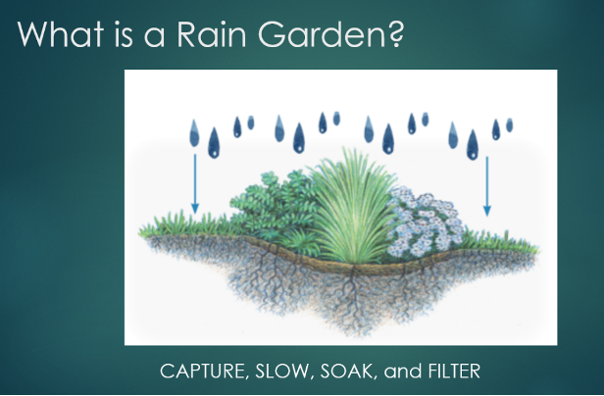
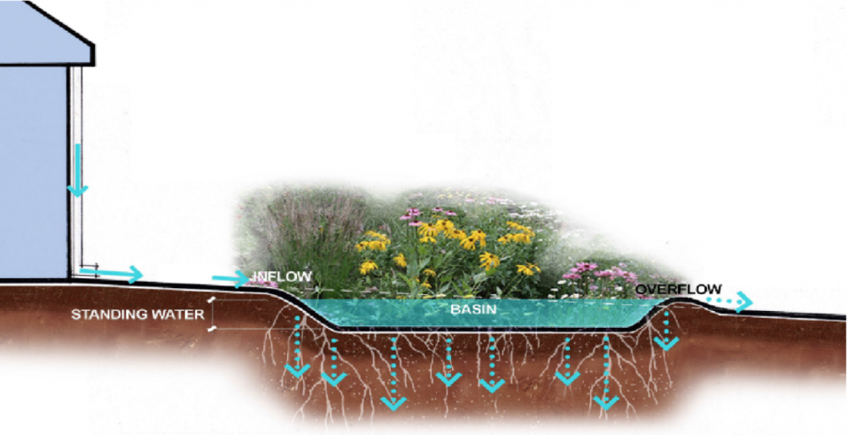

Rainwater Harvesting (IF Discussed)
We recommend rain barrels or cisterns on as many downspouts as possible. They reduce stormwater runoff and erosion. In areas with a mixed stormwater/sewer system they can help prevent treatment facilities from being overwhelmed when heavy rains occur, causing sewage to spill into our waterways.
We see the most success with rain barrel systems that account for:
- Overflow – Even moderate rainfall on a roof can easily generate hundreds of gallons of water, quickly filling almost any size of rain barrel. Make sure it can overflow away from the house’s foundation.
- Winter – Water expands when it freezes, and we have seen a number of rain barrels split open because there wasn’t an easy way for them to be winterized.
- Mosquitoes – A sealed system or screen at the inlet should keep mosquitoes out.
- Debris – Leaves and dirt that wash off the roof can clog things up. A leaf filter or “first flush” system will help to keep it relatively clean.
- Weight – A 55-gallon barrel weighs over 450 pounds when full. Make sure there is a sturdy base for it to rest on, compacted gravel or a small stone pad should be adequate.
- Algae – Where possible, situate a rain barrel or cistern in a shaded spot to avoid algal growth. If a sunny location is the only option, a dark, opaque material is recommended.
If you don’t want to store the water for your garden, equip a low-pressure soaker hose made specifically for rain barrels; it will slowly soak into the ground and it’s almost hands-free. Good Ideas for a Rain Barrel Soaker Hose
For more information:
- Rainscaping Guide: Rainwater Harvesting
- Local Rainwater Harvesting Resources

Why we care about stormwater management
Heavy rains can wash insecticides or fertilizers used on lawns into nearby waterways where they do severe damage to aquatic wildlife. Even pet waste contains phosphates and nitrates that contribute significantly to harmful algal growth.
Vegetated surfaces help slow down rainwater runoff, encouraging water infiltration and the deposition of dirt and debris carried by rainwater, keeping pollutants out of the stormwater system or local waterways. Adding more native plants and a possible rain garden/bioswale will help to further reduce water runoff from your landscape and improve water quality in your community.

Professionals who specialize in raingardens or stormwater practices:
Belfield Botanica Co. - 913.660.2420 - BelfieldBotanica@gmail.com
Bluestem Habitat Restoration - 816.714.8342 - bluestemhabitatrestoration@gmail.com
Bur Oak Ventures - 816.974.3462 - kyle@buroakventures.com
Habitat Architects – 816.645.0026
KCNative Landscapes – 816.262.5109 - info@kcnativelandscapes.com
Ksquared Landscapes – 913.815.0322 - info@ksquaredlandscapes.com
Polli-Native - 913.701.4565 - Paul@atgib.com ; nanette@atgib.com
Grow Native Professional Resource Guide

EDUCATION AND VOLUNTEERISM

Community Science
Consider these community science programs, especially those focused on native wildlife.
Feeder Watch is a longstanding initiative of the Cornell Lab of Ornithology which runs from November - April. Participants choose a location to observe birds - your own bird feeder or another natural area - then enter your bird counts online, enabling you to contribute to a continental data set of bird distribution and abundance.
Monarch Watch: Monarch Watch is a nonprofit education, conservation, and research program based at the University of Kansas that focuses on the monarch butterfly, its habitat, and its spectacular fall migration. There are many opportunities to engage with this organization.
iNaturalist is an app which can be useful in helping you to identify various flora and fauna. A joint initiative of the California Academy of Sciences and the National Geographic Society, this tool also allows you to share your observations with trained scientists who can make valuable use of data collected by community scientists like you.
National Geographic has assembled a large list of easily accessible projects.
Missouri Master Naturalist Programs (find a chapter)
Kansas Master Naturalist Programs (Johnson County, KS)
Stream Team: Missouri has 110,000 miles of streams that provide recreation, drinking water and serenity for us and our children, but they need your help. Stream Team has a busy calendar of litter pickups, tree plantings, streambank stabilization, volunteer water quality monitoring and other activities.

Learning Opportunities
Loads of native plant educational programs exist in webinar format, but many in-person opportunities also abound. Programs include these offerings:
Plan It Native is developed by Deep Roots and other partnering organizations. It presents an educational conference with nationally renowned speakers for professionals to beginners. Plan It Native 2026 will be held live and in-person at the Kaufmann Foundation Conference Center & Anita Gorman Discovery Center on February 10th and 11th, 2026!! Registration will be open in Fall 2025.
Deep Roots offers free short webinars every month on the first and third Thursdays at noon. Our Curious By Nature sessions explore native landscapes in the KC area and throughout Missouri. The Lunch & Learn series covers topics ranging from restoring prairies to planting natives in the smallest urban garden, bringing professional insight to you right at your computer. Volunteer opportunities also exist at deeproots.org/get-involved
Missouri Department of Conservation’s nature centers at nearby places like Anita B. Gorman Discovery Center and Burr Oak Woods Conservation Area in Kansas City. Events | Missouri Department of Conservation.
Missouri Botanical Garden (especially the Native Plant School series from the Shaw Nature Reserve)
Missouri Master Naturalist Programs (find a chapter)
Kansas Master Naturalist Programs (Johnson County, KS)
Grow Native! hosts regular webinars about native plants.

Spread the Word
Please share your experience, the program and our resources with your friends, neighbors, and relatives. Every landscape that incorporates native plants becomes a wildlife habitat that is critical for the future of our birds, native wildlife, and our quality of life.

RESOURCES
Websites | Books
Deeproots.org/webinars  Bring Conservation Home – St. Louis Audubon Society  Grow Native!: Keeping Nature Near  Bird-Friendly Communities | Audubon  Monarch Watch  The Xerces Society for Invertebrate Conservation | Bringing Nature Home Doug Tallamy  Nature’s Best Hope Doug Tallamy  Native Landscaping for Wildlife and People Dave Tylka. No longer in print, available used  Tried and True: Missouri Native Plants for Your Yard - Missouri Dept of Conservation  Native Plants of the Midwest Alan Branhagen  Pollinators of Native PlantsHeather Holm

DISCLAIMER
Deep Roots KC, its employees or volunteers make no direct or implied guarantee about any of the recommendations in this report or discussions during the related landscape survey. Our advice is focused on selecting the right native plants for the right place to provide the desired habitat value. Yet the success of any habitat gardening approach is determined by many other factors as well, including, in part, the quality and origin of the materials, the installation process, and the maintenance routine. Landowners especially concerned about their ability to achieve the desired results are encouraged to consult the references included in this report including the services of a native landscape professional.

"HOMEGROWN NATIONAL PARK." https://homegrownnationalpark.org/. Accessed 28 Jul. 2021.
"Features of a Good Birdhouse - NestWatch - NestWatch." https://nestwatch.org/learn/all-about-birdhouses/features-of-a-good-birdhouse/. Accessed 28 Jul. 2021.
"All About Birdhouses - NestWatch - NestWatch." https://nestwatch.org/learn/all-about-birdhouses/. Accessed 28 Jul. 2021.
"Attract Birds With Birdbaths." 20 Apr. 2009, https://www.allaboutbirds.org/news/attract-birds-with-birdbaths/. Accessed 9 Aug. 2022.
"Bat Houses - Bat Conservation International." https://www.batcon.org/about-bats/bat-houses/. Accessed 28 Jul. 2021.
"How to create habitat for stem-nesting bees - Z." https://z.umn.edu/stemnestingbees. Accessed 28 Jul. 2021.
"5 Ways to Increase Nesting Habitat for Native Bees | Xerces Society." 17 Mar. 2017, https://www.xerces.org/blog/5-ways-to-increase-nesting-habitat-for-bees. Accessed 28 Jul. 2021.
"The horrors of mass-produced bee houses » Colin Purrington." 17 May. 2019, https://colinpurrington.com/2019/05/horrors-of-mass-produced-bee-houses/. Accessed 28 Jul. 2021.
"Building and Managing Bee Hotels for Wild Bees - Michigan ...." https://pollinators.msu.edu/publications/building-and-managing-bee-hotels-for-wild-bees/. Accessed 28 Jul. 2021.
"Good Ideas for a Rain Barrel Soaker Hose - Home Guides." https://homeguides.sfgate.com/good-ideas-rain-barrel-soaker-hose-88795.html. Accessed 28 Jul. 2021.
"Rainscaping Guide: Rainwater Harvesting - Missouri Botanical Garden." https://www.missouribotanicalgarden.org/sustainability/sustainability/sustainable-living/at-home/rainscaping-guide/rainwater-harvesting.aspx. Accessed 28 Jul. 2021.
"Rainscaping Guide: Resources - Missouri Botanical Garden." https://www.missouribotanicalgarden.org/sustainability/sustainability/sustainable-living/at-home/rainscaping-guide/resources.aspx. Accessed 13 May. 2022.
"Harmful Algal Blooms | US EPA." 7 Feb. 2022, https://www.epa.gov/nutrientpollution/harmful-algal-blooms. Accessed 13 May. 2022.
"FeederWatch - Count Feeder Birds for Science." https://feederwatch.org/. Accessed 8 Feb. 2022.
"Monarch Watch." https://monarchwatch.org/. Accessed 8 Feb. 2022.
"A Community for Naturalists · iNaturalist." https://www.inaturalist.org/. Accessed 8 Feb. 2022.
"Citizen Science Projects | National Geographic Society." http://www.nationalgeographic.org/idea/citizen-science-projects/. Accessed 8 Feb. 2022.
"Missouri Master Naturalist Programs." https://extension.missouri.edu/programs/missouri-master-naturalist/find-a-chapter. Accessed 8 Feb. 2023.
"Kansas Master Naturalist Programs." https://www.johnson.k-state.edu/natural-resources/extension-master-naturalist/. Accessed 8 Feb. 2023.
"Missouri Stream Team." http://mostreamteam.org/. Accessed 8 Feb. 2022.
"Plan It Native – Deep Roots, KC." https://planitnative.org/ Accessed 8 Feb. 2023.
"Curious by Nature, Lunch & Learn Series – Deep Roots, KC." https://deeproots.org/webinars/ Accessed 8 Feb. 2023.
"Events | Missouri Department of Conservation - MO.gov." https://mdc.mo.gov/events. Accessed 8 Feb. 2023.
"Classes - Missouri Botanical Garden." https://www.missouribotanicalgarden.org/learn-discover/classes.aspx. Accessed 8 Feb. 2023.
"Missouri Master Naturalist Programs." https://extension.missouri.edu/programs/missouri-master-naturalist/find-a-chapter. Accessed 8 Feb. 2023.
"Kansas Master Naturalist Programs." https://www.johnson.k-state.edu/natural-resources/extension-master-naturalist/. Accessed 8 Feb. 2023.
"Upcoming Events – Grow Native!." https://grownative.org/events/. Accessed 8 Feb. 2023.
"Bring Conservation Home - St. Louis Audubon Society." https://stlouisaudubon.org/bch/. Accessed 17 Nov. 2022.
"Grow Native!: Keeping Nature Near." https://grownative.org/. Accessed 28 Jul. 2021.
"Bird-Friendly Communities | Audubon - National Audubon Society." https://www.audubon.org/bird-friendly-communities. Accessed 28 Jul. 2021.
"Monarch Watch." https://www.monarchwatch.org/. Accessed 28 Jul. 2021.
"The Xerces Society for Invertebrate Conservation." https://xerces.org/. Accessed 28 Jul. 2021.
"Bringing Nature Home: How You Can Sustain Wildlife ... - IndieBound." 1 Apr. 2009, https://www.indiebound.org/book/9780881929928. Accessed 28 Jul. 2021.
"Nature's Best Hope: A New Approach to Conservation ... - IndieBound." 4 Feb. 2020, https://www.indiebound.org/book/9781604699005?aff=workmanpub. Accessed 28 Jul. 2021.
"Native plants of the Midwest ... Workman”– 16 November 2016, https://www.workman.com/products/native-plants-of-the-midwest/hardback Accessed 28 Jul. 2021.
"Pollinators of Native Plants - Pollination Press LLC." https://www.pollinationpress.com/store/p5/Pollinators_of_Native_Plants_Retail.html. Accessed 28 Jul. 2021.

