13 TPI Website Submission – Kyan Bradley

For my website I decided to go with the idea of a small start-up company which specialises in delivery of Belgium ice cream.

For my design I wanted to go with a minimalistic design, I wanted to keep it simple and clean looking. I wanted to incorporate animations which would enhance the user experience.

I started by creating a colour pallet using [coolors.co](https://coolors.co/). My palette: <https://coolors.co/edc9ff-fed4e7-f2b79f-e5b769-d8cc34>

The project can be found on GitHub: <https://github.com/bradley-kyan/13TPI-Website>

The html file contains comments which further explains my outcome.

GitHub commit network graph: 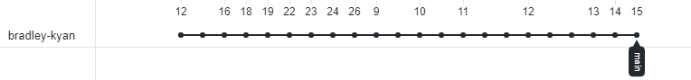

As the network graph shows, it took 22 iterations of the website to reach the desired outcome.

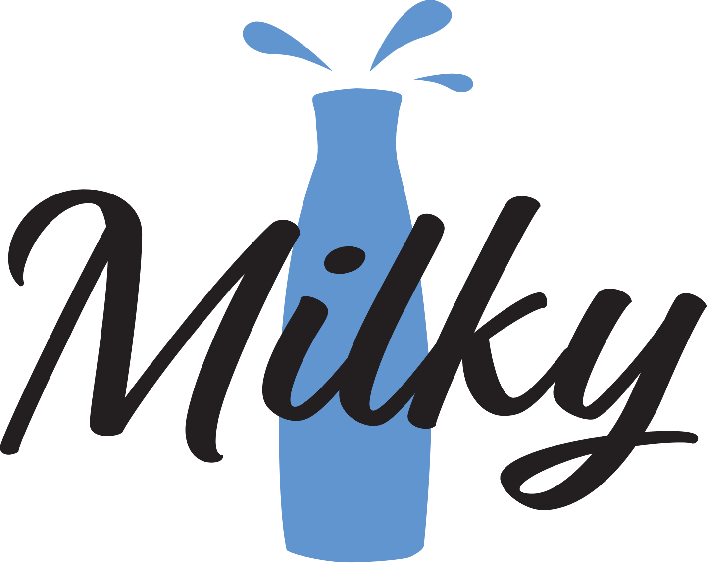When creating the website, I made sure to address the following relevant implications regarding copyright and social implications.

COPYRIGHT IMPLICATIONS

Regarding copyright and fair use implications, I made sure that I only used content that I created myself. The logo ‘Milky’ was created by me in Adobe illustrator. I too made the background and the ice cream SVG(s) in Illustrator as well. For the ice creams in particular, I found a free to use image, and then edited it in Illustrator to convert it into an SVG. By doing this, this allowed be to manually change the colours of the image.

For all the external scripts that I used, I made sure that they were all open source/free use.

Milky Logo

By making sure that I would not infringe any copyright laws, because the website is being designed for a company, it would reduce the risk of copyright claims or disputes with individuals or companies.

SOCIAL IMPLICATIONS

Because the website is planned to be viewed by the public to promote the ‘Milky’ brand, I will need to make sure that the website does not misrepresent the company or give a bad reputation of the company. This would me I will need to address whether the content of the website will be culturally acceptable. This could include but is not limited to:

* Does the website contain culturally unacceptable stereotypes?
* Does the website make the company ‘Milky’ in any way seem rude or furthermore racist?
* Does the website contain any content which could be misinterpreted?
* Is the information on the website clear and concise which will help reduce misinterpretation?

By being able to answer no to all these questions, this would mean that the website can be deemed culturally acceptable. By addressing these cultural implications, this would mean that the company will not gain a bad reputation to its customers.

Accessibility Implications

By making my website accessible to a wider audience, the company will be able to reach a wider range of potential customers. To address accessibility implications, I will need to make the website accessibility friendly. Therefore, I decided to add alt tags to all my images on the website. I also made sure to place my headings appropriately by using <h1> <h2> <h3> etc. tags correctly. This would mean that the website will be able to be used by those with impaired vision through the use of screen readers. By using alt tags, those who may have a bad internet connection would be able to understand what the content of the image is about, if the image doesn’t load.

Functionality Implications

In the creation of the website, I added a loading screen which will allow the websites extensive animations and elements positions to be sorted out before the user accesses the main content. This loading screen also would mean that those who may have a slower internet connection would still be able to view the page as intended because the elements would be properly loaded.

For the contact links I used the ‘tel:’ tag and ‘mailto:’ tag in the link ‘href’. This would allow a user to click on the link which - if they are using a modern browser - will open either an email application, or a phone application respectively.

When I was creating the website, I used Bootstrap 4. I decided to use Bootstrap due to its extensive library of content/styling. Bootstrap is also allowing for cross-compatibility/responsive web design (desktop/mobile). By using Bootstrap, this further would help the website reach a wider audience.

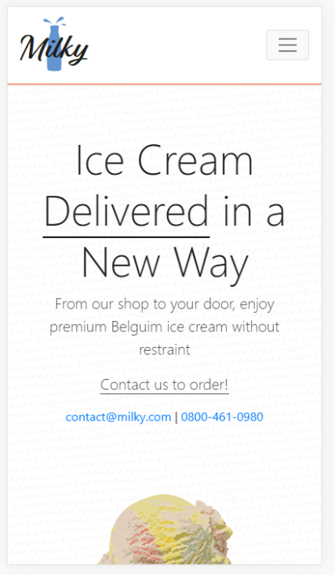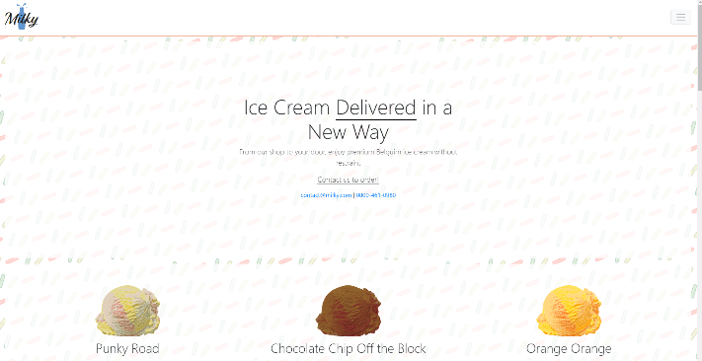When I was creating the website, I made sure to ask around to see if the website looked aesthetically pleasing and fulfilled my idea of the website having a minimalistic vibe. A response I got from a family member for the final product was

Desktop Version

Mobile Version

*“It definitely does look minimalistic, not too minimalistic though. It looks very professional doesn’t it.” - My father.*

From this response to the final product, I was happy that my design met my original design ideas.