Project 2

<Double or Nothing

A Game By Bradley McKenzie>

Course: CIS-17a Section: 48969

Due Date: 12/10/17

Author: Bradley McKenzie

**Introduction**:

Title: Double or Nothing

First you must start by inputting a username and your password (**password=password**). If password is incorrect the player will be prompted to try again. This is a betting game in which, a player in puts a bet. Followed by a color to bet on (Red or Blue). If the player gets the bet right then they bet will be doubled. However, if they get the bet wrong then they lose the amount they put down. The program will tell the player their current winnings.

For example: I put a bet down of $1000 on red.

The spinner landed on: Red

The payout is: $2000

Current Total: $2000

For example: I put a bet down of $1000 on red.

The spinner landed on: Blue

The payout is: $-1000

Current Total: $1000

The percentage of wins and losses are displayed after all games are played. The possible winnings are displayed at the end of the number of games the user plays, as well as the total winnings earn or loss in that game.

For example:

-----------------------------

Percentage Wins of = 50%

Percentage of Losses = 50%

Possible Winnings: $4000

Total Winning: $1000

-----------------------------

Nice Job!

Thank You, For Playing.

A Game By Bradley McKenzie

If the player winning a positive amount, the program then offers to play Double or Nothing x 2. Which the player has the option to double their money or lose it all. It takes their total winnings and bets it all, if they get the spin right then they will double their winnings. However if they get the spin wrong then they lose all of their winnings.

For example:

-----------------------------

Nice Job!

Double or Nothing x 2

Would you like to play?

Enter Yes or No: Yes

-----------------------------

Entering Your Bet: $1200.00

Place Bet On (Red or Blue):r

The spinner landed on: Blue

Your pay out is: $2400.00

Total Winning: $2400.00

-----------------------------

Thank You, For Playing.

A Game By Bradley McKenzie

If the player winning a positive amount, the program then offers the player a free spin for a prize. The player hits enter to spin the wheel. The wheel can land on 1-10, and for each different land there is a different prize.

For Example:

-----------------------------

Better Luck Next Time.

Why Not Try Again?

Double or Nothing

Free Spin for a Prize

-----------------------------

Hit Enter to Spin Wheel…

You Landed on Number 4, You Win a Hat.

-----------------------------

Thank You, For Playing.

A Game By Bradley McKenzie

**Summary**:

Number of Lines: 532

I will be honest, I was unable to get to 1000 lines of code.

Number Lines of Comments: 275

**Description**:

The standard number of games is 6; however the number of games can beset with the file named: "NumberOfGames.txt". Each result per game will be displayed and outputted to a file named: "ResultsOfGames.txt". If the player enters an invalid bet color, the program will tell them it was an invalid bet and that game will not count against their total parentage wins and losses. They player can enter "Red", "red", "RED", and "r", same goes for blue as well, for their bet and the program will still process the game result. If they player entered again else beside what was state before then the program will tell they player "Invalid: Bet Color Must be (Red or Blue)" If the player made money in the game, that result will be put into the "HighScoreOfGame.txt" file along with other games played before high scores.

The player will see responses base on how well they did in that game. If the player makes greater than zero and less than five million then the program will respond with "Nice Job". If the player makes 5 million or more the program will respond with "Quitting Your Job?", and last if player losses money it will respond with "Better Luck Next Time" and "Why Not Try Again". You are able to search for a username at the end of each game, all you have to do is enter "Y" when prompted, if you wish to see the high scores enter “N".

**Flowchart:**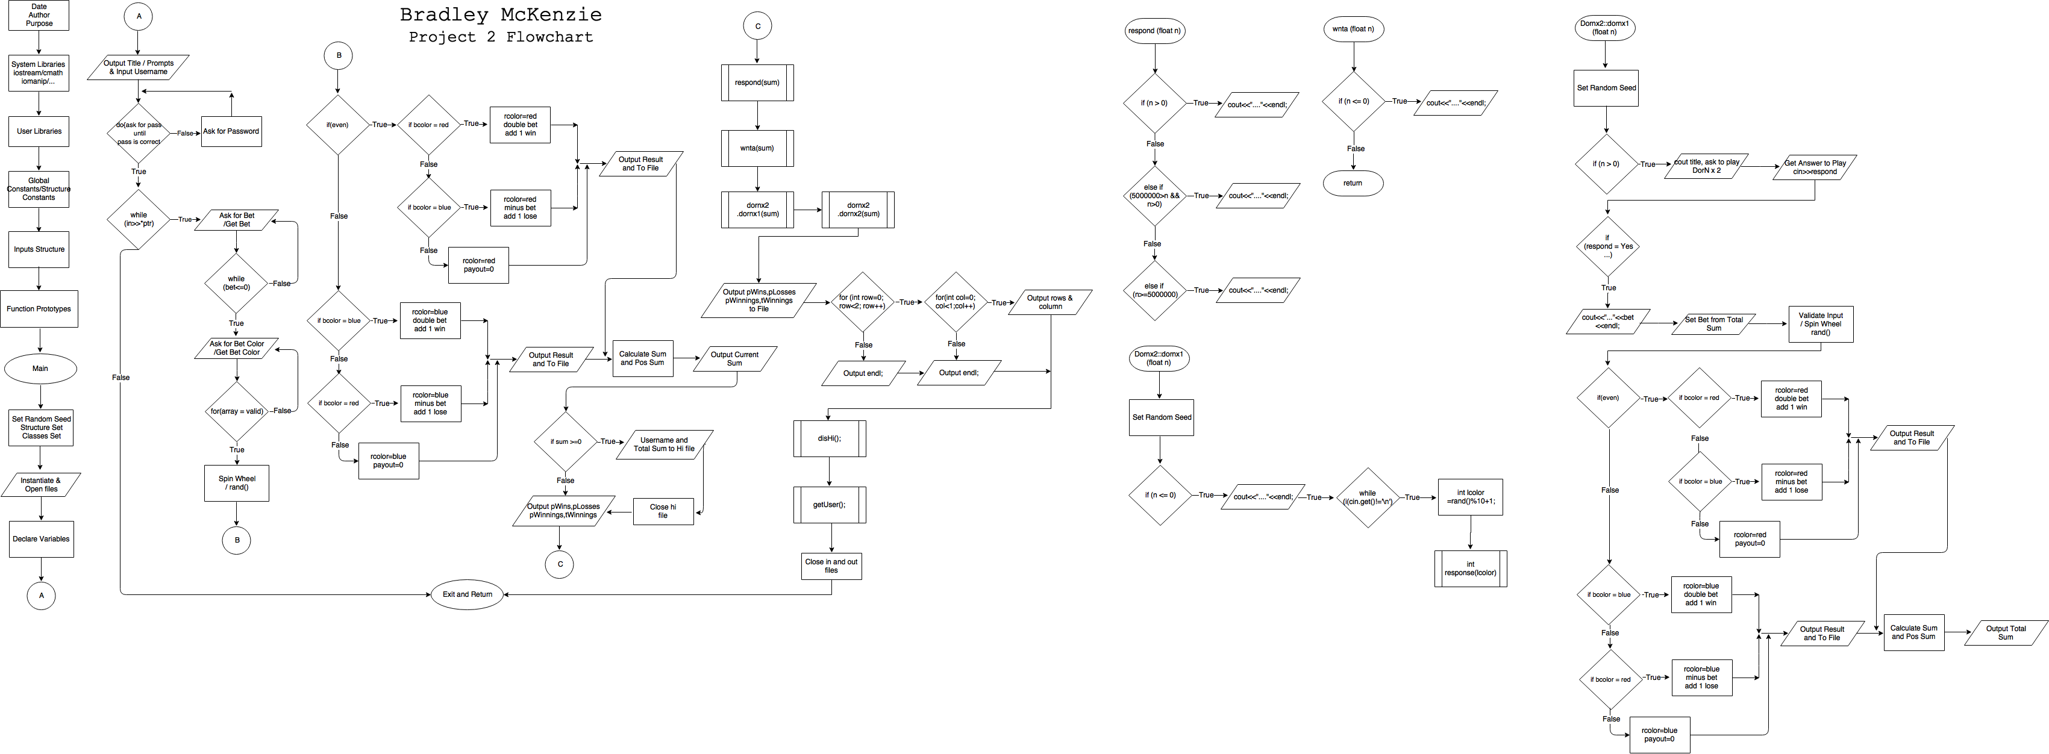

**Pseudo Code:**

/*

File: main.cpp

Author: Bradley McKenzie

Created on December 4, 2017

Purpose: Project 2

*/

//System Libraries

//Standard library

//Random Numbers/Exit

//Time to set the seed

//File stream library

//Format library

//String library

//Vector library

//Character string

//User Libraries

//Global Constants

//Calculate Wins and Losses Percentages

//Limit Number of Games 100's

//Limit to 10's

//Constants for Structure Inputs

//Password

//Username

//Bet Color

//Result Color

//Bet Amount

//Pay Out Result

//Total Winnings

//Possible Wins

//Number of Wins

//Number of Losses

//Valid Color

//Land on Red

//Land on Blue

//Character string

//Character string

//Standard Number of Games

//Function Prototypes

//Calculate Wins and Loss Percentage

//Output a respond based on Winnings

//Respond if player losses money

//Display High Score Yes or No

//Search for a username

//Test Color

//Operator Overloading

//Executable code begins here!!!

//int main

//Set the random number seed for wheel spin

//Structure setup

//Class setup

//Instantiate and Open files

//Input Number of Games

//Output Result of Games

//Output Score if Winnings > 0

//Input Values//Structure in Use

//Declare Variables-Pointer Array

//Select Standard Number of Games

//Title

//Get Username

//Get Correct Password

//If password is wrong ask for it again

//Loop to end

//Limit the number of games

//Loop the Game

//Bet amount input

//Not allow bet to negative or 0

//Bet amount input

//Input validation loop

//Bet color input

//Check if bet color is valid

//if !valid, then output invalid message

//If not valid ask for bet color again

//Bet color input

//end input validation loop

//Process by mapping inputs to outputs

//Last line will be number of games from file

//Call random number generator for the color landed on

//Value from 1 to 26 //Spin Wheel

//Land on Red

//Bet Won

//Double Bet

//Add plus one win

//Bet Loss

//Minus Bet

//Add plus one loss

//Invalid Input

//Output Game Result for Land on Red

//Land on Blue

//Bet Won

//Double bet

//Add plus one win

//Bet Loss

//Minus Bet

//Add plus one loss

//Invalid Input

//Output Game Result For Land on Blue

//Get Sum of Pay Out

//Get Sum of Bet

//Display Current Winnings

//Output Username and Total Winnings if Winnings is > 0

//Close High Score File

//Output Percentage of Wins and Losses

//Percent Wins

//Percent Losses

//Possible Winnings

//Actual Winnings

//Output Result Based on Winnings

//Respond if player losses money

//Run Double or Nothing Free Spin

//Run Double or Nothing x 2

//Percent Wins

//Percent Losses

//Possible Winnings

//Actual Winnings

//Display High Score From File

//Get Y or N input then show high scores or exit

//Find a username in high score file

//Close Files and Exit stage right!

//Calculate Wins and Loss Percentage

//Output a respond based on Winnings

//Loss money respond

//Won money respond

//Won a lot of money respond

//Respond if player losses money

//Display High Score Yes or No

//Declare option to display high score

//Get Yes or No

//Input Y or y to open high score

//Input each line of the file

//Search for a username

//Input High Score File

//Close File and Exit Stage right!

//Calculate Wins and Loss Percentage

//Output a respond based on Winnings

//Loss money respond

//Won money respond

//Won a lot of money respond

//Respond if player losses money

//Display High Score Yes or No

//Declare option to display high score

//Input Y or y to open high score

//Input each line of the file

//Game Over Overload Operator

//Polymorphism

//Game Over Overload Operator

//Polymorphism

//Search for a username

//Input High Score File

//Close File

//Test Color

//Game Over Overload Operator

/*

File: main.cpp

Author: Bradley McKenzie

Created on December 4, 2017

Purpose: Project 2: Double or Nothing x 2 Class

*/

//Dornx2 Input Class Inherit Dornx3

//Bet Amount

//Pay Out Result

//Total Winnings

//Possible Wins

//Number of Wins

//Number of Losses

//Polymorphism Function

//Double or Nothing x 2 Function

//Double or Nothing Free Spin

//Test Color

//Polymorphism

//Polymorphism

//Spin Wheel Land Prize

//Wheel Land on 1

//Wheel Land on 2

//Wheel Land on 3

//Wheel Land on 4

//Wheel Land on 5

//Wheel Land on 6

//Wheel Land on 7

//Wheel Land on 8

//Wheel Land on 9

//Wheel Land on 10

/*

File: main.cpp

Author: Bradley McKenzie

Created on December 4, 2017

Purpose: Project 2: Double or Nothing x 2: String Class

*/

//Constants for Class Inputs

//Dornx3 Inputs Class

//Response to Game Option

//Bet Color

//Result Color

//Valid Color

//Land on Red

//Land on Blue

/*

File: main.cpp

Author: Bradley McKenzie

Created on December 4, 2017

Purpose: Project 2: Double or Nothing x 2 Function

*/

//Test Color

//Free Spin Function

//Set the random number seed for wheel spin

//if pay out is negative run free spin wheel

//Get Key Input

//Value from 1 to 10 //Spin Wheel

//Run Response Function for Wheel Spin

//Double or Nothing x 2 Function

//Set the random number seed for wheel spin

//if pay out is positive ask to pay double or nothing x 2

//get response

//set n(sum) to bet

//Input validation loop

//Bet color input

//Check if bet color is valid

//if !valid, then output invalid message

//If not valid ask for bet color again

//Bet color input

//end input validation loop

//Process by mapping inputs to outputs

//Last line will be number of games from file

//Call random number generator for the color landed on

//Value from 1 to 26 //Spin Wheel

//Land on Red

//Bet Won

//Double Bet

//Add plus one win

//Bet Loss

//Minus Bet

//Add plus one loss

//Invalid Input

//Output Game Result for Land on Red

//Land on Blue

//Bet Won

//Double bet

//Add plus one win

//Bet Loss

//Minus Bet

//Add plus one loss

//Invalid Input

//Output Game Result For Land on Blue

//Get Sum of Pay Out

//Get Sum of Bet

//Display Total Winnings

**Program Code**:

/*

File: main.cpp

Author: Bradley McKenzie

Created on December 4, 2017

Purpose: Project 2

*/

//System Libraries

#include <iostream> //Standard library

#include <cstdlib> //Random Numbers/Exit

#include <ctime> //Time to set the seed

#include <fstream> //File stream library

#include <iomanip> //Format library

#include <string> //String library

#include <vector> //Vector library

using namespace std;

//User Libraries

#include "dornx2.h"

//Global Constants

const int PERCENT=100;//Calculate Wins and Losses Percentages

const int HUNDRDS=100;//Limit Number of Games 100's

const int TENS=10;//Limit to 10's

//Constants for Structure Inputs

const int IN = 1;

const int SIZE = 8;

const int COLOR = 4;

const int SIZE_1 = 28;

const int SIZE_2 = 29;

struct Inputs{

string passwrd;//Password

string usrname;//Username

string bcolor;//Bet Color

string rcolor;//Result Color

float bet;//Bet Amount

float payout;//Pay Out Result

float sum = 0;//Total Winnings

float pwings = 0;//Possible Wins

float wins = 0;//Number of Wins

float losses = 0;//Number of Losses

string vcolor[SIZE] = {"Red","red","RED","r","Blue","blue", "BLUE","b"};//Valid Color

string red[COLOR] = {"Red","red","RED","r"};//Land on Red

string blue[COLOR] = {"Blue","blue","BLUE","b"};//Land on Blue

char endcard1[SIZE_1] = " Thank You, for Playing.";//Character string

char endcard2[SIZE_2] = " A Game By Bradley McKenzie";//Character string

int nGames[COLOR] = {3, 5, 8, 10};//Standard Number of Games

};

//Function Prototypes

int percRes(float, float);//Calculate Wins and Loss Percentage

void respond(float);//Output a respond based on Winnings

bool wnta(float = 0);//Respond if player losses money

void disHi();//Display High Score Yes or No

void getUser();//Search for a username

bool findCol(string [], int , string);//Test Color

void operator++(string);//Operator Overloading

//Executable code begins here!!!

int main(int argc, char** argv) {//int main

//Set the random number seed for wheel spin

srand(static_cast<unsigned int>(time(0)));

//Structure setup

Inputs input[IN];

//Class setup

Dornx2 dornx1;

Dornx2 dornx2;

//Instantiate and Open files

ifstream in;

ofstream out;

ofstream hi;

in.open("NumberOfGames.txt");//Input Number of Games

out.open("ResultsOfGames.txt");//Output Result of Games

hi.open("HighScoreOfGames.txt");//Output Score if Winnings > 0

//Input Values//Structure in Use

for (int index = 0; index < IN; index++){

//Declare Variables-Pointer Array

int *ptr = nullptr;

ptr = &input[index].nGames[0];//Select Standard Number of Games

//Title

cout<<" -----------------------------"<<endl;

cout<<" Double or Nothing"<<endl;

cout<<" A Game By Bradley McKenzie"<<endl;

cout<<" -----------------------------"<<endl;

cout<<"Enter Username: ";

getline(cin,input[index].usrname);//Get Username

do{

cout<<"Enter Password: ";

getline(cin,input[index].passwrd);//Get Correct Password

if(input[index].passwrd!="password")//If password is wrong ask for it again

cout<<" Incorrect Password, Please Try Again: ";

}while(input[index].passwrd!="password");cout<<endl;

while(in>>*ptr);//Loop to end

*ptr=*ptr>HUNDRDS?TENS:*ptr;//Limit the number of games

for(int game=1;game<=*ptr;game++){//Loop the Game

cout<<"Enter the Amount of Your Bet: $";

cin>>input[index].bet;//Bet amount input

while(input[index].bet<=0){//Not allow bet to negative or 0

cout<<" Invalid: Bet Must be Greater Than $0."<<endl;

cout<<" Enter the Amount of Your Bet: $";

cin>>input[index].bet;//Bet amount input

}

//Input validation loop

cout<<"Place Bet On (Red or Blue): ";

cin>>input[index].bcolor;//Bet color input

bool valid = false;

for(int i=0;i<SIZE && !valid ;i++){//Check if bet color is valid

if (input[index].bcolor == input[index].vcolor[i]) valid = true;

}

//if !valid, then output invalid message

if(!valid){//If not valid ask for bet color again

cout<<" Invalid: Bet Color Must be (Red or Blue)"<<endl;

cout<<" Place Bet On (Red or Blue): ";

cin>>input[index].bcolor;//Bet color input

}

//end input validation loop

//Process by mapping inputs to outputs

//Last line will be number of games from file

//Call random number generator for the color landed on

int lcolor=rand()%26+1;//Value from 1 to 26 //Spin Wheel

if(lcolor % 2 == 0){//Land on Red

if(findCol(input[index].red, COLOR, input[index].bcolor))

{//Bet Won

input[index].rcolor="Red";

input[index].payout=input[index].bet*2;//Double Bet

input[index].wins++;//Add plus one win

}

else if(findCol(input[index].blue, COLOR, input[index].bcolor))

{//Bet Loss

input[index].rcolor="Red";

input[index].payout=-input[index].bet;//Minus Bet

input[index].losses++;//Add plus one loss

}

else{//Invalid Input

input[index].rcolor="Invalid: Bet Color";

input[index].payout=0;

}

//Output Game Result for Land on Red

cout<<fixed<<setprecision(2);

cout<<" The spinner landed on: "<<input[index].rcolor<<endl;

cout<<" Your pay out is: $"<<input[index].payout<<endl;

out<<" The spinner landed on: "<<input[index].rcolor<<endl;

out<<" Your pay out is: $"<<input[index].payout<<endl;

}

else{//Land on Blue

if(findCol(input[index].blue, COLOR, input[index].bcolor)){//Bet Won

input[index].rcolor="Blue";

input[index].payout=input[index].bet*2;//Double bet

input[index].wins++;//Add plus one win

}

else if(findCol(input[index].red, COLOR, input[index].bcolor)){//Bet Loss

input[index].rcolor="Blue";

input[index].payout=-input[index].bet;//Minus Bet

input[index].losses++;//Add plus one loss

}

else{//Invalid Input

input[index].rcolor="Invalid Bet Color";

input[index].payout=0;

}

//Output Game Result For Land on Blue

cout<<fixed<<setprecision(2);

cout<<" The spinner landed on: "<<input[index].rcolor<<endl;

cout<<" Your pay out is: $"<<input[index].payout<<endl;

out<<" The spinner landed on: "<<input[index].rcolor<<endl;

out<<" Your pay out is: $"<<input[index].payout<<endl;

}

input[index].sum += input[index].payout;//Get Sum of Pay Out

input[index].pwings += input[index].bet*2;//Get Sum of Bet

cout<<" Current Winning: $"<<input[index].sum<<endl<<endl;//Display Current Winnings

}

if(input[index].sum>=0){//Output Username and Total Winnings if Winnings is > 0

hi<<"Username: "<<input[index].usrname<<" || Total Winnings: $"<<input[index].sum<<"\r\n";

}

hi.close();//Close High Score File

//Output Percentage of Wins and Losses

cout<<fixed<<setprecision(2);

out<<fixed<<setprecision(2);

cout<<" -----------------------------"<<endl;

cout<<" Percentage Wins of = "<<percRes(input[index].wins,*ptr)<<"%"<<endl;//Percent Wins

cout<<" Percentage of Losses = "<<percRes(input[index].losses,*ptr)<<"%"<<endl;//Percent Losses

cout<<" Possible Winnings: $"<<input[index].pwings<<endl;//Possible Winnings

cout<<" Total Winning: $"<<input[index].sum<<endl;//Actual Winnings

cout<<" -----------------------------"<<endl;

respond(input[index].sum);//Output Result Based on Winnings

wnta(input[index].sum);//Respond if player losses money

dornx2.dornx1(input[index].sum);//Run Double or Nothing Free Spin

dornx2.dornx2(input[index].sum);//Run Double or Nothing x 2

cout<<" -----------------------------"<<endl;

out<<" -----------------------------"<<endl;

out<<" Percentage of Wins = "<<percRes(input[index].wins,*ptr)<<"%"<<endl;//Percent Wins

out<<" Percentage of Losses = "<<percRes(input[index].losses,*ptr)<<"%"<<endl;//Percent Losses

out<<" Possible Winnings: $"<<input[index].pwings<<endl;//Possible Winnings

out<<" Total Winning: $"<<input[index].sum<<endl;//Actual Winnings

out<<" -----------------------------"<<endl;

cout<<input[index].endcard1<<endl;

cout<<input[index].endcard2<<endl;

cout<<endl;

cout<<" Show High Scores (Y or N): ";//Display High Score From File

disHi();//Get Y or N input then show high scores or exit

//Find a username in high score file

getUser();

//Close Files and Exit stage right!

in.close();

out.close();

return 0;

}

}

int percRes(float wl, float nGames){//Calculate Wins and Loss Percentage

return (int)(((float)PERCENT)*wl/nGames);

}

void respond(float n){//Output a respond based on Winnings

if(n<=0){//Loss money respond

cout<<" Better Luck Next Time."<<endl;

}

else if(5000000>n && n>0){//Won money respond

cout<<"\t Nice Job!"<<endl;

}

else if(n>=5000000){//Won a lot of money respond

cout<<" Quitting Your Job?"<<endl;

}

}

bool wnta(float n){//Respond if player losses money

if(n<=0){

cout<<" Why Not Try Again?"<<endl;

}

return true;

}

void disHi(){//Display High Score Yes or No

string in;

char openHi;//Declare option to display high score

cin>>openHi;//Get Yes or No

if(openHi=='Y' || openHi=='y'){//Input Y or y to open high score

ifstream inFile("HighScoreOfGames.txt");

if(inFile){

while(!inFile.eof()){

//Input each line of the file

getline(inFile, in);

cout<<in<<endl;

//Game Over Overload Operator

string msg1("\t Game ");

string msg2("Over");

string msg3("");

msg3 += msg1 + msg2;

cout<<msg3<<endl;

//Polymorphism

Play *pm = new Again;

pm->show();

}

}

}

else{

//Game Over Overload Operator

string msg1("\t Game ");

string msg2("Over");

string msg3("");

msg3 += msg1 + msg2;

cout<<msg3<<endl;

//Polymorphism

Play *pm = new Again;

pm->show();

exit(0);

}

}

void getUser(){//Search for a username

int offset;

string line;

string find;

ifstream inFind("HighScoreOfGames.txt");//Input High Score File

cout<<"Enter Username to Search For: ";

getline(cin,find);

cin.ignore();

if(inFind.is_open()){

while(!inFind.eof()){

getline(inFind,line);

if((offset = line.find(find,0)) != string::npos){

cout<<" The Word Has Been Found"<<find<<endl;

}

}

inFind.close();}//Close File

else

cout<<" Could Not Open File"<<endl;

}

bool findCol(string c[], int cSize, string test){//Test Color

bool result = false;

for (int i = 0; i < cSize ; i++){

if (c[i] == test) result = true;

}

return result;

}

void operator++(string s){//Game Over Overload Operator

string msg1("\t Game ");

string msg2("Over");

string msg3("");

msg3 += msg1 + msg2;

cout<<msg3<<endl;

}

/*

File: main.cpp

Author: Bradley McKenzie

Created on December 4, 2017

Purpose: Project 2: Double or Nothing x 2 Function

*/

#include <iostream>

#include <string>

#include <iomanip>

#include "dornx2.h"

using namespace std;

bool findColo(string c[], int cSize, string test){//Test Color

bool result = false;

for (int i = 0; i < cSize ; i++){

if (c[i] == test) result = true;

}

return result;

}

void Dornx2::dornx1(float n){//Free Spin Function

//Set the random number seed for wheel spin

srand(static_cast<unsigned int>(time(0)));

//if pay out is negative run free spin wheel

if (n<=0){

cout<<" Double or Nothing"<<endl;

cout<<" Free Spin for a Prize"<<endl;

cout<<" -----------------------------"<<endl;

cout<<"Hit Enter to Spin Wheel...";

cin.ignore();

while (cin.get()!='\n');//Get Key Input

int lcolor=rand()%10+1;//Value from 1 to 10 //Spin Wheel

response(lcolor);//Run Response Function for Wheel Spin

}

}

void Dornx2::dornx2(float n){//Double or Nothing x 2 Function

//Set the random number seed for wheel spin

srand(static_cast<unsigned int>(time(0)));

//if pay out is positive ask to pay double or nothing x 2

if (n>0){

cout<<" Double or Nothing x 2"<<endl;

cout<<" Would you like to play?"<<endl;

cout<<" Enter Yes or No: ";

cin>>respond;//get response

cout<<" -----------------------------"<<endl;

bet=n;//set n(sum) to bet

if(respond=="Yes" || respond=="yes" || respond=="Y" || respond=="y"){

cout<<"Entering Your Bet: $"<<bet<<endl;

//Input validation loop

cout<<"Place Bet On (Red or Blue): ";

cin>>bcolor;//Bet color input

bool valid = false;

for(int i=0;i<8 && !valid ;i++){//Check if bet color is valid

if (bcolor == vcolor[i]) valid = true;

}

//if !valid, then output invalid message

if(!valid){//If not valid ask for bet color again

cout<<" Invalid: Bet Color Must be (Red or Blue)"<<endl;

cout<<" Place Bet On (Red or Blue): ";

cin>>bcolor;//Bet color input

}

//end input validation loop

//Process by mapping inputs to outputs

//Last line will be number of games from file

//Call random number generator for the color landed on

int lcolor=rand()%26+1;//Value from 1 to 26 //Spin Wheel

if(lcolor % 2 == 0){//Land on Red

if(findColo(red, 4, bcolor))

{//Bet Won

rcolor="Red";

payout=bet*2;//Double Bet

wins++;//Add plus one win

}

else if(findColo(blue, 4, bcolor))

{//Bet Loss

rcolor="Red";

payout=-bet;//Minus Bet

losses++;//Add plus one loss

}

else{//Invalid Input

rcolor="Invalid: Bet Color";

payout=0;

}

//Output Game Result for Land on Red

cout<<fixed<<setprecision(2);

cout<<" The spinner landed on: "<<rcolor<<endl;

cout<<" Your pay out is: $"<<payout<<endl;

}

else{//Land on Blue

if(findColo(blue, 4, bcolor)){//Bet Won

rcolor="Blue";

payout=bet*2;//Double bet

wins++;//Add plus one win

}

else if(findColo(red, 4, bcolor)){//Bet Loss

rcolor="Blue";

payout=-bet;//Minus Bet

losses++;//Add plus one loss

}

else{//Invalid Input

rcolor="Invalid Bet Color";

payout=0;

}

//Output Game Result For Land on Blue

cout<<fixed<<setprecision(2);

cout<<" The spinner landed on: "<<rcolor<<endl;

cout<<" Your pay out is: $"<<payout<<endl;

}

sum += payout;//Get Sum of Pay Out

pwings += bet*2;//Get Sum of Bet

cout<<" Total Winning: $"<<sum<<endl;//Display Total Winnings

}

}

}

/*

File: main.cpp

Author: Bradley McKenzie

Created on December 4, 2017

Purpose: Project 2: Double or Nothing x 2 Class

*/

#ifndef DORNX2_H

#define DORNX2_H

#include <iostream>

#include <string>

#include "dornx3.h"

using namespace std;

class Dornx2 : public Dornx3{//Dornx2 Input Class Inherit Dornx3

public:

float bet;//Bet Amount

float payout;//Pay Out Result

float sum = 0;//Total Winnings

float pwings = 0;//Possible Wins

float wins = 0;//Number of Wins

float losses = 0;//Number of Losses

virtual void show(){cout<<" Play Again?";}//Polymorphism Function

void dornx2(float);//Double or Nothing x 2 Function

void dornx1(float);//Double or Nothing Free Spin

bool findCol(string [], int , string);//Test Color

};

class Play{//Polymorphism

public:

virtual void show(){

cout<<"\t Play Again?"<<endl;

}

};

class Again : public Play{//Polymorphism

public:

void show(){

cout<<"\t Play Again?"<<endl;

}

};

template <class T>

void response(T num){//Spin Wheel Land Prize

if (num == 1){//Wheel Land on 1

cout<<" You Landed on Number "<<num<<", You Win a Pen."<<endl;

}

if (num == 2){//Wheel Land on 2

cout<<" You Landed on Number "<<num<<", You Win a Bike."<<endl;

}

if (num == 3){//Wheel Land on 3

cout<<" You Landed on Number "<<num<<", You Win a Pizza."<<endl;

}

if (num == 4){//Wheel Land on 4

cout<<" You Landed on Number "<<num<<", You Win a Hat."<<endl;

}

if (num == 5){//Wheel Land on 5

cout<<" You Landed on Number "<<num<<", You Win a Tesla Model X."<<endl;

}

if (num == 6){//Wheel Land on 6

cout<<" You Landed on Number "<<num<<", You Win a Shirt."<<endl;

}

if (num == 7){//Wheel Land on 7

cout<<" You Landed on Number "<<num<<", You Win a Baseball Bat."<<endl;

}

if (num == 8){//Wheel Land on 8

cout<<" You Landed on Number "<<num<<", You Win a McDonalds' Coupon."<<endl;

}

if (num == 9){//Wheel Land on 9

cout<<" You Landed on Number "<<num<<", You Win a Fake iPhone X."<<endl;

}

if (num == 10){//Wheel Land on 10

cout<<" You Landed on Number "<<num<<", You Win a Scooter."<<endl;

}

}

#endif /* DORNX2_H */

/*

File: main.cpp

Author: Bradley McKenzie

Created on December 4, 2017

Purpose: Project 2: Double or Nothing x 2: String Class

*/

#ifndef DORNX3_H

#define DORNX3_H

#include <string>

using namespace std;

//Constants for Class Inputs

const int SIZE2 = 8;

const int COLOR2 = 4;

using namespace std;

class Dornx3{//Dornx3 Inputs Class

public:

string respond;//Response to Game Option

string bcolor;//Bet Color

string rcolor;//Result Color

string vcolor[SIZE2] = {"Red","red","RED","r","Blue","blue", "BLUE","b"};//Valid Color

string red[COLOR2] = {"Red","red","RED","r"};//Land on Red

string blue[COLOR2] = {"Blue","blue","BLUE","b"};//Land on Blue

};

#endif /* DORNX3_H */

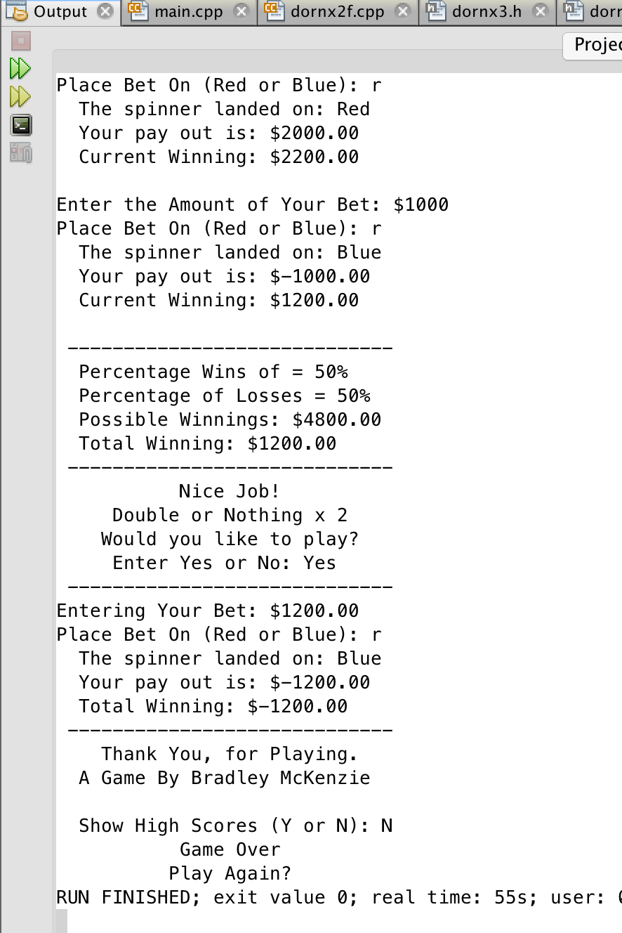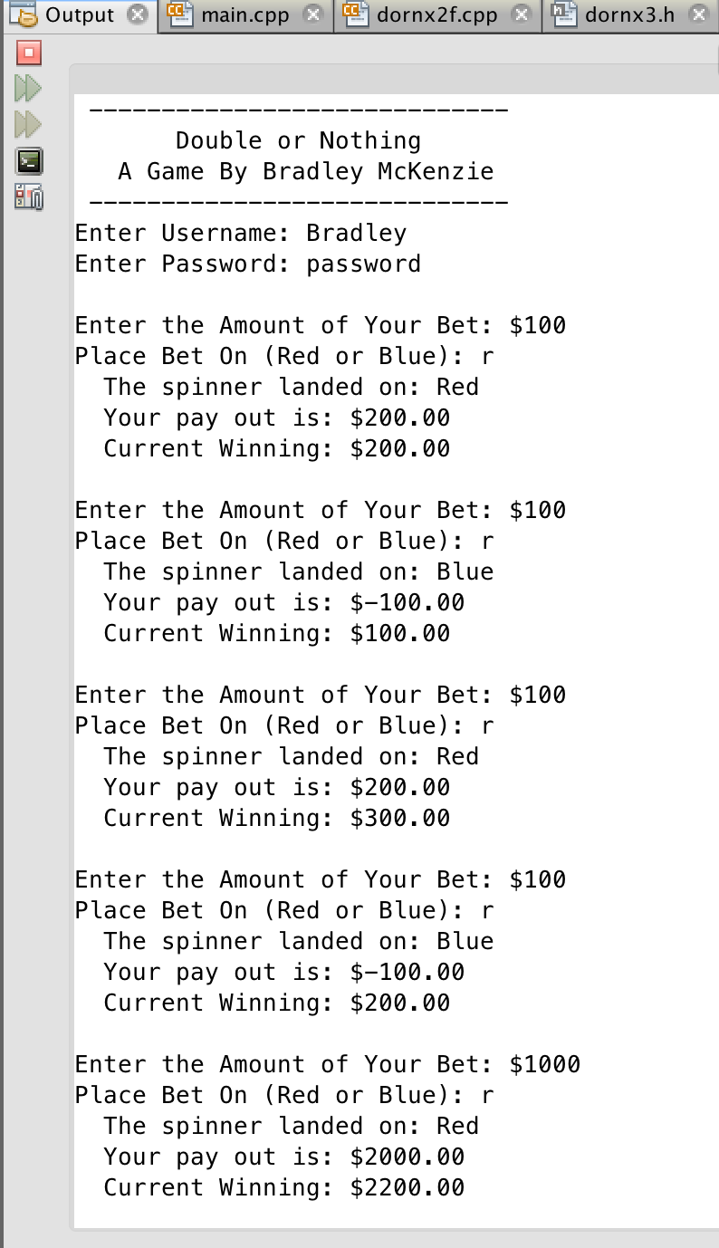**Sample Runs:**

