Project 1

<Double or Nothing

A Game By Bradley McKenzie>

Course: CSC-5 Section: 40107

Due Date: 01/30/17

Author: Bradley McKenzie

**Introduction**:

Title: Double or Nothing

This is a betting game in which, a player in puts a bet. Followed by a color to bet on (Red or Blue). If the player gets the bet right then they bet will be doubled. However, if they get the bet wrong then they lose the amount they put down.

For example: I put a bet down of $1000 on red.

The spinner landed on: Red

The payout is: $2000

For example: I put a bet down of $1000 on red.

The spinner landed on: Blue

The payout is: $-1000

The percentage of wins and losses are displayed after all games are played.

**Summary**:

Number of Lines: 123

Number Lines of Comments: 58

**Description**:

The standard number of games is 3; however the number of games can be set with the file named: "NumberOfGames.dat". Each result per game will be displayed and outputted to a file named: "ResultsOfGames.dat". If the player enters an invalid bet color, the program will tell them it was an invalid bet and that game will not count against their total parentage wins and losses. They player can enter "Red" or "red" for their bet and the program will still process the game result.

**Flowchart**:

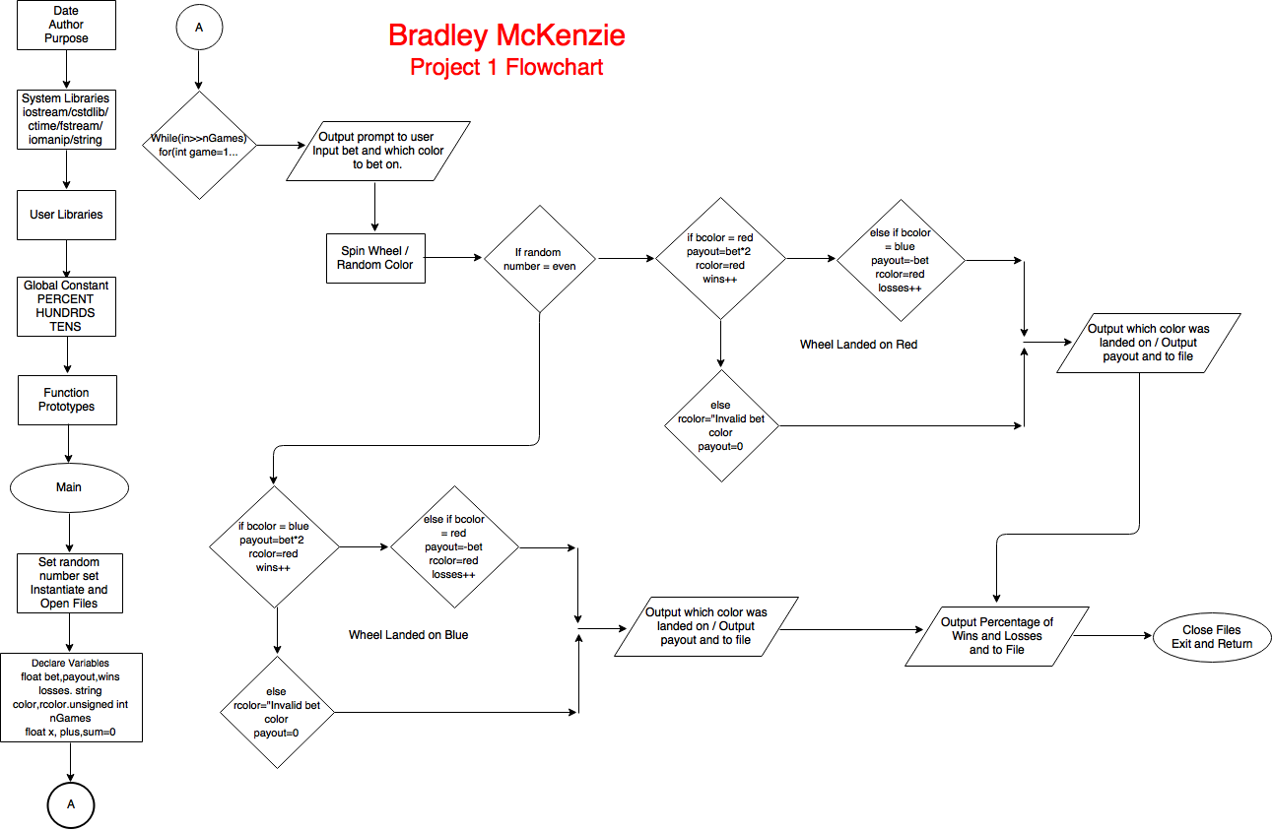

**Pseudo Code**:

/*

File: main.cpp

Author: Bradley McKenzie

Created on January 28, 2017

Purpose: Project 1

*/

//System Libraries

//Standard library

//Random Numbers

//Time to set the seed

//File stream library

//Format library

//String library

//User Libraries

//Global Constants

//Such as PI, Vc, -> Math/Science Values

//as well as conversions from system of units to another

//Calculate Wins and Losses Percentages

//Limit Number of Games 100's

//Limit Number of Games 10's

//Function Prototypes

//Executable code begins here!!!

//Set the random number seed

//Instantiate and Open files

//Declare Variables

//Bet Amount

//Pay Out Result

//Number of Wins

//Number of Losses

//Bet Color

//Result Color

//Standard Number of Games

//Input Values

//Loop to end

//Limit the number of games

//Loop the Game

//Bet color input

//Process by mapping inputs to outputs

//Last line will be number of games from file

//Call random number generator for the color landed on

//Value from 1 to 26 //Spin Wheel

//Land on Red

//Bet Won

//Add plus one win

//Bet Loss

//Add plus one loss

//Invalid Input

//Output Game Result

//Land on Blue

//Bet Won

Add plus one win

//Bet Loss

Add plus one loss

Invalid Input

//Output Game Result

//Output Percentage of Wins and Losses

//Close Files and Exit stage right!

**Cross Reference**:

Where in Code

|  |  |  |  |
| --- | --- | --- | --- |
| **Chapter** | **Section** | **Topic** | **Line number** |
| 2 | 2 | cout |  |
|  | 3 | libraries | iostream, iomanip, cmath, cstdlib, fstream, string, ctime |
|  | 4 | variables/literals |  |
|  | 5 | Identifiers |  |
|  | 6 | Integers |  |
|  | 7 | Characters |  |
|  | 8 | Strings |  |
|  | 9 | Floats No Doubles |  |
|  | 10 | Bools |  |
|  | 11 | Sizeof ***** |  |
|  | 12 | Variables 7 characters or less |  |
|  | 13 | Scope ***** No Global Variables |  |
|  | 14 | Arithmetic operators |  |
|  | 15 | Comments 20%+ |  |
|  | 16 | Named Constants |  |
|  | 17 | Programming Style ***** Emulate |  |
|  |  |  |  |
| 3 | 1 | cin |  |
|  | 2 | Math Expression |  |
|  | 3 | Mixing data types **** |  |
|  | 4 | Overflow/Underflow **** |  |
|  | 5 | Type Casting |  |
|  | 6 | Multiple assignment ***** |  |
|  | 7 | Formatting output |  |
|  | 8 | Strings |  |
|  | 9 | Math Library |  |
|  | 10 | Hand tracing ****** |  |
|  |  |  |  |
| 4 | 1 | Relational Operators |  |
|  | 2 | if |  |
|  | 4 | If-else |  |
|  | 5 | Nesting |  |
|  | 6 | If-else-if |  |
|  | 7 | Flags ***** |  |
|  | 8 | Logical operators |  |
|  | 11 | Validating user input |  |
|  | 13 | Conditional Operator |  |
|  | 14 | Switch |  |
|  |  |  |  |
| 5 | 1 | Increment/Decrement |  |
|  | 2 | While |  |
|  | 5 | Do-while |  |
|  | 6 | For loop |  |
|  | 11 | Files input/output both |  |
|  | 12 | No breaks in loops ****** |  |
|  |  |  |  |
| 6 | 3 | Prototypes |  |
|  | 4 | Pass by Value |  |
|  | 8 | Returning Values |  |
|  | 9 | Boolean return values |  |
|  | 11 | Static Local Variable |  |
|  | 12 | Default Arguments |  |
|  | 13 | Reference Variables |  |
|  | 14 | Overloading functions |  |
|  |  |  |  |
| 7 | 4 | Array Initialization |  |
|  | 7 | Parallel Arrays |  |
|  | 8 | Arrays in function arguments |  |
|  | 9 | 2 Dimensional Arrays |  |
|  |  | 2 Darrays as function argument |  |
|  | 12 | STL Vector |  |
|  |  |  |  |
| 8 | 1 | Search Linear/Binary |  |
|  | 3 | Sorting Bubble/Selection |  |
|  | 5 | Applied to Vectors |  |
|  |  |  |  |
| ****** Not | required to | show |  |

**Program Code**:

/*

File: main.cpp

Author: Bradley McKenzie

Created on January 28, 2017

Purpose: Project 1

*/

//System Libraries

#include <iostream> //Standard library

#include <cstdlib> //Random Numbers

#include <ctime> //Time to set the seed

#include <fstream> //File stream library

#include <iomanip> //Format library

#include <string> //String library

using namespace std;

//User Libraries

//Global Constants

//Such as PI, Vc, -> Math/Science Values

//as well as conversions from system of units to another

const int PERCENT=100;//Calculate Wins and Losses Percentages

const int HUNDRDS=100;//Limit Number of Games 100's

const int TENS=10;//Limit Number of Games 10's

//Function Prototypes

//Executable code begins here!!!

int main(int argc, char** argv) {

//Set the random number seed

srand(static_cast<unsigned int>(time(0)));

//Instantiate and Open files

ifstream in;

ofstream out;

in.open("NumberOfGames.dat");

out.open("ResultsOfGames.dat");

//Declare Variables

float bet;//Bet Amount

float payout;//Pay Out Result

float wins=0;//Number of Wins

float losses=0;//Number of Losses

string bcolor;//Bet Color

string rcolor;//Result Color

unsigned int nGames=3;//Standard Number of Games

//Input Values

cout<<"\tDouble or Nothing\n"<<" A Game By Bradley McKenzie\n"<<endl;

while(in>>nGames);//Loop to end

nGames=nGames>HUNDRDS?TENS:nGames;//Limit the number of games

for(int game=1;game<=nGames;game++){//Loop the Game

cout<<"Enter the Amount of Your Bet: $";

cin>>bet;//Bet amount input

cout<<"Place Bet On (Red or Blue): ";

cin>>bcolor;//Bet color input

//Process by mapping inputs to outputs

//Last line will be number of games from file

//Call random number generator for the color landed on

int lcolor=rand()%26+1;//Value from 1 to 26 //Spin Wheel

if(lcolor % 2 == 0){//Land on Red

if(bcolor=="Red"||bcolor=="red"){//Bet Won

rcolor="Red";

payout=bet*2;

wins++;//Add plus one win

}

else if(bcolor=="Blue"||bcolor=="blue"){//Bet Loss

rcolor="Red";

payout=-bet;

losses++;//Add plus one loss

}

else{//Invalid Input

rcolor="Invalid Bet Color";

payout=0;

}

//Output Game Result

cout<<fixed<<setprecision(2);

cout<<" The spinner landed on: "<<rcolor<<endl;

cout<<" Your pay out is: $"<<payout<<endl<<endl;

out<<" The spinner landed on: "<<rcolor<<endl;

out<<" Your pay out is: $"<<payout<<endl<<endl;

}

else{//Land on Blue

if(bcolor=="Blue"||bcolor=="blue"){//Bet Won

rcolor="Blue";

payout=bet*2;

wins++;//Add plus one win

}

else if(bcolor=="Red"||bcolor=="red"){//Bet Loss

rcolor="Blue";

payout=-bet;

losses++;//Add plus one loss

}

else{//Invalid Input

rcolor="Invalid Bet Color";

payout=0;

}

//Output Game Result

cout<<fixed<<setprecision(2);

cout<<" The spinner landed on: "<<rcolor<<endl;

cout<<" Your pay out is: $"<<payout<<endl<<endl;

out<<" The spinner landed on: "<<rcolor<<endl;

out<<" Your pay out is: $"<<payout<<endl<<endl;

}

}

//Output Percentage of Wins and Losses

cout<<fixed<<setprecision(0);

cout<<" -----------------------------"<<endl;

cout<<" Percentage Wins of = "

<<static_cast<float>(PERCENT)*wins/nGames<<"%"<<endl;

cout<<" Percentage of Losses = "

<<static_cast<float>(PERCENT)*losses/nGames<<"%"<<endl;

cout<<" -----------------------------"<<endl;

out<<" -----------------------------"<<endl;

out<<" Percentage of Wins = "

<<static_cast<float>(PERCENT)*wins/nGames<<"%"<<endl;

out<<" Percentage of Losses = "

<<static_cast<float>(PERCENT)*losses/nGames<<"%"<<endl;

out<<" -----------------------------"<<endl;

//Close Files and Exit stage right!

in.close();

out.close();

return 0;

}